Tutorial for NSTX: https://youtu.be/3u2L7fmq8Lw

So far: https://youtu.be/3u2L7fmq8Lw?t=2549

module load mod_omfit; Module load omfit/unstable

Load the module kineticEFITtime and scope

*1. use scope to look into the discharge

2. run kineticEFITtime,

3. enter the discharge and time, the time stamps of pre-constructed equilibrium can be seen on the left.

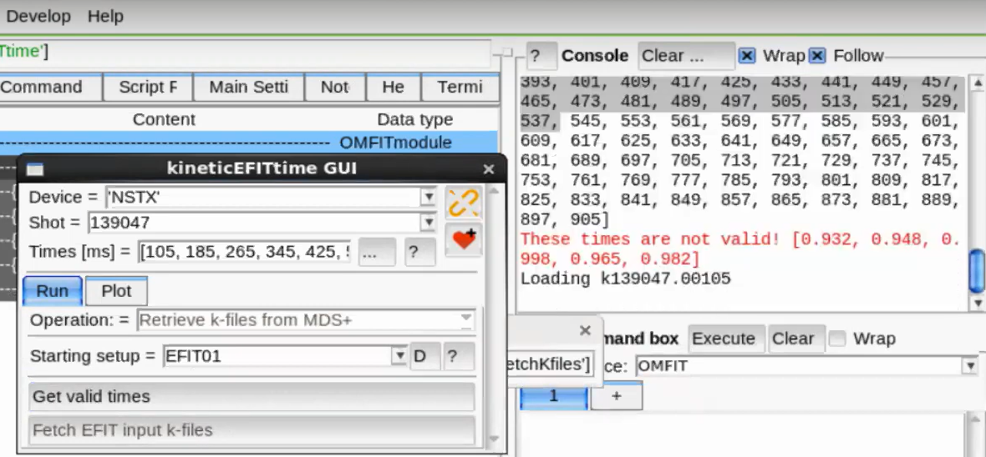

3. Load MSE data

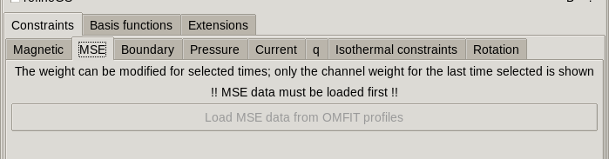

4. Fetch data

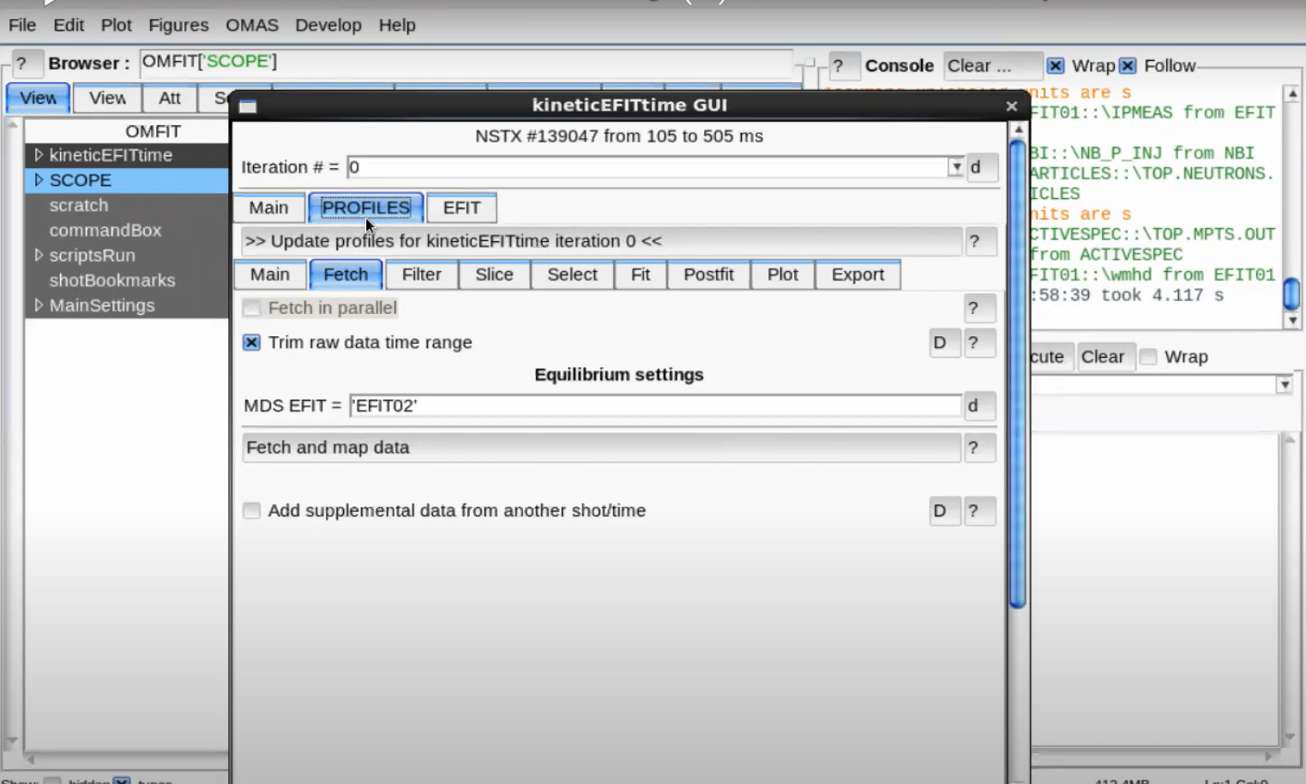

5. Slice data

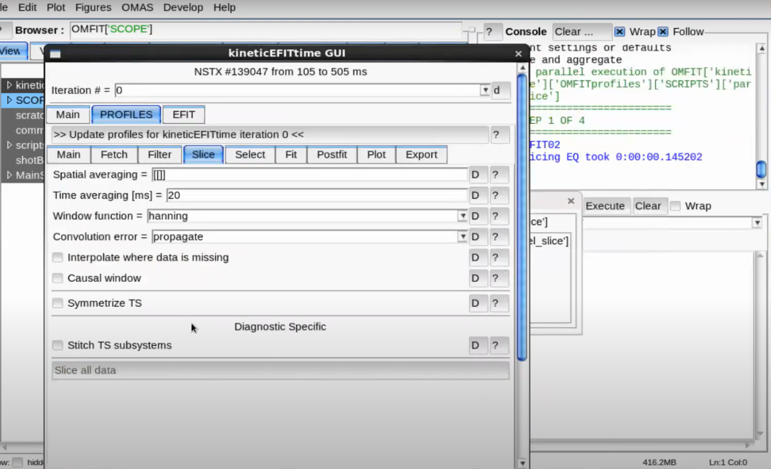

6. Plot the profile 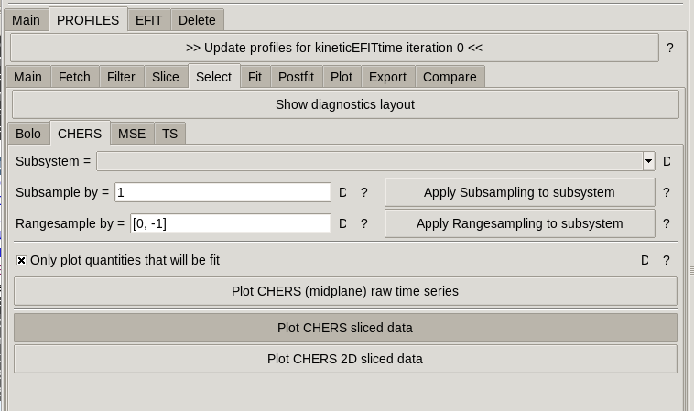

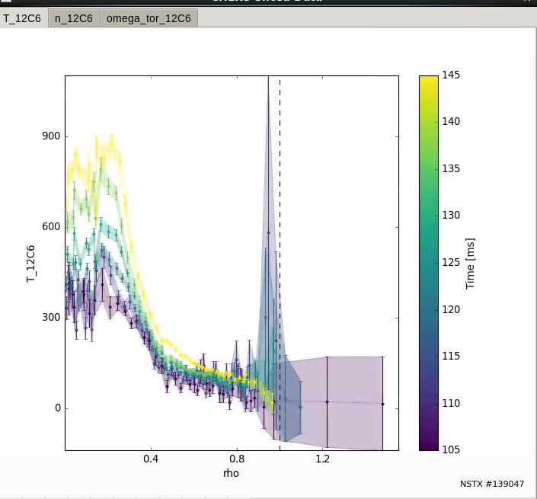

7.Click the data point to see which prob is it. 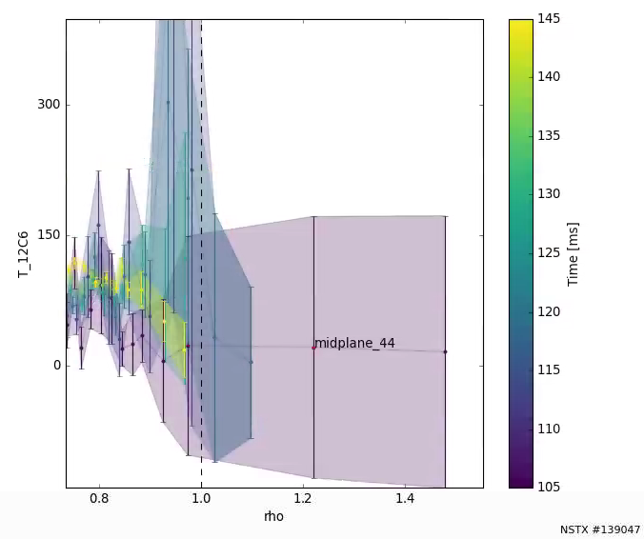

8. Select subsystem and deselect the probs if needed.

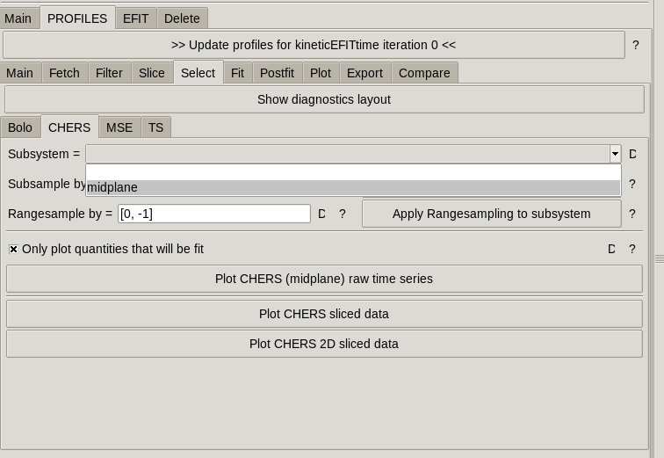 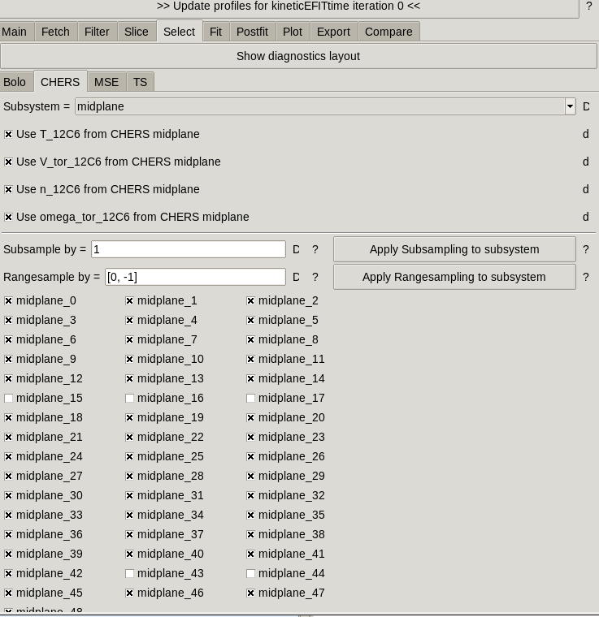

9. fit and plot omega tor, use arrow key in the keyboard to go to the different time slice

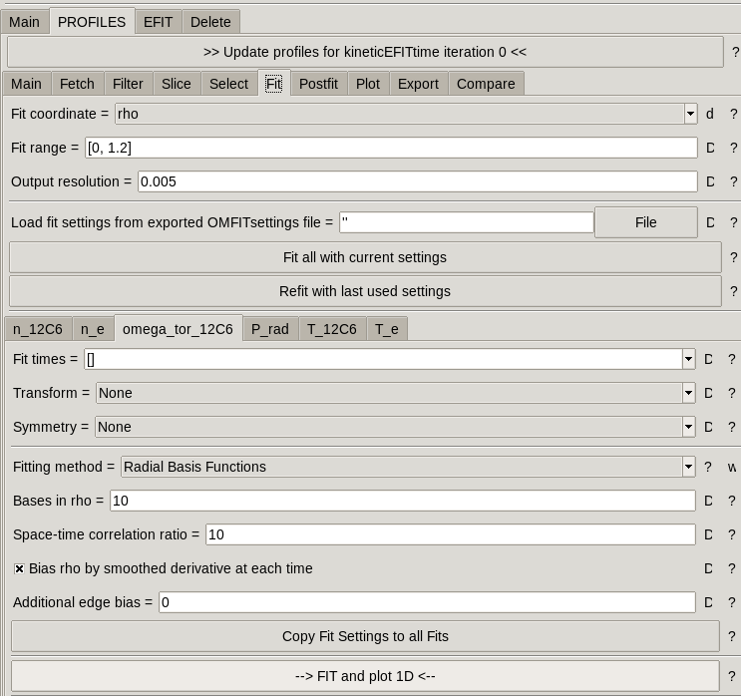

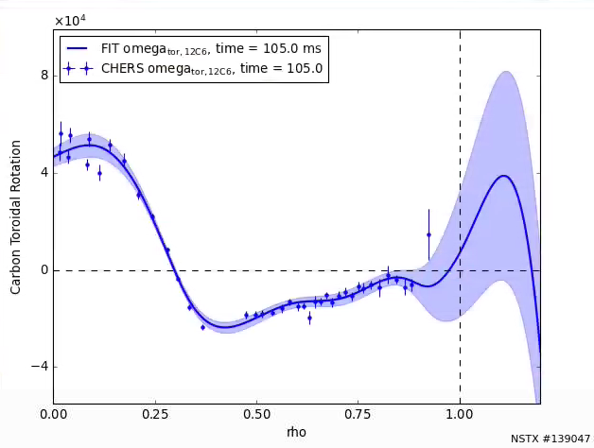

10. calculate derivated quantities

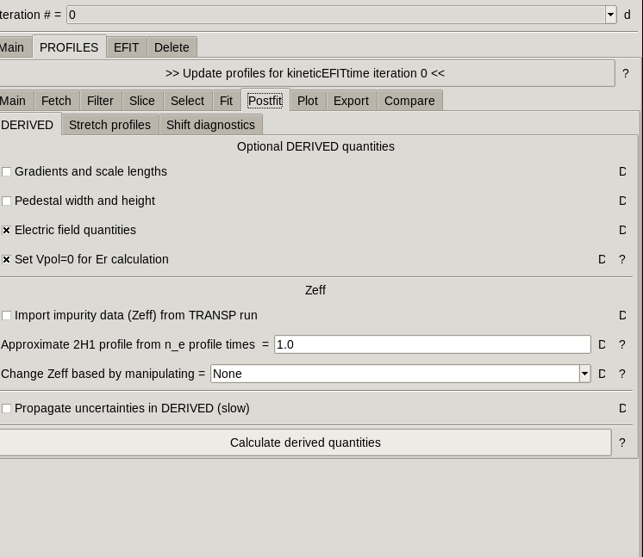

11. update the profile

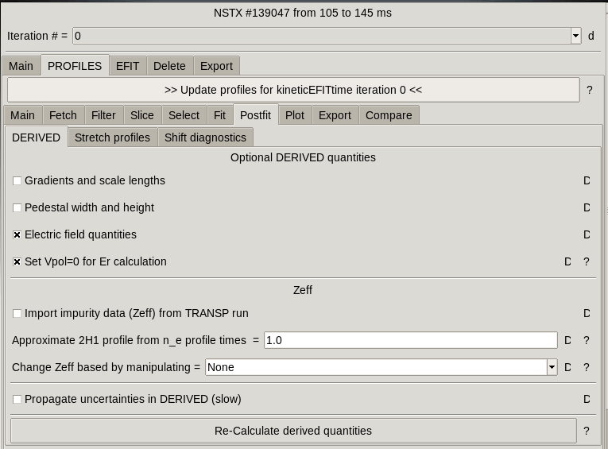

13. load MSE data

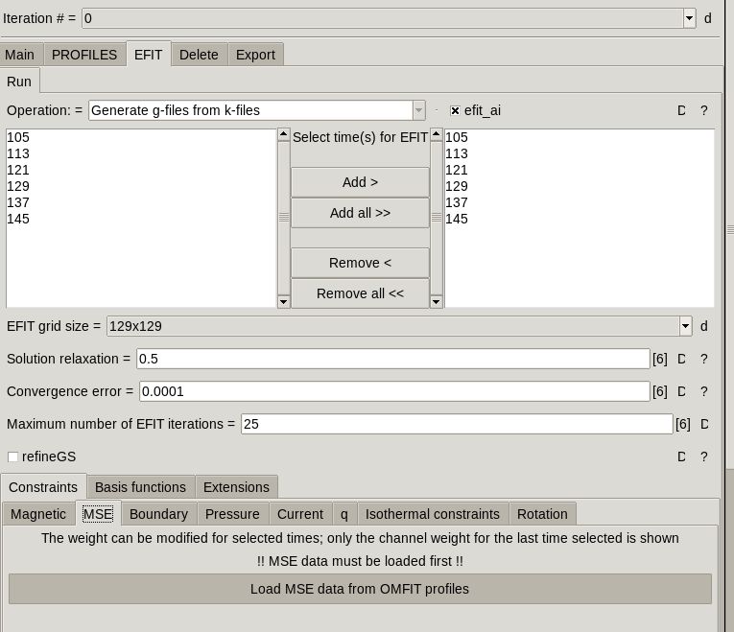

14. change and check the weight for the channel

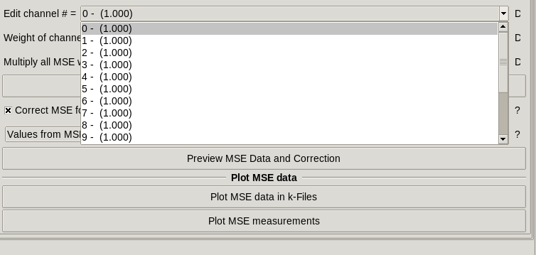

15. edit the isothermal ???

Tutorial version

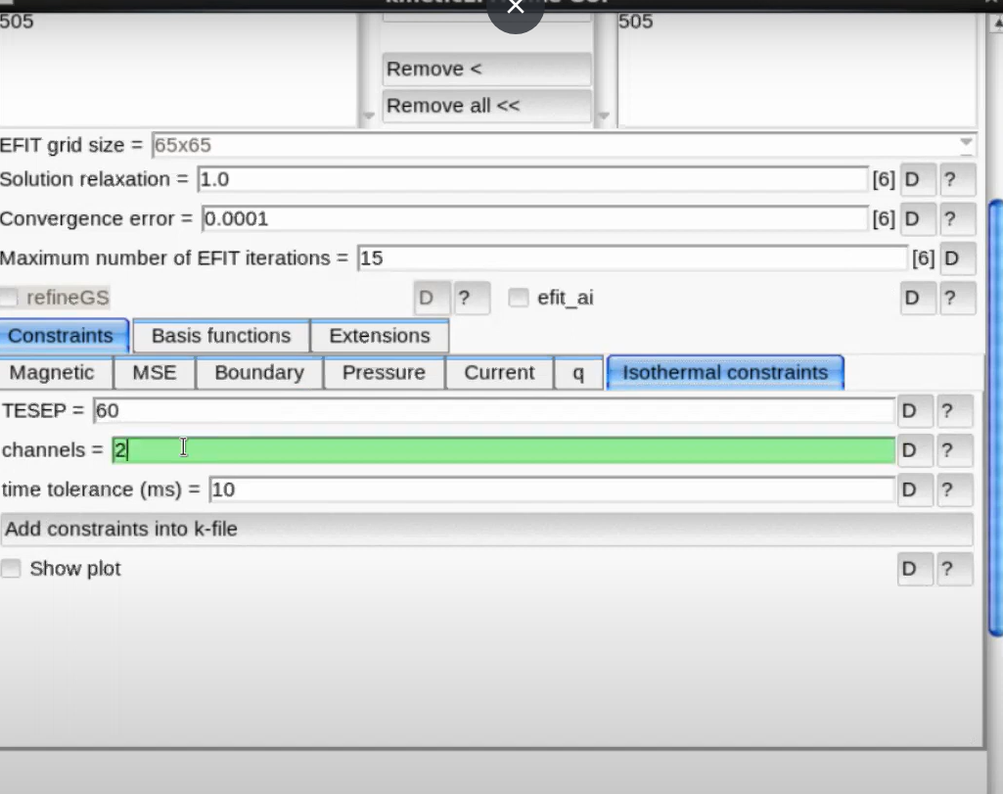

08/16/2022 Version

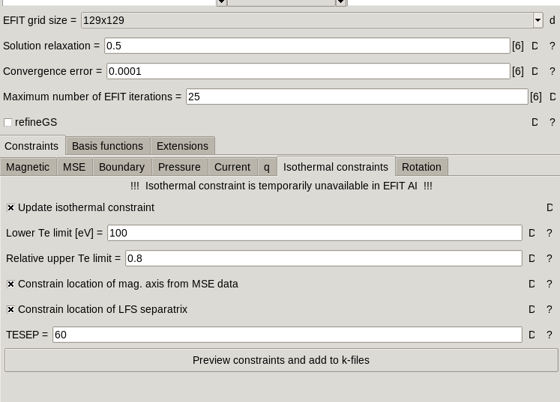

16. deselect the run profile. 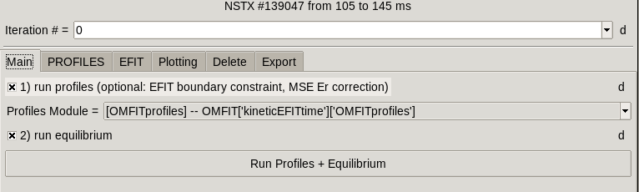

17. turn off EFIT.ai

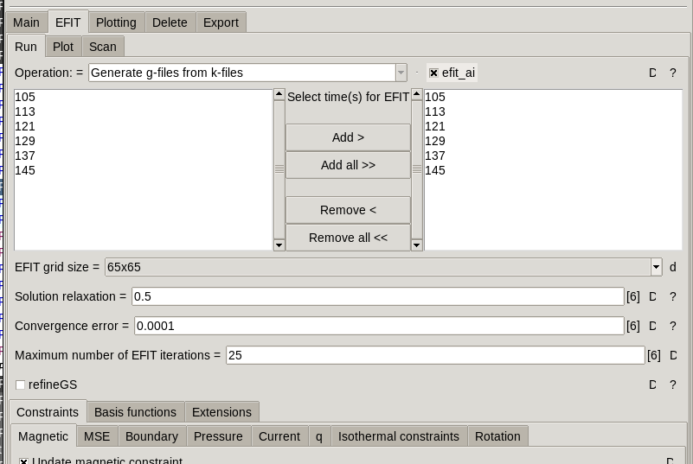

18. And run

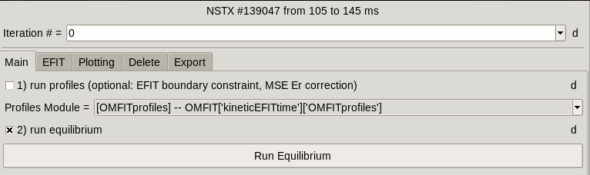

19. Change iteration to 1

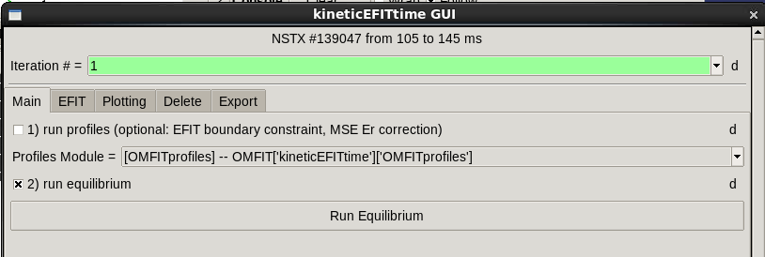

20. remap all diagnostic data

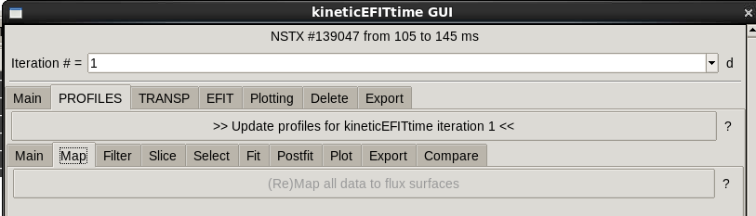

21. slice data

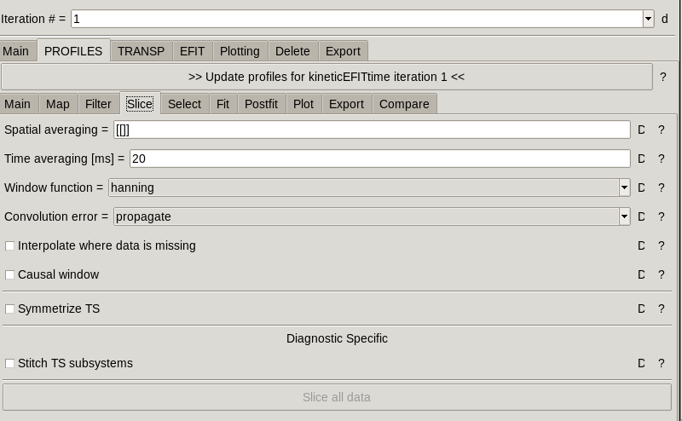

22. fit Te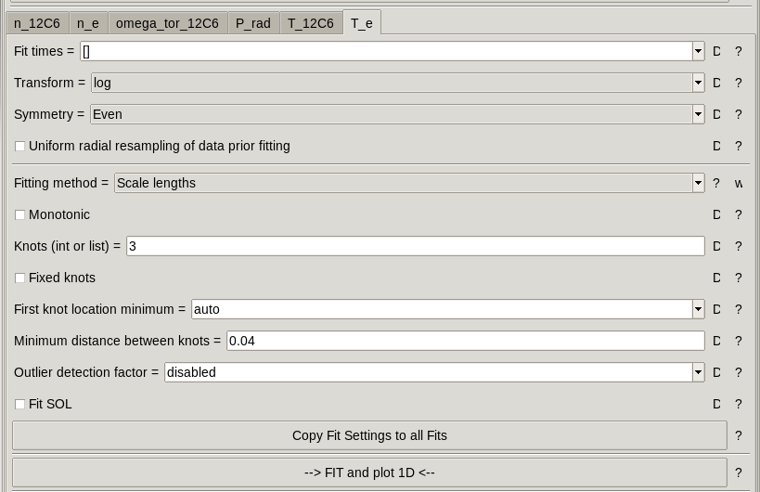

23. Fit all data with current setting

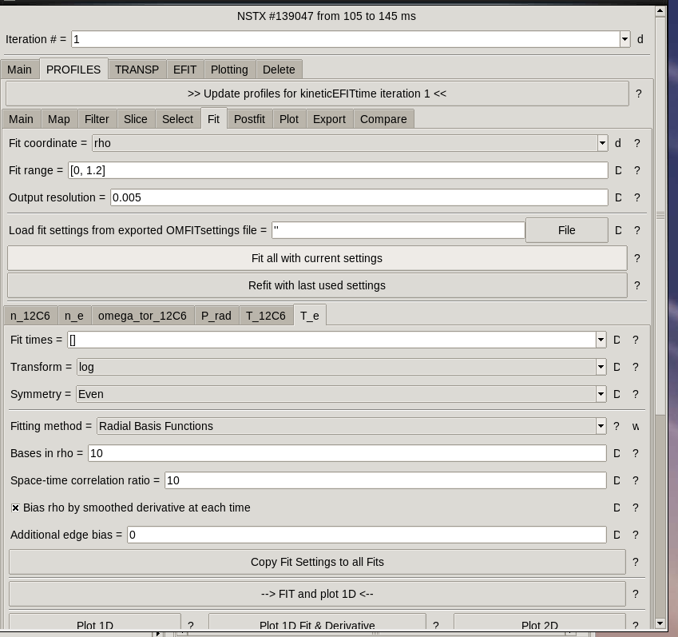

24.calculate the derivateice

25. update the profile

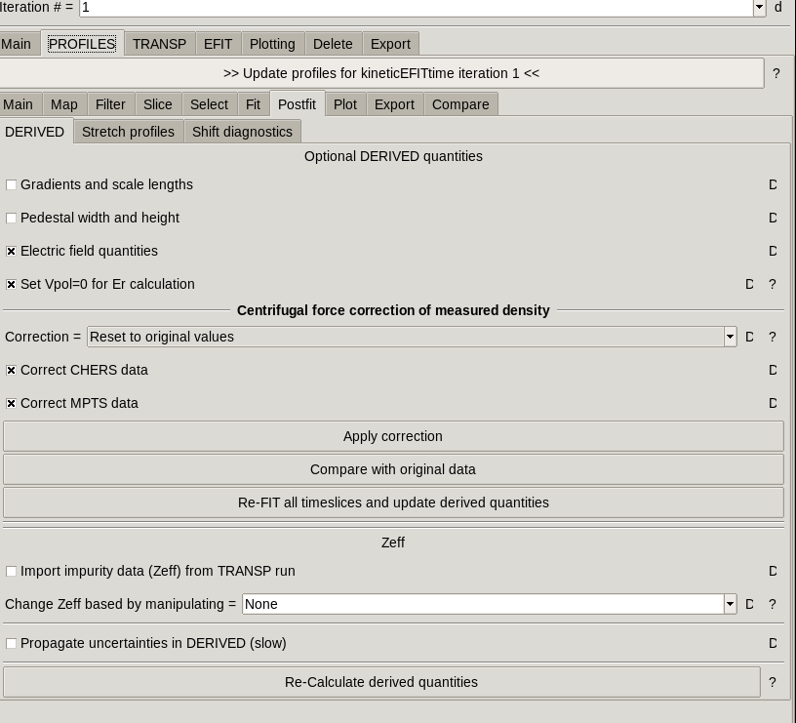

26. SETUP transp

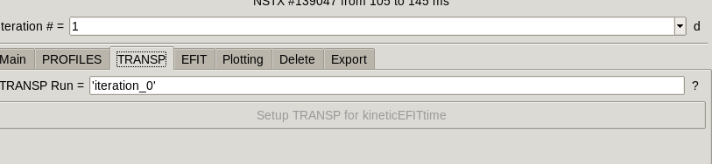

27. input namelist-> heating->NBI-> select ‘use anomalous diffusion’ and ‘PID control’

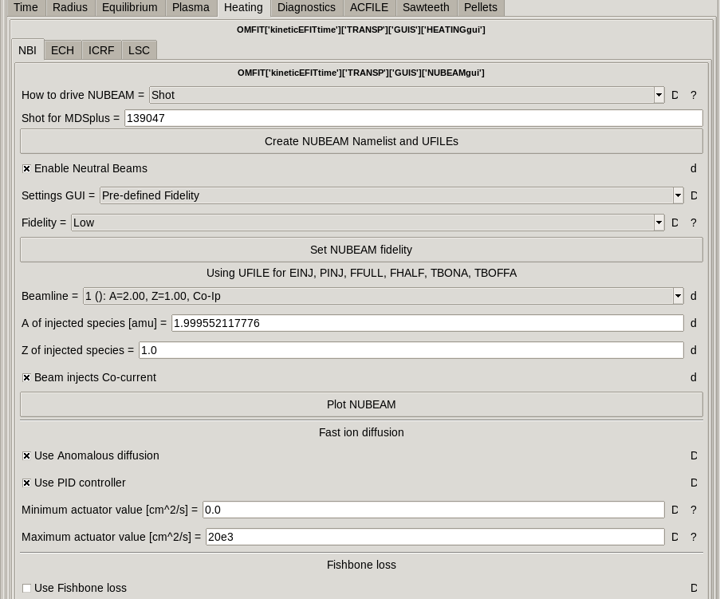

32. run transp

