PROCESS

Program
Program contains information that describes how to construct a process, including:
- Binary format identification:
- Metainformation describing the format of the executable file.
- Enables the kernal to interpret the remain information in file.
- UNIX format: executable format & linking format
- Machine-language instructions:
- These encode the algorithm of the program.
- Program entry-point address:
- The location of the instruction at which execution of the program start.
- Data
- Values used to initialize variables, constants, ...
- Symbol and relocation tables:
- Describe <location, name> of functions, variables within program.
- Shared library and dynamic linking information:
- List the shared libraries needed to use at runtime
- Other information

Process Memory Layout
Process is an instance of an executing program.
Process memory contains many parts called segments, including:
- Text segment:
- Machine-language instructions of the program
- This is made read-only to avoid accidentally modify by its own instructions via bad pointer value.
- Initialized data segment :
- Contain global and static variables that are explicitly initialized
- Read from the executable file when program is loaded into memory
- Uninitialized data segment or block started by symbol (bss):
- Contain global and static variables that are not explicitly initialized
- Stack:
- Dynamically growing and shrinking segment containing stack frames.
- Stack frame is allocated each time a function is called. A frame stores the function's local variables, arguments, return values.
- Heap:
- Can be dynamically allocated at runtime.

Practise
#include <stdlib.h>

static int gs_n = 1; //initialized data segment
static char gs_c; //uninitialized data segment

int g_n = 1; //initialized data segment
char c; //uninitialized data segment

int sum(int a, int b) { //allocated in frame for sum()
int s; //allocated in frame for sum()
s = a + b;
return s; //return value passed via register
}

int main(int argc, char* argv[]) { //allocated in frame for main()
static int s_number = 1; //initialized data segment
static int s_character; //uninitialized data segment

int count = 1; //allocated in frame for main()
char character; //allocated in frame for main()

int* p = malloc(sizeof(int));//point to memroy in heap segment

return 0;
}

Show size of program on terminal
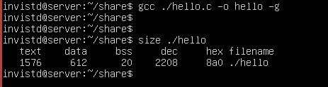

Output:
text: size of text segment
data: size of initialized data segment
bss: size of unitialized data segment
dec, hex: total size of program in decima, hexima

Virtual Address Spaces
Virtual Address
When a process reads or writes to a memory location, it uses a virtual address.
The virtual memory manager will translate the virtual address to a physical address.
Advantages:
- Program can use a contigous range of virtual addresses, although in physic memory they are not continugous.
- Virtual address of one process is isolated from other processes.

Virtual Address Space
Virtual address space (VAS) is the set of ranges of virtual addresses that operating system makes avaiable to a process.

VAS Structure

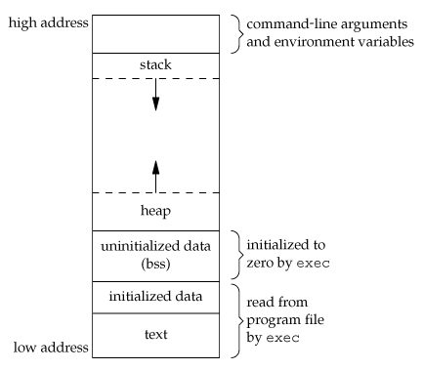

Practise
#include <stdlib.h>

static int global_static_i = 1;
int global_i = 1;

static int global_static_u;
int global_u;

int sum(int a, int b) {
int s = 0;
s = a + b;
return s;
}

int main(int argc, char* argv[]) {
static int local_static_i = 0;
static int local_static_u;

int local_i = 0;
int local_u;

sum(1, 2);
sum(3, 4);

int* p = malloc(sizeof(int));

return 0;
}

Virtual address space of the program

argc, argv, environ
stack  (non-static local variable)
  stack frame for main() | local_i  local_u
  stack frame for sum(1, 2) | int a  int b  int s  return value
  stack frame for sum(3, 4) | int a  int b  int s  return value
unallocated memory
heap  (allocated by malloc, calloc)  (allocated by new) | p = malloc(sizeof(int)
uninitialized data (bss)  (global static variable, uninitialized)  (local static variable, uninitialized)  (global variable) | global_static_u  local_static_u  global_u
initialized data  (global static variable, initalized)  (local static varaible, initialized)  (global variable, initialized) | global_static_i  global_i  local_static_i
text | program code

