FILE & I/O

File
What is File
File is a sequence of bytes.

File Roles
Linux follows "everything is a file" philosophy.
Almost all input/output resouces such as documents, directories, hard-drives, mordems, keyboards, printers and some interprocess, network communication are represented by a file.

File Category
To show file category, we use command: ls -l
The first column represents file category and permission. We call the first character of the column is prefix.
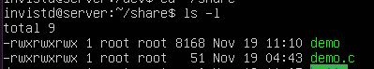
Linux has three basic types of files:
- Regular File
Contains data, text or program instructions.
Prefix: -

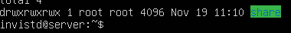
- Directory
Contains a list of other files.
Prefix: d

- Device File
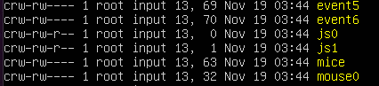
Used to interact with external devices.
Prefix: b,c,p,s

Device File
What is Device File
All I/O devices, such as networks, disks, terminals are mapped and modeled as files. That is called device file.

Where is Device File
Device files are located in folder /dev.

Device File Category
If the first character is b, c, p, or s, file represents a device.
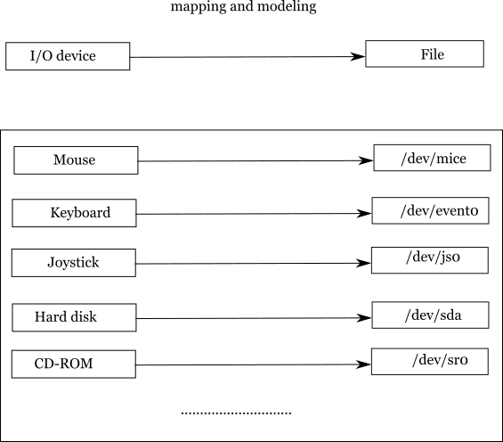
The meaning of characters:
- Character device (c)
Driver communicates with hardware by sending and receiving characters (bytes, octets).

- Block device (b)
Driver communicates with hardware by sending and receiving entire blocks of data.

- Pipe device (p)
Like character device, pipe message is character. But, its endpoint is an I/O stream instead of a kernal driver.

- Socket device (s)
Speical interfaces that are used for interprocess communication.
//continue: file descriptor, v-table, i-node

