MAIN THREAD

Main Thread (UI Thread)
The main thread is started on application start and stays alive during the lifetime of the process.
Main thread is in charge of dispatching events and rendering user interface.

There are many thing we need to be careful when working with main thread:
- If we perform long tasks, such as I/O on main thread, application may lag or thow exception.
- If application has not responded to an input or BroadcastReceiver within 5 seconds, Application Not Responding will appear.
- If UI element is access from outside the main thread, exception CalledFromWrongThreadException will be thrown.

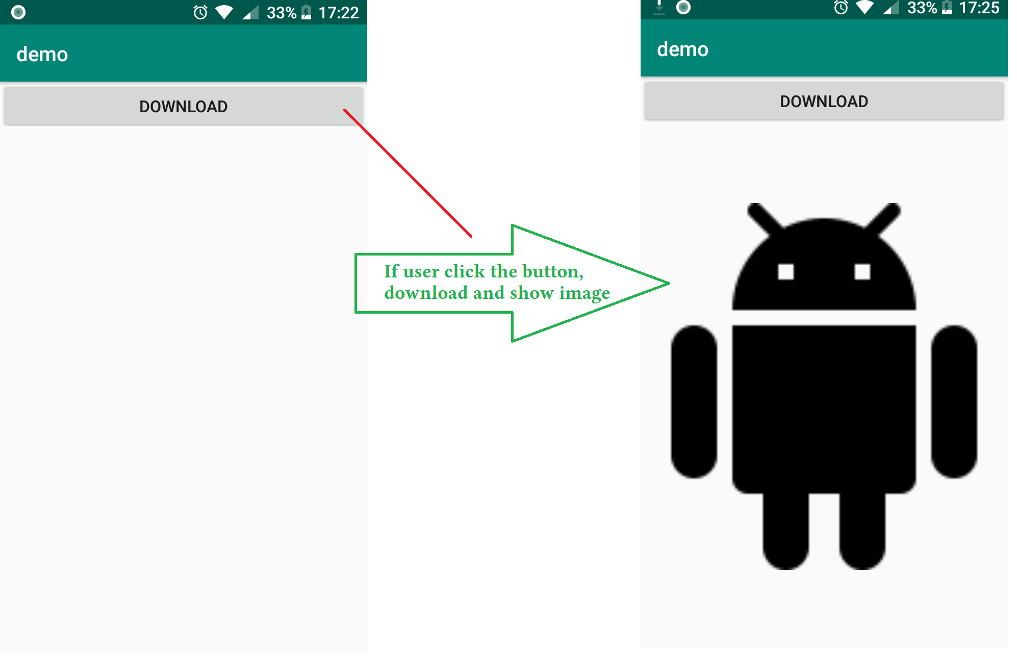
Practice
Lets build an app that downloads an image from internet and show it on a view.

The activity include a button, and an image view.
If user clicks download button, app will download image and show it.

Now, Lets implement it.
Add permission to Manifest
<uses-permission android:name="android.permission.INTERNET"/>

Add button, image view to activity_main.xml
<?xml version="1.0" encoding="utf-8"?>
<LinearLayout xmlns:android="http://schemas.android.com/apk/res/android"
xmlns:tools="http://schemas.android.com/tools"
android:layout_width="match_parent"
android:layout_height="match_parent"
android:orientation="vertical"
tools:context=".MainActivity">

<Button
android:layout_width="match_parent"
android:layout_height="wrap_content"
android:text="download"
android:onClick="onUserClick"/>

<ImageView
android:id="@+id/image_view"
android:layout_width="match_parent"
android:layout_height="match_parent" />

</LinearLayout>

Implement MainActivity.java
package invistd.demo;

import android.graphics.Bitmap;
import android.graphics.BitmapFactory;
import android.support.v7.app.AppCompatActivity;
import android.os.Bundle;
import android.util.Log;
import android.view.View;
import android.widget.ImageView;
import android.widget.TextView;
import android.widget.Toast;

import java.io.InputStream;
import java.net.HttpURLConnection;
import java.net.MalformedURLException;
import java.net.URL;

public class MainActivity extends AppCompatActivity {

@Override
protected void onCreate(Bundle savedInstanceState) {
super.onCreate(savedInstanceState);
setContentView(R.layout.activity_main);
}

void onUserClick(View v) {
Thread thread_download = new Thread() {
@Override
public void run() {
try {
//download image data
URL url = new URL("https://www.materialui.co/materialIcons/action/android_black_144x144.png");
HttpURLConnection connection = (HttpURLConnection) url.openConnection();
connection.setRequestMethod("GET");
connection.connect();
InputStream inStream = connection.getInputStream();

//convert data to bitmap
final Bitmap bitmap = BitmapFactory.decodeStream(inStream);

final ImageView imageView = findViewById(R.id.image_view);

//show bitmap on imageView
runOnUiThread(new Runnable() {
@Override
public void run() {
imageView.setImageBitmap(bitmap);
}
});

} catch (Exception e) {
Log.e("maxter", "exception: " + e.toString());
e.printStackTrace();
}
}
};

thread_download.start();
}
}

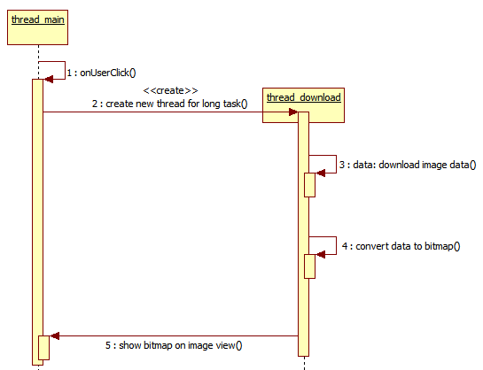
When user click download button, method onUserClick is called.

The method performs a network task.
If the network task is performed on main thread, NetworkOnMainThreadException will be thrown.
So, we create a new thread to do this task.

After converted data, we will show the image.

However, image view is an UI element.
If we access an UI element from a non-main thread, CalledFromWrongThreadException will be thrown.
So, we use runOnUiThread to delegate the action for main thread.

Delegate an Action to Main Thread
There are three simple ways to delegate an action to main thread: Activity.runOnUitThread(), main_handler.post() and View.post(),
Activity.runOnUiThread()
public final void runOnUiThread(Runnable action)
Runs the action on the main thread.
If the calling thread is main thread, the action is executed immediately.
If the calling thread is not main thread, the action is posted to event queue of the UI thread.
main_handler.post()
Handler main_handler = new Handler(Looper.getMainLooper()); //init main handler
main_handler.post(Runnable action);

View.post()
public boolean post(Runnable action)

Add the ation to queue of main thread.
Return true if the action is added successfully.
Return false on failure, usually because looper processing the message queue is exiting.

Activity.runOnUiThread(), main_handler.post() vs View.post()
If the calling thread is not main thread, both of them will call Handler.post() behind the scene.
However, View.post() can be invoked from outside of the UI thread only when this View is attached to a window.
In this example on stackoverflow, Runnable is posted successfully, but it can not be executed.
Because, View.post() is called in Activity.onCreate() and the View is not attached to the window yet.
ImageView img = null;

public void onCreate(...) {

img = (ImageView)findViewById(R.id.image);

new Thread() {
public void run() {
final Bitmap bmp = BitmapFactory.decodeFile("/sdcard/someImage.jpg");

if ( !img.post(new Runnable() {
public void run() {

img.setImageBitmap(bmp);

}
}) )

}
}.start();
}

