Style & Theme

Style: specify appearance for a single View.

Theme: specify appearance for an entire app, activity or view hierachy - not just an individual view.
also apply to non-view elements, such as status bar, window background.

Where to find attributes you can declare with an <item> tag?
Using Android Studio Theme Editor or find it in the XML attributes table in class references. Such as,
- https://developer.android.com/reference/android/widget/TextView#lattrs
- https://developer.android.com/reference/android/view/View#xml-attributes

Create & Apply Style
res/value/styles.xml
<resources>
...
<style name="MyCustomTextViewStyle">
<item name="android:textColor">#FF0000</item>
<item name="android:textAppearance">?android:attr/textAppearanceMedium</item>
<item name="android:textStyle">bold</item>
</style>
...
</resources>

res/layout/activity_main.xml
<LinearLayout
xmlns:android="http://schemas.android.com/apk/res/android"
xmlns:tools="http://schemas.android.com/tools"
android:layout_width="match_parent"
android:layout_height="match_parent"
android:orientation="vertical"
tools:context=".MainActivity">

<TextView
android:layout_width="match_parent"
android:layout_height="wrap_content"
style="@style/MyCustomTextViewStyle"
android:text="hello, nice day" />

</LinearLayout>

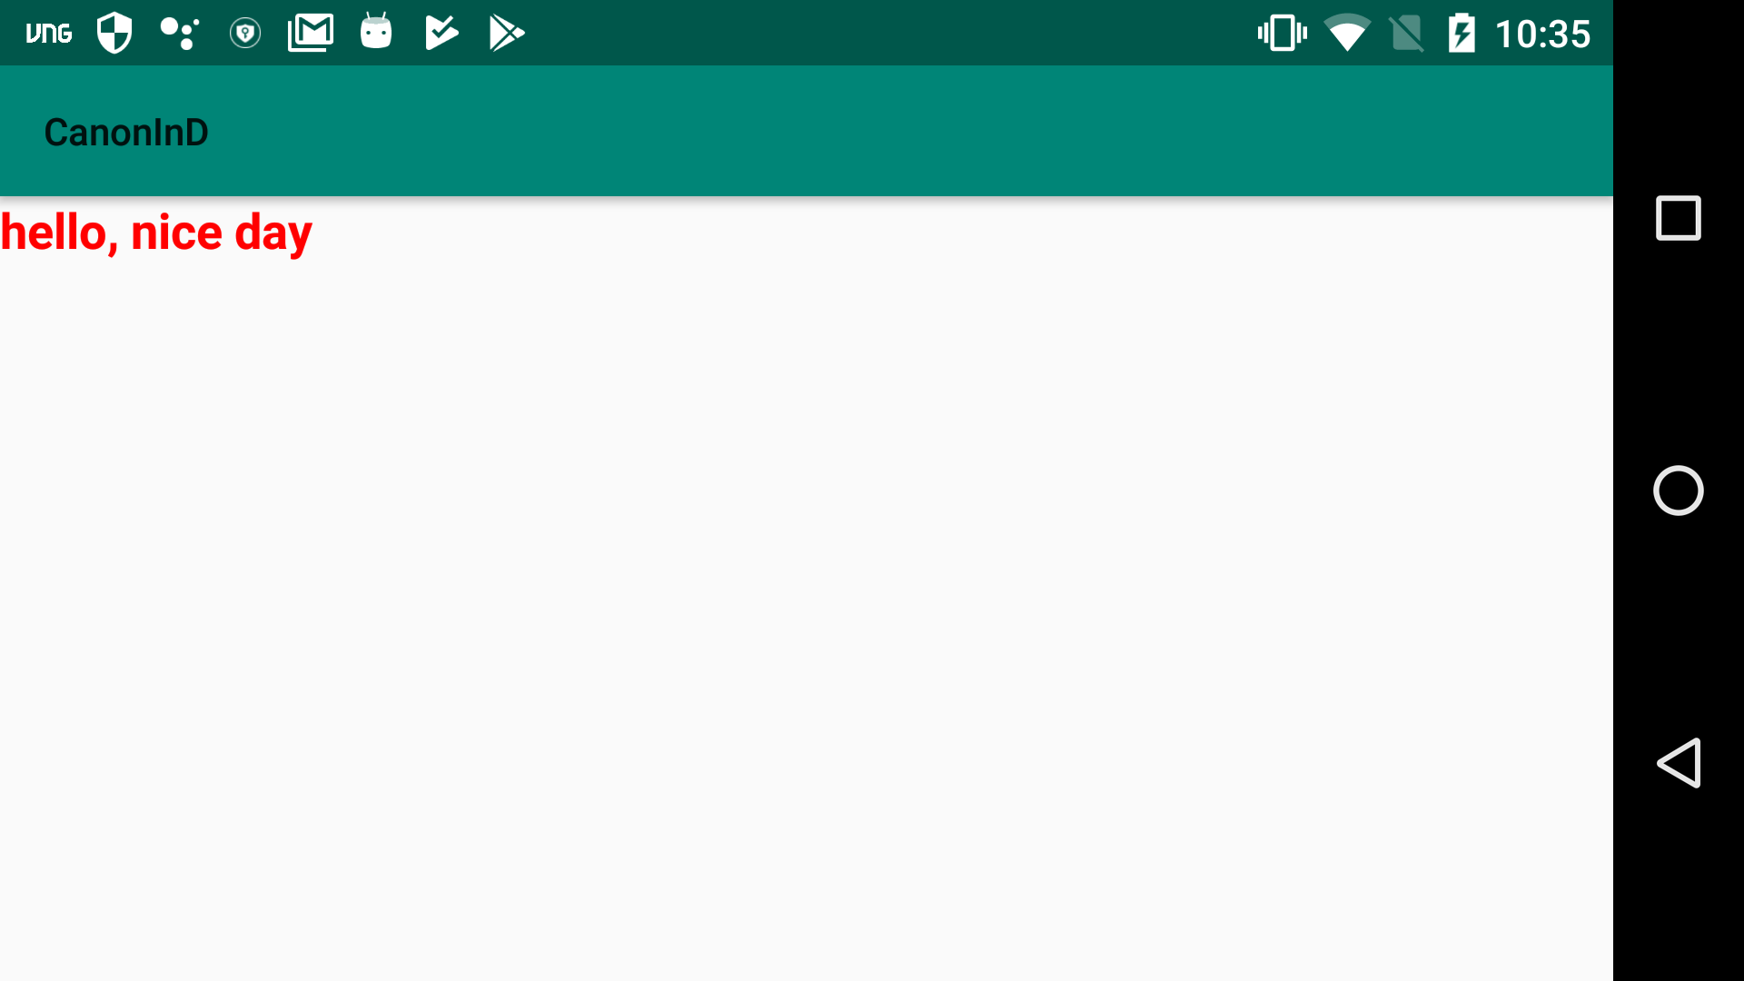
Screenshot

Create & Apply Theme
res/value/styles.xml
<resources>
...
<style name="AppTheme" parent="Theme.AppCompat.Light">
<item name="colorPrimary">@color/colorPrimary</item>
<item name="colorPrimaryDark">@color/colorPrimaryDark</item>
<item name="colorAccent">@color/colorAccent</item>
<item name="windowNoTitle">true</item>
<item name="windowActionBar">false</item>
<item name="android:windowFullscreen">true</item>
...
</style>

AndroidManifest.xml
<manifest xmlns:android="http://schemas.android.com/apk/res/android"
package="maxter.canon">

<application
android:allowBackup="true"
android:icon="@mipmap/ic_launcher"
android:label="@string/app_name"
android:roundIcon="@mipmap/ic_launcher_round"
android:supportsRtl="true"
android:theme="@style/AppTheme">
<activity android:name=".MainActivity">
<intent-filter>
<action android:name="android.intent.action.MAIN" />

<category android:name="android.intent.category.LAUNCHER" />
</intent-filter>
</activity>
</application>

</manifest>

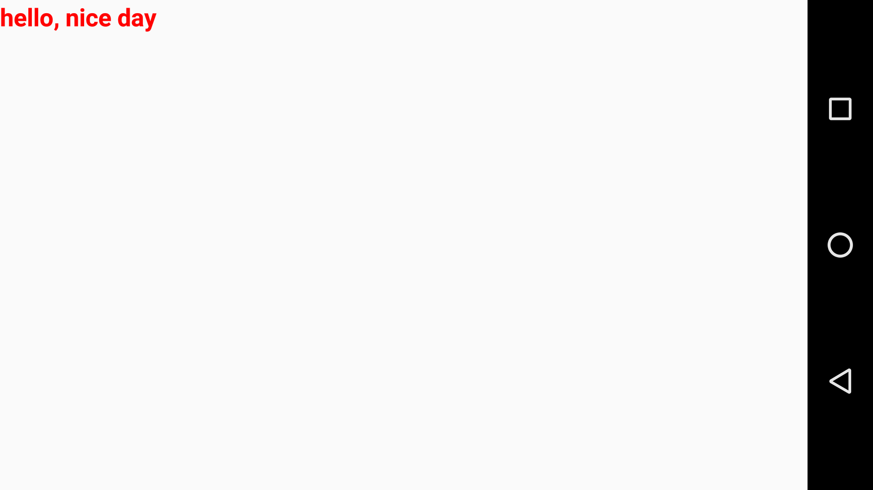
Screenshoot

