LOOP THREAD

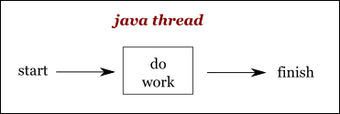
What is Loop Thread?

Java thread executes a work and terminates after it finishes run() method.

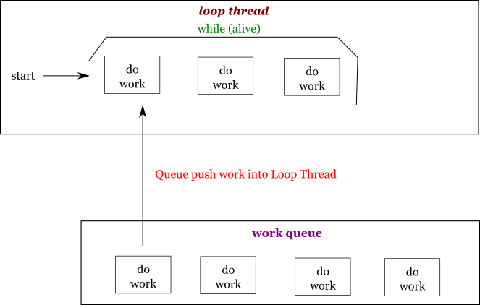
Loop thread keeps alive after run() method.
Each loop thread associates with an work queue. Thread get work from queue to execute.
If we want to perform a work on the loop thread, we can push this work to the queue.

Loop Thread Sample
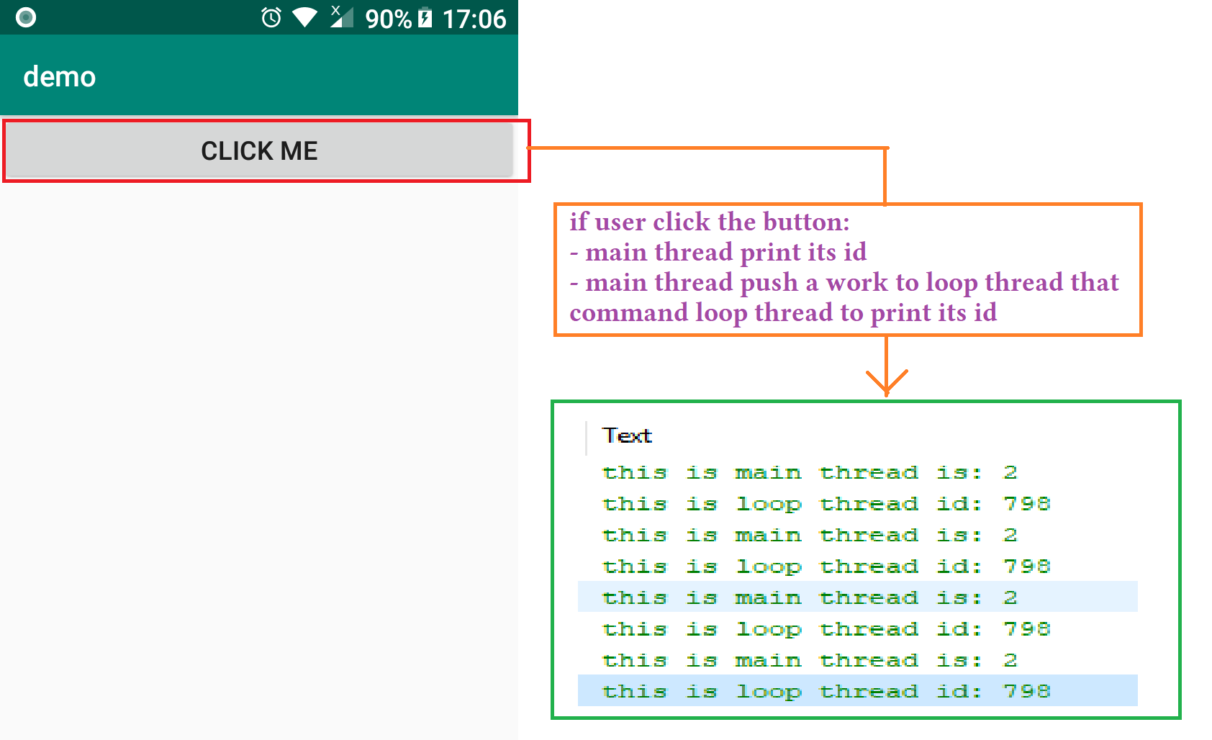
We will create an application that have a button.
If user click the button:
- Main thread print its id
- Main thread push into loop thread a work that command loop thread to print its id.

Now, Lets implement the application.
Design Layout
<?xml version="1.0" encoding="utf-8"?>
<LinearLayout xmlns:android="http://schemas.android.com/apk/res/android"
xmlns:tools="http://schemas.android.com/tools"
android:layout_width="match_parent"
android:layout_height="match_parent"
android:orientation="vertical"
tools:context=".MainActivity">

<Button
android:layout_width="match_parent"
android:layout_height="wrap_content"
android:text="Click Me"
android:onClick="onUserClick"/>

<ImageView
android:id="@+id/image_view"
android:layout_width="match_parent"
android:layout_height="match_parent" />

</LinearLayout>

Implement Loop Thread
package invistd.demo;

import android.os.Handler;
import android.os.Looper;

public class LoopThread extends Thread{
public Handler mHandler;

@Override
public void run() {
//create work queue for thread
Looper.prepare();

//Handler will be used to push work to thread
mHandler = new Handler();

//keep thread alive
Looper.loop();
}
}

Implement Main Activity
package invistd.demo;

import android.os.Handler;
import android.os.Looper;
import android.os.Message;
import android.support.v7.app.AppCompatActivity;
import android.os.Bundle;
import android.util.Log;
import android.view.View;

public class MainActivity extends AppCompatActivity {

LoopThread mLoopThread;

@Override
protected void onCreate(Bundle savedInstanceState) {
super.onCreate(savedInstanceState);
setContentView(R.layout.activity_main);

mLoopThread = new LoopThread();
mLoopThread.start();//start loop thread
}

void onUserClick(View v) {
Log.i("maxter", "this is main thread is: " + Thread.currentThread().getId());

//push work to loop thread
mLoopThread.mHandler.post(new Runnable() {
@Override
public void run() {
Log.i("maxter", "this is loop thread id: " + Thread.currentThread().getId());
}
});
}

@Override
protected void onDestroy() {
super.onDestroy();
mLoopThread.mHandler.getLooper().quit();
}
}

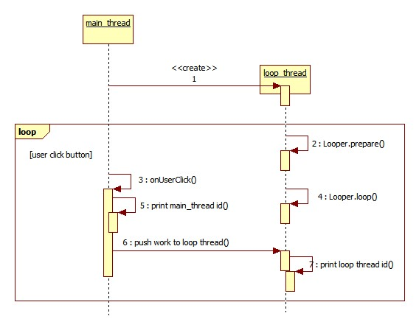
Sequence Diagram

