DATA STRUCTURE
STACK

Table of Content
Implementation
Implement stack using static array
Implement stack using dynamic array
Implement static using linked list
Application

Implementation

Implement stack using static array
Declaration
#define MAX_SIZE 10
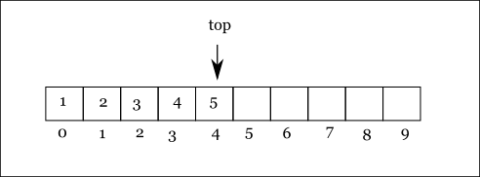
class stack
{
private:
int arr[MAX_SIZE];
int top = -1;

public:
void push(int val);
int pop();
int peek();
int is_empty();
};

Implementation
Push operation
void stack::push(int val)
{
if (top == MAX_SIZE-1)
{
std::cout << "stack is full, can not push\n";
}
else
{
top++;
arr[top] = val;
}
}

Pop operation
int stack::pop()
{
if (is_empty())
{
std::cout << "stack is empty, can not pop\n";
}
else
{
int val = arr[top];
top--;
return val;
}
}

Peek operation
int stack::peek()
{
if (is_empty())
{
std::cout << "stack is empty, can not peek\n";
return -1;
}
else
{
return arr[top];
}
}

Function is_empty()
int stack::is_empty()
{
return (top == -1);
}

Performance |  | Pros  - Simple  - Operations takes constant time  Cons  - Limited size
Operation | Complexity
push | O(1)
pop | O(1)
peek | O(1)

Implement stack using dynamic array
Declaration
class stack
{
private:
int *arr;
int capacity = 5;
int top = -1;

public:
stack();
~stack();

void push(int val);
int pop();
int peek();
int is_empty();
};

Implementation
Constructor & destructor
stack::stack()
{
arr = (int*)calloc(capacity, sizeof(int));
}

stack::~stack()
{
free(arr);
}

Push operation
void stack::push(int val)
{
if (top == capacity-1)
{
std::cout << "stack is full, expand array\n";

capacity *= 2;
int *tmp = (int*)realloc(arr, capacity);
arr = tmp;
}

top++;
arr[top] = val;
}

Performance |  | Pros  - Operations takes constant time  - Unlimited size  Cons  - Expanding stack is expensive.
Operation | Complexity
push | O(1)
pop | O(1)
peek | O(1)

Implement stack using linked list
Declaration
class node
{
public:
int value;
node* next = nullptr;

node(int value);
};

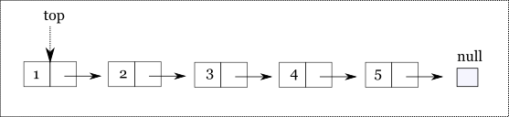
class stack
{
node* top = nullptr;

public:
void push(int value);
int pop();
int peek();
bool is_empty();
};

Implementation
Node constructor
node::node(int value)
{
this->value = value;
}

Push operation
void stack::push(int value)
{
node* tmp = new node(value);
tmp->next = top;
top = tmp;
}

Pop operation
int stack::pop()
{
if (is_empty())
{
std::cout << "stack is empty, can not pop\n";
return -1;
}
else
{
int tmp = top->value;
top = top->next;

return tmp;
}
}

Peek operation
int stack::peek()
{
if (is_empty())
{
std::cout << "stack is empty, can not pop\n";
return -1;
}
else
{
return top->value;
}
}

Function is_empty()
bool stack::is_empty()
{
return (top == nullptr);
}

Performance |  | Pros  - Operations takes constant time  - Unlimited size  Cons  - Extra space and time to deal with references
Operation | Complexity
push | O(1)
pop | O(1)
peek | O(1)

Application

