PTHREAD CONDITION VARIABLE

What is condition variable
Condition variable is a synchronization primitive that can be used to:
- Allow a thread to wait for a condition.
- Allow a thread to notify other threads when condition happens.

Lets start with Counter & Observer sample
- thread_counter increase count variable from 0 to 30.
- thread_observer wait until received notification from thread_counter to print "reached".

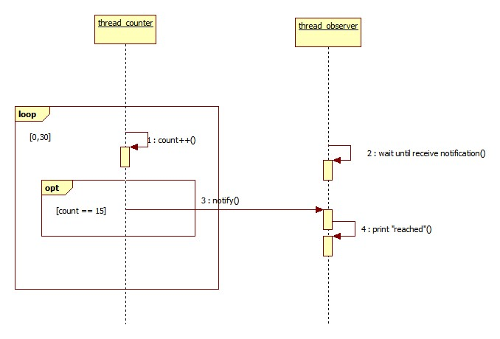

#include <pthread.h>
#include <stdio.h>
#include <stdlib.h>
#include <unistd.h>

int count = 0;

pthread_cond_t cond = PTHREAD_COND_INITIALIZER;

void* inc_count(void* arg) {
for(int i = 0; i < 30; i++){
sleep(1);

count ++;
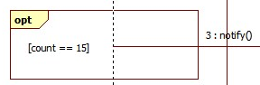
printf("thread counter: %d\n", count);

if (count == 15) {
pthread_cond_signal(&cond);
}
}
}
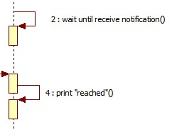

void* watch_count(void* arg) {
pthread_cond_wait(&cond, &mtx);

printf("\nthread observer: reached\n\n");
}

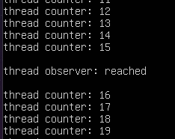
int main(){
pthread_t thread_counter, thread_observer;

pthread_create(&thread_counter, NULL, inc_count, NULL);
pthread_create(&thread_observer, NULL, watch_count, NULL);

pthread_join(thread_counter, NULL);
pthread_join(thread_observer, NULL);
Result

return 0;
}

How does above program work?
pthread_cond_t cond
Variable cond work as a signal.

pthread_cond_wait(&cond, &mtx)
thread_observer call pthread_cond_wait() to suspend and wait until it receive signal on cond. While waiting, thread_observer does not consume CPU resources.

pthread_cond_signal(&cond)
thread_counter call pthread_cond_signal() on cond to notify thread_observer.

Initialize and Destroy
How to Initialize?
int pthread_cond_init(pthread_cond_t *cond, pthread_condattr_t attr)

pthread_cond_init function initialize the condition variable cond with attributes defined by attr.
If attr is NULL, condition variable will initialized with default attribute.

PTHREAD_COND_INITIALIZE
is used to initialize a condition variable only when it is declared.
in order to initialize it during runtime, we must use pthread_cond_init

How to Destroy?
int pthread_cond_destroy(pthread_cond_t *cond)
Destroy the condition variable
which is currently blocked by a thread
lead to undefined behavior

pthread_cond_destroy function deinitialize condition variable
and release underlying memory.

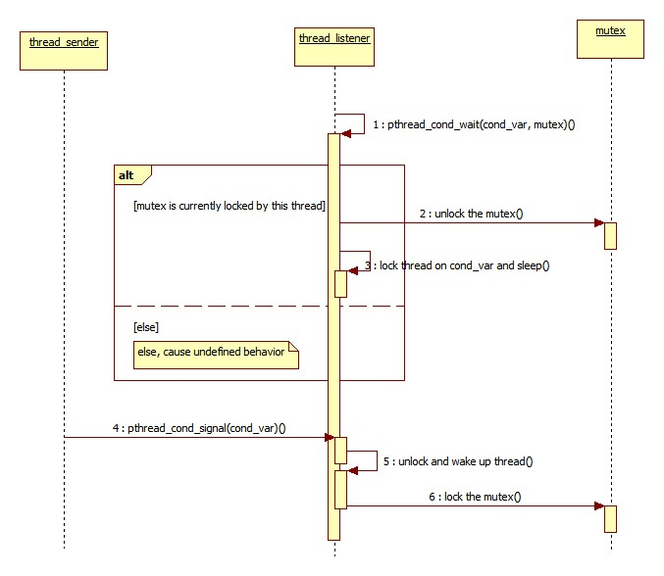
Wait & Signal
We can use pthread_cond_wait() to command thread to wait for a condition variable and pthread_cond_signal() to notify that the condition happened.

Each condition variable is used together with a mutex.

What does pthread_cond_wait do?
pthread_cond_wait(pthread_cond_t* cond_var, pthread_mutex_t* mutex)

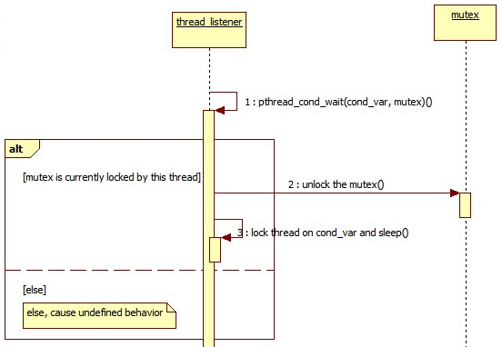
If mutex is currently locked by the calling thread, the function performs following steps:
- Release the mutex
- Block the thread on condition variable. Until another thread signals on the condition variable. While blocking, the thread does not consume CPU resources.

If the mutex is not locked by the calling thread, it will cause undefined behavior.

What does pthread_cond_signal do?
pthread_cond_signal(pthread_cond_t* cond_var)

- Unblock at least on of threads that are blocked on the condition variable cond_var.
- The unblocked thread will release the mutex that is in conjunction with the condition variable.
Conjunct condition variable and mutex
What wrong with previous Counter & Observer sample?
void* inc_count(void* arg) {
count variable can be read/write by multiple threads at the same time but it is not protected by any exclusive mechanism
This may cause data race.
for(int i = 0; i < 30; i++){
sleep(1);

count ++;
printf("thread counter: %d\n", count);

if (count == 15) {
pthread_cond_signal(&cond);
pthread_cond_wait is called on a unlocked mutex.
This may cause undefined behavior.
}
}
}

void* watch_count(void* arg) {
pthread_cond_wait(&cond, &mtx);

printf("\nthread observer: reached\n\n");
}

Lets fix the issue

void* inc_count(void* arg) {
for(int i = 0; i < 30; i++){
sleep(1);
Protect count variable from data race
pthread_mutex_lock(&mtx);

count ++;
printf("thread counter: %d\n", count);

if (count == 15) {
pthread_cond_signal(&cond);
State of mutex
}
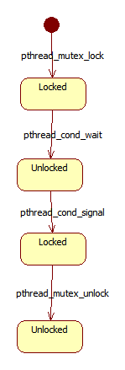
pthread_mutex_unlock(&mtx);
}
}
Lock mutex before pthread_cond_wait()

void* watch_count(void* arg) {

pthread_mutex_lock(&mtx);
Because pthread_cond_wait() will unlock the mutex.
If mutex is not currently locked, undefined behavior may happen

pthread_cond_wait(&cond, &mtx);

pthread_mutex_unlock(&mtx);
After thread receive signal and wake up
it relock the mutex
Unlock the mutex, to avoid deadlock

printf("\nthread observer: reached\n\n");
}

All code
#include <pthread.h>
#include <stdio.h>
#include <stdlib.h>
#include <unistd.h>

int count = 0;

pthread_mutex_t mtx = PTHREAD_MUTEX_INITIALIZER;
pthread_cond_t cond = PTHREAD_COND_INITIALIZER;

void* inc_count(void* arg) {
for(int i = 0; i < 30; i++){
sleep(1);

pthread_mutex_lock(&mtx);

count ++;
printf("thread counter: %d\n", count);

if (count == 15) {
pthread_cond_signal(&cond);
}

pthread_mutex_unlock(&mtx);
}
}

void* watch_count(void* arg) {
pthread_mutex_lock(&mtx);
pthread_cond_wait(&cond, &mtx);
pthread_mutex_unlock(&mtx);

printf("\nthread observer: reached\n\n");
}

int main(){
pthread_t thread_counter, thread_observer;

pthread_create(&thread_counter, NULL, inc_count, NULL);
pthread_create(&thread_observer, NULL, watch_count, NULL);

pthread_join(thread_counter, NULL);
pthread_join(thread_observer, NULL);

return 0;
}

