

SDL In Practice
Keep It Small and Simple

Draw BMP Image
&
Move It Around Screen

maxterjy@gmail.com

Draw BMP Image
SDL_Surface is a structure that contains a collection of pixels.
SDL_BlitSurface is used to perform a surface copy to a destination surface.
To draw an image on a window, we load image to a surface and perform it to window surface.
draw_image_bmp_01.cpp
#include <SDL2/SDL.h>

int main()
{
//init
SDL_Init(SDL_INIT_VIDEO);
SDL_Window* pWindow = SDL_CreateWindow("BMP", 100, 100, 400, 400, 0);
SDL_Surface* pWindowSurface = SDL_GetWindowSurface(pWindow);

//load image
SDL_Surface* pImageSurface = SDL_LoadBMP("assassin.bmp");

//draw background
SDL_FillRect(pWindowSurface, NULL, 0x3b5999);

//draw image
SDL_BlitSurface(pImageSurface, NULL, pWindowSurface, NULL);

SDL_UpdateWindowSurface(pWindow);
SDL_Delay(5000);

//destroy
SDL_FreeSurface(pImageSurface);
SDL_DestroyWindow(pWindow);
SDL_Quit();
}

Compile
g++ draw_image_bmp_01.cpp -o demo_01 -lSDL2

Run
./demo_01

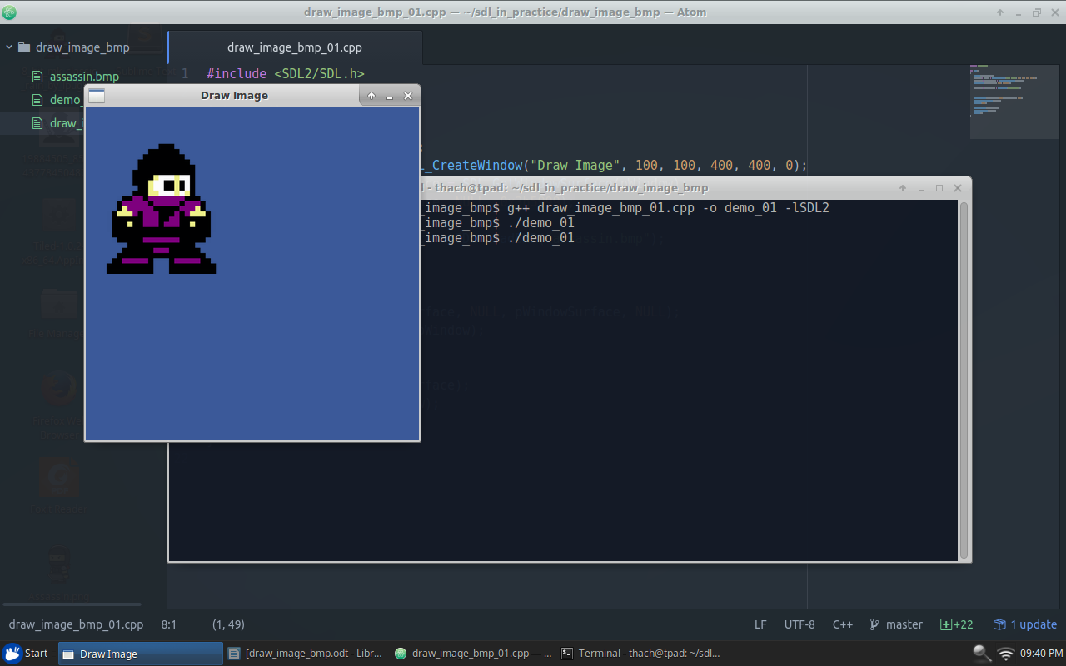

Draw Image In Action

Draw Image At Another Position
Declare a variable store position on screen and pass it to SDL_BlitSurface() function.
SDL_Rect dstRect = {x, y, 0, 0};
SDL_BlitSurface(pImageSurface, NULL, pWindowSurface, &dstRect);
dstRect: represent the position on screen.
draw_image_bmp_02.cpp
#include <SDL2/SDL.h>

int main()
{
//init
SDL_Init(SDL_INIT_VIDEO);
SDL_Window* pWindow = SDL_CreateWindow("Move", 100, 100, 500, 500, 0);
SDL_Surface* pWindowSurface = SDL_GetWindowSurface(pWindow);
SDL_FillRect(pWindowSurface, NULL, 0x3b5999);

//load image
SDL_Surface* pImageSurface = SDL_LoadBMP("assassin.bmp");
SDL_Rect dstRect = {200, 200, 0, 0};

//draw image
SDL_BlitSurface(pImageSurface, NULL, pWindowSurface, &dstRect);
SDL_UpdateWindowSurface(pWindow);
SDL_Delay(5000);

//destroy
SDL_FreeSurface(pImageSurface);
SDL_DestroyWindow(pWindow);
SDL_Quit();
}

Compile
g++ draw_image_bmp_02.cpp -o demo_02 -lSDL2

Run
./demo_02

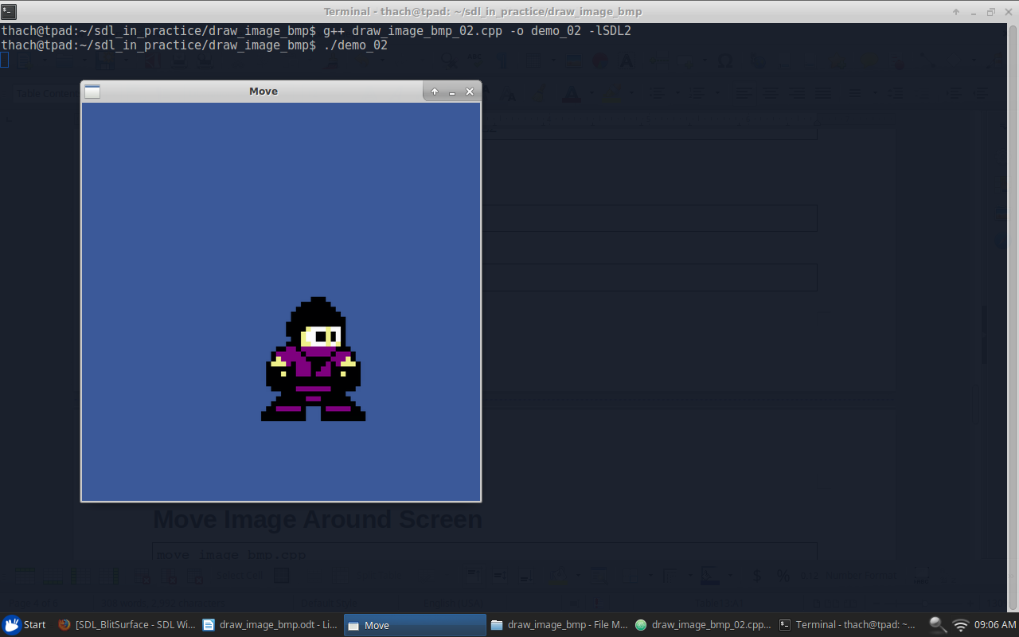

Draw A Part Of Image
Declare a variable store which part of image that need to draw and pass it to SDL_BlitSurface() function.
SDL_Rect srcRect = {x, y, w, h};
SDL_BlitSurface(pImageSurface, &srcRect, pWindowSurface, NULL);
srcRect: represent the part of image that need to draw.
draw_image_bmp_03.cpp
#include <SDL2/SDL.h>

int main()
{
//init
SDL_Init(SDL_INIT_VIDEO);
SDL_Window* pWindow = SDL_CreateWindow("Move", 100, 100, 500, 500, 0);
SDL_Surface* pWindowSurface = SDL_GetWindowSurface(pWindow);
SDL_FillRect(pWindowSurface, NULL, 0x3b5999);

//load image
SDL_Surface* pImageSurface = SDL_LoadBMP("assassin.bmp");

SDL_Rect srcRect = {30, 30, 120, 120};

//draw image
SDL_BlitSurface(pImageSurface, &srcRect, pWindowSurface, NULL);
SDL_UpdateWindowSurface(pWindow);
SDL_Delay(5000);

//destroy
SDL_FreeSurface(pImageSurface);
SDL_DestroyWindow(pWindow);
SDL_Quit();
}

Compile
g++ draw_image_bmp_03.cpp -o demo_03 -lSDL2

Run
./demo_03

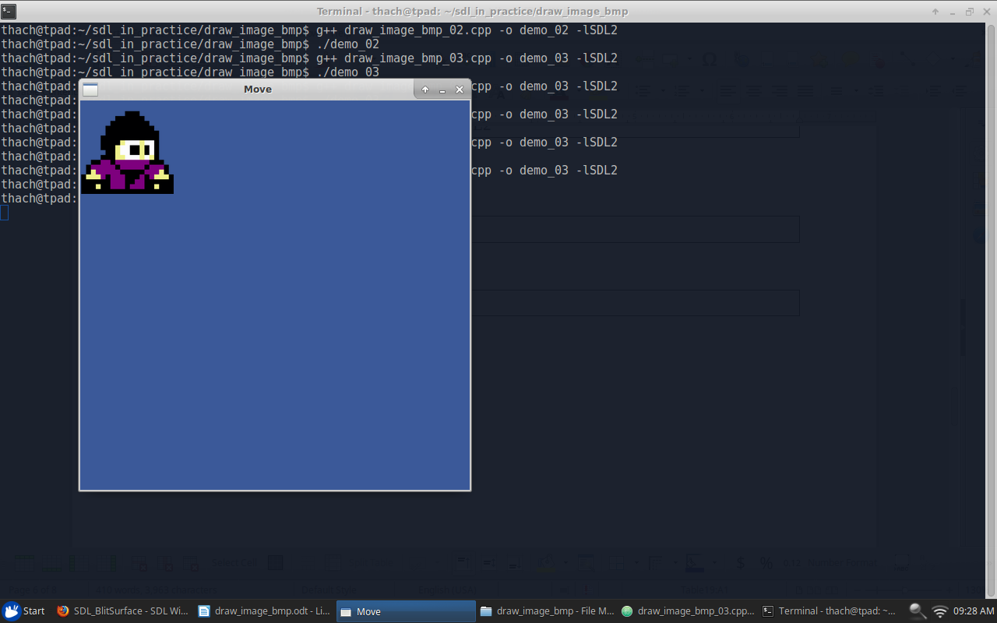

Move Image Around Screen
Add drawing image to game loop and update it position.
move_image_bmp.cpp
#include <SDL2/SDL.h>

int main()
{
SDL_Init(SDL_INIT_VIDEO);

SDL_Window *pWindow = SDL_CreateWindow("Move", 100, 100, 800, 480, 0);
SDL_Surface *pWindowSurface = SDL_GetWindowSurface(pWindow);

SDL_Surface* pImageSurface = SDL_LoadBMP("assassin.bmp");

SDL_Rect dstRect = {0, 0, 0, 0};
int speed = 1;

bool isRunning = true;
SDL_Event event;
while(isRunning)
{
//draw
SDL_FillRect(pWindowSurface, NULL, 0x3b5999);
SDL_BlitSurface(pImageSurface, NULL, pWindowSurface, &dstRect);
SDL_UpdateWindowSurface(pWindow);

//update
dstRect.x += speed;
if (dstRect.x > 700 || dstRect.x < 0)
speed = -speed;

//handle input
SDL_PollEvent(&event);
if (event.type == SDL_QUIT)
{
isRunning = false;
}
}

//destroy
SDL_FreeSurface(pImageSurface);
SDL_DestroyWindow(pWindow);
SDL_Quit();
}

Compile
g++ move_image_bmp.cpp -o demo_02 -lSDL2

Run
./demo_02

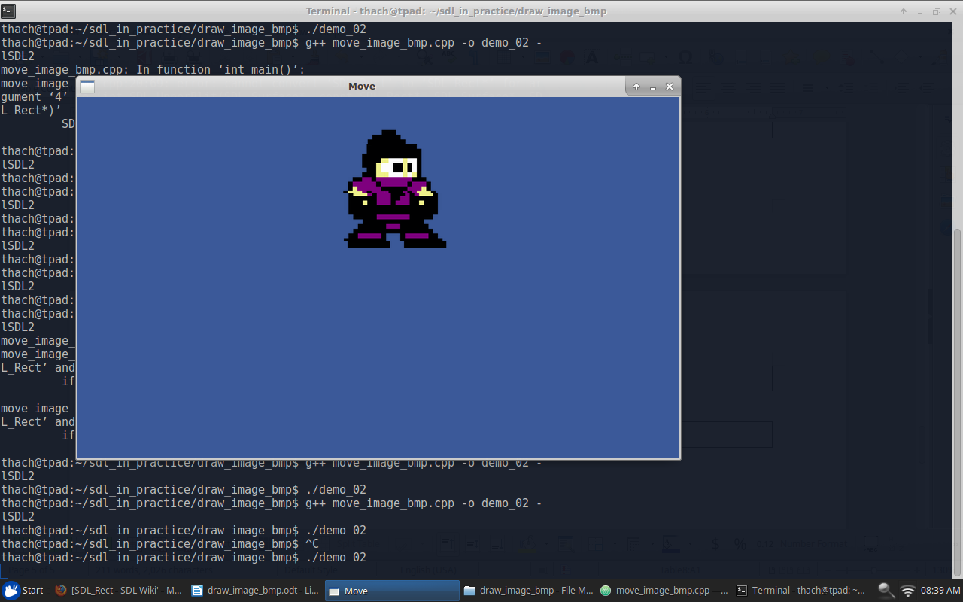

Draw Image In Theory
Function SDL_BlitSurface()
int SDL_BlitSurface(SDL_Surface* srcSurface,
const SDL_Rect* srcRect,
SDL_Surface* dstSurface,
SDL_Rect* dstRect)

Suppose, we are playing picture pasting game. We have to paste an ninja picture into a blue sky picture.
srcSurface: is ninja picture
dstSurface: is blue sky picture.
dstRect: is the location on blue sky picture where we need to put ninja on.
srcRect: is the part of ninja picture that we need to use. We can use the entire of ninja picture or a part of it.

If dstRect is NULL, ninja will be put on upper left corner (position: x = 0, y = 0).
In dstRect, only the position parameters (x,y) are used. The size parameters (width, height) are ignored.
If srcRect is NULL, the entier of ninja picture will be used.

