

SDL In Practice
Keep It Small and Simple

Setup Environment
&
Write Your First Application

maxterjy@gmail.com

Setup Environment
Install SDL
sudo apt-get install libsdl2-dev

Check Installation
dpkg -l | grep libsdl

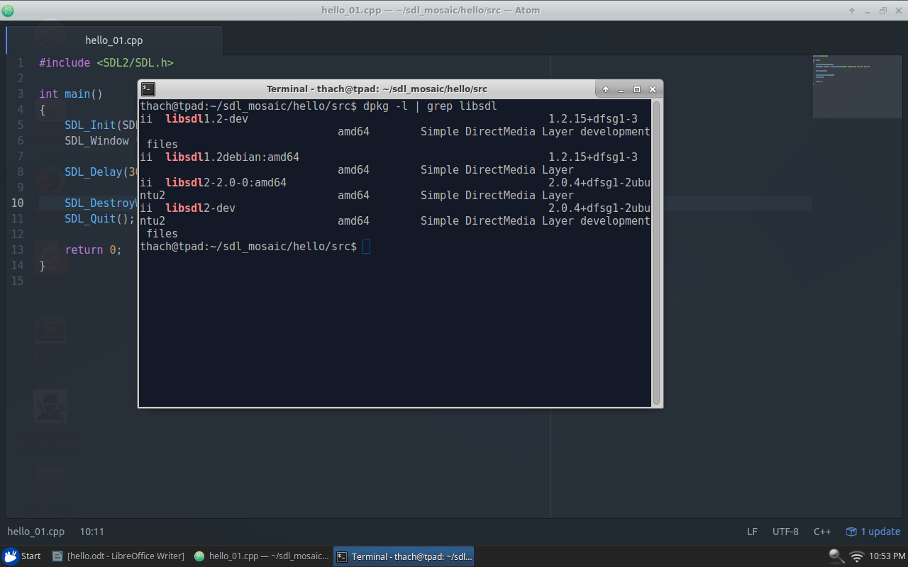

Header File Location
/usr/include/SDL2

List header files
ls /usr/include/SDL2

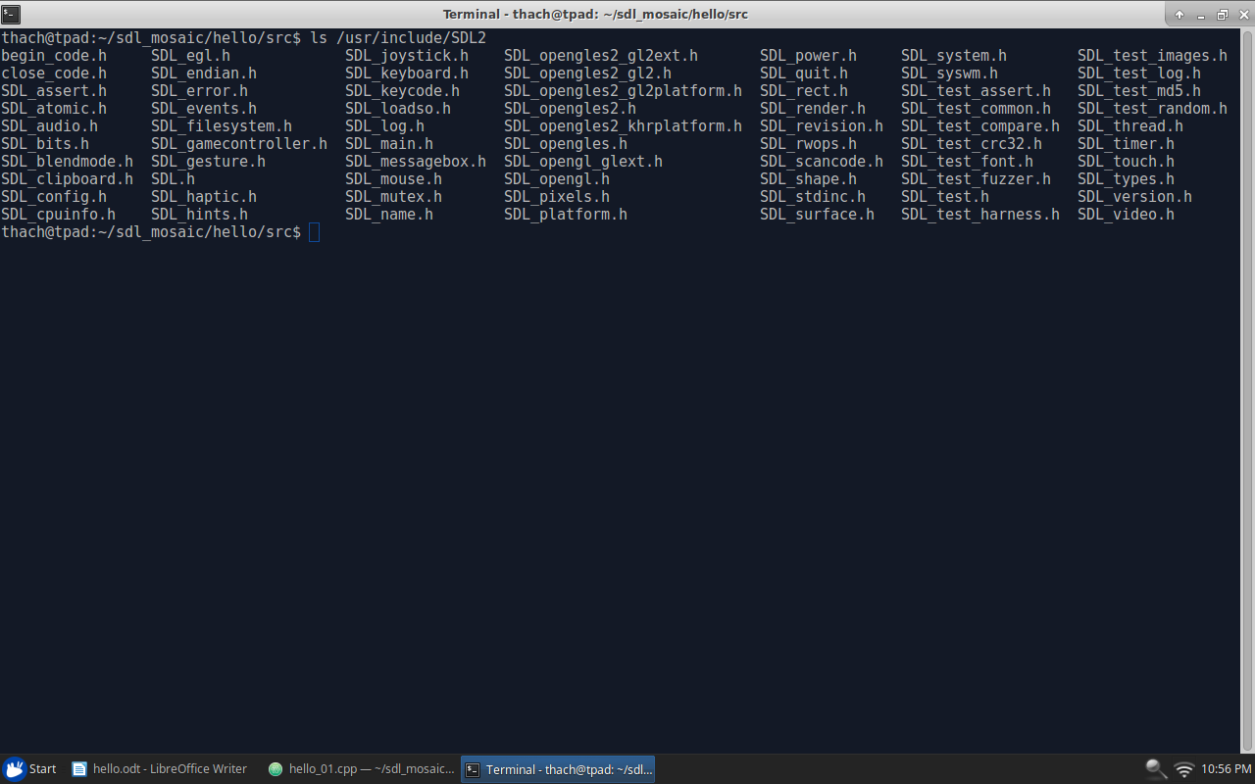

Hello World
hello_01.cpp
#include <SDL2/SDL.h>

int main()
{
SDL_Init(SDL_INIT_VIDEO);
SDL_Window *window = SDL_CreateWindow("Hello World", 100, 100, 320, 320, 0);

SDL_Delay(3000);

SDL_DestroyWindow(window);
SDL_Quit();

return 0;
}

Compile
g++ hello_01.cpp -o hello_01 -lSDL2

Run application
./hello_01

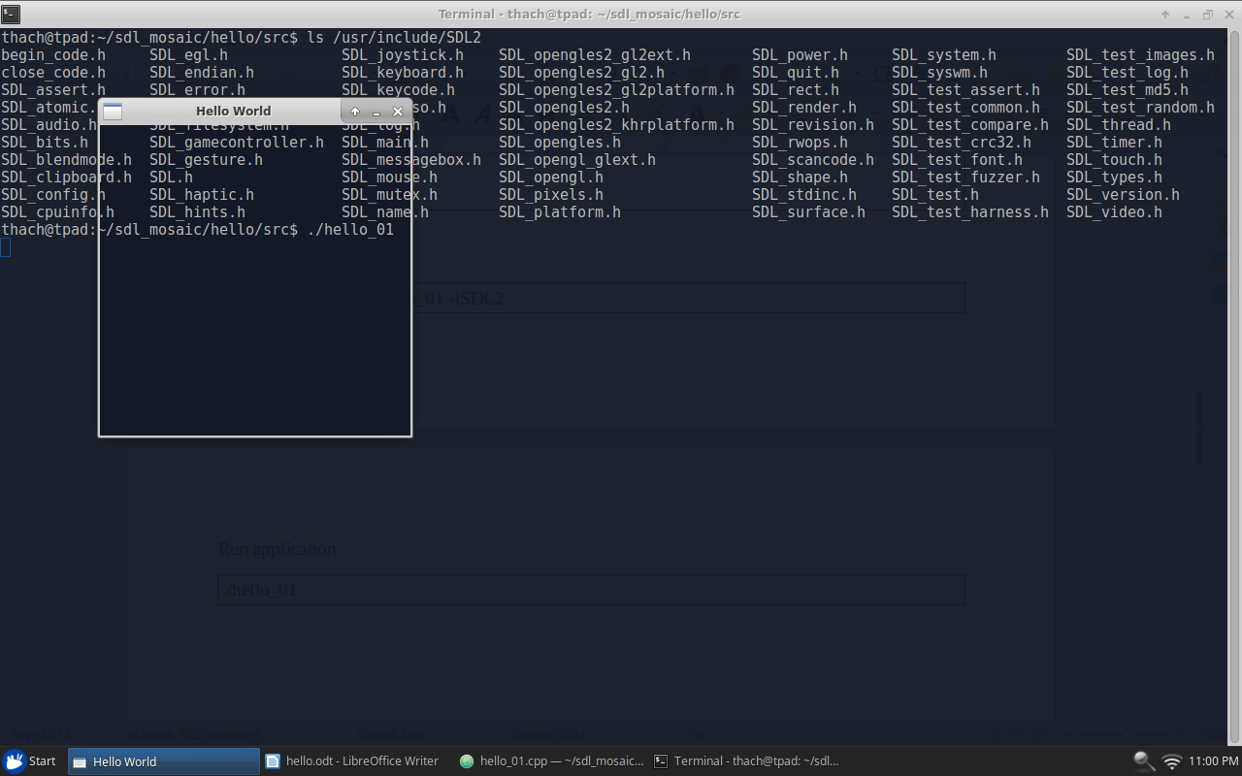

Hello World In Action
hello_02.cpp
#include <SDL2/SDL.h>

int main()
{
SDL_Init(SDL_INIT_VIDEO);

SDL_Window *window = SDL_CreateWindow("Hello World", 100, 100, 320, 320, 0);
SDL_Renderer *renderer = SDL_CreateRenderer(window, -1, 0);

SDL_SetRenderDrawColor(renderer, 0, 255, 0, 255);
SDL_RenderClear(renderer);
SDL_RenderPresent(renderer);

bool isRunning = true;
SDL_Event event;
while (isRunning)
{
SDL_PollEvent(&event);

if (event.type == SDL_QUIT)
{
isRunning = false;
}
}

SDL_DestroyWindow(window);
SDL_Quit();

return 0;
}

Compile
g++ hello_02.cpp -o hello_02 -lSDL2

Run application
./hello_02

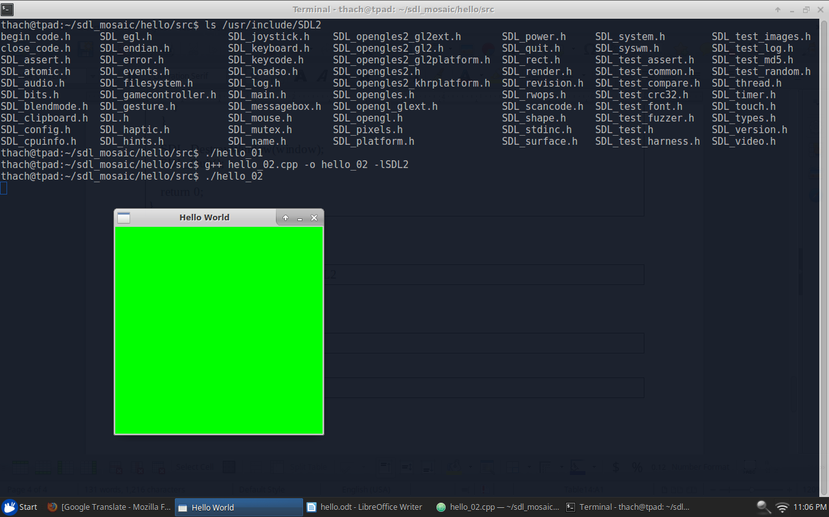

Make some change.
Change window tile, position, size
SDL_Window *window = SDL_CreateWindow("Hi SDL", 50, 50, 200, 200, 0);

Change background color
SDL_SetRenderDrawColor(renderer, 255, 0, 0, 255);

