

TinyXml In Practice
Keep It Small and Simple

Enable Using STL Mode
Get Element
Query Attribute Of Element

maxterjy@gmail.com

Enable Using STL Mode
TinyXml can be compiled to use or not use STL.
Using STL mode support std::string, std::istream, std::ostream, operator << and operator >>.
In Non-STL mode, no STL files are included. All the string classes are implemented by TinyXml itself.

Enable Using STL Mode
Set TINYXML_USE_STL in tinyxml/Makefile to YES
tinyxml/Makefile
TINYXML_USE_STL := YES

Define TIXML_USE_STL as the first line of tinyxml/tinyxml.h
tinyxml/tinyxml.h
#define TIXML_USE_STL

Traversing Through All Elements Of Document
ninja.xml
<?xml version="1.0" ?>
<Hero role="ganker" speed="890" strength="450">Ninja</Hero>
<Hero role="tanker" speed="400" strength="830">axe</Hero>

RootElement(): get the root element - the only top level element of the document. In that case, the root element is <Hero role="ganker" speed="890" strength="450">Ninja</Hero>.
NextSiblingElement(): get the next element. In this example, the next element of <Hero role="ganker" speed="890" strength="450">Ninja</Hero> is <Hero role="tanker" speed="400" strength="830">axe</Hero>.
main.cpp
#include "tinyxml.h"

int main()
{
TiXmlDocument doc;
doc.LoadFile("ninja.xml");

for(TiXmlElement *pElement = doc.RootElement();
pElement != 0;
pElement = pElement->NextSiblingElement())
{
const char* text = pElement->GetText();
std::cout << text << std::endl;
}

return 0;
}

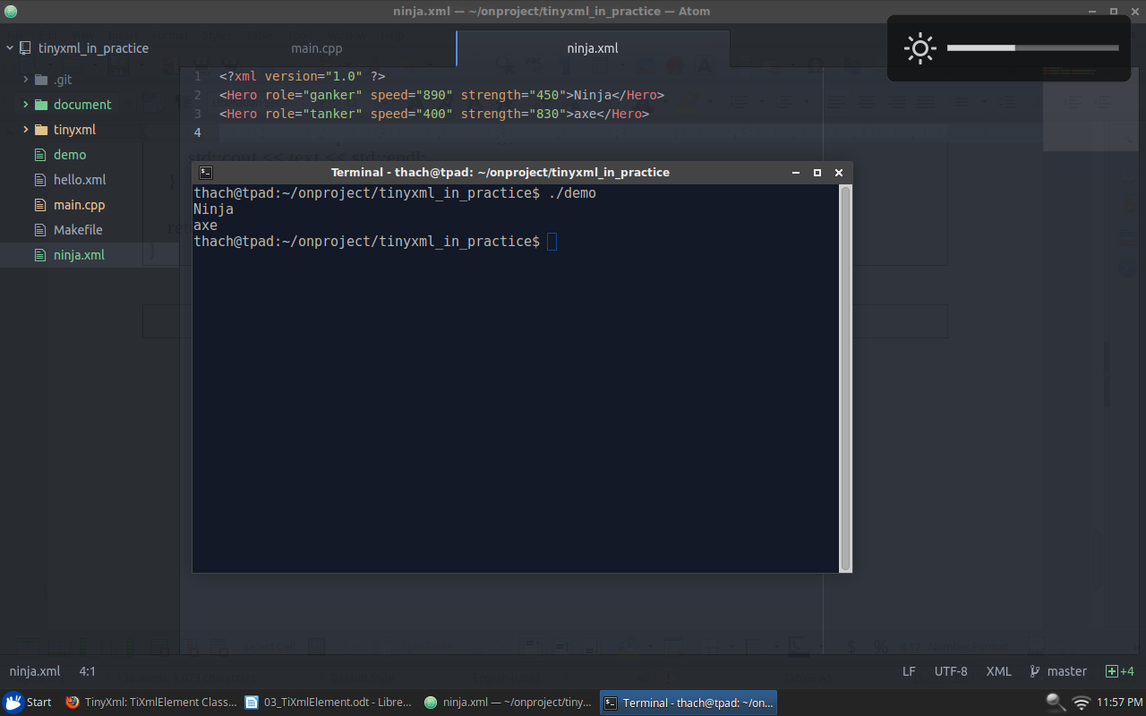

Get Element By Value
ninja.xml
<?xml version="1.0" ?>
<Hero role="ganker" speed="890" strength="450">ninj</Hero>
<Hero role="tanker" speed="400" strength="830">axe</Hero>
<Enemy role="ganker" speed="600" strength="700">pudge</Enemy>

Find Element Had Value: "Enemy".
NextSiblingElement("Enemy"): find the next element which has value is "Enemy".
main.cpp
#include "tinyxml.h"

int main()
{
TiXmlDocument doc;
doc.LoadFile("ninja.xml");

TiXmlElement *pRootElement = doc.RootElement();

TiXmlElement *pEnemy = pRootElement->NextSiblingElement("Enemy");

const char* text = pEnemy->GetText();
std::cout << text << std::endl;

return 0;
}

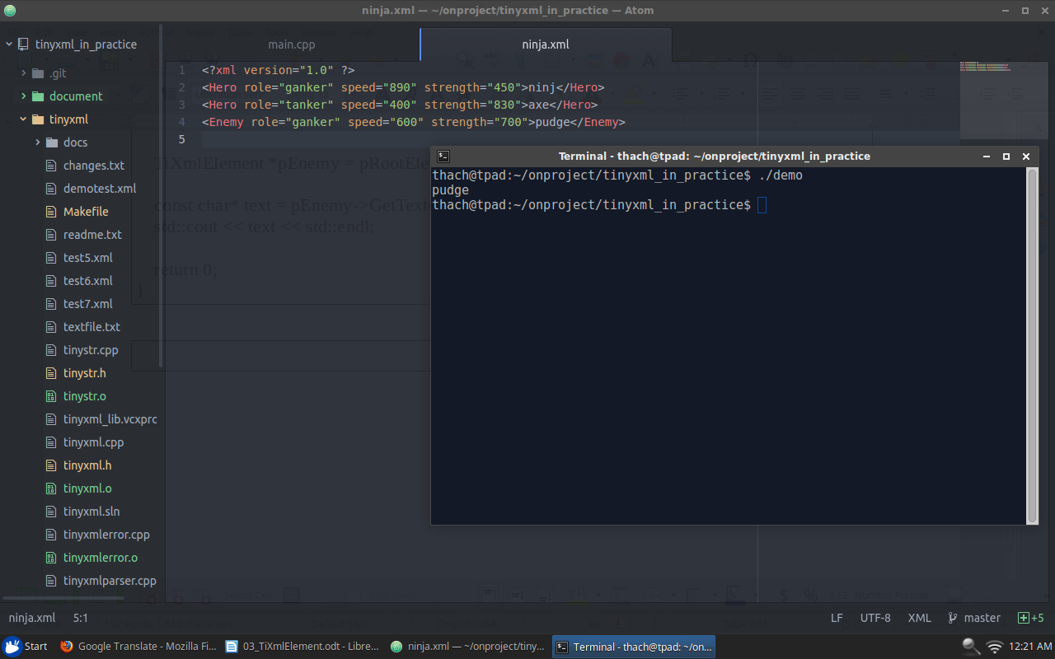

Query Attribute Of Element

ninja.xml
<?xml version="1.0" ?>
<Hero role="ganker" speed="890" strength="450">ninja</Hero>
<Hero role="tanker" speed="400" strength="830">axe</Hero>
<Enemy role="ganker" speed="600" strength="700">pudge</Enemy>

Query***Attribute("role", &role): find the attribute has name "role" and assign the value of the attribute to role variable.
main.cpp
#include "tinyxml.h"

int main()
{
TiXmlDocument doc;
doc.LoadFile("ninja.xml");

TiXmlElement *pElement = doc.RootElement();

const char* text = pElement->GetText();

std::string role;
pElement->QueryStringAttribute("role", &role);

int speed = 0;
pElement->QueryIntAttribute("speed", &speed);

int strength = 0;
pElement->QueryIntAttribute("strength", &strength);

std::cout << text << " : " << role
<< speed << " : " << strength << std::endl;

return 0;
}

