THREAD

Thread is a mechanism that permits an application to perform multiple tasks concurrently.
A process can contain multiple threads.

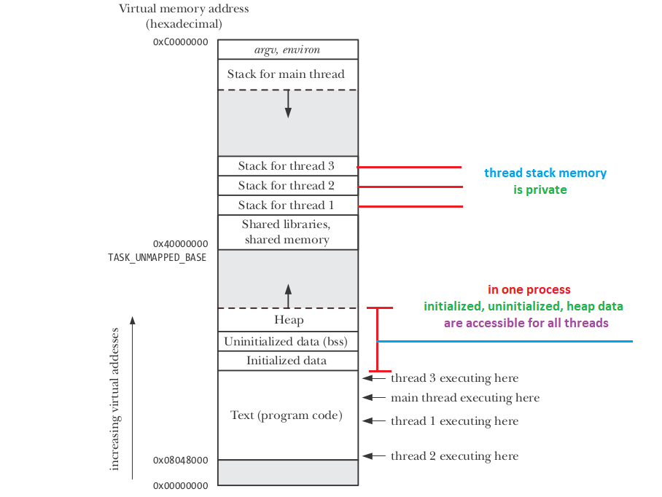

Memory
Stack
Stack is a portion of memory (in RAM). It grows and shinks similar to a stack data struct, things can be added and removed at the top.
When thread is created, it is allocated a stack space. If we store more information than stack capacity, we will get a stack overflow and crash.
Default thread stack size for a few architectures

i386 | 2 MB
x86_64 | 2 MB
IA-64 | 32 MB
PowerPC | 4 MB

However, the stack size can be explicitly set in the attribute argument used to create thread by using pthread_attr_setstacksize.

Initialized Data, Uninitalized Data & Heap
In one process, threads all share the same global memory, including:

Initalized data | global initalized variables  global static initalized variables  local static initalized variables
Uninitalized data | global uninitalized variables  global static uninitalized variables  local static uninitalized variables
Heap data | allocated by new, malloc, calloc

Practise
Check thread default stack size
ulimit -s

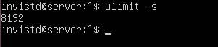

Errno
In threaded programs, each thread has its own errno value.
Reason:
- To avoid race conditions

Example
#include <pthread.h>
#include <stdio.h>
#include <errno.h>
#include <string.h>
#include <stdlib.h>
#include <unistd.h>

void* func_1() {
errno = 1;
printf("func_1, errno value: %d\n", errno);
}

void* func_2() {
printf("func_2, errno value: %d\n", errno);
}

int main() {
pthread_t thread_1;
pthread_create(&thread_1, NULL, func_1, NULL);
sleep(1);

pthread_t thread_2;
pthread_create(&thread_2, NULL, func_2, NULL);
sleep(1);

return 0;
}

In above program,
- thread_1 set errno to 1. However, thread_1 set its own errno instead of global errno.
- One second later, thread_2 print errno value. However, thread_2 print its own errno instead of global errno.

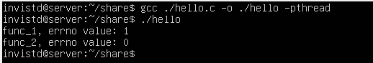

Return value from pthreads functions
In pthreads API, functions return 0 on success or a positive value on failure.
The returned failure value is used to replace errno.

