1) The bicyclist is signaling?

1. Turning left
2. Stopping
3. Debris in roadway

2)If you see a funeral procession you:

a)Must yield the right-of-way to any vehicles in the funeral procession  
 b)May drive between the vehicles moving in the funeral procession

c)Must pass a funeral procession the right on a multiple lane highway

3)When passing another vehicle:

a) Pass the vehicle as slowly as possible

b)Drive at the same speed as the vehicle you are passing

c)Pass the vehicle as safely and as quickly as possible

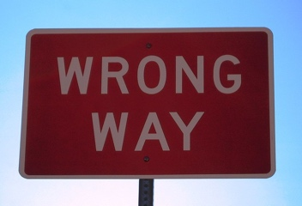

[This Photo](http://www.flickr.com/photos/27413690@N00/366976968) by Unknown Author is licensed under [CC BY-NC-ND](https://creativecommons.org/licenses/by-nc-nd/3.0/)

4)This road sign means:

a)Do not enter

b)You are not allowed to travel this direction

c)Exit at intersection

5)Night driving poses special problems for drivers because:

a)The speed limit is increased at night

b)There are fewer cars on the roads at night

c)Vehicle speed and distance are harder to judge

6)Texting while driving a motor vehicle is:

a)Permitted when driving at a slow speed

b)Not legal

c)Legal if the driver is 21 years of age or older

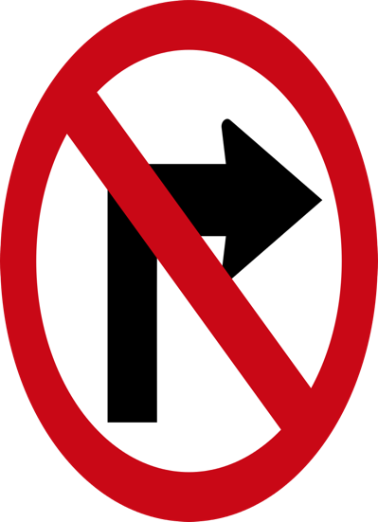

[This Photo](https://en.wikipedia.org/wiki/File:No_Turn_Right_(Saudi_Aarbia_Road_Sign).svg) by Unknown Author is licensed under [CC BY-SA](https://creativecommons.org/licenses/by-sa/3.0/)

7)This road sign means:

a)No right turn

b)No U-turns

c)No left turn

8)As it relates to your driver’s license, implied consent means:

a)Submitting to a chemical test to determine BAC

b)Submitting to a field sobriety test to determine impairment

c)Submitting to a physical examination before licensure

9)If the vehicle is equipped with air bags:

a)Seatbelts should still be worn

b) Seatbelts do not need to. Be worn

c)Seatbelts do not need to be worn

10)When following another vehicle you should use:

a)Low beams

b)High beams

c)Parking lights

11)What should you do if an emergency vehicle is approaching you form behind with sirens and flashing :

a)Pull over to the curb or edge of the road and stop

b)Slow down so the emergency vehicle can pass

c)Pull over to the right-most lane so the vechicle can pass

12)Before returning to the original lane after passing another vehicle, you should:

a)Beep your horn

b)See both headlights of the passed vehicle in your rear view mirror

c)Flash your headlights

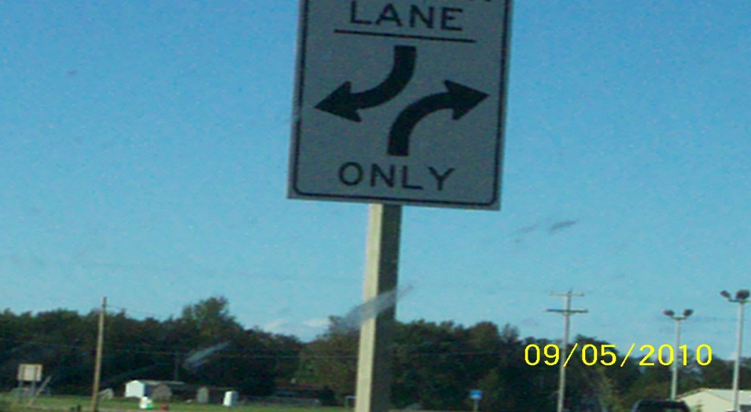

[This Photo](http://flickr.com/photos/tenpoundhammer/4965110348) by Unknown Author is licensed under [CC BY](https://creativecommons.org/licenses/by/3.0/)

13)This road sign means:

a)Two-way left turn only

b)One-way right turn only

c)Turn left to avoid oncoming traffic

14)This road sign means:

a)Do not enter

b) Roundabout ahead

c) No U turn

15)If you encounter an aggressive driver you should:

a)Challenge them

b)Get out of their way

c)Speed up

16)When driving in a contruction zone:

a)slightly increase your speed

b)Expect the unexpected

c)Contruction workers must yield to roadway users

17)When being passed by another vehicle:

a)slow down

b)Maintain a constant speed

c)speed up

18)The maxiumum posted speed limit should be driven only:

a)During the night

b)During the day

c)In ideal conditions

19)MVA will sudpend the licence of any driver who:

a)Refuses to use a false ID to purchase alcohol

b)fails to meet the attendance requirement for school

c)Refuses to submit to a test to determine BAC

20)If the roadway is wet or icy you should:

a)Follow the posted speed limit

b)Reduce your speed

c)Speed up

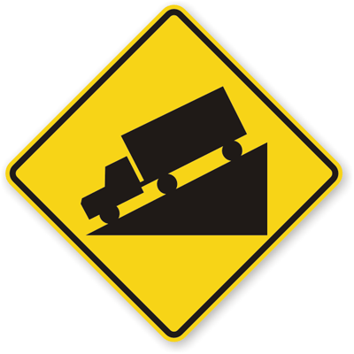

[This Photo](http://www.xaktly.com/Slope.html) by Unknown Author is licensed under [CC BY-SA-NC](https://creativecommons.org/licenses/by-nc-sa/3.0/)

21)Intersection ahead

a)Intersection ahead

b) Merging traffic

c)Steep hill

22)To avoid traction loss from hydroplaning, you should:

a)Drive at a constant speed

b)Apply the brakes firmly

c)slow down

23)When turning left at an intersection:

a)You should always yield to oncoming traffic and pedestrians

b)Oncoming traffic and pedestrians should yield to you

d)You should never yield to oncoming traffic and pedestrians