High-Fidelity

UI Prototype

Prepared by: The Skyentists  
Due Date: 12/05/19

## Overview

The high-fidelity prototype is the interactive representation between the user and the software that is closest to the final design and implementation. These prototypes let users give feedback on all parts of the software, especially when dealing with edge cases. Users can give more meaningful feedback than lower-fidelity prototypes, as they can interact with the prototype as if it were the software. The users can see how the interface will function and behave, while showing off what is available for viewing during the software’s runtime.

## High-Fidelity Prototype

The full high-fidelity prototype for the calibration software can be found in this git repository: <https://github.com/markm700/CalibrationUIPrototype>

This is a public repository that is cloned from the private repository that the client created (and is private) that includes the project documents and medium to high fidelity prototype. Input the command “python3 calibration.py” in the folder that the prototype is in to begin the calibration process.

Apart from viewing the full prototype, this section highlights the changes made from the low-fidelity prototype to creating this functioning prototype. Most of these changes were based on the original user feedback from all user groups (the class, client, and professor), although some decisions were made by the team to change the prototype. The team decided not to include the functionality of a back button, as this calibration process is very linear and needs to be followed in that order. However, there is the exit option at any time to stop the calibration process by clicking the exit button in the top right corner. The addition of a pop-up “help” menu when clicking on a definition was also not implemented but will be added later.

Configuration File Page

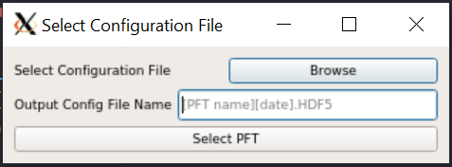

This page now gives the user an option to name the output configuration file while choosing the current config file. The output file naming was a function that was suggested in the feedback. This functionality happens here because the output configuration file will be written once all the plant functional types (PFT) for that file have been calibrated.

PFT Selection Page

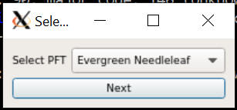  
The changes to this page were the most drastic from the low-fidelity prototype. Based on feedback from all sources, the plant functional types (PFTs) will be read in from the current configuration file and will not be strictly limited to the original 8 PFTs. Pictures were not included in this prototype but can be added later depending on feedback.

Selecting Outliers Pag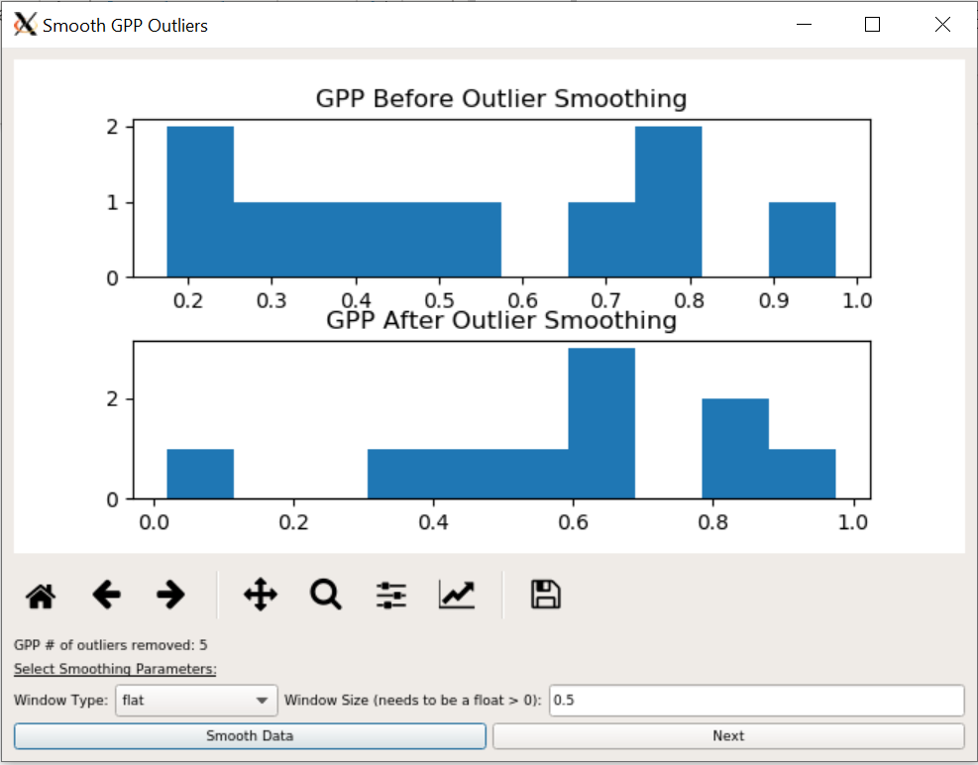e

The changes to this page from the low-fidelity prototype were that the GPP and RECO outliers both have their own distinct page in this prototype. This change was based upon client feedback, as histograms would be easier to view the window size and outliers removed. The number of outliers removed for that process are now shown.

Ramp Function Pages

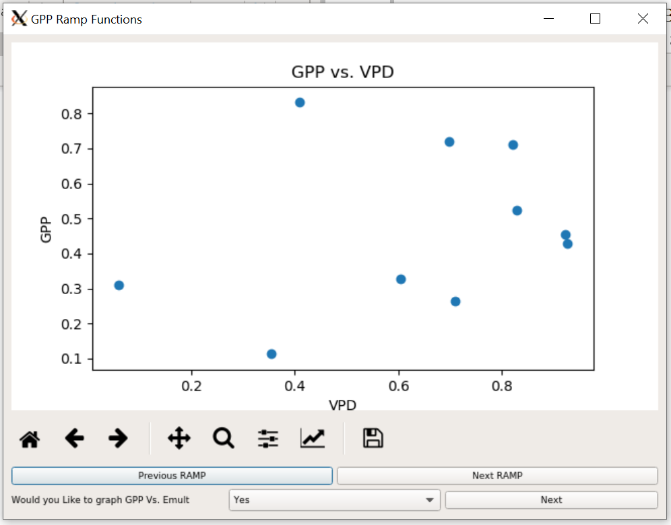

This page still displays the ramp functions as in the low fidelity prototype. The previous and next ramp buttons were changed from arrows to buttons for easy identification in this prototype, although the team and client are open to changing this.

Parameter Pages

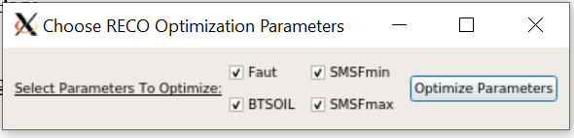

This page displays all the parameters for RECO (or GPP) that are being chosen to optimize. These parameters are now all included, by default, to be optimized. Although the class provided feedback to select/de-select all parameters, the team did not decide to implement this since a majority of or all parameters will be optimized in most cases. Only rarely will one or two parameters be selected.

RECO Hyperparameters Page

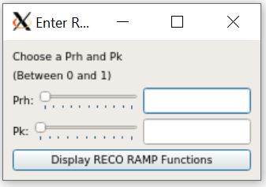

The change to this page was the addition of a slider bar. If the value (a float between 0 and 1) is changed by the slider or text field, then the value of the other one will update with it. The user inputting a number greater than 1 will cause the slider of either Prh or Pk to disappear and an error message to be thrown before proceeding.

Ending Page

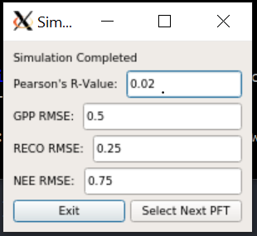

The changes to this ending page include the root mean square error (RMSE) of GPP, RECO, and NEE as well as Pearson’s R-value. This decision was made based upon client feedback. The values of these fields are read only.

## User Feedback

Feedback on this prototype was provided by peers (11 total) and the client (only 1) prior to the final presentation. The class provided some feedback during the presentation. All the feedback provided on the high-fidelity prototype is categorized by page and then further divided by the user groups

All Pages/General:

* Peers
  + Get rid of taskbars (may be too many clicks/buttons for user)
  + Better scaling of y-axis for graphs
  + Make graph titles uniform (x vs y OR y vs x, not both)
  + Make fonts a little bigger for easier readability
  + Window resizing too small for some pages
* Client
  + Include indicator of which PFT is currently being calibrated
  + Include some sort of progress indication for that specific PFT
  + Window resizing is cutting off the dialog titles
* Class
  + Start over/exit button
  + Fix resizing of windows (encompass in a larger shell)
  + Have option to view just the current values of the BPLUT table
  + Keep track of calibration steps and current PFT calibrated
  + Make tooltips more easily accessible

Outliers Page:

* Peers
  + Placeholder “Required” text in Window Size fields

Ramp Function Pages:

* Peers
  + Change default from yes to no to make the optional graph
* Client
  + Display the old and new values of the optimized parameters next to RAMP functions (Example: old and new VPDmin and VPDmax listed next to VPD ramp)
* Class
  + Provide axis labels for all graphs
  + Make graphs side-by-side or switch the next/previous ramp buttons to a tab

SOC Plot Page:

* Peers
  + Remove underscores from SOC

## Execution and Acknowledgement

The team members hereby indicate by their signatures below that they have read and agree with the specifications of this document.

