**A. Introduction**

Technology dramatically increases student engagement in the classroom. When educators incorporate visual elements like presentations or digital tools, students often find these methods far more appealing than traditional assignments like writing papers or creating posters. By integrating technology into the learning process, we can capture students’ attention and foster a more interactive and stimulating educational environment (Walden University, 2017). One example is the School Portal, a platform where students can check their grades, view pending assignments, track upcoming activities, and find their scheduled exams. While using the portal, they can also connect through tools like Google Meet, Zoom, or Google Drive for online meetings and collaboration. This way, students stay organized and informed about their academic responsibilities.

**B. Project Features and Characteristics**

The proposed project SVFC portal consist the following features:

1. Authentication – Login – user
2. User management – Logs – user
3. Organize Section/Course – Students and professor
4. Resource Sharing – Students and professor
5. Analytics Dashboard – Professor
6. Real-Time Notifications – students
7. Assignment History and feedback – students and professor
8. Discussion Boards – students and professor

**C. Project Scope**

The SVFC Portal is designed to provide both students and professors with a user-friendly platform for managing academic tasks efficiently. Its main purpose is to help users easily navigate the site, enabling them to stay informed about their current tasks and new assignments through timely notifications. By offering these features, the portal aims to enhance communication and collaboration within the educational environment.

However, while the project may include a basic administrative section, it will not be fully functional. This means that tasks such as managing student enrollments, validating accounts, distributing documents, assigning courses, or organizing students into their respective sections and academic years may be limited. As a result, some aspects of course management will not be fully addressed in the initial implementation.

**D. Work breakdown Structure**

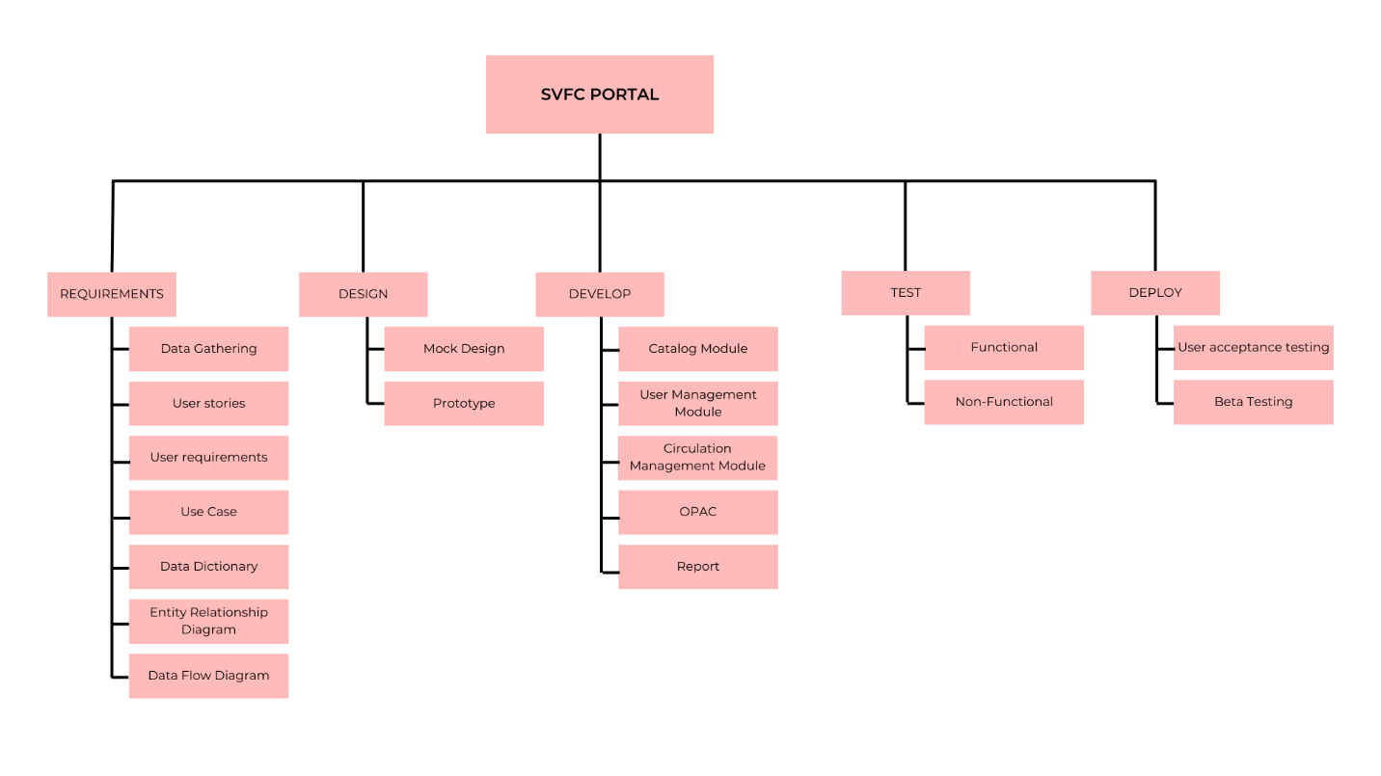

**E. Functional Requirements**

        1.User Requirements

* Admin
  + Add/accept students
  + Assign professor course & year
* Professor
* Students

        2. Use case

**F. Database Architecture**

1. Data Dictionary
2. ERD