1. Using module <https://registry.terraform.io/modules/terraform-aws-modules/vpc/aws/latest> create your VPC. Add tags with next fields: Owner:, CreatedBy:, Purpose:step3.

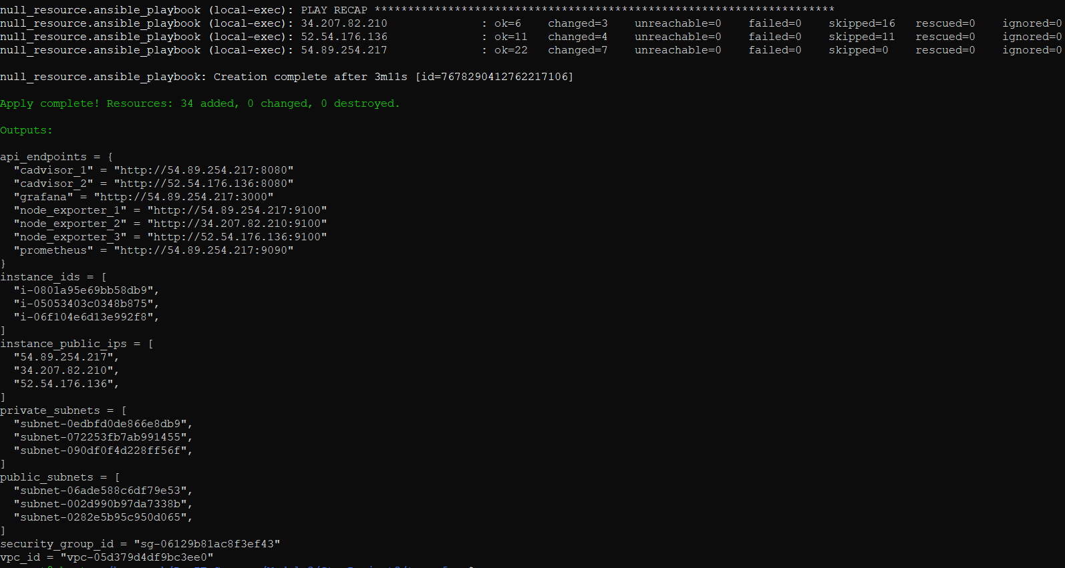

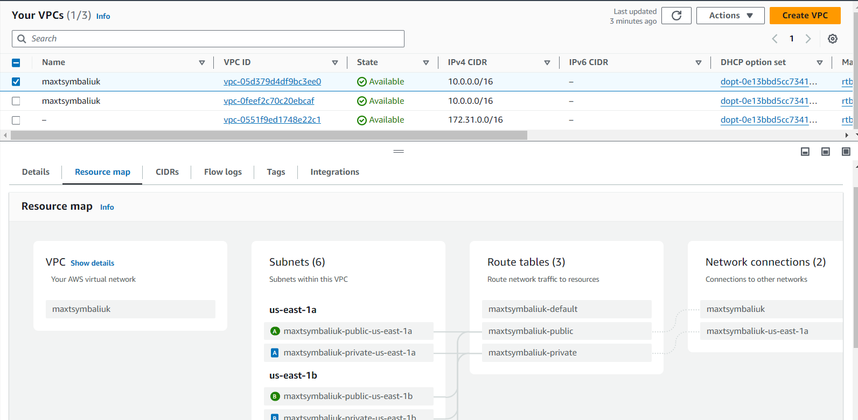

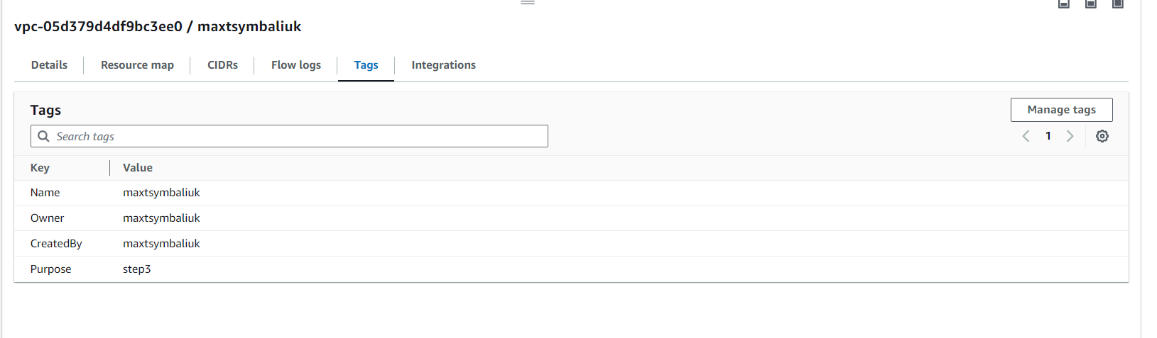

1. Wrote terraform code which will create 3 ec2 with docker installed.  
   Also it should add your public ssh key to ec2. So when you create ec2 with this module you can connect to it with command: ssh YOUR_USER@IP

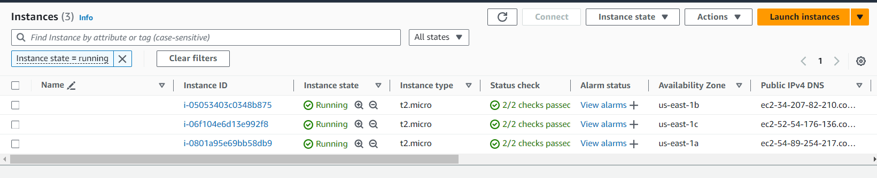

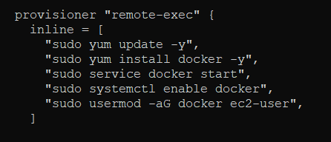

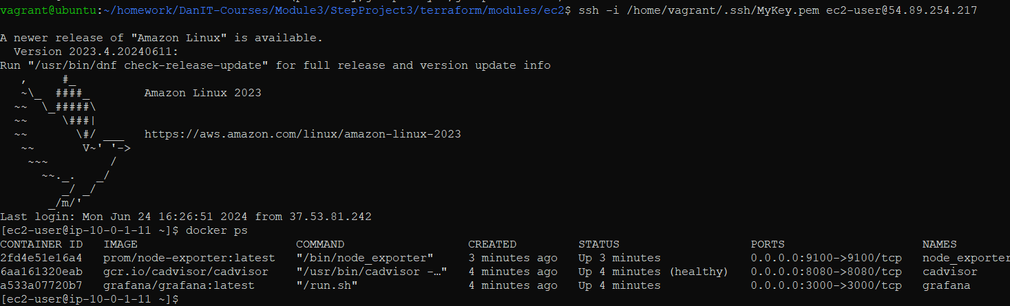

1. Write terraform code which will create load balancer.

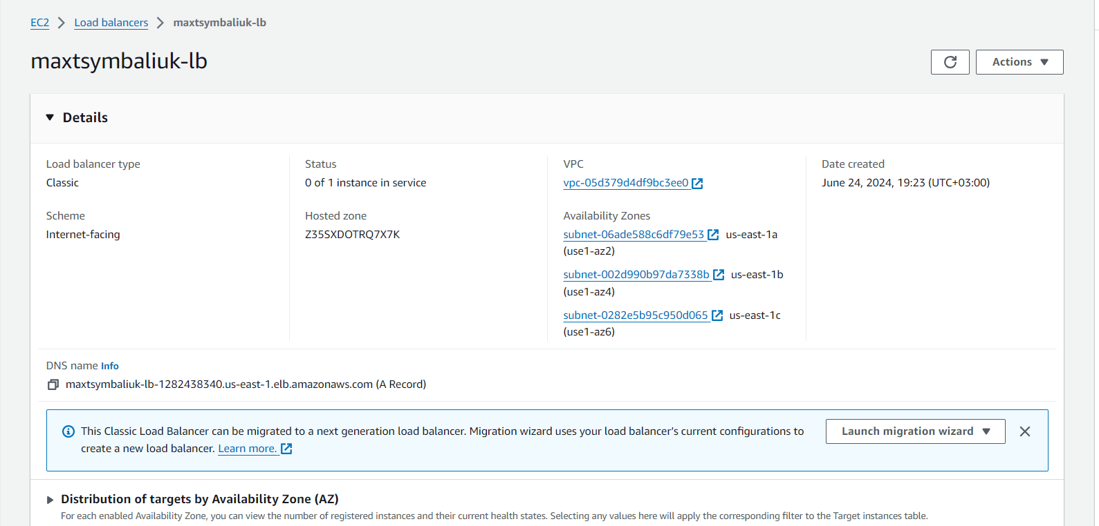

1. Add to this balancer only first ec2 instance, it will contain Prometheus and Grafana

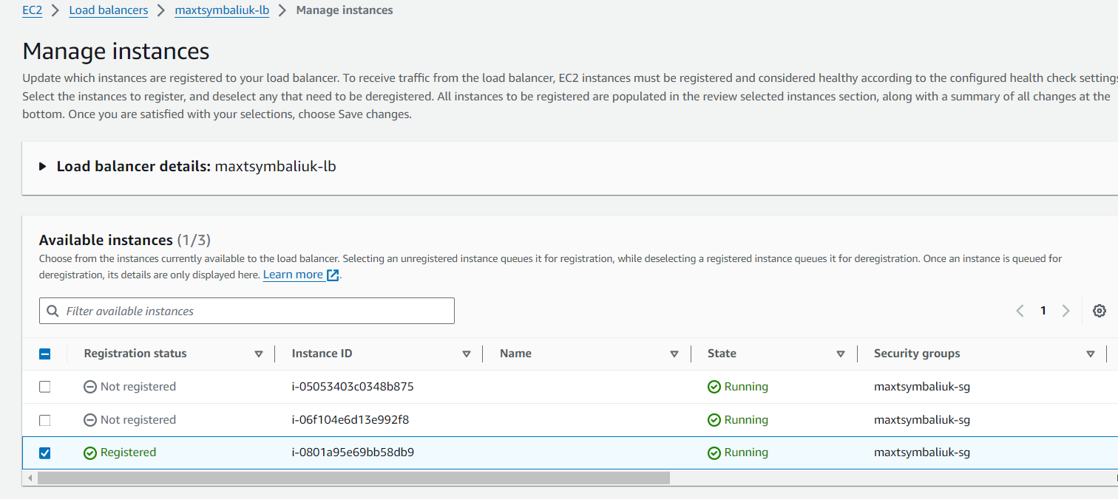

1. Write terraform code to generate ansible inventory file for the next step
2. Using article: <https://www.padok.fr/en/blog/prometheus-monitoring-ansible> deploy software on these 3 ec2 instances automatically from terraform.

Prometheus "http://54.89.254.217:9090"

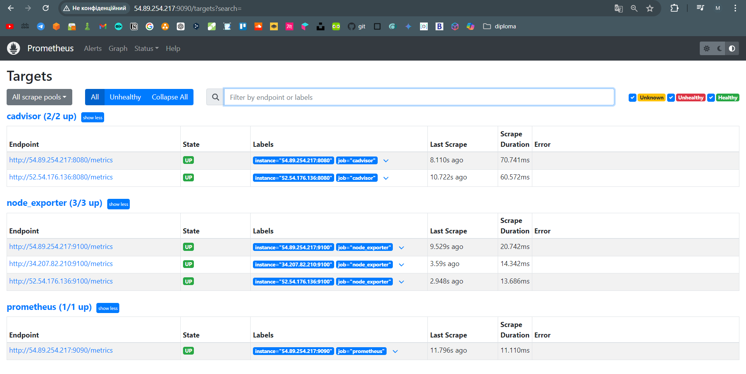

cAdvisor1 "cadvisor_1" = "http://54.89.254.217:8080"

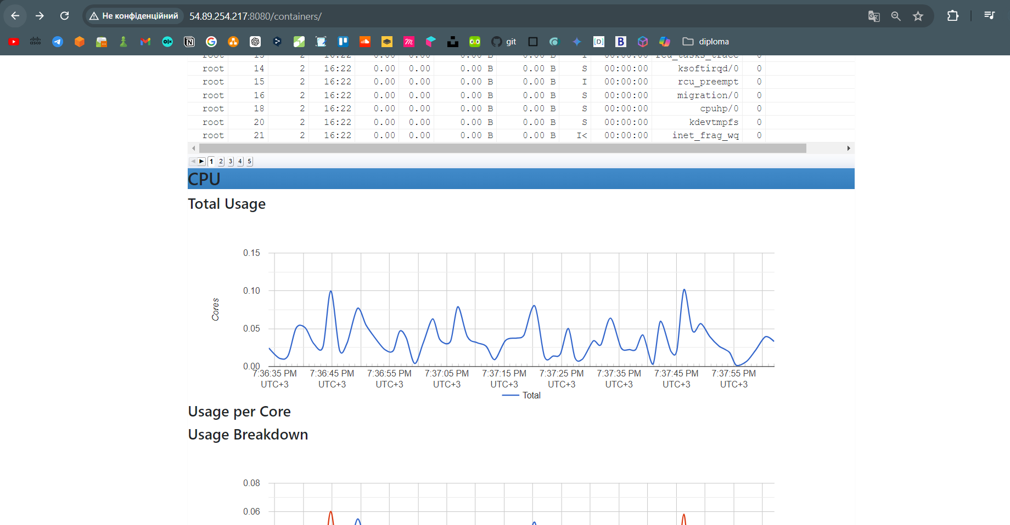

cAdvisor2 "cadvisor_2" = "http://52.54.176.136:8080"

