1. Create pod via deployment with nginx in your local kind cluster

Create cluster “kind”

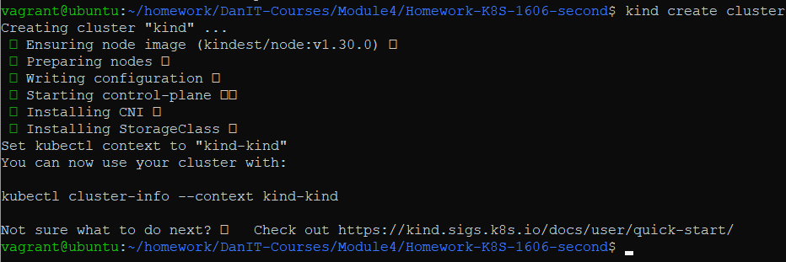

Create pod nginx deployment via yaml file



Check pod

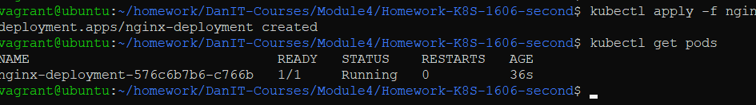

1. Create ClusterIP service for this deployment

Create cluster ip



Check services

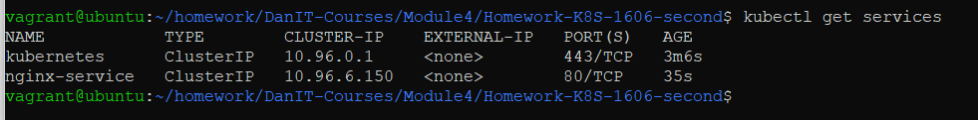

1. Use port-forward to connect to it

Start port-forwading on ip of my vagrant-VM(192.168.56.30) port 8080



Check access in web browser

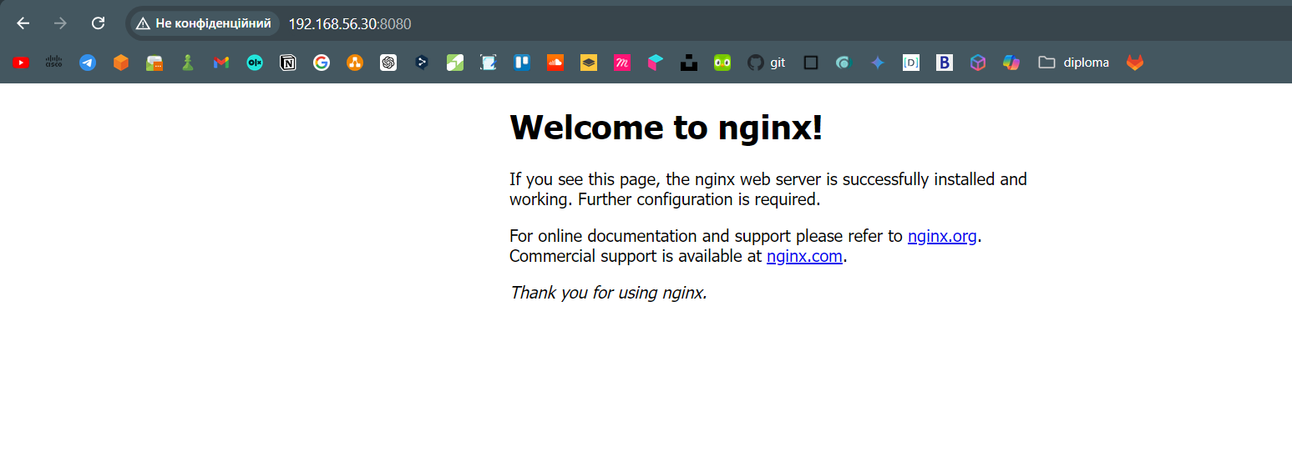

1. Configure service as NodePort



1. Expose this node port to your laptop via configuration of the kind cluster and re-creation

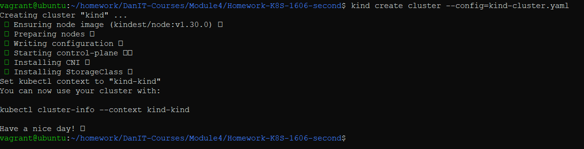

1. Connect to service via this exposed port without port-forward

