1. Add your user to EKS and create namespace for your test

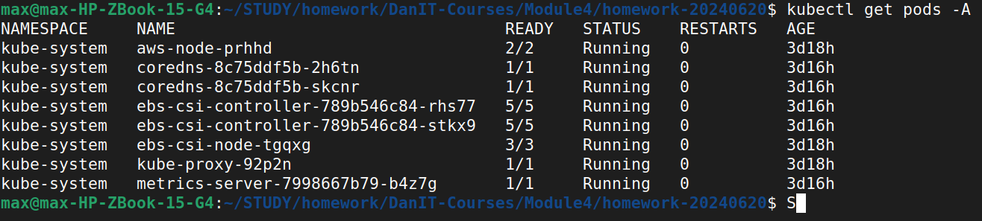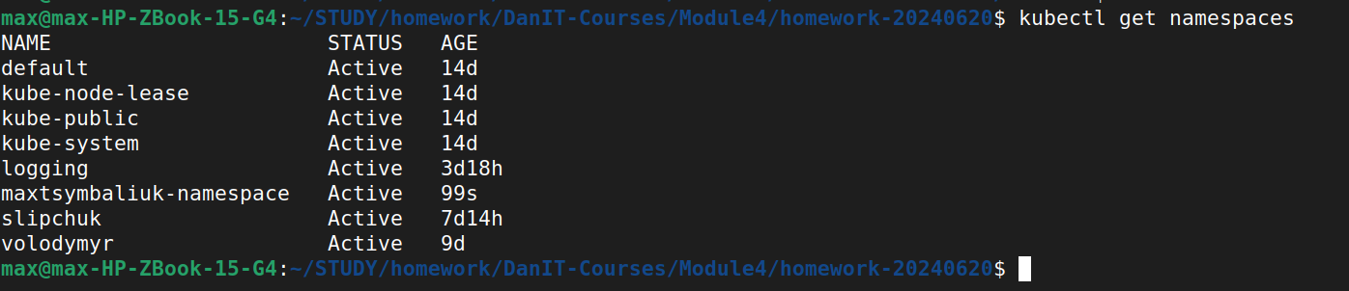

1. Create PVC(1Gb) for your deployment



1. Create deployment with nginx and mount PVC to it



1. Config nginx to get files from this PVC



1. Copy test html to volume

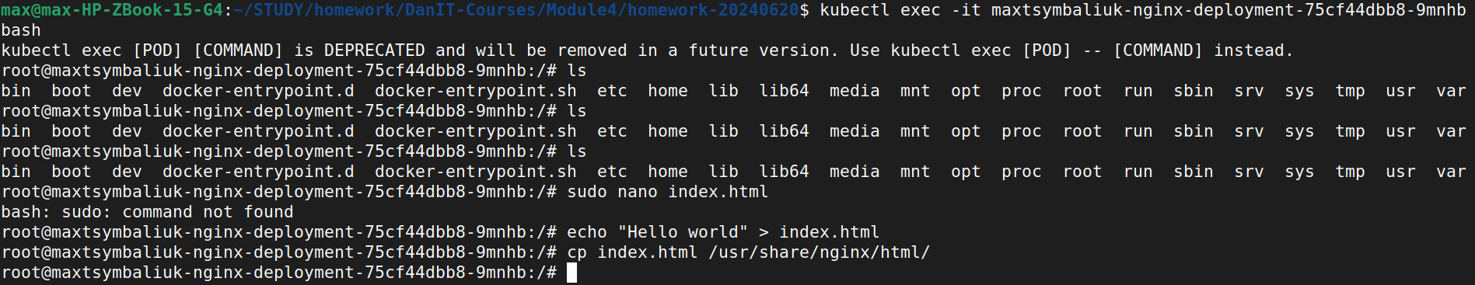

1. Check that nginx return test html

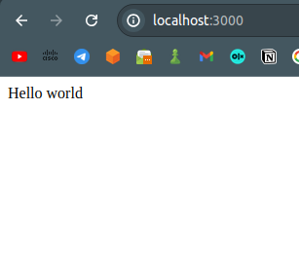

1. Delete pod with nginx



1. Make sure that nginx return test html

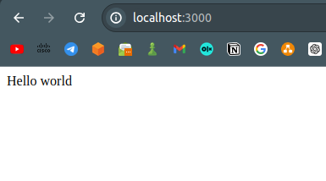

ADVANCED

create configmap resource with different nginx config file which change default path for static files to /mystatic

Create nginx.conf file



