Run you own docker registry, create a volume and mount it as the registry folder, push images into it, stop container, start it again and confirm that you can pull images



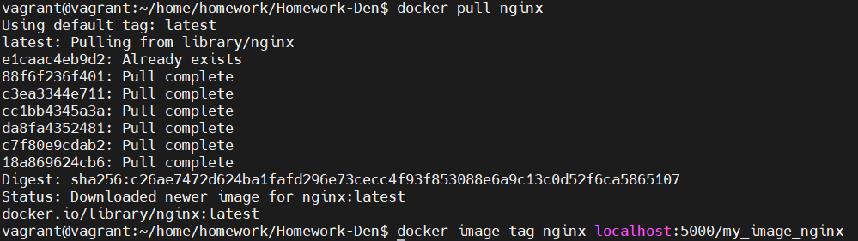

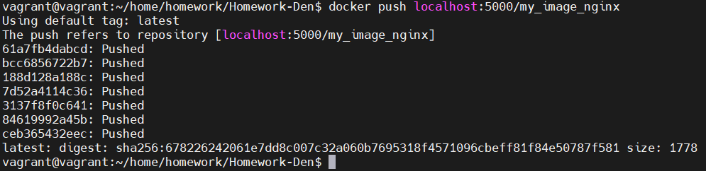



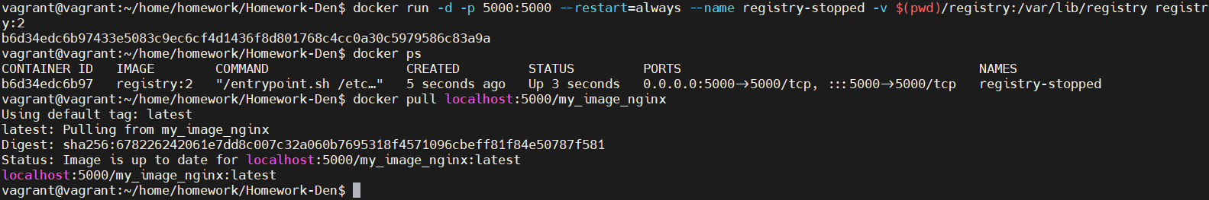

Tag image with different name, e.g. localhost:5000/python, push it to registry and confirm that it shows that layes already exist

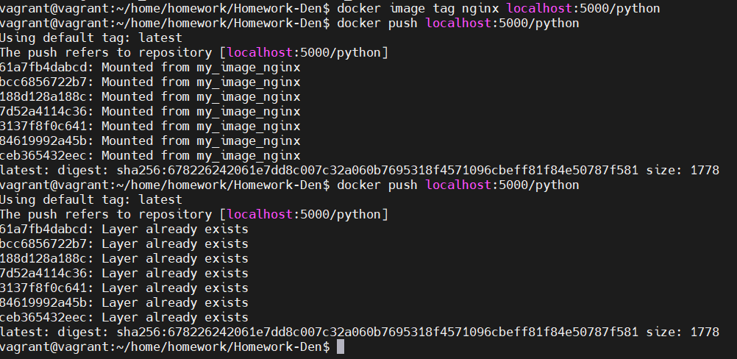

Add /healthz endpoint to python app which works in the same way like nodejs endpoint, optionally, add healthcheck to image using this endpoint

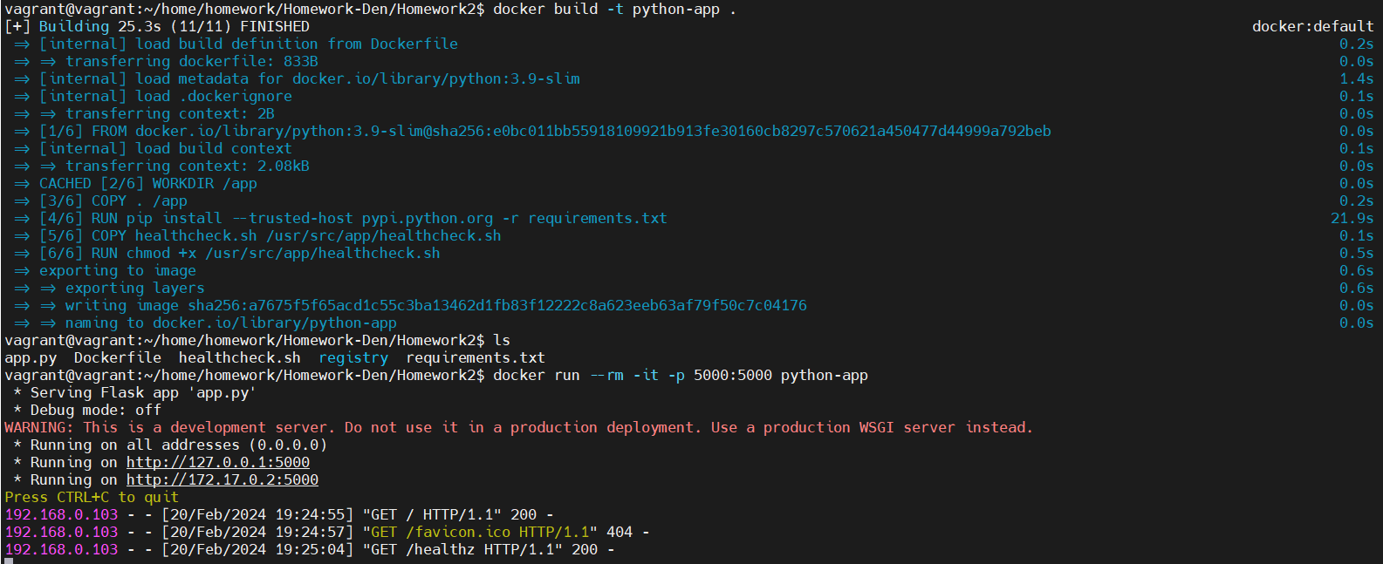

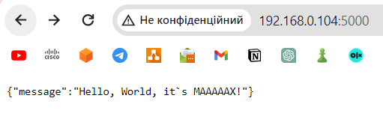

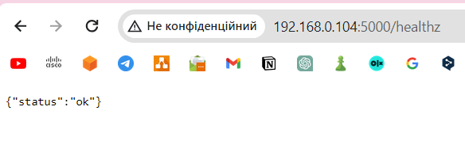]

Additional

Start nexus and configure it to proxy dockerhub, pull default image via proxy

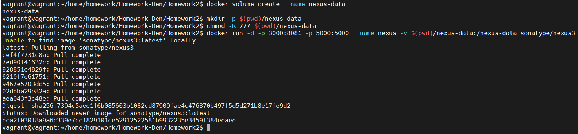

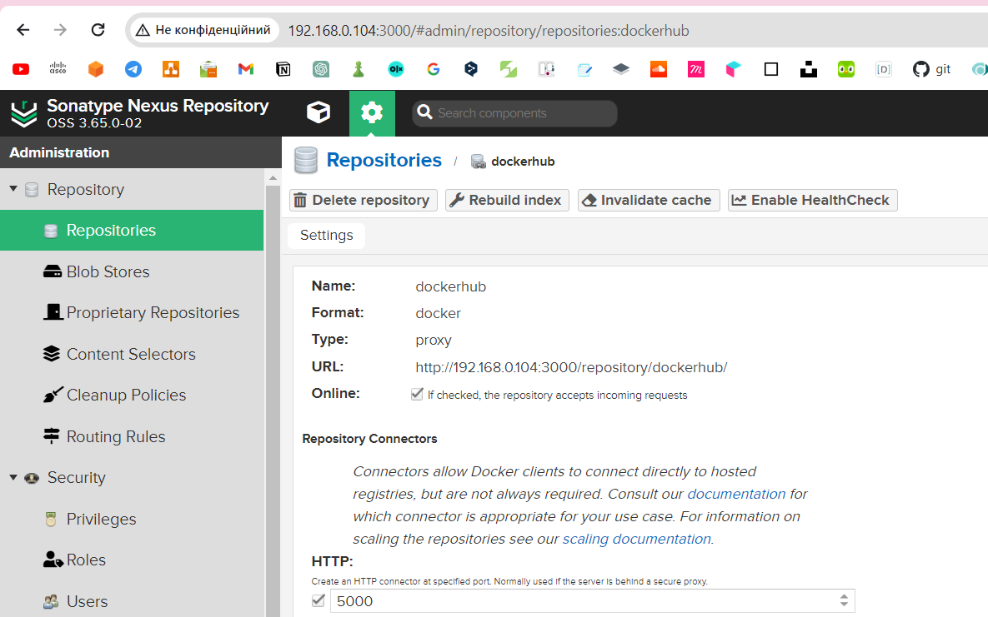

Configure local repository in nexus and push image to it, confirm that it was added

