• Launch Jenkins

• Generate SSH key and import it to Jenkins secrets

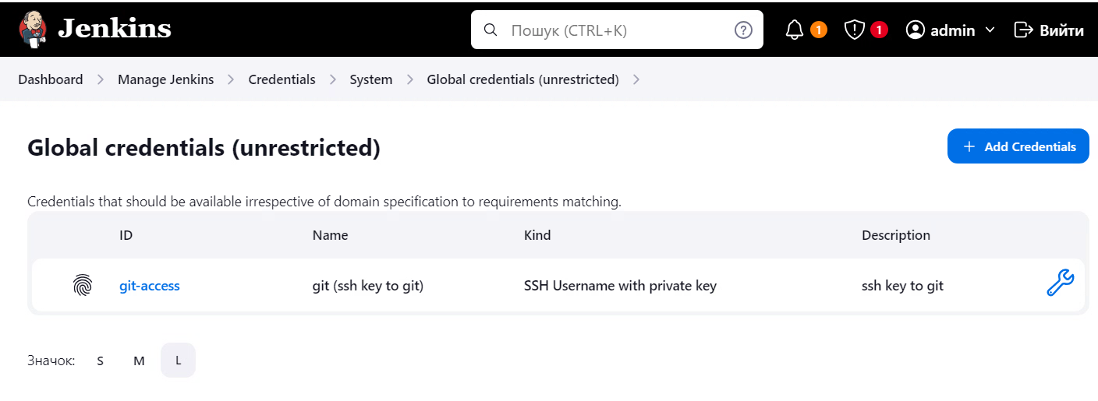

• Configure Pipeline job

• Configure downloading of pipeline code from repo using SSH authentication by using Jenkins secret

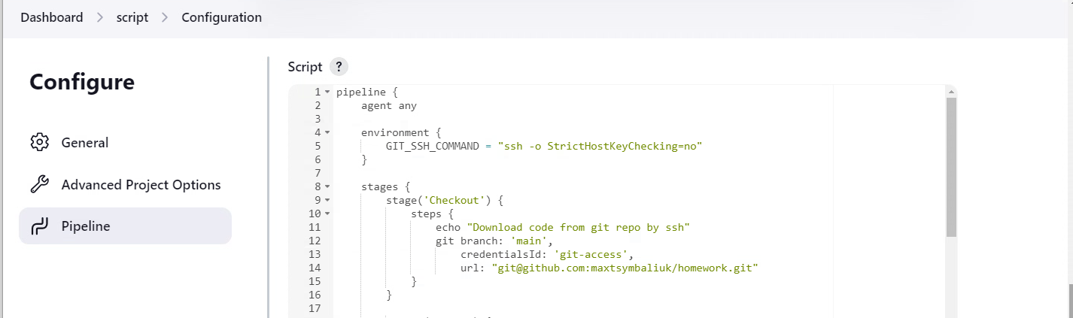

• The code should have the following stages:

* Checkout: get some project code from remote repo, use SSH here as well
* Build: create folder and file with current data and time named pipeline/${BUILD_NUMBER}.txt
* Publish: add the file to git, commit change, add tag v0.2.${BUILD_NUMBER}, push to origin
* Post Build: add generated file as job artifact

CHECK JENKINS FILE

• Run the job several times and confirm that project has multiple files and tags after that

