• Take an example static web site, create compose file with nginx container serving this content via volume mount, expose it at port 8080

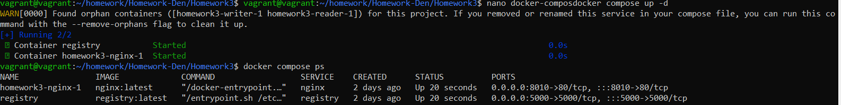

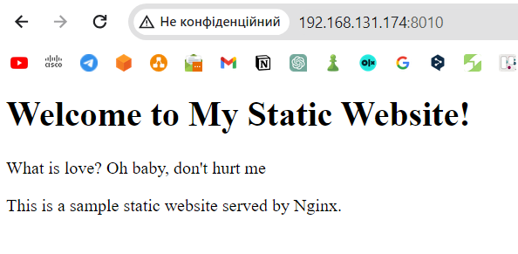

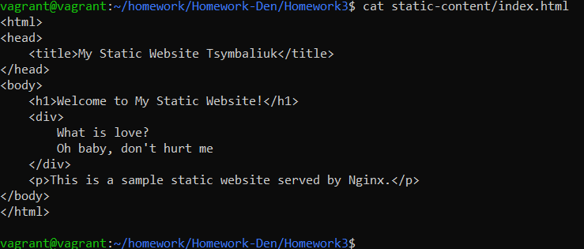

• Create compose file to run registry in persistent mode, push images to it and confirm that they stay after service down/up

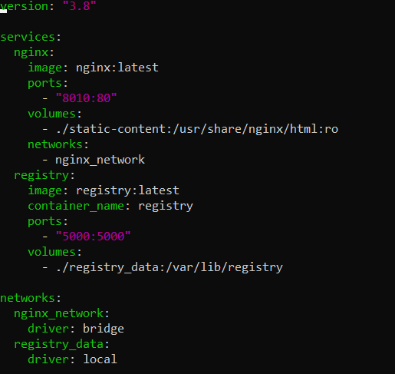

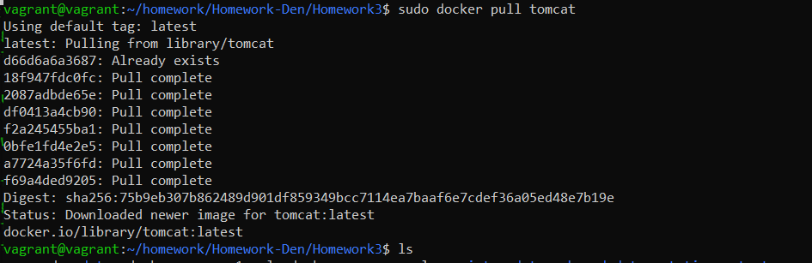

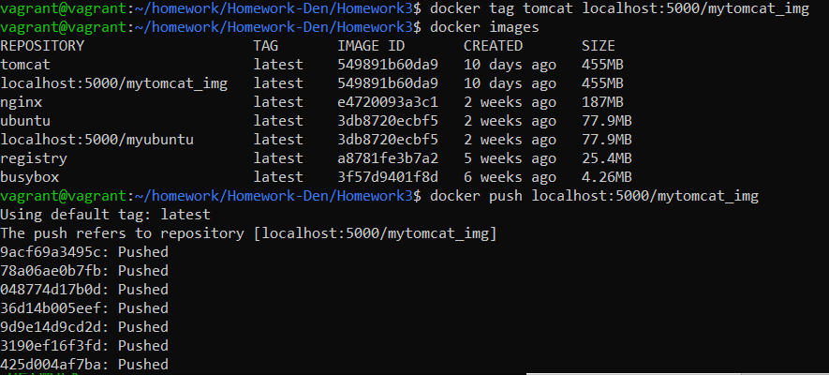

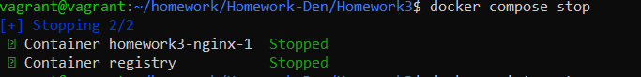

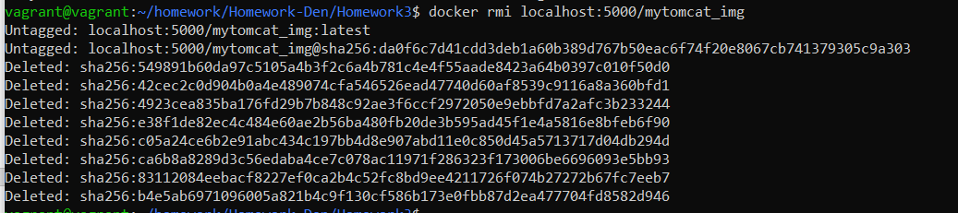

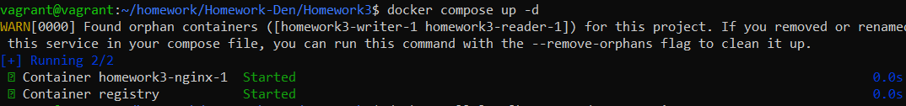

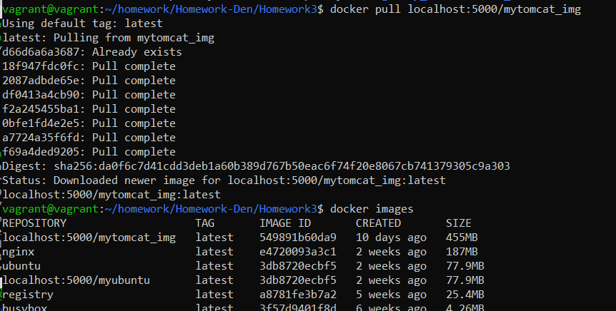

• Use any compose file to start service, scale them up/down from 1 instance to 3 and back

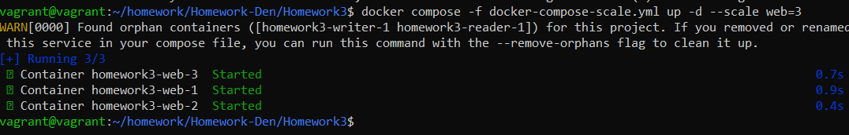

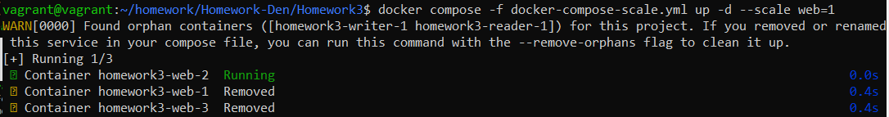

• Create compose file which runs two services using same volume to share files between them, one service should create file and second one should be able to read it

