前端路由配置文件

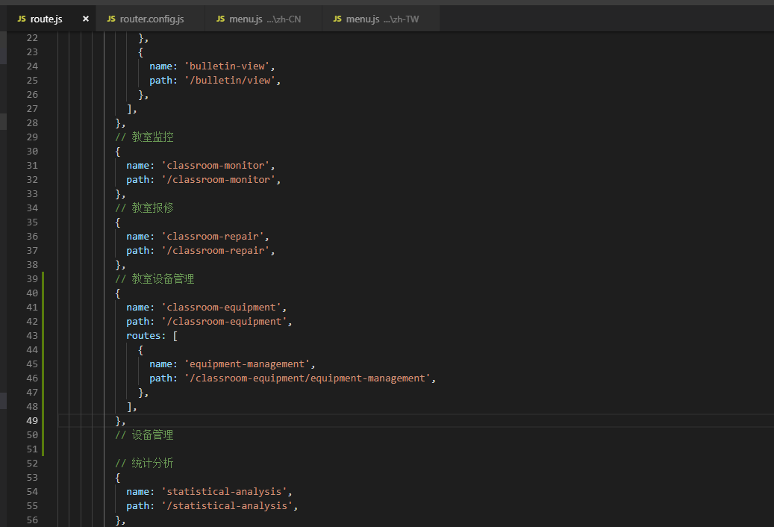

备份： {/* <Row gutter={16}>

<Col lg={6} md={12} sm={24}>

<Form.Item label="设备编号">

{getFieldDecorator('deviceNo', {

rules: [{ required: true, message: '请输入设备编号' }],

})(<Input placeholder="请输入设备编号" />)}

</Form.Item>

</Col>

<Col xl={{ span: 6, offset: 2 }} lg={{ span: 8 }} md={{ span: 12 }} sm={24}>

<Form.Item label="设备名称">

{getFieldDecorator('deviceName', {

rules: [{ required: true, message: '请输入设备名称' }],

})(<Input placeholder="请输入设备名称" />)}

</Form.Item>

</Col>

{

edit ? '' :

<Col xl={{ span: 8, offset: 2 }} lg={{ span: 10 }} md={{ span: 24 }} sm={24}>

<Form.Item label="设备二维码">

<img style={{width: 150,marginLeft: 120,marginTop: -10}} src="https://timgsa.baidu.com/timg?image&quality=80&size=b9999_10000&sec=1556003824&di=75d7c0df07a5cac2242cbb48b038d2b9&imgtype=jpg&er=1&src=http%3A%2F%2Fb-ssl.duitang.com%2Fuploads%2Fitem%2F201701%2F28%2F20170128085020_jfRhX.jpeg" />

</Form.Item>

</Col>

}

</Row>

<Row gutter={16} className={styles.qrcode}>

<Col lg={6} md={12} sm={24}>

<Form.Item label="设备状态">

{getFieldDecorator('deviceStatus', {

rules: [{ required: true, message: '请选择设备状态' }],

})(

<Select placeholder="请选择设备状态">

<Option value="xiao">付晓晓</Option>

<Option value="mao">周毛毛</Option>

</Select>

)}

</Form.Item>

</Col>

<Col xl={{ span: 6, offset: 2 }} lg={{ span: 8 }} md={{ span: 12 }} sm={24}>

<Form.Item label="设备类型">

{getFieldDecorator('dateRange', {

rules: [{ required: true, message: '请选择设备类型' }],

})(

<Select placeholder="请选择设备类型">

<Option value="xiao">付晓晓</Option>

<Option value="mao">周毛毛</Option>

</Select>

)}

</Form.Item>

</Col>

</Row> */}

{/* <Row gutter={16} className={styles.qrcode}>

<Col lg={6} md={12} sm={24}>

<Form.Item label="设备型号">

{getFieldDecorator('deviceStatus', {

rules: [{ required: true, message: '请输入设备型号' }],

})(<Input placeholder="请输入设备型号" />)}

</Form.Item>

</Col>

<Col xl={{ span: 6, offset: 2 }} lg={{ span: 8 }} md={{ span: 12 }} sm={24}>

<Form.Item label="规格">

{getFieldDecorator('dateRange', {

rules: [{ required: true, message: '请输入规格' }],

})(<Input placeholder="请输入规格" />)}

</Form.Item>

</Col>

<Col xl={{ span: 8, offset: 2 }} lg={{ span: 10 }} md={{ span: 24 }} sm={24}>

<Form.Item label="品牌">

{getFieldDecorator('deviceModelId', {

rules: [{ required: true, message: '请选择品牌' }],

})(

<Select placeholder="请选择设备类型">

<Option value="xiao">付晓晓</Option>

<Option value="mao">周毛毛</Option>

</Select>

)}

</Form.Item>

</Col>

</Row>

<Row gutter={16} className={styles.qrcode}>

<Col lg={6} md={12} sm={24}>

<Form.Item label="国家地区">

{getFieldDecorator('deviceStatus', {

rules: [{ required: true, message: '请输入设备型号' }],

})(

<Select placeholder="请选择设备类型">

<Option value="xiao">付晓晓</Option>

<Option value="mao">周毛毛</Option>

</Select>

)}

</Form.Item>

</Col>

<Col xl={{ span: 6, offset: 2 }} lg={{ span: 8 }} md={{ span: 12 }} sm={24}>

<Form.Item label="代理商">

{getFieldDecorator('dateRange', {

rules: [{ required: true, message: '请输入规格' }],

})(

<Select placeholder="请选择设备类型">

<Option value="xiao">付晓晓</Option>

<Option value="mao">周毛毛</Option>

</Select>

)}

</Form.Item>

</Col>

<Col xl={{ span: 8, offset: 2 }} lg={{ span: 10 }} md={{ span: 24 }} sm={24}>

<Form.Item label="保修截止日期">

{getFieldDecorator('deviceModelId', {

rules: [{ required: true, message: '请选择品牌' }],

})(

<Select placeholder="请选择设备类型">

<Option value="xiao">付晓晓</Option>

<Option value="mao">周毛毛</Option>

</Select>

)}

</Form.Item>

</Col>

</Row>

<Row gutter={16} className={styles.qrcode}>

<Col lg={6} md={12} sm={24}>

<Form.Item label="有效年限">

{getFieldDecorator('deviceStatus', {

rules: [{ required: true, message: '请输入设备型号' }],

})(

<Select placeholder="请选择设备类型">

<Option value="xiao">付晓晓</Option>

<Option value="mao">周毛毛</Option>

</Select>

)}

</Form.Item>

</Col>

</Row> */}