# NovaIoT — E-commerce Platform

Author: Akylbek Maxutov  
Matricola: 537775

## Introduction

NovaIoT is a smart-home IoT e-commerce platform designed to provide an intuitive and seamless shopping experience. Users can browse products, manage their cart, and place orders, while administrators have access to powerful tools for managing products, categories, and orders. The project demonstrates a full-stack web solution using a modern and efficient technology stack.

## Key Features

- User registration and login with secure password storage (MySQL + bcrypt)  
- Product catalog browsing with search, filters, and sorting  
- Shopping cart and checkout process  
- User profile with order history and profile management  
- Product reviews and ratings  
- Admin dashboard to manage products, categories, and orders

## Technologies Used and Motivation

NovaIoT uses a modern technology stack chosen for performance, scalability, and ease of deployment:  
- **Frontend (HTML, CSS, JavaScript)**: Single-page application (SPA) for fast navigation and smooth UX.  
- **Backend (Node.js + Express)**: Lightweight and flexible solution for building REST APIs.  
- **Database (MySQL)**: Ensures structured storage of users, products, orders, and reviews.  
- **Authentication (JWT + bcrypt)**: Provides secure session handling and encrypted password storage.  
- **Infrastructure (Docker + Nginx)**: Simplifies deployment, ensures consistent environments, and optimizes performance.

## Architecture and Development Decisions

NovaIoT follows a single-page application (SPA) approach, with the frontend communicating with the backend via RESTful APIs. JWT-based authentication is implemented for security, while bcrypt ensures safe password hashing. Nginx is configured as a reverse proxy to serve static files and forward API requests. Docker Compose is used to manage containers for the Node.js backend, MySQL database, and Nginx, ensuring consistent deployments.

## Setup and Run

1. Install Docker and Docker Compose.  
2. Run: docker compose up --build  
3. Access the app at: http://localhost  
4. Default admin credentials: admin@example.com / admin123

## Screenshots

Home Page

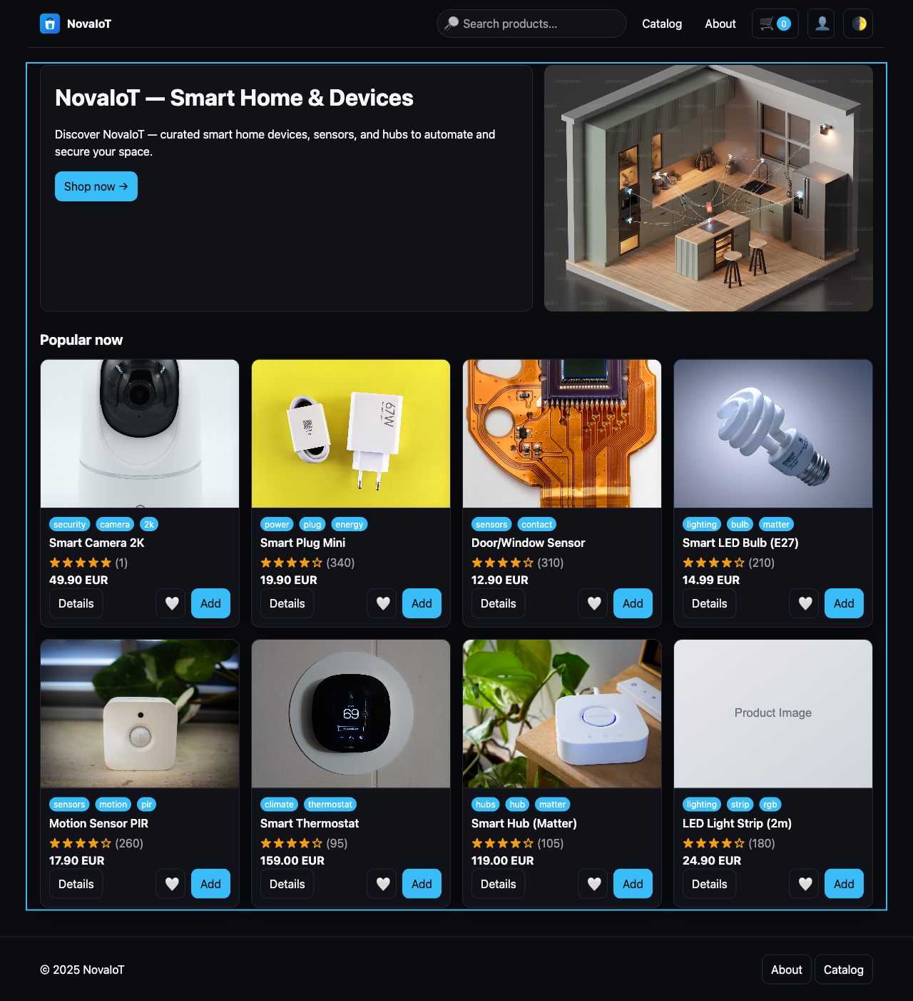

Product Catalog

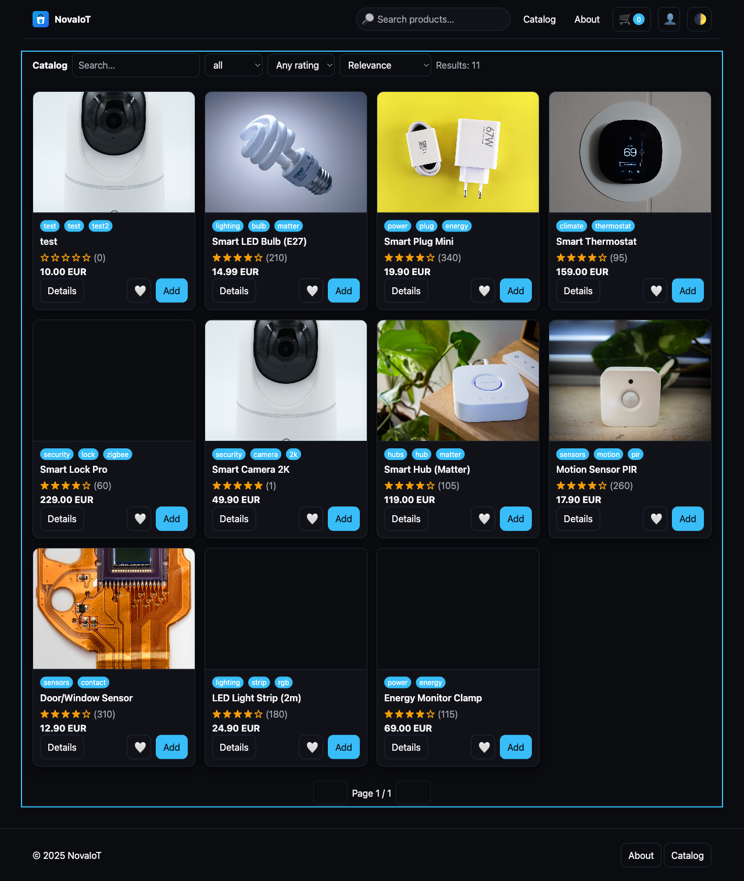

Product Details

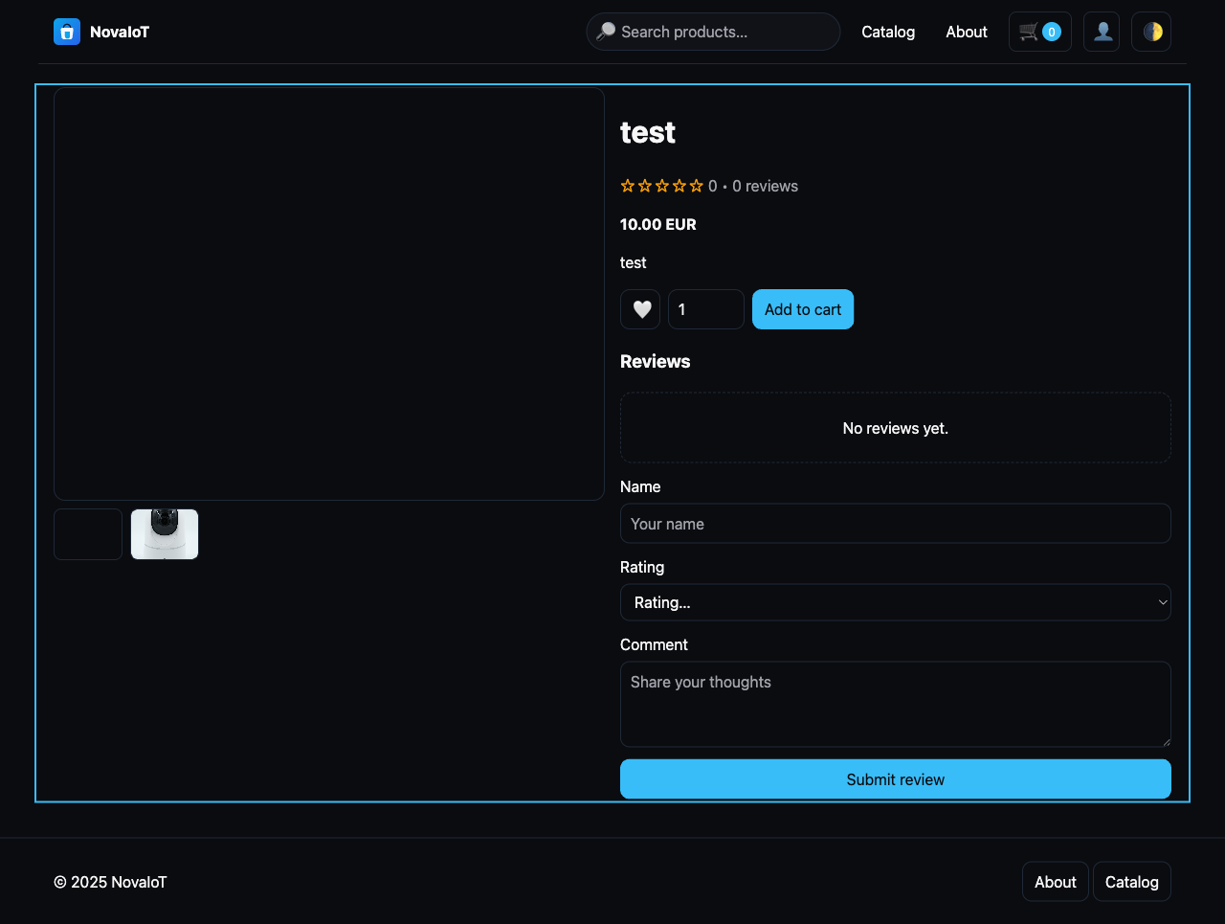

Shopping Cart

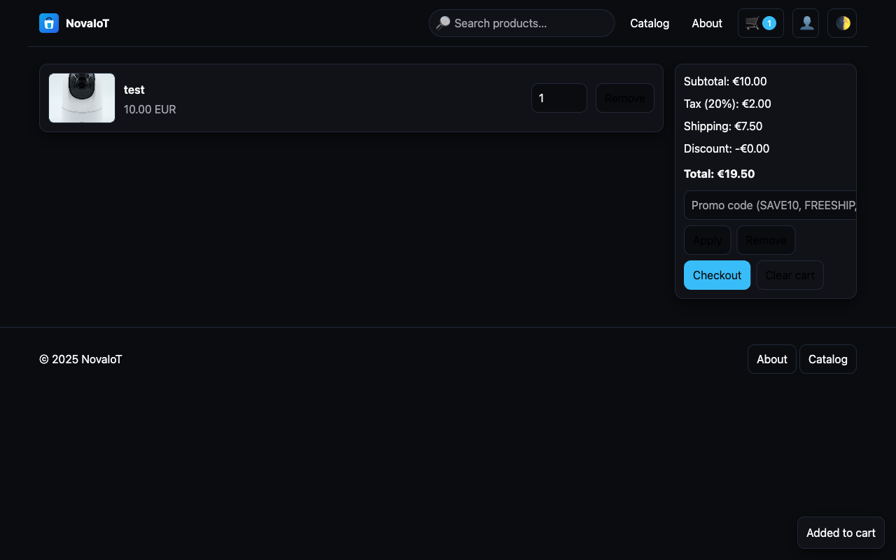

Checkout

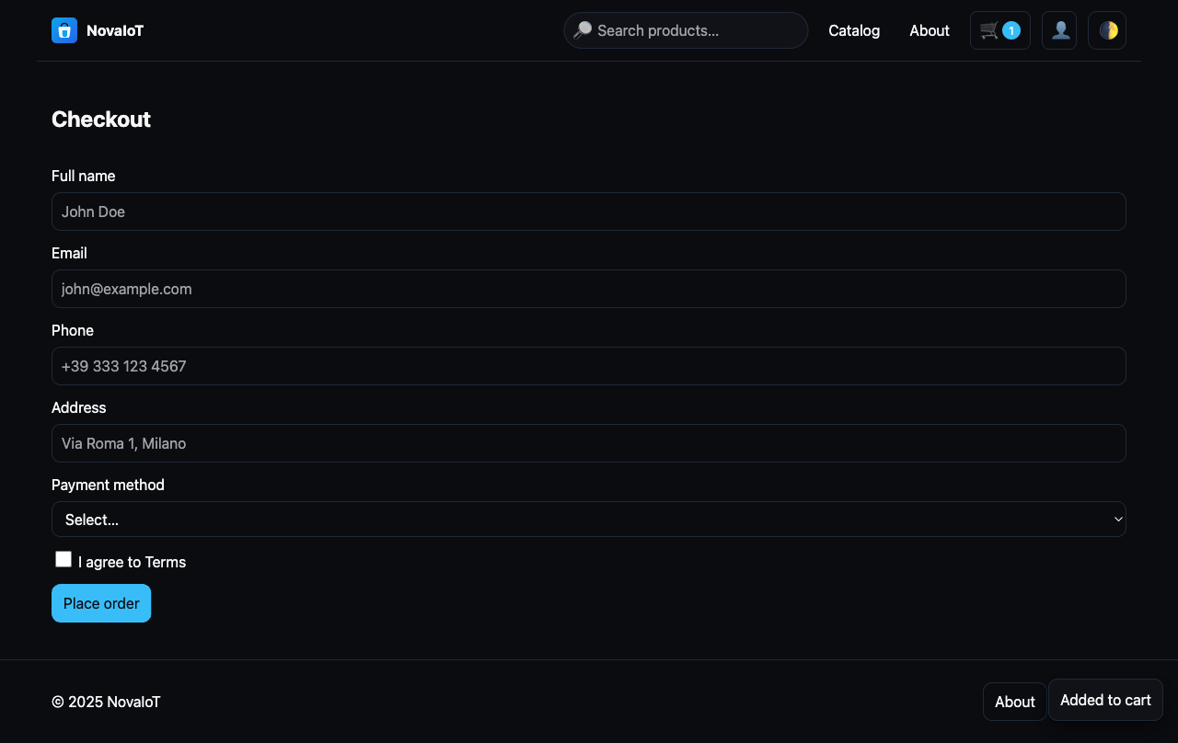

Order Confirmation

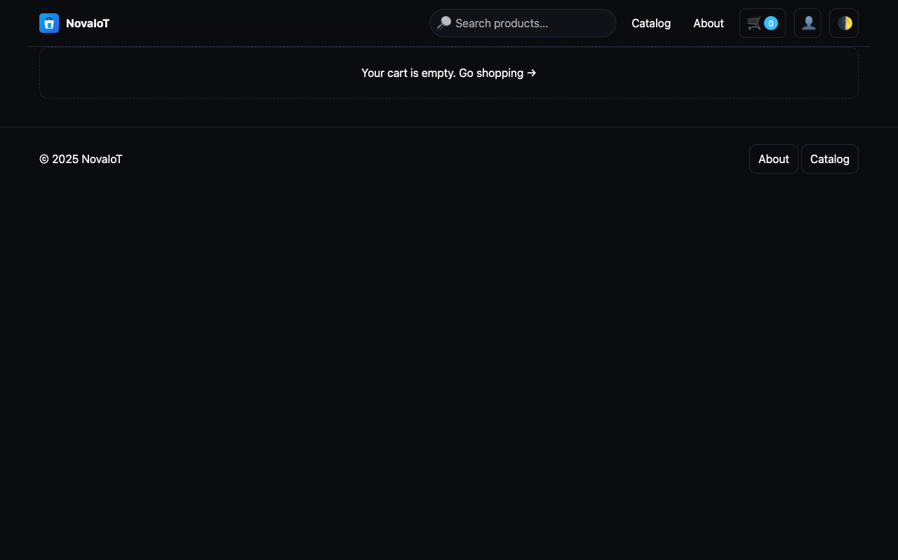

Admin Dashboard

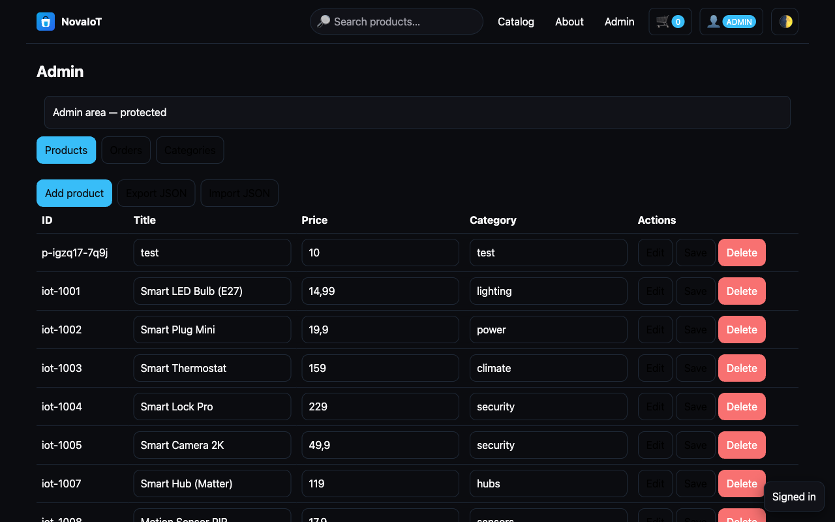

Admin Orders

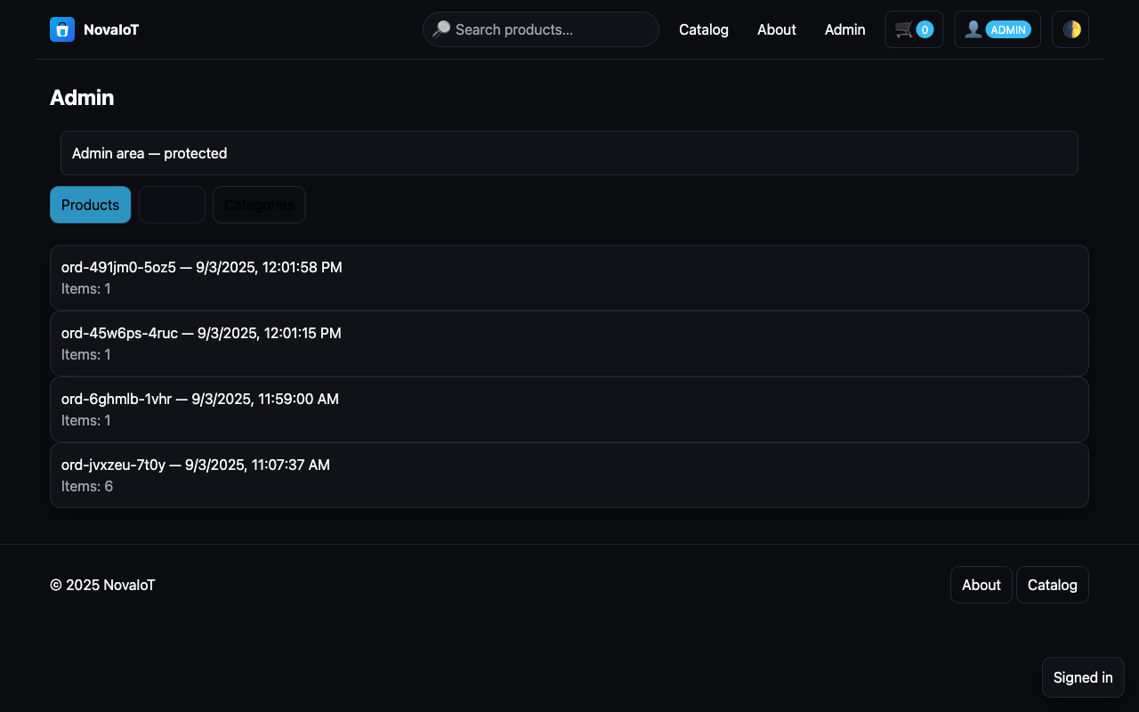

Admin Categories

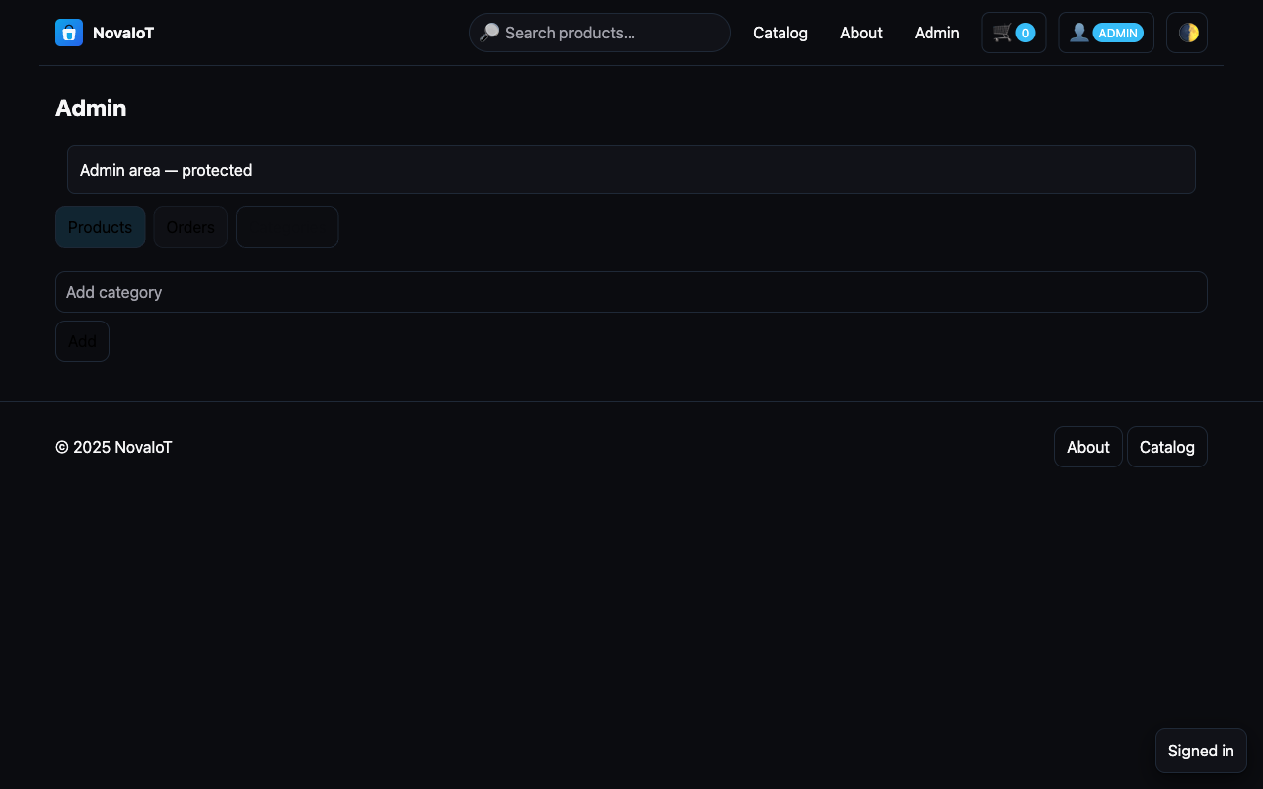

About Page

