Description of Website:

* One page resume which contains primary information that an employer would look for.

Summary:

* The skeleton for the website has been created
* There are currently five main sections on the page: hero image, three information boxes and footer.

Relevant implication:

* Usability: the website is easy to navigate.
* End-user considerations: the language used on the website is appropriate for the target market.
* Sustainability: Use conventional HTML tag for its intended purpose - <section>, <div>, <nav>; name the tags efficiently - class=””, id=”” and indentation where required.
* Aesthetics: The information on the website is displayed clearly.

Code Validation: using validator.w3.org I found the following

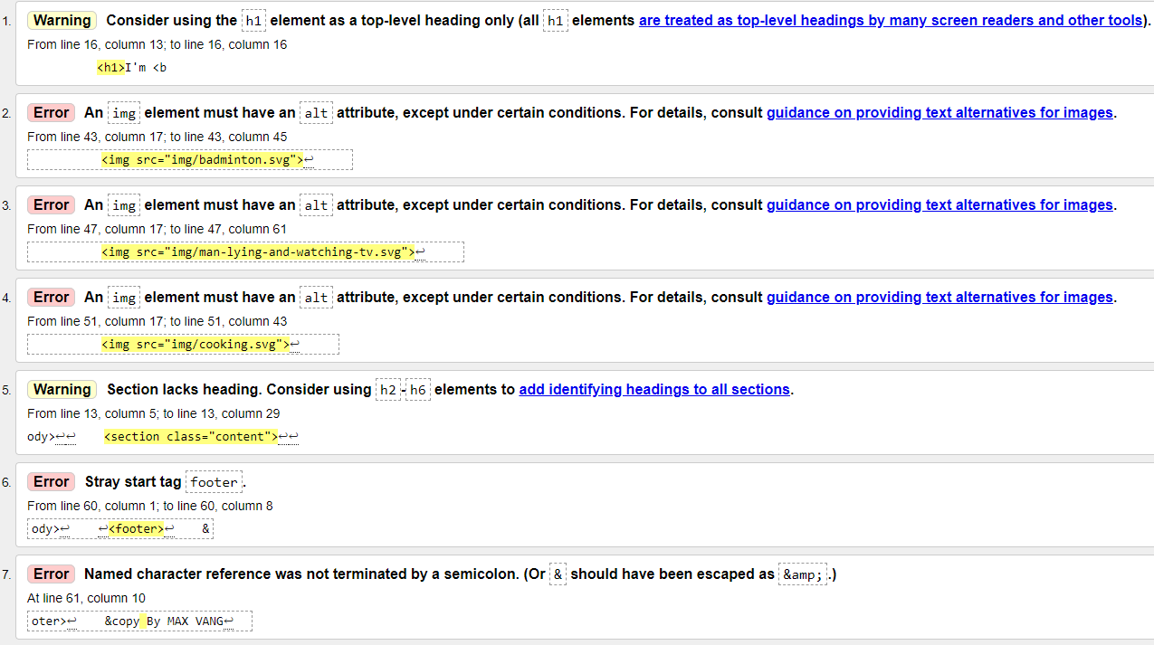

Gantt chart:

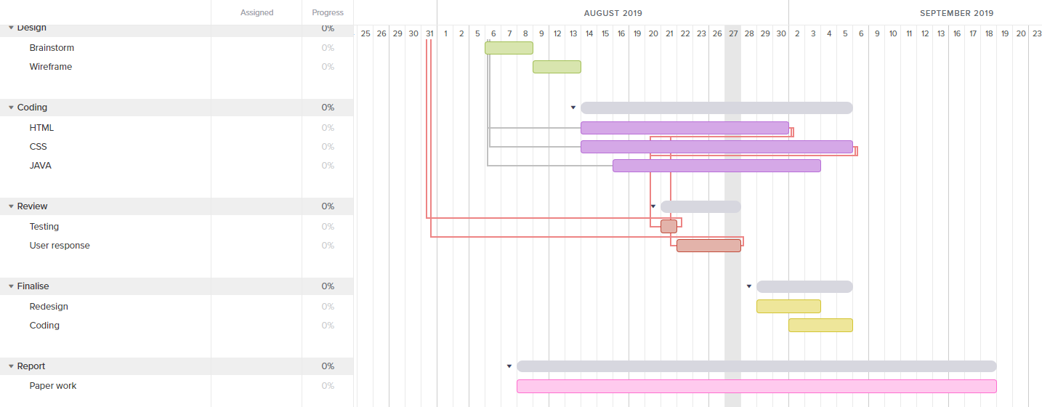

Currently, I am behind schedule. The time I intended to use for coding has nearly finished and I cannot say the same for my website.

Future planning:

* Implement CSS grid in “About Myself” section.
* Add “Accomplishment” section.
* Fix the border around the cells.
* Fix the background colour in the text boxes.

Issues currently facing:

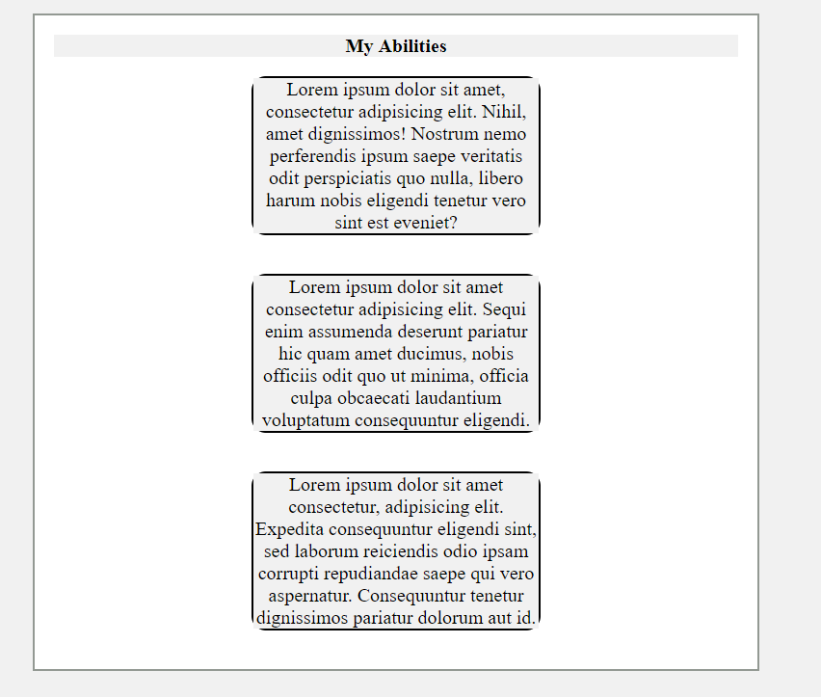

* The background colour in small cells is not the same as the background colour on the box they are in.
* The border-radius on the cells are not displaying properly.