New changes:

* Layout enhancements
* Applied box shadows
* Highlighted titles
* New text fonts
* Set a main color theme for the website

Relevant implications:

* Sustainability: uses CSS variables – summarizes the repeating color setting in one place so it the changes can be simple but repeat through the entire webpage.
* Usability: Looking forward to adding navigation bar to make the experience smoother.
* End-user considerations: the content on the website is kept to a minimum in order to deliver the key informations as quick and as convenient as possible.
* Aesthetics: Clean layout with colored sections

Code validation: with validator.w3.org

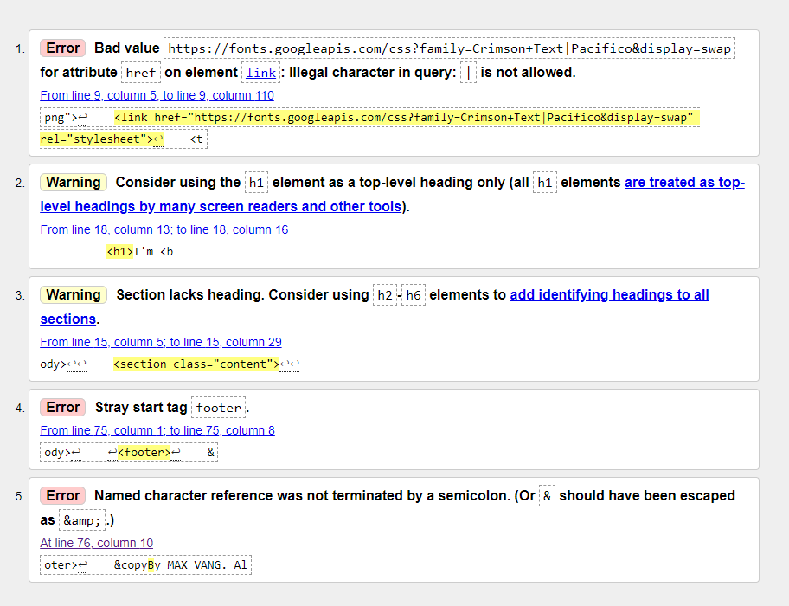

2 less errors from previous validation

Gantt chart: Had to change the timeline for most activities from “Coding” to “Report”, marked off finished activities

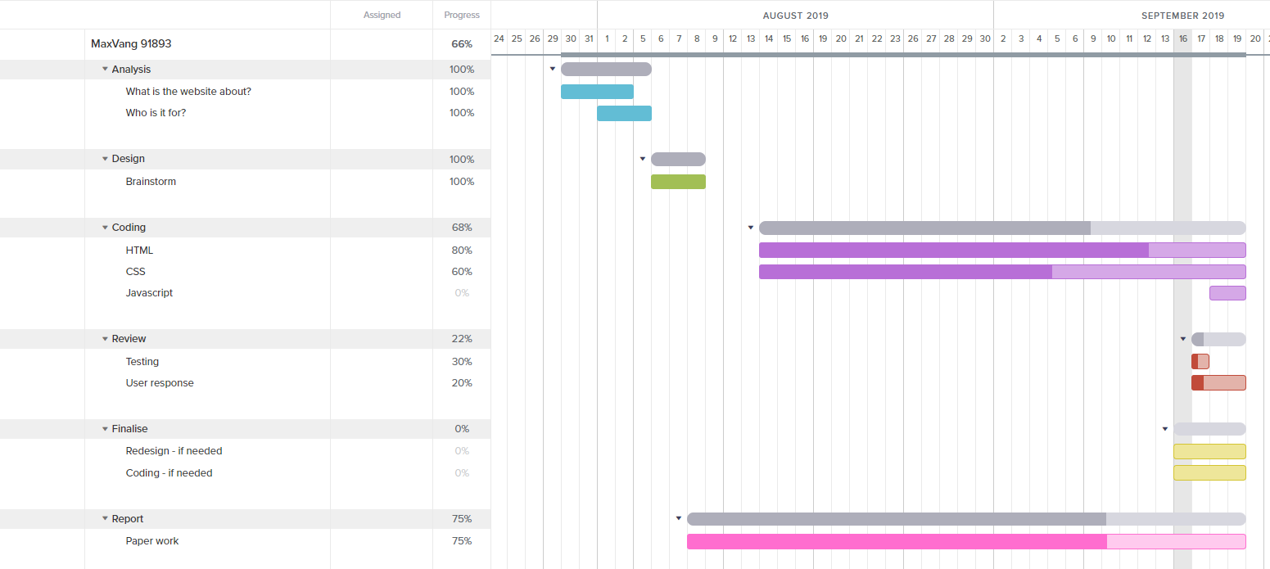

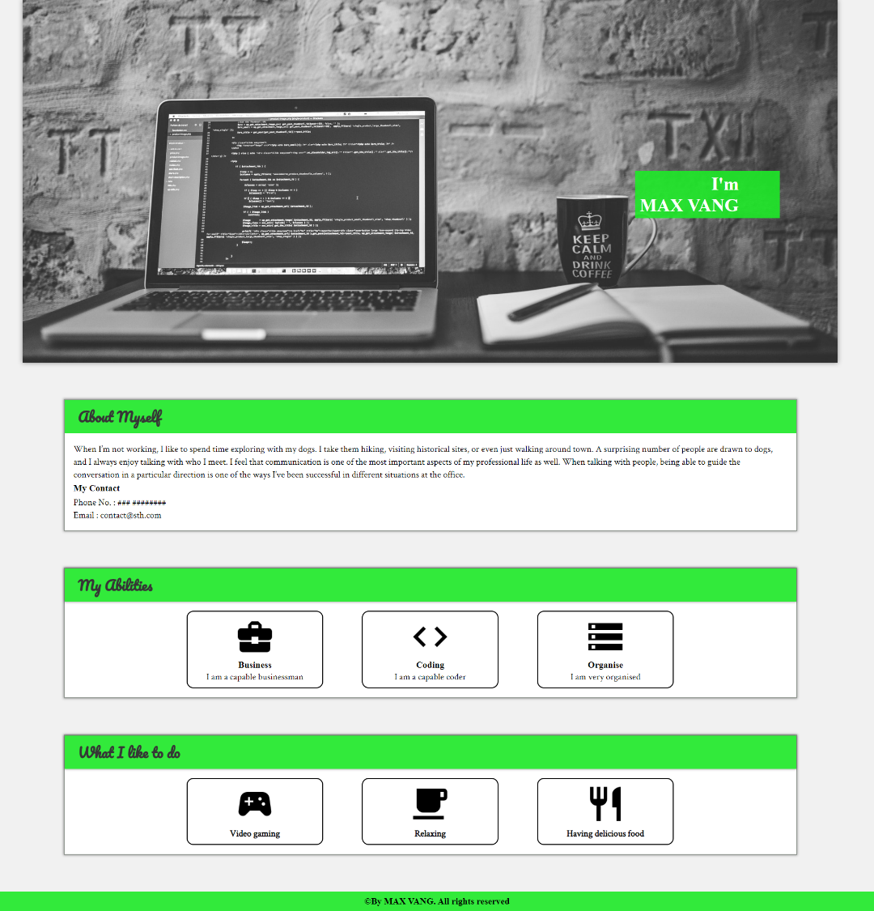The website so far:

Issues:

None to my opinion

Future planning:

* Implement javascript slideshow for the hero image section
* Add navigation bar
* Gather user review