USB To UART COMMUNICATION Using SiFive -HiFive1 Board

AIM:

To establish an UART(Universal Asynchronous Receiver/Transmitter) Communication with USB interface between the Host Pc and Hifive1.

REQUIREMENTS:
- Hifive1 Microcontroller
- Usb cable(Type A Micro B)
- GTK term (Hyper Terminal program for Serial Communication)
- Eclipse IDE /gedit for C programing
- Gcc compiler on Host pc
- Freedom-e-SDK

NOTE:

- For Eclipse platform based IDE- use FREEDOM STUDIO / EMBEDDED STUDIO FOR RISC-V for built in Toolchains.
- JTAG(j-link) is Required to load the program.

PROCEDURE:

1.Set up the Host Pc environment for the Hifive1 application developement (Read getting started guide document of Hifive1 and user manual for Freedom e31) .

2.Understand the requirements for establishing the USB to UART communication.

3.Open IDE or gedit ,do codings and save it in a new seperate folder which should be in the Software directory of the freedom SDK.

4.If Coding is done through any text editors like 'gedit' a Makefile has to be created alongside .c file.

5.For code compilation,debugging read the manual of hifve1.

6.While using GTK term for serial I/O set the PORT=/dev/ttyUSB1 and Baud rate=115200, from the Configuration option.Enable the Local echo option aswell.

CODE FLOW:

(Assuming that the code is going to be developed in gedit text editor)

STEP 1:
Open gedit and save the program name with .c extension
STEP 2:
Header files to be Included

- #include <stdint.h> // to specify exact-width integer types
- #include <string.h> // for string macros and funtions
- #include <stdio.h> // for standard input and output
- #include "platform.h" // for Hifive1 platform based funtions,macros and header files

STEP 3:
Initialize UART

CLOCK CONFIGURATION:

HFROSC:- High frequency Ring Oscillator for High Speed Clock.
Run off 16 MHz Crystal for accuracy

// Make sure the HFROSC is on before the next line
PRCI_REG(PRCI_HFROSCCFG) |= ROSC_EN(1); //enable ring oscillator configuration

//Note that the first line is
PRCI_REG(PRCI_PLLCFG) = (PLL_REFSEL(1) | PLL_BYPASS(1));
PRCI_REG(PRCI_PLLCFG) |= (PLL_SEL(1));

// Turn off HFROSC to save power
PRCI_REG(PRCI_HFROSCCFG) &= ~(ROSC_EN(1));

Configure UART to print

GPIO_REG(GPIO_OUTPUT_VAL) |= IOF0_UART0_MASK; //slelect the o/p gpio for uart
GPIO_REG(GPIO_OUTPUT_EN) |= IOF0_UART0_MASK; //enable the o/p gpio pin
GPIO_REG(GPIO_IOF_SEL) &= ~IOF0_UART0_MASK; // select the gpio uart pin
GPIO_REG(GPIO_IOF_EN) |= IOF0_UART0_MASK; // enable the gpio uart pin

Set Baud Rate

UART0_REG(UART_REG_DIV) = <Value>;

Assign enabled txdata nd rxdata to tx & rx control registers

UART0_REG(UART_REG_TXCTRL) = UART_TXEN;
UART0_REG(UART_REG_RXCTRL) = UART_RXEN;

Note: The Value for UART_REG_DIV could be either hard code eg-138(from Table of UART in Document) or using the formula { div = (input frq\ baud rate) -1 }
We can get the input clock frequencyfrom the get_clock_frequency() (refer init.c)

Wait a bit to avoid corruption on the UART. (In some cases, switching to the IOF can lead to output glitches, so need to let the UART reciever time out and resynchronize to the real start of the stream.

volatile int i=0;
while(i < 10000){i++;}

STEP 4:
Sample Functions to Tansmit and Receive data.

static void _putc(char c) {
while ((int32_t) UART0_REG(UART_REG_TXFIFO) < 0);
UART0_REG(UART_REG_TXFIFO) = c;
}

int _getc(char * c){
int32_t val = (int32_t) UART0_REG(UART_REG_RXFIFO);
if (val > 0) {
*c = val & 0xFF;
return 1;
}
return 0;
}
static void _puts(const char * s) {
while (*s != '\0'){
_putc(*s++);
}
}
We can also use read() and write() predefined funtions provided in the BSP
Directory- $freedom e sdk/bsp/libwrap/sys

Sample Program for USB-UART communication
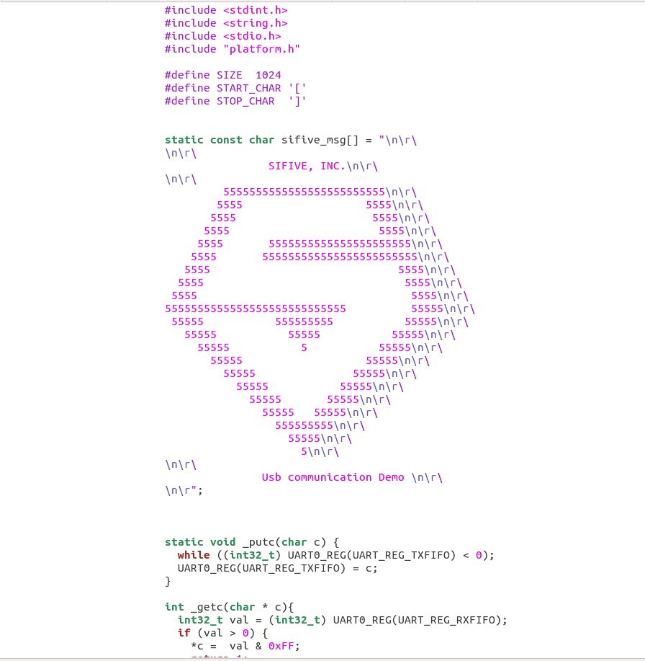

img-1

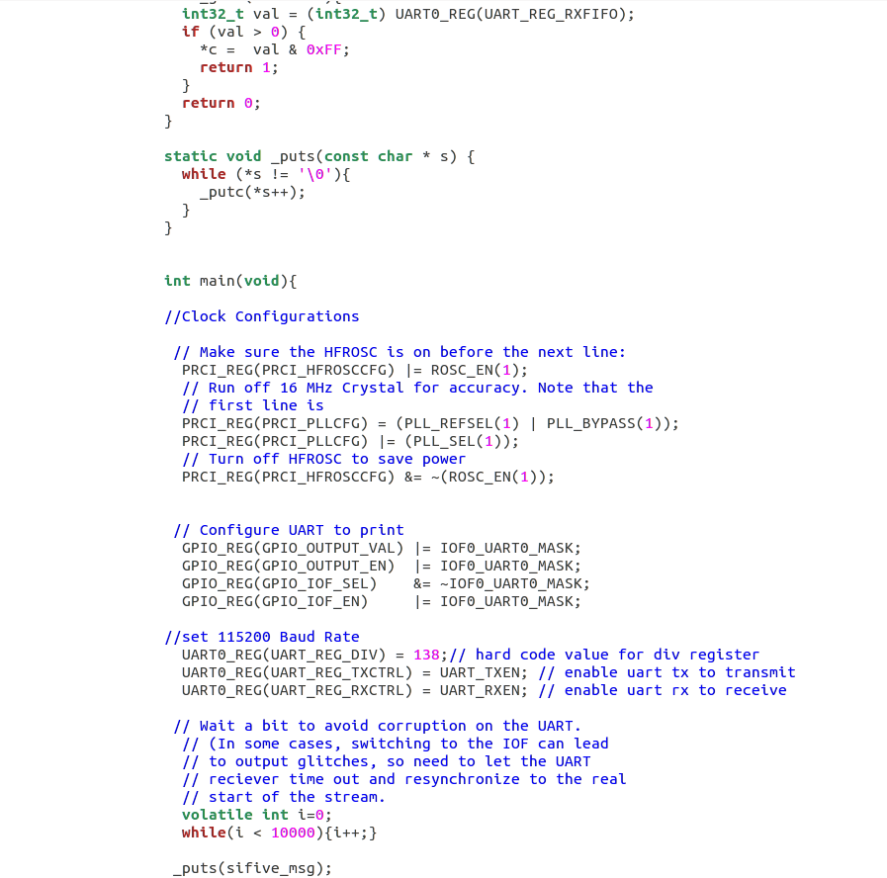

img-2
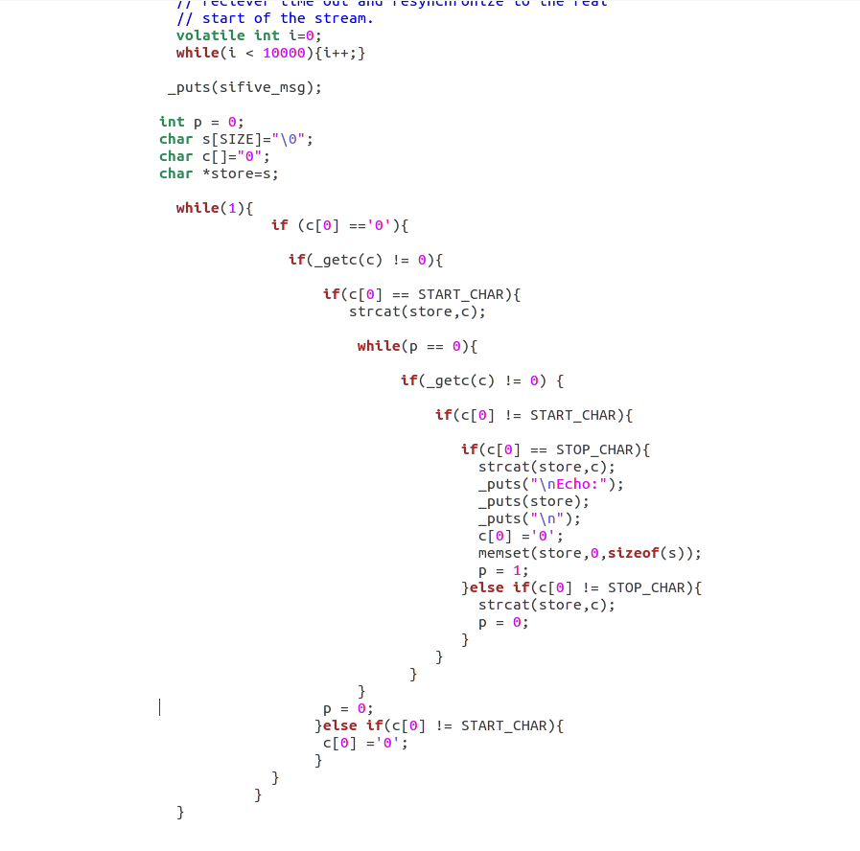

img-3

COMPILATION TERMINAL COMMAND

~/freedom-e-sdk$ make software PROGRAM=<program name> BOARD=freedom-e300-hifive1

UPLOAD TERMINAL COMMAND

~/freedom-e-sdk$ make upload PROGRAM=<program name> BOARD=freedom-e300-hifive1

Example :-maxvy02@maxvy02-OptiPlex-755:~/HIFIVE1/freedom-e-sdk$ make upload PROGRAM=USBcom BOARD=freedom-e300-hifive1

DEBUGGING IN TERMINAL

Open two terminal windows 1.For GDB & 2.For OpenOCD.

Compile and Upload the program before debugging

Term 1: ~/freedom-e-sdk$ make run_gdb PROGRAM=<program name> BOARD=freedom-e300-hifive1

Term 2: ~/freedom-e-sdk$ make run_openocd PROGRAM=<program name> BOARD=freedom-e300-hifive1

You can step through the running program with stepi, or load the new program
using load The usual suite of GDB commands are available to set breakpoints, examine and
modify memory, continue execution, etc.

GDB commands are available in the internet for debugging.

GTK TERM OUTPUT

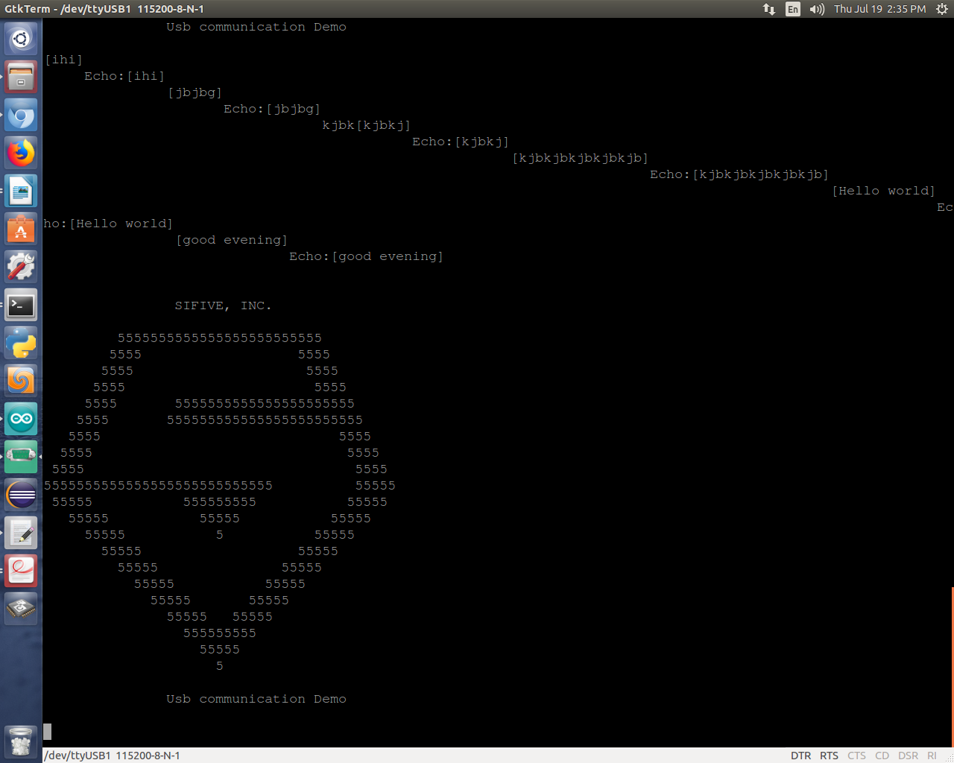
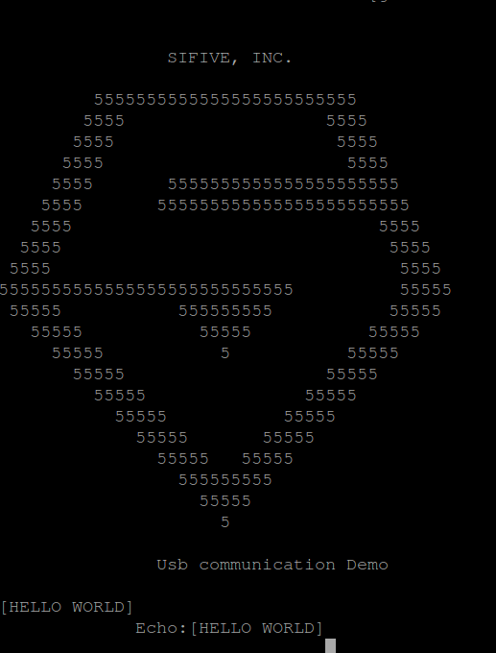

SIFIVE symbol print (no input has given) i/p-[HELLO WORLD]
o/p-Echo:[HELLO WORLD]

GTK Term set up pictures
click on gtkterm->configuration->Set port and Baud rate as shown below
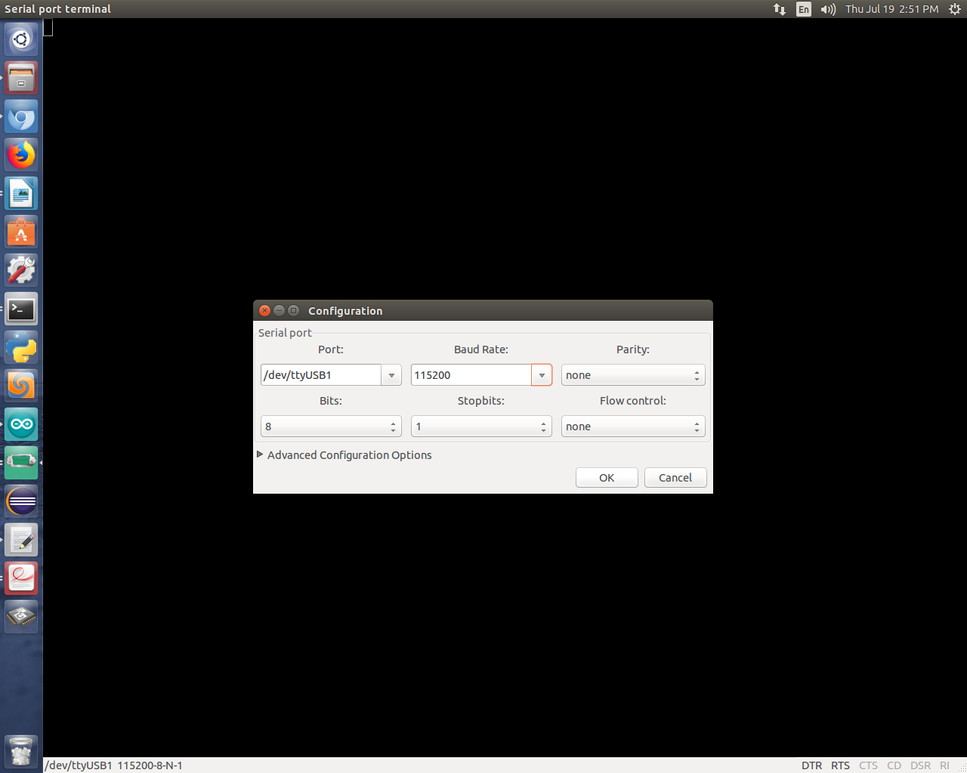

Enable local echo aswell
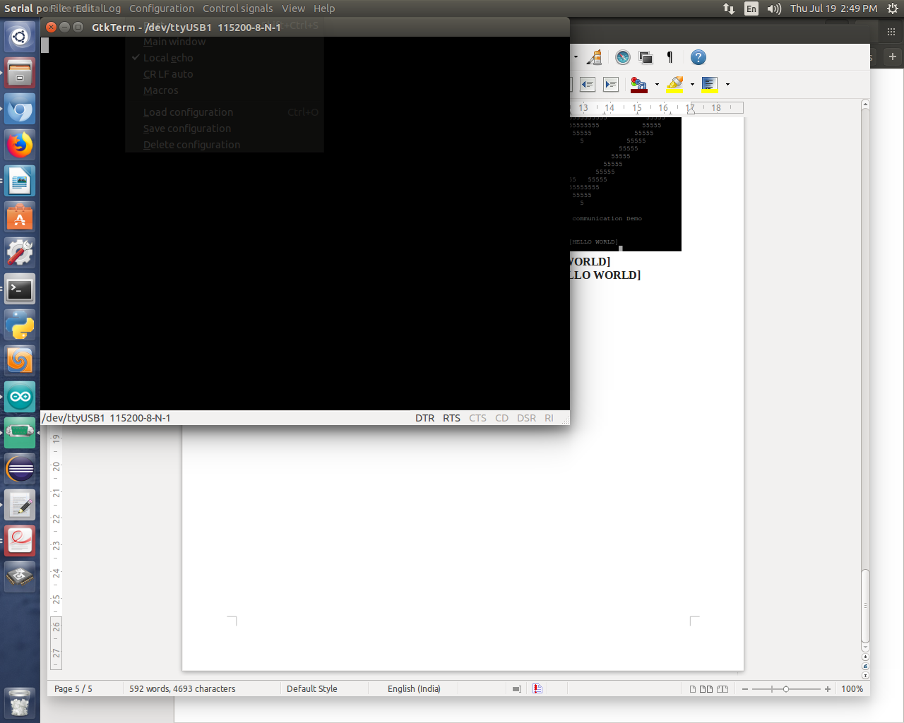

MAKEFILE

Create a makefile for the program

sample:
TARGET = USBcom
C_SRCS += Usbcom.c
CFLAGS += -O2 -fno-builtin-printf -DNO_INIT

BSP_BASE = ../../bsp
include $(BSP_BASE)/env/common.mk

Additional INFO:

- This program was developed in Ubuntu 14.04 operating system.
- Go through schematics,Datasheet,user Manual of Hifive1 and E31 Risc-V processor
- Make use of github repository https://github.com/maxvytech/maxvytechRepo.git

