Homework 1

Max Wagner

February 7, 2015

#### 10.

a0 = 50,000 an+1 = 0.01 * an - 1000

solving in R:

i = 50000  
n = 0  
while (i > 1000) {  
 i = (i * 1.01) - 1000  
 n = n + 1  
}

On month 69, they will be left with 655.28 dollars

#### 9.

Solving in R:

n <- c(1:16)  
an <- c(3,6,11,21,32,47,65,87,112,140,171,204,241,282,325,376)  
delta <- c(diff(an), NA)  
plot(n, delta)

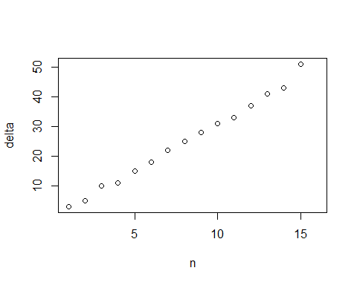

The graph appears to be mostly linear, with a little variation. The slope is roughly 3, which gives a rough equation of:

delta_an = 3an

approx <- c(1:16) * 3  
diff <- c(delta[1:15] - approx[1:15], NA)  
plot(n, diff)

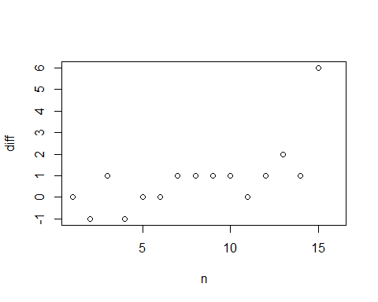

The differences are typically from 1 to -1, with an outlier at n = 15, where the difference is 6. The model fits reasonably for the purposes of this assignment.

#### 13.

k <- .001  
r <- 4  
n <- 0  
while (r < 999) {  
 r <- r + ((k * r) * (1000 - r))  
 n <- n + 1  
 print(c(n,r))  
}

## [1] 1.000 7.984  
## [1] 2.00000 15.90426  
## [1] 3.00000 31.55557  
## [1] 4.00000 62.11538  
## [1] 5.0000 120.3724  
## [1] 6.0000 226.2554  
## [1] 7.0000 401.3192  
## [1] 8.0000 641.5813  
## [1] 9.000 871.536  
## [1] 10.000 983.497  
## [1] 11.0000 999.7277

The table above shows that it would take 11 periods for all 1000 people to hear the rumor.

#### 6.

1. The underlying idea of the models is that at a price of 100, and a quantity of 500, neither value will change. When price is above 100, quantity will increase by the growth factor 0.2, when quanity is above 500, price will decrease by a growth factor of -0.1. Typically when price increases, quantity decreases, so the first part is a bit odd. But the equilibrium point of the price of 100, and quantity of 500 remains the same regardless.

Case A:

p <- 110  
q <- 500  
for (i in 1:10) {  
 p <- p - .1 * (q - 500)  
 q <- q + .2 * (p - 100)  
 print(c(p, q))  
}

## [1] 110 502  
## [1] 109.80 503.96  
## [1] 109.4040 505.8408  
## [1] 108.8199 507.6048  
## [1] 108.0594 509.2167  
## [1] 107.1378 510.6442  
## [1] 106.0734 511.8589  
## [1] 104.8875 512.8364  
## [1] 103.6038 513.5572  
## [1] 102.2481 514.0068

Case B:

p <- 200  
q <- 500  
for (i in 1:10) {  
 p <- p - .1 * (q - 500)  
 q <- q + .2 * (p - 100)  
 print(c(p, q))  
}

## [1] 200 520  
## [1] 198.0 539.6  
## [1] 194.040 558.408  
## [1] 188.1992 576.0478  
## [1] 180.5944 592.1667  
## [1] 171.3777 606.4423  
## [1] 160.7335 618.5890  
## [1] 148.8746 628.3639  
## [1] 136.0382 635.5715  
## [1] 122.4811 640.0678

Case C:

p <- 100  
q <- 600  
for (i in 1:10) {  
 p <- p - .1 * (q - 500)  
 q <- q + .2 * (p - 100)  
 print(c(p, q))  
}

## [1] 90 598  
## [1] 80.20 594.04  
## [1] 70.7960 588.1992  
## [1] 61.97608 580.59442  
## [1] 53.91664 571.37774  
## [1] 46.77886 560.73352  
## [1] 40.70551 548.87462  
## [1] 35.81805 536.03823  
## [1] 32.21423 522.48107  
## [1] 29.96612 508.47430

Case D:

p <- 100  
q <- 400  
for (i in 1:10) {  
 p <- p - .1 * (q - 500)  
 q <- q + .2 * (p - 100)  
 print(c(p, q))  
}

## [1] 110 402  
## [1] 119.80 405.96  
## [1] 129.2040 411.8008  
## [1] 138.0239 419.4056  
## [1] 146.0834 428.6223  
## [1] 153.2211 439.2665  
## [1] 159.2945 451.1254  
## [1] 164.1819 463.9618  
## [1] 167.7858 477.5189  
## [1] 170.0339 491.5257