GameFlix — Login & Registration Endpoints
HCDD 412 · Module 4 · Implement and Test Login & Registration Endpoints (20 pts)
Max Dumont · October 2026
GitHub repository: https://github.com/maxwdumont-cpu/gameflix-auth
README.md covers run instructions, schema, hashing and token-lifetime justification, ddl-auto choice, the Module 3 design-change note, and AI use. application.properties.example is committed; no secrets are.

Stack
Java 21 · Spring Boot 3.5.16 (Spring Security 6.5, lambda SecurityFilterChain) · Spring Data JPA · MySQL 8.4 · bcrypt cost 12 via DelegatingPasswordEncoder · HS256 JWT (spring-boot-starter-oauth2-resource-server), 15-minute exp · CORS limited to http://localhost:3000 · Test evidence: automated (@SpringBootTest + MockMvc against MySQL) plus a live curl run.

Required cases — where to find them
Required case | Automated test | Live run | Result
Successful registration | #1 | Fig. 2 | 201
Duplicate-email rejection | #3 | Fig. 3 | 409
Successful login returning a token | #6 | Fig. 5 | 200 + JWT
Login with wrong password | #7 | Fig. 6 | 401
Protected call with valid token | #9 | Fig. 8 | 200
Protected call, missing token | #10 | Fig. 9 | 401
Protected call, tampered token | #11 | Fig. 10 | 401
MySQL SELECT showing hashed password | #2 | Fig. 11 | {bcrypt}$2a$12$…, 68 chars

About the images: all output was produced on my machine (pop-os) on 2026-10-17 by `mvn package`, `./run-evidence.sh`, `mysql` and `docker logs`. The panels are that captured console text, rendered for readability; nothing was edited. The raw text files are reproducible by running the same commands (README §1).

1. Automated tests — 16 passed
@SpringBootTest + @AutoConfigureMockMvc: full security filter chain, real MySQL database (gameflix_test, ddl-auto=create-drop). Covers every required case plus invalid input (400), the 72-byte bcrypt limit, unknown-email login (same message), expired token, token with no exp, token signed with another key, and CORS allow/deny.
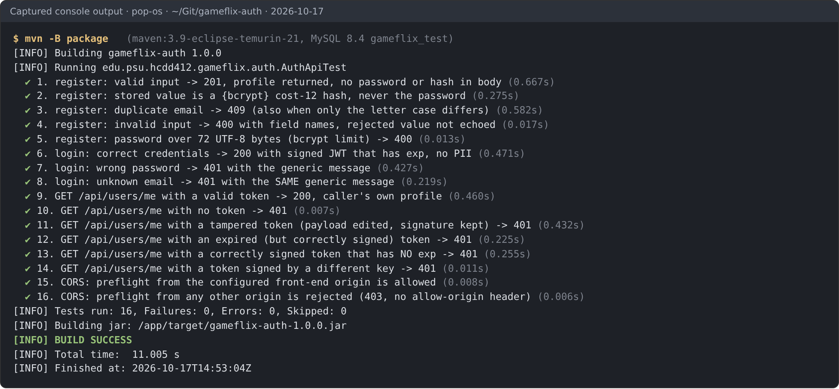
Figure 1. mvn -B package: 16 tests, 0 failures, BUILD SUCCESS. Test names are the @DisplayName values from target/surefire-reports.

2. Live run against the packaged service (curl)
java -jar target/gameflix-auth-1.0.0.jar on port 8081, then ./run-evidence.sh. Throwaway account: demo.player@example.com / Demo-Throwaway-42.
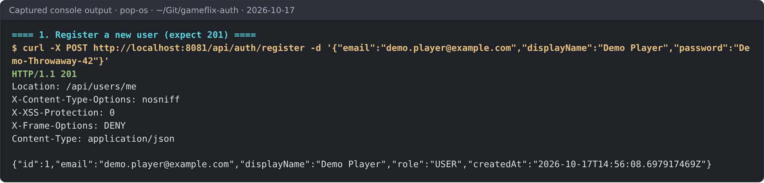
Figure 2. POST /api/auth/register → 201 Created. Body is the profile; no password or hash.
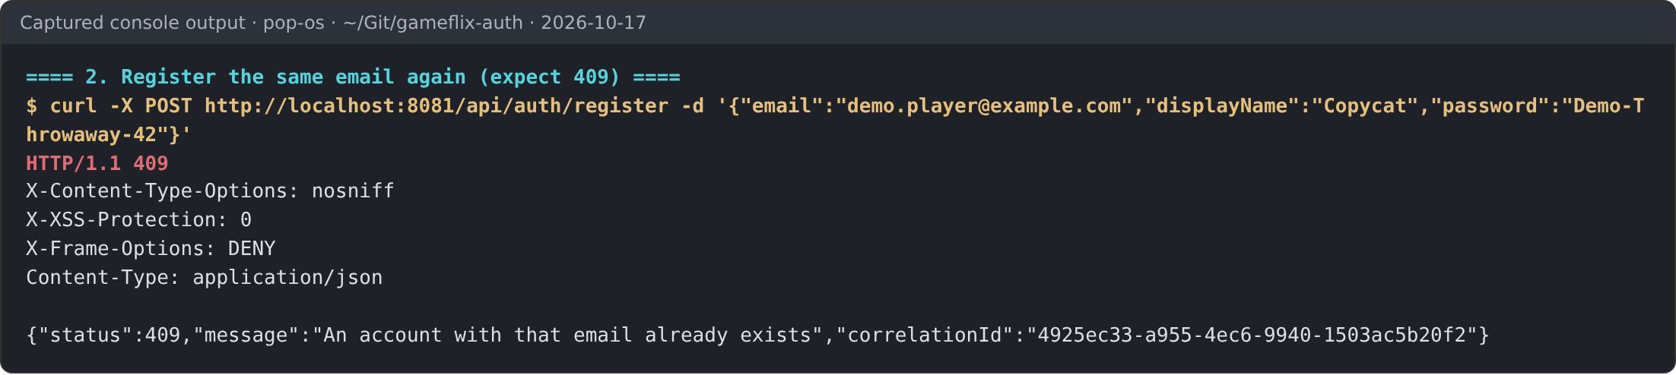
Figure 3. Same email again → 409. Driven by the uk_users_email unique constraint (see Fig. 13).
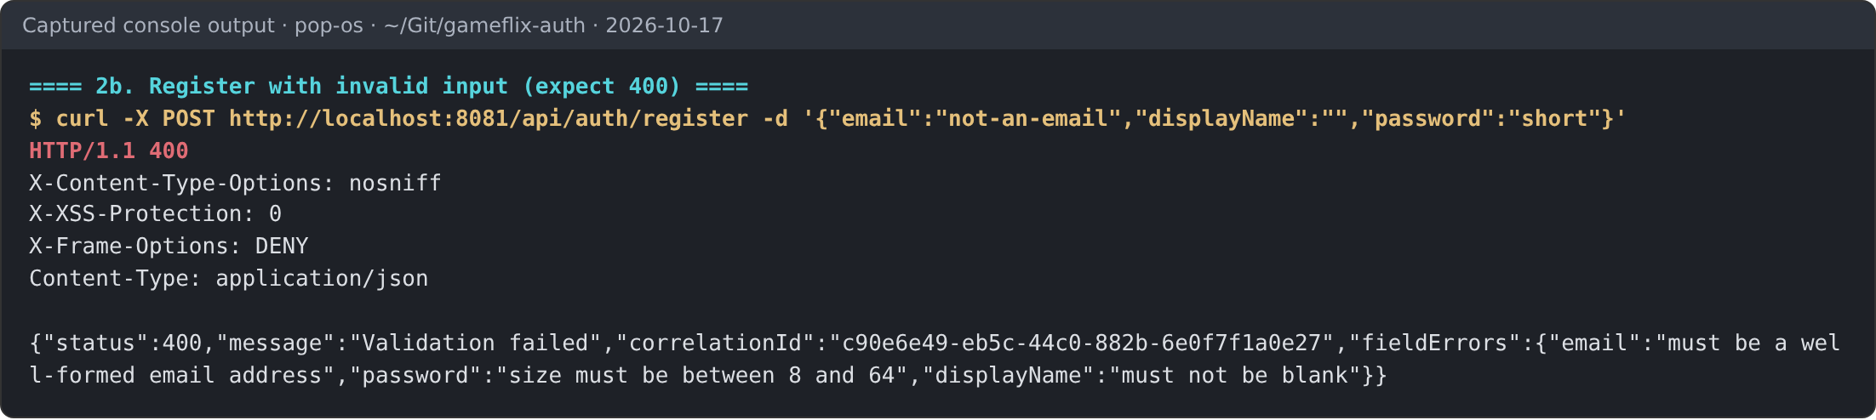
Figure 4. Invalid input → 400 with the failing field names; rejected values are not echoed back.
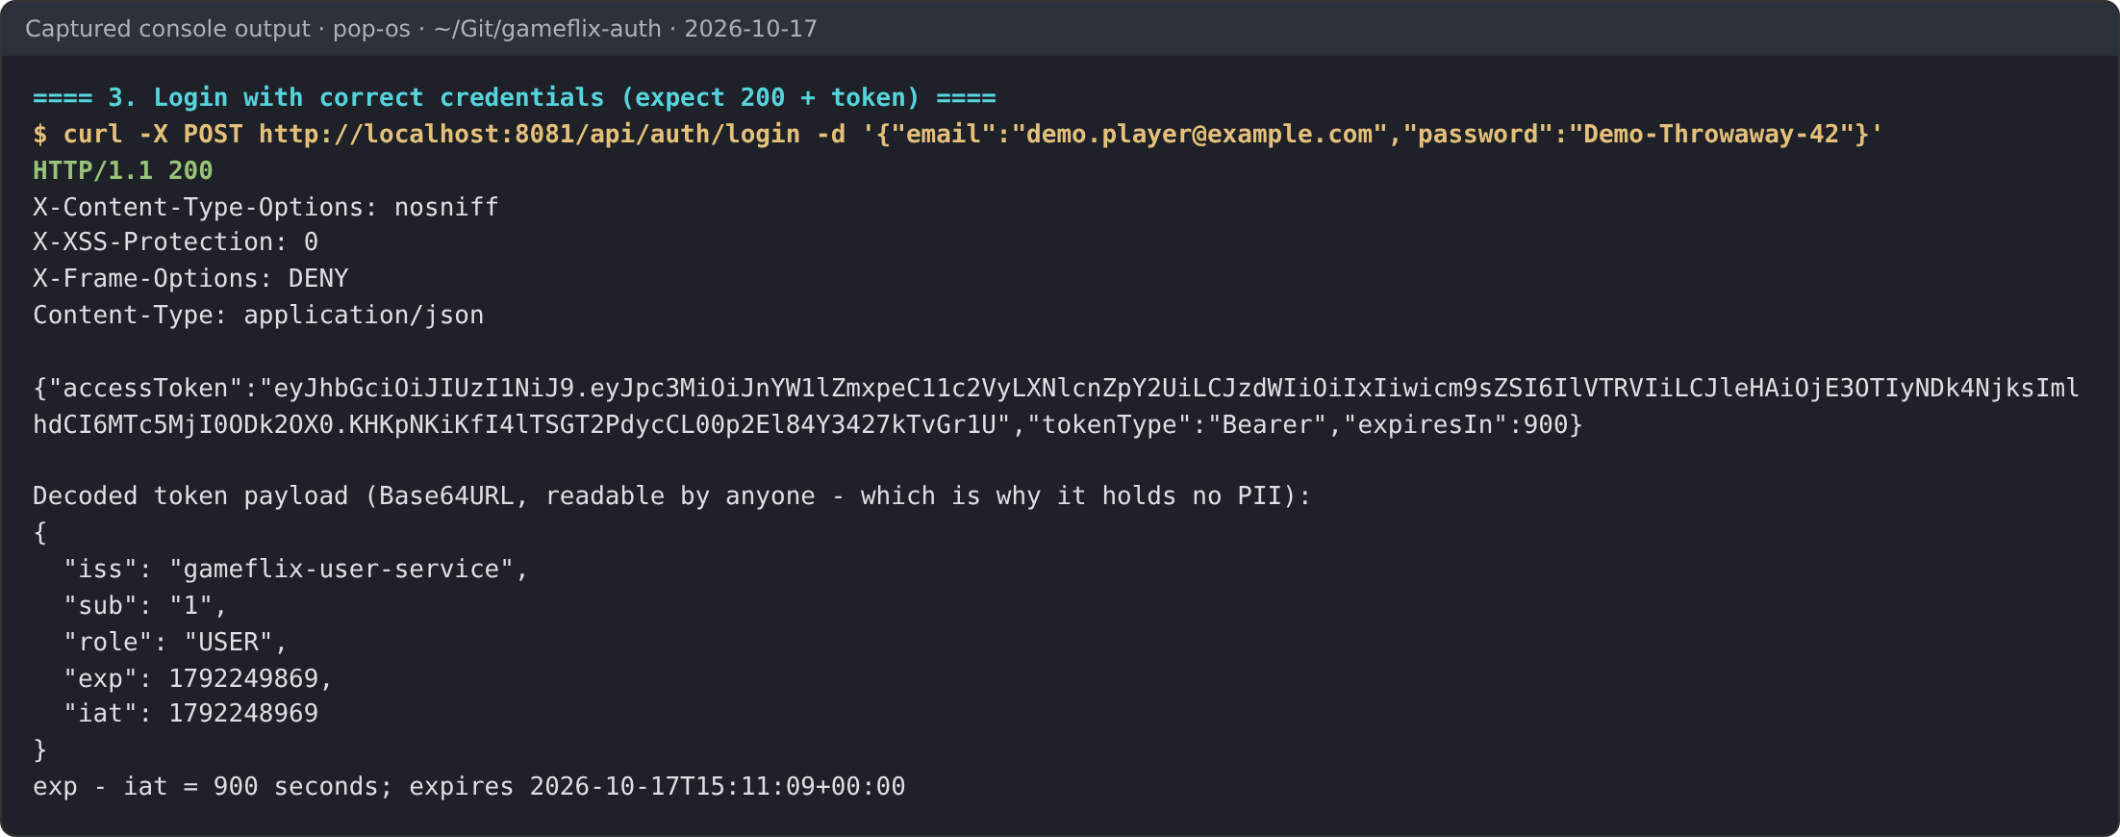
Figure 5. POST /api/auth/login → 200 with an HS256 token. Decoded payload: iss, sub, role, iat, exp (exp − iat = 900 s). No email or password.
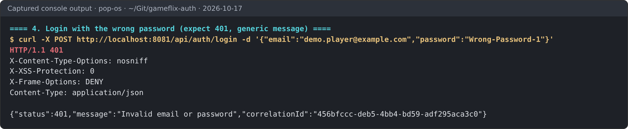
Figure 6. Wrong password → 401 "Invalid email or password".
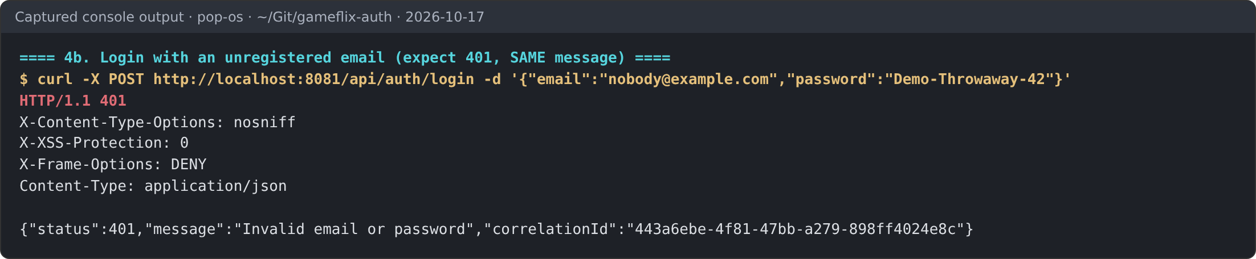
Figure 7. Unregistered email → 401 with the identical message.
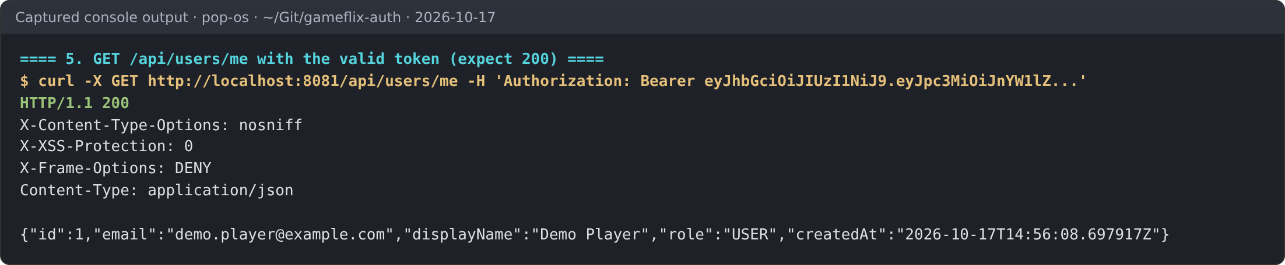
Figure 8. GET /api/users/me with the valid token → 200, the caller's own profile.
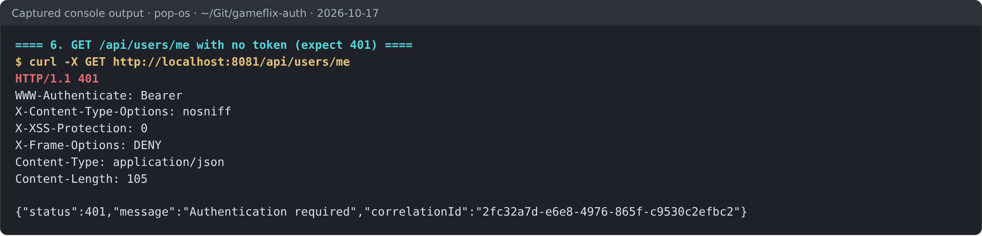
Figure 9. GET /api/users/me with no token → 401 and WWW-Authenticate: Bearer.
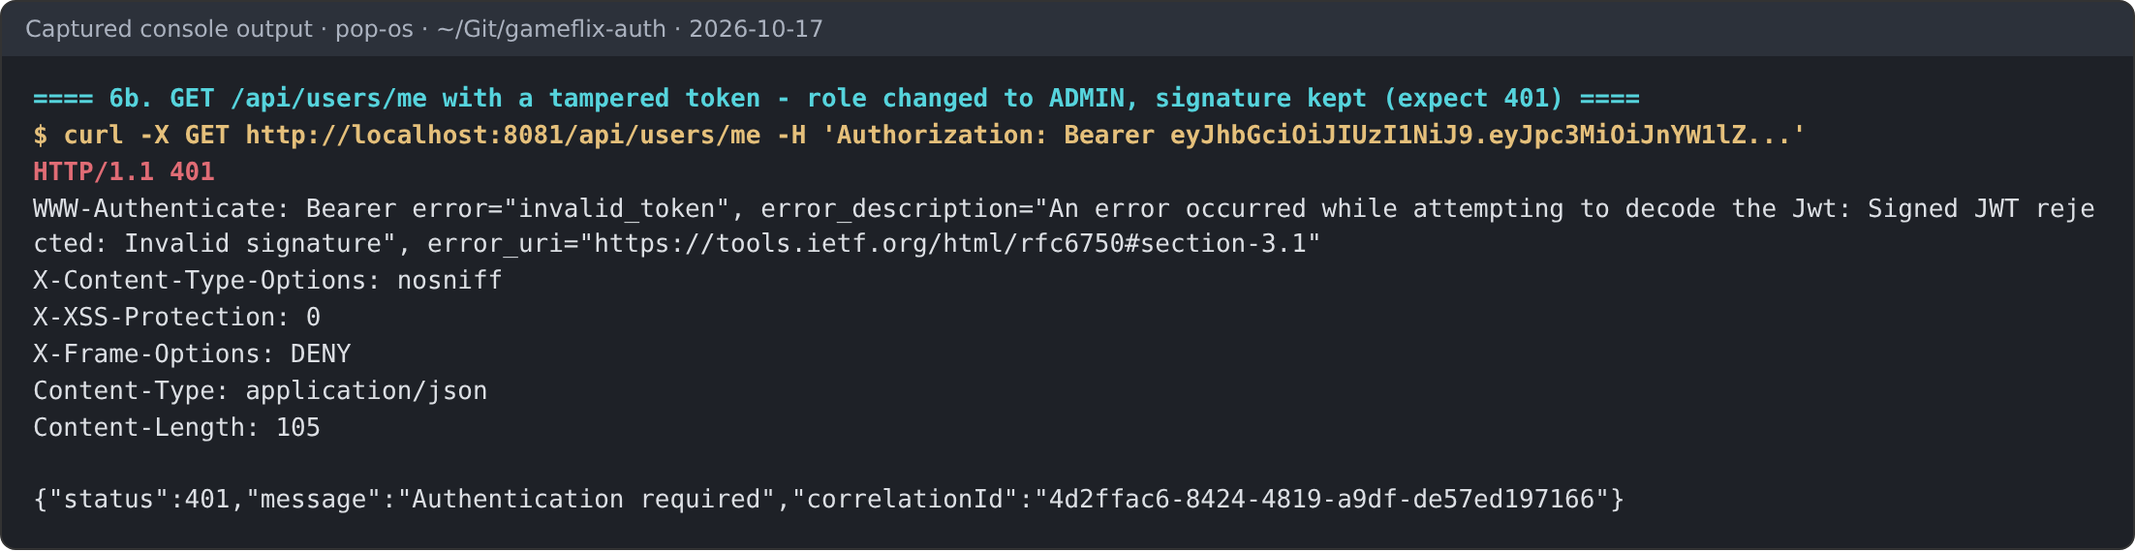
Figure 10. Tampered token (payload role changed USER → ADMIN, original signature kept) → 401, invalid signature.

3. MySQL
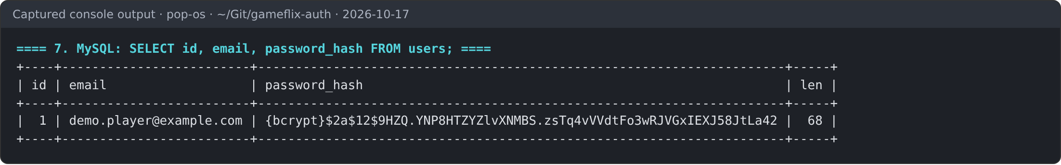
Figure 11. SELECT id, email, password_hash FROM users; — the stored value is a {bcrypt} cost-12 hash, 68 characters. (The ERD column is password_hash, not password.)
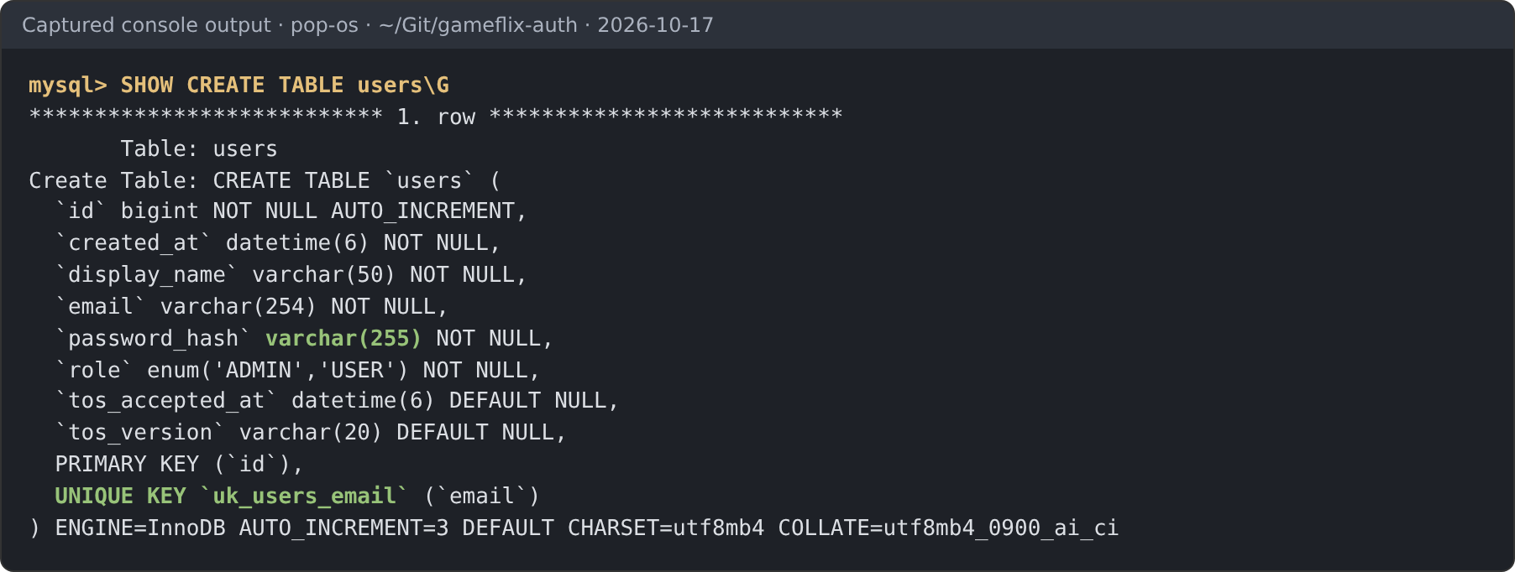
Figure 12. SHOW CREATE TABLE users: password_hash VARCHAR(255) and UNIQUE KEY uk_users_email. Also committed as db/schema.sql.
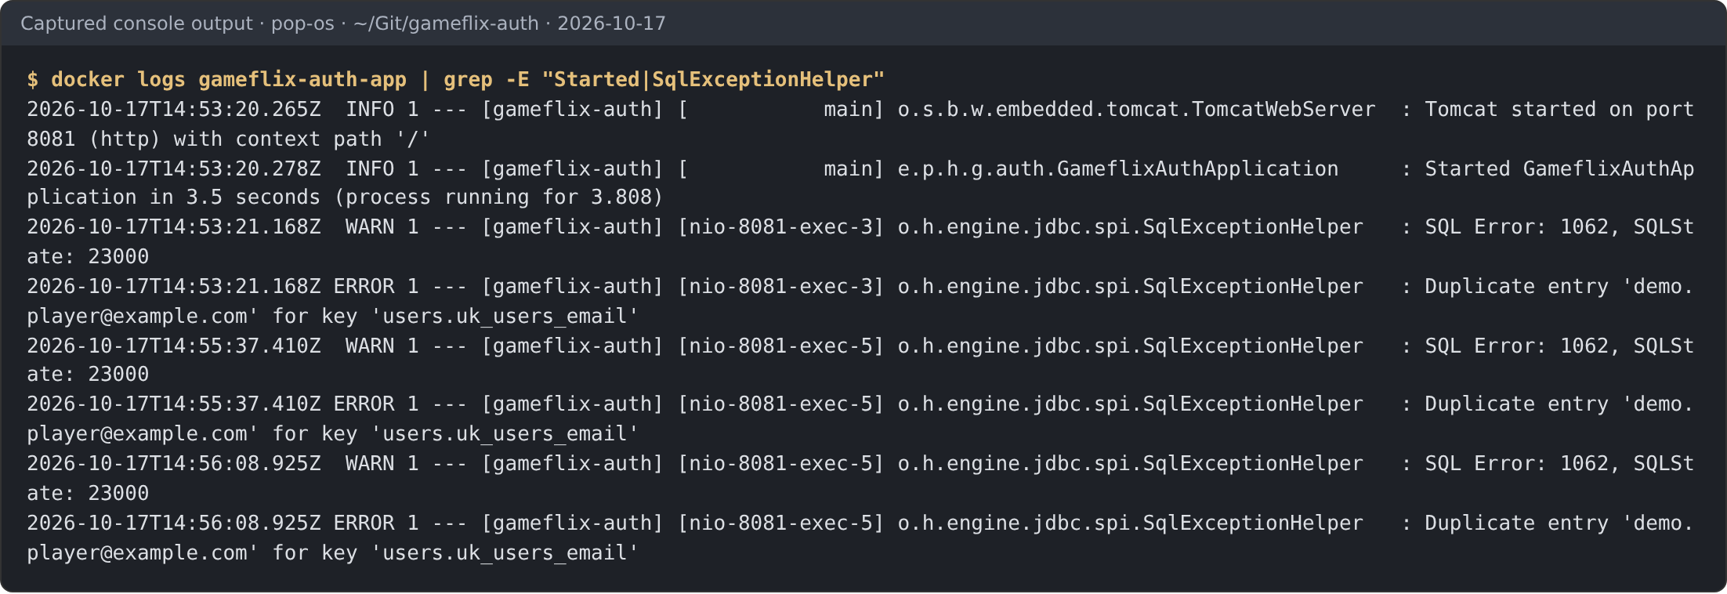
Figure 13. Service log: one MySQL error 1062 pair per evidence run (three runs that day) on users.uk_users_email — the 409 comes from the database constraint. No application-side "does it exist" query runs.

