This template provides section headings and instructions for Weed Science manuscripts. When using the template to format a manuscript, insert your own text and remove this paragraph and the section instructions. Retain line numbering.

Short title: Amaranthus Seedbank

Seedbank Longevity of Dioecious Weedy Amaranthus

Author One¹, Author Two², and Author Three³

ORCID iD is required for corresponding author. Provide details for each author of professional affiliation at the time the research was conducted, using this format:
¹Author Job Title (ORCID 0000-000x-xxxx-xxxx), Department (if applicable), Institution, City, State, Province or Territory abbreviation, Country; ²Author Job Title, Department (if applicable), Institution, City, State, Province or Territory abbreviation, Country; and ³Department (if applicable), Institution, City, State, Province or Territory abbreviation, Country

Author for correspondence:
Corresponding Author Name; Email: xxx@institution.edu

Abstract
A single paragraph of no more than 300 words that provides an objective and informative digest of the significant content of the paper, not simply a description of the contents. When a plant is first mentioned, give the scientific and usual common names e.g. large crabgrass [Digitaria sanginalis (L.) Scop.] or soybean [Glycine max (L.) Merr.]. After first mention, use abbreviated scientific names (e.g. D. sanguinalis), and use the common name for crops (e.g. soybean). Refer to the USDA Plants Database (https://plants.usda.gov) for plant names. For microorganisms and animals, at first mention use the common name and scientific name without author, and the abbreviated scientific name thereafter. Do not include citations, tables or figures. At the first mention of a herbicide rate, express the rate either on the acid equivalent (ae) basis or active ingredient (ai) basis. Omit trade names for herbicides, other pesticides, and surfactants or other adjuvants in the abstract.

Keywords: Up to 8 additional words from the manuscript that will direct online searches to the article. Alphabetical, lower case.

Introduction
Modern agriculture
Palmer amaranth and waterhemp have become major weeds to row crops in the United States.
Begin on a new page.

The objective of this study was to evaluate the seedbank longevity of Palmer amaranth and waterhemp

The Introduction should provide context for the work presented in the manuscript by reviewing other relevant research and citing key references. Include a summary of the research goals or other aims of the work. Follow the instructions in the Abstract section for first and subsequent mentions of plant and animal names in the Introduction and the rest of the manuscript.

Materials and Methods
Plant Material
Three Palmer amaranth and waterhemp biotypes were used in this study originated from College Station, Corpus Christi and Luddock in Texas. The seeds were collected in 20XX from each experimental location, cleaned and stored separately at 5 C until the onset of the experiment.
Site Description
The experiments were conducted from April 2016 to April 2021 at College Station, Corpus Christi and Luddock in Texas. At each location, experiments were set up as a randomized complete block design with four replication and arranged in a split-split-plot design. The main plot was two depth of seed burial, including 5 and 25 cm; the sub-plot was the six timing of burial duration, which is 6, 12, 24, 36, 48, and 60 months; and the sub-sub-plot was species, Palmer amaranth and waterhemp. A second experimental run was established in October 2018, in a three year burial duration, including 6, 12, 24, and 36 months seed burial timing.
The experimental unit was established using polyvinyl chloride (pvc) cage of 30-cm diameter × 5 cm-depth, with a 2.5-cm lip remaining above the soil surface. Polyvinyl chloride was used to delineate experimental units and to ensure the Palmer amaranth and waterhemp seeds remain intact during the experiment. Two hundred seeds of each species were thoroughly mixed with weed-free soil collected from 20 cm depth at each experimental location. The seed-soil mix were placed in durable nylon micro-mesh bags (10 cm × 15 cm) and completely sealed prior to burial at required depths. A total of 96 bags were buried in late March 2016 in respective soil depth at each location. Each pvc was covered with a mesh to avoid external influence (e.g., rodents and birds) in the experiment.
When a given time-period of burial was reached, micro-mesh bags containing seeds of each species were carefully removed from respectively treatments, placed in brown bags and stored at 4 C. Micro-mesh bags were placed in a box and shipped to the Weed Research laboratory at Texas A&M University for seed viability analysis. In the laboratory, micro-mesh bags with seeds were opened, gently washed, and the seeds recovered from each envelope were transferred to petri dishes. They were then treated with 100 ppm (w/v) captan.
The seeds were incubated under conditions previously identified as favorable for each species, and seed viability was assessed through a series of three tests. Initially, seeds underwent a four-week incubation period, during which the number of germinated seeds was noted. Subsequently, non-germinated seeds from the first test had their seed coats pierced at the radicle end, and these seeds were then subjected to another seven days of incubation. The number of pierced seeds that germinated was recorded. Lastly, non-germinated seeds from the preceding test were treated with 0.3% (w/v) triphenyl tetrazolium chloride (TTC). After an additional seven days of incubation in TTC, the seeds were dissected, and those with pink to red embryos were identified and recorded as viable. Details of the recovery and testing procedure were described previously by Egley and Chandler (1978, 1983).
The total count of viable seeds comprised the sum of germinated seeds before piercing, germinated seeds after piercing, and seeds with embryos staining pink to red with TTC. The total number of viable seeds ( comprised the sum of germinated seeds before piercing (, germinated seeds after piercing ( a, and seeds with embryos staining pink to red with TTC (. The weed seed germination (%) was calculated as follows:
[1]
where is the weed seed germination (%) without piercing, the number of recovered weed seeds that germinated without piercing, and is the number of buried weed seeds; while the weed seed viability (%) was calculated as follows:
[2]
where is the weed seed viability (%), the number of viable seeds (, and is the number of buried weed seeds. The seeds that decayed during burial or weren’t recovered from the soil were noted as non-viable.

Statistical analysis
The statistical analysis were performed separately for each location (Corpus Christi, College Station and Lubbock) using R statistical software version 4.5.1 (R Core Team 2025). The models were fitted using the three-parameter Weibull function (W1.3) with viable seeds (%) as the response variable and retrieval time (months) as the predictor using the drc package (Ritz et al. 2015)

where Y is the seed viability reduction (%), d is the upper limit, e is the inflection point, b is the slope, and x is the month after burial.
The required month after burial for reaching 99, 90, 50, 10 and 1% of viable seeds were estimated using the ED function of the drc package. These values were compared between Palmer amaranth and waterhemp using t-statistics at P=0.05 through EDcomp function of the drc package.
Model selection. To evaluate the influence of species and burial depth on seed viability over burial time, we compared a series of nested non-linear models using variance ratio or F-test via the anova function in the stats package (Lindquist et al. 1996; Oliveira et al. 2018b). The Full model included species × soil depth interactions, while reduced models excluded either soil depth effects (Reduced 1) or both species and soil depth effects (Reduced 2). The F-test is calculated as:

where RSS_{RED} and RSS_{FULL} represent the minimized RSS of the parameters estimated for the Full and Reduced models, respectively; d.f._{RED} and d.f._{FULL} represent the degrees of freedom of the Full and Reduced models, respectively. First, the Full model was compared to Reduced 1 model to asses whether the excluded term, soil depth, significantly contributes to the model fit. If the F-test returned a P-value > 0.05, we fail to reject the null hypothesis, indicating that soil depth did not significantly improve the model; therefore, Reduced 1 model should be used for further analysis. However, if F-test returned a P-value < 0.05, the null hypothesis was rejected, suggesting that soil depth significantly improved the model fit. In this case, Full model should be used. If Reduced 1 is retained, a second F-test was conducted to compare Reduced 1 vs Reduced 2, following the same logic. A P-value > 0.05 supported the more parsimonious Reduced 2 model, while P-value < 0.05 favored Reduced 1.
In addition to F-test, model selection was further evaluated using corrected Akaike’s Information Criterion (AIC_{c}) (Hurvich and Tsai 1991), offering an information-theoretic complement to the F-test results. The AIC_{c} was performed using the AICc function from the MuMIn package in R (Bartoń 2025).
Goodness of the fit. All models performance were assessed using the root mean square error (RMSE) (Chai and Draxler 2014):

where y_{i} is the observed values; ŷ_{i} is the predicted value; and n is the number of observations. Lower RMSE values indicate better model fit, with RSME values of 0 representing a perfect match between predictions and observations. In addition, model efficiency (ME) was calculated to assess the predictive performance of the models (Nash and Sutcliffe 1970):

where O_{i} and P_{i} are the observed and predicted values, respectively; is the mean of observed values, and n is the number of observations. The ME values range from -∞ to 1, with values closer to 1 indicating excellent predictions.

Results and Discussion
Influence of species and soil depth on weed seed viability
The F-test indicated that the Full model, including species × soil depth, was not the best to described the viable seeds (%) across month after burial of Palmer amaranth and waterhemp at College Station, Corpus Christi and Luddock (Table 1). At College Station (P=0.28) and Corpus Christi (P=0.99), the best model was Reduced 1 (species), while in Luddock Reduced 2 (P=0.50). These results revealed that soil depth (5 × 25 cm) did not influence seed viability of Palmer amaranth and waterhemp any of the three locations in Texas. In addition, data of species were combined due to the lack of significant difference between seed viability of Palmer amaranth and waterhemp in Luddock. The AIC_{c} corroborates with the F-test, showing lowest AIC_{c} values for the best model selected in College Station (809), Corpus Christi (842.4) and Luddock (950.3). The goodness-of-fit was excellent for the selected models, including RMSE < 10 and ME > 0.91 (Table 1).
Both Palmer amaranth and waterhemp are dioecious species, belong to the same genus and produce morphologically similar seedling and seeds, making them challenge to distinguish (Oliveira et al. 2018a; Venkataraju et al. 2024). Given these similarities, little or no different was expected between their seedbank longevity, which was confirmed in Luddock. Interestingly, our study showed that soil depth did not influence seed viability for both species over five years of burial. These results are consistent with previous findings for Palmer amaranth (Jha et al. 2014). Additionally, burying seeds of 20 weed species, including Amaranthus retroflexus, at 8, 23 and 38 cm had little to no influence on seed longevity in Mississippi (Egley and Chandler 1983). However, it was reported viability Palmer amaranth and waterhemp seeds buried at 15 cm (5 to 5.3%) slighly higher than seeds on soil surface (4.1 to 4.3%) after 36 months (Korres et al. 2018). In addition, waterhemp was less persistence at soil surface compare to deeper burial depths (Steckel et al. 2007). This slight increase in seed viability at greater soil depths is likely due to the more stable environmental conditions experienced by buried seeds. Deeper in the soil, seeds are buffered from temperature and moisture fluctuations, microbial activity, light exposure, and predation, all of which can contribute to premature germination or seed death (Chee-Sanford et al. 2006). Therefore, soil depth may influence both viability and persistence when compared to seeds at the soil surface or soil germination zone.
Although our study did not detect statistically difference of depth effect (5 × 25 cm) on seed viability, the tendency for greater seed persistance with deeper burial compare to soil surface has critical management implications. Waterhemp was documented more persistant under tillage regime; however, in no-tillage systems, where seeds often remain at the soil surface, waterhemp and Palmer amaranth can become problematic due to higher germination rate and survival (Steckel et al. 2007; Ward et al. 2013). Both weedy Amaranthus are known to thrive under minimal soil disturbance, allowing seeds to remain in favorable conditions for emergence (Refsell and Hartzler 2009; Steckel et al. 2007). These findings suggests that management practices influencing seed placement in the soil profile is critical for long-term management of Palmer amaranth and waterhemp. Prevention strategies that limit seed return to the surface, including minimum tillage or cover crops, may reduce seedbank longevity and aid in integrated weed management.
Longevity of Palmer amaranth and waterhemp seedbanks
Seedbank viability of Palmer amaranth and waterhemp had a steep decline at 12 months after burial (Figure 2A, Figure 3A, Figure 4A). At College Station, 1% seed viability was estimated at 14.2 and 13.6 (P = 0.69) for Palmer amaranth and waterhemp, respectively (Figure 2B). Similar trend for Palmer amaranth was observed in Corpus Christi, but not for waterhemp (Figure 3A). Interestingly, waterhemp had a steeper decline than Palmer amaranth. However, while 1% seed viability was estimated at 13.8 months after burial for Palmer amaranth, it was estimated at 90 months for waterhemp (Figure 2B). In addition, the estimatated 50 and 1% seed viability at Lubbock — nested Palmer amaranth and waterhemp — was 6.5 and 14.2 months, respectively (Figure 3 B). These results suggests that it takes < 15 months to reduce 99% of initial viability of buried (5 cm or 25 cm depth) Palmer amaranth and waterhemp seeds at all three Texas locations, except to waterhemp at Corpus Christi.

A study reported that 11% of initial waterhemp seedbank remained viable after four years of burial, with 95% seed viability of the recovered seeds (Buhler and Hartzler 2001),

It is reported 11% seed viability of waterhemp after four years of burial, with retrieved seeds

There are several factors influencing persistance of buried seeds across years. A major factor is the seed morphology. Seeds with a robust seed coat tend to persist viable long periods buried in soil

Example of a Subheading
There is no separate Conclusion section. Provide a clear and precise description of the experimental results and how they were interpreted, including details of statistical analyses. Use tables and figures where appropriate to present data; cite them in the text as Table 1, Figure 1 etc. and attach them to the end of the manuscript (see below). Discuss the results in the broader context of previous research, and describe their implications for the research goals and/or working hypotheses presented in Materials and Methods.

Acknowledgments
Individuals who contributed to the research but who do not meet the criteria for authorship may be acknowledged in this section.

Funding
Authors must disclose all funding received to support the research described in the manuscript by describing and acknowledging funding sources in this section. Where no specific funding was provided for research, provide the following statement: "This research received no specific grant from any funding agency, commercial or not-for-profit sectors."

Competing Interests
A competing interest declaration is required. Competing interests are situations that could be perceived to exert an undue influence on the content or publication of an author’s work. They may include, but are not limited to, financial, professional, contractual, or personal relationships or situations. If the manuscript has multiple authors, include competing interest declarations relevant to all contributing authors. Example: “Competing interests: Author 1 is employed at organization A, Author 2 is on the Board of company B and is a member of organization C. Author 3 has received grants from company D.” If no competing interests exist, the declaration should state “Competing interests: The author(s) declare none."

References
Bartoń K (2025) MuMIn: Multi-Model Inference
Chai T, Draxler RR (2014) Root mean square error (RMSE) or mean absolute error (MAE)? – Arguments against avoiding RMSE in the literature. Geosci Model Dev 7:1247–1250
Chee-Sanford JC, Ii MMW, Davis AS, Sims GK (2006) Do microorganisms influence seed-bank dynamics? Weed Sci 54:575–587
Egley GH, Chandler JM (1983) Longevity of Weed Seeds After 5.5 Years in the Stoneville 50-Year Buried-Seed Study. Weed Sci 31:264–270
Hurvich CM, Tsai C-L (1991) Bias of the corrected AIC criterion for underfitted regression and time series models. Biometrika 78:499–509
Jha P, Norsworthy JK, Garcia J (2014) Depletion of an Artificial Seed Bank of Palmer Amaranth (Amaranthus palmeri) over Four Years of Burial. Am J Plant Sci 05:1599–1606
Korres NE, Norsworthy JK, Young BG, Reynolds DB, Johnson WG, Conley SP, Smeda RJ, Mueller TC, Spaunhorst DJ, Gage KL, Loux M, Kruger GR, Bagavathiannan MV (2018) Seedbank Persistence of Palmer Amaranth (Amaranthus palmeri) and Waterhemp (Amaranthus tuberculatus) across Diverse Geographical Regions in the United States. Weed Sci 66:446–456
Lindquist JL, Mortensen DA, Clay SA, Schmenk R, Kells JJ, Howatt K, Westra P (1996) Stability of Corn (Zea mays)-Velvetleaf (Abutilon theophrasti) Interference Relationships. Weed Sci 44:309–313
Nash JE, Sutcliffe JV (1970) River flow forecasting through conceptual models part I — A discussion of principles. J Hydrol 10:282–290
Oliveira MC, Gaines TA, Patterson EL, Jhala AJ, Irmak S, Amundsen K, Knezevic SZ (2018a) Interspecific and intraspecific transference of metabolism-based mesotrione resistance in dioecious weedy Amaranthus. Plant J 96:1051–1063
Oliveira MC, Pereira G a M, Ferreira EA, Santos JB, Knezevic SZ, Werle R (2018b) Additive design: the concept and data analysis. Weed Res 58:338–347
R Core Team (2025) R: A Language and Environment for Statistical Computing. R. Vienna, Austria: R Foundation for Statistical Computing
Refsell DE, Hartzler RG (2009) Effect of Tillage on Common Waterhemp (Amaranthus rudis) Emergence and Vertical Distribution of Seed in the Soil. Weed Technol 23:129–133
Ritz C, Baty F, Streibig JC, Gerhard D (2015) Dose-Response Analysis Using R. PLOS ONE 10:e0146021
Steckel LE, Sprague CL, Stoller EW, Wax LM, Simmons FW (2007) Tillage, Cropping System, and Soil Depth Effects on Common Waterhemp (Amaranthus rudis) Seed-Bank Persistence. Weed Sci 55:235–239
Venkataraju A, Arumugam D, Kiran R, Peters T (2024) Automated approaches for the early stage distinguishing of Palmer amaranth from waterhemp. Front Agron 6

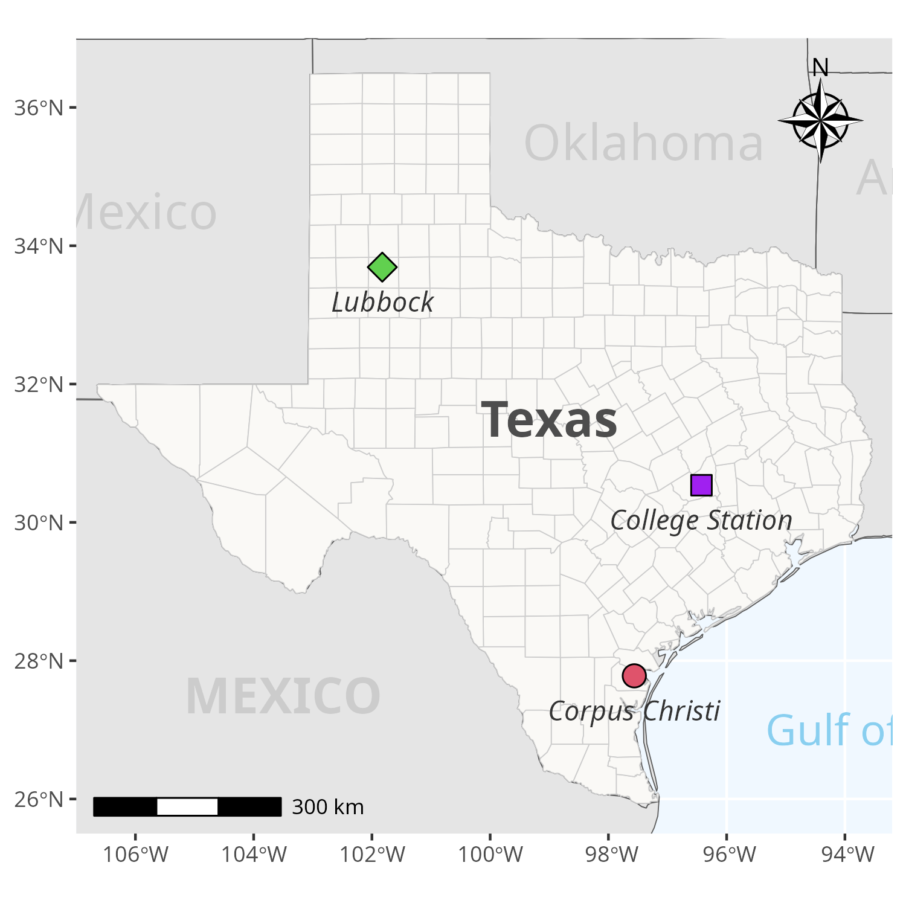

Figure 1.
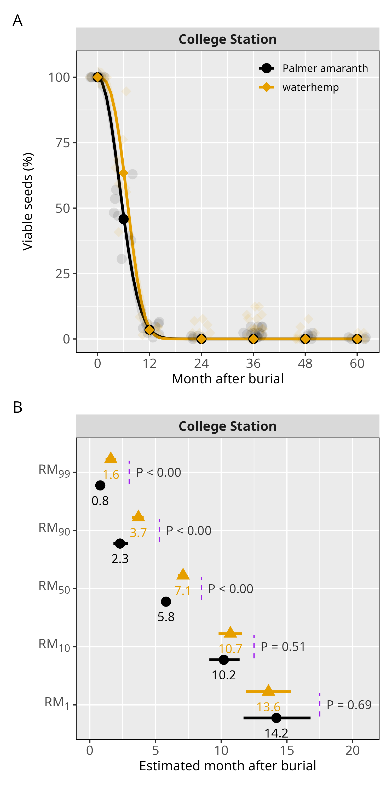

Figure 2.
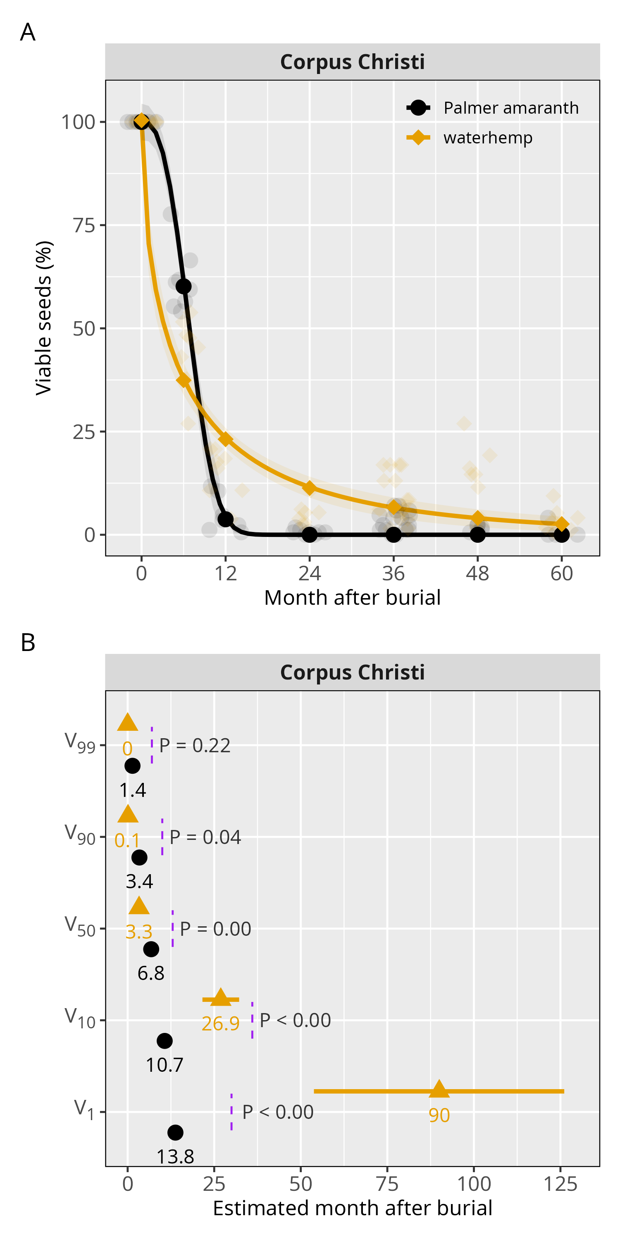

Figure 3.

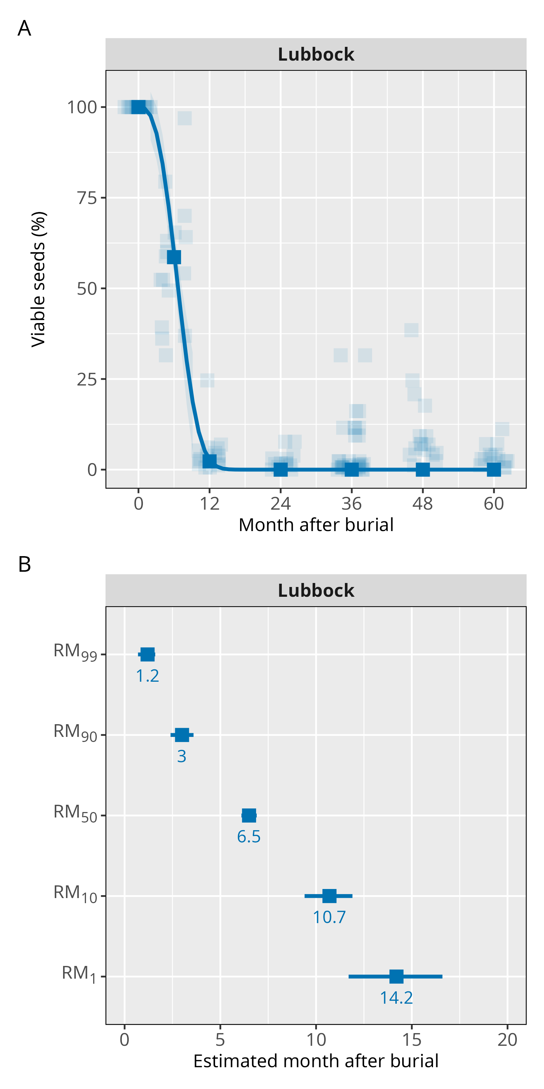

Figure 4.

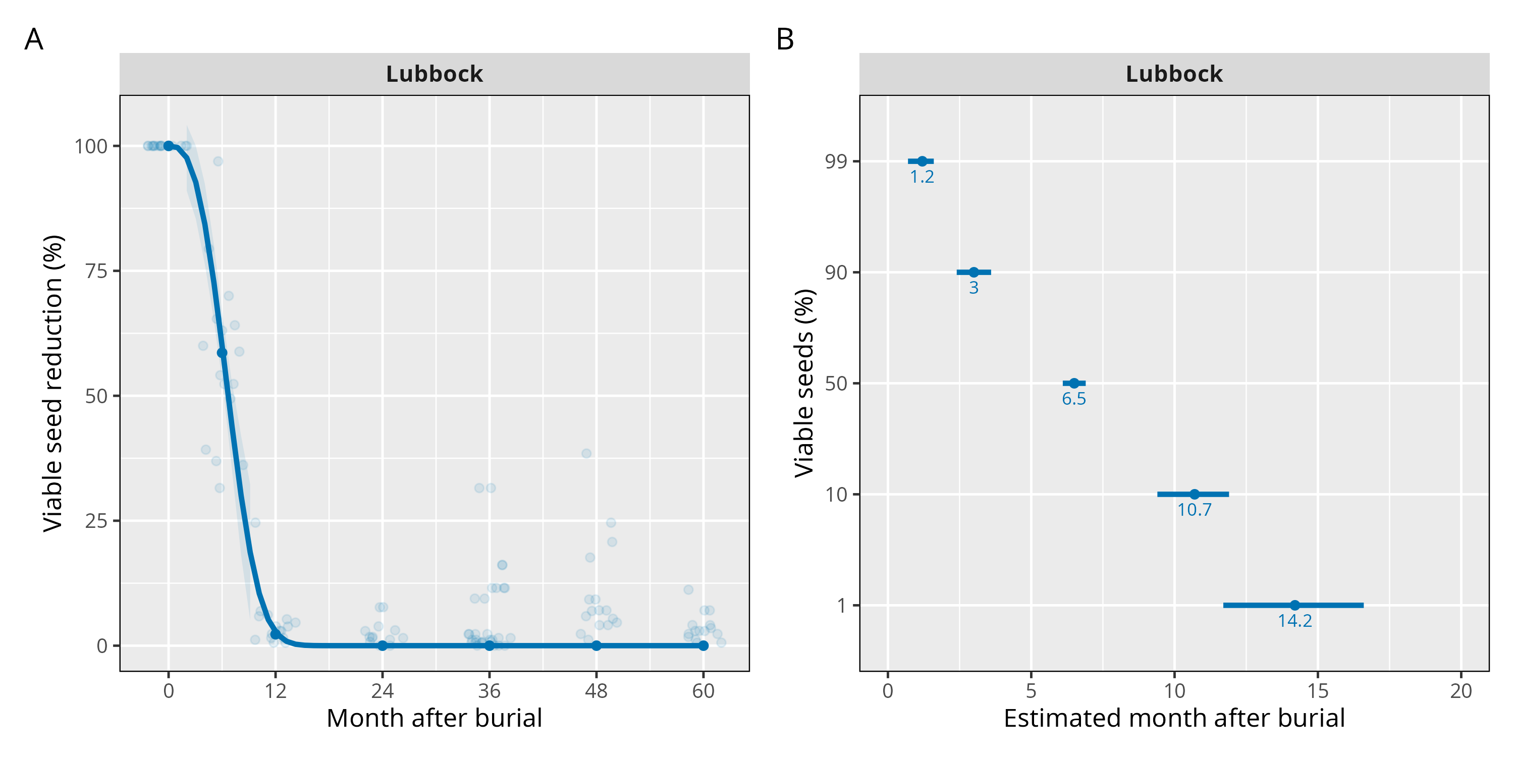
Figure 3.
Table 1.
Location | Model | Term | Curve | Model selection |  |  | Goodness-of-fit
 |  |  |  | F-test | P-value | AIC_{c}ª | RSME^{b} | ME^{c}
College Station | Full | species × soil depth | Palmer amaranth at 25 cm | - | - | 812.9 | 3.4 | 0.99
College Station | Full | species × soil depth | Palmer amaranth at 5 cm | - | - | 812.9 | 3.5 | 0.99
College Station | Full | species × soil depth | waterhemp at 25 cm | - | - | 812.9 | 8.5 | 0.94
College Station | Full | species × soil depth | waterhemp at 5 cm | - | - | 812.9 | 3.5 | 0.99
College Station | Reduced 1 | species | Palmer amaranth | 1.25 | 0.28 | 809.0 | 3.9 | 0.99
College Station | Reduced 1 | species | waterhemp | 1.25 | 0.28 | 809.0 | 6.5 | 0.97
College Station | Reduced 2 |  |  | 13.72 | 0.00 | 840.2 | 10.6 | 0.91
Corpus Christi | Full model | species × soil depth | Palmer amaranth at 25 cm |  |  | 843.5 | 4.7 | 0.98
Corpus Christi | Full model | species × soil depth | Palmer amaranth at 5 cm |  |  | 843.5 | 1.8 | 0.99
Corpus Christi | Full model | species × soil depth | waterhemp at 25 cm |  |  | 843.5 | 8.7 | 0.92
Corpus Christi | Full model | species × soil depth | waterhemp at 5 cm |  |  | 843.5 | 6.2 | 0.96
Corpus Christi | Reduced 1 | species | Palmer amaranth | 1.71 | 0.12 | 842.4 | 3.7 | 0.99
Corpus Christi | Reduced 1 | species | waterhemp | 1.71 | 0.12 | 842.4 | 7.9 | 0.93
Corpus Christi | Reduced 2 |  |  | 21.43 | 0.00 | 890.60 | 7.6 | 0.95
Luddock | Full | species × soil depth | Palmer amaranth at 25 cm | - | - | 965.4 | 5.9 | 0.97
 |  |  |  |  |  |  | 3.8 | 0.98
 |  |  |  |  |  |  | 11.9 | 0.87
 |  |  |  |  |  |  | 13 | 0.86
Luddock | Reduced 1 | species | Palmer amaranth | 0 | 0 | 954.2 | 5 | 0.97
Luddock | Reduced 1 | species | waterhemp | 0 | 0 | 954.2 | 12.4 | 0.86
Luddock | Reduced 2 |  |  | 0.79 | 0.50 | 950.3 | 9.6 | 0.92
ª AIC_{c}, Akaike’s Information Criterion
^{b} RMSE, Root Mean Square Error
^{c} ME, Model efficiency
Table 4. Model parameters of viable seed reduction across month after burial in Luddock, Texas.
Parameter | Estimate (SE) | P-value
Slope | 2.43 (±0.27) | 0.00
Upper limit | 99.99 (±0.27) | 0.00
Inflection point | 7.58 (±0.25) | 0.00

Table 2. Model parameters of viable seed reduction across month after burial in College Station, Texas.
Parameter | Species | Estimate (SE) | P-value
Slope | Palmer amaranth | 2.09 (±0.23) | 0.00
Slope | waterhemp | 2.88 (±0.24) | 0.00
Upper limit | Palmer amaranth | 99.99 (±1.96) | 0.00
Upper limit | waterhemp | 99.99 (±1.96) | 0.00
Inflection point | Palmer amaranth | 6.86 (±0.18) | 0.00
Inflection point | waterhemp | 8.01 (±0.22) | 0.00

Table 3. Model parameters of viable seed reduction across month after burial in Corpus Christi, Texas.
Parameter | Species | Estimate (SE) | P-value
Slope | Palmer amaranth | 2.69 (±0.26) | 0.00
Slope | waterhemp | 0.57 (±0.05) | 0.00
Upper limit | Palmer amaranth | 99.99 (±2.22) | 0.00
Upper limit | waterhemp | 100.39 (±2.21) | 0.00
Inflection point | Palmer amaranth | 7.84 (±0.24) | 0.00
Inflection point | waterhemp | 6.24 (±0.60) | 0.00

Table 6. Required month after burial for reaching 90%, 50% and 10% viable seeds in Luddock, Texas.
Viable seeds (%) | Estimate (SE) | Confidence interval
Viable seeds (%) | Estimate (SE) | Lower | Upper
90 | 3.01 (±0.29) | 9.44 | 11.91
50 | 6.53 (±0.21) | 6.10 | 6.95
10 | 10.68 (±0.62) | 2.43 | 3.60

Table 7. Required month after burial for reaching 90%, 50% and 10% viable seeds in College Station, Texas
Viable seeds (%) | Species | Estimate (SE) | Confidence interval |  | P-value
Viable seeds (%) | Species | Estimate (SE) | Lower | Upper | P-value
90 | Palmer amaranth | 2.34 (±0.28) | 1.80 | 2.90 | 0.00
90 | waterhemp | 3.68 (±0.22) | 3.23 | 4.12 | 0.00
50 | Palmer amaranth | 5.76 (±0.18) | 5.41 | 6.12 | 0.00
50 | waterhemp | 7.06 (±0.18) | 6.70 | 7.41 | 0.00
10 | Palmer amaranth | 10.21 (±0.57) | 9.08 | 11.36 | 0.51
10 | waterhemp | 10.70 (±0.47) | 9.77 | 11.63 | 0.51

Table 8. Required month after burial for reaching 90%, 50% and 10% viable seeds in Corpus Christi, Texas
Viable seeds (%) | Species | Estimate (SE) | Confidence interval |  | P-value
Viable seeds (%) | Species | Estimate (SE) | Lower | Upper | P-value
90 | Palmer amaranth | 3.40 (±0.26) | 2.89 | 3.92 | 0.03
90 | waterhemp | 0.13 (±0.06) | 0.01 | 0.25 | 0.03
50 | Palmer amaranth | 6.85 (±0.20) | 6.46 | 7.24 | 0.00
50 | waterhemp | 3.33 (±0.49) | 2.35 | 4.31 | 0.00
10 | Palmer amaranth | 10.70 (±0.55) | 9.61 | 11.78 | 0.00
10 | waterhemp | 26.87 (±2.68) | 21.58 | 32.18 | 0.00

Figures
Attach figures to the end of the manuscript with the figure legends (as editable text) directly beneath them. Color graphics and color photographs are welcome. Use scientific names in full (without authority) in figure legends for weeds and other non-crop organisms. Include data points with plotted curves, and provide equations with predicted curves or in figure legends. If an explanation of symbols is required, include the key in the figure. Scale bars included in photomicrographs should be placed directly on the image. For details of image formatting and acceptable file types, see https://www.cambridge.org/core/services/authors/journals/journals-artwork-guide

