Maxwell Lee

1. Top output is descriptive statistics, lower output is correlation matrix.

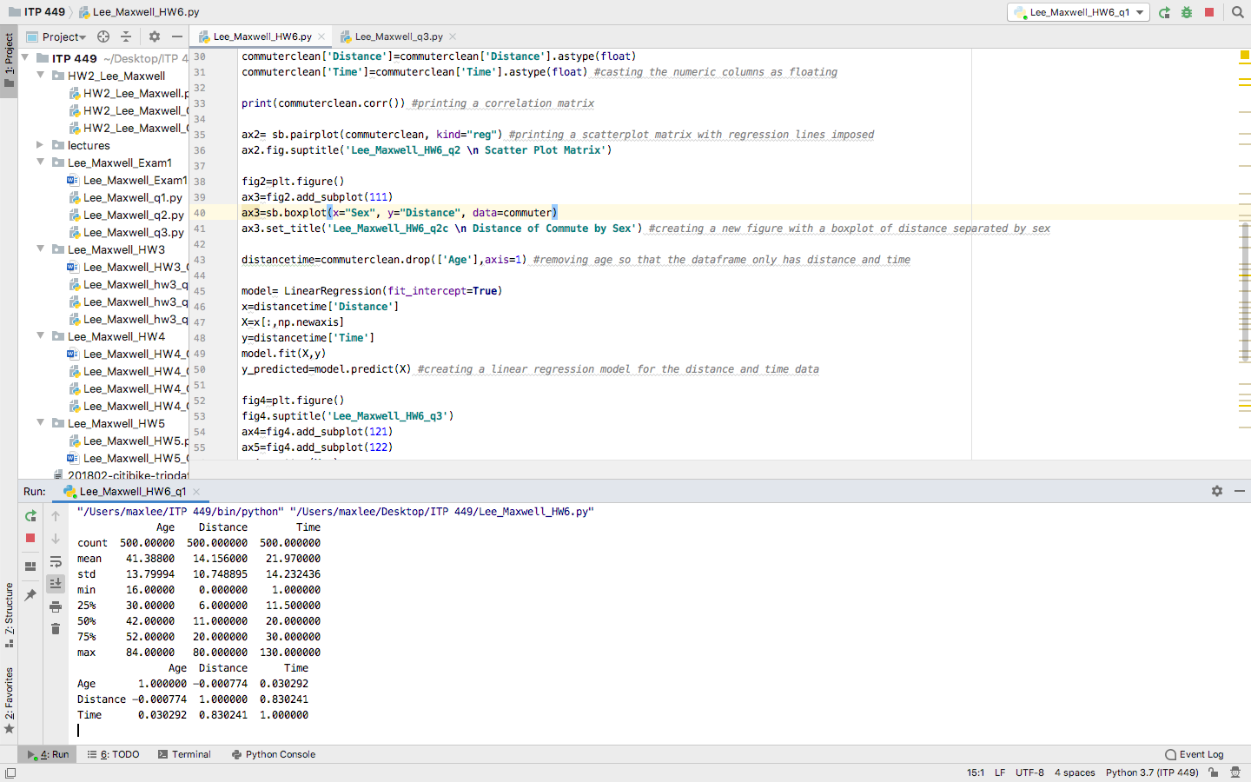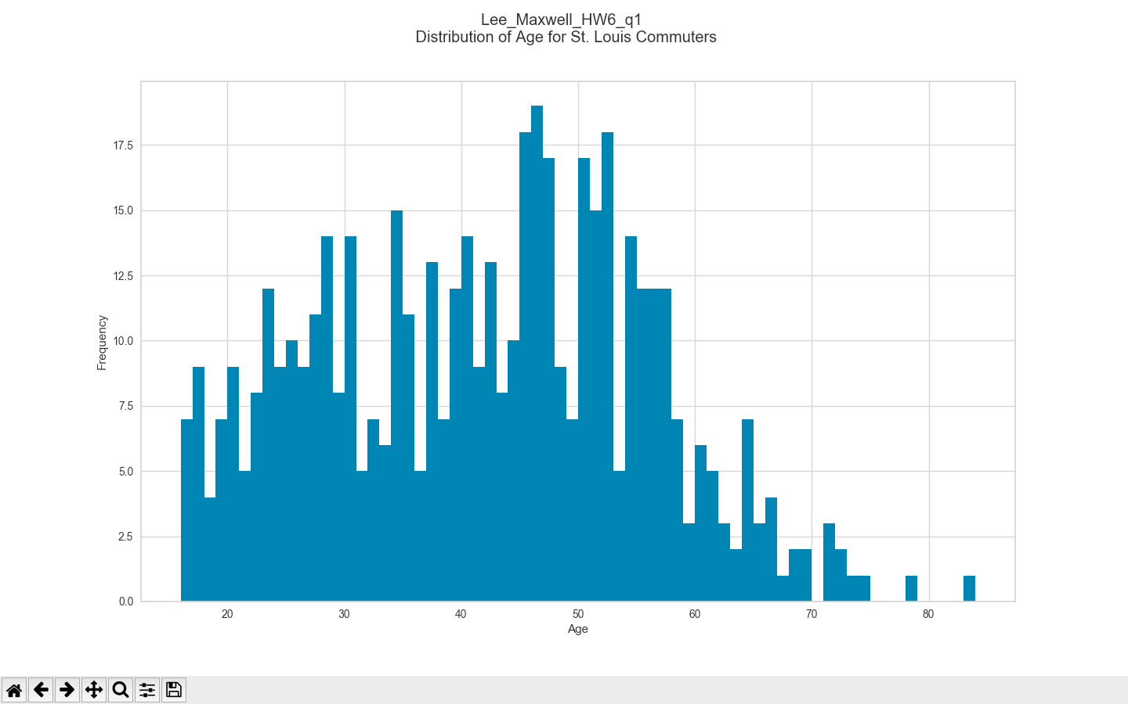

2a. 

Bottom output is the correlation matrix. The most correlated are time and distance with a correlation coefficient of .83.

2b. 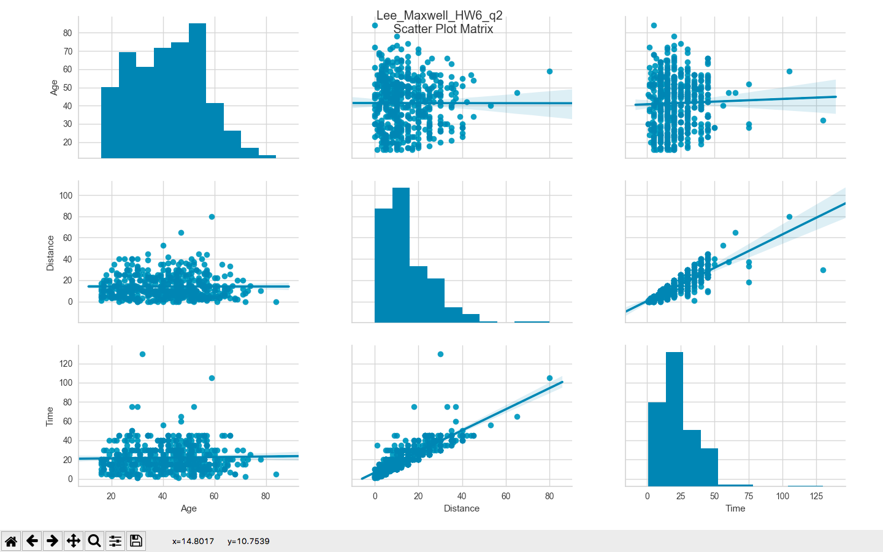

The diagonals show the distribution of the variable. These variables are all skewed right, with a few number of larger outliers.

2c. 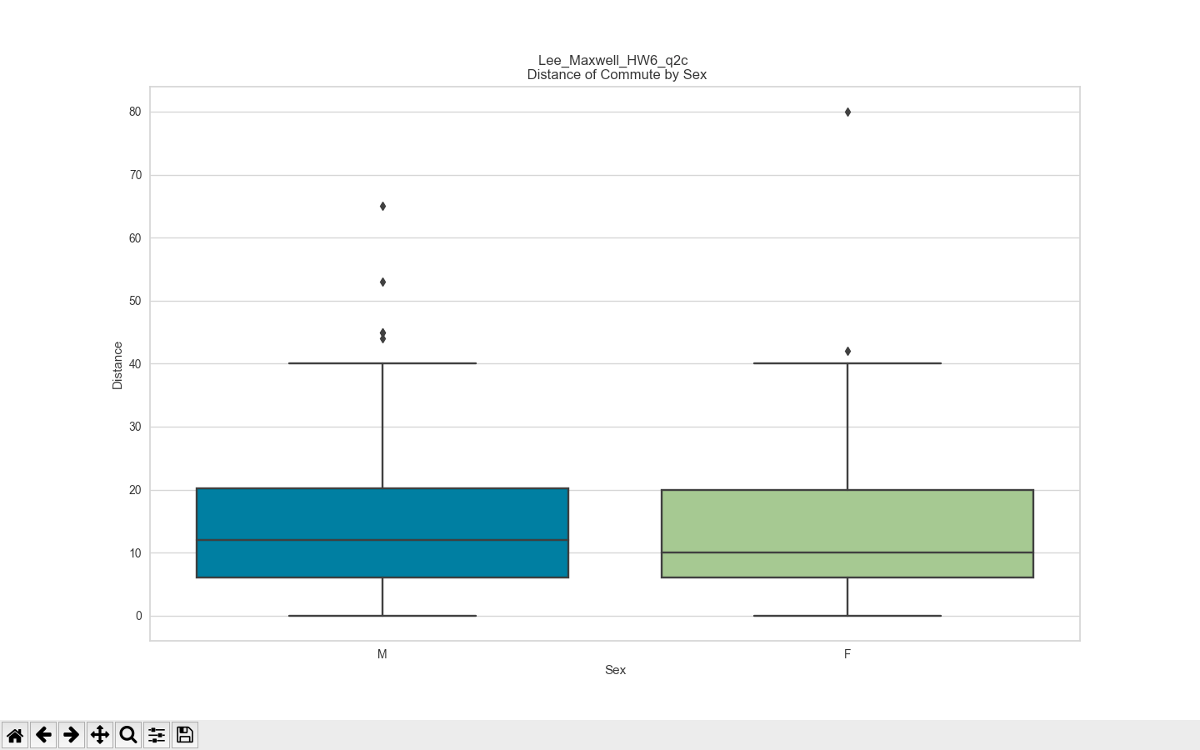

The boxplot would indicate a lower median distance travelled for women, however the difference in distribution is not dramatic.

3. 