Maxwell Lee

Q2. The target variable is Survived

Q3. The passenger column is not necessary.

Q5. 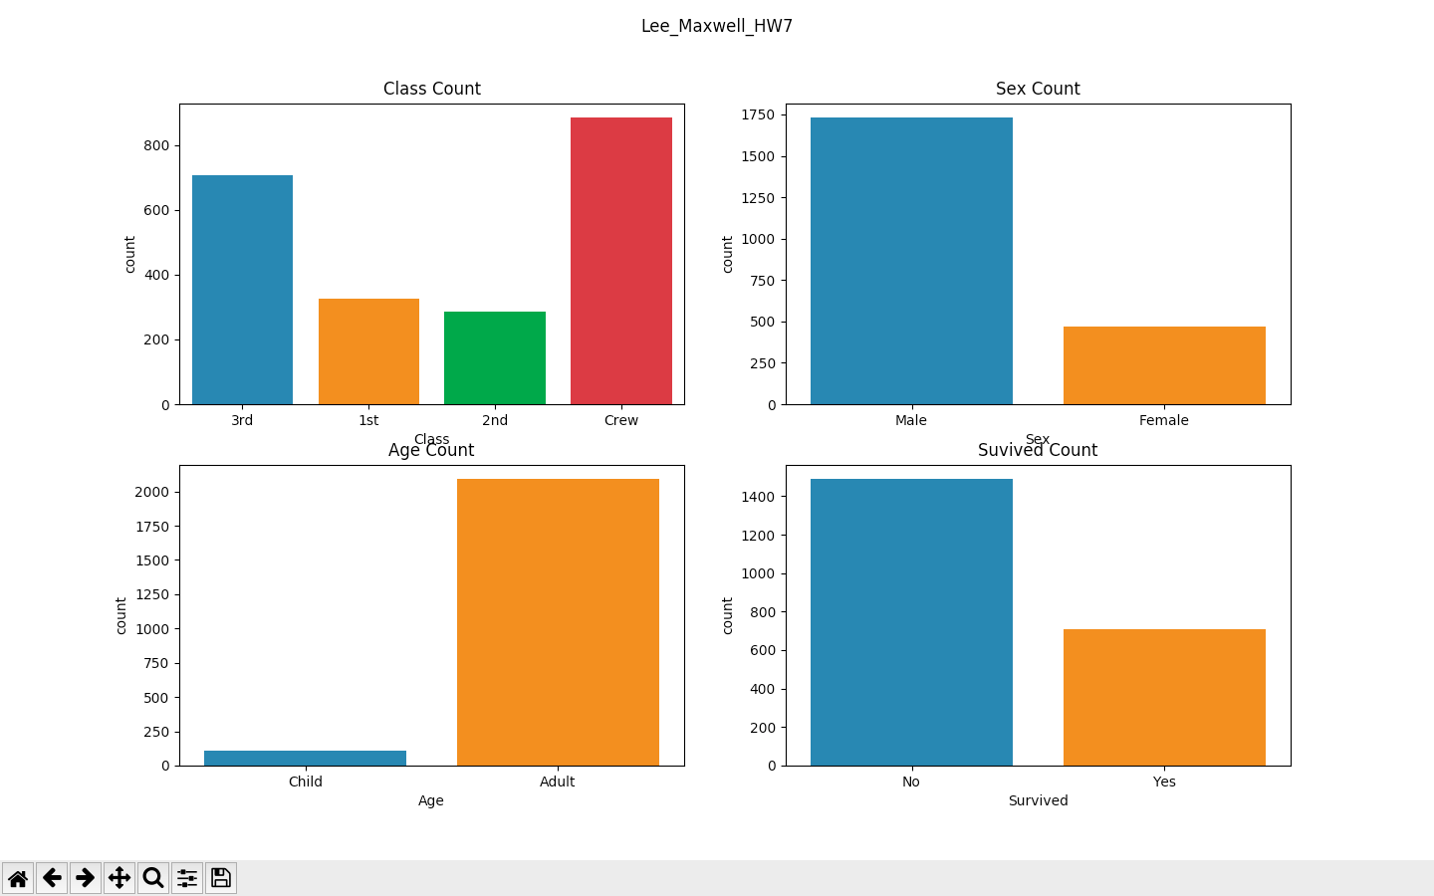

Q9/10. Accuracy score and confusion matrix

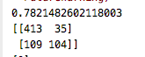

Q11.The predicted value of zero indicates an adult male in 3rd class is not predicted to survive.