Higher Fidelity Models of Spacecraft Reachability – Maxwell Zweig, DOD NDSEG 2025
Motivation: The term “Kessler Syndrome” refers to the grave possibility of run-away collisions occurring between satellites if their density in orbit reaches a critical threshold. While the likelihood of a full Kessler-like scenario is debated, the probability of catastrophic debris-strewing collisions has been increasing along with the number of commercial and government satellites in orbit. As a result, the need for improved space traffic management tools is more pressing than ever. Reachable domain (RD) theory may be brought to bear on the problem of space traffic management: computation of the RD of a satellite allows the operator to determine the set of possible positions reachable to that satellite from a given initial position and velocity. By studying when the RD of a satellite intersects with orbiting debris or the RD of another satellite, satellite operators can determine if a collision may occur. As a result of its direct applicability to safety analysis the RD problem has been well-studied under varying dynamical contexts and control assumptions [5, 1, 7], however only limited attention has been given to difficult generalizations of the problem including RD computation under multi-impulse control, initial state, or dynamic uncertainty [9, 4]. Analysis of these cases is of significant interest to spacecraft operators because satellites may maneuver with multiple near-impulsive burns (as opposed to the well-studied single-impulse case) and the initial state of or dynamical environment the satellite is subject to are often only known approximately. Higher fidelity models for satellite reachability are needed to address these cases and are warranted to help mitigate the possibility of satellite collisions under the demands of a busy space environment and to better enable mission designers and policy makers to construct robust flight plans. To meet this need, I propose to extend my previous work in optimal control and reachability to the computation of reachable sets under multi-impulse, initial state and dynamic uncertainty.
Methodology: During my graduate study, I will perform three related novel studies to address each of these cases. I will perform each study in the relative motion Hill-Clohessy-Wiltshire (HCW) dynamics because this dynamical regime builds directly on my previous work will remaining applicable to spacecraft operators; however, my methodology will be directly applicable to arbitrary dynamical models. In the multi-impulse case, researchers have recently studied optimal multi-impulse trajectories as a limit of continuous thrust fuel-limited trajectories [8]. Motivated by this, I will compute the multi-impulse RD as a limiting solution of the continuous-thrust fuel-limited RD. In previous work I compute the fuel-limited set by “sweeping” as in [7] through a selection of directions sampled to cover the RS, solving a different optimal control problem for each direction and propagating the spacecraft along the optimally controlled dynamics to recover the set boundary. In this work, I make sure my control efforts $u\left(t\right)$ heed the inequality constraint $\int_{0}^{T}{\frac{||u\left(t\right)||}{c}}dt≤M_{\text{max}}=Δv_{\text{total}}$, to respect the fuel-constraint. To compute the multi-impulsive RD, the same “sweeping” procedure will be performed while increasing the maximal allowable thrust authority but holding the maximum allowable delta-v across the trajectory constant, forcing solutions closer to trajectories that bring the satellite to a point on the N-Impulsive RD. As the maximum allowable thrust magnitude increases while delta-v across the trajectory is held constant, the control cost will approach the optimal impulsive objective: $\int_{0}^{T}{\frac{||u\left(t\right)||}{c}}dt→\sum_{i=1}^{N}{||Δv_{i}||}$ .
Along the way, I will have to implement numerical optimal control methods to increase the robustness of the fuel-limited computation in the high-thrust limit, as mentioned in [8]. For full convergence to a point on the multi-impulse RD, once a fuel-limited problem is solved for large maximal thrust the resulting costate primer vector and state trajectory will be used as an initial guess to a direct optimization procedure [8].
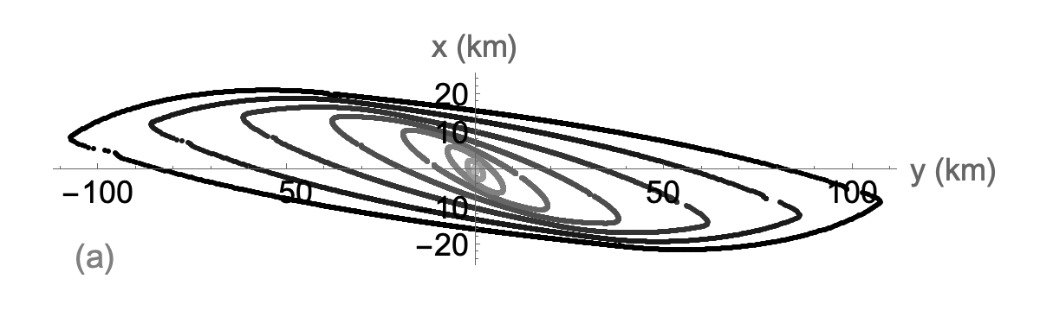
Figure 1: Fuel-limited HCW reachable sets for various flight times.
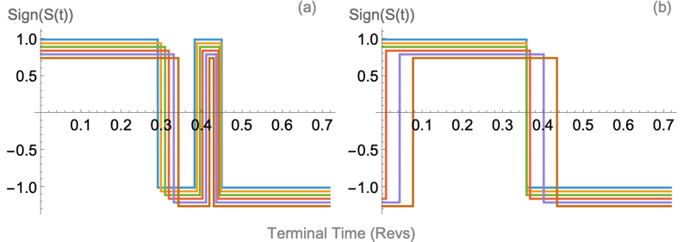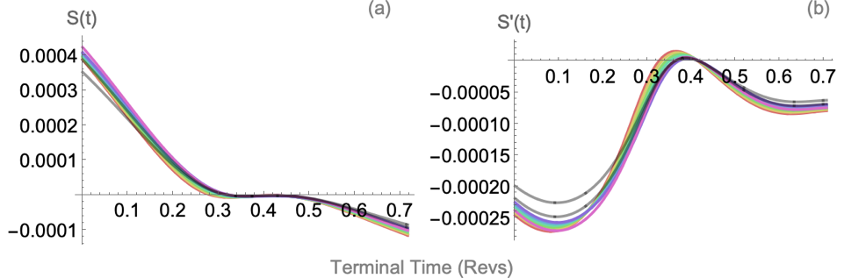
Figure 2: Bifurcated optimal switching behavior in maximum reachable trajectories and associated near singular switching functions.
To study uncertain-initial state RD, I will extend my prior work computing reachable sets to an initial-state constrained to an ellipsoidal admissible region 𝑥 ∈ X. My methodology will generalize to any convex admissible region; however, the ellipsoidal case will serve as an applicable proof-of-concept corresponding to the ellipsoidal uncertainty regions produced by Kalman Filter tracking routines. The same sweeping procedure will be performed as in the multi-impulse case, including a simultaneous optimization will be performed over states in the admissible region to determine the optimal starting state for each given terminal direction. The PMP gives conditions for this that define a 14-dimensional Two-Point-Boundary-Value-Problem (TPBVP): in the case that the optimal starting state 𝑥 for a given direction lies inside the boundary of X, then the optimal initial costates satisfy 𝝀 = [0,0,0,0,0,0,η] . In the case of fixed initial mass of the satellite if 𝑥 lies on the boundary of the admissible region, then the optimal initial states and costates satisfy the transversality condition [−𝝀 𝜆] = [η k] [2]. Solution to each TPBVP would be performed through a shooting method, using techniques like those applied in the multi-impulse case.
Finally, to study computation of reachable sets under dynamic uncertainty, I will introduce process noise to my HCW case study as a proxy for dynamic uncertainty. I will then solve a corresponding stochastic optimal control problem and associated Hamilton-Jacobi-Bellman equation to obtain the probability that under the optimal policy a spacecraft arrives in a target set at a given terminal time, while respecting a realistic hard constraint (as opposed to a chance constraint) on the energy or fuel of its thrusting efforts. For a sufficiently small target set, level sets of the solution to this HJB equation will give a stochastic-controllable set or “backwards reachable set”. As the process noise is taken to zero, this set ought to approach a corresponding deterministic fuel or energy-limited set depending on the exact formulation of the problem. While the dimensionality of the HJB equation will be challenging, Physics Informed Neural Networks (PINNs) have emerged as a new-type of neurodynamic programming that show significant promise in solving high-dimensional HJB equations, and so during my research I will explore a PINN as a solver for the HJB equation [3]. Since much controlled motion in astrodynamics occurs in the vicinity of periodic orbits, computation of the “backwards reachable set” will yield much of the same information to satellite operators as the forward one.
Intellectual Merit: Higher-fidelity solutions to the RD problem will directly enable satellite operators to place satellites in orbits where they are less likely to be involved in maneuver-caused collisions during normal operation. Improved models of the RD will provide a tactical advantage as well, better enabling satellite operators to understand the maneuvering capabilities of other satellites. But beyond these immediate applications, more realistic solutions to the reachability problem will enable satellite operators to design trajectories that are robust to “missed thrust events” (MTE). If a satellite cannot follow a scheduled burn during a low-thrust trajectory, this may have significant consequences for the satellite’s mission if the satellite is not carrying enough fuel to recover from the missed burn [6]. Better knowledge of the RD will help to ensure that the planned trajectory remains well within a realistic boundary of the reachable set, aiding MTE recovery.
Each of my studies will advance understanding of the RD problem by examining a variant of the RD problem that has been significantly understudied. In the multi-impulse case, successful implementation of my methodology will involve analyzing the “switching surface” [8] of reachable sets which would be of interest because it would fully characterize the bifurcated optimal switching that occurs as related families of optimal control problems are solved [8] and lead to a better understanding of the qualitative behavior seen in common optimal control problems in astrodynamics. My proposed multi-impulse research would help to fill a significant literature gap. In the case of uncertain-initial state reachable sets, my approach could be used to perform novel studies of non-fixed initial state reachable sets under constraints such as the “rest-to-rest” constraint, which directly lead to improved understanding of reachability in real-world flight scenarios. In the case of reachable set under dynamic uncertainty, my research would contribute to the emerging study of PINNs, as well as their application to optimal control problems. Each of these studies would advance general knowledge of reachable set computation while providing specific insights to spacecraft operators through application to dynamical environments arising in space.
In future work, I could perform these reachability studies in other dynamical environments, such as near a periodic orbit in cislunar space or under a perturbed orbital regime. Once I am successful in my initial HCW case study, these dynamical environments will serve as natural steppingstones towards an active industry-implementation.
Impact: Any research undertaken to maintain the safety of satellites would carry significant national security benefit: GPS satellites aid both civilian and military navigation on Earth. Surveillance satellites provide the United States with key intelligence insights and improve early warning and launch detection systems. My research would help to advance U.S. standing in space by supporting these operations through tools meant to mitigate the danger of collisions in orbit and construct more robust missions. Higher fidelity solutions to the satellite RD problem could enable mission designers to place sensitive satellites in safer orbits and would help operators to design realistic reach-avoid maneuvers. An improved understanding of relative satellite RD in the HCW case will aid satellite operators in rendezvous and proximity operations, helping to support the capabilities needed for in-space refueling and maintenance of satellites. Notwithstanding the important national security benefits of its satellite operations, U.S. leadership in space is coincident to geopolitical leadership on the world-stage. By working to improve the safety of satellites, my research indirectly supports the litany of essential scientific, commercial, and national security functions served by satellites.
References: [1] Abate et al., Automatica, 2008; [2] Bonnans., Course on Opt. Control., 2022; [3] Holzinger et al., IEEE Trans. on Aero. and Elec. Sys., 2012; [4] Lee, Hwang, Aero. Sci. and Tech., 2018; [5] Natherson, Scheeres, JGCD, 2024; [6] Zhang et al., Chinese Jrnl. of Aero., 2024; [7] Taheri et al., JASS, 2020; [8] Roberto et al., AIAA SCITECH, 2022; [9] Natherson, Scheeres, 76th Inter. Astro. Conf., 2025

