

Requirement & Design Specification
Football Field Booking System
Version: 1.0

– Can Tho, August 2026–

Record of Changes
Version | Date | A*  M, D | In charge | Change Description
V1.0 | 24/07/26 | A | BonVT | Added Account & Customer Status requirements and design specifications.
V1.0 | 24/07/26 | A | NgocPA | Added Booking Lifecycle requirements and design specifications.
V1.0 | 24/07/26 | A | BaoNG | Added Field, Slot, Service & Issue Management requirements and design specifications.
V1.0 | 24/07/26 | A | AnNP | Added Payment Gateway, Refund & Invoice requirements and design specifications.
V1.0 | 24/07/26 | A | AnPTT | Added Promotion, Membership, Notification & Report requirements and design specifications.
*A - Added M - Modified D - Deleted

Contents
Record of Changes 2
I. Overview 5
1. User Requirements 5
1.2 Use Cases 6
2. Overall Functionalities 16
2.1 Screens Flow 16
Guest’s Screen Flow 16
2.2 Screen Descriptions 16
2.3 Screen Authorization 20
2.4 Non-UI Functions 21
3. System High Level Design 22
3.1 Database Design 22
3.2 Code Packages 26
II. Requirement Specifications 28
Account & Customer Status 28
Field, Slot, Service & Issue Management 37
Booking Lifecycle 50
Payment Gateway, Refund & Invoice 65
Promotion, Membership, Notification & Report 78
III. Design Specifications 91
1. Account & Customer Status 91
1.1 Screen Designs 91
2. Field, Slot, Service & Issue Management 98
2.1 Screen Designs 98
3. Booking Lifecycle 107
3.1 Screen Designs 107
4. Payment Gateway, Refund & Invoice 114
4.1 Screen Designs 114
5. Promotion, Membership, Notification & Report 120
5.1 Screen Designs 120
IV. Appendix 130
1. Assumptions & Dependencies 130
2. Limitations & Exclusions 131
3. Business Rules 131
4. Booking Status Values 133
5. Code-First Alignment Notes 133

I. Overview

1. User Requirements

# | Actor | Description
1 | Guest | Unauthenticated visitor who can view public information and register/login.
2 | Customer | Registered user who searches fields, creates bookings, pays, manages own bookings, views membership and reports issues.
3 | Staff | Venue operation employee who handles calendar, walk-in bookings, check-in, completion, no-show, issues and refunds.
4 | Admin | System administrator/owner who manages accounts, fields, prices, services, promotions, membership rules and reports.
5 | System | Internal automated actor for payment capture, invoice generation, notification and scheduled reminders.

1.2 Use Cases

b. Descriptions

Account & Customer Status
ID | Feature | Use Case | Use Case Description
UC-01 | Account onboarding | Register account | A Guest creates a Customer account and completes email verification.
UC-02 | Authentication | Login | An active user signs in with email or phone and receives a revocable JWT.
UC-03 | Authentication | Logout | A signed-in user signs out and invalidates all previously issued JWTs for that account.
UC-04 | Profile management | Manage personal profile | A user views and updates only their own editable profile information.
UC-05 | Credential security | Change password | A signed-in user replaces their password after proving the current password.
UC-06 | Account recovery | Recover password | A Guest requests, validates, and consumes a one-hour single-use password recovery link.
UC-07 | Customer account administration | View customer accounts | An Admin lists Customer accounts and opens business-facing account and activity context in read-only mode.
UC-08 | Customer account administration | Lock/unlock customer account | An Admin locks or restores Customer sign-in access with a reason, token revocation, and notification.
UC-09 | Staff account administration | Manage staff accounts | An Admin creates and maintains Staff identity/status while Staff privately owns the invited password.
UC-10 | Customer activity | View customer activity | An Admin opens an operational activity drill-down for one Customer using business context rather than raw IDs.

Field, Slot, Service & Issue Management
ID | Feature | Use Case | Use Case Description
UC-11 | Field catalogue | View field list | A visitor views active football fields and their catalogue context.
UC-12 | Field catalogue | View field detail | A visitor views the selected field, images, facilities, prices, and active services.
UC-13 | Availability search | Search available fields by date/time | A visitor searches generated, priced, non-blocked field slots whose start time is still in the future, with optional filters.
UC-14 | Field management | Manage football fields | An Admin creates, updates, activates, deactivates, and uploads images for football fields.
UC-15 | Field pricing | Manage field pricing by time range | An Admin maintains effective weekday/weekend price bands without any fallback price.
UC-16 | Slot generation rules | Configure slot generation rules | An Admin configures opening time, closing time, duration, and the rolling generation horizon.
UC-17 | Slot exceptions | Block/unblock field slots | Venue Staff records or removes operational exceptions without overwriting active bookings.
UC-18 | Operations calendar | View field operation calendar | Venue Staff views generated available, blocked, and booked field slots for one date.
UC-19 | Extra-service catalogue | Manage extra services | An Admin maintains priced rental, sale, and staff services and their limits/status.
UC-20 | Booking add-ons | Add extra services to booking | Customer or Staff selects validated extra services while creating a booking.
UC-21 | Booking add-ons | Update extra services before check-in | The booking owner or Venue Staff edits add-ons before start and the system recalculates all financial effects.
UC-22 | Issue management | Report field/service issue | An authenticated Customer or Staff member reports a described issue under their own identity.
UC-23 | Issue management | Resolve field/service issue | Venue Staff progresses an open issue to a terminal resolved or rejected state with notes.

Booking Lifecycle
ID | Feature | Use Case | Use Case Description
UC-24 | Booking creation | Create online booking | A Customer creates a validated pending online booking and continues to PayPal Sandbox.
UC-25 | Booking creation | Create walk-in booking | Venue Staff creates a walk-in booking for either a matched Customer account or a first-time visitor identified by name and phone, then records cash or leaves payment pending.
UC-26 | Booking details | View booking detail | An authorized user views slot, service, promotion, payment, invoice, and refund detail for a booking.
UC-27 | Booking history | View my bookings | A Customer views current and past owned bookings.
UC-28 | Booking calendar | View booking calendar | Venue Staff views the daily booking queue by field and date.
UC-29 | Booking rescheduling | Reschedule booking | Customer or Staff moves an eligible booking before start and the system recalculates the destination and balance.
UC-30 | Booking cancellation | Cancel booking | Customer or Staff reviews policy amounts and cancels an eligible booking before it starts.
UC-31 | Venue operations | Check in booking | Venue Staff checks in a paid confirmed booking from 30 minutes before its start.
UC-32 | Venue operations | Complete booking | Venue Staff completes a started checked-in booking only after the remaining balance is zero.
UC-33 | Venue operations | Mark no-show | Venue Staff records no-show from 15 minutes after start without increasing membership progress.

Payment Gateway, Refund & Invoice
ID | Feature | Use Case | Use Case Description
UC-34 | Checkout | View checkout summary | Customer or Staff reviews authoritative field, service, discount, deposit, paid, and remaining amounts.
UC-35 | Checkout | Choose payment option | A Customer chooses online deposit/full payment; Staff chooses an eligible counter-cash amount.
UC-36 | Online payment | Pay online via PayPal Sandbox | A Customer approves a PayPal Sandbox order whose verified idempotent capture automatically confirms eligible booking state.
UC-37 | Counter payment | Confirm remaining payment | Venue Staff records a real on-site cash payment against a booking balance.
UC-38 | Payment recovery | Handle failed/expired payment | Provider failure remains visible/retryable and the scheduler releases aged unpaid holds.
UC-39 | Payment records | View payment history | An authorized user views persisted cash/PayPal transactions with booking, field, slot, amount, time, and refund context.
UC-40 | Billing status | View invoice/payment status | An authorized user views the system-maintained invoice, paid, remaining, refunded, and transaction status.
UC-41 | Refund management | Process online refund | Venue Staff submits an approved online refund idempotently and accepts only provider COMPLETED as final.
UC-42 | Refund management | Manage refund requests | The booking owner submits an amount and reason; Venue Staff reviews its auditable lifecycle while Admin remains read-only.
UC-43 | Booking policies | Configure deposit rules | An Admin configures the default online deposit percentage.
UC-44 | Booking policies | Configure cancellation/refund policy | An Admin configures before-24-hour and same-day refund percentages.

Promotion, Membership, Notification & Report
ID | Feature | Use Case | Use Case Description
UC-45 | Promotions | View active promotions | A visitor views currently eligible active promotion campaigns.
UC-46 | Promotions | Manage promotion campaigns | An Admin creates, updates, activates, deactivates, and uploads banners for campaigns.
UC-47 | Promotions | Apply promotion to booking | A Customer applies one eligible code whose discount and reserved usage are snapshotted.
UC-48 | Membership | View membership progress | A Customer views progress under the active lifetime, monthly, or consecutive-week rule.
UC-49 | Membership | Manage membership rules | An Admin maintains qualification periods, thresholds, ordering, status, discounts, and benefits.
UC-50 | Membership | View membership benefits | A visitor views active membership levels and benefit descriptions.
UC-51 | Notifications | Send booking confirmation notification | A confirmation event creates one visible notification for the affected Customer.
UC-52 | Notifications | Send booking reminder notification | The scheduler creates at most one reminder inside the configured pre-start window.
UC-53 | Notifications | Send cancellation/refund notification | Cancellation and completed refund events notify the affected Customer.
UC-54 | Reporting | View revenue report | An Admin views gross collected, fees, refunds, net revenue, discounts, and commercial values for a period.
UC-55 | Reporting | View booking report | An Admin views valid lifecycle counts, peak time, and field utilization for a period.
UC-56 | Reporting | View customer activity report | An Admin views aggregate returning/top-customer and membership activity for a selected period.

2. Overall Functionalities

2.2 Screen Descriptions

# | Feature | Screen | Description
1 | Account & Customer Status | Landing Page | Public entry point for browsing fields, active promotions, membership benefits, and account actions.
2 | Account & Customer Status | Login Screen | Authenticates a registered user and routes the user to role-appropriate navigation.
3 | Account & Customer Status | Register Account | Creates a unique Customer account and starts email verification.
4 | Account & Customer Status | Forgot/Reset Password | Issues a time-limited reset link and accepts a replacement password.
5 | Account & Customer Status | Profile / Edit Profile | Displays account status and permits safe profile/password changes.
6 | Account & Customer Status | Customer Management | Admin reviews Customer accounts, manages account lock/unlock, and alone may inspect selected Customer activity.
7 | Account & Customer Status | Staff Management | Admin creates and maintains Staff identity/status; Staff chooses the password from an emailed invitation.
8 | Field, Slot, Service & Issue Management | Field List | Shows the public catalogue of active football fields.
9 | Field, Slot, Service & Issue Management | Field Detail | Displays one active field with image, facilities, pricing, and booking entry points.
10 | Field, Slot, Service & Issue Management | Search Available Fields | Searches generated slots by playing date, field type, and optional field.
11 | Field, Slot, Service & Issue Management | Field Management | Admin creates, updates, activates, and deactivates football fields, including images.
12 | Field, Slot, Service & Issue Management | Field Pricing Management | Admin maintains effective weekday/weekend price bands for each field.
13 | Field, Slot, Service & Issue Management | Extra Service Selection | Selects and updates booking add-ons while validating stock/capacity and pre-check-in timing.
14 | Field, Slot, Service & Issue Management | Extra Service Management | Admin maintains rental, sale, and staff-provided add-ons.
15 | Field, Slot, Service & Issue Management | Unavailable Slot Management | Staff blocks/unblocks field time with a reason and reviews daily field operations.
16 | Field, Slot, Service & Issue Management | Issue Report / Issue Management | Customer/Staff reports a field, booking, or service issue; Staff resolves it and notifies the reporter.
17 | Booking Lifecycle | Online Booking | Customer creates a pending online booking and continues to Customer-only PayPal checkout.
18 | Booking Lifecycle | Walk-in Booking | Staff creates a confirmed booking for an existing on-site Customer and records cash payment.
19 | Booking Lifecycle | Booking Detail | Role/ownership-protected view of booking, billing, and allowed lifecycle actions.
20 | Booking Lifecycle | My Bookings | Customer workspace for current and past owned bookings.
21 | Booking Lifecycle | Booking Calendar | Staff booking queue with selected-booking lifecycle, schedule, payment, invoice, and service controls.
22 | Booking Lifecycle | Reschedule Booking | Moves an eligible owned/operated booking to a free slot and reconciles the price delta.
23 | Booking Lifecycle | Cancellation Preview | Shows policy-derived cancellation fee/refundable amount before the user confirms cancellation.
24 | Payment Gateway, Refund & Invoice | Checkout Summary | Displays a single USD pricing source of truth before Customer online or Staff walk-in payment choice.
25 | Payment Gateway, Refund & Invoice | Payment Sandbox | Customer-only PayPal Sandbox Orders v2 create/capture/cancel flow.
26 | Payment Gateway, Refund & Invoice | Payment History | Shows real persisted transaction history subject to booking ownership/operator access.
27 | Payment Gateway, Refund & Invoice | Invoice Detail | Displays the generated booking invoice and current settlement state.
28 | Payment Gateway, Refund & Invoice | Refund Management | Customer submits an eligible request; Staff reviews it and completes PayPal or cash refund workflows.
29 | Payment Gateway, Refund & Invoice | Booking and Refund Policies | Admin policy workspace for deposit, cancellation/refund, payment timeout, reminder, and automatic slot opening/closing/duration/horizon rules.
30 | Promotion, Membership, Notification & Report | Promotion List | Public list of active, date-valid promotion campaigns and event sales.
31 | Promotion, Membership, Notification & Report | Promotion Management | Admin creates/updates campaigns; checkout validates and snapshots one eligible code.
32 | Promotion, Membership, Notification & Report | Membership Benefits | Public view of active membership levels, thresholds, and benefit descriptions.
33 | Promotion, Membership, Notification & Report | Membership Progress | Customer view of current membership and lifetime/monthly/consecutive-week progress toward the next active level.
34 | Promotion, Membership, Notification & Report | Membership Rule Management | Admin maintains ordered membership benefits and lifetime, monthly, or consecutive-week qualification rules.
35 | Promotion, Membership, Notification & Report | Notification List | Displays persisted in-app booking, payment, issue, cancellation, refund, and reminder notifications.
36 | Promotion, Membership, Notification & Report | Revenue Report | Admin-only aggregate of gross collections, tracked PayPal fees, refunds, net revenue, discounts, and portfolio value in USD.
37 | Promotion, Membership, Notification & Report | Booking Report | Admin-only booking lifecycle, peak-demand, and field-utilization statistics.
38 | Promotion, Membership, Notification & Report | Customer Account State Report | Admin-only aggregate of tracked/returning Customers, top activity, and membership distribution.

2.3 Screen Authorization

Screen | Guest | Customer | Staff | Admin
Landing Page | X | X
Login Screen | X | X | X | X
Register Account | X
Forgot/Reset Password | X
Profile / Edit Profile |  | X | X | X
Customer Management |  |  |  | X
Staff Management |  |  |  | X
Field List | X | X | X | X
Field Detail | X | X | X | X
Search Available Fields | X | X | X
Field Management |  |  |  | X
Field Pricing Management |  |  |  | X
Extra Service Selection | X | X | X
Extra Service Management |  |  |  | X
Unavailable Slot Management |  |  | X
Issue Report / Issue Management |  | X | X | X
Online Booking |  | X
Walk-in Booking |  |  | X
Booking Detail |  | X | X | X
My Bookings |  | X
Booking Calendar |  |  | X
Reschedule Booking |  | X | X
Cancellation Preview |  | X | X
Checkout Summary | X | X | X
Payment Sandbox |  | X
Payment History |  | X | X | X
Invoice Detail |  | X | X | X
Refund Management |  | X | X | X
Booking and Refund Policies |  |  |  | X
Promotion List | X | X | X | X
Promotion Management |  |  |  | X
Membership Benefits | X | X | X | X
Membership Progress |  | X
Membership Rule Management |  |  |  | X
Notification List |  | X | X | X
Revenue Report |  |  |  | X
Booking Report |  |  |  | X
Customer Account State Report |  |  |  | X

2.4 Non-UI Functions

# | Feature | System Function | Description
1 | Booking Lifecycle | Availability validation | Checks the selected field/slot against existing bookings, blocked slots, and past-time validation.
2 | Payment Gateway, Refund & Invoice | Price calculation | Calculates field price, services, promotion discount, membership benefit, deposit and payable amount.
3 | Field, Slot, Service & Issue Management | Extra service availability check | Checks service active status, stock/capacity and quantity limit.
4 | Promotion, Membership, Notification & Report | Promotion validation | Validates date range, usage limit, field/time condition, membership condition and stacking rule.
5 | Payment Gateway, Refund & Invoice | Payment capture callback | Receives sandbox payment result and stores transaction status.
6 | Booking Lifecycle | Booking status transition | Controls valid transitions such as Pending -> Confirmed -> Checked-in -> Completed.
7 | Payment Gateway, Refund & Invoice | Cancellation/refund calculation | Calculates cancellation fee and refundable amount before cancellation.
8 | Payment Gateway, Refund & Invoice | Invoice generation | Generates invoice from booking price, services, discounts, paid amount and refund amount.
9 | Promotion, Membership, Notification & Report | Membership progress update | Updates progress after booking becomes Completed.
10 | Promotion, Membership, Notification & Report | Notification dispatch | Creates in-app notifications for confirmation, reminder, cancellation, payment and refund.
11 | Payment Gateway, Refund & Invoice | Payment expiration cleanup | Marks pending payment/booking as expired after timeout.
12 | Promotion, Membership, Notification & Report | Report aggregation | Aggregates revenue, booking, field utilization and customer activity data.

3. System High Level Design

3.1 Database Design

a. Entity Relationship Diagram (ERD)
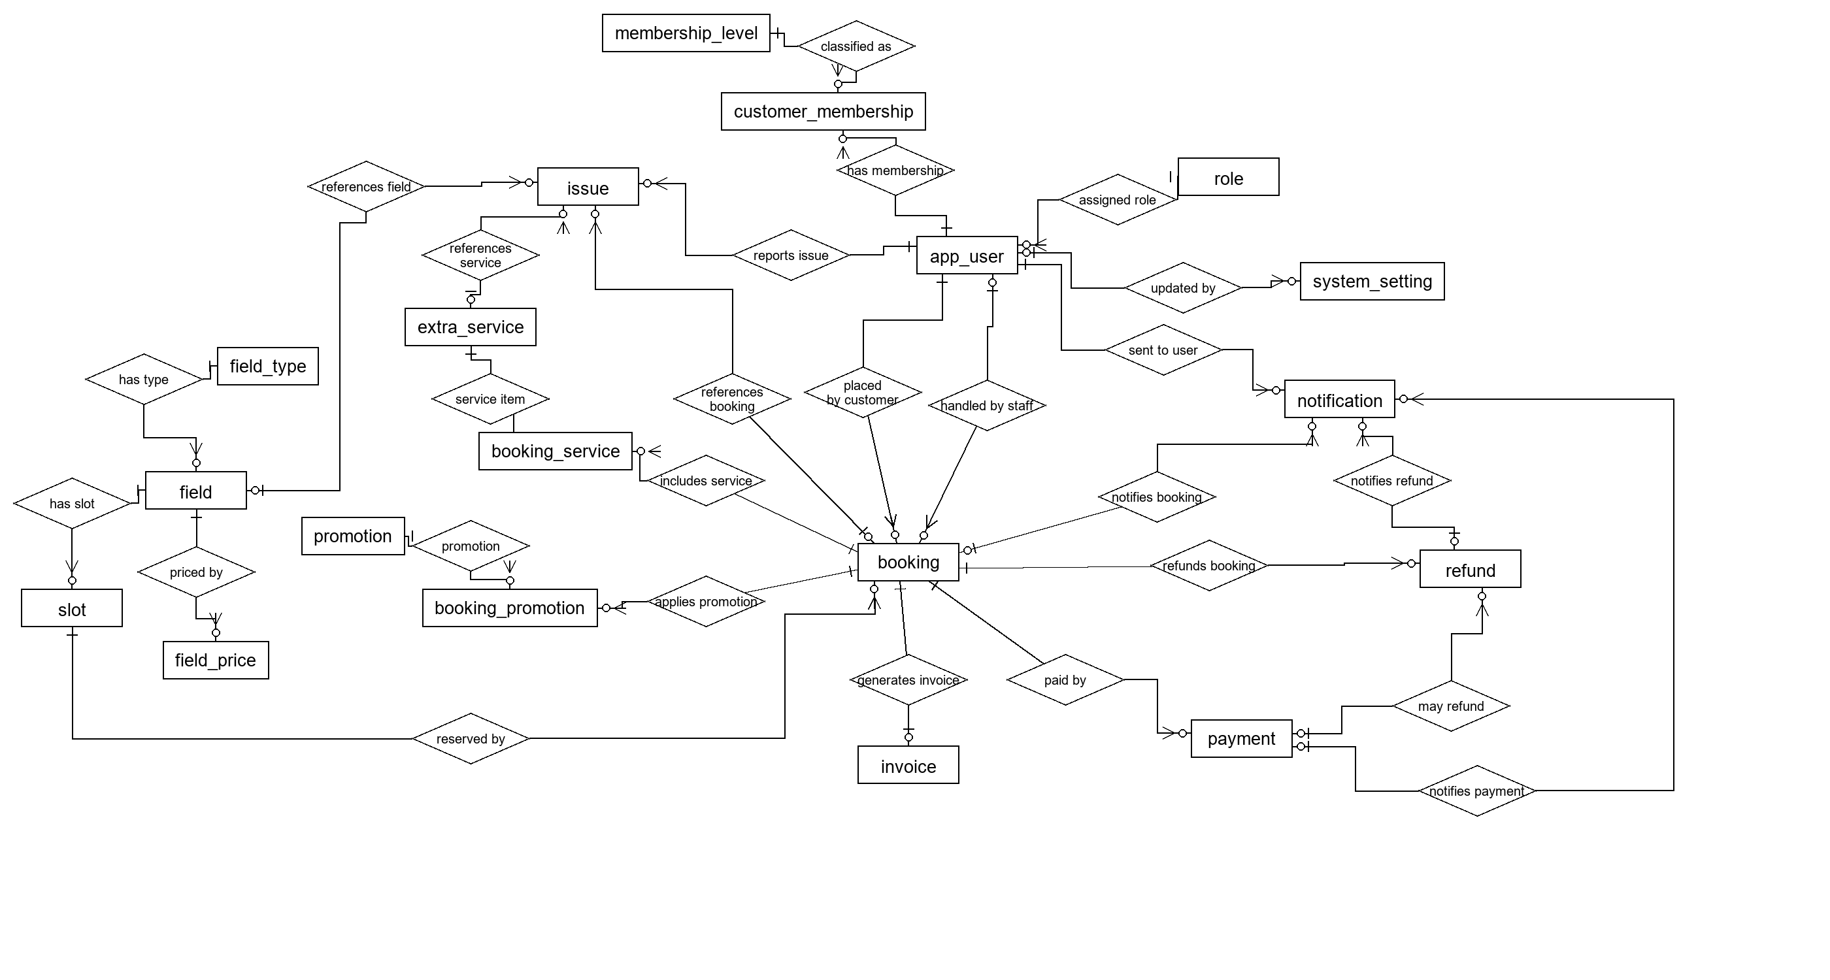

b. Database Schema
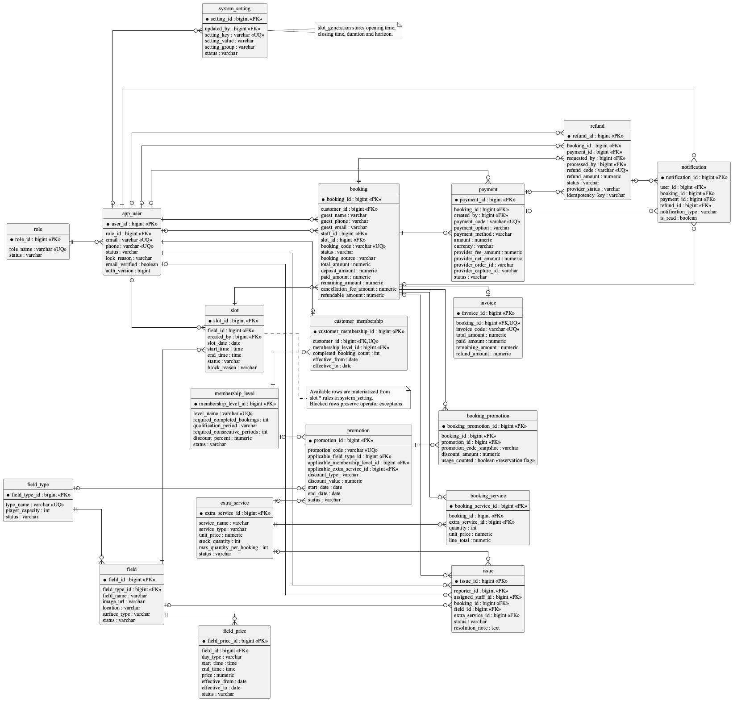

c. Table Descriptions

No | Table | Description
01 | role | Primary key: role_id. Use role, not roles or user_role.
02 | app_user | Primary key: user_id. Stores Customer, Staff, and Admin identities. status is the single persisted source of truth for active/inactive/locked access; lock_reason explains an administrative Customer lock and auth_version revokes JWTs.
03 | membership_level | Primary key: membership_level_id. Stores lifetime/monthly/weekly completed-booking rules with consecutive-week requirements added by V10.
04 | customer_membership | Primary key: customer_membership_id. One row per customer is enforced by later integrity migration.
05 | field_type | Primary key: field_type_id. Normalizes reusable field-type name and player capacity so multiple fields do not duplicate the same catalogue metadata.
06 | field | Primary key: field_id. Physical table is field although the entity is FootballField.
07 | field_price | Primary key: field_price_id. Keeps effective weekday/weekend and time-band prices separate from field identity so pricing can change over time without rewriting a field.
08 | slot | Primary key: slot_id. Unavailable periods are represented by slot.status='blocked'; no unavailable_slot table exists.
09 | booking | Primary key: booking_id. Reserves one slot and stores pricing/lifecycle state. Identity is exclusive: customer_id for a registered Customer, or guest_name and guest_phone (guest_email optional) for a walk-in visitor. Guest details are a booking snapshot, not an account.
10 | extra_service | Primary key: extra_service_id. Use extra_service, not service.
11 | booking_service | Primary key: booking_service_id. Physical table is booking_service although the entity/repository use BookingServiceItem naming.
12 | issue | Primary key: issue_id. Resolution fields are on issue; no issue_resolution table exists.
13 | promotion | Primary key: promotion_id. Applicability dimensions are nullable columns on promotion, not join tables.
14 | booking_promotion | Primary key: booking_promotion_id. Snapshots the applied code and discount for one booking. usage_counted records whether the pending/active booking currently reserves campaign capacity.
15 | payment | Primary key: payment_id. Provider order/capture/status/currency/idempotency fields are on payment; V11 also records the exact provider fee and provider net amount returned by PayPal.
16 | invoice | Primary key: invoice_id. booking_id is unique, so the relationship is one invoice per booking.
17 | refund | Primary key: refund_id. Provider status, idempotency key, and gateway message are added by V9; V11 reconciles completed legacy refunds with booking, invoice, and payment status.
18 | notification | Primary key: notification_id. Supports optional booking_id/payment_id/refund_id, but current shared notifyUser only supplies booking_id.
19 | system_setting | Primary key: setting_id. Stores administrator-editable deposit, refund, payment-timeout, reminder, and automatic slot-generation policies as key/value configuration; it is not redundant field data.

3.2 Code Packages
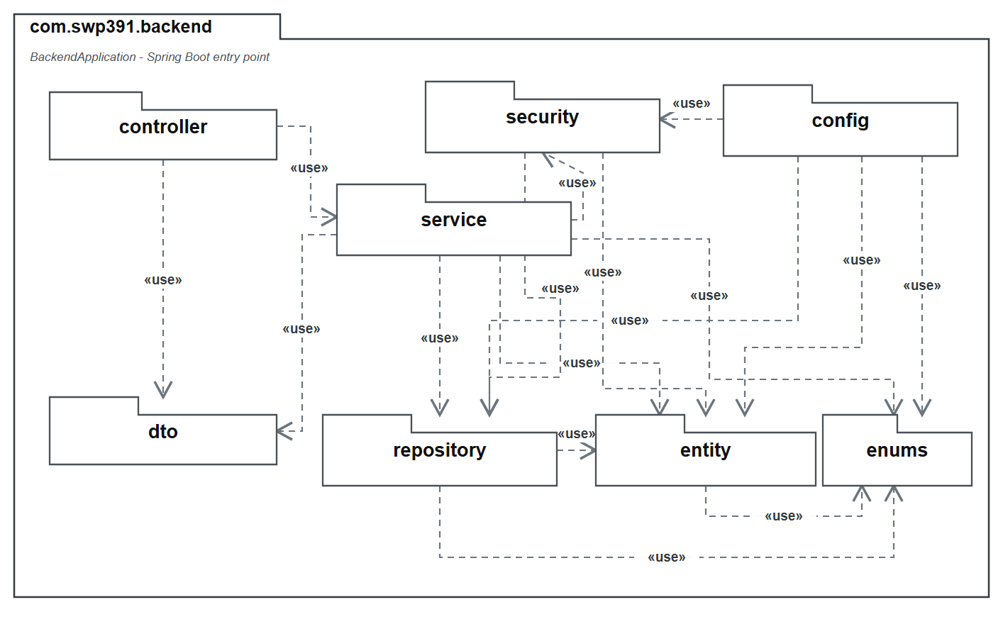

Package descriptions
No | Package | Description
01 | com.swp391.backend | 1 Java file(s): BackendApplication. Count the Spring Boot entry point separately from feature packages.
02 | com.swp391.backend.config | 4 Java file(s): CorsConfig, DataSeeder, PostgresDdlSafetyEnvironmentPostProcessor, SecurityConfig. Authorization rules for many Admin/Staff endpoints live in SecurityConfig, not inside every service method.
03 | com.swp391.backend.controller | 8 Java file(s): AccountController, ApiExceptionHandler, BookingController, FieldOperationController, ImageUploadController, PaymentController, PromotionReportController, and SystemController.
04 | com.swp391.backend.dto | 1 Java file(s): ApiRequests. Request records are nested in one ApiRequests class rather than separate DTO files.
05 | com.swp391.backend.entity | 20 Java file(s): AppUser, AuditEntity, Booking, BookingPromotion, BookingServiceItem, CustomerMembership, ExtraService, FieldPrice, FieldType, FootballField, Invoice, Issue, MembershipLevel, Notification, Payment, Promotion, Refund, Role, Slot, SystemSetting. There are 19 table-backed entities plus the mapped superclass AuditEntity; do not count AuditEntity as a table.
06 | com.swp391.backend.enums | 13 Java file(s): AccountStatus, BookingSource, BookingStatus, CommonStatus, DiscountType, IssueStatus, NotificationType, PaymentMethod, PaymentOption, PaymentStatus, RefundStatus, ServiceType, SlotStatus. Status/value sets are Java enums persisted as strings; they are not lookup tables.
07 | com.swp391.backend.repository | 19 Java file(s): AppUserRepository, BookingPromotionRepository, BookingRepository, BookingServiceItemRepository, CustomerMembershipRepository, ExtraServiceRepository, FieldPriceRepository, FieldTypeRepository, FootballFieldRepository, InvoiceRepository, IssueRepository, MembershipLevelRepository, NotificationRepository, PaymentRepository, PromotionRepository, RefundRepository, RoleRepository, SlotRepository, SystemSettingRepository. Only BookingServiceItemRepository contains explicit JPQL; most queries are Spring Data derived or inherited CRUD.
08 | com.swp391.backend.security | 4 Java file(s): CustomUserDetailsService, JwtAuthenticationFilter, JwtService, SecurityUser. JWT identity and role authorization are cross-cutting implementation components, not persistence entities.
09 | com.swp391.backend.service | 15 Java file(s): AccountService, ApiException, BookingMaintenanceScheduler, BookingWorkflowService, DomainSupportService, FieldOperationService, ImageStorageService, PayPalCheckoutService, PaymentWorkflowService, PromotionReportService, SlotGenerationScheduler, SlotGenerationService, SystemQueryService, VerificationEmailDelivery, and VerificationEmailService.

II. Requirement Specifications

Account and Access

UC-01. Register account
UC ID and Name: | UC-01 Register account
Created By: | BonVT | Date Created: | 30/05/2026
Primary Actor: | Guest | Secondary Actors: | System, Email service
Trigger: | The guest selects Register and submits the registration form.
Description: | A Guest creates a Customer account and completes email verification.
Preconditions: | PRE-1: The guest is not authenticated.  PRE-2: The Customer role and a default membership level are configured.
Postconditions: | POST-1: A unique active Customer account is stored with a BCrypt password hash and email_verified = false.  POST-2: A default customer membership is attached.  POST-3: A JWT session and user summary are returned, and a one-hour verification link is sent or its delivery failure is reported.
Normal Flow: | A. Guest Registers an Account  1. The guest enters full name, email, phone, password, and password confirmation.  2. The system validates required fields, email format, Vietnamese phone format, and password policy.  3. The system verifies that email and phone are not already registered.  4. The system creates an active Customer account and stores the BCrypt password hash.  5. The system creates a 16-character verification token valid for one hour and sends the verification email.  6. The system attaches the default membership level.  7. The system returns the JWT, user summary, verification status, and email delivery status.
Alternative Flow: | A1: Email delivery is delayed  1. The account remains unverified and the Customer can request a new verification email.
Exceptions: | EXC-01: Account or membership persistence fails; the registration transaction is rolled back.
Priority: | Medium
Frequency of Use: | Medium
Business Rules: | BR-01
Other Information: | Password: 8-72 characters, no whitespace, with uppercase, lowercase, number, and special character. Phone: 10 digits starting with 0.
Assumptions: | SMTP and the frontend verification URL are configured; failure to send email does not delete the created account.

UC-02. Login
UC ID and Name: | UC-02 Login
Created By: | BonVT | Date Created: | 30/05/2026
Primary Actor: | Guest/User | Secondary Actors: | System
Trigger: | The user submits an email-or-phone identity and password on the Login screen.
Description: | An active user signs in with email or phone and receives a revocable JWT.
Preconditions: | PRE-1: A registered account exists.
Postconditions: | POST-1: The active user receives a JWT containing role and auth-version claims.  POST-2: last_login_at is updated and the role-aware application area is opened.
Normal Flow: | A. User Logs In  1. The user enters email or phone and password.  2. The system locates the account by exact email, then by phone when needed.  3. The system compares the password with the stored BCrypt hash.  4. The system verifies that account status is active.  5. The system records the login time and returns a JWT plus user summary.  6. The client stores the session and opens the permitted role-based area.
Alternative Flow: | A1: Sign in by phone  1. The user supplies the registered phone number instead of email and continues through the same credential check.
Exceptions: | EXC-01: Account data cannot be loaded; no session is issued.
Priority: | Medium
Frequency of Use: | High
Business Rules: | BR-02
Other Information: | A locked account cannot log in. The login response asks the Customer to check email for the lock reason.
Assumptions: | The JWT signing secret and role data are configured.

UC-03. Logout
UC ID and Name: | UC-03 Logout
Created By: | BonVT | Date Created: | 30/05/2026
Primary Actor: | User | Secondary Actors: | System
Trigger: | The user selects Sign out.
Description: | A signed-in user signs out and invalidates all previously issued JWTs for that account.
Preconditions: | PRE-1: The client has a local authenticated session; the token may still be valid or may already be expired.
Postconditions: | POST-1: The local session is cleared.  POST-2: authVersion is incremented so all JWTs issued earlier for the account are rejected.
Normal Flow: | A. User Logs Out  1. The client calls the authenticated logout endpoint.  2. The server resolves the current account and increments auth_version.  3. The server confirms that the token has been revoked.  4. The client removes all local authentication state.  5. A later request using the old token fails authentication.
Alternative Flow: | A1: Server logout cannot be reached  1. The client still clears its local token; server-side tokens remain subject to expiry until a later successful revocation.
Exceptions: | EXC-01: The logout request fails because the server is unavailable; the client still signs out locally.
Priority: | Low
Frequency of Use: | High
Business Rules: | BR-02
Other Information: | Logout currently means sign out from all sessions because token revocation is account-version based rather than per-token storage.
Assumptions: | JWT validation compares the token auth-version claim with the current account value.

UC-04. Manage personal profile
UC ID and Name: | UC-04 Manage personal profile
Created By: | BonVT | Date Created: | 30/05/2026
Primary Actor: | User | Secondary Actors: | System
Trigger: | An authenticated user opens Profile and submits allowed profile changes.
Description: | A user views and updates only their own editable profile information.
Preconditions: | PRE-1: The requester is authenticated.  PRE-2: The requester updates their own account, or is an Admin updating another account.
Postconditions: | POST-1: Allowed profile fields are updated and the latest user summary is displayed.
Normal Flow: | A. User Updates Profile  1. The system displays the current profile.  2. The user edits full name, phone, and/or address.  3. The system verifies that the requester owns the account.  4. The system validates phone format and uniqueness when phone is supplied.  5. The system stores cleaned values and returns the updated profile.
Alternative Flow: | A1: No profile changes  1. The user leaves without saving and the stored profile remains unchanged.
Exceptions: | EXC-01: Profile persistence fails; the previous stored values remain effective.
Priority: | Medium
Frequency of Use: | Low
Business Rules: | BR-01, BR-02, BR-03
Other Information: | Email, role, status, email-verification, and account-lock fields are not editable through this use case.
Assumptions: | Profile images are outside the approved project scope.

UC-05. Change password
UC ID and Name: | UC-05 Change password
Created By: | BonVT | Date Created: | 30/05/2026
Primary Actor: | User | Secondary Actors: | System
Trigger: | The user submits current password, new password, and confirmation.
Description: | A signed-in user replaces their password after proving the current password.
Preconditions: | PRE-1: The user is authenticated and is changing their own account password.
Postconditions: | POST-1: The new BCrypt password hash is stored.  POST-2: auth_version is incremented and all previously issued JWTs are invalid.
Normal Flow: | A. User Changes Password  1. The user enters the current password and a confirmed new password.  2. The system verifies the current password against the stored hash.  3. The system validates the new password policy and confirmation.  4. The system verifies that the new password differs from the current password.  5. The system stores a new BCrypt hash and revokes all active tokens.  6. The client requires the user to sign in again.
Alternative Flow: | A1: New password matches the current password  1. GoalZone asks the user to choose a different password.
Exceptions: | EXC-01: Password persistence fails; the current password and token version remain in effect.
Priority: | Medium
Frequency of Use: | Low
Business Rules: | BR-02
Other Information: | The same password policy as registration applies.
Assumptions: | The client discards its JWT after a successful password change.

UC-06. Recover password
UC ID and Name: | UC-06 Recover password
Created By: | BonVT | Date Created: | 30/05/2026
Primary Actor: | Guest/User | Secondary Actors: | System, Email service
Trigger: | The user requests a password reset and later opens the emailed reset link.
Description: | A Guest requests, validates, and consumes a one-hour single-use password recovery link.
Preconditions: | PRE-1: The reset-request and reset-password screens are available.
Postconditions: | POST-1: For an eligible account, a one-hour reset token is issued and emailed.  POST-2: After a valid reset, the new BCrypt hash is stored, reset data is cleared, and all JWTs are revoked.
Normal Flow: | A. User Resets a Forgotten Password  1. The user submits an email address.  2. The system validates the email format and returns the same neutral response for registered and unregistered addresses.  3. For an active matching account, the system creates a 16-character reset token and sends a one-hour link.  4. The user opens the link; the system validates user ID, token, and issue time.  5. The user submits and confirms a policy-compliant new password.  6. The system stores the new hash, clears reset fields, revokes prior tokens, and confirms success.
Alternative Flow: | A1: Earlier reset link exists  1. Issuing a new link invalidates the earlier unused link.
Exceptions: | EXC-01: Email delivery fails; the user may submit another reset request without exposing account existence.
Priority: | Medium
Frequency of Use: | Low
Business Rules: | BR-01
Other Information: | The neutral response prevents account enumeration.
Assumptions: | The password-reset frontend URL and SMTP service are configured.

UC-07. View customer accounts
UC ID and Name: | UC-07 View customer accounts
Created By: | BonVT | Date Created: | 30/05/2026
Primary Actor: | Admin | Secondary Actors: | GoalZone booking and issue repositories
Trigger: | An Admin opens People & Access and selects a Customer to inspect.
Description: | An Admin lists Customer accounts and opens business-facing account and activity context in read-only mode.
Preconditions: | PRE-1: The requester is authenticated as Admin.  PRE-2: The selected account has the Customer role.
Postconditions: | POST-1: The Admin sees read-only Customer profile and operational activity context.  POST-2: No Customer data or access state is changed.
Normal Flow: | 1. Admin opens the Customer directory.  2. GoalZone returns Customer accounts only.  3. Admin selects View.  4. GoalZone loads bookings and issues visible as business context.  5. The UI shows names, booking codes, fields, descriptions, statuses, and dates without exposing raw IDs as content.
Alternative Flow: | A1: No activity  1. The Customer detail opens with a clear empty state instead of raw identifiers.
Exceptions: | EXC-1: Non-Admin callers receive 403.  EXC-2: A missing or non-Customer target is rejected.
Priority: | Medium
Frequency of Use: | Medium
Business Rules: | BR-01, BR-02, BR-03, BR-04
Other Information: | UC-07 is deliberately read-only. The security mutation is isolated in UC-08 Lock/unlock customer account.
Assumptions: | SMTP is required for external delivery. The stored account state remains authoritative when email delivery is unavailable.

UC-08. Lock/unlock customer account
UC ID and Name: | UC-08 Lock/unlock customer account
Created By: | BonVT | Date Created: | 30/05/2026
Primary Actor: | Admin | Secondary Actors: | VerificationEmailService and notification repository
Trigger: | An Admin chooses Lock or Unlock for a Customer account.
Description: | An Admin locks or restores Customer sign-in access with a reason, token revocation, and notification.
Preconditions: | PRE-1: The requester is authenticated as Admin.  PRE-2: The target has the Customer role.  PRE-3: Lock includes a non-blank reason.
Postconditions: | POST-1: status and lockReason reflect the decision.  POST-2: authVersion is incremented so older JWTs fail.  POST-3: The Customer receives the relevant email/in-app notification.
Normal Flow: | 1. Admin selects a Customer and chooses Lock.  2. The UI requires a reason.  3. GoalZone validates the actor and target.  4. It sets status=locked, stores the reason, increments authVersion, and notifies the Customer.  5. Unlock later restores status=active, clears the reason, increments authVersion, and sends restoration notice.
Alternative Flow: | A1: Unlock account  1. Admin confirms restoration; GoalZone activates the account, clears the reason, revokes older tokens, and notifies the Customer.
Exceptions: | EXC-1: Non-Admin callers receive 403.  EXC-2: Blank lock reason or non-Customer target is rejected.
Priority: | Medium
Frequency of Use: | Medium
Business Rules: | BR-01, BR-02, BR-03, BR-04
Other Information: | UC-08 changes access state and audit evidence; UC-07 remains the separate read-only directory/detail goal.
Assumptions: | SMTP is required for external delivery. The stored account state remains authoritative when email delivery is unavailable.

UC-09. Manage staff accounts
UC ID and Name: | UC-09 Manage staff accounts
Created By: | BonVT | Date Created: | 30/05/2026
Primary Actor: | Admin | Secondary Actors: | System
Trigger: | The Admin opens People & Access and selects Staff accounts.
Description: | An Admin creates and maintains Staff identity/status while Staff privately owns the invited password.
Preconditions: | PRE-1: The requester is authenticated with the Admin role.  PRE-2: The Staff role is configured.
Postconditions: | POST-1: The Staff account is created or its permitted profile/status fields are updated.  POST-2: A new account has a one-time password-reset token and an invitation email delivery result; the Admin never receives or sets the Staff password.
Normal Flow: | A. Admin Creates or Updates Staff  1. The Admin opens People & Access and selects Staff accounts.  2. For creation, the Admin enters full name, unique email, unique phone, and status.  3. The system creates the verified Staff identity with an unguessable internal credential and issues a one-hour setup token.  4. The system emails a Set my password link and reports delivery status to the Admin.  5. The Staff member follows the link and sets a password that satisfies policy.  6. For later maintenance, the Admin may edit Staff profile/status but cannot change the Staff password.  7. Non-active status revokes existing Staff sessions.
Alternative Flow: | A1: Edit existing Staff account  1. Admin updates identity or status without viewing or replacing the Staff member's password.
Exceptions: | EXC-01: Staff persistence fails; the previous account state remains effective.
Priority: | Medium
Frequency of Use: | Low
Business Rules: | BR-01, BR-02, BR-03
Other Information: | Administrators manage Staff identity and status only. Password ownership stays with the Staff member through invitation, Change password, and Forgot password flows.
Assumptions: | The Staff member controls the destination email inbox and opens the invitation within its one-hour validity window.

UC-10. View customer activity
UC ID and Name: | UC-10 View customer activity
Created By: | BonVT | Date Created: | 30/05/2026
Primary Actor: | Admin | Secondary Actors: | Admin, Customer, System
Trigger: | Staff selects a customer while handling a booking or support case.
Description: | An Admin opens an operational activity drill-down for one Customer using business context rather than raw IDs.
Preconditions: | PRE-1: The requester has Admin role.  PRE-2: The selected Customer account exists.
Postconditions: | POST-1: The system returns the customer summary, up to 20 recent bookings, completed-booking count, and up to 20 reported issues.
Normal Flow: | A. Admin Views Customer Activity  1. Admin selects View for a Customer in People & access.  2. The system verifies Admin access.  3. The system loads the Customer summary.  4. The system loads recent bookings in descending booking-ID order and counts all completed bookings.  5. The system loads recent issues reported by the Customer.  6. The system displays the consolidated read-only activity view.
Alternative Flow: | A1: No activity in the selected context  1. GoalZone shows an empty operational summary and leaves the Customer account unchanged.
Exceptions: | EXC-01: Account state data cannot be loaded; the system shows an error instead of partial invented data.
Priority: | Low
Frequency of Use: | Medium
Business Rules: | BR-02, BR-03
Other Information: | This is an operational customer-history view, not the aggregate Admin report in UC-56.
Assumptions: | Recent-list limits are sufficient for the Staff workflow.

Fields, Slots, Services, and Issues

UC-11. View field list
UC ID and Name: | UC-11 View field list
Created By: | BaoNG | Date Created: | 30/05/2026
Primary Actor: | Guest/Customer | Secondary Actors: | GoalZone catalogue API
Trigger: | The visitor opens the Home or Fields page.
Description: | A visitor views active football fields and their catalogue context.
Preconditions: | PRE-1: The application and public GET /api/fields endpoint are available.  PRE-2: At least one FootballField may exist; no authentication is required.
Postconditions: | POST-1: Active fields are returned and rendered as selectable field cards.  POST-2: No field, slot or booking data is changed.
Normal Flow: | A. View field list  1. The visitor navigates to Home or Fields.  2. The frontend requests GET /api/fields.  3. The service queries fields whose status is active.  4. The API maps the catalogue attributes for each active field.  5. The frontend renders each active field and lets the visitor open its details.
Alternative Flow: | A1: No active fields  1. The catalogue displays an explicit no-fields message.
Exceptions: | EXC-1: A catalogue request failure prevents the current list from loading.  EXC-2: Inactive fields are deliberately omitted from this endpoint.
Priority: | Low
Frequency of Use: | Frequent; normally every public browsing session
Business Rules: | BR-05
Other Information: | Implementation rule: Only fields with CommonStatus.active are listed publicly. Basic price is not included in the implemented list response.  Backend: FieldOperationController.fields and FieldOperationService.fields. Frontend: FieldsPage.
Assumptions: | Guests and authenticated customers use the same public catalogue response.

UC-12. View field detail
UC ID and Name: | UC-12 View field detail
Created By: | BaoNG | Date Created: | 30/05/2026
Primary Actor: | Guest/Customer | Secondary Actors: | GoalZone catalogue API
Trigger: | The visitor selects a field card.
Description: | A visitor views the selected field, images, facilities, prices, and active services.
Preconditions: | PRE-1: The selected field ID exists.  PRE-2: No authentication is required.
Postconditions: | POST-1: The field-detail modal displays the returned information.  POST-2: The visitor may continue to availability search with the field/type filters preselected.
Normal Flow: | A. View field detail  1. The visitor selects an active field card.  2. The frontend requests GET /api/fields/{fieldId}.  3. The service loads active price rules and calculates minimum/maximum prices.  4. The service gathers globally active extra services and the next five unblocked, unreserved slots in an eight-day window.  5. The modal displays field facts, price bands, add-ons and a Check availability action.
Alternative Flow: | A1: Optional services are unavailable  1. The field detail remains viewable and states that no active add-ons are configured.
Exceptions: | EXC-1: A nonexistent field ID returns not found.  EXC-2: An inactive or unknown field ID returns not found.  EXC-3: Reviews always return an empty list because there is no review model.
Priority: | Low
Frequency of Use: | Frequent; commonly before availability search
Business Rules: | BR-05, BR-06
Other Information: | Implementation rule: Only active field-price rows contribute to detail pricing. Availability excludes blocked slots and slots reserved by pending, confirmed or checked-in bookings. Services are not field-specific in the schema.  The frontend does not render a review area or the returned availability summary; it renders field facts, price bands and services.
Assumptions: | Catalogue navigation supplies an active field ID, even though the endpoint itself does not enforce active status.

UC-13. Search available fields by date/time
UC ID and Name: | UC-13 Search available fields by date/time
Created By: | BaoNG | Date Created: | 30/05/2026
Primary Actor: | Guest/Customer | Secondary Actors: | GoalZone slot-search service
Trigger: | The visitor opens booking search or changes the playing date or field type.
Description: | A visitor searches generated, priced, non-blocked field slots whose start time is still in the future, with optional filters.
Preconditions: | PRE-1: At least one active field exists and the four slot-generation rules are active.  PRE-2: No authentication is required for ordinary slot search.
Postconditions: | POST-1: Missing non-overlapping slots for the requested date are materialized idempotently.  POST-2: Only matching future-start rows are displayed with price and availability; an available row may continue to checkout.
Normal Flow: | 1. The visitor opens availability search.  2. The visitor chooses a date and may filter by field type or field.  3. GoalZone prepares any missing slots under the active venue schedule.  4. GoalZone excludes elapsed starts and marks booked or blocked rows unavailable.  5. GoalZone prices matching rows and displays the daily result.  6. The visitor may select only an available row and continue to checkout.
Alternative Flow: | A1: No date supplied  1. GoalZone uses tomorrow as the default search date.  A2: No available result  1. Booked and blocked rows remain unavailable and the UI shows that no selectable slots match.
Exceptions: | EXC-1: Past dates and stale direct checkout/create attempts are rejected.  EXC-2: Dates beyond the configured generation horizon are rejected.  EXC-3: A database or network error prevents results from refreshing.
Priority: | High
Frequency of Use: | Very frequent; expected before each new booking
Business Rules: | BR-05, BR-06, BR-07, BR-08, BR-09
Other Information: | Booked/blocked preservation and price matching are business rules within the search. Scheduled rolling-calendar extension is background behavior owned by UC-16, not an alternative visitor action.
Assumptions: | The venue uses one global operating schedule for all active fields; field-specific hours may be introduced later without changing the booking lifecycle.

UC-14. Manage football fields
UC ID and Name: | UC-14 Manage football fields
Created By: | BaoNG | Date Created: | 30/05/2026
Primary Actor: | Admin | Secondary Actors: | GoalZone field repository
Trigger: | An administrator opens the Fields section of the Admin console or selects a field to edit.
Description: | An Admin creates, updates, activates, deactivates, and uploads images for football fields.
Preconditions: | PRE-1: The user is authenticated with the Admin role.  PRE-2: A field type exists for the field being saved.
Postconditions: | POST-1: A new or updated field is persisted.  POST-2: Public catalogue/search visibility reflects active or inactive status.
Normal Flow: | A. Manage football fields  1. Admin opens managed fields.  2. The system loads all fields, including inactive rows.  3. Admin enters field type, name, location, surface, optional description/image, and status.  4. The backend validates required values and saves the field.  5. The Admin console refreshes the managed list.
Alternative Flow: | A1: Deactivate field  1. Admin confirms deactivation; the field remains in administration history but disappears from public selection.
Exceptions: | EXC-1: Missing name, location, surface or field type is rejected.  EXC-2: An unknown field or field type returns not found.  EXC-3: Direct booking and reschedule reject slots owned by an inactive field.
Priority: | Medium
Frequency of Use: | Occasional; during setup and facility changes
Business Rules: | BR-02, BR-03, BR-30
Other Information: | Implementation rule: Status values are active/inactive. There is no delete endpoint. Public endpoints normally expose only active fields.  Admin endpoints are under /api/admin/fields and are protected by SecurityConfig.
Assumptions: | Existing bookings remain associated with a field after it is deactivated.

UC-15. Manage field pricing by time range
UC ID and Name: | UC-15 Manage field pricing by time range
Created By: | BaoNG | Date Created: | 30/05/2026
Primary Actor: | Admin | Secondary Actors: | GoalZone pricing service
Trigger: | Admin selects a field's pricing configuration.
Description: | An Admin maintains effective weekday/weekend price bands without any fallback price.
Preconditions: | PRE-1: The user is authenticated as Admin.  PRE-2: The target football field exists.
Postconditions: | POST-1: The pricing rule is persisted and visible in field detail/admin pricing.  POST-2: Active matching rules may affect checkout pricing.
Normal Flow: | A. Manage field pricing by time range  1. Admin selects a field and opens its price rows.  2. The frontend loads all active and inactive price rows for that field.  3. Admin enters day type, start/end time, positive USD price, optional effective dates and status.  4. The backend validates the values and saves the row.  5. The UI refreshes pricing and public field detail shows active bands.
Alternative Flow: | A1: Retire a price band  1. Admin marks the rule inactive; other effective non-overlapping rules continue to price slots.
Exceptions: | EXC-1: Price must be greater than zero.  EXC-2: Start time must precede end time.  EXC-3: Day type must be all, weekday or weekend.  EXC-4: Effective-from cannot be after effective-to.  EXC-5: An active rule overlapping the same applicable day, time, and effective-date range is rejected.
Priority: | High
Frequency of Use: | Occasional; more often around pricing changes
Business Rules: | BR-02, BR-03, BR-06, BR-30
Other Information: | Implementation rule: Calculation matches active rows by weekday/weekend or all and containment of the slot time. It applies effective-from/effective-to dates; overlapping active rules are rejected when configured.  Currency is USD throughout the code-first project.
Assumptions: | Every bookable slot must match an active pricing rule.

UC-16. Configure slot generation rules
UC ID and Name: | UC-16 Configure slot generation rules
Created By: | BaoNG | Date Created: | 30/05/2026
Primary Actor: | Admin | Secondary Actors: | SlotGenerationService and Scheduler
Trigger: | Admin saves opening time, closing time, slot duration, or rolling horizon.
Description: | An Admin configures opening time, closing time, duration, and the rolling generation horizon.
Preconditions: | PRE-1: The requester is authenticated as Admin.  PRE-2: The combined rule set is complete.
Postconditions: | POST-1: The validated setting is stored.  POST-2: Only unbooked available auto-generated rows are rebuilt; bookings and blocks are preserved.
Normal Flow: | 1. Admin opens Policies and edits a slot rule.  2. GoalZone validates HH:mm times, duration, divisibility, and 1–90 day horizon.  3. It stores the setting.  4. SlotGenerationService rebuilds the rolling window idempotently.  5. Search and operations calendar use the new rules.
Alternative Flow: | A1: Scheduled horizon extension  1. The scheduler applies the saved rules to extend the rolling calendar without changing those rules.
Exceptions: | EXC-1: Opening must precede closing.  EXC-2: Duration must be 30–360 minutes in 30-minute steps and divide the operating window.  EXC-3: Horizon outside 1–90 days is rejected.
Priority: | High
Frequency of Use: | Occasional; whenever maintenance, weather or internal use affects a field
Business Rules: | BR-02, BR-03, BR-09
Other Information: | This Admin policy flow is separate from the Venue Staff exception flow in UC-17.
Assumptions: | Only unbooked rows originally generated by the system are replaceable when rules change.

UC-17. Block/unblock field slots
UC ID and Name: | UC-17 Block/unblock field slots
Created By: | BaoNG | Date Created: | 30/05/2026
Primary Actor: | Staff | Secondary Actors: | Booking and slot repositories
Trigger: | Venue Staff must record or remove an operational field exception.
Description: | Venue Staff records or removes operational exceptions without overwriting active bookings.
Preconditions: | PRE-1: The requester is authenticated as Staff.  PRE-2: Field, future date, valid time range, and block reason are supplied.
Postconditions: | POST-1: Every overlapping eligible slot is blocked, or one blocked row is restored.  POST-2: Customer search and the operation calendar immediately reflect the exception.
Normal Flow: | 1. Staff chooses field, date, time range, reason, and optional note.  2. GoalZone loads overlapping slots and active bookings.  3. With no conflict, it blocks every overlap or records a future exception row.  4. Staff later selects Unblock to restore the chosen blocked row.  5. The calendar refreshes.
Alternative Flow: | A1: Future exception outside generated rows  1. Staff records the exception and later slot generation preserves it.  A2: Restore blocked slot  1. Staff selects Unblock and GoalZone makes the row available again when no booking occupies it.
Exceptions: | EXC-1: Past date, invalid range, or blank reason is rejected.  EXC-2: Any overlapping active booking blocks the operation.  EXC-3: Admin and Customer callers receive 403.
Priority: | High
Frequency of Use: | Occasional; whenever maintenance, weather or internal use affects a field
Business Rules: | BR-02, BR-03, BR-09
Other Information: | Block/Unblock is for exceptions only; UC-16 owns the ordinary automatic slot-generation policy.
Assumptions: | Only unbooked rows originally generated by the system are replaceable when rules change.

UC-18. View field operation calendar
UC ID and Name: | UC-18 View field operation calendar
Created By: | BaoNG | Date Created: | 30/05/2026
Primary Actor: | Staff | Secondary Actors: | Admin (backend/API only)
Trigger: | Staff selects the Field schedule tab or changes its date.
Description: | Venue Staff views generated available, blocked, and booked field slots for one date.
Preconditions: | PRE-1: The caller has Staff or Admin backend authority; Staff owns the current React calendar.  PRE-2: Slot-generation rules are valid for the requested date.
Postconditions: | POST-1: The requested date exists in the rolling calendar and the operator sees available, blocked, and booked states.  POST-2: Viewing does not change bookings or block exceptions.
Normal Flow: | A. View field operation calendar  1. Staff opens Field schedule or changes its date.  2. The frontend requests GET /api/operations/calendar?date=... .  3. The backend materializes any missing slots from Admin rules.  4. It loads slots and bookings, sorts by field/time, and derives operationalStatus.  5. The UI displays field, time, booking/customer or block reason, and status.
Alternative Flow: | A1: Empty operating day  1. The calendar shows generated available rows even when no bookings or blocks exist.
Exceptions: | EXC-1: Unauthenticated and Customer callers are forbidden.  EXC-2: Past or beyond-horizon operation dates are rejected by the generation rules.
Priority: | Medium
Frequency of Use: | Daily and throughout venue operation
Business Rules: | BR-02, BR-03
Other Information: | Implementation rule: booking status takes precedence over slot status in the operational display; Block/Unblock remains adjacent to this calendar.
Assumptions: | The calendar is a daily operations view rather than a month-grid planning engine.

UC-19. Manage extra services
UC ID and Name: | UC-19 Manage extra services
Created By: | BaoNG | Date Created: | 30/05/2026
Primary Actor: | Admin | Secondary Actors: | GoalZone service catalogue
Trigger: | Admin opens the Services section or selects an existing add-on.
Description: | An Admin maintains priced rental, sale, and staff services and their limits/status.
Preconditions: | PRE-1: The user is authenticated as Admin.
Postconditions: | POST-1: The service record is saved.  POST-2: Only active services appear in public field detail and booking selection.
Normal Flow: | A. Manage extra services  1. Admin opens managed services.  2. Admin enters name, type, unit, unit price, optional description, stock, per-booking maximum and status.  3. The backend validates and saves the service.  4. The frontend reloads the managed service catalogue.  5. The managed list refreshes.
Alternative Flow: | A1: Deactivate an existing service  1. Admin retires the service from new selection while preserving it on historical bookings.
Exceptions: | EXC-1: Name and unit are required.  EXC-2: Unit price and stock cannot be negative.  EXC-3: A per-booking maximum, when provided, must be at least one.  EXC-4: There is no delete endpoint.
Priority: | Medium
Frequency of Use: | Occasional; catalogue maintenance
Business Rules: | BR-02, BR-03, BR-10, BR-30
Other Information: | Implementation rule: Allowed service types are rental, sale and staff_service. Null stock means no shared-inventory cap.  Services are global; there is no field-to-service mapping.
Assumptions: | Deactivating a service does not delete historical booking-service snapshots.

UC-20. Add extra services to booking
UC ID and Name: | UC-20 Add extra services to booking
Created By: | BaoNG | Date Created: | 30/05/2026
Primary Actor: | Customer/Staff | Secondary Actors: | Admin (walk-in backend/API only), GoalZone pricing/invoice services
Trigger: | The actor selects add-ons before creating a booking.
Description: | Customer or Staff selects validated extra services while creating a booking.
Preconditions: | PRE-1: A slot has been selected.  PRE-2: Each selected service passes included active, quantity, and overlapping-stock validation.  PRE-3: The actor is a Customer creating their own online booking or an operator creating a walk-in.
Postconditions: | POST-1: BookingServiceItem rows are stored with price snapshots.  POST-2: Booking total, discounts, deposit and remaining amount include service value.  POST-3: The generated invoice includes service amount after payment/completion.
Normal Flow: | A. Add extra services to booking  1. The actor chooses services and quantities in checkout.  2. Checkout preview validates them and recalculates service and total amounts.  3. The actor creates the online or walk-in booking.  4. The backend revalidates services and stores one snapshot item per selection.  5. Payment capture or completion creates/updates an invoice with the service amount.
Alternative Flow: | A1: No add-on selected  1. Booking continues with field price only.
Exceptions: | EXC-1: Any included service-validation failure rejects the preview/create request.  EXC-2: Inactive services cannot be newly added even if their ID is known.
Priority: | Medium
Frequency of Use: | Frequent; optional per booking
Business Rules: | BR-10, BR-11
Other Information: | Implementation rule: Service prices are snapshotted at booking time. Membership discount is applied only to online bookings; walk-ins receive no membership discount.  The Staff UI combines walk-in booking creation with immediate cash deposit/full capture.
Assumptions: | The selected service catalogue remains unchanged between preview and creation; the backend revalidates if it changes.

UC-21. Update extra services before check-in
UC ID and Name: | UC-21 Update extra services before check-in
Created By: | BaoNG | Date Created: | 30/05/2026
Primary Actor: | Customer/Staff | Secondary Actors: | Admin (backend/API only), invoice and notification services
Trigger: | The booking owner or operator saves a replacement set of add-ons.
Description: | The booking owner or Venue Staff edits add-ons before start and the system recalculates all financial effects.
Preconditions: | PRE-1: The booking exists and is pending or confirmed.  PRE-2: A Customer owns the booking, or the caller is Venue Staff.  PRE-3: The replacement selections pass active, quantity and overlapping-inventory checks.
Postconditions: | POST-1: Old booking-service rows are replaced by the submitted set.  POST-2: All monetary snapshots and the invoice are updated in the same transaction.  POST-3: The customer receives an in-app booking notification.
Normal Flow: | A. Update extra services before check-in  1. The actor opens a pending/confirmed booking and adjusts quantities.  2. The frontend submits PUT /api/bookings/{id}/services with the complete selection list.  3. The backend checks visibility and lifecycle state, then validates inventory excluding the current booking.  4. The system recalculates applicable discounts and total/balance/refundable delta.  5. The system replaces service rows, updates the invoice and notifies the customer.
Alternative Flow: | A1: Remove all add-ons  1. The user saves zero quantities and GoalZone recalculates the invoice without service charges.
Exceptions: | EXC-1: Checked-in, completed, cancelled, rejected, expired and no-show bookings cannot be edited.  EXC-2: A Customer cannot edit another customer's booking.  EXC-3: Unavailable/inactive selections and edits at or after the booked start time are rejected.
Priority: | Medium
Frequency of Use: | Occasional; before check-in
Business Rules: | BR-10, BR-11
Other Information: | Implementation rule: The submitted list is a full replacement. Promotion eligibility is recalculated against the proposed services; membership discount remains online-only.  Customer Account and Venue Staff workspace expose editors; Admin is read-only for booking audit.
Assumptions: | Any refundable delta is handled by the separate refund workflow.

UC-22. Report field/service issue
UC ID and Name: | UC-22 Report field/service issue
Created By: | BaoNG | Date Created: | 30/05/2026
Primary Actor: | Customer/Staff | Secondary Actors: | Admin, GoalZone issue repository
Trigger: | An authenticated user submits an issue report.
Description: | An authenticated Customer or Staff member reports a described issue under their own identity.
Preconditions: | PRE-1: The reporter is authenticated.  PRE-2: The issue title and description are provided.  PRE-3: A Customer-linked booking, if present, belongs to that customer.
Postconditions: | POST-1: An open Issue row is persisted under the authenticated reporter.  POST-2: Venue Staff can handle it; Admin may inspect it as audit context.
Normal Flow: | A. Report field/service issue  1. The reporter opens the issue form and provides title/description.  2. The reporter optionally relates the issue to a permitted booking or field.  3. The backend derives the reporter from authentication and verifies booking ownership for Customers.  4. The backend resolves any supplied booking, field, service or Staff assignment references.  5. The issue is saved with status open.
Alternative Flow: | A1: General issue  1. The reporter leaves booking and field blank and submits a venue-level issue.
Exceptions: | EXC-1: Unauthenticated requests are rejected.  EXC-2: A Customer cannot report against another customer's booking.  EXC-3: Blank title or description is rejected.  EXC-4: Booking, field, and service links must agree with the selected booking.
Priority: | Medium
Frequency of Use: | Occasional; event-driven
Business Rules: | BR-02, BR-29
Other Information: | Implementation rule: Reporter identity is always the authenticated principal. Venue Staff is self-assigned; Customers cannot retrieve the global issue list.  Customer UI supports booking, field or general reports; direct extra-service linking exists only at API level.
Assumptions: | An issue may legitimately relate to more than one optional target in raw API usage.

UC-23. Resolve field/service issue
UC ID and Name: | UC-23 Resolve field/service issue
Created By: | BaoNG | Date Created: | 30/05/2026
Primary Actor: | Staff | Secondary Actors: | Admin (backend/API only), notification service
Trigger: | An operator starts, resolves or rejects an issue.
Description: | Venue Staff progresses an open issue to a terminal resolved or rejected state with notes.
Preconditions: | PRE-1: The issue exists.  PRE-2: The caller is Venue Staff.
Postconditions: | POST-1: Issue status, assignment, resolution note and resolved timestamp reflect the update.  POST-2: The reporter receives an in-app issue notification.
Normal Flow: | A. Resolve field/service issue  1. Staff opens Issues & refunds and reviews open/in-progress issues.  2. Staff optionally starts the issue, assigning it to themself in the current UI.  3. Staff enters a resolution note and selects Resolve.  4. The backend validates the closing note and records resolvedAt.  5. The backend stores resolved status/time and sends a reporter notification.
Alternative Flow: | A1: Reject report  1. Staff records a reason and closes the report as rejected rather than resolved.
Exceptions: | EXC-1: Customer callers are forbidden.  EXC-2: Resolved/rejected updates without a nonblank resolution note are rejected.  EXC-3: Closed issues cannot be reopened, and the browser cannot choose an assignee identity.
Priority: | Medium
Frequency of Use: | Daily or as reports arrive
Business Rules: | BR-02, BR-03, BR-29
Other Information: | Implementation rule: Statuses are open, in_progress, resolved and rejected. The service enforces open -> in_progress/resolved/rejected and in_progress -> resolved/rejected.  There is no service replacement or refund automatically coupled to issue resolution; operators use separate booking/refund actions.
Assumptions: | Resolution notes contain enough operational detail for later review.

Booking and Venue Operations

UC-24. Create online booking
UC ID and Name: | UC-24 Create online booking
Created By: | NgocPA | Date Created: | 30/05/2026
Primary Actor: | Customer | Secondary Actors: | PayPal sandbox, pricing/promotion/membership/inventory services
Trigger: | A verified Customer starts PayPal checkout after selecting a slot and payment option.
Description: | A Customer creates a validated pending online booking and continues to PayPal Sandbox.
Preconditions: | PRE-1: The actor is authenticated as the same Customer identified by customerId.  PRE-2: The Customer email is verified and `status` is `active`.  PRE-3: The slot exists, is not blocked, is not before today's date, and has no active booking.  PRE-4: Selected services and promotion are valid.
Postconditions: | POST-1: A pending online booking and any service/promotion snapshots are stored.  POST-2: The slot is reserved against another active booking.  POST-3: The Customer receives a Booking created in-app notification.  POST-4: After valid PayPal capture of at least the deposit, the booking is confirmed and invoiced.
Normal Flow: | A. Create online booking  1. Customer searches and selects an available slot, add-ons, promotion and deposit/full option.  2. The public preview calculates the checkout amounts.  3. The frontend creates a pending online booking before opening PayPal.  4. The backend revalidates identity, account lock, verification, slot, services and pricing and stores snapshots.  5. Customer authorizes sandbox payment; server-side capture validates provider amount/currency.  6. Payment updates paid/remaining amounts, confirms the pending booking and generates the invoice.
Alternative Flow: | A1: Pay full amount  1. The Customer chooses full payment instead of the default deposit before PayPal approval.
Exceptions: | EXC-1: Venue Staff cannot create online bookings; Customers cannot create walk-ins.  EXC-2: Unverified, locked, or wrong-owner Customer requests are forbidden.  EXC-3: Blocked, past-date or actively reserved slots are rejected.  EXC-4: A same-day slot whose start time has elapsed is rejected.  EXC-5: Database active-slot uniqueness is the concurrency backstop for simultaneous requests.
Priority: | High
Frequency of Use: | Frequent; core customer transaction
Business Rules: | BR-04, BR-05, BR-06, BR-07, BR-08, BR-09, BR-10, BR-21, BR-22
Other Information: | Implementation rule: Online source starts pending. Membership discount applies only online. Active statuses reserve a slot. Deposit percent comes from system settings. Payment is a subsequent operation, not atomic with booking creation.  Online payment is Customer-only and PayPal Sandbox-only in current scope.
Assumptions: | Normal UI navigation supplies an active-field, current/future available slot.

UC-25. Create walk-in booking
UC ID and Name: | UC-25 Create walk-in booking
Created By: | NgocPA | Date Created: | 30/05/2026
Primary Actor: | Staff | Secondary Actors: | Booking, payment, and invoice repositories
Trigger: | Venue Staff receives a walk-in request from a registered Customer or a first-time visitor.
Description: | Venue Staff creates a walk-in booking for either a matched Customer account or a first-time visitor identified by name and phone, then records cash or leaves payment pending.
Preconditions: | PRE-1: The caller is authenticated Venue Staff in both UI and API.  PRE-2: Staff either selects an active Customer matched by phone/email or supplies a first-time visitor's name and phone.  PRE-3: A bookable future slot is selected; services and promotion are valid.
Postconditions: | POST-1: The slot is reserved under the Staff identity and exactly one customer identity: registered account or guest contact snapshot.  POST-2: Pay later remains pending; successful deposit/full cash confirms the booking and updates its invoice.  POST-3: A failed immediate cash transaction leaves neither a partial booking nor payment.
Normal Flow: | 1. Staff opens Walk-in booking and searches by phone or email.  2. GoalZone returns a matching active Customer and Staff confirms that account.  3. Staff selects date, slot, services, and optional promotion.  4. Staff chooses deposit or full cash payment.  5. GoalZone validates the request and atomically stores the booking and cash transaction.  6. GoalZone confirms the booking, updates the invoice, and opens it in Staff operations.
Alternative Flow: | A1: First-time visitor has no account  1. Staff selects First-time visitor after no account matches the supplied phone or email.  2. Staff enters the visitor's name, phone, and optional email.  3. GoalZone stores those details on the booking without creating an account, then continues at Normal Flow step 3.  A2: Pay later  1. Staff chooses Pay later instead of immediate cash.  2. GoalZone creates a pending booking with the full balance remaining and no payment row.
Exceptions: | EXC-1: Missing customer identity, unavailable slot, invalid service, or ineligible promotion is rejected.  EXC-2: A first-time visitor requires a non-blank name and phone; email is optional.  EXC-3: If immediate cash capture fails, the create-and-pay transaction is rolled back.  EXC-4: Non-Staff callers receive 403.
Priority: | Medium
Frequency of Use: | Frequent at the venue
Business Rules: | BR-05, BR-06, BR-07, BR-08, BR-09, BR-10, BR-12
Other Information: | The guest contact is stored only on the booking and does not create a Customer account. Guest walk-ins receive no membership discount, account notification, or PayPal checkout; Staff manages their booking and any cash refund at the venue.
Assumptions: | Staff verifies either the matched Customer account or the first-time visitor's contact details before confirming the booking.

UC-26. View booking detail
UC ID and Name: | UC-26 View booking detail
Created By: | NgocPA | Date Created: | 30/05/2026
Primary Actor: | Customer/Staff | Secondary Actors: | Admin
Trigger: | The actor selects a booking in Customer Account or Staff operations.
Description: | An authorized user views slot, service, promotion, payment, invoice, and refund detail for a booking.
Preconditions: | PRE-1: The actor is authenticated.  PRE-2: The booking exists.  PRE-3: A Customer owns the booking, or the actor is Staff/Admin.
Postconditions: | POST-1: The permitted actor sees current booking and billing detail.  POST-2: No data is changed.
Normal Flow: | A. View booking detail  1. The actor selects a booking.  2. The frontend requests GET /api/bookings/{bookingId}.  3. The service checks Customer ownership or operator role.  4. The service aggregates booking, service items, transactions, promotions, invoice, refunds and payment state.  5. The appropriate account/staff panels render the result.
Alternative Flow: | A1: No payments or refunds yet  1. The booking detail shows the invoice with explicit empty transaction sections.
Exceptions: | EXC-1: A Customer requesting another customer's booking receives forbidden.  EXC-2: A nonexistent booking returns not found.
Priority: | Low
Frequency of Use: | Frequent; throughout booking and venue workflows
Business Rules: | BR-02, BR-03
Other Information: | Implementation rule: Staff/Admin can view any booking. Payment status is derived from completed refunds, booking expiry, failed payments, paid and remaining amounts.  The endpoint is authenticated by SecurityConfig; seeding code may call the same service internally without HTTP authentication.
Assumptions: | Historical monetary fields are trustworthy booking snapshots.

UC-27. View my bookings
UC ID and Name: | UC-27 View my bookings
Created By: | NgocPA | Date Created: | 30/05/2026
Primary Actor: | Customer | Secondary Actors: | GoalZone booking repository
Trigger: | Customer opens My bookings/Account.
Description: | A Customer views current and past owned bookings.
Preconditions: | PRE-1: The Customer is authenticated.
Postconditions: | POST-1: Only that Customer's booking summaries are listed.  POST-2: No data changes merely by viewing the list.
Normal Flow: | A. View my bookings  1. Customer opens Account.  2. The frontend requests the bookings endpoint with the current customer ID.  3. The service forces non-operator callers to their own user ID.  4. The repository returns that Customer's bookings in descending booking ID order.  5. The UI displays all returned current and historical bookings and loads the selected booking detail.
Alternative Flow: | A1: No bookings  1. The Customer sees an empty state with a direct action to start a booking.
Exceptions: | EXC-1: A Customer cannot request another customer's list.  EXC-2: The implemented Customer list has no date/status filtering; supplying date does not narrow the result because customer lookup takes precedence.
Priority: | Low
Frequency of Use: | Frequent; before and after bookings
Business Rules: | BR-02
Other Information: | Implementation rule: Customer scoping is enforced server-side regardless of the customerId submitted by the client.  The Account page organizes actions in tabs but does not expose booking list filters.
Assumptions: | Descending booking ID approximates newest-first creation order.

UC-28. View booking calendar
UC ID and Name: | UC-28 View booking calendar
Created By: | NgocPA | Date Created: | 30/05/2026
Primary Actor: | Staff | Secondary Actors: | Admin (backend/API only)
Trigger: | Staff opens the booking queue or selects a date in the operational schedule.
Description: | Venue Staff views the daily booking queue by field and date.
Preconditions: | PRE-1: Venue Staff is authenticated in the React workspace and protected API.
Postconditions: | POST-1: Staff can select a booking for lifecycle actions and billing detail.  POST-2: No booking changes merely by viewing.
Normal Flow: | A. View booking calendar  1. Staff opens Staff workspace.  2. The application loads the operator-visible booking list.  3. Staff selects a booking to view detail and lifecycle controls.  4. The application displays the selected booking's invoice/payment information and available state transitions.  5. For a field/date schedule, Staff opens Field schedule and the app loads /api/operations/calendar for that date.
Alternative Flow: | A1: Filter to past records  1. Staff selects a previous operating date and reviews historical bookings without changing them.  A2: No bookings on the date  1. Staff sees the field schedule and an empty booking queue for that day.
Exceptions: | EXC-1: Customers are limited to their own booking list and cannot use the operation calendar.  EXC-2: Admin and Customer callers are denied the Venue Staff operations calendar.
Priority: | Medium
Frequency of Use: | Continuous/daily for venue staff
Business Rules: | BR-02, BR-03
Other Information: | Implementation rule: Operator list without customer/date returns all bookings newest first; date-specific operation calendar is slot-centric.  The implementation is list/calendar-like rather than a graphical month/week calendar.
Assumptions: | Staff uses the field schedule for the operational date view and booking list for the broader queue.

UC-29. Reschedule booking
UC ID and Name: | UC-29 Reschedule booking
Created By: | NgocPA | Date Created: | 30/05/2026
Primary Actor: | Customer/Staff | Secondary Actors: | Admin (backend/API only), pricing/promotion/invoice/notification services
Trigger: | The permitted actor selects a different available slot for an unstarted booking.
Description: | Customer or Staff moves an eligible booking before start and the system recalculates the destination and balance.
Preconditions: | PRE-1: The booking is pending or confirmed.  PRE-2: The Customer owns it, or the caller is Venue Staff.  PRE-3: The new slot is different, not blocked, not before today's date, and has no active booking.
Postconditions: | POST-1: The booking references the new slot and the old slot is released.  POST-2: Field price, discounts, total, deposit, remaining/refundable amounts and invoice are recalculated.  POST-3: The customer receives a reschedule notification.
Normal Flow: | 1. Customer or Staff opens an eligible booking.  2. The actor chooses a new date.  3. GoalZone displays available slots for that date.  4. The actor selects a destination and confirms.  5. GoalZone revalidates availability, moves the booking, and recalculates invoice, balance, and refundable difference.
Alternative Flow: | A1: Destination costs more  1. GoalZone preserves paid value and shows the new remaining balance.  A2: Destination costs less  1. GoalZone creates refundable value for the difference without auto-paying it.
Exceptions: | EXC-1: The same slot, blocked/past-date/reserved slot, unauthorized owner or non-pending/non-confirmed state is rejected.  EXC-2: Inactive fields, past/elapsed slots, blocked slots, and active booking conflicts are rejected.  EXC-3: Current service quantities must remain within overlapping inventory at the destination slot.
Priority: | High
Frequency of Use: | Occasional
Business Rules: | BR-04, BR-06, BR-07, BR-08, BR-09
Other Information: | Implementation rule: Original Booking and Payment rows are retained. Membership discounts are online-only. The reschedule itself does not capture additional money or create a refund.  Customer Account and Venue Staff workspace expose the action; Admin is read-only for booking audit.
Assumptions: | The actor separately settles a balance or requests an available refund after reschedule.

UC-30. Cancel booking
UC ID and Name: | UC-30 Cancel booking
Created By: | NgocPA | Date Created: | 30/05/2026
Primary Actor: | Customer/Staff | Secondary Actors: | Admin (backend/API only), notification/refund workflow
Trigger: | The Customer confirms reviewed cancellation terms or an operator selects Cancel.
Description: | Customer or Staff reviews policy amounts and cancels an eligible booking before it starts.
Preconditions: | PRE-1: The booking is pending or confirmed.  PRE-2: The Customer owns it, or the caller is Venue Staff.
Postconditions: | POST-1: Booking status is cancelled and cancelledAt is recorded.  POST-2: Cancellation fee and refundable amount are stored.  POST-3: The slot becomes available to new bookings and the customer receives a notification.
Normal Flow: | A. Cancel booking  1. The permitted actor requests status cancelled.  2. The backend checks ownership/operator authority and validates the lifecycle transition.  3. The service calculates and stores cancellation fee/refundable amount.  4. The service records cancellation time/status and sends an in-app notification.  5. If refundableAmount is positive, the Customer or operator may create a separate refund request.
Alternative Flow: | A1: Cancellation has no refund  1. After preview, the user may still confirm cancellation and GoalZone records a zero refundable amount.
Exceptions: | EXC-1: Checked-in, completed, cancelled, rejected, expired and no-show bookings cannot be cancelled.  EXC-2: A Customer cannot cancel another customer's booking.  EXC-3: Cancellation does not automatically create or complete a Refund row.
Priority: | High
Frequency of Use: | Occasional
Business Rules: | BR-16, BR-17, BR-18, BR-28
Other Information: | Implementation rule: Allowed transitions are pending-to-cancelled and confirmed-to-cancelled. Cancelled is terminal and no longer reserves the slot.  Customer UI enforces preview-first presentation; the API does not require a separate prior preview call.
Assumptions: | Eligible refundable money is handled by UC-41/47 after cancellation.

UC-31. Check in booking
UC ID and Name: | UC-31 Check in booking
Created By: | NgocPA | Date Created: | 30/05/2026
Primary Actor: | Staff | Secondary Actors: | Admin (backend/API only)
Trigger: | Staff confirms that the Customer has arrived.
Description: | Venue Staff checks in a paid confirmed booking from 30 minutes before its start.
Preconditions: | PRE-1: The caller is Venue Staff.  PRE-2: The booking exists and is confirmed.
Postconditions: | POST-1: Booking status is checked_in.  POST-2: checkedInAt and operator association are recorded.
Normal Flow: | 1. Staff selects an eligible confirmed booking at the venue.  2. GoalZone checks the time window and minimum required payment.  3. Staff reviews the confirmation and may add an audit note.  4. GoalZone records checked-in status and the Staff identity.
Alternative Flow: | A1: Staff adds an audit note  1. The note is stored with the confirmed check-in action.
Exceptions: | EXC-1: Only confirmed bookings can be checked in.  EXC-2: Customers cannot perform check-in.  EXC-3: Check-in opens 30 minutes before start and requires the configured deposit to be paid.
Priority: | Medium
Frequency of Use: | Per attended booking
Business Rules: | BR-14
Other Information: | Implementation rule: checked_in remains an active slot-reserving status and is the sole predecessor of completed.  No notification is sent specifically for check-in.
Assumptions: | Venue staff verifies identity/arrival outside the system.

UC-32. Complete booking
UC ID and Name: | UC-32 Complete booking
Created By: | NgocPA | Date Created: | 30/05/2026
Primary Actor: | Staff | Secondary Actors: | Admin (backend/API only), membership and invoice services
Trigger: | Staff records that field use has finished.
Description: | Venue Staff completes a started checked-in booking only after the remaining balance is zero.
Preconditions: | PRE-1: The caller is Venue Staff.  PRE-2: The booking exists and is checked_in.
Postconditions: | POST-1: Booking status is completed and completedAt is recorded.  POST-2: Customer membership count/level is recalculated from completed bookings.  POST-3: The invoice is generated or updated.
Normal Flow: | 1. Staff selects a checked-in booking after its start.  2. GoalZone verifies that the remaining balance is zero.  3. Staff reviews the confirmation and may add an audit note.  4. GoalZone records completion and updates membership progress.
Alternative Flow: | A1: Remaining balance exists  1. Staff records the remaining payment first, then confirms completion.
Exceptions: | EXC-1: A booking not checked in, not yet started, or carrying a remaining balance cannot be completed.  EXC-2: Customers cannot complete bookings.  EXC-3: If no membership levels are configured, default membership attachment fails.
Priority: | Medium
Frequency of Use: | Per attended booking
Business Rules: | BR-15, BR-20
Other Information: | Implementation rule: Only completed bookings count. Membership eligibility uses each level's lifetime, monthly, or consecutive-week rule.  CustomerMembership.completedBookingCount remains the lifetime audit count while eligibility may use a narrower configured period.
Assumptions: | Any remaining payment is operationally handled before or independently of completion; the status transition does not require remainingAmount to be zero.

UC-33. Mark no-show
UC ID and Name: | UC-33 Mark no-show
Created By: | NgocPA | Date Created: | 30/05/2026
Primary Actor: | Staff | Secondary Actors: | Admin (backend/API only)
Trigger: | Staff determines that the Customer did not arrive for a confirmed booking.
Description: | Venue Staff records no-show from 15 minutes after start without increasing membership progress.
Preconditions: | PRE-1: Staff is authenticated.  PRE-2: The booking is confirmed and at least 15 minutes past its start.  PRE-3: Staff supplies a no-show note.
Postconditions: | POST-1: Booking status is no_show and the slot is no longer active-reserved.  POST-2: The booking will not count as completed membership progress.  POST-3: Existing payment amounts remain unchanged.
Normal Flow: | 1. Staff selects the overdue confirmed booking.  2. Staff chooses No-show and records what was checked.  3. GoalZone asks for confirmation.  4. GoalZone stores no-show status, note, time, and Staff identity without adding membership progress.
Alternative Flow: | A1: Customer arrives before confirmation  1. Staff cancels the no-show action and uses Check-in instead.  A2: No-show confirmed  1. Staff must enter an operational note before GoalZone records no-show.
Exceptions: | EXC-1: Only confirmed bookings can be marked no-show.  EXC-2: Customers cannot mark no-show.  EXC-3: No-show is rejected until 15 minutes after the booked start time.  EXC-4: There is no explicit deposit-forfeiture calculation, noShowAt timestamp or notification.
Priority: | Medium
Frequency of Use: | Occasional
Business Rules: | BR-19, BR-20
Other Information: | Implementation rule: no_show is terminal, does not reserve the slot, and is never counted by membership progress because only completed status is counted.  The practical loss of deposit is represented only by leaving captured money unchanged and providing no automatic refund.
Assumptions: | Staff applies venue policy and chooses the action at the appropriate time.

Checkout, Payments, Refunds, and Policy

UC-34. View checkout summary
UC ID and Name: | UC-34 View checkout summary
Created By: | AnNP | Date Created: | 30/05/2026
Primary Actor: | Customer/Staff | Secondary Actors: | System; Guest (preview only)
Trigger: | The actor selects a slot or changes services, promotion code, customer context, or booking source on the Booking page.
Description: | Customer or Staff reviews authoritative field, service, discount, deposit, paid, and remaining amounts.
Preconditions: | PRE-1: A valid slot exists.  PRE-2: Selected extra services, if any, exist and satisfy active-status, quantity, and overlapping-inventory rules.  PRE-3: Customer login is not required for an anonymous preview; it is required to save a booking.
Postconditions: | POST-1: No booking or payment record is created by preview.  POST-2: The response contains field price, service total, promotion discount, membership discount, total, deposit, and remaining-after-deposit values.
Normal Flow: | A. View checkout summary  1. Actor selects a date, field/slot, and optional services and promotion code.  2. Client posts the basket to /api/bookings/checkout-preview.  3. System resolves field pricing and service availability.  4. System validates the promotion and calculates the online-customer membership discount when applicable.  5. System applies the configured default deposit percentage and returns the breakdown.  6. Client renders the checkout summary and deposit/full choices.
Alternative Flow: | A1: Promotion is not eligible  1. GoalZone keeps the base checkout amounts and explains why the code was not applied.
Exceptions: | EXC-1: Unknown slot, promotion, service, or customer data produces an API error.  EXC-2: Inactive/expired/ineligible promotion or unavailable service inventory rejects the preview.  EXC-3: A client-supplied customer ID is accepted by the public preview to calculate context, although customer profile data is not returned.
Priority: | Medium
Frequency of Use: | High
Business Rules: | BR-06, BR-10, BR-21, BR-25
Other Information: | Implementation rule: USD only. Total = field price + services - promotion discount - online-customer membership discount. Deposit uses system_setting deposit.default_percent. Membership discount does not apply to guest preview or walk-in source.  Evidence: BookingController.checkoutPreview, BookingWorkflowService.previewCheckout, DomainSupportService pricing methods, CheckoutSummary and BookingPage.
Assumptions: | The returned slot data is sufficient context for the UI; preview values are recalculated again during booking creation rather than trusted from the client.

UC-35. Choose payment option
UC ID and Name: | UC-35 Choose payment option
Created By: | AnNP | Date Created: | 30/05/2026
Primary Actor: | Customer/Staff | Secondary Actors: | System
Trigger: | The actor chooses Deposit or Full in the checkout payment selector.
Description: | A Customer chooses online deposit/full payment; Staff chooses an eligible counter-cash amount.
Preconditions: | PRE-1: A checkout summary is available.  PRE-2: Customer is signed in for online checkout, or Staff is signed in for walk-in checkout.  PRE-3: The selected booking amount is greater than zero.
Postconditions: | POST-1: The selected option is passed to booking/payment processing.  POST-2: Deposit charges the configured deposit balance; full charges the remaining total.
Normal Flow: | 1. GoalZone shows deposit and full-payment choices for Customer checkout.  2. For a walk-in, GoalZone also shows Pay later.  3. The actor selects one option and reviews its paid and remaining amounts.  4. The chosen option is passed to the corresponding online or counter-payment flow.
Alternative Flow: | A1: Staff chooses pay later  1. Checkout displays the full unpaid balance and preserves pending status.  A2: Customer chooses full payment  1. Checkout sends the total amount instead of the deposit amount.
Exceptions: | EXC-1: A supplied amount that differs from the server-derived payable amount is rejected.  EXC-2: Customers cannot create walk-in bookings; Venue Staff cannot create online bookings.  EXC-3: Admin has no checkout UI or API authority for walk-in and counter-cash operations.
Priority: | Medium
Frequency of Use: | High
Business Rules: | BR-21, BR-22
Other Information: | Implementation rule: Online PayPal checkout is Customer-only and online-booking-only. Staff UI records cash for walk-ins. Deposit means unpaid configured deposit; full means remaining booking balance.  Evidence: PaymentOptionModal text area, BookingPage, BookingWorkflowService.requireBookingCreationRole, PaymentWorkflowService.payableAmount, PayPalCheckoutService.payableAmount.
Assumptions: | The intended product role is Staff for walk-in checkout and Admin for administration, despite broader backend operator authorization.

UC-36. Pay online via PayPal Sandbox
UC ID and Name: | UC-36 Pay online via PayPal Sandbox
Created By: | AnNP | Date Created: | 30/05/2026
Primary Actor: | Customer | Secondary Actors: | PayPal Sandbox; System
Trigger: | Customer clicks the PayPal button after preparing an online booking and choosing deposit or full payment.
Description: | A Customer approves a PayPal Sandbox order whose verified idempotent capture automatically confirms eligible booking state.
Preconditions: | PRE-1: Authenticated Customer owns an online booking.  PRE-2: Booking is not cancelled, rejected, expired, or no-show and has a positive payable amount.  PRE-3: PayPal credentials are configured and mock mode is off for real sandbox use.  PRE-4: Customer ID in the request matches the signed-in Customer.
Postconditions: | POST-1: A pending Payment stores provider order ID, amount, USD currency, payment option, and idempotency key.  POST-2: Successful verified capture is an included step that reconciles booking, payment, invoice, and confirmation state.  POST-3: Customer cancellation marks the Payment expired and may expire an unpaid pending Booking.
Normal Flow: | A. Pay deposit/full amount via online payment sandbox  1. Client prepares the online booking.  2. Server derives the payable amount and creates a PayPal order with CAPTURE intent.  3. Customer approves in the PayPal Sandbox UI.  4. Client asks the server to capture the returned order ID.  5. Server validates provider status, currency, and amount before applying payment state.
Alternative Flow: | A1: Customer cancels PayPal approval  1. GoalZone releases the unpaid hold and records no captured payment.
Exceptions: | EXC-1: Missing credentials return service unavailable and the client reports online payment unavailable.  EXC-2: Non-Customer, non-owner, actor mismatch, or walk-in booking is rejected.  EXC-3: Provider/OAuth/order errors return bad gateway.  EXC-4: Booking balance changed after order creation or provider amount/currency mismatch is rejected.
Priority: | High
Frequency of Use: | High
Business Rules: | BR-22, BR-23
Other Information: | Implementation rule: Customer-only; online-booking-only; USD settlement; exact server-derived amount; PayPal Sandbox is classroom scope, not production/live-money certification.  Evidence: PayPalCheckout React component, PaymentController PayPal endpoints, PayPalCheckoutService, PayPalCheckoutServiceTest and E2E authorization tests.
Assumptions: | A final external Sandbox buyer smoke test is required because automated tests use mock mode.

UC-37. Confirm remaining payment
UC ID and Name: | UC-37 Confirm remaining payment
Created By: | AnNP | Date Created: | 30/05/2026
Primary Actor: | Staff | Secondary Actors: | System; Admin (API-authorized operator)
Trigger: | Staff selects Remaining payment for a booking with an outstanding balance.
Description: | Venue Staff records a real on-site cash payment against a booking balance.
Preconditions: | PRE-1: Staff is authenticated and the Booking has a positive remaining amount.  PRE-2: Booking is not cancelled, rejected, expired, or no-show.  PRE-3: Payment method is cash.
Postconditions: | POST-1: A paid or failed cash Payment row is stored.  POST-2: On success, paid amount increases, remaining amount decreases, invoice is updated, and Customer is notified.  POST-3: A pending Booking is confirmed if the cumulative paid amount reaches its deposit.
Normal Flow: | 1. Staff opens a booking with an unpaid balance.  2. Staff chooses Record remaining payment.  3. GoalZone shows the exact cash amount and asks for confirmation.  4. Staff confirms cash was received.  5. GoalZone records the payment and reconciles the invoice.
Alternative Flow: | A1: Partial cash is not accepted  1. Staff chooses the supported remaining-balance action or leaves the balance unchanged.
Exceptions: | EXC-1: Customer call is forbidden.  EXC-2: Non-cash method, zero payable amount, ineligible Booking state, or amount mismatch is rejected.
Priority: | Medium
Frequency of Use: | High
Business Rules: | BR-23, BR-24
Other Information: | Implementation rule: Remaining payment is the current Booking.remainingAmount and venue counter payments must be cash.  Evidence: StaffPage remaining-payment action, /api/payments/capture, PaymentWorkflowService.capturePayment.
Assumptions: | Physical cash handling and reconciliation occur outside the application.

UC-38. Handle failed/expired payment
UC ID and Name: | UC-38 Handle failed/expired payment
Created By: | AnNP | Date Created: | 30/05/2026
Primary Actor: | Customer/PayPal/Scheduler | Secondary Actors: | Customer; Staff
Trigger: | A payment attempt fails, Customer cancels PayPal checkout, or the pending unpaid hold exceeds the configured timeout.
Description: | Provider failure remains visible/retryable and the scheduler releases aged unpaid holds.
Preconditions: | PRE-1: A pending payment/booking attempt exists, or a pending Booking has no paid amount.  PRE-2: Scheduler is enabled for automatic timeout processing.
Postconditions: | POST-1: Cancelled PayPal Payment becomes expired and an unpaid pending Booking becomes expired.  POST-2: Scheduler marks aged unpaid pending Bookings expired and creates a Customer notification.  POST-3: Expired Bookings no longer count as active slot conflicts.
Normal Flow: | A. Handle failed/expired payment  1. Scheduler reads payment.pending_timeout_minutes.  2. System finds pending Bookings older than the cutoff with zero paid amount.  3. System marks them expired, timestamps them, and notifies Customers.  4. Slot search can show the released slots as available.
Alternative Flow: | A1: Customer retries before expiry  1. A new provider attempt is associated with the same eligible pending booking.  A2: Hold expires  1. The scheduler expires the unpaid booking and releases the slot.
Exceptions: | EXC-1: Paid pending Bookings and newly created holds are skipped by the scheduler.  EXC-2: Captured PayPal orders cannot be cancelled.  EXC-3: Remote non-COMPLETED capture failure persistence is uncertain because an exception rolls back the transactional method.
Priority: | Medium
Frequency of Use: | Medium
Business Rules: | BR-23, BR-28
Other Information: | Implementation rule: Default timeout is 15 minutes when no setting exists; configured value is clamped to at least one minute. Only zero-paid pending Bookings auto-expire.  Evidence: BookingMaintenanceScheduler.expireUnpaidPendingBookings, PayPalCheckoutService.cancelOrder, payment status derivation, scheduler E2E test.
Assumptions: | No provider webhook or separate asynchronous reconciliation job exists.

UC-39. View payment history
UC ID and Name: | UC-39 View payment history
Created By: | AnNP | Date Created: | 30/05/2026
Primary Actor: | Customer/Staff/Admin | Secondary Actors: | Admin; System
Trigger: | Actor opens payment history or booking billing detail.
Description: | An authorized user views persisted cash/PayPal transactions with booking, field, slot, amount, time, and refund context.
Preconditions: | PRE-1: Actor is authenticated.  PRE-2: Customer accesses only their own account/booking context.
Postconditions: | POST-1: Payment records are displayed newest first with code, booking, option, method, amount, status, transaction code, gateway message, and paid time where available.
Normal Flow: | 1. The authorized user opens payment history.  2. GoalZone filters transactions to the caller's authority.  3. Each row shows payment code, booking code, field, booking date/time, method, paid time, status, and amount.  4. Staff or Admin may open the related invoice context where authorized.
Alternative Flow: | A1: No payment records  1. The history displays an empty state rather than a booking code without context.
Exceptions: | EXC-1: Unauthenticated request is rejected.  EXC-2: Customer cannot obtain another Customer's booking detail through the protected booking endpoint.
Priority: | Low
Frequency of Use: | High
Business Rules: | BR-02, BR-03, BR-23
Other Information: | Implementation rule: Role/ownership limits history: Customer sees own; Staff/Admin are operators and see all.  Evidence: PaymentWorkflowService.payments, BookingWorkflowService.bookingDetail, AccountPage and BillingDetails.
Assumptions: | Payment history is an on-screen list; export and provider-led reconciliation are out of scope.

UC-40. View invoice/payment status
UC ID and Name: | UC-40 View invoice/payment status
Created By: | AnNP | Date Created: | 30/05/2026
Primary Actor: | Customer/Staff | Secondary Actors: | Admin; System
Trigger: | Actor selects a Booking in Account, Staff, or Admin-loaded booking data.
Description: | An authorized user views the system-maintained invoice, paid, remaining, refunded, and transaction status.
Preconditions: | PRE-1: Actor is authenticated and either owns the Booking or is Staff/Admin.  PRE-2: Booking exists.
Postconditions: | POST-1: The actor sees current billing detail without changing financial state.
Normal Flow: | A. View invoice/payment status  1. Client calls /api/bookings/{bookingId}.  2. System checks ownership/operator visibility.  3. System loads services, payments, promotions, invoice, refunds, and derives paymentStatus.  4. BillingDetails displays invoice totals and transaction timeline.
Alternative Flow: | A1: Refund is still processing  1. The invoice keeps paid, remaining, refundable, and refund status visible without treating the refund as completed.
Exceptions: | EXC-1: Unauthorized Customer access to another Booking is forbidden.  EXC-2: Missing Booking returns not found.
Priority: | Low
Frequency of Use: | High
Business Rules: | BR-02, BR-03, BR-24
Other Information: | Implementation rule: Derived statuses are unpaid, failed, expired, partially_paid, paid, partially_refunded, or refunded based on paid amount, remaining amount, Booking expiry, failed Payment presence, and completed Refund totals.  Evidence: bookingDetail, paymentStatus, BillingDetails, AccountPage and StaffPage.
Assumptions: | Admin can load billing data, although the main dedicated billing interaction is presented in Customer/Staff workspaces.

UC-41. Process online refund
UC ID and Name: | UC-41 Process online refund
Created By: | AnNP | Date Created: | 30/05/2026
Primary Actor: | Staff | Secondary Actors: | PayPal Sandbox
Trigger: | Staff approves an eligible refund tied to a captured PayPal payment and selects Send/Retry to PayPal.
Description: | Venue Staff submits an approved online refund idempotently and accepts only provider COMPLETED as final.
Preconditions: | PRE-1: Venue Staff is authenticated.  PRE-2: The refund request is approved and references a captured PayPal payment.
Postconditions: | POST-1: Refund stores provider status, gateway message, provider refund ID when returned, and processed time for terminal states.  POST-2: Only PayPal COMPLETED produces local completed state and updates invoice refunded amount.  POST-3: Customer receives a refund-status notification.
Normal Flow: | 1. Staff opens an approved online refund case.  2. Staff confirms provider processing.  3. GoalZone sends the idempotent refund request to PayPal Sandbox.  4. GoalZone accepts provider COMPLETED as final and stores provider evidence.  5. GoalZone updates refundable totals and notifies the Customer.
Alternative Flow: | A1: Provider reports pending  1. The refund remains processing and Staff may retry safely with the same idempotency key.
Exceptions: | EXC-1: A PayPal Refund cannot be directly changed from approved to completed; this transition is rejected.  EXC-2: Missing capture, wrong method/status, insufficient per-payment capacity, or absent credentials results in failed/rejected processing.  EXC-3: Provider sandbox confirmation remains an external smoke test.
Priority: | High
Frequency of Use: | Medium
Business Rules: | BR-18, BR-23, BR-28
Other Information: | Implementation rule: Provider state is authoritative. Stable idempotency prevents duplicate refunds. Each Refund is tied to a single paid Payment with sufficient remaining capacity. Cash refund completion is not this online flow.  Evidence: PaymentWorkflowService.processProviderRefund/resolveRefundPayment, PayPalCheckoutService.refundCapture, V9 provider-refund migration, StaffPage controls, E2E transition test.
Assumptions: | PayPal merchant credentials and a genuinely captured sandbox transaction are required for final external verification.

UC-42. Manage refund requests
UC ID and Name: | UC-42 Manage refund requests
Created By: | AnNP | Date Created: | 30/05/2026
Primary Actor: | Customer or Staff | Secondary Actors: | Admin (read-only audit), PayPal Sandbox
Trigger: | The booking-owning Customer creates a refund request, or Staff opens the refund queue.
Description: | The booking owner submits an amount and reason; Venue Staff reviews its auditable lifecycle while Admin remains read-only.
Preconditions: | PRE-1: Booking has a positive refundable amount.  PRE-2: The authenticated Customer owns the Booking.  PRE-3: A single paid Payment has sufficient remaining refundable capacity.
Postconditions: | POST-1: Refund request is persisted with code, requester, amount, selected Payment, reason, idempotency key, and requested time.  POST-2: Approved/rejected/processing/completed/failed transitions are recorded with operator/provider evidence.  POST-3: Customer is notified on request and each handled status.
Normal Flow: | 1. The booking owner opens an eligible booking.  2. The owner enters a refund amount within the displayed maximum and a reason.  3. GoalZone stores a requested refund.  4. Staff reviews the request and records approve or reject with a note.  5. Approved cash refunds may be completed by Staff; approved online refunds continue through UC-41.  6. Admin may inspect the resulting audit trail without changing it.
Alternative Flow: | A1: Staff rejects request  1. Staff supplies a review note and GoalZone closes the request as rejected.  A2: Admin opens the case  1. Admin may inspect the audit trail but receives no processing action.
Exceptions: | EXC-1: Unauthorized ownership, no refundable amount, invalid amount, wrong Payment, or insufficient single-payment capacity is rejected.  EXC-2: Only requested may transition to approved/rejected; approved PayPal must go through processing; approved cash alone may transition directly to completed.  EXC-3: Staff/Admin cannot submit a Customer request, and Customers cannot approve or process a request.
Priority: | Medium
Frequency of Use: | Medium
Business Rules: | BR-18, BR-23
Other Information: | Implementation rule: Committed capacity counts requested, approved, processing, and completed refunds; rejected/failed are excluded. PayPal completion is provider-only; cash completion is manual venue action.  The Customer account page owns the request action. The Staff workspace owns handling actions; Admin receives read/audit access and the same operator authorization at API level.
Assumptions: | Refund eligibility amount was previously established by cancellation policy or a lower-price reschedule/service amendment.

UC-43. Configure deposit rules
UC ID and Name: | UC-43 Configure deposit rules
Created By: | AnNP | Date Created: | 30/05/2026
Primary Actor: | Admin | Secondary Actors: | System
Trigger: | Admin edits deposit.default_percent in Policies or chooses the 30%/50% shortcut.
Description: | An Admin configures the default online deposit percentage.
Preconditions: | PRE-1: Admin is authenticated.  PRE-2: deposit.default_percent setting exists.
Postconditions: | POST-1: Setting value is saved and used by subsequent preview, booking, reschedule, and service-amendment deposit calculations.
Normal Flow: | A. Configure deposit rules  1. Admin opens Policies.  2. System lists settings.  3. Admin enters a percentage or selects 30%/50%.  4. Server validates 0 through 100 and saves the setting.
Alternative Flow: | A1: Deposit percentage is changed  1. New checkout previews use the new percentage; stored booking snapshots remain unchanged.
Exceptions: | EXC-1: Non-Admin update is forbidden.  EXC-2: Blank, nonnumeric, below-zero, or above-100 value is rejected.  EXC-3: Unknown setting key returns not found.
Priority: | Medium
Frequency of Use: | Low
Business Rules: | BR-22
Other Information: | Implementation rule: Deposit = booking total multiplied by one global default percentage and rounded to two decimals.  Historical examples such as higher deposits for locked customers or forced full payment are not implemented.
Assumptions: | Existing Bookings retain stored deposit amounts until another repricing workflow recalculates them.

UC-44. Configure cancellation/refund policy
UC ID and Name: | UC-44 Configure cancellation/refund policy
Created By: | AnNP | Date Created: | 30/05/2026
Primary Actor: | Admin | Secondary Actors: | System
Trigger: | Admin edits refund percentage settings in Policies.
Description: | An Admin configures before-24-hour and same-day refund percentages.
Preconditions: | PRE-1: Admin is authenticated.  PRE-2: refund.before_24h_percent and refund.same_day_percent settings exist.
Postconditions: | POST-1: Updated percentage is used in subsequent cancellation previews and cancellations.
Normal Flow: | A. Configure cancellation/refund policy  1. Admin opens Policies and reviews settings.  2. Admin edits a refund percentage.  3. Server validates 0 through 100 and saves the setting.  4. Later cancellation preview selects the applicable window and calculates refund/fee from paid amount.
Alternative Flow: | A1: Same-day cancellation  1. GoalZone applies the configured same-day percentage rather than the early-cancellation percentage.
Exceptions: | EXC-1: Non-Admin update is forbidden.  EXC-2: Invalid numeric percentage is rejected.  EXC-3: Only pending or confirmed Bookings can be previewed/cancelled.
Priority: | Medium
Frequency of Use: | Low
Business Rules: | BR-16, BR-17, BR-18
Other Information: | Implementation rule: Refund and cancellation fee are percentages of paid amount, not booking total. No-show and post-start refunds are not configurable in this implementation.  This is a compact settings editor, not a general multi-window rule engine.
Assumptions: | Policy changes affect future preview calculations immediately and are not versioned per Booking.

Promotions, Membership, Notifications, and Reports

UC-45. View active promotions
UC ID and Name: | UC-45 View active promotions
Created By: | AnPTT | Date Created: | 30/05/2026
Primary Actor: | Customer/Guest | Secondary Actors: | System
Trigger: | Visitor opens /promotions or the application loads public catalogue data.
Description: | A visitor views currently eligible active promotion campaigns.
Preconditions: | PRE-1: Promotion records exist.  PRE-2: No authentication is required for the public list.
Postconditions: | POST-1: Visitor sees promotion code/name, banner, description, value, period, usage, status, and eligibility metadata returned by the API.
Normal Flow: | 1. The visitor opens active offers.  2. GoalZone displays active campaigns and their eligibility conditions.  3. The visitor chooses Use this code.  4. GoalZone opens booking with that code filled in; final eligibility is checked in checkout.
Alternative Flow: | A1: Visitor chooses an offer  1. GoalZone copies the selected campaign code into booking checkout for eligibility validation.
Exceptions: | EXC-1: Backend list does not filter by current date; an active-status campaign outside its date window can still appear.  EXC-2: Because includeInactive is a public query flag, any caller can technically retrieve inactive campaigns.
Priority: | Low
Frequency of Use: | Medium
Business Rules: | BR-25
Other Information: | Implementation rule: Displayed public catalogue is status-filtered; actual usability is revalidated against status, dates, usage, and other conditions during application.  Evidence: SecurityConfig public GET /api/promotions, PromotionReportService.promotions, PromotionsPage.
Assumptions: | Campaign visibility and campaign eligibility are separate concepts in the current code.

UC-46. Manage promotion campaigns
UC ID and Name: | UC-46 Manage promotion campaigns
Created By: | AnPTT | Date Created: | 30/05/2026
Primary Actor: | Admin | Secondary Actors: | System
Trigger: | Admin adds a promotion or edits an existing promotion in the Promotions page.
Description: | An Admin creates, updates, activates, deactivates, and uploads banners for campaigns.
Preconditions: | PRE-1: Admin is authenticated.  PRE-2: Referenced field type, service, or membership level exists when supplied.
Postconditions: | POST-1: Promotion is created or updated and returned to the Admin catalogue.  POST-2: New campaigns start with usedCount zero.
Normal Flow: | 1. Admin opens the promotion catalogue and chooses Add or Edit.  2. Admin enters campaign dates, value, limits, conditions, status, and whether membership stacking is allowed.  3. GoalZone validates the campaign.  4. Admin saves it and GoalZone refreshes the catalogue only after success.
Alternative Flow: | A1: Campaign is not stackable  1. Admin leaves stacking off so an eligible promotion replaces the membership discount.  A2: Deactivate campaign  1. Admin confirms deactivation and the campaign stops appearing to visitors.
Exceptions: | EXC-1: Non-Admin create/update is forbidden.  EXC-2: Duplicate/blank code, blank name, nonpositive discount, invalid date/time range, percent above 100, or invalid referenced IDs is rejected.  EXC-3: Usage limit/min/max non-negativity is mostly dependent on UI constraints; backend validation is incomplete for some numeric fields.
Priority: | High
Frequency of Use: | Low
Business Rules: | BR-02, BR-03, BR-25, BR-30
Other Information: | Implementation rule: Promotion code is unique and stored uppercase. Only one code can enter the booking flow even though a stackable flag is stored.  Banner uses the shared image upload field. There is no delete endpoint; activation status is the lifecycle control.
Assumptions: | Admin follows UI numeric constraints where backend validation is not exhaustive.

UC-47. Apply promotion to booking
UC ID and Name: | UC-47 Apply promotion to booking
Created By: | AnPTT | Date Created: | 30/05/2026
Primary Actor: | Customer/System | Secondary Actors: | System; Staff (walk-in application)
Trigger: | Actor enters a promotion code during checkout.
Description: | A Customer applies one eligible code whose discount and reserved usage are snapshotted.
Preconditions: | PRE-1: Promotion code exists.  PRE-2: Slot, selected services, base amount, booking source, and optional Customer membership context are available.
Postconditions: | POST-1: Valid preview includes promotion discount.  POST-2: Booking creation stores BookingPromotion code snapshot and amount and increments usedCount.  POST-3: Invoice total includes the discount.
Normal Flow: | A. Apply promotion to booking  1. Actor enters one code.  2. System validates active status, current date, usage limit, minimum amount, field type, required service, membership level, day type, and time range.  3. System calculates percent or fixed discount and applies maximum cap.  4. System returns revised checkout total.  5. On booking creation, system snapshots the application and increments usage.
Alternative Flow: | A1: Code is eligible but capacity is exhausted  1. GoalZone rejects the code and leaves checkout undiscounted.  A2: Booking is cancelled before use  1. Reserved campaign usage is released.
Exceptions: | EXC-1: Unknown, inactive, out-of-date, exhausted, below-minimum, or context-ineligible promotion is rejected during initial preview/creation.  EXC-2: Only one code is accepted; multiple-code stacking is not available regardless of stackable flag.
Priority: | High
Frequency of Use: | Medium
Business Rules: | BR-25, BR-26
Other Information: | Implementation rule: Discount cannot exceed base amount; percent rounds to two decimals; optional max cap applies; one promotion code per Booking.  Membership-level condition requires an actual Customer membership; anonymous preview cannot qualify for such a code.
Assumptions: | Concurrent usage-limit enforcement relies on normal transactional use; no explicit database lock is visible in calculation.

UC-48. View membership progress
UC ID and Name: | UC-48 View membership progress
Created By: | AnPTT | Date Created: | 30/05/2026
Primary Actor: | Customer | Secondary Actors: | System; Admin
Trigger: | Customer opens Account or Membership Benefits, or completion updates membership.
Description: | A Customer views progress under the active lifetime, monthly, or consecutive-week rule.
Preconditions: | PRE-1: Customer is authenticated and requests their own progress; Admin may request any Customer.  PRE-2: CustomerMembership exists.
Postconditions: | POST-1: Progress data is displayed without mutation.  POST-2: On Booking completion, membership count/tier is recalculated from completed history.
Normal Flow: | 1. Customer opens Membership.  2. GoalZone loads the current active tier and its qualification period.  3. GoalZone shows the matching lifetime, monthly, or consecutive-week progress toward the next tier.  4. The tier list marks unlocked levels by tier order, not by unrelated lifetime totals.
Alternative Flow: | A1: Monthly or weekly rule is active  1. Progress uses the active period metric while lifetime completed bookings remain informational only.
Exceptions: | EXC-1: Another Customer or Staff requesting this Customer's progress is forbidden.  EXC-2: Missing membership returns not found on the read endpoint.
Priority: | Medium
Frequency of Use: | Medium
Business Rules: | BR-02, BR-20
Other Information: | Implementation rule: Only completed bookings count. A level may qualify by lifetime total, current-month total, or a consecutive-week streak where each week meets requiredCompletedBookings.  CustomerMembership.completedBookingCount remains the lifetime audit count; nextLevelProgress/Target carry the configured period-aware progress.
Assumptions: | Display order defines progression order; active levels are evaluated against LocalDate.now().

UC-49. Manage membership rules
UC ID and Name: | UC-49 Manage membership rules
Created By: | AnPTT | Date Created: | 30/05/2026
Primary Actor: | Admin | Secondary Actors: | System
Trigger: | Admin adds or edits a membership tier in /membership/rules.
Description: | An Admin maintains qualification periods, thresholds, ordering, status, discounts, and benefits.
Preconditions: | PRE-1: Admin is authenticated.  PRE-2: Tier name is unique.
Postconditions: | POST-1: MembershipLevel is created or updated.  POST-2: Subsequent membership recalculation and online checkout use the configured threshold/discount.
Normal Flow: | A. Manage membership rules  1. Admin opens Tier rules.  2. Admin enters level identity, booking threshold, discount, benefit, display order, status, qualification period, and any consecutive-week requirement.  3. Server validates unique name, allowed period, and consecutive count, then saves the level.  4. Client refreshes the complete admin catalogue including inactive levels.
Alternative Flow: | A1: Deactivate a tier  1. Admin confirms deactivation; the tier remains historical but is excluded from new qualification.
Exceptions: | EXC-1: Non-Admin create/update or includeInactive read is forbidden.  EXC-2: Blank or duplicate name is rejected.  EXC-3: Qualification period outside lifetime/monthly/weekly or consecutive periods below one is rejected.  EXC-4: The backend does not yet enforce nonnegative thresholds, 0-100 discount bounds, or unique display order.
Priority: | Medium
Frequency of Use: | Low
Business Rules: | BR-02, BR-03, BR-27, BR-30
Other Information: | Implementation rule: Qualification period is lifetime, monthly, or weekly. Weekly qualification requires requiredCompletedBookings in each of requiredConsecutivePeriods consecutive weeks.  Public catalogue filters inactive levels; Admin requests includeInactive=true and receives status/displayOrder/period fields.
Assumptions: | Admin maintains ascending, non-overlapping thresholds and sensible discount values.

UC-50. View membership benefits
UC ID and Name: | UC-50 View membership benefits
Created By: | AnPTT | Date Created: | 30/05/2026
Primary Actor: | Customer/Guest | Secondary Actors: | System
Trigger: | Visitor opens /membership/benefits or the app loads public membership levels.
Description: | A visitor views active membership levels and benefit descriptions.
Preconditions: | PRE-1: Membership levels exist.  PRE-2: No authentication is required for the tier catalogue.
Postconditions: | POST-1: Visitor sees benefit descriptions and thresholds.  POST-2: Signed-in Customer sees current tier and progress to the next tier.
Normal Flow: | A. View membership benefits  1. Client calls public GET /api/membership/levels.  2. System returns active levels ordered by displayOrder with qualification fields.  3. Page renders lifetime, monthly, or consecutive-week rule text.  4. If Customer membership is loaded, page marks the current tier and progress.
Alternative Flow: | A1: Visitor is not signed in  1. Active tier benefits remain visible without showing personal progress.
Exceptions: | EXC-1: No configured active levels produces an empty catalogue.  EXC-2: Admin-only includeInactive=true is rejected for non-Admin callers.
Priority: | Low
Frequency of Use: | Medium
Business Rules: | BR-27
Other Information: | Implementation rule: Only active levels are public. Each summary includes display order, status, qualification period, and consecutive-period requirement.  Admin management uses includeInactive=true; public benefits use the default false value.
Assumptions: | Public ordering follows persisted displayOrder.

UC-51. Send booking confirmation notification
UC ID and Name: | UC-51 Send booking confirmation notification
Created By: | AnPTT | Date Created: | 30/05/2026
Primary Actor: | Customer | Secondary Actors: | Customer; Staff
Trigger: | Booking is created or later transitions to confirmed; payment/reschedule/service changes also generate related in-app messages.
Description: | A confirmation event creates one visible notification for the affected Customer.
Preconditions: | PRE-1: Booking and Customer exist.  PRE-2: A notification-producing booking workflow completes.
Postconditions: | POST-1: Notification is stored with Customer, Booking, type, title, message, sent time, and unread state.  POST-2: Customer can see it through the notification bell/account feed.
Normal Flow: | A. Send booking confirmation notification  1. Booking workflow completes creation or confirmation.  2. System creates an unread in-app notification.  3. Client loads/polls the Customer notification endpoint.  4. Customer opens the bell and may toggle read state or mark all read.
Alternative Flow: | A1: Notification already exists  1. GoalZone keeps the single confirmation notification and does not create a duplicate.
Exceptions: | EXC-1: Notifications are in-app only; external email is not part of this UC.  EXC-2: Only the owner or Admin can list/toggle the Customer's notifications; Staff may access only their own notification list.
Priority: | Medium
Frequency of Use: | High
Business Rules: | BR-12, BR-28
Other Information: | Implementation rule: Notification read/unread changes do not alter Booking state. Notification access is self-or-Admin.  The UI polls every 15 seconds and supports individual toggle and mark-all-read.
Assumptions: | A 15-second polling delay is acceptable for the classroom deployment; real-time push is out of scope.

UC-52. Send booking reminder notification
UC ID and Name: | UC-52 Send booking reminder notification
Created By: | AnPTT | Date Created: | 30/05/2026
Primary Actor: | Scheduler/Customer | Secondary Actors: | Customer
Trigger: | Scheduled maintenance runs and finds an eligible upcoming pending/confirmed Booking within the configured reminder window.
Description: | The scheduler creates at most one reminder inside the configured pre-start window.
Preconditions: | PRE-1: Scheduler is enabled and runs.  PRE-2: Booking is pending or confirmed and its start is between now and the configured reminder window.  PRE-3: No booking_reminder notification already exists for the Booking.
Postconditions: | POST-1: One unread reminder notification is stored for the Customer.  POST-2: Repeated scheduler runs do not duplicate the reminder.
Normal Flow: | A. Send booking reminder notification  1. Scheduler reads notification.booking_reminder_hours, default 24.  2. System scans pending and confirmed Bookings.  3. System calculates minutes until slot start.  4. For each eligible Booking without a prior reminder, system creates the notification.
Alternative Flow: | A1: Reminder was already sent  1. The scheduler skips the booking to preserve at-most-once reminder delivery.
Exceptions: | EXC-1: Past, outside-window, terminal-status, or already-reminded Bookings are skipped.  EXC-2: Configured hours below one are rejected and runtime calculation clamps to at least one hour.
Priority: | Medium
Frequency of Use: | High
Business Rules: | BR-28
Other Information: | Implementation rule: At most one booking_reminder per Booking, enforced by repository existence check. Scheduler default delay is 60 seconds.  E2E scheduler test invokes maintenance and confirms reminder type and nonduplication.
Assumptions: | Application process and database are available during the reminder window; no external queue/email fallback exists.

UC-53. Send cancellation/refund notification
UC ID and Name: | UC-53 Send cancellation/refund notification
Created By: | AnPTT | Date Created: | 30/05/2026
Primary Actor: | Customer | Secondary Actors: | Customer; Staff
Trigger: | Booking is cancelled, refund is requested, or Staff changes refund status.
Description: | Cancellation and completed refund events notify the affected Customer.
Preconditions: | PRE-1: Customer and relevant Booking exist.  PRE-2: Cancellation/refund transaction reaches the notification call.
Postconditions: | POST-1: Customer receives an unread cancellation/refund notification with current outcome.  POST-2: Notification is available in the bell/account feed.
Normal Flow: | A. Send cancellation/refund notification  1. Customer or operator cancels an eligible Booking, or submits/updates a Refund.  2. System persists the workflow state.  3. System creates the matching in-app notification.  4. Customer retrieves and reads it.
Alternative Flow: | A1: Refund fails or remains processing  1. GoalZone reports the current refund state and sends completion wording only after final success.
Exceptions: | EXC-1: A failed/rolled-back transaction does not leave a committed notification.  EXC-2: No external email/SMS notification is implemented for these events.
Priority: | Medium
Frequency of Use: | Medium
Business Rules: | BR-18, BR-28
Other Information: | Implementation rule: Notification reflects local persisted workflow status; PayPal completed wording is used only after provider COMPLETED is mapped locally.  A Refund request creates one notification and each later status update creates another.
Assumptions: | Multiple lifecycle notifications for the same Refund are intentional audit communication.

UC-54. View revenue report
UC ID and Name: | UC-54 View revenue report
Created By: | AnPTT | Date Created: | 30/05/2026
Primary Actor: | Admin | Secondary Actors: | System
Trigger: | Admin opens the Admin Overview and the client loads /api/reports.
Description: | An Admin views gross collected, fees, refunds, net revenue, discounts, and commercial values for a period.
Preconditions: | PRE-1: Admin is authenticated.  PRE-2: Report data can be read from Booking, Payment, and Refund repositories.
Postconditions: | POST-1: Admin sees net/gross revenue, tracked processor fee, untracked-fee warning count, completed refund total, field/service booked value, promotion/membership discounts, and Booking counts.
Normal Flow: | A. View revenue report  1. Client requests /api/reports.  2. System sums paid, partially refunded, and refunded Payment amounts as gross collected.  3. System sums completed Refund amounts and exact provider_fee_amount values returned by PayPal.  4. System calculates net revenue as gross collected minus completed refunds minus tracked provider fees.  5. System aggregates Booking financial components.  6. Admin page renders metrics and field revenue data.
Alternative Flow: | A1: No date range  1. Admin views all-time revenue; payments use paid time and refunds use processed time.
Exceptions: | EXC-1: Non-Admin access is forbidden.  EXC-2: No date range, export, currency conversion, or accounting-period filter exists.  EXC-3: Booked field/service/discount values exclude rejected/expired only and may include cancelled/no-show bookings; they are portfolio values, not strictly realized revenue.
Priority: | Medium
Frequency of Use: | Medium
Business Rules: | BR-31, BR-32
Other Information: | The range applies revenue by actual payment paidAt and completed refund processedAt. Booking commercial breakdown remains tied to the booking's slotDate.
Assumptions: | A whole-life aggregate without temporal filters is acceptable for the classroom scope; external PayPal settlement statements remain the final accounting authority.

UC-55. View booking report
UC ID and Name: | UC-55 View booking report
Created By: | AnPTT | Date Created: | 30/05/2026
Primary Actor: | Admin | Secondary Actors: | System
Trigger: | Admin opens the Admin Overview.
Description: | An Admin views valid lifecycle counts, peak time, and field utilization for a period.
Preconditions: | PRE-1: Admin is authenticated.  PRE-2: Booking records exist or empty results are acceptable.
Postconditions: | POST-1: Admin sees current all-time Booking operational statistics.
Normal Flow: | A. View booking report  1. System loads all Bookings.  2. System groups them by field name, start time, and status.  3. System counts completed, cancelled, and no-show Bookings.  4. Admin page renders field utilization and booking trends lists.
Alternative Flow: | A1: No date range  1. Admin views all-time booking metrics based on booked slot date.
Exceptions: | EXC-1: Non-Admin access is forbidden.  EXC-2: Field utilization is raw Booking count, not occupancy percentage or time-normalized utilization.  EXC-3: Peak slots are grouped by start-time string only, with no date/day segmentation.
Priority: | Medium
Frequency of Use: | Medium
Business Rules: | BR-31, BR-32
Other Information: | Booking counts, lifecycle totals, peak time, and utilization use slotDate for the selected range.
Assumptions: | All-time raw counts satisfy the assessed classroom reporting scope.

UC-56. View customer activity report
UC ID and Name: | UC-56 View customer activity report
Created By: | AnPTT | Date Created: | 30/05/2026
Primary Actor: | Admin | Secondary Actors: | System
Trigger: | Admin opens the Customer activity section of the Admin Overview.
Description: | An Admin views aggregate returning/top-customer and membership activity for a selected period.
Preconditions: | PRE-1: Admin is authenticated.  PRE-2: Customer and membership data can be read.
Postconditions: | POST-1: Admin sees current all-time Customer activity aggregates.
Normal Flow: | A. View customer activity report  1. System loads all Customer users.  2. System counts each Customer's Bookings and sorts descending.  3. System counts Customers with more than one Booking as returning.  4. System groups CustomerMembership records by level name.  5. Admin page renders returning/tracked metrics, top five, and membership distribution.
Alternative Flow: | A1: No qualifying Customer activity  1. The report returns zero totals and empty ranked lists without exposing raw identifiers.
Exceptions: | EXC-1: Non-Admin access is forbidden.  EXC-2: No date range, cohort, cancellation/no-show rate, spend ranking, or export exists.
Priority: | Medium
Frequency of Use: | Medium
Business Rules: | BR-31, BR-32
Other Information: | Implementation rule: Returning means more than one Booking of any status. Top Customer ranking uses raw Booking count, not completed count or revenue.  UC-10 provides a per-Customer operational modal, while UC-56 is the aggregate report.
Assumptions: | Raw all-status Booking count is the agreed customer-activity measure.

III. Design Specifications

1. Account & Customer Status

1.1 Screen Designs

a. Landing Page
Public entry point for browsing fields, active promotions, membership benefits, and account actions.
Related use cases: UC-11, UC-12, UC-45, UC-50

UI Design
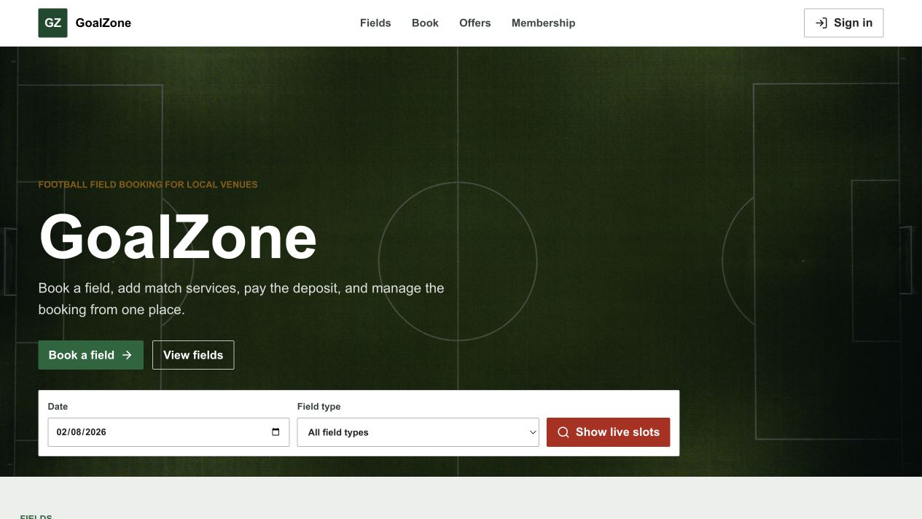
Field Name | Field Type | Description
Primary navigation | Navigation | Opens Fields, Find a slot, promotion/membership information, Login, or the current role workspace.
Featured fields | Card list | Shows active field image, type, location, surface, capacity, and price context.
Active promotions | Card list | Shows active campaign name, eligibility period, banner, and discount summary.
Membership benefits | Summary list | Shows active membership levels and benefit descriptions.
Sign in / Register | Buttons | Opens the account authentication flows.

Database Access
Table | CRUD | Description
field, field_type, field_price | R | Loads public active field catalogue and price context.
promotion | R | Loads active public promotions.
membership_level | R | Loads active public membership benefits.
Detailed as-built SQL is specified under UC-11, UC-12, UC-45, UC-50 in the SDS Database Queries sections.

b. Login Screen
Authenticates a registered user and routes the user to role-appropriate navigation.
Related use cases: UC-02, UC-03

UI Design
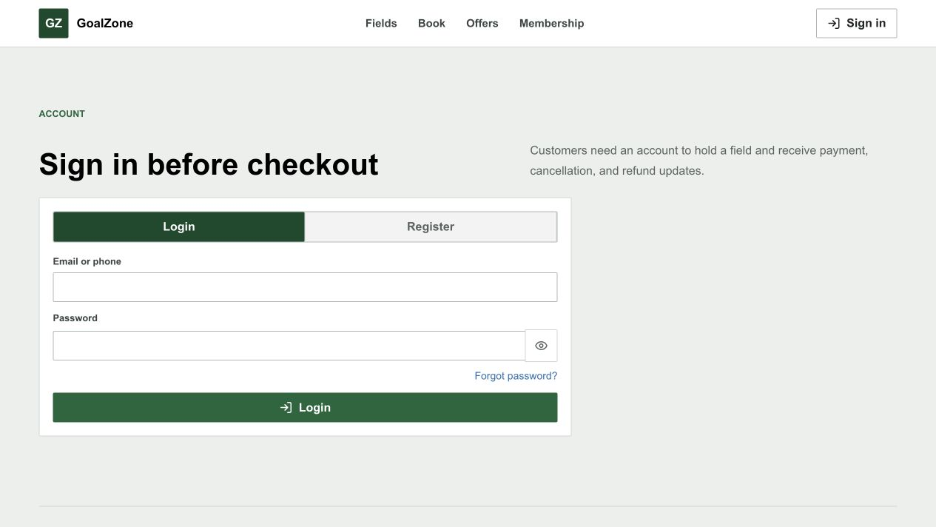
Field Name | Field Type | Description
Email or phone | Text box | Required account identity.
Password | Password box | Required credential; characters are masked.
Login | Button | Submits credentials and stores the returned JWT/user summary.
Forgot password | Link | Opens the password-reset request screen.
Register | Link | Opens Customer registration.

Database Access
Table | CRUD | Description
app_user, role | R/U | Finds the identity with role, validates account state, and records last_login_at.
Detailed as-built SQL is specified under UC-02, UC-03 in the SDS Database Queries sections.

c. Register Account
Creates a unique Customer account and starts email verification.
Related use cases: UC-01

UI Design
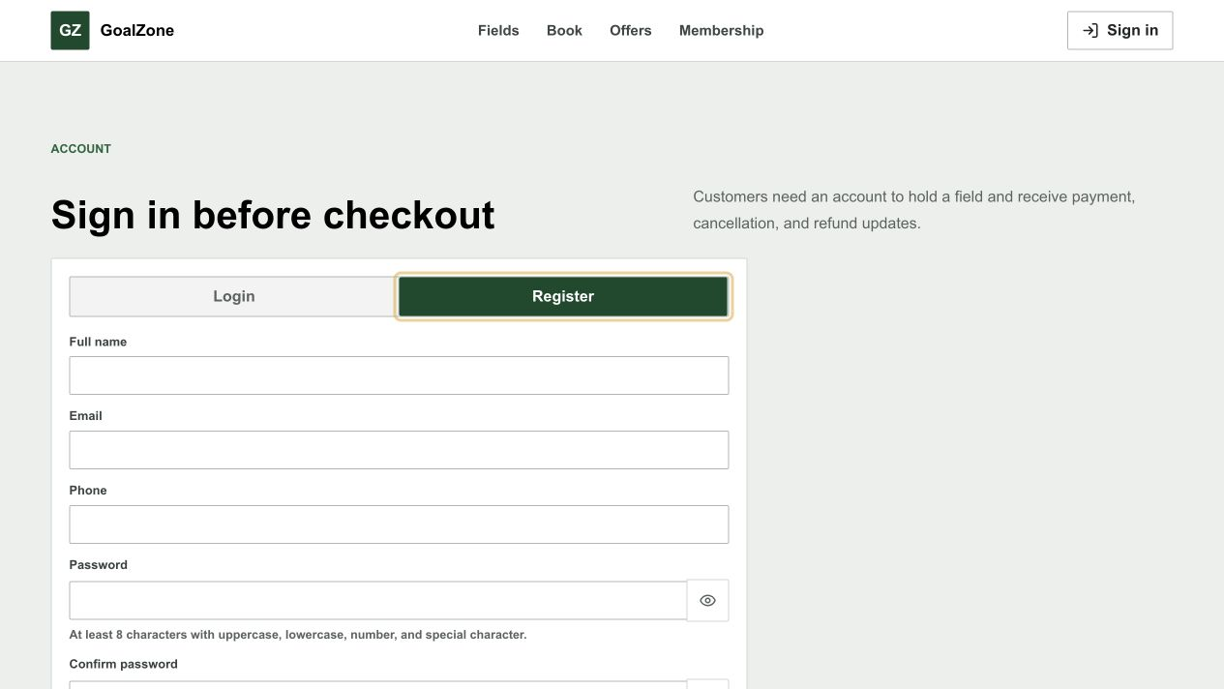
Field Name | Field Type | Description
Full name | Text box | Required Customer name.
Email | Email box | Required unique email used for verification and login.
Phone | Text box | Required unique 10-digit phone beginning with 0.
Password | Password box | Required 8-72 character policy-compliant password.
Confirm password | Password box | Must match Password.
Create account | Button | Validates and creates the Customer account.

Database Access
Table | CRUD | Description
app_user, role | R/C | Checks identity uniqueness, loads Customer role, and creates the account.
membership_level, customer_membership | R/C | Finds the default level and creates Customer membership progress.
Detailed as-built SQL is specified under UC-01 in the SDS Database Queries sections.

d. Forgot/Reset Password
Issues a time-limited reset link and accepts a replacement password.
Related use cases: UC-06

UI Design
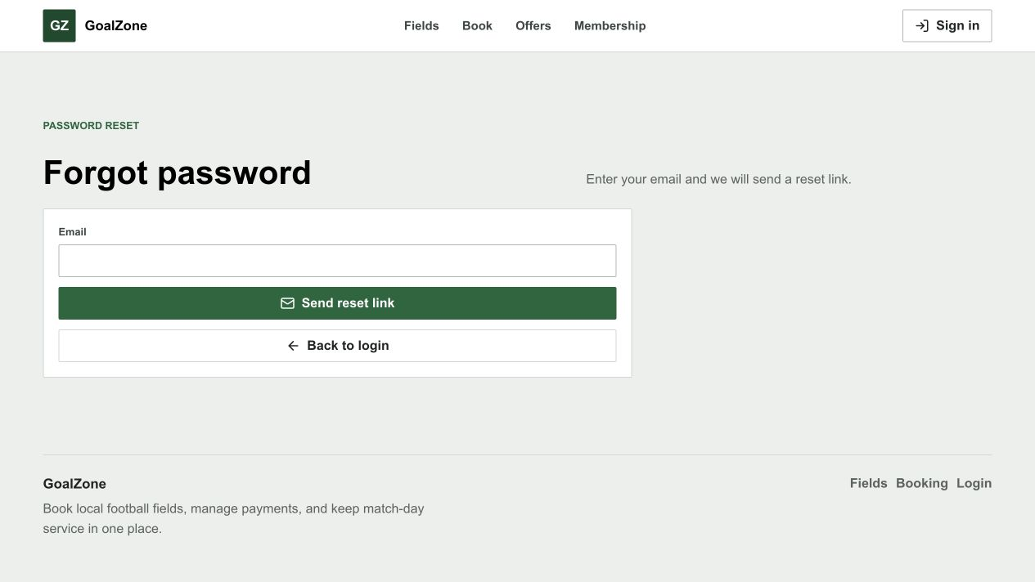
Field Name | Field Type | Description
Email | Email box | Requests a reset link without revealing whether the address exists.
Reset link token | URL parameter | One-hour single-use token tied to user ID.
New password | Password box | Must satisfy the shared password policy.
Confirm password | Password box | Must match the new password.
Reset password | Button | Stores the new hash and revokes existing JWTs.

Database Access
Table | CRUD | Description
app_user | R/U | Finds active account, stores reset token/time, then stores the new hash and clears reset data.
Detailed as-built SQL is specified under UC-06 in the SDS Database Queries sections.

e. Profile / Edit Profile
Displays account status and permits safe profile/password changes.
Related use cases: UC-04, UC-05

UI Design
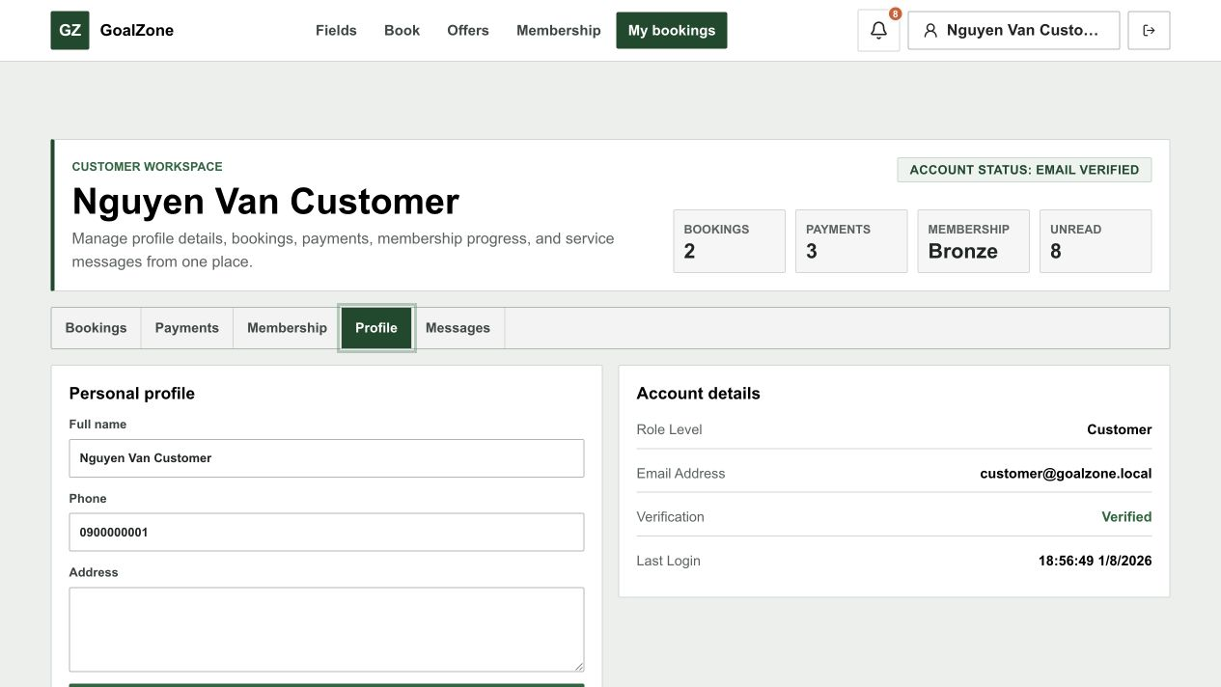
Screen state - Change password form
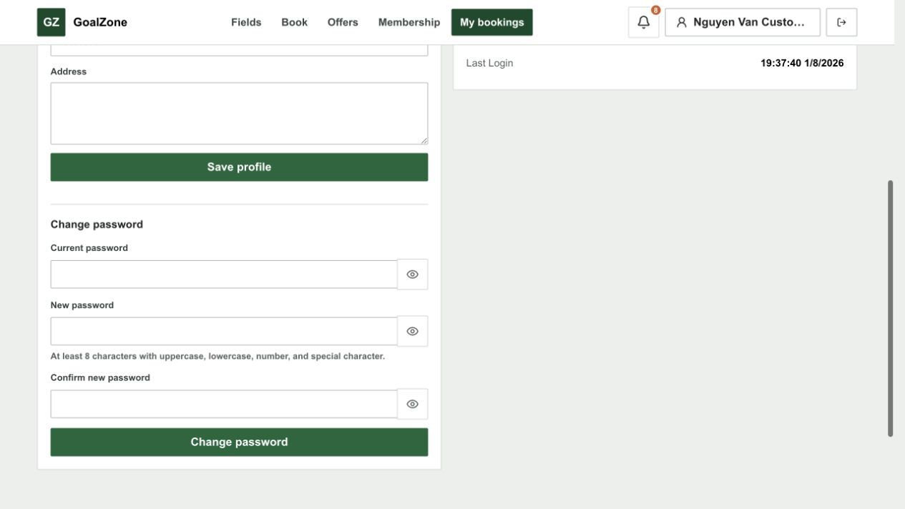
Field Name | Field Type | Description
Email / role / status | Read-only text | Displays protected identity and access data.
Full name | Text box | Optional profile name update.
Phone | Text box | Optional unique phone update.
Address | Text area | Optional address.
Change password | Action | Opens current/new password fields and revokes active tokens on success.

Database Access
Table | CRUD | Description
app_user | R/U | Loads and updates allowed profile fields or password/auth_version.
Detailed as-built SQL is specified under UC-04, UC-05 in the SDS Database Queries sections.

f. Customer Management
Admin reviews Customer accounts, manages account lock/unlock, and alone may inspect selected Customer activity.
Related use cases: UC-07, UC-08, UC-10

UI Design
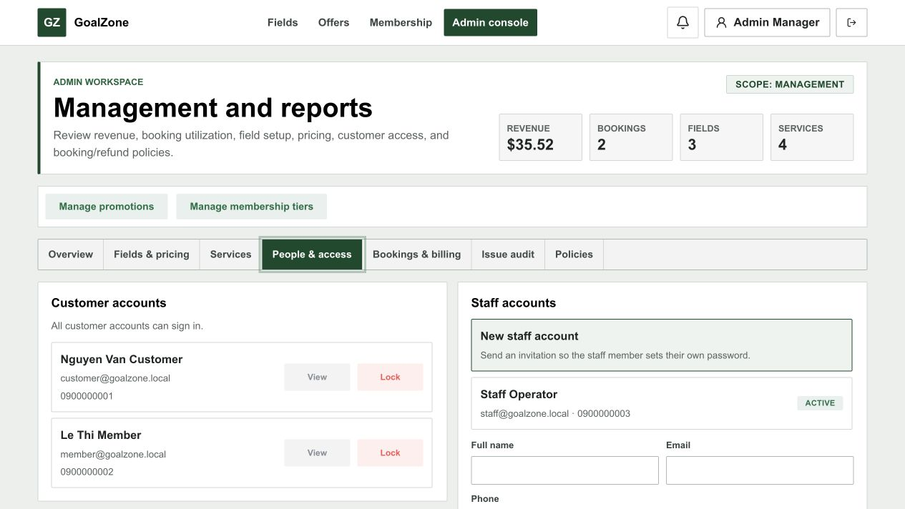
Screen state - Customer activity detail
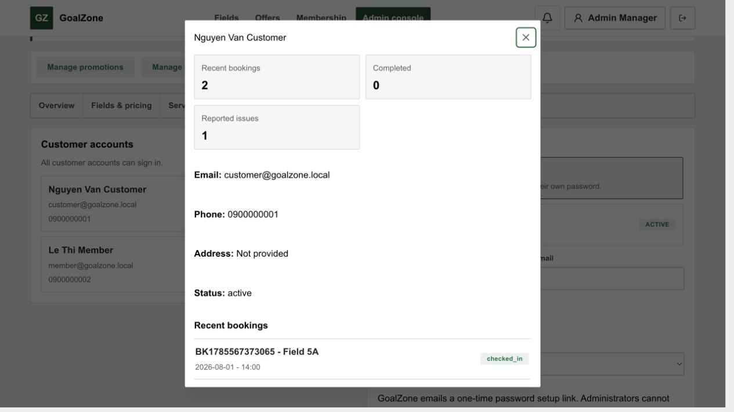
Screen state - Customer lock confirmation
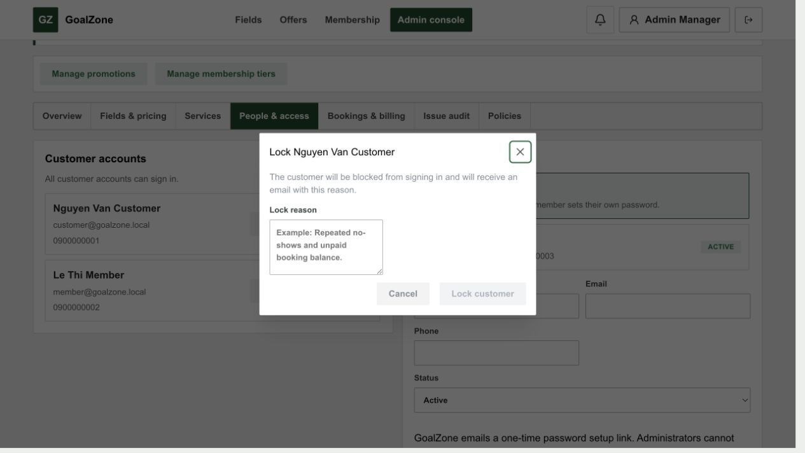
Field Name | Field Type | Description
Customer list | Data list | Shows Customer name, email, phone, account status, and lock reason.
Lock action | Button | Admin opens the lock-reason dialog for an unlocked Customer.
Lock reason | Modal text area | Admin must enter a reason before locking.
Unlock action | Button | Admin unlocks a locked Customer account.
Account state | Badge | Shows whether the Customer account is active or locked.

Database Access
Table | CRUD | Description
app_user, role | R/U | Lists Customers and updates status/lock_reason/auth_version.
booking | R | Loads Customer booking activity.
issue | R | Loads issues reported by the Customer.
customer_membership, membership_level | R | Displays membership context.
Detailed as-built SQL is specified under UC-07, UC-08, UC-10 in the SDS Database Queries sections.

g. Staff Management
Admin creates and maintains Staff identity/status; Staff chooses the password from an emailed invitation.
Related use cases: UC-09

UI Design

Field Name | Field Type | Description
Staff list | Data list | Shows Staff identity and active/locked status.
Full name | Text box | Required Staff name.
Email | Email box | Required unique email.
Phone | Text box | Required unique phone.
Invitation delivery | Status message | Reports whether the one-hour Set my password invitation was sent.
Status | Modal text area | Active or locked/inactive account state.
Save | Button | Creates or updates Staff without exposing any Admin password control.

Database Access
Table | CRUD | Description
app_user, role | R/C/U | Loads Staff role/list and persists identity, status, an unknown initial hash, setup token, and auth_version.
Detailed as-built SQL is specified under UC-09 in the SDS Database Queries sections.

2. Field, Slot, Service & Issue Management

2.1 Screen Designs

a. Field List
Shows the public catalogue of active football fields.
Related use cases: UC-11

UI Design
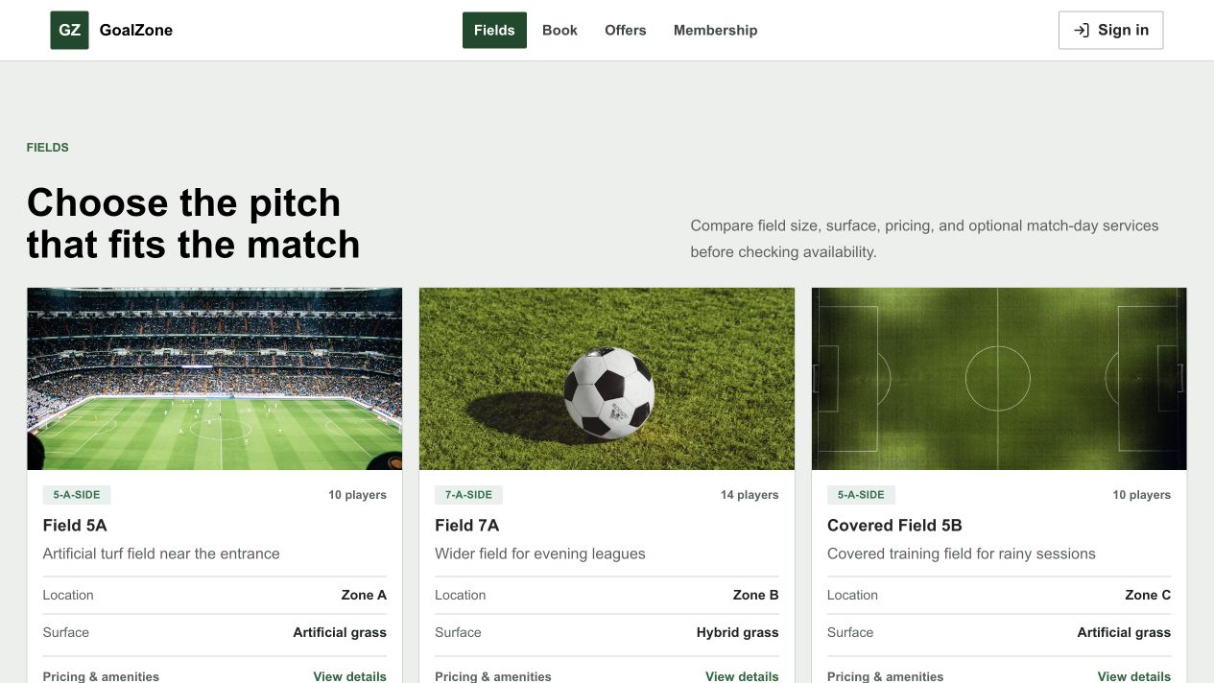
Field Name | Field Type | Description
Field cards | Card list | Shows image, name, type, location, surface, capacity, and price range.
View details | Button | Opens selected Field Detail.
Find a slot | Button | Opens availability search for the field.

Database Access
Table | CRUD | Description
field, field_type | R | Loads active field profiles.
field_price | R | Builds public price context.
Detailed as-built SQL is specified under UC-11 in the SDS Database Queries sections.

b. Field Detail
Displays one active field with image, facilities, pricing, and booking entry points.
Related use cases: UC-12

UI Design
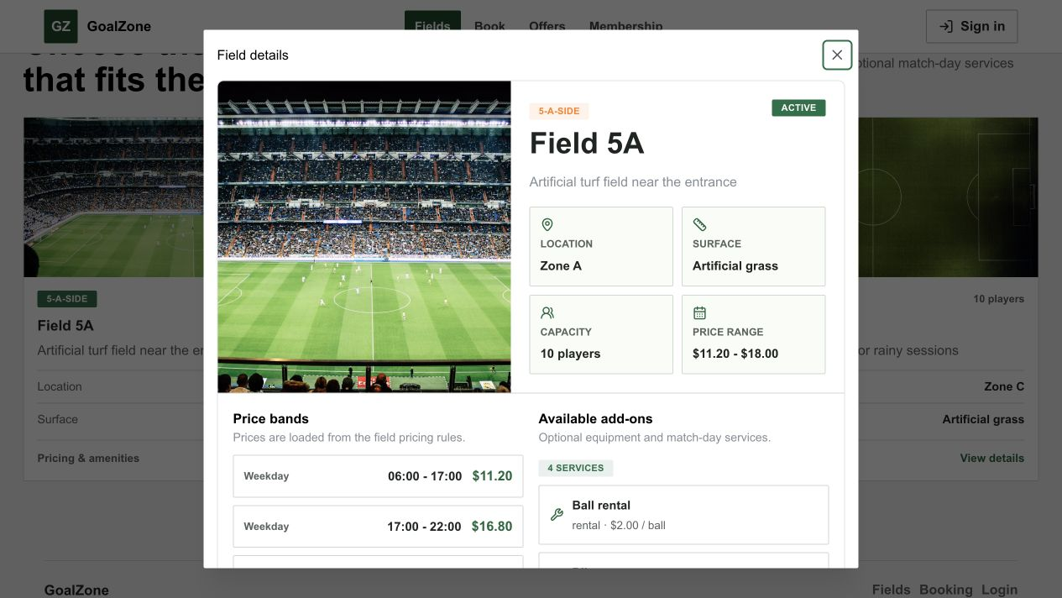
Field Name | Field Type | Description
Field image | Image | Displays the uploaded field image or safe fallback.
Profile | Read-only group | Name, type, location, surface, capacity, and description.
Price bands | Table | Active weekday/weekend time bands and USD prices.
Available services | List | Active add-ons relevant to booking.
Find available slot | Button | Opens availability search.

Database Access
Table | CRUD | Description
field, field_type | R | Loads selected active field.
field_price | R | Loads active price rules.
extra_service | R | Loads active add-ons.
Detailed as-built SQL is specified under UC-12 in the SDS Database Queries sections.

c. Search Available Fields
Searches generated slots by playing date, field type, and optional field.
Related use cases: UC-13

UI Design
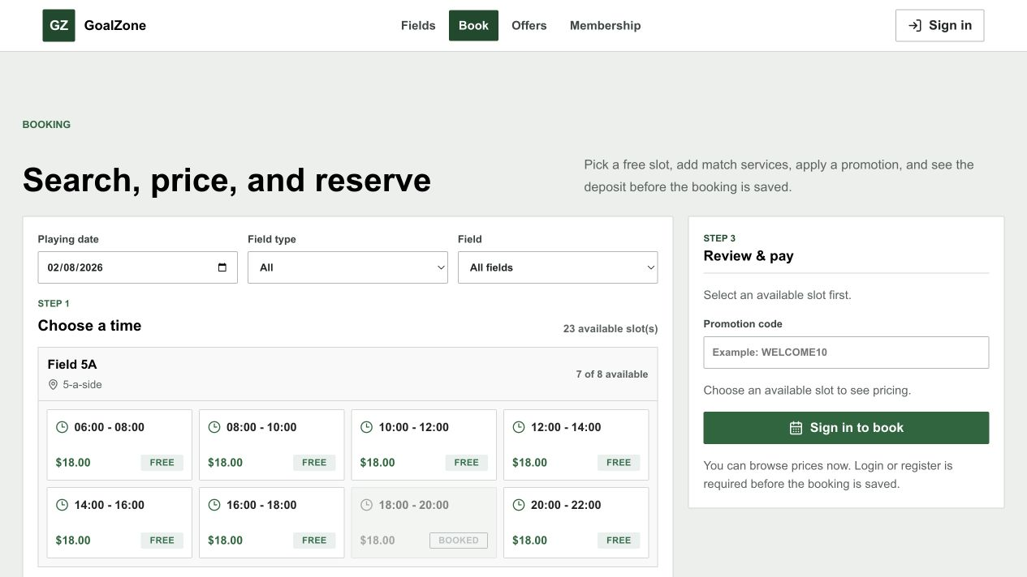
Field Name | Field Type | Description
Playing date | Date picker | Required non-past date.
Field type | Modal text area | Optional active field-type filter.
Field | Modal text area | Optional field filter.
Search | Button | Loads bookable slots.
Available slots | Result list | Shows field, date/time, price, and booking action.

Database Access
Table | CRUD | Description
field, field_type, slot | R/C | Loads active fields and generates/persists daily slots when required.
booking | R | Excludes slots with active bookings.
field_price | R | Resolves applicable USD price.
Detailed as-built SQL is specified under UC-13 in the SDS Database Queries sections.

d. Field Management
Admin creates, updates, activates, and deactivates football fields, including images.
Related use cases: UC-14

UI Design
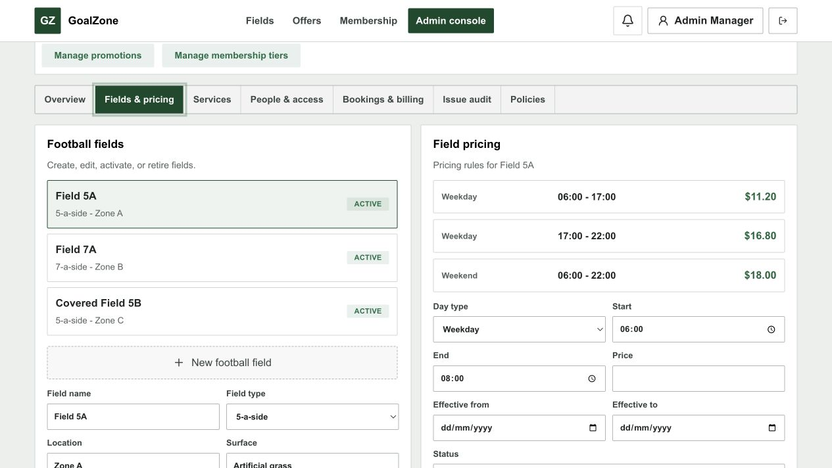
Field Name | Field Type | Description
Field list | Data list | Shows active and inactive fields.
Name/type/location/surface | Form fields | Required field identity and playing context.
Capacity/description | Form fields | Operational metadata.
Image | File upload | JPEG, PNG, WebP, or GIF up to 5 MB; stores returned image URL.
Status | Modal text area | Active/inactive catalogue state.
Save | Button | Creates or updates the field.

Database Access
Table | CRUD | Description
field, field_type | R/C/U | Loads type data and persists the field profile/image URL/status.
Detailed as-built SQL is specified under UC-14 in the SDS Database Queries sections.

e. Field Pricing Management
Admin maintains effective weekday/weekend price bands for each field.
Related use cases: UC-15

UI Design

Screen state - Pricing rule list and editor
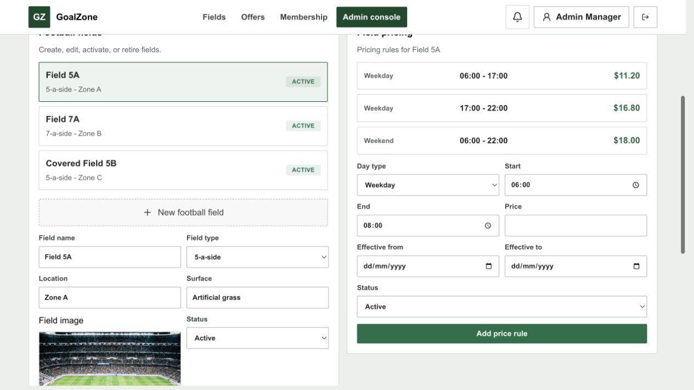
Field Name | Field Type | Description
Field | Modal text area | Selects the managed field.
Day type | Modal text area | Weekday or weekend applicability.
Start/end time | Time inputs | Defines a valid non-overlapping pricing range.
USD price | Currency input | Positive field rental price.
Effective dates | Date inputs | Optional rule validity range.
Status | Modal text area | Active/inactive price rule.

Database Access
Table | CRUD | Description
field | R | Validates the selected field.
field_price | R/C/U | Lists and persists field/day/time/effective-date pricing rules.
Detailed as-built SQL is specified under UC-15 in the SDS Database Queries sections.

f. Extra Service Selection
Selects and updates booking add-ons while validating stock/capacity and pre-check-in timing.
Related use cases: UC-20, UC-21

UI Design
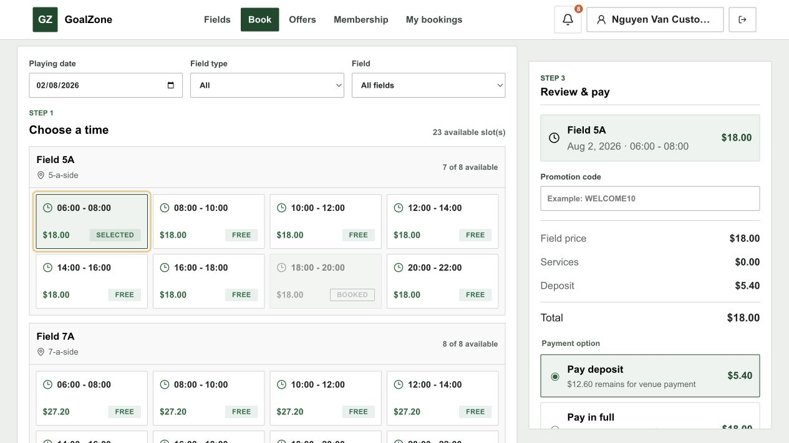
Field Name | Field Type | Description
Service | Selectable list | Active rental/sale/staff add-on with USD unit price.
Quantity | Number input | Positive quantity within per-booking and shared availability limits.
Availability message | Status text | Explains stock/capacity rejection.
Service total | Currency summary | Recalculated booking service value.
Save services | Button | Persists selection and updates billing/invoice before check-in.

Database Access
Table | CRUD | Description
extra_service | R | Loads active service rules/stock.
booking_service | R/C/U/D | Reads overlapping usage and persists the booking selection/price snapshot.
booking, invoice, refund | R/U/C | Recalculates total, balance/refund delta, and invoice atomically.
Detailed as-built SQL is specified under UC-20, UC-21 in the SDS Database Queries sections.

g. Extra Service Management
Admin maintains rental, sale, and staff-provided add-ons.
Related use cases: UC-19

UI Design
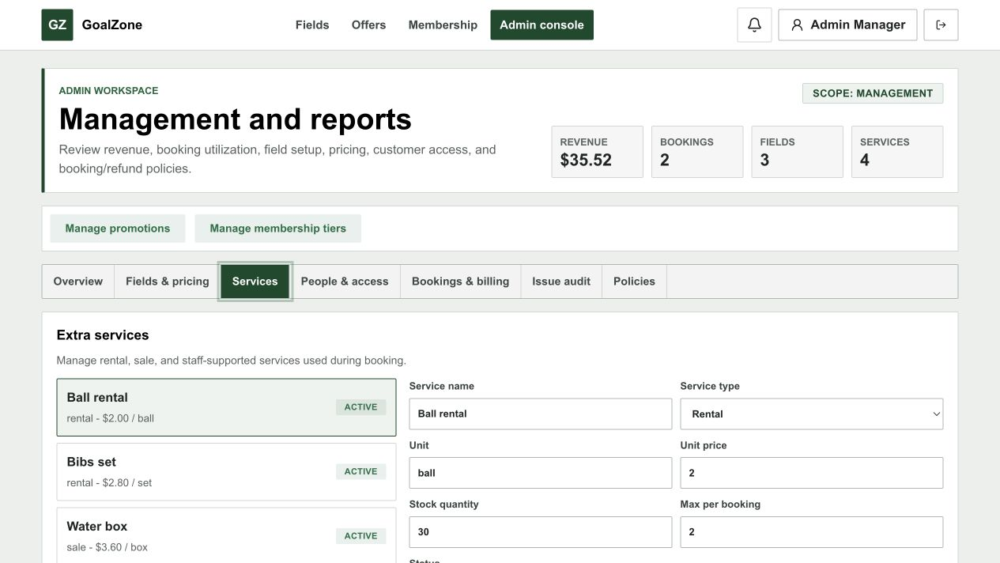
Screen state - Service list and editor
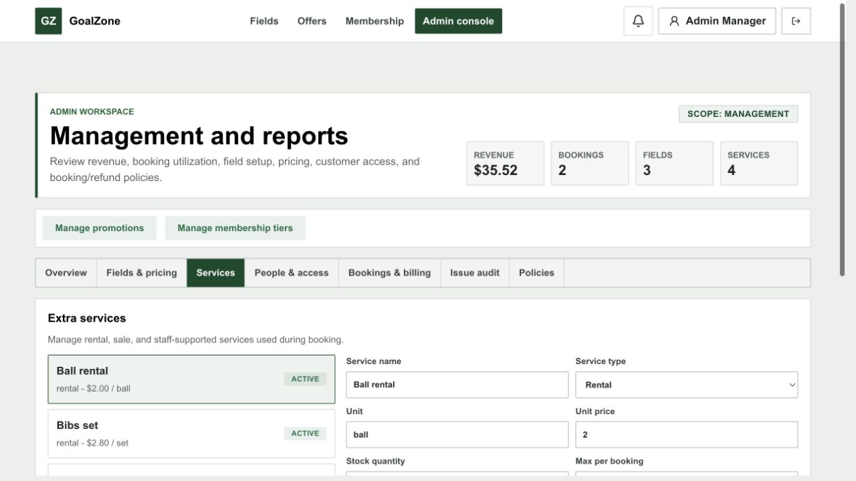
Field Name | Field Type | Description
Service list | Data list | Shows active and inactive services.
Name/type | Form fields | Required service identity and rental/sale/staff category.
USD unit price | Currency input | Non-negative service price.
Stock/max per booking | Number inputs | Optional shared stock and quantity limits.
Status | Modal text area | Active/inactive availability.
Save | Button | Creates or updates the service.

Database Access
Table | CRUD | Description
extra_service | R/C/U | Lists and persists service price, limits, and status.
Detailed as-built SQL is specified under UC-19 in the SDS Database Queries sections.

h. Unavailable Slot Management
Staff blocks/unblocks field time with a reason and reviews daily field operations.
Related use cases: UC-16, UC-17, UC-18

UI Design
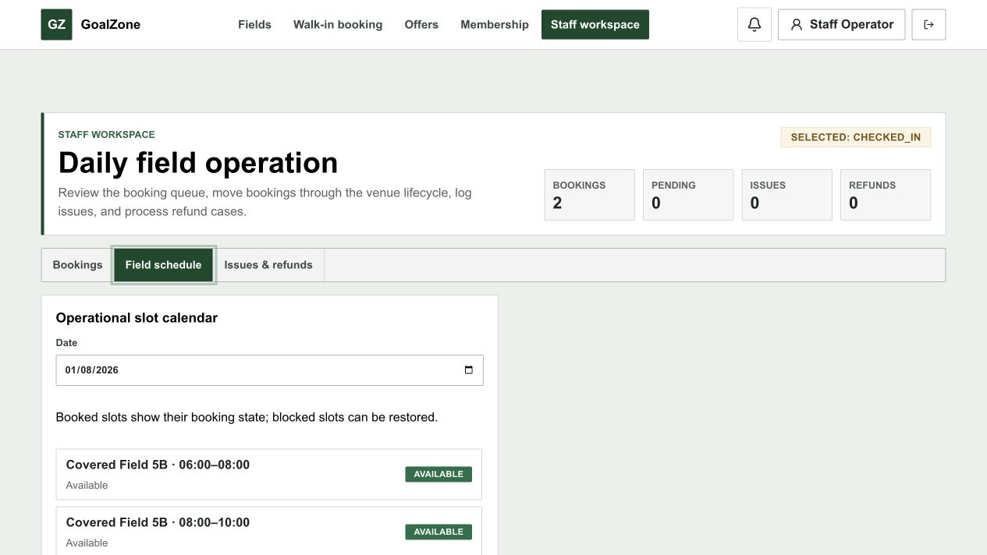
Screen state - Daily field schedule
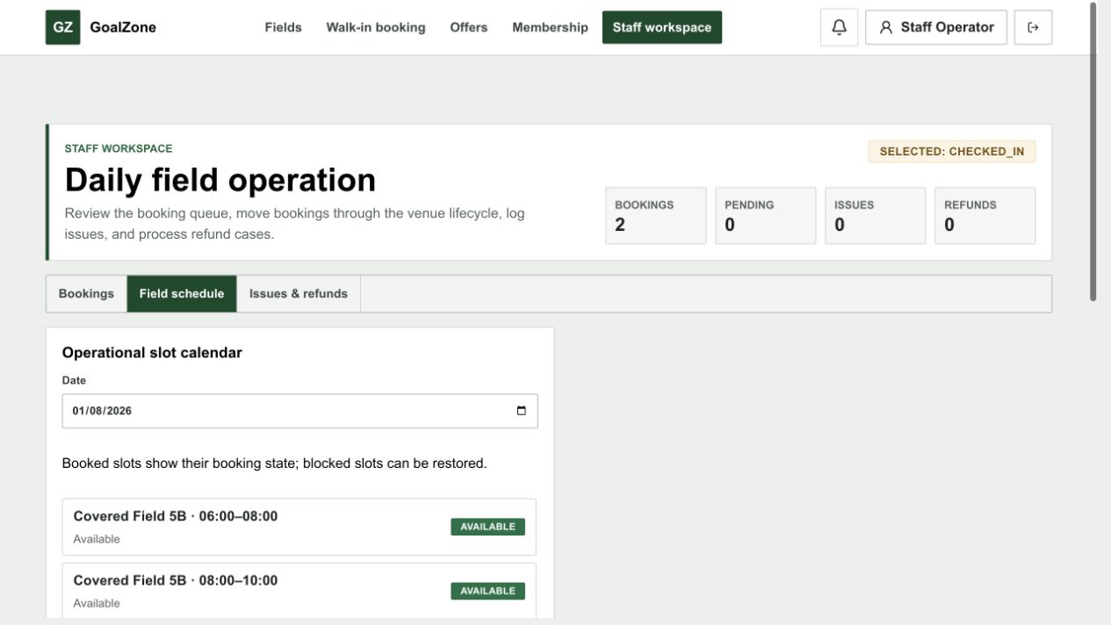
Screen state - Block slot form
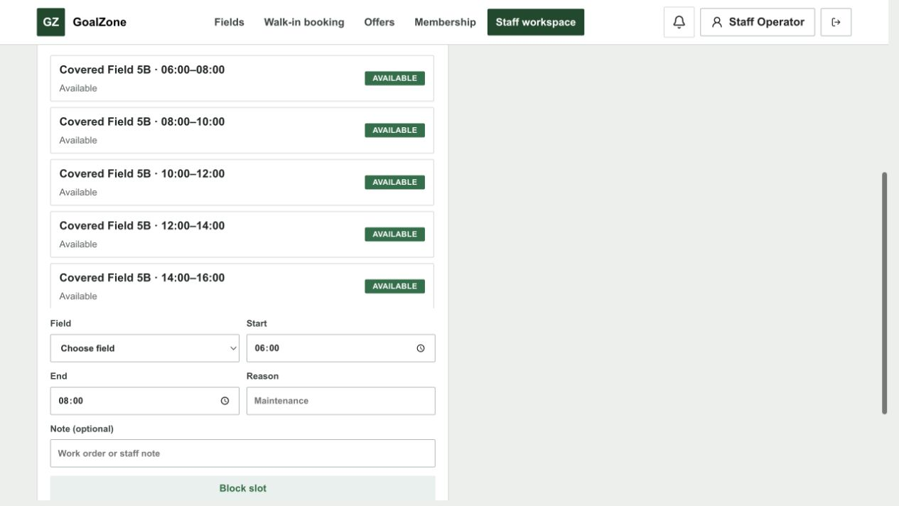
Field Name | Field Type | Description
Date | Date picker | Selected operating date.
Field | Modal text area | Selected active field.
Start/end time | Time inputs | Target slot interval.
Block reason | Text area | Required operational reason.
Block / Unblock | Buttons | Changes slot availability when no protected booking conflict exists.
Daily calendar | Calendar/list | Shows available, blocked, and booked slots with customer/booking context.

Database Access
Table | CRUD | Description
slot, field | R/C/U | Loads/generates daily slots and stores block state/reason/creator.
booking, app_user | R | Shows booked-slot customer context and prevents invalid blocking.
Detailed as-built SQL is specified under UC-16, UC-17, UC-18 in the SDS Database Queries sections.

i. Issue Report / Issue Management
Customer/Staff reports a field, booking, or service issue; Staff resolves it and notifies the reporter.
Related use cases: UC-22, UC-23

UI Design
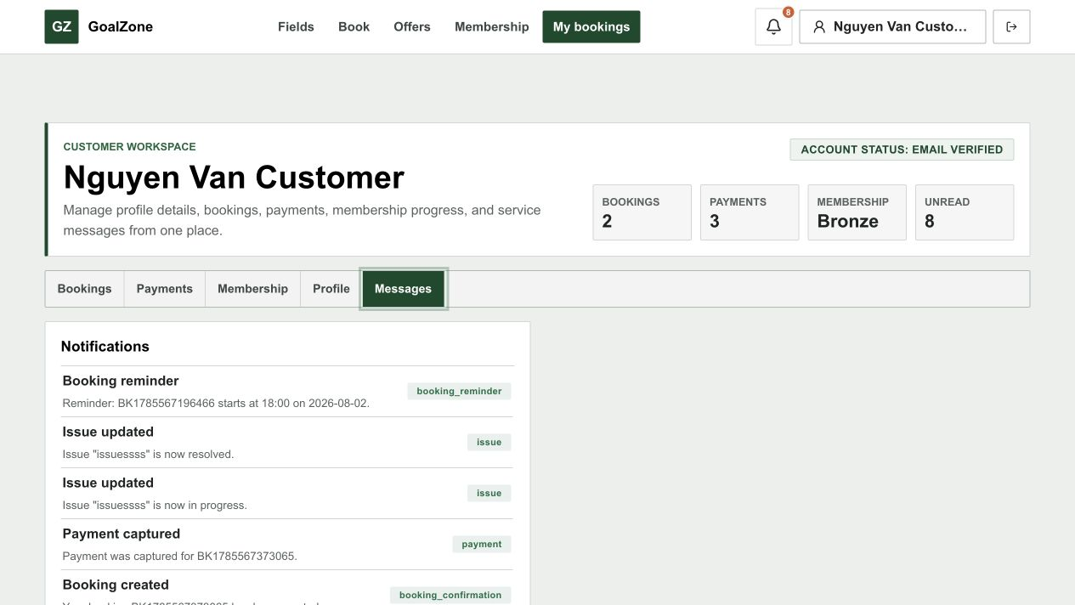
Screen state - Customer issue report form
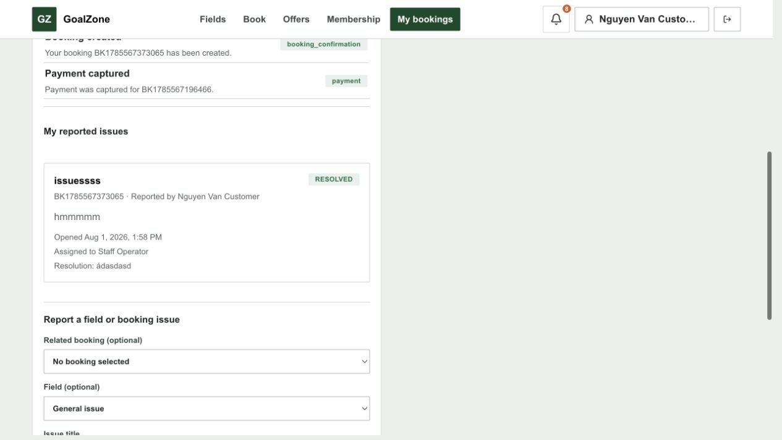
Screen state - Issue details and submit action
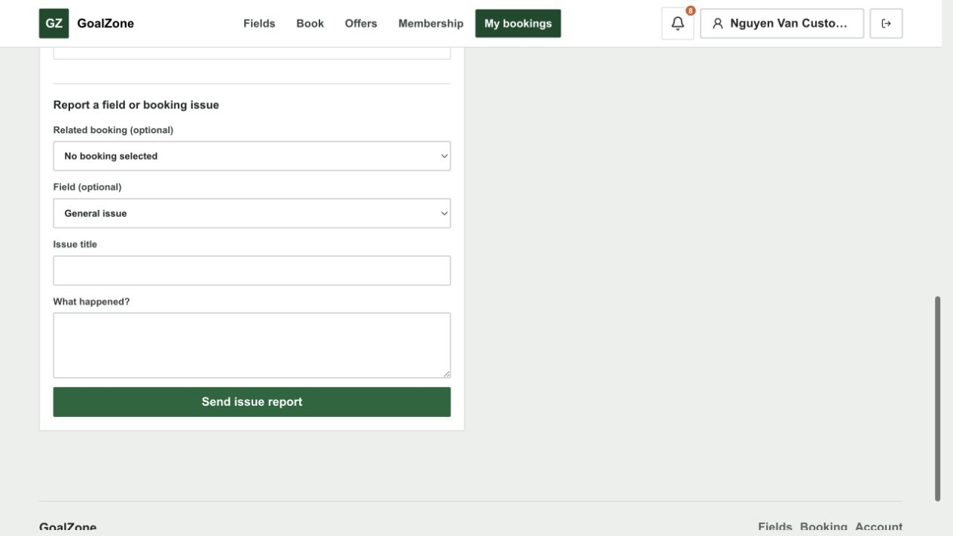
Screen state - Staff issue handling
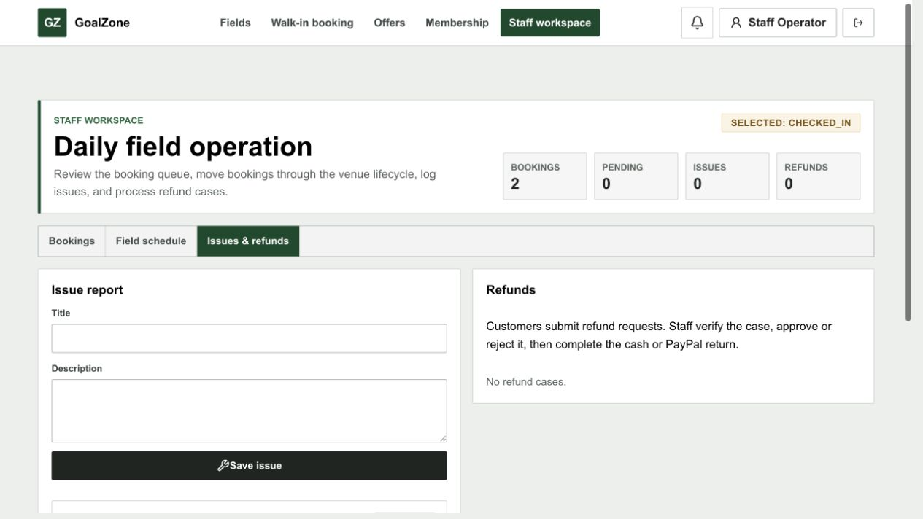
Field Name | Field Type | Description
Context | Modal text areas | Optional booking, field, and extra-service references.
Title | Text box | Required concise issue title.
Description | Text area | Required issue details.
Status | Modal text area | Staff-managed issue lifecycle.
Resolution note | Text area | Required operational resolution details when resolved.
Save / Resolve | Buttons | Creates issue or updates its status and notification.

Database Access
Table | CRUD | Description
issue | R/C/U | Stores reporter, context, status, assignee, resolution note/time.
booking, field, extra_service, app_user | R | Validates referenced context and actors.
notification | C | Notifies reporter after resolution is persisted.
Detailed as-built SQL is specified under UC-22, UC-23 in the SDS Database Queries sections.

3. Booking Lifecycle

3.1 Screen Designs

a. Online Booking
Customer creates a pending online booking and continues to Customer-only PayPal checkout.
Related use cases: UC-24, UC-36

UI Design

Screen state - Slot services and checkout summary
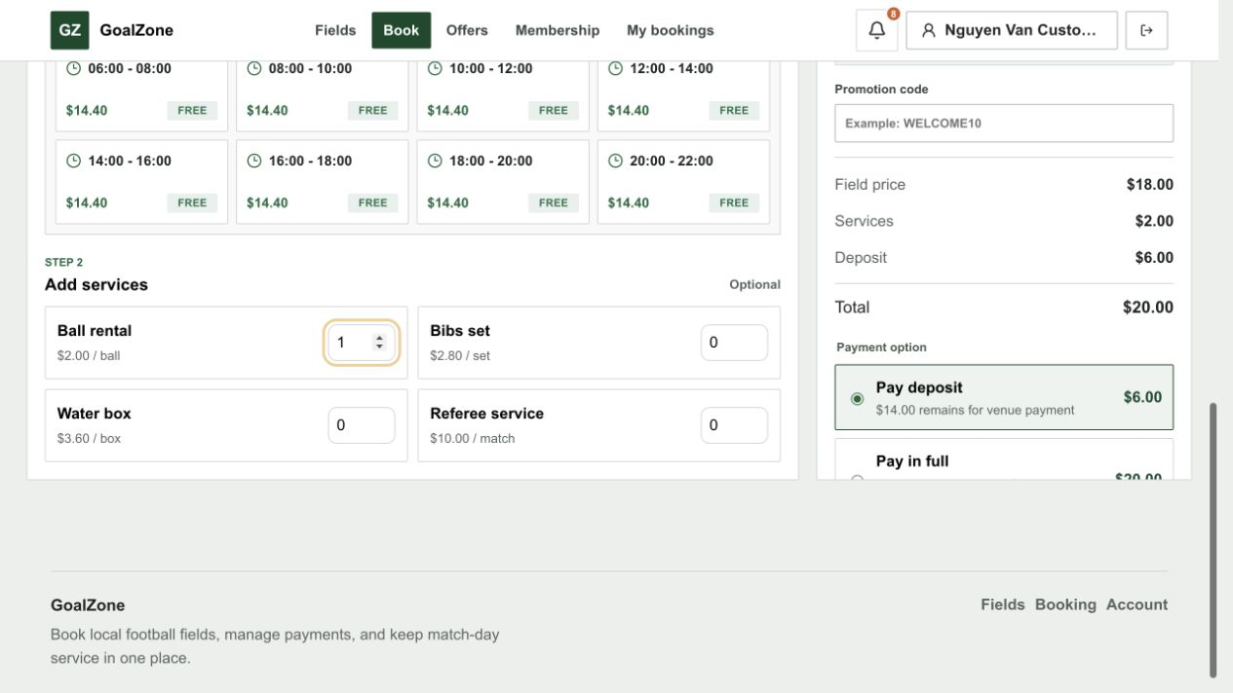
Screen state - Online payment choice
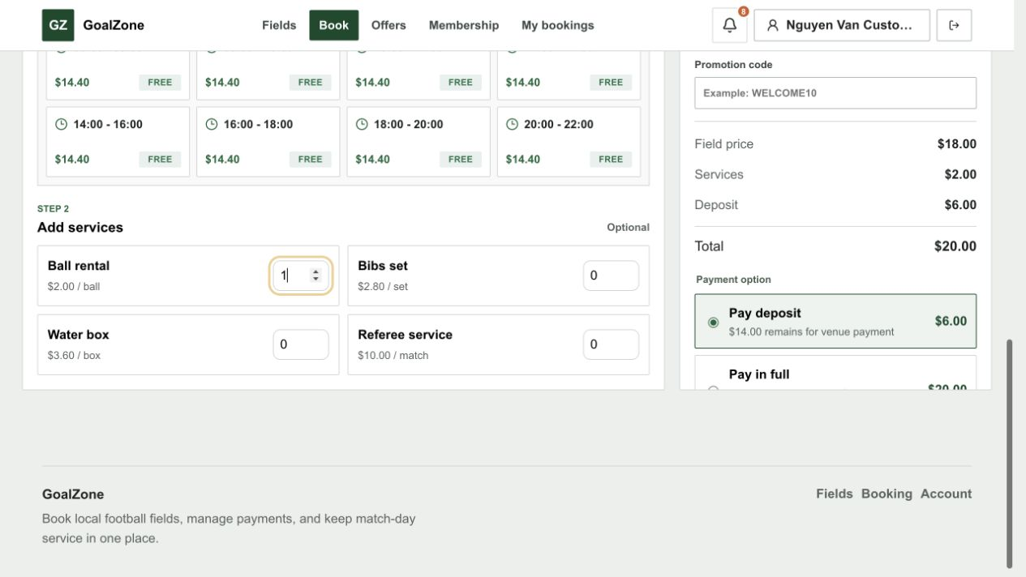
Field Name | Field Type | Description
Selected field/slot | Read-only summary | Active, available, non-past slot.
Extra services | Selection | Optional validated add-ons.
Promotion code | Text box | Optional eligible promotion.
Price summary | Currency panel | Field, services, discounts, total, deposit, and balance in USD.
Deposit / Full | Choice | Customer online PayPal amount option.
Create and pay | Button | Creates a pending hold then opens PayPal Sandbox checkout.

Database Access
Table | CRUD | Description
booking, slot | C/R/U | Creates pending online booking and protects the slot.
booking_service, booking_promotion | C | Stores service and promotion snapshots.
invoice | C/U | Creates billing summary.
payment | C/U | Stores PayPal order/capture result used for confirmation.
Detailed as-built SQL is specified under UC-24, UC-36 in the SDS Database Queries sections.

b. Walk-in Booking
Staff creates a walk-in booking for either a matched Customer account or a first-time visitor identified by name and phone, then records cash or leaves payment pending.
Related use cases: UC-25, UC-35, UC-37

UI Design
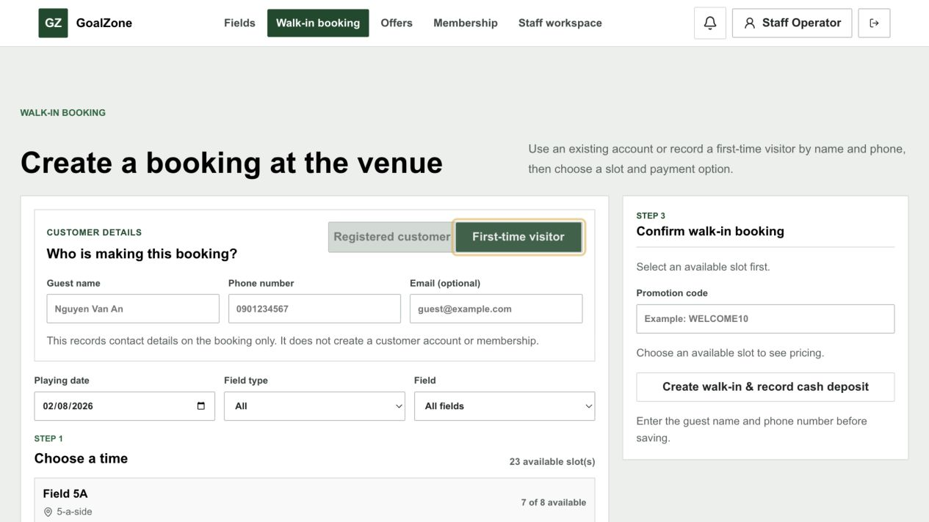
Screen state - Selected slot and services
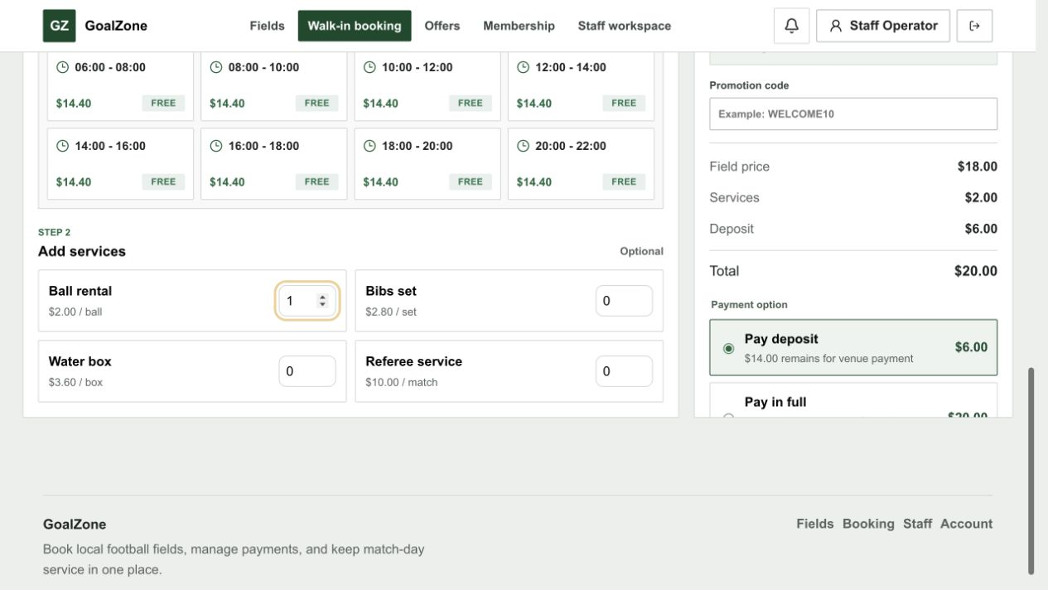
Screen state - Counter payment summary
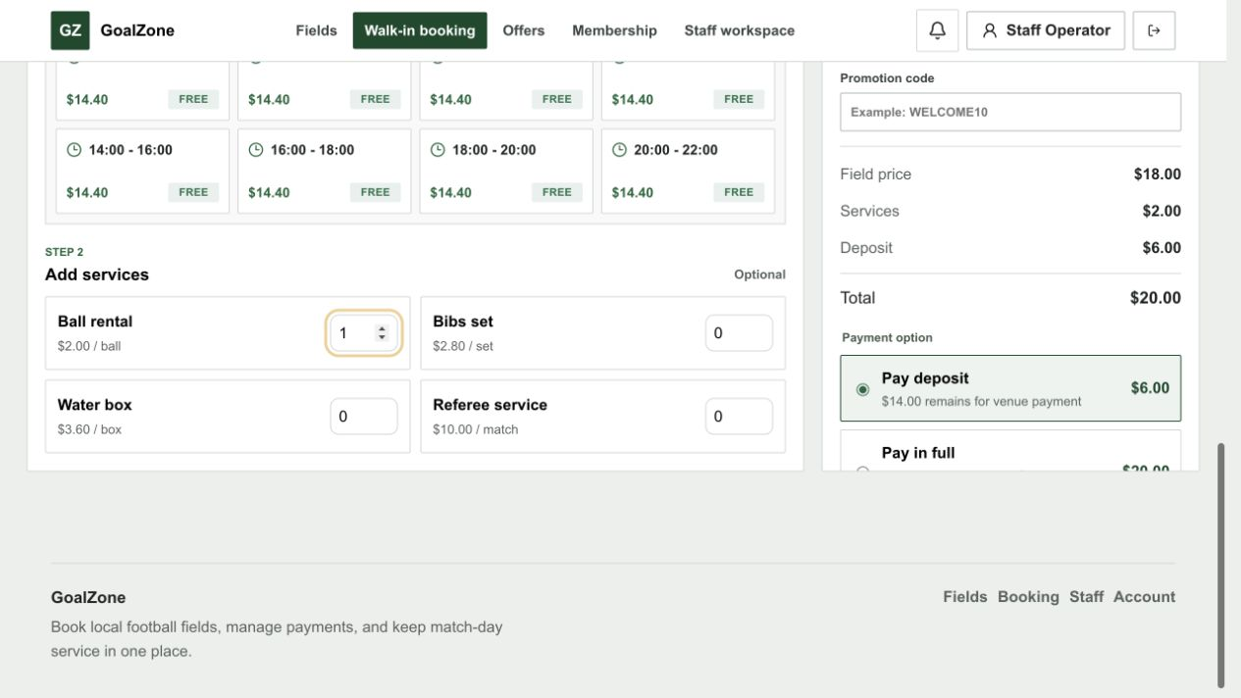
Field Name | Field Type | Description
Customer type | Segmented buttons | Choose a registered Customer or a first-time visitor.
Phone or email | Search box | Optionally matches an active registered Customer at the counter.
Guest contact | Text inputs | First-time visitor name and phone are required; email is optional.
Field/date/slot | Selection | Selects an available non-past slot.
Services/promotion | Selection | Optional validated add-ons and promotion.
Payment option | Choice | Deposit/full cash confirms the booking; Pay later keeps it pending.
Create booking | Button | Stores exactly one customer identity and creates the walk-in safely.

Database Access
Table | CRUD | Description
app_user, booking, slot | R/C/U | Validates Staff and an optional matched Customer, records either registered or guest identity, and creates a pending or confirmed walk-in booking.
booking_service, booking_promotion | C | Stores selected snapshots.
payment, invoice | C/U | Stores cash when collected and maintains invoice and billing state.
Detailed as-built SQL is specified under UC-25, UC-35, UC-37 in the SDS Database Queries sections.

c. Booking Detail
Role/ownership-protected view of booking, billing, and allowed lifecycle actions.
Related use cases: UC-26, UC-31, UC-32, UC-33, UC-37, UC-40

UI Design
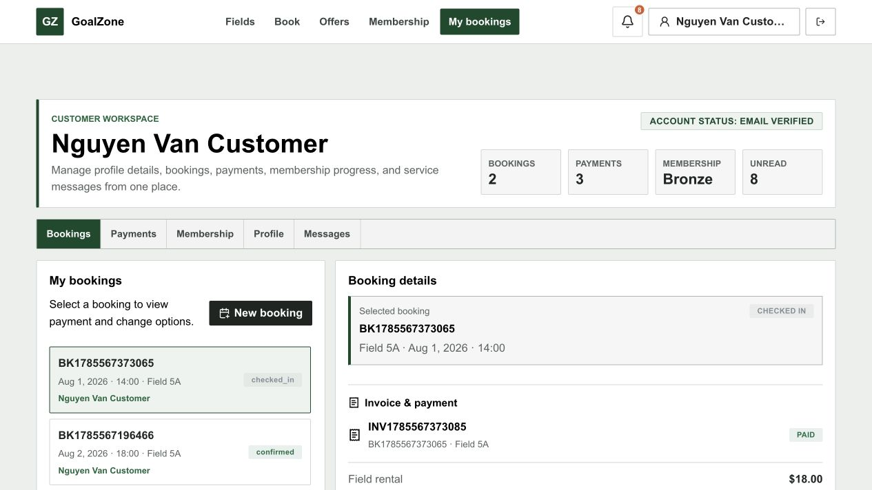
Screen state - Booking list and selected detail
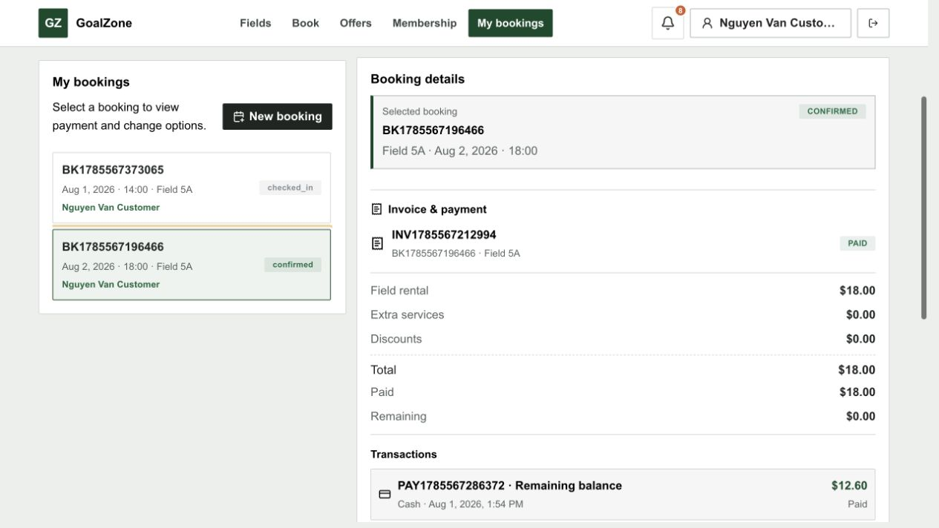
Screen state - Invoice and transaction history
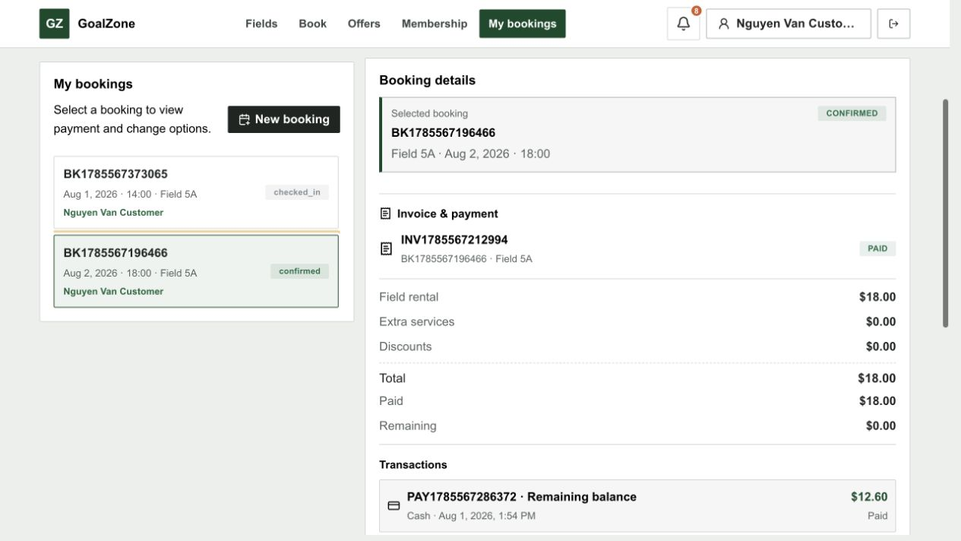
Field Name | Field Type | Description
Booking identity/status | Read-only group | Code, source, lifecycle status, customer, and staff handler.
Field/slot | Read-only group | Field and playing date/time.
Services/promotion | Line list | Selected add-ons and applied promotion snapshot.
Billing | Summary | Total, paid, remaining, invoice, payment, and refund state.
Operational actions | Buttons | Role/status-aware confirm, reject, check-in, complete, no-show, reschedule, cancel, or edit services.

Database Access
Table | CRUD | Description
booking, slot, field, app_user | R/U | Loads detail and applies valid lifecycle transitions.
booking_service, extra_service, booking_promotion, promotion | R | Loads line items and discounts.
payment, invoice, refund | R | Loads billing and refund history.
Detailed as-built SQL is specified under UC-26, UC-31, UC-32, UC-33, UC-37, UC-40 in the SDS Database Queries sections.

d. My Bookings
Customer workspace for current and past owned bookings.
Related use cases: UC-27

UI Design

Field Name | Field Type | Description
Status filter | Modal text area | Filters current/past lifecycle groups.
Booking list | Data list | Shows code, date/time, field, status, total, and balance.
Open detail | Button | Opens the ownership-protected Booking Detail.

Database Access
Table | CRUD | Description
booking, slot, field | R | Loads bookings for the authenticated Customer.
payment, invoice, refund | R | Builds billing status summaries.
Detailed as-built SQL is specified under UC-27 in the SDS Database Queries sections.

e. Booking Operations
Staff booking queue with selected-booking lifecycle, schedule, payment, invoice, and service controls.
Related use cases: UC-28, UC-29, UC-30, UC-31, UC-32, UC-33, UC-37

UI Design
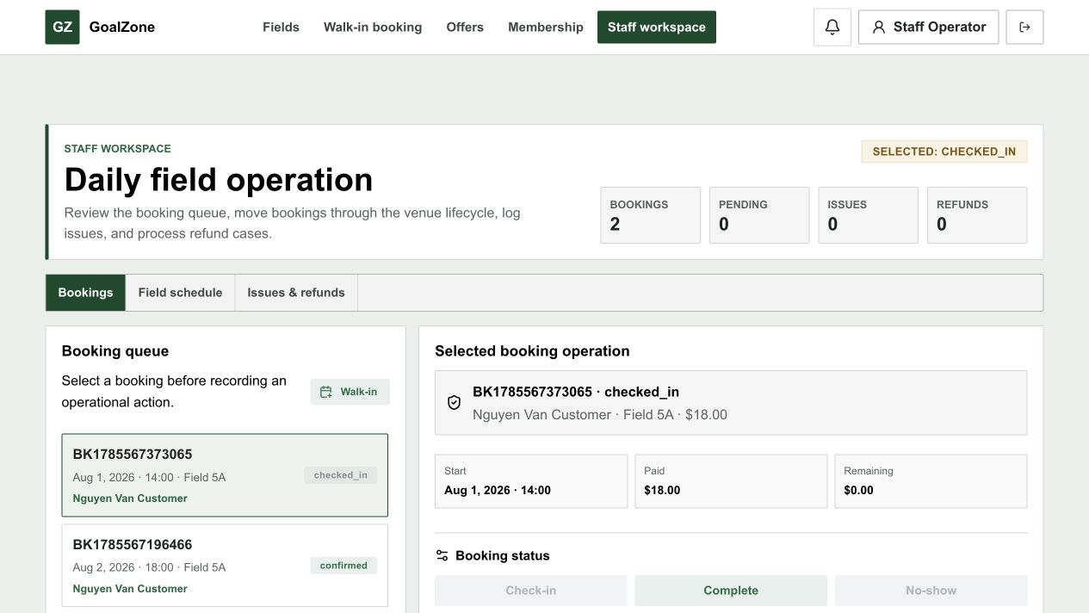
Screen state - Booking queue and selected operation
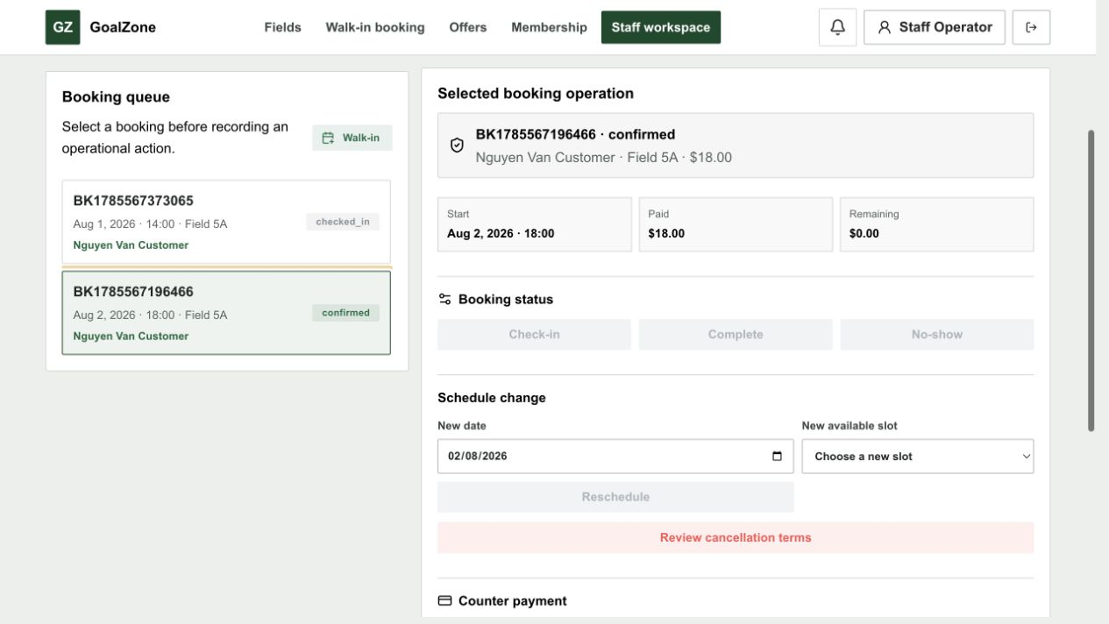
Screen state - Schedule and counter payment actions
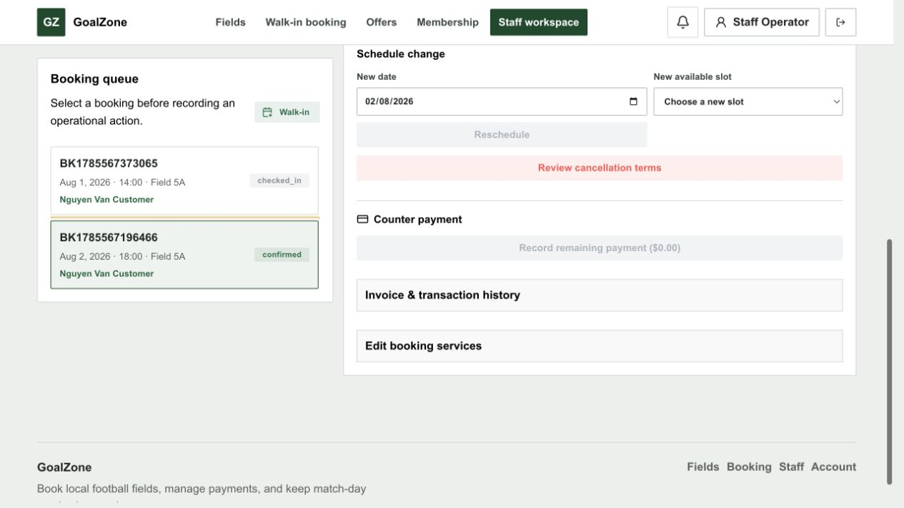
Screen state - Invoice and transaction disclosure
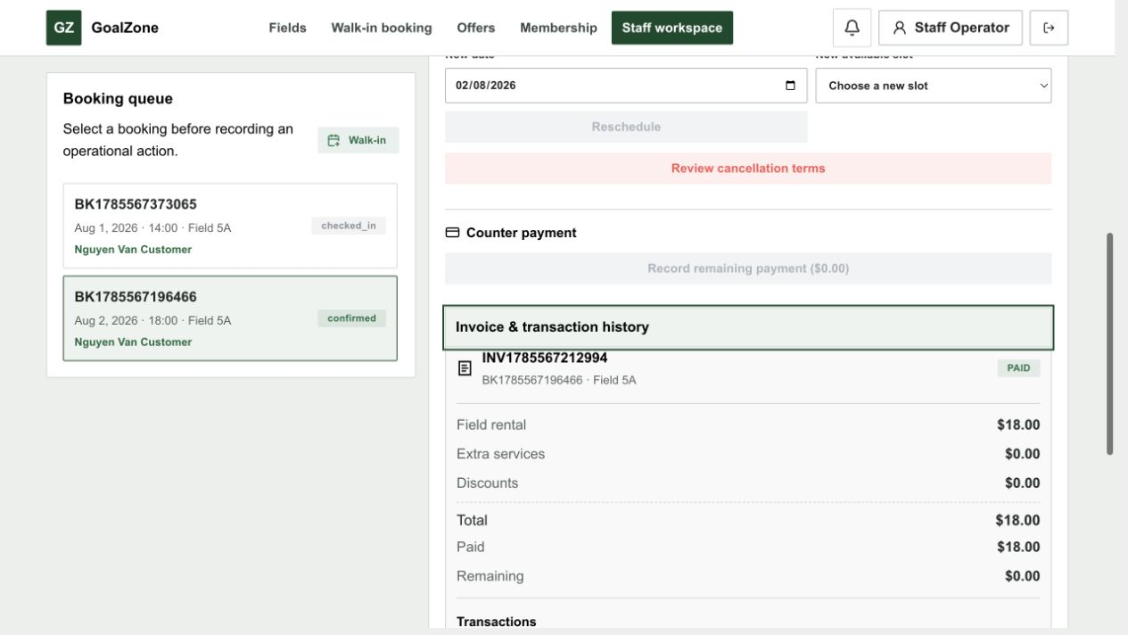
Field Name | Field Type | Description
Date | Date picker | Operating day filter.
Field/status | Modal text areas | Optional operation filters.
Daily queue | Calendar/list | Shows booking, slot, customer, source, status, and billing context.
Selected booking | Detail panel | Opens lifecycle, issue, reschedule, cancellation, and payment tools.

Database Access
Table | CRUD | Description
booking, slot, field, app_user | R/U | Loads daily operations and persists valid Staff actions.
issue, payment, invoice, refund | R/C/U | Supports conflict and billing workflows.
Detailed as-built SQL is specified under UC-28, UC-29, UC-30, UC-31, UC-32, UC-33, UC-37 in the SDS Database Queries sections.

f. Reschedule Booking
Moves an eligible owned/operated booking to a free slot and reconciles the price delta.
Related use cases: UC-29

UI Design
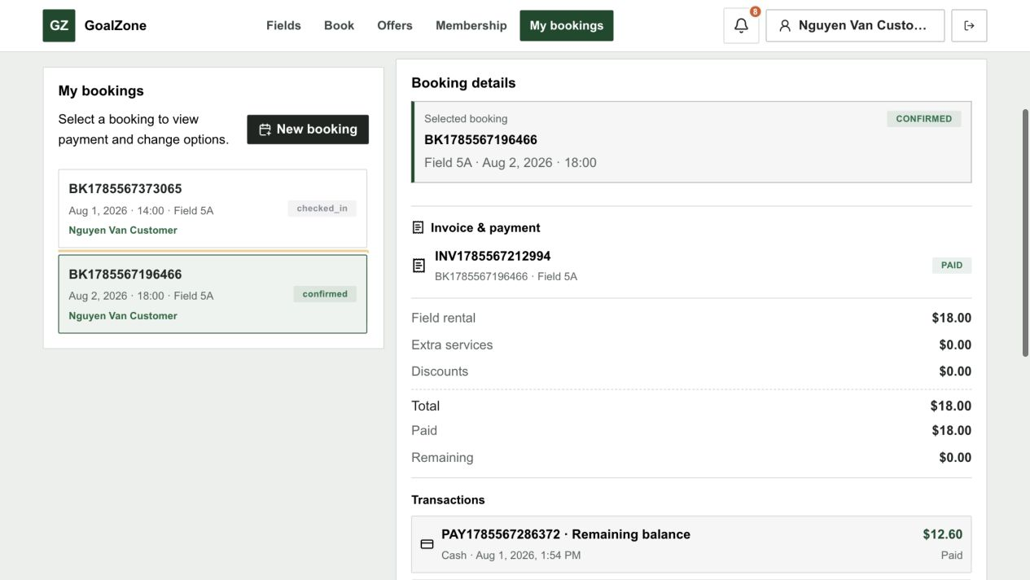
Screen state - Reschedule controls and available slot selection
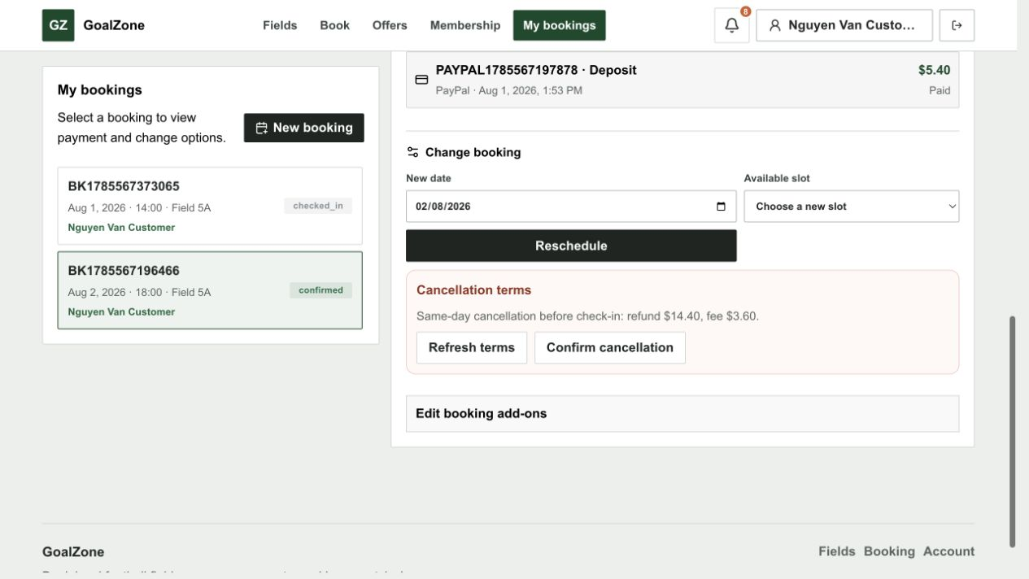
Field Name | Field Type | Description
Current slot | Read-only summary | Existing field/date/time and price.
New slot | Modal text area | Available active non-past slot.
Price comparison | Currency summary | Old total, new total, paid amount, balance due, or refundable delta.
Confirm reschedule | Button | Atomically moves the booking and updates invoice/refund state.

Database Access
Table | CRUD | Description
booking, slot, field_price | R/U | Validates availability, moves slot, and stores new price summary.
booking_service, booking_promotion | R/U | Revalidates service and discount snapshots.
invoice, refund | U/C | Stores remaining balance or refundable delta while preserving payment history.
Detailed as-built SQL is specified under UC-29 in the SDS Database Queries sections.

g. Cancellation Preview
Shows policy-derived cancellation fee/refundable amount before the user confirms cancellation.
Related use cases: UC-30

UI Design
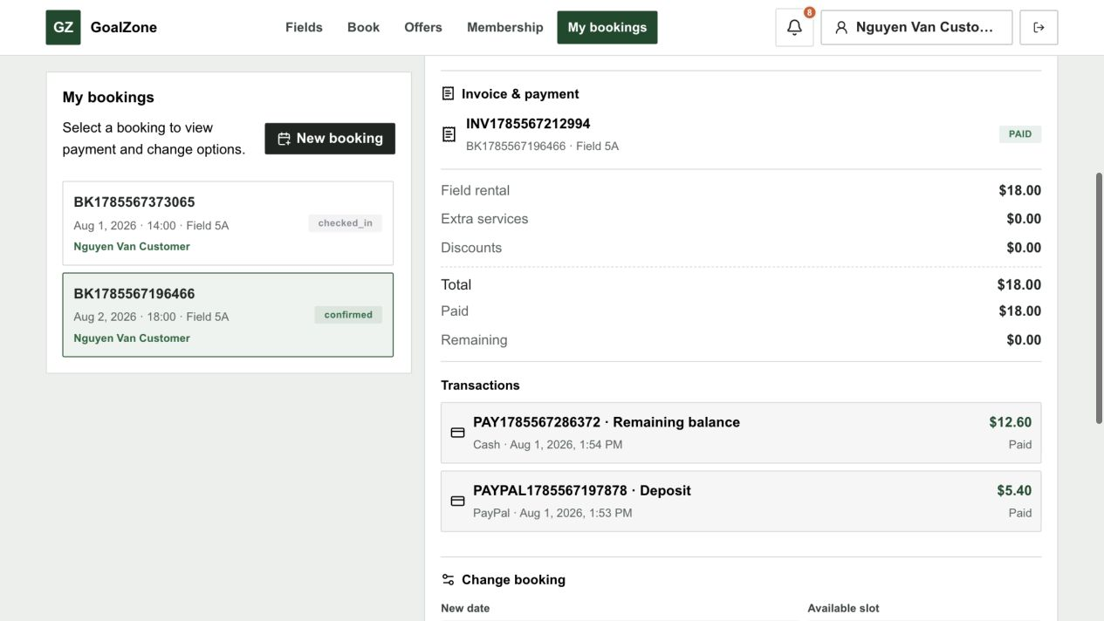
Screen state - Policy-derived cancellation terms

Field Name | Field Type | Description
Booking summary | Read-only group | Selected eligible booking and start time.
Paid amount | Currency | Captured/recorded payment total.
Refund policy | Read-only text | Applicable before-24-hour or same-day rate.
Refundable amount | Currency | Previewed amount before mutation.
Cancel booking | Confirmation button | Applies cancellation and creates eligible refund workflow.

Database Access
Table | CRUD | Description
booking, payment | R/U | Loads eligibility/paid amount and changes status after confirmation.
system_setting | R | Loads configured refund percentages.
refund, invoice, notification | C/U | Creates eligible refund, updates invoice, and notifies after cancellation.
Detailed as-built SQL is specified under UC-30 in the SDS Database Queries sections.

4. Payment Gateway, Refund & Invoice

4.1 Screen Designs

a. Checkout Summary
Displays a single USD pricing source of truth before Customer online or Staff walk-in payment choice.
Related use cases: UC-34, UC-35

UI Design

Screen state - Service totals and payment choices

Field Name | Field Type | Description
Field price | Currency line | Applicable field/day/time price.
Services | Currency lines | Quantity and unit-price snapshots.
Promotion discount | Currency line | Eligible promotion amount.
Membership discount | Currency line | Customer benefit amount where applicable.
Total/deposit/balance | Currency summary | Final payable values in USD.
Payment choice | Choice | Customer: online deposit/full; Staff walk-in: cash deposit/full/remaining.

Database Access
Table | CRUD | Description
slot, field_price, extra_service | R | Calculates field/service value.
promotion, customer_membership, membership_level | R | Validates discounts.
system_setting | R | Loads configured deposit percentage.
Detailed as-built SQL is specified under UC-34, UC-35 in the SDS Database Queries sections.

b. Payment Sandbox
Customer-only PayPal Sandbox Orders v2 create/capture/cancel flow.
Related use cases: UC-36, UC-38

UI Design

Screen state - Customer online payment selection

Field Name | Field Type | Description
Payment amount | Read-only currency | Server-calculated deposit or full amount in USD.
PayPal Buttons | Provider component | Creates and approves the sandbox order for the Customer.
Provider status | Status message | Shows created, captured, cancelled, failed, or unavailable state.
Retry | Button | Allows a safe new attempt after a non-final failure.

Database Access
Table | CRUD | Description
booking, invoice | R/U | Validates ownership/amount and reconciles confirmed booking/billing state.
payment | C/U | Stores provider order ID, capture ID, transaction code, amount, method, status, and time.
Detailed as-built SQL is specified under UC-36, UC-38 in the SDS Database Queries sections.

c. Payment History
Shows real persisted transaction history subject to booking ownership/operator access.
Related use cases: UC-39

UI Design
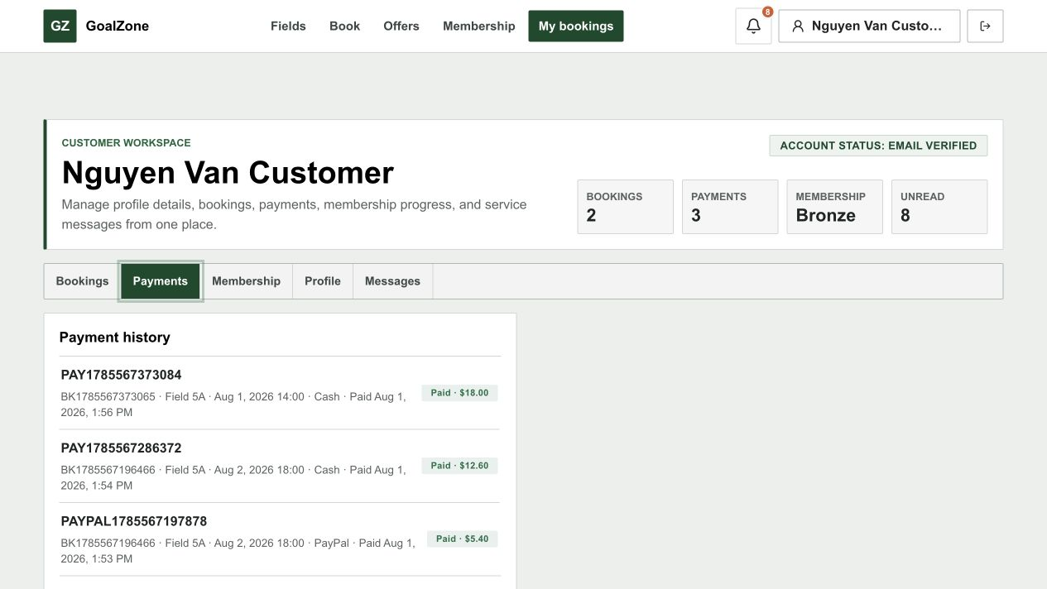
Field Name | Field Type | Description
Transaction list | Table/list | Payment code, booking, method, amount, status, provider reference, and paid time.
Status filter | Modal text area | Optional payment-status filter.
Open booking | Link | Opens related Booking Detail/Invoice.

Database Access
Table | CRUD | Description
payment, booking, app_user | R | Loads authorized persisted transactions and related booking context.
Detailed as-built SQL is specified under UC-39 in the SDS Database Queries sections.

d. Invoice Detail
Displays the generated booking invoice and current settlement state.
Related use cases: UC-40

UI Design

Field Name | Field Type | Description
Invoice code/status | Read-only text | Invoice identity and status.
Field/services | Currency lines | Rental and add-on amounts.
Discounts | Currency lines | Promotion and membership discounts.
Total/paid/remaining | Currency summary | Settlement state in USD.
Refunded amount | Currency | Completed refund total.
Payment history | Transaction list | Related persisted payments.

Database Access
Table | CRUD | Description
invoice, booking | R | Loads invoice snapshot and booking totals.
booking_service, booking_promotion | R | Loads auditable line/discount snapshots.
payment, refund | R | Loads paid and refunded transactions.
Detailed as-built SQL is specified under UC-40 in the SDS Database Queries sections.

e. Refund Management
Customer submits an eligible request; Staff reviews it and completes PayPal or cash refund workflows.
Related use cases: UC-41, UC-42

UI Design
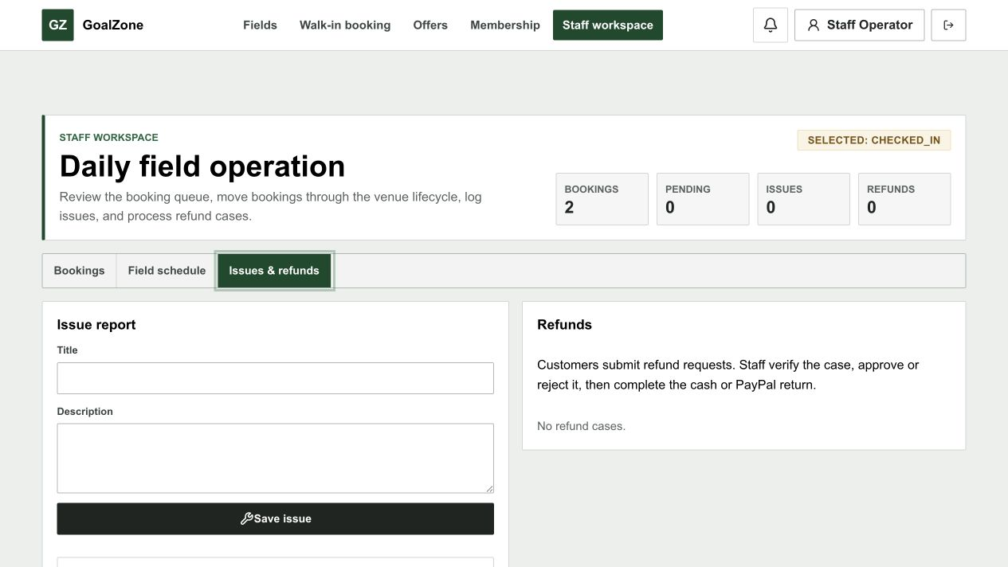
Field Name | Field Type | Description
Refund queue | Data list | Booking, payment method, requested/approved amount, status, reason, and provider IDs.
Approve / Reject | Buttons | Staff decision with valid state transition.
Submit / Retry PayPal | Button | Calls provider refund by capture ID with idempotency.
Record cash completion | Button | Explicitly confirms cash was returned on site.
Provider result | Status message | Only provider COMPLETED is final for PayPal.

Database Access
Table | CRUD | Description
refund, payment, booking | R/C/U | Creates owner-authorized Customer requests and stores Staff/provider handling state.
invoice | U | Updates refunded amount/status after final completion.
notification | C | Notifies Customer after completed refund is persisted.
Detailed as-built SQL is specified under UC-41, UC-42 in the SDS Database Queries sections.

f. Booking and Refund Policies
Admin maintains deposit, payment-timeout, cancellation/refund, and reminder settings.
Related use cases: UC-43, UC-44

UI Design
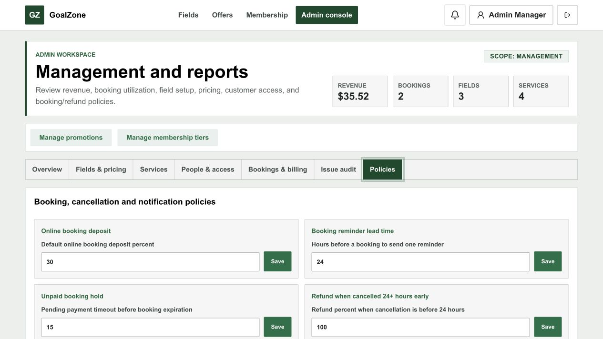
Screen state - Booking, cancellation, and notification policies
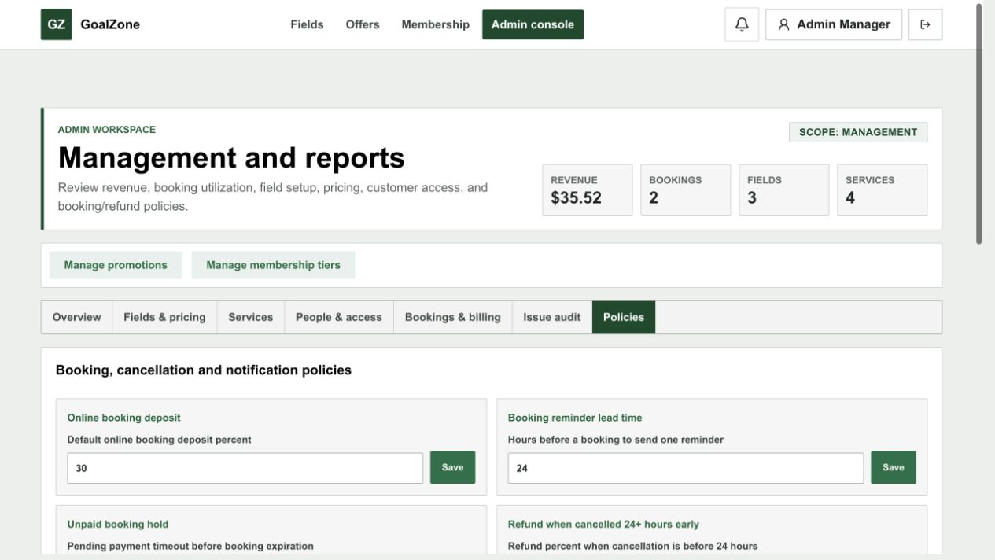
Screen state - Automatic slot generation policies
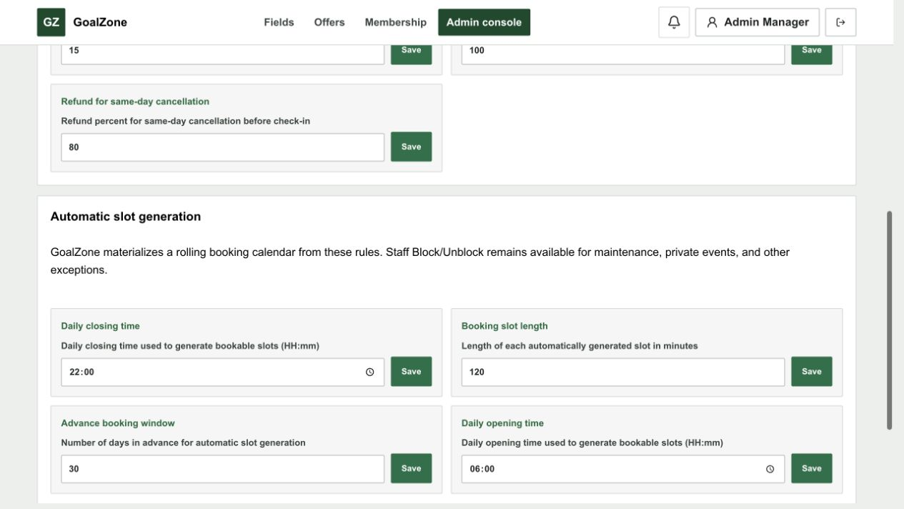
Field Name | Field Type | Description
Default deposit percent | Number input | Online booking deposit percentage.
Pending payment timeout | Number input | Minutes before an unpaid hold expires.
Before-24-hour refund percent | Number input | Refund percentage for early cancellation.
Same-day refund percent | Number input | Refund percentage for same-day cancellation before check-in.
Reminder hours | Number input | Lead time for one booking reminder.
Save | Button | Validates and persists each system setting.

Database Access
Table | CRUD | Description
system_setting | R/U | Loads and updates typed policy values used by booking/payment schedulers.
Detailed as-built SQL is specified under UC-43, UC-44 in the SDS Database Queries sections.

5. Promotion, Membership, Notification & Report

5.1 Screen Designs

a. Promotion List
Public list of active, date-valid promotion campaigns and event sales.
Related use cases: UC-45

UI Design
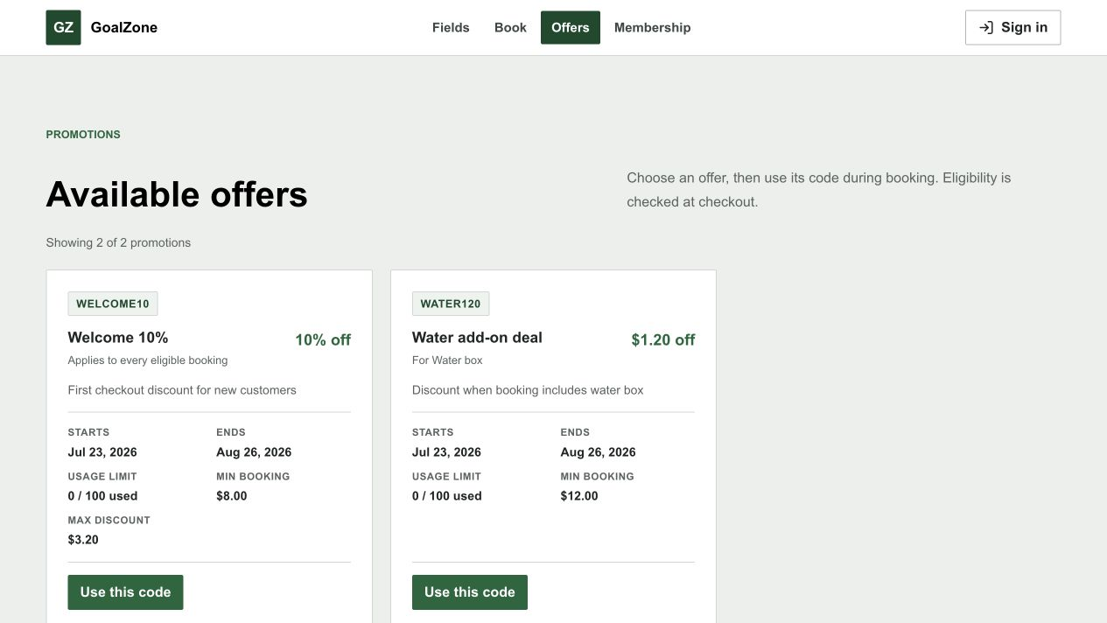
Field Name | Field Type | Description
Promotion cards | Card list | Banner, name, code, period, and discount summary.
Eligibility summary | Read-only text | Minimum amount and applicable conditions where public.

Database Access
Table | CRUD | Description
promotion | R | Loads active public campaigns.
Detailed as-built SQL is specified under UC-45 in the SDS Database Queries sections.

b. Promotion Management
Admin creates/updates campaigns; checkout validates and snapshots one eligible code.
Related use cases: UC-46, UC-47

UI Design
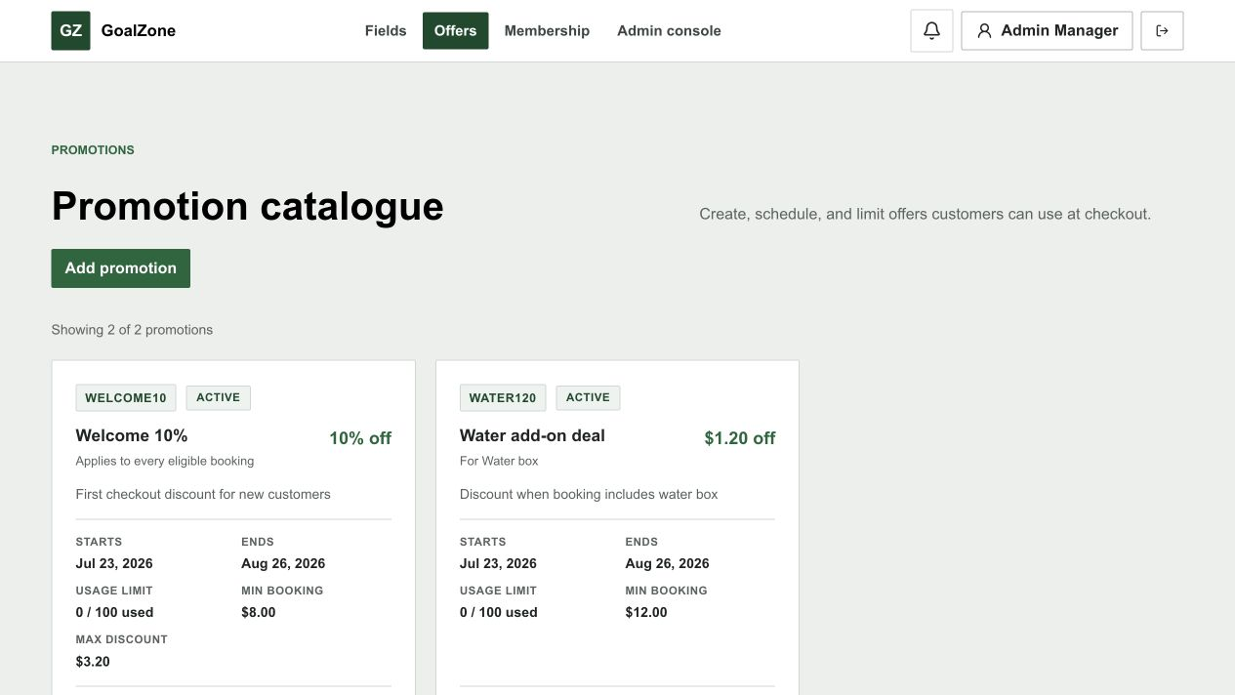
Screen state - Promotion editor
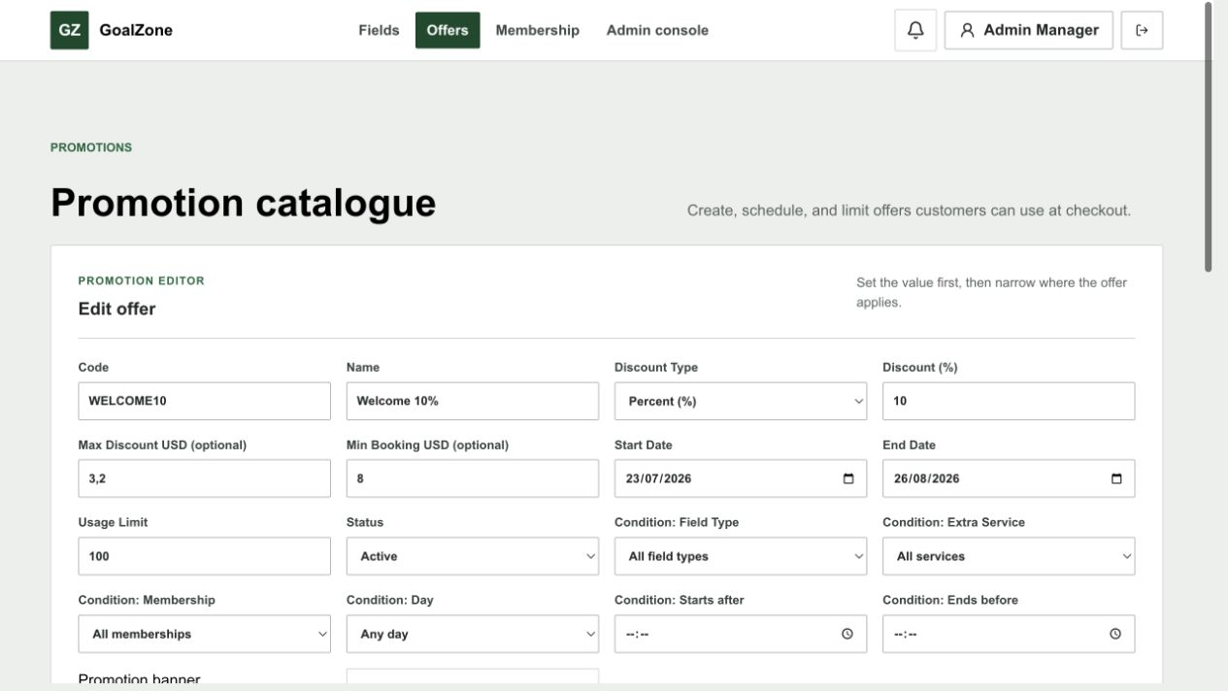
Field Name | Field Type | Description
Campaign list | Data list | Active/inactive campaigns and usage.
Code/name/banner | Form fields | Unique campaign identity and optional uploaded banner URL.
Discount type/value | Inputs | Percent or fixed USD discount with valid bounds.
Start/end and usage limit | Inputs | Eligibility period and maximum use.
Eligibility conditions | Inputs | Minimum amount, field type, service, membership, day, and time conditions.
Status | Modal text area | Active/inactive campaign.

Database Access
Table | CRUD | Description
promotion | R/C/U | Lists and persists campaign/condition/status data.
booking_promotion, booking | R/C | Validates usage and stores the applied discount snapshot.
Detailed as-built SQL is specified under UC-46, UC-47 in the SDS Database Queries sections.

c. Membership Benefits
Public view of active membership levels, thresholds, and benefit descriptions.
Related use cases: UC-50

UI Design
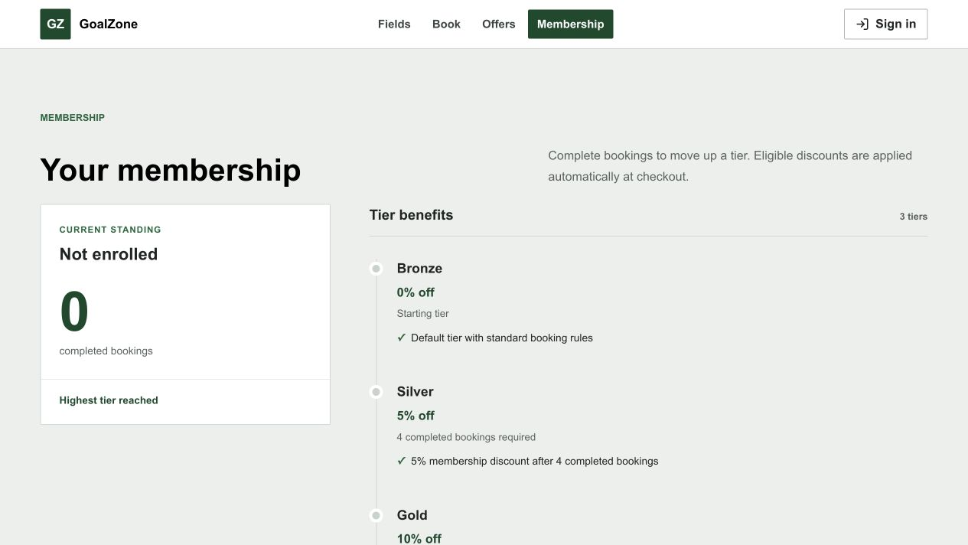
Field Name | Field Type | Description
Level list | Card/list | Level name, completed-booking threshold, discount percent, and benefit description.

Database Access
Table | CRUD | Description
membership_level | R | Loads active levels ordered by display order.
Detailed as-built SQL is specified under UC-50 in the SDS Database Queries sections.

d. Membership Progress
Customer view of current membership and lifetime/monthly/consecutive-week progress toward the next active level.
Related use cases: UC-48

UI Design
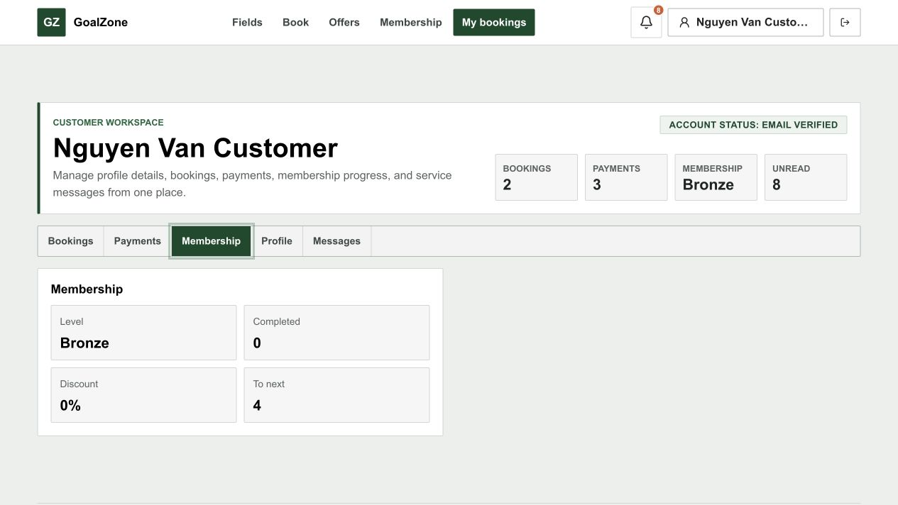
Field Name | Field Type | Description
Current level | Read-only text | Current membership level and benefit.
Completed bookings | Number | Lifetime completed-booking audit count.
Next-level rule | Read-only text | Qualification period and remaining booking/streak target.
Progress | Progress indicator | Period-aware progress toward the next active level.

Database Access
Table | CRUD | Description
customer_membership, membership_level | R/U | Loads current progress and updates level after eligible completion.
booking | R | Counts completed bookings only.
Detailed as-built SQL is specified under UC-48 in the SDS Database Queries sections.

e. Membership Rule Management
Admin maintains ordered membership benefits and lifetime, monthly, or consecutive-week qualification rules.
Related use cases: UC-49

UI Design
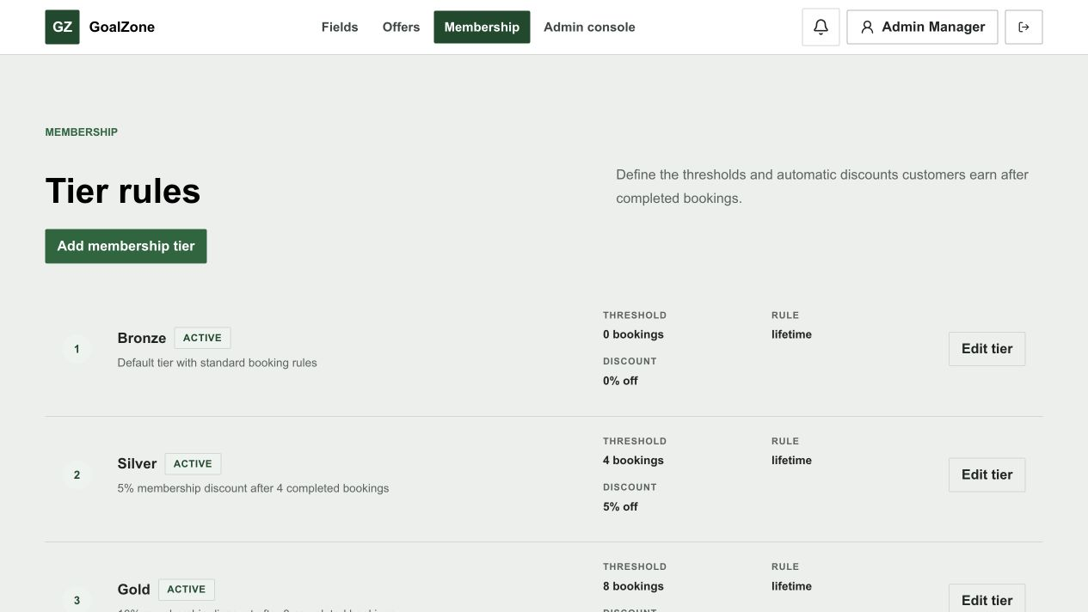
Screen state - Membership tier editor
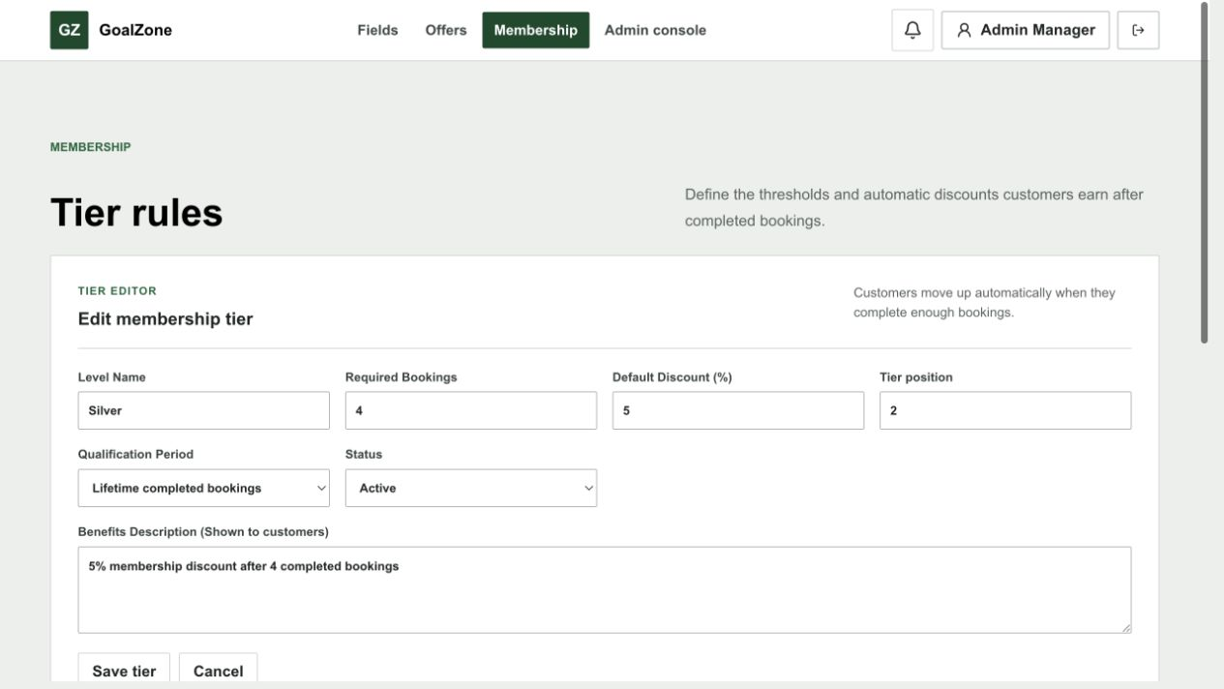
Field Name | Field Type | Description
Level list | Data list | Active/inactive levels ordered for progression.
Level name | Text box | Required unique display name.
Required completed bookings | Number input | Lifetime/monthly count or per-week minimum.
Qualification period | Modal text area | Lifetime, monthly, or weekly.
Consecutive weeks | Number input | Required qualifying-week streak for weekly rules.
Discount and benefit | Inputs | Customer-visible benefit configuration.
Display order/status | Inputs | Ordering and active/inactive state.

Database Access
Table | CRUD | Description
membership_level | R/C/U | Lists and persists thresholds, benefits, order, and status.
customer_membership | R/U | Re-evaluates affected Customer level/progress when appropriate.
Detailed as-built SQL is specified under UC-49 in the SDS Database Queries sections.

f. Notification List
Displays persisted in-app booking, payment, issue, cancellation, refund, and reminder notifications.
Related use cases: UC-51, UC-52, UC-53

UI Design

Screen state - Customer notification list
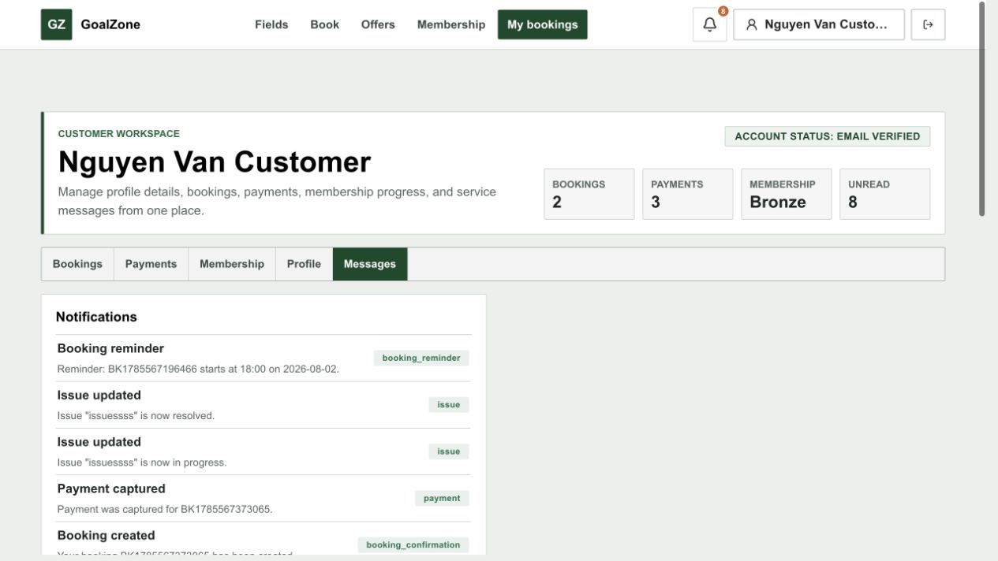
Field Name | Field Type | Description
Notification list | List | Type, title, message, related booking/payment/refund, created time, and read state.
Toggle read | Action | Marks one notification read/unread.
Mark all read | Button | Marks the authenticated user's notifications read.

Database Access
Table | CRUD | Description
notification, app_user | R/U | Loads authorized notifications and updates read state.
booking, payment, refund | R | Provides related context links.
Detailed as-built SQL is specified under UC-51, UC-52, UC-53 in the SDS Database Queries sections.

g. Revenue Report
Admin-only aggregate of gross collections, tracked PayPal fees, refunds, net revenue, discounts, and portfolio value in USD.
Related use cases: UC-54

UI Design
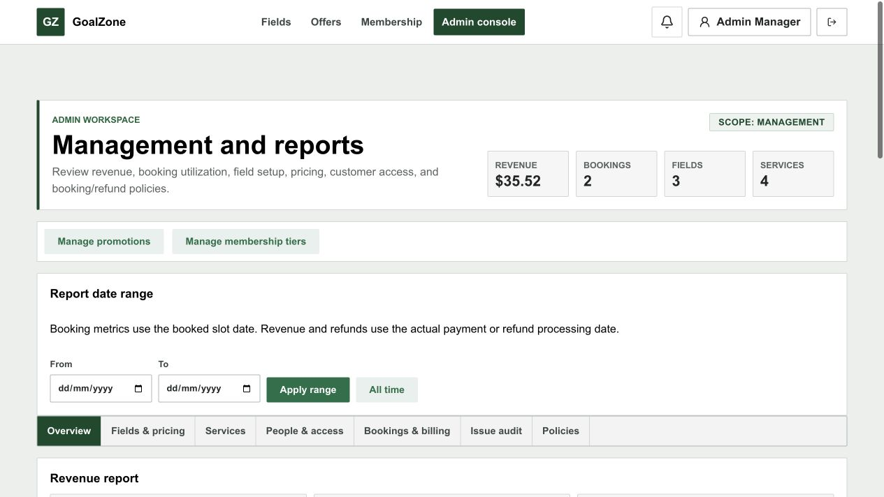
Screen state - Revenue range and summary
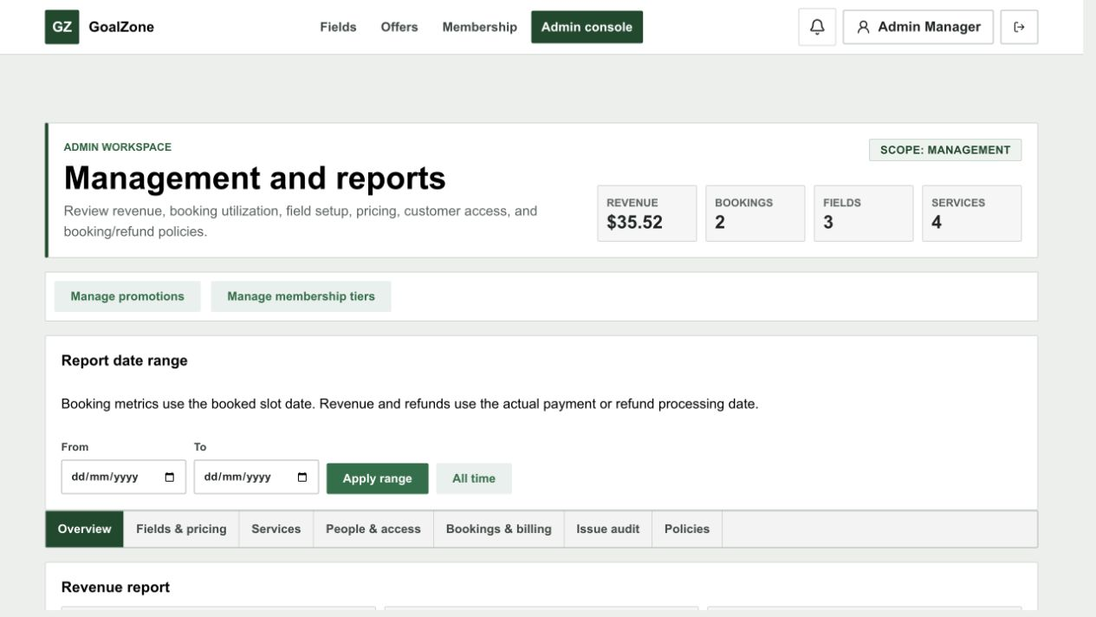
Field Name | Field Type | Description
Net revenue | KPI | Gross collected minus completed refunds and exact tracked provider fees.
Gross collected | KPI | Successful payment value.
Refunded | KPI | Completed refund value.
PayPal fees | KPI/status | Exact tracked processor fees plus a warning count for legacy rows without provider breakdown.
Field/service value | Breakdown | Booking field and service portfolio amounts.
Promotion/membership discounts | Breakdown | Stored discount snapshots.
Booking totals | Counts | Related lifecycle counts.

Database Access
Table | CRUD | Description
payment, refund, invoice, booking | R | Aggregates stored transaction and invoice amounts.
booking_service, booking_promotion, customer_membership | R | Aggregates service and discount impact.
Detailed as-built SQL is specified under UC-54 in the SDS Database Queries sections.

h. Booking Report
Admin-only booking lifecycle, peak-demand, and field-utilization statistics.
Related use cases: UC-55

UI Design
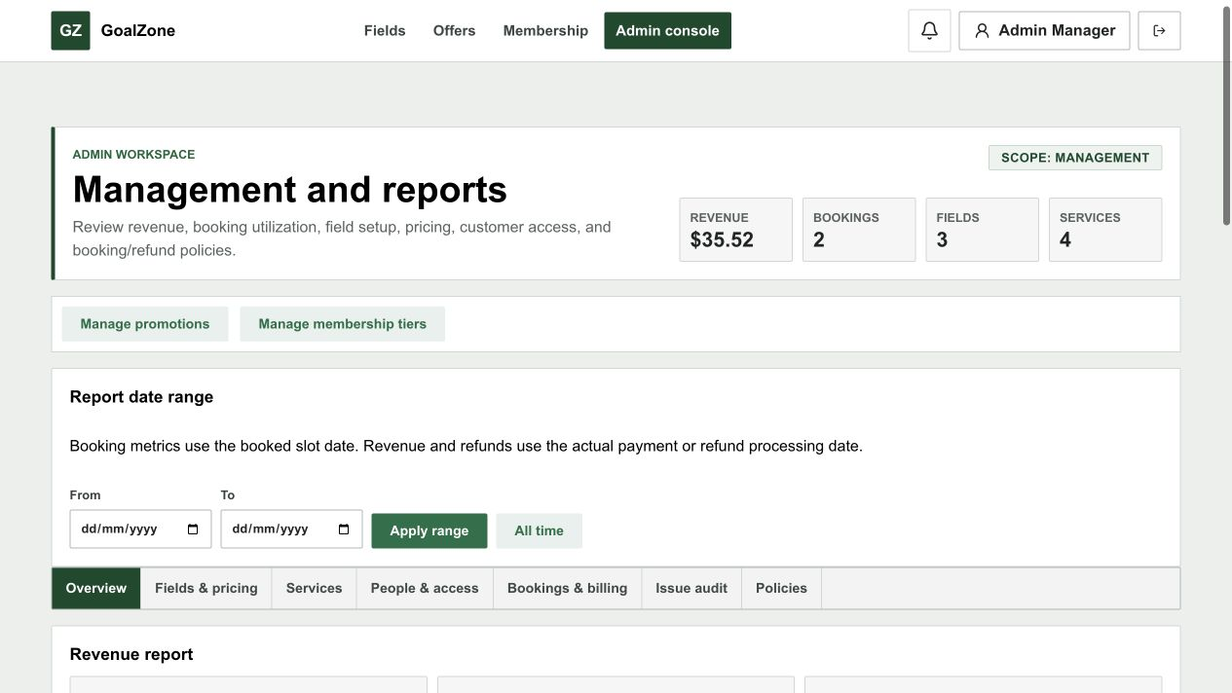
Screen state - Booking trends and field utilization
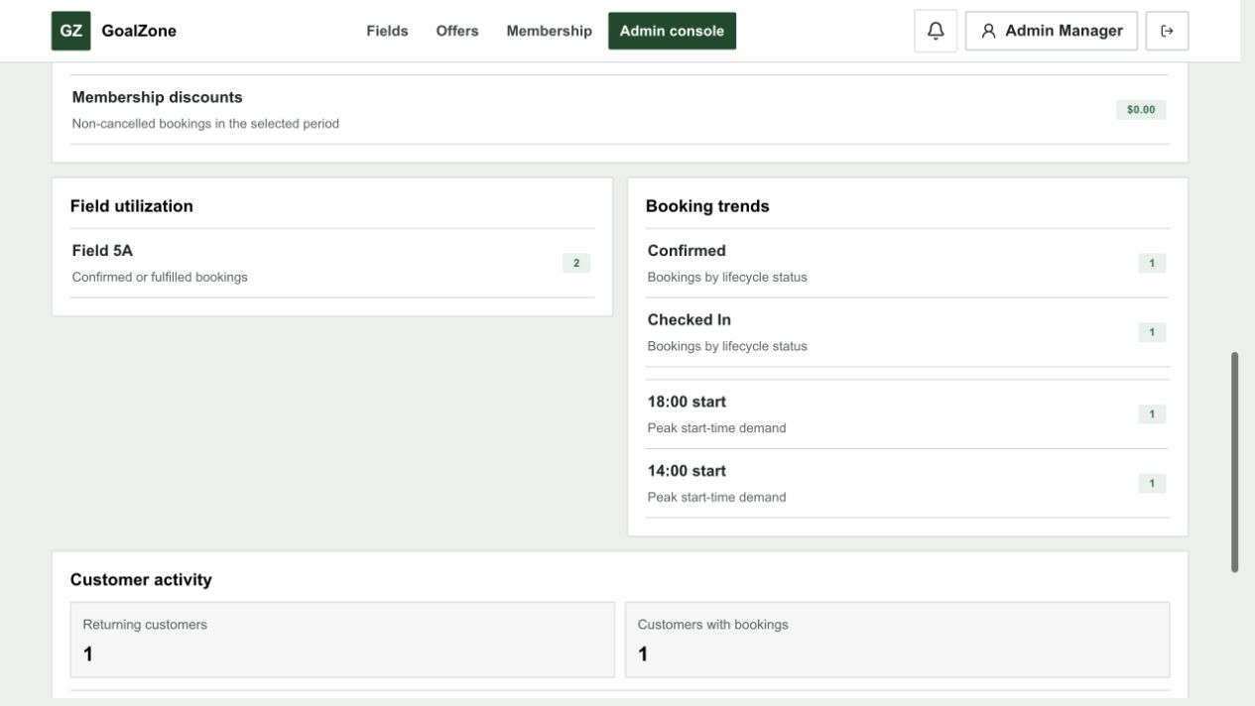
Field Name | Field Type | Description
Lifecycle counts | KPI/list | Pending, confirmed, checked-in, completed, cancelled, no-show, expired, and rejected counts.
Peak start time | Statistic | Most frequent slot start time.
Field utilization | Ranked list | Booking count by field.

Database Access
Table | CRUD | Description
booking, slot, field | R | Aggregates lifecycle, time, and field usage data.
Detailed as-built SQL is specified under UC-55 in the SDS Database Queries sections.

i. Customer Account State Report
Admin-only aggregate of tracked/returning Customers, top activity, and membership distribution.
Related use cases: UC-56

UI Design
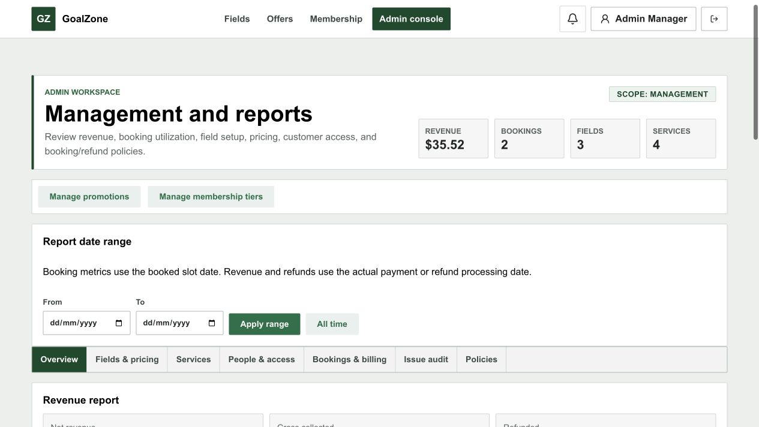
Screen state - Returning customers and membership distribution

Field Name | Field Type | Description
Tracked customers | KPI | Customers included in stored activity.
Returning customers | KPI | Customers with repeated bookings.
Top customers | Ranked list | Customer booking counts.
Membership distribution | Breakdown | Customer counts by membership level.

Database Access
Table | CRUD | Description
app_user, role, booking | R | Aggregates Customer booking behavior.
customer_membership, membership_level | R | Aggregates membership distribution.
Detailed as-built SQL is specified under UC-56 in the SDS Database Queries sections.

IV. Appendix

1. Assumptions & Dependencies
ID | Category | Rule Definition
A-01 | Assumption/Dependency | The system is designed for a small or medium football-field venue and covers the approved classroom booking operations.
A-02 | Assumption/Dependency | Online Customer payment uses the configured PayPal sandbox; Staff records walk-in cash payment.
A-03 | Assumption/Dependency | In-app notifications cover operational events; email is additionally used for verification, password setup/reset, account status, and account-lock reason.
A-04 | Assumption/Dependency | Deposit, payment-timeout, refund, and reminder policy values are maintained in the system_setting table.
A-05 | Assumption/Dependency | Promotion conditions are kept practical and stored in promotion fields instead of a separate promotion condition table.
A-06 | Assumption/Dependency | UC-13 is the single deterministic availability-search journey over generated, priced GoalZone slots.

2. Limitations & Exclusions
ID | Category | Rule Definition
L-01 | Limitation/Exclusion | Online payment uses the configured PayPal sandbox; production PayPal credentials and production settlement are outside the classroom deployment scope.
L-02 | Limitation/Exclusion | The assistant/ranking journey is removed; UC-13 deterministic live availability search is sufficient for the classroom scope.
L-03 | Limitation/Exclusion | No complex inventory warehouse module for extra services. The system only checks service availability/capacity at booking level.
L-04 | Limitation/Exclusion | No separate HR/payroll/accounting system integration is included.
L-05 | Limitation/Exclusion | Use case diagram, screen flow, and UI mockups can be manually drawn in draw.io or Google Docs for better visual quality.

3. Business Rules

ID | Category | Rule Definition
BR-01 | Account Uniqueness | Registered account email or phone number must be unique.
BR-02 | Authentication | Private screens and functions require a valid authenticated session.
BR-03 | Role Authorization | A user can access only screens and functions allowed for their role.
BR-04 | Locked Customer | A locked Customer cannot log in or perform authenticated actions until an Admin unlocks the account.
BR-05 | Field Active Status | Only active fields can be shown for new customer booking.
BR-06 | Field Pricing Validity | Field price must match the selected field, day type, time range, and effective date.
BR-07 | Past Slot Rule | Customers and staff must not create or reschedule bookings to slots in the past.
BR-08 | Booking Conflict | The system must not allow more than one active booking for the same field slot.
BR-09 | Unavailable Slot Rule | The system must not allow booking on slots blocked for maintenance, weather, private event, internal use, or other operational reasons.
BR-10 | Extra Service Availability | Limited extra services must not be selected beyond available inventory or staff capacity.
BR-11 | Extra Service Update Window | Extra services can be added or updated only before booking check-in.
BR-12 | Booking Confirmation | A pending online booking becomes Confirmed only after valid the required payment is captured.
BR-13 | Booking Rejection | Only pending booking requests can be rejected, and the rejection reason must be recorded.
BR-14 | Check-in Status | Only Confirmed bookings can be checked in.
BR-15 | Completion Status | Only Checked-in bookings can be completed.
BR-16 | Cancellation Rule | Checked-in and Completed bookings cannot be cancelled through the normal cancellation flow.
BR-17 | Cancellation Preview | Before cancellation, the system must show cancellation fee and refundable amount.
BR-18 | Refund Calculation | Refund amount is calculated from booking time, cancellation time, paid amount, and cancellation/refund rules.
BR-19 | No-show Handling | No-show is not treated as customer-initiated cancellation. The customer may lose the deposit according to policy.
BR-20 | Membership Progress | Only Completed bookings count toward membership progress; Cancelled, Rejected, Expired, and No-show bookings do not count.
BR-21 | Checkout Summary | Checkout summary must show field price, extra services, promotion discount, membership benefit, deposit amount, and payable total.
BR-22 | Online Deposit | Online booking requires at least the configured deposit amount before the booking can be confirmed.
BR-23 | Payment Transaction | Payment status must be updated from the sandbox result and stored with amount, method, transaction code, and payment time.
BR-24 | Invoice Generation | An invoice must include field rental, extra services, discounts, paid amount, remaining amount, and refund amount if any.
BR-25 | Promotion Validity | Promotion can be applied only when date range, usage limit, field/time condition, membership condition, and stacking rule are satisfied.
BR-26 | Promotion Audit | Applied promotion details must be stored with the booking so invoice and reports remain auditable.
BR-27 | Membership Rule Validity | Membership levels must have non-overlapping thresholds and valid benefit values.
BR-28 | Notification Trigger | Booking, payment, cancellation, refund, and reminder notifications are created only after the related event is stored successfully.
BR-29 | Issue Tracking | Each issue must store reporter, issue type/context, status, and resolution note when resolved.
BR-30 | Management Data Status | Master data such as fields, prices, services, promotions, and membership levels should be disabled instead of physically deleted when already used by transactions.
BR-31 | Report Access | Only Admin can view system reports, and report filters must use a valid date range.
BR-32 | Report Data Source | Reports must aggregate from stored booking, payment, invoice, refund, promotion, and membership records.

4. Booking Status Values
ID | Category | Rule Definition
BS-01 | Pending | Booking is created but not yet confirmed.
BS-02 | Confirmed | Booking is confirmed after valid required payment; there is no manual approval queue.
BS-03 | Checked-in | Customer has arrived and staff has checked in the booking.
BS-04 | Completed | Customer has finished using the field and the booking is closed.
BS-05 | Cancelled | Booking has been cancelled according to policy.
BS-06 | No-show | Customer did not arrive for a confirmed booking.
BS-07 | Expired | Booking or payment expired before confirmation.
BS-08 | Rejected | Historical compatibility status; current invalid requests fail during booking/payment instead of Staff review.

5. Code-First Alignment Notes
ID | Category | Rule Definition
CF-01 | Field catalogue | UC-11 list response does not contain price; price is resolved in field detail/checkout.
CF-02 | Field detail | Public detail rejects inactive fields. Reviews/ratings are not modeled; services shown are the global active catalogue.
CF-03 | Slot discovery | UC-13 is the single public date/time/type availability search over generated, priced live slots.
CF-04 | Field booking | Booking and reschedule reject blocked/reserved/past slots and slots owned by inactive fields.
CF-05 | Field pricing | Active price bands honor day/time/effective dates and reject overlapping active rules; A slot is not bookable when no active effective price band matches.
CF-06 | Role boundary | Customer online booking uses PayPal. Staff creates walk-in bookings and records cash. Admin has no checkout UI or API authority; Venue Staff owns walk-in cash operations.
CF-07 | Reschedule | The destination slot, current service inventory, promotion/membership discounts, balance/refund delta, invoice and notification are recalculated.
CF-08 | Payment failure | A non-COMPLETED PayPal capture returns an error while preserving the local failed payment/provider status for history and diagnosis.
CF-09 | Refund accounting | Only PayPal provider COMPLETED or explicit staff-recorded cash completion reconciles refund, invoice and booking financial snapshots.
CF-10 | Reporting | Booked commercial value excludes cancelled/rejected/expired rows; utilization counts only qualifying operational statuses.
CF-11 | Conflict handling | Booking conflict is an alternate flow that composes issue, UC-29 reschedule, UC-30 cancel, refund, and notification behavior; there is no dedicated conflict entity.
CF-12 | Availability scope | UC-13 deterministically reads live GoalZone availability; no assistant, LLM, or fabricated result source is included.

