Climate Change and Diversity and Quality of Food-away-from-home: Evidence from A Large-scale Chain Restaurant

Chen Zhu
China Agricultural University

Rigoberto Lopez
University of Connecticut

Xiaoou Liu
Renmin University of China

Xun Li*
Wuhan University

______________________________
*School of Economics and Management, Wuhan University.
Email: li.xun@whu.edu.cn

Climate Change and Diversity and Quality of Food-away-from-home: Evidence from A Large-scale Chain Restaurant

Abstract
Climate change is anticipated to have profound effects, impacting both food producers and consumers. This study explores the repercussions of climate change on food-away-from-home (FAFH) meal quality in China. Leveraging a unique dataset comprising 15,420,075 restaurant transactions spanning the years 2016 to 2020 across 17 Chinese cities, alongside daily climate data and comprehensive nutritional information, we empirically examine the impact of climate change on FAFH meal diversity, imbalance, and overall quality. Employing high-dimensional fixed effects (HDFE) models, our findings reveal that extreme high temperatures and heat waves lead to a reduction in meal diversity and balance, culminating in an overall decline in FAFH meal quality. We also address the potential sample selection by examining the impacts of temperature and heat waves by group size as larger dining groups, comprising more than two customers, are more likely to have pre-scheduled or booked their reservations, making them less sensitive to immediate weather conditions. This research underscores the profound impact of climate change on food consumption behaviors and quality from the consumer perspective, while emphasizing the potential co-benefits of climate action for environmental sustainability and public health.

Keywords: food-away-from-home; climate change; food consumption; meal quality
JEL Classification: Q54 I12 Q56

1. Introduction
Climate change encompasses a range of consequences, including rising temperatures, extreme weather events, and rising sea levels (Van Aalst, 2006). Evidence has shown that many regions around the world are already experiencing an increase in temperatures and more frequent heat waves (IPCC, 2022; Milman, 2022). In agro-food systems, climate change is expected to have an adverse impact on both producers and consumers. The effects of climate change on food systems include challenges related to production, distribution, and access to food. These challenges will, in turn, have negative impacts on food security and nutrition, particularly in vulnerable populations and developing countries.
Previous research has primarily focused on the impact of climate change on agricultural production and therefore food security, as global warming and extreme temperatures can significantly reduce output (Deschênes and Greenstone, 2012; Wheeler and Von Braun, 2013; Burke and Emerick, 2016; Aragón et al., 2021; IPCC, 2014; Singh et al., 2022). However, the effects of climate change on the dietary behavior of consumers after controlling food prices and income, are equally important, as they are closely linked to diet quality and health. Recent studies by Niles et al. (2021) and van der Merwe et al. (2022), which draw on annual diet and weather data from Africa, have illustrated that climate change can lead to decreased child diet diversity and increased malnutrition. These findings are largely explained to alterations in crop growth and food security conditions. On the other hand, there remains a notable gap in our understanding concerning how immediate consequences of rising temperatures and extreme weather events affect the quality of consumers’ diets. This gap is especially pronounced in urban settings where food-away-from-home (FAFH) consumption is prevalent. Therefore, further research is necessary to understand better the impact of climate change on consumer dietary behavior, particularly in urban area and in the wake of recent climate events.
The interplay between climate change and diet quality is a multifaceted issue, with numerous factors contributing to its complexity. One key aspect is the impact of climate change-induced extreme weather events on consumers’ food environment and accessibility. Such events can disrupt food production and supply chains, leading to higher prices and decreased availability of certain foods. These effects are further compounded by the negative impacts of rising temperatures on agricultural yields, potentially reducing the variety and quality of foods available to consumers. Additionally, changes in weather conditions can directly affect consumers’ dietary choices and eating behaviors. Exposure to hot ambient temperatures, for example, has been linked to decreased energy intake and appetite suppression (Richardson et al., 2018; Zakrzewski-Fruer et al., 2021). These physiological and psychological thermal adaptations may influence consumers’ food preferences and lead to altered dietary patterns. Furthermore, exposure to extreme temperatures may have broader impacts on consumers’ cognitive function, mental health, and overall wellbeing, affecting their decision-making processes when selecting foods (Zivin et al., 2020; Fishman et al., 2019; Hua et al., 2022).
This study aims to investigate the relationship between climate change and consumers’ meal diversity, balance, and quality using a unique dataset of 15.4 million high-frequency restaurant transactions from 17 Chinese cities between 2016 and 2020. The study focuses on urban areas, where over half of the global population resides, and food-away-from-home consumption is prevalent. Dining out has become a ubiquitous practice and an essential part of urban lifestyle in China, making food-away-from-home an important component of the Chinese diet and accounting for a significant portion of food expenditures (Liu et al., 2015). For instance, in 2019, consumer spending in restaurants grew at a rate of 10 percent, accounting for over 55 percent of total food expenditures in China (Zhu et al., 2021). By examining the impact of climate change on meal diversity, balance, and quality, this study sheds light on the implications of climate change for food consumption patterns and related health outcomes in urban China.
To accurately estimate the impact of climate change, we match daily climate records from the meteorological station nearest to each restaurant site, using the China surface climate daily data set from the China Meteorological Administration (2023), which provides complete daily information on temperature, precipitation, and wind speed from 699 meteorological stations in China. We also construct a binary climate variable to indicate whether an order was made during a heat wave, which is defined as consecutive days of high-temperature exposure when daily mean temperatures exceed the 90th percentile of local temperatures for at least two successive days (Kent et al., 2014).
Furthermore, we have detailed data on the ingredients and precise amounts used in each dish for each order, which enables us to construct a variety of dietary measures based on food groups. Specifically, we use the Individual Diet Diversity Score (IDDS) to measure meal diversity, as recommended by the Food and Agriculture Organization (FAO) guidelines (Kennedy et al., 2011; Ganpule-Rao et al., 2021). We use the Diet Quality Distance (DQD) from the Chinese Diet Balance Index to measure meal imbalance (Xu et al., 2015). To measure overall meal quality, we use the Healthy Eating Index-2015 (HEI-2015), which is a validated measure of diet quality developed by the US Department of Agriculture (Krebs-Smith et al., 2018).
China’s diverse geography, coupled with recent extreme weather events and high rates of diet-related diseases, make it a compelling case study to explore the relationship between climate change and diet quality. The dataset employed in our current study pertains to a distinct latitude and longitude range, spanning from 102 to 122 degrees East and from 23 to 40 degrees North. This specific range provides a range of climatic conditions and geographical features that are conducive to robust model identification and analysis. Furthermore, the widespread impact of recent extreme weather events on over 900 million Chinese citizens provides a unique opportunity to estimate the social costs of climate change on diet quality. Given China’s ranking among countries with the highest rates of diet-related deaths globally (GBD 2017 Diet Collaborators, 2019), it is crucial to investigate the potential involvement of climate change in exacerbating the burden of diet-related diseases in the country.
One major challenge of this research is the potential sample selection problem. We address the potential sample selection by examining the impacts of temperature and heat waves by group size as larger dining groups, comprising more than two customers, are more likely to have pre-scheduled or booked their reservations, making them less sensitive to immediate weather conditions. Overall, our findings reveal that extreme high temperatures and heat waves lead to a reduction in meal diversity and balance, culminating in an overall decline in FAFH meal quality. This research underscores the profound impact of climate change on food consumption behaviors and quality from the consumer perspective, while emphasizing the potential co-benefits of climate action for environmental sustainability and public health. It contributes substantively to the existing body of literature concerning the impact of climate change on diet quality, encompassing considerations related to food supply, prices, and income. The rest of this paper is organized as follows: Section 2 describes the data and methodology; Section 3 reports the empirical results; Section 4 is a discussion on policy implication; Section 5 concludes the paper.

2. Data and method
To assess the impact of extreme weather on diet quality, we employ a unique, high-frequency, proprietary dataset of 15,420,075 restaurant transactions. The main dataset used in the empirical analysis comes from a major chain restaurant in China. The full dataset contains the complete sales records of transactions between January 1, 2016, and December 31, 2020, from 118 restaurants located in 17 cities in China. For each order, we have a unique bill ID, the precise ordering/checkout time, the number of people in the dining group, the name and price of each dish ordered on that bill, and the total amount spent.
The restaurant chain under investigation predominantly specializes in Yunnan cuisine, boasting consistently high taste score reviews, with an average rating of approximately 4.6 out of 5.0 on Dianping (i.e., the Chinese Yelp). These restaurants fall within the mid-range price category and primarily cater to gatherings of family and friends, as opposed to serving as venues for business-related dining engagements. It is worth noting that the menus and culinary offerings remain uniform and consistent across various cities and restaurant sites.
2.1 Meal quality measures
By considering the same menu across restaurants and using control variables, we identify the effect of weather on diet choices across locations and over time. To better understand how individual food preferences and intake might be impacted by extreme weather, it is essential to acquire detailed nutritional information for each dish ordered. To this end, we obtained detailed data on the ingredients and precise amounts used in each dish directly from the restaurant chain administrator. This allows us to match each ingredient with the nutritional data and compute the total calories for the entire order. Meal diversity is measured by the FAO individual diet diversity score (IDDS) (Kennedy et al., 2013; Ganpule-Rao et al., 2021). IDDS ranges from 0 to 9 based on intake of nine groups of food including starchy staples (cereals, white tubers, and roots), legumes (nuts and seeds), milk and milk products, organ meats (e.g., liver), meat and fish, eggs, dark green leafy vegetables, other vitamin A-rich fruits and vegetables (e.g., mango, carrot, pumpkin), and other fruits and vegetables. The Diet Quality Distance (DQD), which serves as an indicator of meal imbalance among Chinese consumers, was calculated using the methodology proposed by Xu et al. (2015). In this approach, a lower DQD score is indicative of a higher level of dietary balance. The Healthy Eating Index-2015 (HEI-2015), a widely used standard measurement tool, was employed to assess the overall meal quality in this study (Krebs-Smith et al., 2018). The HEI-2015 was computed following the methodology outlined by the US Department of Agriculture.
These three diet indices, while interconnected to some extent, offer unique insights into different facets of dietary behavior. IDDS captures the diversity of foods consumed, DQD assesses the balance of food groups in a meal, and HEI-2015 evaluates the overall quality of a meal based on established dietary guidelines. IDDS and HEI-2015 allow cross-country comparisons, enhancing our understanding of dietary patterns across regions and populations.
2.2 Temperature measures
The main explanatory variable of interest is extreme weather. The weather data come from the China surface climate daily data set from the China Meteorological Data Service Center (2020). These data provide complete daily information on temperature, wind speed, and precipitation from 699 meteorological stations in China. For each restaurant site, we match daily weather records from the nearest meteorological station. We use daily maximum temperatures and temperature bins to account for the contemporaneous impact of extreme temperatures. In addition, we use wind speed and precipitation as complementary weather variables that have been shown to be associated with consumers’ emotional status or cognitive perceptions that may affect food consumption decisions (Denissen et al., 2008; Chen, 2019).
We consider two alternative specifications of temperature in our empirical models. First, we use the daily maximum temperatures, as they have been commonly used in previous studies. To fully capture potential non-linearities between temperature and diet outcomes (Carleton and Hsiang, 2016), we follow Baylis (2020) and Hanlon et al. (2020) and adopt a flexible binned model specification to allow for nonparametric impacts of temperature on diet outcomes, defined as follows:
$f\left({TEMP}_{irt}\right)= \sum_{b}^{B}{γ_{b}}{TEMP}_{irt}^{b}$, (1)
where ${TEMP}_{imt}^{b}$ is an indicator variable equal to 1 if ${TEMP}_{imt}^{b}$ falls into the given temperature bin $b$, which is specified as 3-degree bins based on the daily maximum temperature (16 bins in total). The bin of 21-24 C is selected as the baseline group in all regressions (Baylis, 2020). The parameters of interest $γ_{b}$ quantify the nonparametric relationships between temperature and diet outcomes, which can be interpreted as the average change in $y_{imt}$ resulting from replacing a day in the omitted bin (i.e., 21-24 C) with a day in the temperature bin $b$.
2.3 Other control variables
We also use other control variables related to the characteristics of the transactions drawn from the food purchase database, such as the size of the party, whether it was for dinner or lunch, time spent at the restaurant, whether the transaction occurred during peak hours, and a daily time trend variable. In addition, we use 2,278 fixed effects to control for unobservable factors, including fixed effects for each restaurant, city, month, day of the week, and their interactions.
2.4 Empirical Models
Our identification strategy relies on high-frequency variation in local temperature at the time the orders are placed. However, one crucial concern in our analysis is the potential selection bias arising from the possibility that people may make decision of dining based on the weather condition. For example, during days of bad weather (e.g., extreme hot/cold, rainy), there may be a greater proportion of working professionals with stringent work schedules who visit restaurants, whereas during days of comfortable weather, children and seniors may be more likely to come to a restaurant. In such cases, the estimated impacts of temperatures on diet outcomes may be driven by systematic differences among distinct customer groups rather than the weather per se.
To address the potential self-selection issues, we adopt the high-dimensional fixed effects (HDFE) model proposed by Guimaraes and Portugal (2010), which enables us to include hundreds of fixed effects (FE), such as site-by-day-of-week FE, site-by-month FE, city-by-month FE, thereby partially alleviating the potential self-selection problem. We also further address self-selection problem in robustness check, where we further examine the impacts of temperature and heat waves by group size as larger dining groups, comprising more than two customers, are more likely to have pre-scheduled or booked their reservations, making them less sensitive to immediate weather conditions. The general form of our HDFE model is:
$y_{imt}=α_{0}+f({TEMP}_{imt})+β_{1}ψ_{imt}+β_{2}X_{imt}+θ_{1}site+θ_{2}city+θ_{3}month$
$+θ_{4}dow+θ_{5}site×dow+θ_{6}site×month+ε_{imt} ,$ (2)
where $y_{imt}$ denotes a diet outcome for each dining party/order i that was made in restaurant site m at time t. We employ multiple measures of meal outcomes: meal diversity (IDDS), meal imbalance (DQD), and meal quality (HEI-2015). TEMP denotes the temperature on the day of the order at a given restaurant site, and $f(TEMP)$ is a function of temperature. $Ψ$ contains other weather-related variables, such as wind speed and precipitation, which have been shown to be associated with consumer emotional status or cognitive perceptions that may affect food consumption decisions (Denissen et al., 2008; Chen, 2019). $X$ denotes a set of additional control variables, including size of the party, meal duration, dinner dummy, peak hours dummy, and daily time trend.
There are a total of 2,278 fixed effects included in the HDFE model: 16 city FE, 117 site FE, 4 year FE, 11 month FE, 6 day-of-week FE, 736 site × day-of-week FE, 1,344 site × month FE, and 44 city × year FE. The inclusion of the large number of fixed effects thus provides further control for the systematic differences among customer groups dining at a specific restaurant location or time.
In all regression analyses, we rigorously cluster standard errors at the restaurant site level. Additionally, we employ a conservative approach to calculate standard errors without any adjustment for degrees-of-freedom when absorbing fixed effects. This meticulous methodology ensures the robustness and reliability of our statistical inferences.

3. Results
3.1 Descriptive analysis
A binary variable of the heat wave is also included to account for consecutive extreme hot daily temperatures, as well as 30-day cumulative days of heat waves. Table 1 provides summary statistics of the matched data. On average, the size of a dining party is 2.1 customers, and they spend 94.2 CNY (about $13) per person and 77.4 minutes in the restaurant per meal. Figure 1 shows average climate conditions of the studied area during 2016-2020. It includes (a) average daily maximum temperature, (b) average daily minimum temperature, (c) average daily precipitation, (d) 30-day cumulative days of heat waves, and (e) a visualization of the average daily maximum temperature in 31 provinces, municipalities, and autonomous regions in China, where red dots represent meteorological stations and green dots represent 118 restaurant sites located in 17 Chinese cities investigated in this study.

Table 1. Summary statistics of key variables (N = 15,420,075)
Variable | Mean/Proportion | Std. Dev | Min. | Max.
Total spending (in CNY) | 194.8 | 124.5 | 8.1 | 5212.0
Spending per person (in CNY) | 94.2 | 42.0 | 5.2 | 476.0
Meal duration (in minutes) | 77.4 | 61.6 | 10.0 | 347.0
Size of party | 2.1 | 1.2 | 1.0 | 21.0
Meal diversity (IDDS) | 3.8 | 1.1 | 0.0 | 9.0
Meal balance (DQD) | 23.0 | 5.0 | 2.0 | 35.0
Meal quality (HEI-2015) | 34.5 | 8.1 | 10.0 | 60.0
Minimum daily temperature (in Celsius) | 12.6 | 10.8 | -16.4 | 31.1
Maximum daily temperature (in Celsius) | 21.6 | 10.5 | -10.9 | 40.9
Wind speed (in meters per second) | 1.7 | 1.0 | 0.0 | 11.2
Precipitation (in millimeters) | 2.7 | 10.3 | 0.0 | 253.5
Heat wave | 6.8% | - | - | -
30-day cumulative days in heat waves | 2.1 | 4.1 | 0.0 | 28.0
Number of observations | 15,420,075

Figure 1. 2016-2020 average climate conditions of the studied area
a.

b.
c.
d.

e.
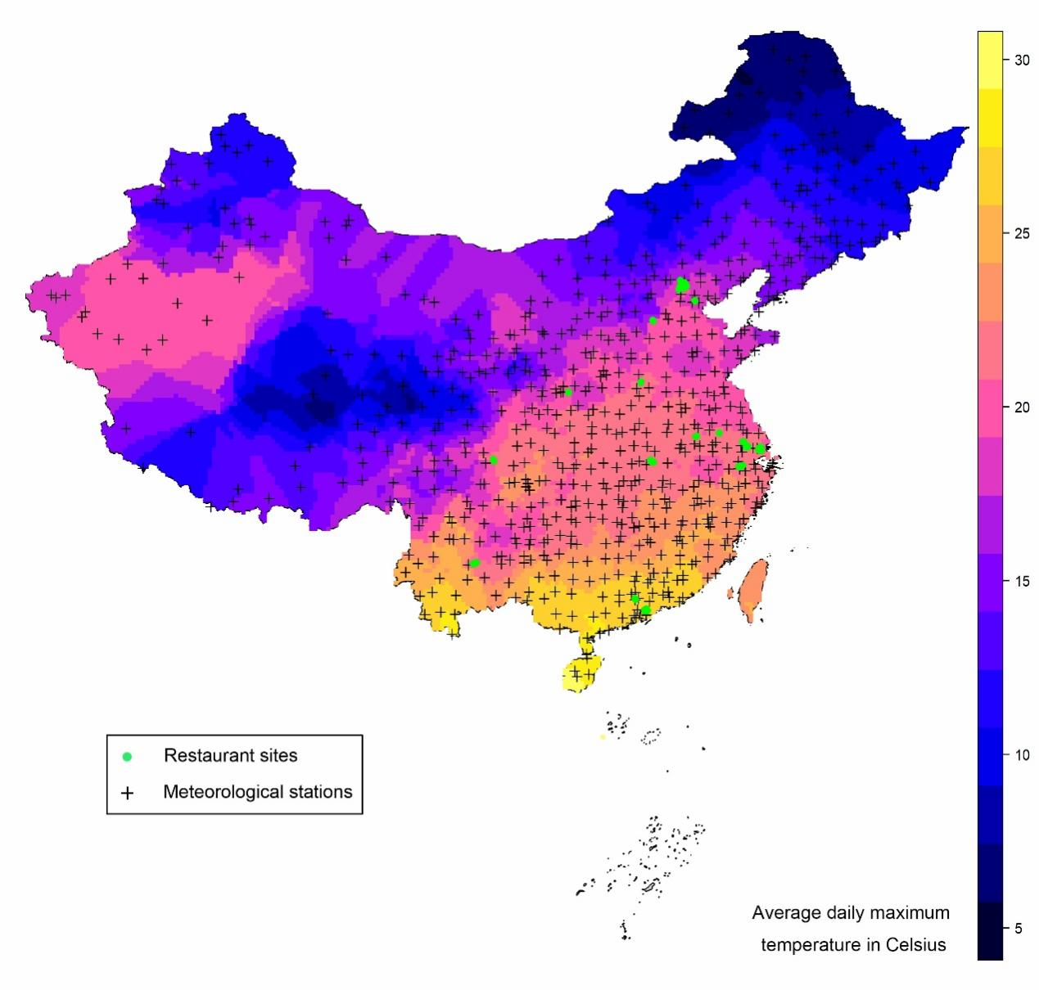
Notes: (a) average daily maximum temperature; (b) average daily minimum temperature; (c) average daily precipitation; (d) 30-day cumulative days of heat waves; and (e) a map of China illustrates the average daily maximum temperature in 31 provinces, municipalities, and autonomous regions, where red dots represent meteorological stations and green dots represent 118 restaurant sites located in 17 Chinese cities investigated in this study.

3.2 Impact of temperature
Results from linear HDFE regressions show that an increase of 1 degree Celsius in the daily maximum temperature leads to a 0.0005 decrease (P = 0.003) in meal diversity as measured by IDDS, a 0.009 increase (P =0 .001) in meal imbalance as measured by DQD, and a 0.007 decrease (P = 0.001) in meal quality as measured by the HEI-2015 score (Figure 2, panel a). These estimates point to a generally negative impact of temperature on diet outcomes among Chinese consumers. All models were adjusted for the size of the party and a daily time trend variable that can capture the trajectory of diet outcomes over time (e.g., changes due to COVID-19), and 2,278 fixed effects (FE, including 16 city FE, 6 day-of-week FE, 4 year FE, 11 month FE, 117 restaurant site FE, 736 day-of-week*restaurant site FE, 1,344 month*restaurant site FE, and 44 city*year FE). Note that we present the visualization of our findings and leave the tables in the appendix for simplicity.

Figure 2. Effects of climate variables on meal quality (N = 15,420,075)
a.
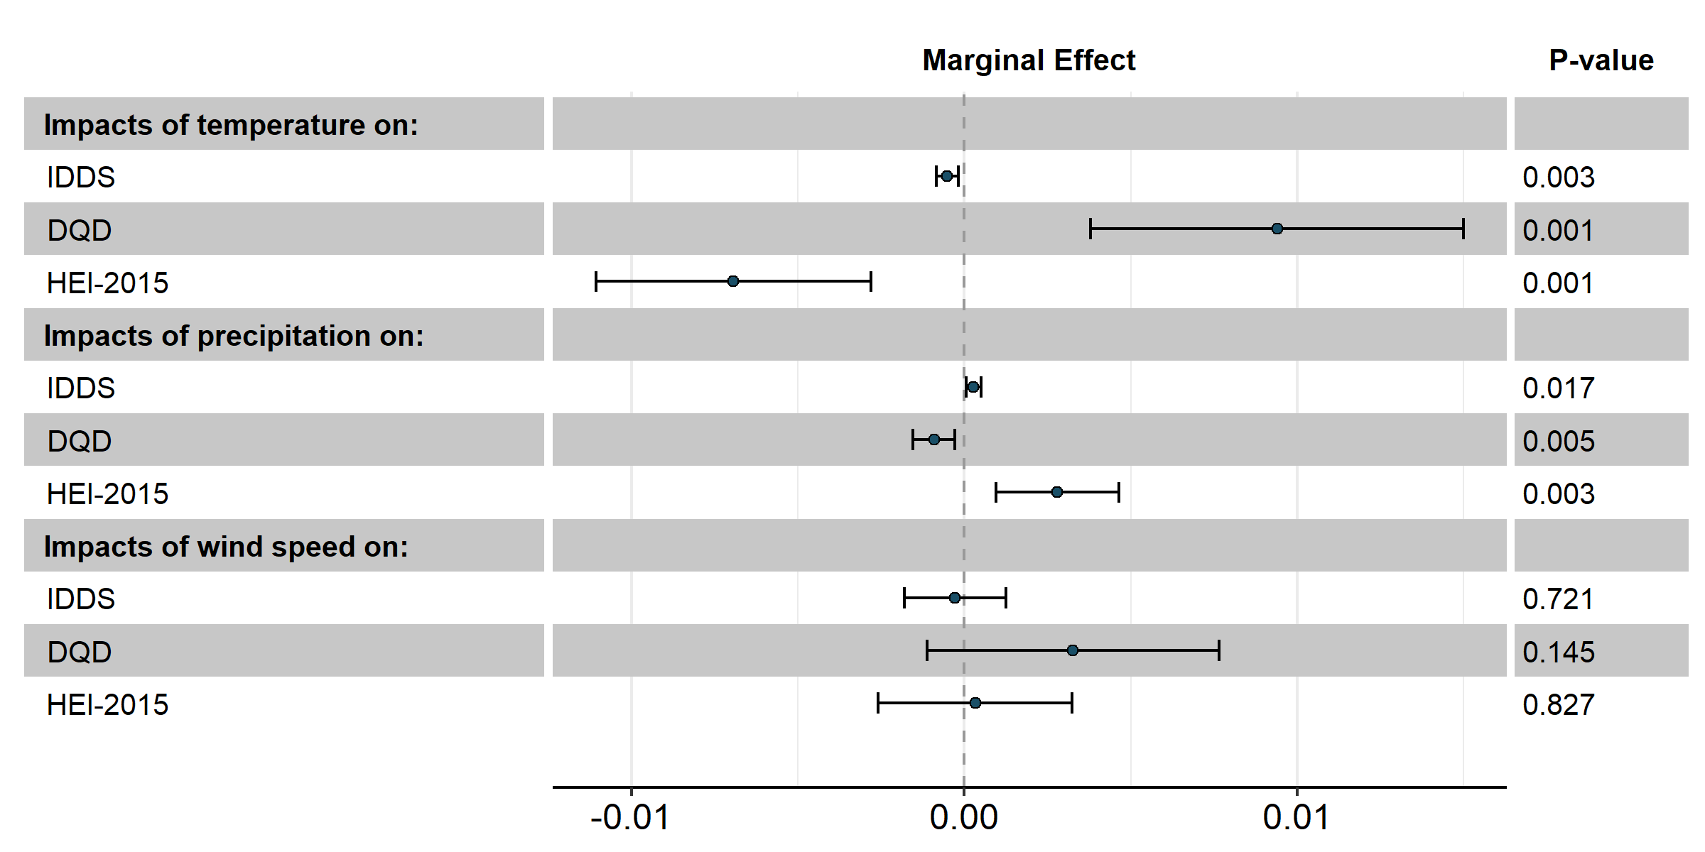
b.
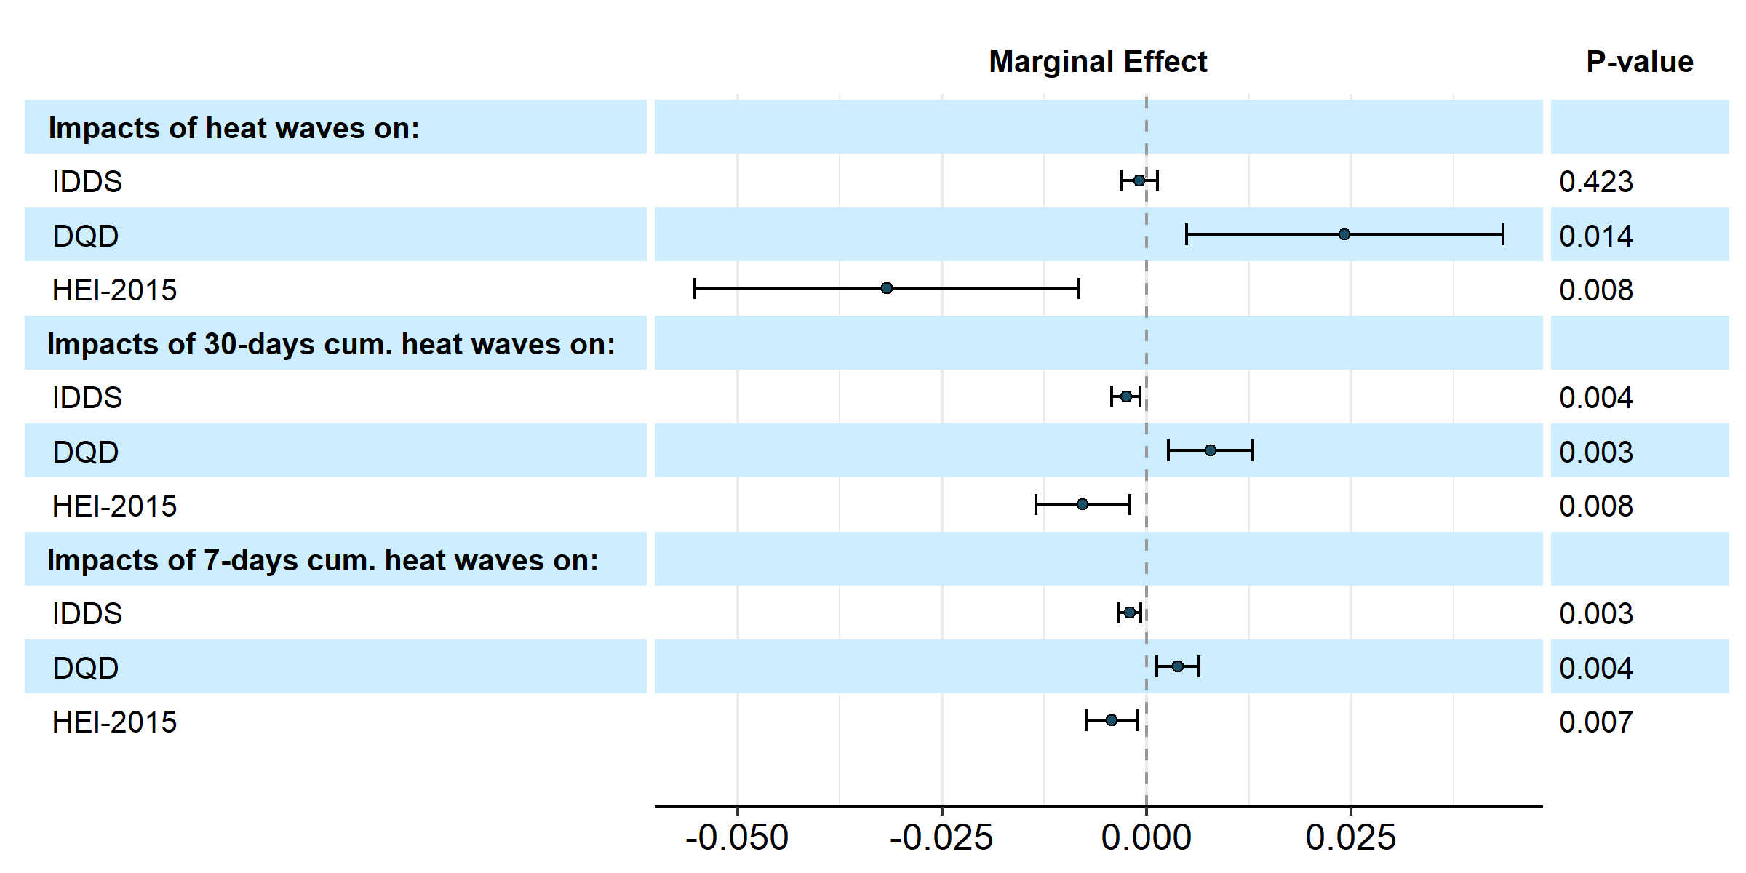
Notes: Forest plots show key estimates of climate variables for 12 HDFE regressions implemented separately. (a) The marginal effects or estimated coefficients (with 95% confidence intervals) of daily maximum temperature, precipitation, and wind speed on diet outcomes were estimated in the linear specification simultaneously; (b) the marginal effects (with 95% confidence intervals) of heat waves, 30-day cumulative days in heat waves, and 7-day cumulative days in heat waves on diet outcomes were estimated separately. Diet outcomes evaluated include diet diversity measured by IDDS, diet imbalance measured by DQD, and diet quality measured by HEI-2015. Controls include the size of the party, daily time trend, and 2,278 fixed effects (FE; including 16 city FE, 6 day-of-week FE, 4 year FE, 11 month FE, 117 restaurant site FE, 736 day-of-week*restaurant site FE, 1,344 month*restaurant site FE, and 44 city*year FE). Standard errors are clustered by the restaurant site. P values are for two-tailed tests.

To capture non-linearities between temperature and diet outcomes, we adopt a more flexible binned model specification to allow for nonparametric effects of temperature on diet outcomes. Figure 3 plots key estimates of temperature responses for each meal outcome across 16 temperature bins (with 95% confidence intervals denoted by dashed lines) from the nonparametric binned HDFE regressions. From panels a-c of Figure 3, although the relationship between temperature and meal outcomes is less precisely estimated at some of the coldest or hottest bins of the temperature spectrum, the results are markedly similar across all three meal outcomes: each exhibits the inverted J or J-shaped curve, and each reaches the optimal point between 9-12°C. The inverted J-shaped relationships between temperature and both meal diversity (Figure 3, panel a) and quality (Figure 3, panel c), and the J-shaped relationship between temperature and meal imbalance (Figure 3, panel b) together indicate more evident stress of hot temperature on meal outcomes.

Figure 3. Nonparametric temperature-meal relationships (N = 15,420,075)
Notes: Each plot shows key estimates (with 95% confidence intervals) of 16 temperature bins from nonparametric binned HDFE regressions. Meal outcomes evaluated include: (a) meal diversity measured by IDDS; (b) meal imbalance measured by DQD; and (c) meal quality measured by HEI-2015. Controls include the size of the party, daily time trend, and 2,278 fixed effects (FE; including 16 city FE, 6 day-of-week FE, 4 year FE, 11 month FE, 117 restaurant site FE, 736 day-of-week*restaurant site FE, 1,344 month*restaurant site FE, and 44 city*year FE). Standard errors are clustered by the restaurant site. P values are for two-tailed tests.
3.3 Impact of heat waves
Panel b of Figure 2 reports the marginal effects of heat waves, 30-day cumulative days of heat waves, and 7-day cumulative days of heat waves on meal outcomes from separate linear HDFE regressions, respectively. The results indicate that a heat wave in general leads to lower meal diversity measured by IDDS, higher meal imbalance measured by DQD, and lower meal quality measured by the HEI-2015 score across different measures (except that the estimated coefficient of the heat wave dummy on IDDS is insignificant). Consistent with the results presented above, these findings further support the notion that extreme hot temperature events have a negative effect on meal outcomes.
3.4 Impact of precipitation and wind speed
As reported in Figure 2, panel a, increasing precipitation shows a significantly positive effect on all three meal outcome measures. van der Merwe et al. (2022) reported that higher precipitation is associated with a lower probability of child stunting in Nigeria. López-Olmedo et al. (2021) found that each 0.5mm annual decrease in precipitation was associated with lower consumption of unprocessed foods and higher consumption of ultra-processed foods in Mexico. Our results thus expand existing findings by showing that a 10 mm increase in daily precipitation is immediately associated with a 0.003 increase (P = 0.017) in meal diversity as measured by IDDS, a 0.009 decrease (P = 0.005) in meal imbalance as measured by DQD, and a 0.028 increase (P = 0.003) in meal quality as measured by the HEI-2015 score. These findings underscore the intricate interplay between precipitation and dietary behaviors, highlighting the instant significance of rainfall in promoting dietary diversity, balance, and nutritional quality. In contrast, our analysis does not reveal a significant impact of wind speed on any of the three meal outcome measures examined in our study.

3.5 Impact on energy intake
To test how climate variables might affect consumers’ energy intake, we match each ingredient of the dishes ordered with the nutrition information from the China Food Composition Tables (Chinese Center for Disease and Prevention, 2019), and calculate the aggregated calories of each order. Interestingly, an increase of 1 degree Celsius in the daily maximum temperature is associated with a 1.822 decrease (P = 0.006) in caloric intake, despite the negative impact on diet quality presented in previous sections. Conventionally, lower caloric intake had been regarded as “healthier.” However, in order to achieve public health improvement more efficiently, recent studies advocate focusing on food and diet quality rather than caloric quantity per se (Lucan and DiNicolantonio, 2015; Fernandes et al., 2019). Our findings lend support to this notion by showing that although hot temperatures lead to lower caloric intake among Chinese consumers, meal quality still declines.
3.6 Robustness check: Impacts by group size
As previously noted, a potential concern in our analysis is the issue of self-selection. Larger dining groups, comprising more than two customers, are more likely to have pre-scheduled or booked their reservations, making them less sensitive to immediate weather conditions. To address this concern and enhance the robustness of our findings, we further examine the impacts of temperature and heat waves by group size.
We constructed three subsamples based on dining group size: (1) groups with three or more customers (N = 4,862,384), (2) groups with four or more customers (N = 2,198,116), and (3) groups with five or more customers (N = 978,343). We applied High-Dimensional Fixed Effects (HDFE) estimation to each subsample.
The subsample results indicate that an increase of 1 degree Celsius in the daily maximum temperature leads to a decrease in meal diversity (IDDS) by 0.0007 (P = 0.011), 0.0010 (P = 0.017), and 0.0009 (P = 0.024) for groups with at least 3, 4, and 5 customers, respectively. Similarly, a 1 degree Celsius increase in the daily maximum temperature is associated with an increase in meal imbalance (DQD) by 0.011 (P = 0.005), 0.013 (P = 0.007), and 0.014 (P = 0.010) for the same group sizes. For meal quality (HEI-2015), a 1 degree Celsius increase corresponds to a decrease of 0.008 (P = 0.004), 0.011 (P = 0.012), and 0.010 (P = 0.018) in HEI-2015 scores for groups of 3 or more, 4 or more, and 5 or more customers, respectively.
These consistent findings across subsamples highlight the significant impact of temperature on diet quality, further supporting our main conclusions.

Table 2. The impact of climate change on diet quality by customer group size
Customer Group Size | Impact on Meal Diversity (IDDS) | P-Value | Impact on Meal Imbalance (DQD) | P-Value | Impact on Meal Quality (HEI-2015) | P-Value
At least 3  (N = 4,862,384) | -0.0007 | 0.011 | 0.011 | 0.005 | -0.008 | 0.004
At least 4  (N = 2,198,116) | -0.001 | 0.017 | 0.013 | 0.007 | -0.011 | 0.012
At least 5  (N = 978,343) | -0.0009 | 0.024 | 0.014 | 0.010 | -0.010 | 0.018

4. Policy implications
This study has important policy implications that can guide decision-making in addressing the challenges posed by climate change and its impact on food systems. Firstly, policymakers should recognize the need to consider the consumer side of climate change in addition to the commonly focused areas of the food supply side, land use, water resources, and migration. Understanding how changes in consumer food preferences, driven by climate change, can influence the entire food supply chain is crucial. Therefore, adopting a comprehensive approach that integrates consumer behavior considerations into climate change mitigation and adaptation strategies is recommended. This approach will enable policymakers to develop effective measures that account for the consumer’s role in shaping food systems.
Secondly, mitigating climate change can have positive implications for both environmental sustainability and public health. By addressing climate change and its underlying causes, such as greenhouse gas emissions from the food system, policymakers can contribute to improved diets and reduced prevalence of diet-related diseases. Recognizing the interconnectedness of climate change, food systems, and public health is essential. Policymakers should prioritize climate action as a means to enhance diet quality and promote healthier lifestyles, thereby fostering better overall health outcomes for the population.
Finally, given the complex and interdependent nature of climate change and food systems, it is recommended to develop policy tools that monitor countries’ climate change performance and the effectiveness of climate change policies. These tools should incorporate additional factors related to diets and nutrition to provide a more comprehensive assessment of the impact of climate change on food systems. By considering the nutritional aspects of food systems, policymakers can make informed decisions and identify areas for intervention that promote sustainable and healthy diets.
In summary, this study underscores the significance of examining the consumer dimension of climate change and the potential co-benefits of climate action for both environmental sustainability and public health. It suggests that policymakers can explore a comprehensive approach that incorporates dietary and nutritional factors alongside climate action considerations. Such an approach may involve developing monitoring tools and strategies to effectively address the influence of climate change on food systems while simultaneously promoting better dietary behaviors and health outcomes.

5. Conclusion
The present paper sheds new light on a crucial aspect of climate change, namely its impact on meal quality and consumer behavior. Specifically, the study focuses on how climate factors such as hot temperatures and heat waves can have a detrimental effect on meal diversity, balance, and quality among Chinese consumers, and how this can ultimately impact the nutritional quality of food supply chains and consumer health.
While the effect size associated with a 1-degree Celsius rise in daily maximum temperature may appear modest when considered in isolation, it is paramount to contextualize these findings within a broader framework. Indeed, seemingly small effects can accumulate both over time and across populations, potentially yielding substantial consequences for dietary patterns and, consequently, health outcomes. This is particularly salient when contemplating the enduring and cumulative impact of such exposures. As an illustrative example, in June 2022, the Chinese government released the National Climate Change Adaptation Strategy 2035. This strategy delineates enduring principles and action plans aimed at enhancing climate adaptation within the domains of health and the food system. The findings presented in the current study can provide valuable insights into the intricate interplay between climate change and dietary choices, which hold significant ramifications for health and the food system.
One of the key contributions of this paper is its emphasis on the need to examine the impact on the consumer side of climate change, which complements the extensive literature on the food supply side, land use, water resources, and migration. By highlighting how changes in consumer food preferences due to climate change can affect the entire supply chain, the paper underscores the importance of adopting a more comprehensive approach to understanding the impact of climate change on agro-food systems.
Furthermore, the study suggests that mitigating climate change could have a positive impact not only on environmental sustainability but also on public health by improving diets and reducing the burden of diet-related diseases. This finding underscores the importance of climate action and its potential to benefit society in numerous ways.
Nevertheless, the paper also acknowledges that the long-term effects of heat waves and extreme temperatures on food consumption diversity, nutritional content, and negative health consequences are still uncertain, as consumers and producers may adopt mitigation strategies and adapt to these changes. Future research using large-scale datasets spanning several years could help identify the long-term effects of climate change on dietary outcomes and investigate the fundamental behavioral responses of both consumers and producers to climate change.
Some limitations and caveats of this study provide opportunities for future research. Firstly, our analysis is confined to a specific restaurant chain, rendering it not fully representative of the expansive Chinese food market and potentially limiting the generalizability of our findings to a broader population. The applicability of our results beyond our sample, comprising urban Chinese consumers, remains a subject for future empirical exploration. Secondly, our dataset lacks essential consumer demographic information, such as gender and income, since it is primarily derived from sales transactions. The inclusion of demographic data in future studies could enable an examination of dietary responses to climate changes across diverse demographic groups, thus offering a more nuanced understanding of the impact. Lastly, our analysis focuses on the association between climate change and dietary outcome, where the utilization of fixed effects cannot entirely address the complexities of self-selection and evolving preferences over time. These nuanced dynamics warrant further investigation in future research endeavors.
In summary, this paper highlights a crucial aspect of climate change that has received relatively less attention in the literature, namely its direct impact on dietary outcomes and consumer behavior. The findings underscore the need for a more comprehensive approach to understanding the impact of climate change on food systems, particularly consumers’ behavior and diet quality, and the importance of climate action for public health and environmental sustainability.

References
- Aragón FM, Oteiza, F & Rud JP (2021) Climate change and agriculture: subsistence farmers’ response to extreme heat. American Economic Journal: Economic Policy 13, 7, 1-35.
- Baylis P (2020) Temperature and temperament: evidence from Twitter. Journal of Public Economics 184, 104161.
- Burke M & Emerick K (2016) Adaptation to climate change: evidence from US agriculture. American Economic Journal: Economic Policy 8, 235-239.
- Carleton T & Hsiang S (2016) Social and economic impacts of climate. Science 353, 6304.
- Chen X (2019) Smog, cognition and real-world decision-making. International Journal of Health Policy and Management 8(2), 76-80.
- China Meteorological Administration (2023). The 2022 China Climate Bulletin (In Chinese). Accessed at https://finance.sina.com.cn/jjxw/2023-02-07/doc-imyewcsp6237363.shtml?cref=cj (Last accessed: May 7, 2023).
- Chinese Center for Disease Control and Prevention (2019) China Food Composition Tables. 6th ed. Beijing: Peking University Publishing.
- Denissen JJ, Butalid L, Penke L et al. (2008) The effects of weather on daily mood: a multilevel approach. Emotion 8, 662.
- Deschênes O & Greenstone M (2011) Climate change, mortality, and adaptation: evidence from annual fluctuations in weather in the US. American Economic Journal: Applied Economics 3, 152-185.
- Deschênes O & Greenstone M (2012) The economic impacts of climate change: evidence from agricultural output and random variations in weather. American Economic Review 97(1), 354-385.
- Fernandes, A. C., Rieger, D. K., & Proença, R. P. (2019). Perspective: Public health nutrition policies should focus on healthy eating, not on calorie counting, even to decrease obesity. Advances in Nutrition, 10(4), 549-556.
- Fishman R, Carrillo P & Russ J (2019) Long-term impacts of exposure to high temperatures on human capital and economic productivity. Journal of Environmental Economics and Management 93, 221-238
- Ganpule-Rao, A. V., Bhat, D., Yajnik, C. S., & Rush, E. (2021). Dietary diversity scores, nutrient intakes and biomarkers vitamin B12, folate and Hb in rural youth from the Pune Maternal Nutrition Study. British Journal of Nutrition, 126(2), 236-243.
- GBD 2017 Diet Collaborators. (2019). Health effects of dietary risks in 195 countries, 1990-2017: A systematic analysis for the Global Burden of Disease Study 2017. Lancet, 393(10184), 1958-1972.
- Guimaraes, P & Portugal, P (2010) A simple feasible procedure to fit models with high-dimensional fixed effects. Stata Journal 10(4), 628.
- Hanlon WW, Hansen CW, & Kantor JW (2021) Temperature, Disease, and Death in London: Analyzing Weekly Data for the Century from 1866-1965. The Journal of Economic History 81(1): 40-80.
- Hua, Y., Qiu, Y., & Tan, X. (2022). The effects of temperature on mental health: evidence from China. Journal of Population Economics, 1-40.
- IPCC (2014) IPCC (Intergovernmental Panel on Climate Change) Fifth Assessment Report. Technical Report. Cambridge, United Kingdom and New York, NY, USA: IPCC.
- IPCC (2022) Climate Change 2022: Mitigation of Climate Change. Contribution of Working Group III to the Sixth Assessment Report of the Intergovernmental Panel on Climate Change [P.R. Shukla, J. Skea, R. Slade, A. Al Khourdajie, R. van Diemen, D. McCollum, M. Pathak, S. Some, P. Vyas, R. Fradera, M. Belkacemi, A. Hasija, G. Lisboa, S. Luz, J. Malley, (eds.)]. Cambridge University Press, Cambridge, UK and New York, NY, USA. doi: 10.1017/9781009157926
- Kennedy, G., Ballard, T., & Dop, M. C. (2011). Guidelines for Measuring Household and Individual Dietary Diversity. Food and Agriculture Organization of the United Nations.
- Kent, S. T., McClure, L. A., Zaitchik, B. F., Smith, T. T., & Gohlke, J. M. (2014). Heat waves and health outcomes in Alabama (USA): The importance of heat wave definition. Environmental health perspectives, 122(2), 151-158.
- Krebs-Smith, S. M., Pannucci, T. E., Subar, A. F., Kirkpatrick, S. I., Lerman, J. L., Tooze, J. A., ... & Reedy, J. (2018). Update of the healthy eating index: HEI-2015. Journal of the Academy of Nutrition and Dietetics, 118(9), 1591-1602.
- Liu, H., Wahl, T. I., Seale Jr, J. L., & Bai, J. (2015). Household composition, income, and food-away-from-home expenditure in urban China. Food Policy, 51, 97-103.
- López-Olmedo, N., Diez-Roux, A. V., Pérez-Ferrer, C., Prado-Galbarro, F. J., Riojas-Rodríguez, H., Rivera-Dommarco, J., & Barrientos-Gutierrez, T. (2021). Climate trends and consumption of foods and beverages by processing level in Mexican cities. Frontiers in Nutrition, 8, 647497.
- Lucan, S. C., & DiNicolantonio, J. J. (2015). How calorie-focused thinking about obesity and related diseases may mislead and harm public health. An alternative. Public Health Nutrition, 18(4), 571-581.
- Milman, O. (2022) A third of Americans are already facing above-average warming. The Guardian. February 5, 2022. https://www.theguardian.com/environment/2022/feb/05/americans-above-average-temperature-increase-climate-crisis (accessed Feb 7, 2022).
- Niles, M. T., Emery, B. F., Wiltshire, S., Brown, M. E., Fisher, B., & Ricketts, T. H. (2021). Climate impacts associated with reduced diet diversity in children across nineteen countries. Environmental Research Letters, 16(1), 015010.
- Richardson, M. B., Li, P., Gohlke, J. M., & Allison, D. B. (2018). Effects of indoor thermal environment on human food intake, productivity, and comfort: pilot, randomized, crossover trial. Obesity, 26(12), 1826-1833.
- Singh, B. K., Fraser ED, Arnold T, Biermayr-Jenzano P, Broerse JE, Brunori G, Caron P, De Schutter O, Fabbri K, Fan S, Fanzo J, et al. (2022). Food systems transformation requires science–policy–society interfaces that integrate existing global networks and new knowledge hubs. Nature Food, 1-3.
- Van Aalst, M. K. (2006). The impacts of climate change on the risk of natural disasters. Disasters, 30(1), 5-18.
- van der Merwe, E., Clance, M., & Yitbarek, E. (2022). Climate change and child malnutrition: A Nigerian perspective. Food Policy, 113, 102281.
- Wheeler, T., & Von Braun, J. (2013). Climate change impacts on global food security. Science, 341(6145), 508-513.
- Xu, X., Hall, J., Byles, J., & Shi, Z. (2015). Assessing dietary quality of older Chinese people using the Chinese Diet Balance Index (DBI). PLoS One, 10(3), e0121618.
- Zakrzewski-Fruer, J. K., Horsfall, R. N., Cottrill, D., & Hough, J. (2021). Acute exposure to a hot ambient temperature reduces energy intake but does not affect gut hormones in men during rest. British Journal of Nutrition, 125(8), 951-959.
- Zhu, C., Lopez, R. A., Gao, Y., & Liu, X. (2021). The COVID‐19 Pandemic and Consumption of Food away from Home: Evidence from High‐frequency Restaurant Transaction Data. China & World Economy, 29(6), 73-94.
- Zivin JSG, Song Y, Tang Q et al. (2020) Temperatures and high-states cognitive performance: evidence from the National College Entrance Examination in China. Journal of Environmental Economics and Management, 104, 102365.

Appendix
Table A1. The impact of temperature, precipitation and wind speed on diet quality
Outcome | Impact of temperature | P-Value | Impact of precipitation | P-Value | Impact of wind speed | P-Value
Meal Diversity (IDDS) | -0.0005 | 0.003 | 0.0002 | 0.017 | -0.0001 | 0.721
Meal Imbalance (DQD) | 0.009 | 0.001 | -0.001 | 0.005 | 0.003 | 0.145
Meal Quality (HEI-2015) | -0.007 | 0.001 | 0.002 | 0.003 | 0.000 | 0.827
Table A2. The impact of heat wave on diet quality

Outcome | Impact of heat wave | P-Value | Impact of 30-days cumulative heat waves | P-Value | Impact of 7-days cumulative heat waves | P-Value
Meal Diversity (IDDS) | -0.0009 | 0.423 | -0.0025 | 0.004 | -0.0020 | 0.003
Meal Imbalance (DQD) | 0.024 | 0.014 | 0.008 | 0.003 | 0.004 | 0.004
Meal Quality (HEI-2015) | -0.032 | 0.008 | -0.008 | 0.008 | -0.004 | 0.007

The 17 cities include Beijing, Shanghai, Tianjin, Guangzhou, Shenzhen, Wuhan, Hangzhou, Hefei, Kunming, Zhengzhou, Nanjing, Shijiazhuang, Xi’an, Chengdu, Huizhou, Suzhou, and Wuxi.
year/month/day/hour/minute/second
Accessed at https://www.fns.usda.gov/how-hei-scored (Last accessed: May 27, 2023).
We also ran the estimation using 5-degree bins for robustness, which did not have any discernable impact on our results.

