**Title:** Aspen's influence on fire radiative energy and burn severity is moderated by forest composition, structure, and fire weather in the Southern Rockies

**Target journal:** [Ecology Letters](https://onlinelibrary-wiley-com.colorado.idm.oclc.org/page/journal/14610248/homepage/forauthors.html#tips1)

**Code:** <https://github.com/maxwellCcook/aspen-fire/tree/main/Aim2>

Abstract

Highlights

Keywords

# 

# Introduction

Forest composition, or the abundance, dominance and diversity of forest species, has an important influence on fire activity and post-fire ecosystem impacts (Hagmann et al., 2021). Alongside climate and topography, forest composition and species traits help govern fire regimes and fire effects at a variety of spatial and temporal scales (Johnstone et al., 2016). Tree species composition and structure (*e.g.*, density, height, diameter), for example, help drive *fire intensity*, or how hot a fire burns, and *fire severity*, or the consumption of organic matter (Keeley, 2009). Fire intensity and severity influence suppression difficulty (Thompson et al., 2018), impacts to the built environment (Penman et al., 2014), and ecosystem responses such as post-fire tree recruitment (Chapman et al., 2020; Meigs & Krawchuk, 2018). Given recent extreme fire activity and changes to the composition, structure and fire regimes of western North American forests (Hagmann et al., 2021; Hessburg et al., 2021), there is an urgent need to understand the influence of forest species composition and structure on contemporary fire intensity and severity.

The modification of forest composition and structure is a viable management tool often leveraged to reduce wildfire hazard to communities and ecosystems (Prichard et al., 2021). These management actions often involve reduction of fuels through mechanical treatment or prescribed fire, thereby reducing the potential for extreme fire activity (Agee & Skinner, 2005; Stephens et al., 2009). However, this presents a persistent management problem where treatments must be revisited to maintain positive benefits. Furthermore, while far more prescribed fire is ultimately needed to restore increasingly fire-starved ecosystems in the western U.S. (Parks et al., 2025), its use is limited by policy restrictions, public support, and a shortening window of appropriate weather conditions for burning (Schultz et al., 2019; Swain et al., 2023). The promotion of “fire-resistant” species, which may provide natural buffers to extreme fire behavior that are more self-sustaining, presents a complimentary management tool to reduce extreme fire behavior (Girardin & Terrier, 2015). With increasing fire activity and hazards, particularly across the western U.S. (Parks & Abatzoglou, 2020), assessments of which species may provide these benefits and under what conditions they are likely to do so are needed.

In some regions of western North America, quaking aspen (*Populus tremuloides Michx.*) is one forest species potentially capable of reducing extreme fire hazard (Fechner & Barrows, 1976). Aspen, which is also the most widely distributed tree species in North America and often considered a keystone species (Rogers et al., 2020), has been characterized by fire-moderating traits such as lower canopy bulk density, higher canopy base height, and greater leaf moisture content (DeByle & Winokur, 1985; Shepperd, 1990; Shinneman et al., 2013). Existing in a functional gradient of seral (*e.g.*, having a conifer component) to stable (*e.g.*, pure stands), aspen exhibits varying fire regimes and degrees of fire resistance (Rogers et al., 2014; Shinneman et al., 2013). Generally, seral aspen exhibits more extreme fire behavior compared to stable aspen and, in turn, fire activity drives the persistence of either functional type (Morris et al., 2019; Shinneman et al., 2013). Evidence points to fire weather and stand condition influencing the fire behavior in aspen, where even pure stands are likely to burn when the conditions align (DeRose & Leffler, 2014). However, with these potentially fire-moderating traits, aspen may offer a natural buffer, a so-called *living fire break*, to extreme fire intensity and severity. Despite this recognition, there remains a knowledge gap between management and scientific understanding of how, when, and where aspen moderates fire, especially relative to other forest types and during recent extreme fire activity at regional-to-continental scales (Nesbit et al., 2023).

Widespread availability of satellite remote sensing data before, during, and after wildfires presents a unique opportunity to quantify the influence of aspen on wildfire activity across large spatial scales. Burn severity mapping, which is based on differences between pre- and post-fire multispectral imagery, is one of the most commonly applied uses of satellite remote sensing in fire ecology (Szpakowski & Jensen, 2019). Satellite-based metrics of burn severity, such as the composite burn index (CBI), have been shown to correlate well with field-based measurements, enabling large-scale assessments of ecosystem impacts and their drivers (Parks et al., 2019). In tandem, active fire detection, which relies on middle-infrared (~ 4 µm) imagery, has become a crucial tool for monitoring global fire activity (Wooster et al., 2021). Spectral radiance in the middle-infrared is used to calculate fire radiative power (FRP), which is a measure of the energy released by actively burning fires and is highly correlated with the rate of biomass consumption per unit time (Kaufman et al., 1998; Schroeder et al., 2010; Wooster et al., 2003). Studies have applied FRP to, for example, track wildfire smoke emissions (Li et al., 2019, 2020) and investigate the relationship between energy released and fire size (Laurent et al., 2019). However, as a proxy for fire intensity, FRP has been underutilized to assess the influence of forest composition and structure, fire weather, and landscape factors on fire activity. The harmonization of satellite-derived burn severity metrics such as CBI and fire intensity proxies like FRP alongside forest inventories is a promising approach to exploring these relationships.

To investigate the influence of aspen and other forest types on fire intensity and severity during recent (2017-2023) wildfires, we harmonized satellite-based FRP and CBI with imputed wall-to-wall forest inventory data derived from the United States Forest Service (USFS) Forest Inventory and Analysis (FIA) program. Using Bayesian spatial hierarchical modeling, we investigate three primary questions: (i) how do dominant forest types influence FRP and CBI *relative to aspen*; (ii) how does forest composition and species-specific structure, such as live basal area, tree height and diameter, influence FRP and CBI; and (iii) where aspen co-occurs with other forest types, how does its dominance, measured as the proportion of live basal area, influence FRP and CBI both with and without mediating effects of fire weather. To account for landscape and climatic effects on fire activity, we include variables describing the topography and fire weather. Given the spatial-temporal dependence of wildfires, we also include random effects for day-of-burn and a structured spatial model, uncovering the landscape patterns of FRP and CBI. The results of this study have important implications for management of aspen and other common forest types in the context of fire intensity and burn severity in the Southern Rockies. We also highlight a novel application of satellite-derived FRP as a proxy for fire intensity to investigate the biotic and abiotic controls and spatial patterns of fire heat. These methods can be applied across large geographic regions to answer a variety of important questions related to forest and fire management.

# Materials and Methods

## 2.1. Study System and Wildfire Census

The Southern Rockies includes portions of southern Wyoming, central and western Colorado, and northern New Mexico. Aspen is the dominant deciduous forest type, encompassing an estimated 9,482 km2 (7.4% of total land area) based on recent mapping (Cook et al., 2024). In this region, aspen co-occurs with all major forest types including ponderosa mixed-conifer, lodgepole, and spruce-fir, and across a wide range of elevation and site conditions (Bartos, 2001). We collected a census of recent (2017-2023) wildfire events from the ICS-209-PLUS (St. Denis et al., 2023; updated through 2023). Since 2017, 113 wildfires burned approximately 1.68M acres including five large events (>100k acres): Calf Canyon / Hermit’s Peak (New Mexico, 2022), East Troublesome (Colorado, 2020), Cameron Peak (Colorado, 2020), Mullen (Colorado/Wyoming, 2020) and Spring Creek (Colorado, 2018). Where possible, we obtained fire perimeters from the Monitoring Trends in Burn Severity (MTBS; Eidenshink et al., 2007) using the link to MTBS in the ICS-209-PLUS database. For fire events without an MTBS identifier, we gathered perimeter data from FIRED (Balch et al., 2020). These fire perimeters were used to locate associated active fire detections (*Section 2.3*). Additionally, we created a regular, 375m2 fishnet grid covering the region, which was used to aggregate active fire detections, burn severity (*Section 2.4*), forest inventory data (*Section 2.5*), and topography and fire weather (*Section 2.6*).

## 2.3. Active fire detections and fire radiative power (FRP)

Active fire detections from the Visible Infrared Imaging Radiometer Suite (VIIRS) Collection 2 Active Fire product (Schroeder et al., 2014) were collected across the study region. These data were produced in 6-minute temporal satellite increments (swaths) at 375 m spatial resolution at-nadir from VIIRS sensors aboard the NASA/NOAA Suomi National Polar-orbiting Partnership (S-NPP; VNP14IMG) and Joint Polar Satellite System (JPSS-1 or NOAA-20; VJ114IMG) satellites. Acquisitions occur twice daily around 1:30AM and 1:30PM at mid latitudes. We remotely queried the cloud-hosted swaths using the *earthaccess* Python library (Barrett et al., 2024) for all burn dates in the fire census. From the swaths, we extracted spatial coordinates of active fire pixels and their attributes including swath sample position, detection confidence, acquisition datetime, and fire radiative power (FRP). Only detections meeting the “nominal” or “high” confidence were retained. We used the swath sample position to assign along-scan and along-track pixel dimensions to account for changes in pixel area as the sample gets further from nadir (Li et al., 2018; Schroeder et al., 2014). Coordinates were buffered by these dimensions to generate the “true” ground area of the detection (**Figure S2**). We identified duplicate detections resulting from adjacent scans by flagging those acquired at the same datetime and with >30% spatial overlap (*ref*). In cases where duplicates were identified, we retained the detection with the higher FRP value. To aggregate FRP retrievals into a consistent spatial unit, we created a fishnet grid of 375 m(140,625 m2) gridcells (the approximate resolution of the VNP/VJ114IMG at nadir) across the entire Southern Rockies and assigned FRP based on fractional overlap of true pixel areas. This involved first converting FRP to watts/km2 for a consistent area-based measurement. Then, FRP was assigned to grid cells based on the fractional overlap (*FRP * grid cell overlap %*). Only grid cells which had greater than 50% spatial overlap with detections were retained for analyses, limiting the contribution of grid cells with low fractional FRP. The total number of acquisitions, day/night counts, datetime of acquisition, and FRP summary statistics (cumulative, maximum and percentiles) were assigned to the grid cells. For analysis, this study focused on the *total cumulative* FRP to leverage the full accounting of FRP retrievals throughout the fire event.

## 2.4. Composite Burn Index (CBI)

We created burn severity rasters for each wildfire in the census using pre- and post-fire Landsat 8 imagery following methods from Parks et al. (2019) in the Google Earth Engine cloud-compute platform (Gorelick et al., 2017). While this method produces a variety of burn severity metrics based on spectral indices, we use the bias-corrected CBI for analysis as this metric adjusts values at the extreme low and high ends of the range, better quantifying the variability in burn severity (Parks et al., 2019). We calculated zonal statistics of CBI within our 375 mgridcells to align the spatial scale with FRP aggregations including the average, standard deviation, and percentiles. For analysis, we use the 90th percentile CBI which emphasizes more extreme gridcell burn severity while capturing some variability.

## 2.5. Forest Composition and Structure

To assess the influence of forest composition and structure on FRP and CBI, we gathered information from the ca. 2016 USFS TreeMap (Riley et al., 2022). TreeMap imputes Forest Inventory and Analysis (FIA) plot identifiers onto 30 m2 LANDFIRE (Picotte et al., 2019) pixels based on a set of LANDFIRE biophysical characteristics including topography, vegetation type, and disturbance (Riley et al., 2021, 2022). The FIA is a nationally consistent forest inventory monitoring program consisting of thousands of systematically located and revisited 675 m2 plots at a density of one plot per 24.3 km2 (Gray et al., 2012; Riley et al., 2021). While representing a sparse network of field plots, the TreeMap demonstrates good agreement with existing vegetation and field plots, enabling estimation of wall-to-wall forest characteristics (Riley et al., 2021, 2022). We use the TreeMap to, (**i**) identify gridcell majority forest cover, and (**ii**) estimate forest composition and structure metrics from the *Tree Table*, which links TreeMap pixels to their imputed FIA tree-level data. We focused efforts on commonly occurring forest types in the Southern Rockies including lodgepole pine, ponderosa pine, spruce-fir (Engelmann spruce and subalpine fir), Douglas-fir, white fir, pinon-juniper, Gambel oak, and quaking aspen (**Appendix X**).

For (**i**), the algorithmic forest type (*FORTYPCD*), which aligns closely with LANDFIRE existing vegetation type, was used to calculate the percent cover of each forest type present in a gridcell. For (**ii**), following methods from Riley et al. (2021), we linked TreeMap pixels to their imputed tree-level information (the TreeMap *Tree Table*) using the *TM_ID* attribute. We calculated the live basal area of each measured tree using its diameter (*DIA* in the *Tree Table*), which was then multiplied by the number of trees per acre it represents (*TPA_UNADJ* in the *Tree Table*) and summed for each species in the plot. We converted this to live basal area *per pixel* using a conversion factor (0.222395 acres/pixel). The total trees per pixel (TPP), hereafter referred to as abundance, was also calculated using this conversion factor. These metrics were then multiplied by the total number of pixels for each FIA plot identifier in the gridcell to calculate the total live basal area, total abundance, and average tree height and diameter for each species. Finally, the Shannon diversity index (H) was calculated for each gridcell based on the abundance of forest species (H-TPP). Each gridcell is composed of approximately 182 TreeMap pixels.

In addition, we used the ca. 2016 remap LANDFIRE (Picotte et al., 2019) to calculate gridcell forest canopy cover (%), as this metric shows the lowest agreement between TreeMap and FIA tree-level measurements (Riley et al., 2022). Given the importance of forest canopy structure in the context of FRP retrievals and potential interception of radiative energy (Roberts et al., 2018), we calculated the canopy percent from LANDFIRE, which derives these measurements more directly from satellite data rather than from imputed forest inventories.

## 2.6. Climate and Topography

Elevation data were sourced from a 1/3 arc-second (~10 m) digital elevation model (*ref*), which was used to calculate elevation, slope, and aspect. Gridcell average Topographic Position Index (TPI), derived at a 270 m resolution (Theobald et al., 2015), was also calculated to represent the landscape position (e.g., valley bottom, ridgetop). To characterize fire weather, we gathered vapor pressure deficit (VPD), energy release component (ERC), and wind speed from gridMET, a daily 4 x 4 km gridded meteorological product (Abatzoglou, 2013). Both VPD and ERC represent atmospheric and fuel aridity and correlate well with fire activity (Abatzoglou & Williams, 2016). For ERC, we calculated the deviation from the 15-year average (ERCdv) to represent the more extreme fuel dryness in the western U.S. during recent history (Parks & Abatzoglou, 2020). Gridcells were spatially aggregated by the first VIIRS detection day and the average VPD, ERCdv, and wind speed was calculated.

## 2.7. Statistical analysis

To assess the influence of forest composition and structure on FRP and CBI, we fit Bayesian hierarchical spatial models using the Integrated Nested Laplace Approximation (INLA) framework, implemented in *R-INLA* (R Core Team, 2024; Rue et al., 2009). Unlike traditional Markov Chain Monte Carlo (MCMC) methods, INLA leverages deterministic (Laplace) approximations, providing a computationally efficient alternative for Bayesian inference that has been widely applied in recent years (e.g., Gomez-Rubio, 2020; Niekerk et al., 2019). These models are particularly well-suited for dynamic ecological systems, offering precise inference on spatial processes and rapid computation of posterior distributions (Beguin et al., 2012; Engel et al., 2022; Niekerk et al., 2019; Sadykova et al., 2017). *R-INLA* allows fitting complex hierarchical models to account for structured and unstructured random effects such as fire-level variability, temporal day-of-burn effects, and spatial dependence. We fit separate models for FRP and CBI to address three primary goals: 1) establish the difference between dominant forest types, where those types represent a majority of forested area, on FRP and CBI *relative to aspen*, 2) assess how forest composition and structure influence FRP and CBI, and 3) determine how aspen co-occurrence and relative dominance influences FRP and CBI both with and without mediating effects of fire weather. For FRP models only, we include covariates describing the VIIRS aggregation including the overlap percent and the proportion of daytime observations. For all models, we include random effects for the fire event, gridcell day-of-burn, and a spatial model. These models are described further in the sections below.

For goals (1) and (2) we fit a single hierarchical spatial model in *R-INLA* which assessed the difference between major forest types *relative to aspen* and the influence of composition and structural metrics including percent cover, live basal area, average tree height, and average diameter for all species present in each gridcell. We fit this model with interaction terms including the majority gridcell forest cover type along with the associated percent cover and species-specific live basal area, average height, and average diameter. A categorical variable for the gridcell majority forest type was included using aspen as the baseline level, allowing us to compare the differences between forest types relative to aspen.

### 2.7.1. Dominant forest cover relative to aspen

We established the baseline differences between dominant forest cover on cumulative FRP and 90th percentile CBI *relative to aspen*. Forest cover dominance was defined where TreeMap *FORTYPCD* was >50% of the total forest cover in the gridcell. Because aspen was the reference forest type, an additional fixed effect was included in this model indicating fire-level aspen presence. We removed *Gambel oak* and *white fir* forest types due to insufficient number of gridcells where they were dominant.

### 2.7.2. Effect of forest composition and structure

We leveraged the TreeMap *Tree Table* summaries to assess the effect of forest composition and structure using metrics including the gridcell proportion of live basal area, tree height and diameter, and abundance-based diversity of forest species. For each gridcell, we retained contributions from species where the proportion of live BA or TPP was greater than 10% to eliminate noise from the *Tree Table* estimates. Models were fit using interaction terms between all species in a gridcell and their aggregated structural metrics (*i.e., ponderosa * proportional live BA*). In this approach, we thus estimate the contributions of all species present including mixed stands not captured by the *FORTYPCD* alone.

### 2.7.3. Influence of quaking aspen co-dominance and fire weather

To test the influence of aspen co-occurrence and dominance on FRP and CBI, we identified fires which had at least 1% pre-fire aspen cover (N=53). Aspen dominance was measured as the proportion of live basal area based on the *Tree Table* summary. An interaction term between the gridcell majority forest type and aspen dominance was constructed to test the effect of aspen co-occurrence across major forest types (including gridcells where aspen was the majority type). To test the influence of fire weather on mediating these relationships, an additional interaction term was set with VPD (*fortypcd:aspen dominance * VPD*).

*2.7.4. Model parameters and assessment*

Models were parameterized using the gaussian family for FRP and gamma for CBI based on the observed distribution of the response variables (**Figure SX)**. Specification of priors for fixed and random effects was done to allow for flexibility in model estimates based on expectations in the data and comparison of model fit statistics, specifically Watanabe-Akaike information criterion (WAIC) and conditional predictive ordinates (CPO), two measures of model robustness and predictive power, respectively, commonly used to compare model outputs in *R-INLA* (Gomez-Rubio, 2020). For FRP models only, additional terms were included to represent the total contributing detection count, overlap percentage, and the proportion of daytime observations of VIIRS active fire detections within each grid to account for the aggregation methods (*Section 2.3*). Prior to fitting models, we tested correlations between predictor variables using a Spearman correlation coefficient, allowing for non-linearity in relationships.

### 2.7.1. Spatial mesh grid

Wildfires are inherently spatially dependent processes, requiring careful assessment of model covariates. To account for these spatial processes, we implemented the Stochastic Partial Differential Equation (SPDE) approach, which is a key innovation within the INLA framework for modeling spatial processes (Lindgren et al., 2011). The SPDE efficiently approximates continuous spatial Gaussian random fields (GRFs) using sparse precision matrices, linking GRFs to Gaussian Markov Random Fields (GMRFs) through a triangulated mesh representation (Bakka et al., 2018). We developed a spatial mesh for the Southern Rockies designed to reflect the expected within-fire spatial processes and minimize the influence of between-fire dependence. The mesh parameters, including maximum edge, cutoff, offset, and priors were chosen to balance computational efficiency with observed spatial process based on fire-specific semivariograms fit using the *gstat* R package (Gräler et al., 2016). More detailed information about the mesh creation and SPDE model definitions can be found in the supplement and in Figure 3 in *Section 3.1*.

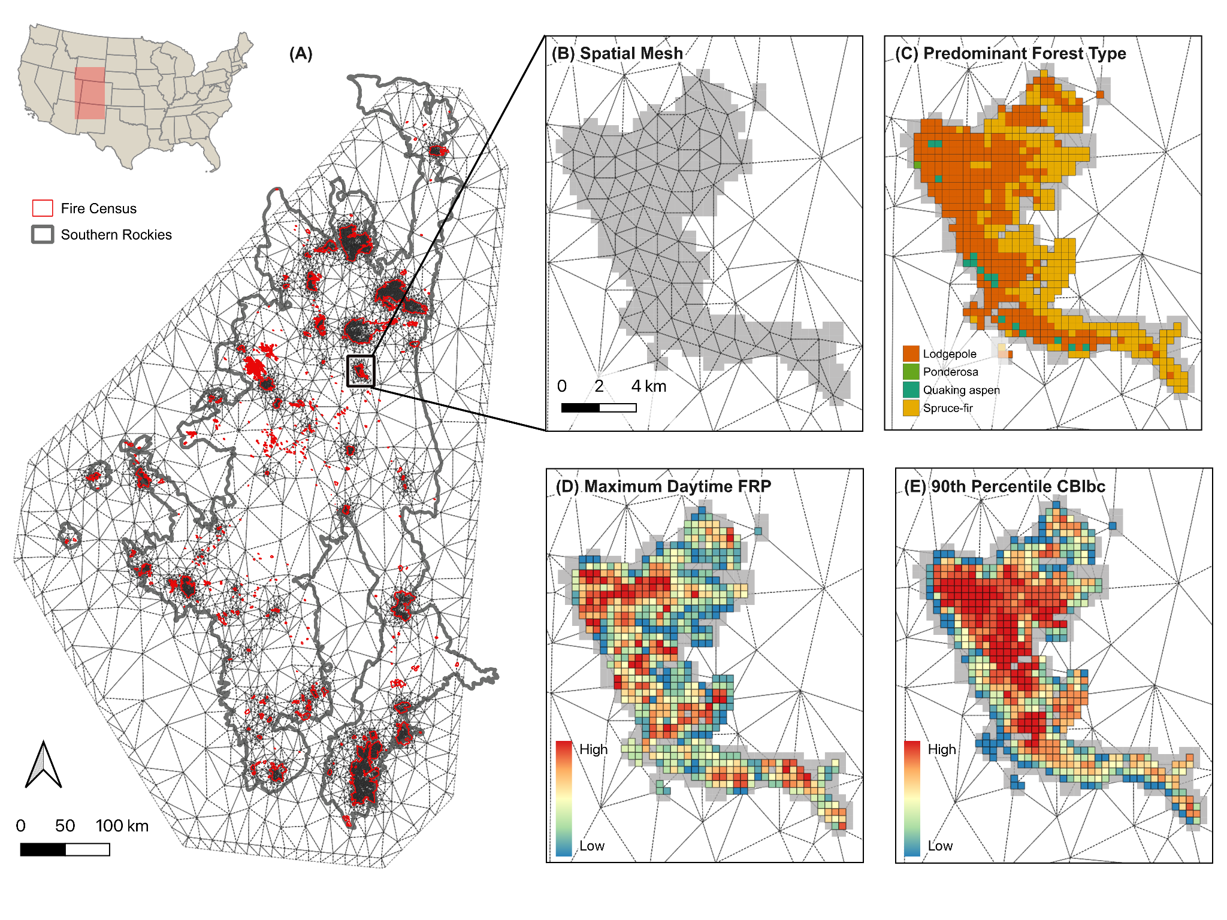

**Figure 1.** Southern Rockies study area with spatial mesh and highlight for the Williams Fork Fire, CO (2020). **(A)** Full spatial mesh for the study region with all fire census in red. The mesh is designed to capture within-fire variability while relaxing the intra-fire spatial dependence as seen by the wider triangular mesh between fire events. **(B)** Spatial mesh for the Williams Fork Fire, CO (2020) showing the within-fire spatial dependence with smaller triangles, set at a minimum distance of ~1 km between nodes. **(C)** Predominant forest type aggregated to gridcells, defined by the pixel count majority from TreeMap FORTYPCD. **(D)** Aggregateddaytime maximum FRP (W/km2). Where grids remain gray, there were no daytime observations. **(E)** Observed spatial effect of FRP for the predominant forest type model (see *Section 3.1*). FRP exhibits tight spatial clustering, and the spatial dependence is strongest with ~1.4 km indicating fine-scale spatial dependence. The Williams Fork Fire burned approximately 14,833 acres and emitted a cumulative FRP of 3071.13 W/km2 (ranked 14th overall) based on VIIRS active fire detections.

# Results

## 3.1. Effect of dominant forest type relative to aspen

In the Southern Rockies, dominant forest types influenced cumulative FRP and 90th percentile CBI *relative to aspen*, demonstrated by the posterior distribution of effects (**Figure 2**). For FRP, lodgepole-dominated gridcells showed the highest relative effect, with a 34% higher FRP than aspen-dominated gridcells. Douglas-fir, ponderosa pine, and spruce-fir forest types also showed a significant positive effect relative to aspen. Ponderosa-dominated gridcells tended towards a lower relative FRP, although the credible intervals (.25 and .95) overlap zero indicating uncertainty in model estimates. Pinon-juniper gridcells exhibited significantly lower FRP compared to aspen-dominated gridcells. For all forest types, the effect on CBI was significant and positive with tighter credible intervals, demonstrating higher certainty in the effects on burn severity relative to aspen. Models were better able to predict CBI than FRP, demonstrated by the higher CPO and lower WAIC. The inclusion of fire-level and day-of-burn random effects and the spatial SPDE model (see *Section 3.1.1* below) significantly improved model fit based on CPO and WAIC (**Table S2**). Significant positive effects emerged for VPD, ERCdv, slope, TPI, and grid-level mean canopy percent highlighting the importance of these factors in predicting fire behavior (**Table S3**). Steeper slopes and localized high points like ridges (higher TPI values) increase FRP and CBI. Similarly, higher VPD and ERCdv resulted in higher FRP and CBI, though with wider credible intervals, and the effect of wind speed was highly uncertain (**Figure SX**). For FRP models, inclusion of VIIRS aggregation attributes (percent cumulative overlap, detection count, and proportion of daytime detections) significantly improved model fit.

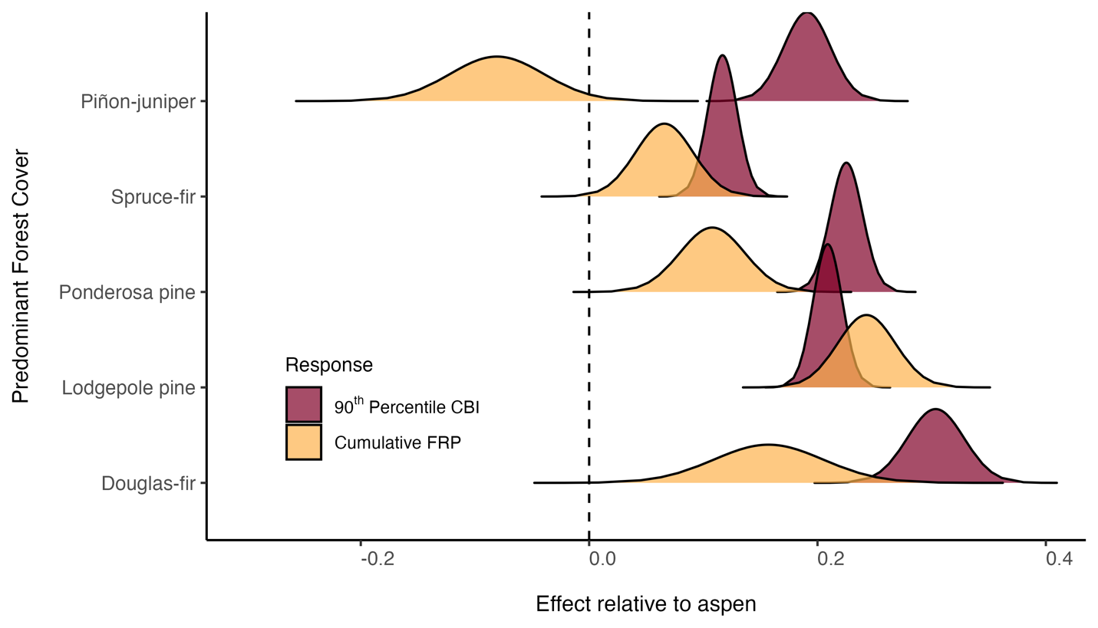

**Figure 2.** Posterior distributions of effects of predominant forest type on cumulative FRP and 90th percentile CBI *relative to aspen*. Lodgepole, Douglas-fir, and ponderosa forest types had significant positive effects on both FRP and CBI. Spruce-fir forests had a slight positive effect with the lower credible interval passing zero. The effects of pinon-juniper relative to aspen are highly uncertain for FRP but were significant and positive for CBI. All forest types demonstrate a significant positive effect on CBI, indicating higher burn severity relative to aspen.

### 3.1.1 Spatial patterns in FRP and CBI

Substantial spatial structure emerged in different ways for both FRP and CBI, described by the SPDE structured random effects model implemented in *R-INLA* (**Figure 3**). Semi variogram analysis provided an initial assessment of the expected spatial range for both responses (**Figure SX**), suggesting that the expected mean range for FRP was ~2.2 km and ~2.9 km for CBI. As such, the maximum edge length in the spatial mesh grid was set to 0.01 degrees (~ 1.1 km) in order to capture potential fine-scale spatial patterns. The SPDE results indicate moderate alignment with these expectations alongside fixed and random effects, with slight differences. For FRP, the mean effective range of spatial correlation is 0.014 degrees (~1.4 km), suggesting a fine-scale clustering and influence of localized conditions unexplained by fixed or random effects (**Figure 3E**). A relatively large standard deviation (mean 0.769) indicated moderately strong spatial variation in FRP and residual spatial effects left unexplained by the model. In the case of CBI, the effective range of spatial correlation increases to 0.078 (~7.8 km), suggesting more broad-scale spatial patterns in burn severity compared to FRP. With a far lower standard deviation (mean 0.088), the spatial variation in CBI is significantly lower than for FRP and may be better explained by the fixed and random effects such as day-of-burn, forest type, fire weather, and topography.

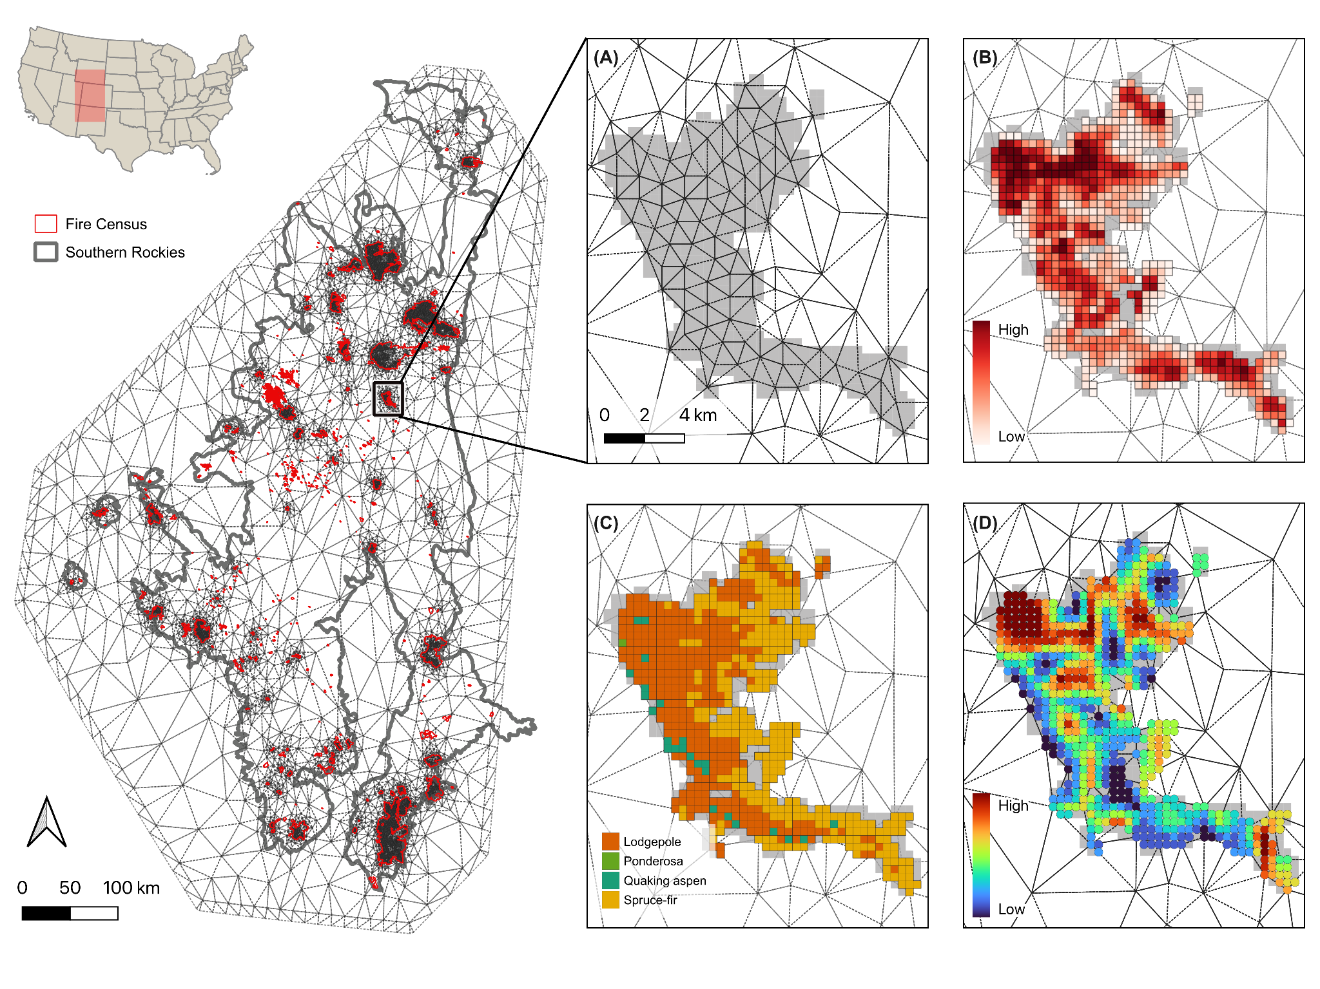

**Figure 3.** Southern Rockies spatial mesh grid example grid data for the Williams Fork Fire, CO (2020). **(A)** Full mesh grid covering the Southern Rockies study region with all fire census data in red. The spatial mesh is designed to capture within-fire variability while relaxing the intra-fire spatial dependence as seen by the wider triangular mesh between fire events. **(B)** Spatial mesh grid for the Williams Fork Fire. The mesh grid captures within-fire spatial dependence with a tighter triangle mesh around data points, set at a minimum distance of ~1 km between nodes. **(C)** Daytime maximum FRP (W/km2). Where grids remain gray, there were no daytime observations. **(D)** Grid-level predominant forest type, defined by the pixel count majority from TreeMap FORTYPCD. **(E)** Observed spatial effect of FRP for the predominant forest type model (see *Section 3.1*). FRP exhibits tight spatial clustering and the spatial dependence is strongest with ~1.4 km indicating fine-scale spatial dependence. The Williams Fork Fire burned approximately 14,833 acres and emitted a cumulative FRP of 3071.13 W/km2 (ranked 14th overall) based on VIIRS active fire detections.

## 3.2. Effect of composition and structure

We tested the influence of composition and structure metrics on FRP and CBI while accounting for fire weather, topography, grid-level mean canopy percent. Grid-level composition was measured using forest type diversity (H-TPP) and proportional live BA (hereafter *dominance*) for all forest types co-occurring in a grid. Structural metrics included the type-specific QMD and tree height. Each forest type represented in the grid was interacted with composition and structure metrics derived from the Tree Table based on FIA plot-level information (see *Section 2.5.2*). Again, separate models were fit for FRP and CBI with fixed and random effects and VIIRS aggregation information (for FRP). The same SPDE mesh was applied to account for the spatial dependence in effects. The credible intervals of the posterior distributions are tighter for the CBI model than for FRP, and the conditional predictive ordinates (CPO) indicated better predictive power for CBI models (**Table S3**). Again, the spatial effects operated at a much smaller range for FRP (~1.4 km) compared to CBI (~7.8 km) and with higher residual variance, indicating that CBI is better captured by the fixed, random and spatial effects models. The results from each composition and structure metric are described in greater detail below.

### 3.2.1. Forest type dominance

The dominance of forest type influenced FRP and CBI with varying levels of certainty (**Figure 4**). Quaking aspen pinon-juniper showed the strongest negative effect on both FRP (**Figure 4a**) and CBI (**Figure 4b**). As aspen dominance increases, both FRP and CBI were significantly lower than most other forest types. A similar pattern in dominance emerged for spruce-fir, although with a smaller relative effect. For both ponderosa and lodgepole, dominance slightly increased FRP while the effects on CBI were uncertain (credible intervals passing zero). Mixed-conifer dominance had a strong positive effect on burn severity although its effect on FRP was also uncertain.

**Figure 4.** Posterior distribution of effects for forest type-specific composition and structure metrics on (**A**) FRP, and (**B**) CBI. We assessed the proportion of grid-level forest type basal area, forest-specific mean quadratic diameter and tree height, and the relationship between majority forest type and diversity measured using the Shannon diversity index (H). Posterior distributions which overlap zero are uncertain. Quaking aspen demonstrates strong and significant (credible intervals not passing zero) effects for all four metrics.

### 3.2.2. Forest type QMD and tree height

Quaking aspen-specific QMD had a strong positive effect on FRP and CBI, suggesting aspen forests which are dominated by few but large individuals may exhibit greater intensity and severity (**Figure 4a, 4b**). Except for ponderosa, where QMD had a significant *negative* effect, all other forest types were uncertain with credible intervals overlapping zero. Ponderosa-specific QMD demonstrated an opposite effect relative to aspen, where forests dominated by few large individuals tended to exhibit lower FRP and CBI. The influence of tree height on FRP was less certain (wider credible intervals) but significant effects emerged for quaking aspen, pinon-juniper, and ponderosa. For quaking aspen, increasing tree height tends to decrease FRP where the opposite is true for pinon-juniper and more so for ponderosa. Tree height has a more profound effect on CBI, particularly for both quaking aspen and ponderosa, which again demonstrate opposite relationships.

### 3.2.3. Forest type diversity

For all forest types, H-TPP increased both FRP and CBI (**Figure 4**). This effect was less strong and uncertain for lodgepole and pinon-juniper forests but profound for FRP in spruce-fir and for CBI in mixed-conifer and quaking aspen grids, indicating that as the diversity of forest types increased, both FRP and burn severity tended to increase. The credible intervals for H-TPP were tighter for FRP models than for other variables, indicating more confidence in model estimates.

## 3.3 Influence of aspen co-occurrence across major forest types

Quaking aspen co-occurrence and dominance relative to predominant forest types influenced FRP and CBI, although effects were mediated by VPD in some cases (**Figure 5**). Where quaking aspen is predominant, increasing proportional live BA significantly decreases FRP (mean effect -0.21) and CBI (mean effect -0.23). However, there is a strong VPD-mediating effect, where the influence of aspen dominance on reducing FRP and CBI either diminishes greatly (CBI, **Figure 5b**) or becomes slightly positive (FRP, **Figure 5a**). In both cases, the credible intervals for the VPD-mediated effect slightly overlap zero, indicating a more negligible effect. Similarly, in lodgepole-predominant grids the effect of increasing aspen dominance on FRP was significant and negative, with a moderate diminishing influence of VPD-mediation. Conversely, in spruce-fir, ponderosa, and pinyon-juniper predominant grids, the VPD-mediating effect on FRP and CBI actually improved the effect of aspen dominance (*i.e.*, decreasing effect, reduction in the response variables). In ponderosa-dominated grids, aspen dominance tends to decrease CBI *only* when mediated by VPD, whereas it has a slight positive effect without mediation. The same is true for spruce-fir dominant grids and the effect on FRP. For pinyon-juniper and mixed-conifer predominant grids, which are relatively rare (Figure S1), the effects of aspen dominance exhibited extreme credible intervals overlapping zero for the FRP models. These forest types rarely co-occur with aspen in great proportions (**Figure SX**), which helps explain the wide credible intervals and uncertain estimates. Again, the credible intervals were tighter for the CBI model and the CPO was significantly higher (Table S2), suggesting better predictive power for CBI compared to FRP.

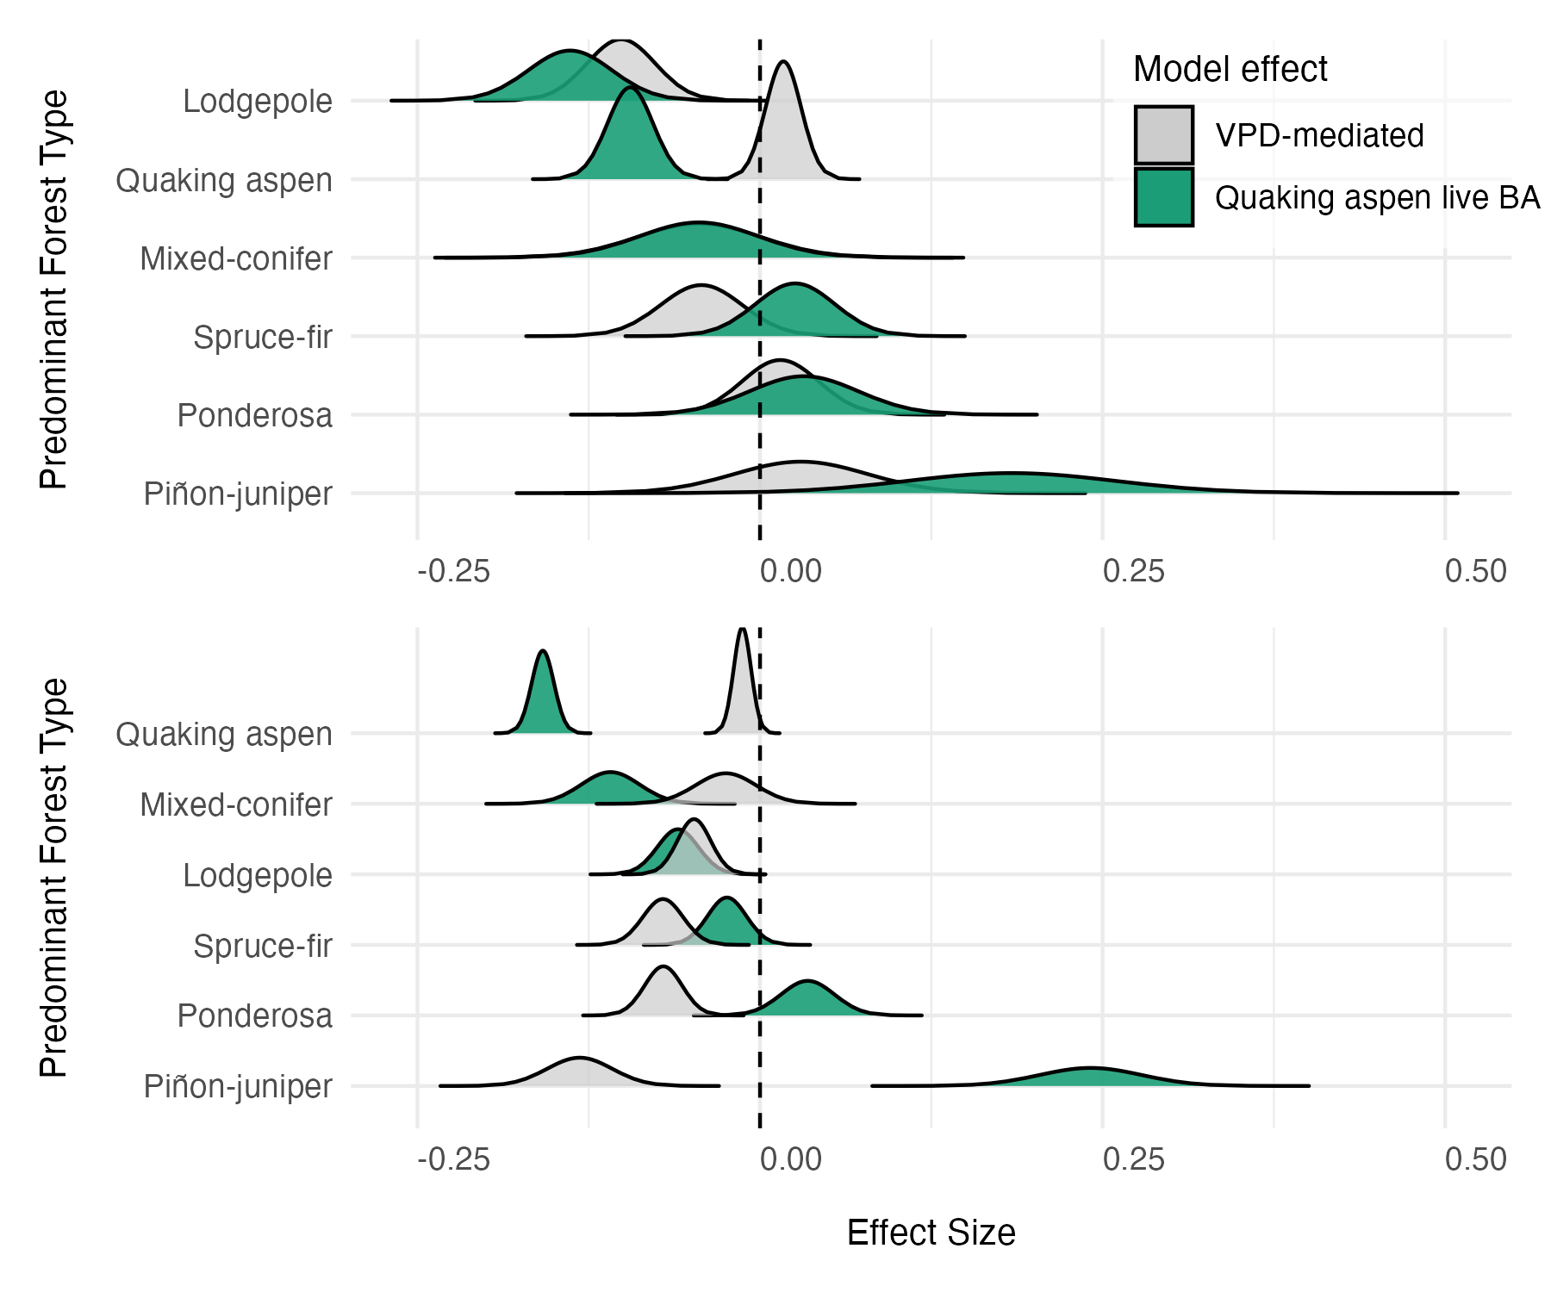

**Figure 5.** Posterior distribution of effects on (**A**) FRP, and (**B**) CBI, for the influence of quaking aspen *dominance* relative to co-occurring predominant forest types with and without VPD mediation. Grey distributions represent the VPD-mediated effect which was modeled as an interaction term (*forest type:aspen dominance * VPD*). For both models, terms were included to account for other fire weather, topography, fire-dependent random effects, day-of-burn temporal random effects, and spatial effects. Additional terms accounting for VIIRS detection aggregation were included for the FRP model (see *Section 2.7*).

# Discussion

Significant differences in the effect on FRP and CBI relative to aspen emerged across predominant forest types in the Southern Rockies during recent (2017-2023) wildfires. Lodgepole, mixed-conifer, spruce-fir, and ponderosa forests tend to exhibit higher fire intensity and severity relative to aspen forests while accounting for weather, topography, fire-level and temporal random effects and spatial dependence (**Figure 2, Figure 3**). The spatial effects of FRP and CBI occur at different ranges, with FRP demonstrating tighter spatial clustering of effects at ranges of ~1.2 km and CBI at ranges of ~7.8 km. In both cases, evidence of spatial dependence was strong and addition of SPDE models influenced the fixed effects and model performance estimates in meaningful ways. Additionally, we found that the relative composition and structure of forest types had varying effects on FRP and CBI, with live BA, tree height, and QMD elucidating these differences (**Figure 4**). Importantly, quaking aspen effects were significant (credible intervals not passing zero) in all four metrics for both models of composition and structure. Finally, the influence of aspen dominance across major forest types demonstrates the ability of aspen to moderate FRP and CBI, especially in lodgepole-dominant grids, although this influence can be VPD-mediated (**Figure 5**). In terms of model performance, CBI models consistently had higher CPO indicating better predictive power of CBI than FRP. Furthermore, the lower residual variance in the spatial model for CBI suggests that forest type, fire weather, topography better predict CBI spatial patterns than they do for FRP. These findings have wide implications for management quaking aspen forests for potential wildfire risk reduction. The methods described herein provide a framework for assessing forest composition and structure effects on satellite-observed fire behavior, which helps inform broader management decisions and assessment of management actions such as fuel treatments. The implications of these findings are discussed in more detail below.

In aspen-dominated grids, for example, a significant reduction FRP and CBI occurs as the proportion of live basal area increases, but when interacting with VPD this effect either becomes insignificant or slightly positive (Figure 5). In the case of lodgepole, VPD had a weaker influence on the capacity for aspen dominance to reduce FRP and CBI. However, in spruce-fir and ponderosa forests, aspen dominance seems to improve its influence in reducing both FRP and CBI, suggesting that the presence and dominance of aspen is more influential under certain VPD conditions. In terms of model performance, CBI models consistently had higher CPO indicating better predictive power of CBI than FRP. Furthermore, the significantly lower residual variance in the spatial model for CBI suggests that forest type, fire weather, topography better predict CBI spatial patterns than they do for FRP. These findings have wide implications for management of quaking aspen forests for potential wildfire risk reduction. The methods described herein provide a framework for assessing forest composition and structure effects on satellite-observed fire behavior, which helps inform broader management decisions and assessment of management actions such as fuel treatments.

## 4.1. Quaking aspen moderates fire intensity and severity, but this effect may be mediated by VPD and forest structure

Quaking aspen co-occurrence and dominance had a strong moderating effect on both FRP and CBI , especially in lodgepole forests. In this forest type, increasing aspen dominance, measured as the proportional live BA, significantly reduced both FRP and CBI (**Figure 5**). Importantly, the VPD-mediating effect of aspen dominance is minimal in lodgepole forests compared to other forest types, suggesting that greater proportions of aspen moderate intensity and severity *even under more extreme conditions*. In the case of aspen-predominant grids, greater live BA also had a significant reducing effect on FRP and CBI, although this effect is *significantly* VPD-mediated. This suggests that aspen forests *can* moderate fire intensity and severity except, perhaps, under more extreme fire weather conditions. This finding aligns with simulated potential aspen fire behavior under different weather conditions (DeRose & Leffler, 2014). Moreover, the specific structure of aspen forests may play a role in the moderating effects on both FRP and CBI. For example, aspen forests which are dominated by few large individuals (high QMD) tend to exhibit higher intensity and severity (**Figure 4**). This structure is representative of older, decadent aspen forests which may have limited understory regeneration and are often typified by having a conifer component (Rogers et al., 2014). Additionally, in grids where aspen was predominant, increasing diversity (H-TPP) tended to increase fire behavior, suggesting that understory conifer components or mixed conifer-aspen forest types may be more susceptible to higher fire intensity and severity which is supported in the literature (Shinneman et al., 2013). In spruce-fir and ponderosa forests, the influence of aspen dominance on FRP was uncertain, although significant relationships emerged for CBI. Interestingly, the VPD-mediation suggests that aspen dominance has a greater influence on reducing burn severity under more extreme weather conditions. While aspen co-occurrence and dominance influenced other forest types, it is clear that its codominance with lodgepole has a more significant relative effect on fire behavior. From a management perspective, this is significant as it suggests targeted aspen management and expansion in lodgepole-dominated areas may provide a more influential buffering effect to extreme fire, at least in the Southern Rockies. In some of these forests, future aspen dominance is already expected following compound disturbance interactions (Andrus et al., 2021) although the future of aspen habitat suitability should also be considered (Hart et al., *In Review*). Integrating more fine-scale field measurements of aspen forest structure may help elucidate this relationship further, and the methods presented herein offer one approach for assessing the effect of fine-scale structure on fire intensity and severity using satellite data.

## 4.2. Forest structure effects on fire behavior align with expected fire regime characteristics

Forest type-specific fire regime characteristics emerged when assessing the influence of structural metrics on fire intensity and severity, highlighting the capacity of these methods to understand observed fire behavior from satellite-derived information harmonized with wall-to-wall forest structure data. For example, the interesting relationship between forest-specific QMD and fire behavior corroborates expected fire regime characteristics in both ponderosa and quaking aspen forests. Ponderosa forests have historically evolved with high frequency, low severity/intensity wildfire (*ref*). This expectation assumes a open, park-like structure where large individuals are interspersed with meadows and some regeneration (*ref*). These forests have been particularly impacted by a century of fire-exclusion leading to a forest structure that is more densely packed with potentially smaller individual trees and changing fire behavior (*ref*). The results of this study demonstrate that where ponderosa exhibits higher QMD (*i.e.,* closer to the expected forest structure), FRP and CBI are significantly lower (**Figure 4**). In the case of quaking aspen, an opposite relationship emerges (see *Section 4.1* above). These findings also match expected fire regimes of aspen forests, where stable and seral aspen stands exhibit different characteristics (Shinneman et al., 2013). Importantly, in some regions of the Southern Rockies, fire regimes of aspen forests have been modified greatly by lack of disturbance leading to older, decadent, or seral aspen compositions (Rosenblum, 2015). Our models suggest that these aspen forest types increase FRP and CBI, demonstrated by the effects of QMD and tree height (**Figure 4**). These findings are significant, as the methods herein provide a relatively accurate way to assess the influence of forest structure on *observed* fire behavior; an important consideration when planning fuels treatments or assessing their effectiveness.

## 4.3. Patterns of spatial dependence differ for FRP and CBI

Interesting spatial patterns emerged for both FRP and CBI across fire events. The spatial range of dependence is much smaller for FRP (~1.2 km) than for CBI (~7.8 km). This suggests more localized clustering of effects for FRP compared to more landscape-scale processes of burn severity. The much lower residual variance in the CBI models also indicates the fixed effects, particularly forest type, composition and/or structure, are better able to explain the differences in burn severity. For FRP, significant residual variance in the spatial effect suggests the opposite; forest composition and structure patterns alone cannot explain the spatial dependence of FRP as well. This is significant, as the spatial pattern on FRP is more sensitive to localized conditions unexplained in the present models such as specific live fuel moisture or fine-scale wind patterns. Future work can leverage this information to better predict radiative intensity at localized scales. Despite this, some significant effects of forest type, composition and structure did overcome the spatial dependence in FRP, albeit with wider credible intervals than for CBI. This demonstrates the importance of incorporating spatial structure into analysis of wildfire behavior, especially as it relates to satellite-based measurements. The SPDE models implemented in *R-INLA* were effective for assessing and accounting for spatial dependence and their computational feasibility makes this analysis scalable to wide geographic regions.

## 4.4. Opportunities, limitations and future directions

Broadly speaking, the methods of this study are widely applicable to other regions, forest types, and satellite-derived information. Leveraging FRP as a proxy to fire intensity is underutilized and our results highlight the potential of these data to understand how landscape factors influence fire intensity, an important measure of how difficult a fire will be to control (Keeley, 2009). These data could, for example, be leveraged to monitor fuel treatment effectiveness, the influence of beetle-kill on fire intensity, and understand the influence of more fine-scale measurements of live fuel moisture. The VIIRS data in particular offer an important source of *globally* available FRP information. The aggregation of active fire detections in the present study could also be used to integrate data across sensors, such as VIIRS, MODIS, and GOES, to fill the spatial and temporal gaps in detections. As new satellites come online, such as the FireSat constellation scheduled for 2026, these methods may become more applicable with higher temporal and spatial resolution imagery measuring fire radiative energy.

Of course, limitations exist in our current approach. While we demonstrate that TreeMap information combined with fire behavior metrics aligns with forest type-specific expectations, there is potentially high uncertainty in these data. Our use of aggregation and filtering to keep only species which are likely to occur in the Southern Rockies is crucial, as some FIA plot identifiers in the region belong to plots in California, for example. This eliminates plots which fall outside of the ecoregion and improves our confidence in the *Tree Table* estimates. However, these data still represent a sparse network of field sampling locations, introducing uncertainty into our estimates of forest structure. Future efforts will benefit from integrating our approach with other satellite-based measures of forest type, canopy characteristics, and forest structure (e.g., LiDAR) or fine-scale field-based measurement of forest structure and composition to better define these relationships. For example, high-resolution maps of the distribution of aspen forests (e.g., Cook et al., 2024) and other forest types may improve these models in the future. Additionally, while we do include canopy percent estimates from TreeMap in our models, more accurate observed canopy cover data may help define the relationship between FRP and canopy interception, which has been explored in tropical regions (Roberts et al., 2018) but less so in the arid west. Despite this uncertainty, our results highlight important successes in the integration of satellite-derived FRP and CBI with wall-to-wall forest metrics from TreeMap and the information provided in the *Tree Table* provides unique estimates of understory and mixed-forest composition which have been understudied at landscape scales.

# Conclusion

This study demonstrates the influence of forest composition and structure on fire behavior and elucidates the potential moderating influences of quaking aspen forests on fire intensity and severity in the Southern Rockies. From a management perspective, the expansion of aspen forests may reduce the risk of extreme fire behavior under certain conditions, although this influence is likely mediated by the specific structure of aspen forest and the fire weather conditions. The moderating influence of aspen forests is far more pronounced in lodgepole-dominated areas and targeted management of aspen in these forests is likely to provide a larger benefit of wildfire risk reduction. Given this information, aspen management in lodgepole forests can be targeted to provide a potential buffer in regions near communities where wildfire risk and suppression difficulty are high. This study provides important insights into the effects of not only aspen forests, but other predominant forest types and their structure, on observed fire behavior in the Southern Rockies with implications for wildfire risk reduction and forest management.

# References