**Title:** Aspen's influence on fire radiative power and burn severity is moderated by forest composition, structure, and fire weather in the Southern Rockies

**Alt title**: Aspen turns down the heat during recent wildfires in the Southern Rockies

**Target journal:** [Ecology Letters](https://onlinelibrary-wiley-com.colorado.idm.oclc.org/page/journal/14610248/homepage/forauthors.html#tips1)

**Code:** <https://github.com/maxwellCcook/aspen-fire/tree/main/Aim2>

Abstract

Highlights

Keywords

# 

# Introduction

Forest composition, or the abundance, dominance and diversity of forest species, has an important influence on fire activity and post-fire ecosystem impacts (Hagmann et al., 2021). Alongside climate and topography, forest composition and species traits help govern fire regimes and fire effects at a variety of spatial and temporal scales (Johnstone et al., 2016). Tree species composition and structure (*e.g.*, cover, height, diameter), for example, help drive *fire intensity*, or how hot a fire burns, and *fire severity*, or the consumption of organic matter (Keeley, 2009). Fire intensity and severity influence suppression difficulty (Thompson et al., 2018), impacts to the built environment (Penman et al., 2014), and ecosystem responses such as post-fire tree recruitment (Chapman et al., 2020; Meigs & Krawchuk, 2018). Given recent extreme fire activity and changes to the composition, structure and fire regimes of western North American forests (Hagmann et al., 2021; Hessburg et al., 2021), there is an urgent need to understand the influence of forest species composition and structure on contemporary fire intensity and severity.

The modification of forest composition and structure is a viable management tool often leveraged to reduce wildfire hazard to communities and ecosystems (Prichard et al., 2021). These management actions often involve reduction of fuels through mechanical treatment or prescribed fire, thereby reducing the potential for extreme fire activity (Agee & Skinner, 2005; Stephens et al., 2009). However, this presents a persistent management problem where treatments must be revisited to maintain positive benefits. Furthermore, while far more prescribed fire is ultimately needed to restore increasingly fire-starved ecosystems in the western U.S. (Parks et al., 2025), its use is limited by policy restrictions, public support, and a shortening window of appropriate weather conditions for burning (Schultz et al., 2019; Swain et al., 2023). The promotion of “fire-resistant” species, which may provide natural buffers to extreme fire behavior that are more self-sustaining, presents a complimentary management tool to reduce extreme fire behavior (Girardin & Terrier, 2015). With increasing fire activity and hazards, particularly across the western U.S. (Parks & Abatzoglou, 2020), assessments of which species may provide these benefits and under what conditions they are likely to do so are needed.

In some regions of western North America, quaking aspen (*Populus tremuloides Michx.*) is one forest species potentially capable of reducing extreme fire hazard (Fechner & Barrows, 1976). Aspen, which is also the most widely distributed tree species in North America and often considered a keystone species (Rogers et al., 2020), has been characterized by fire-moderating traits such as lower canopy bulk density, higher canopy base height, and greater leaf moisture content (DeByle & Winokur, 1985; Shepperd, 1990; Shinneman et al., 2013). Existing in a functional gradient of seral (*e.g.*, having a conifer component) to stable (*e.g.*, pure stands), aspen exhibits varying fire regimes and degrees of fire resistance (Rogers et al., 2014; Shinneman et al., 2013). Generally, seral aspen exhibits more extreme fire behavior compared to stable aspen and, in turn, fire activity drives the persistence of either functional type (Morris et al., 2019; Shinneman et al., 2013). Evidence points to fire weather and stand condition influencing the fire behavior in aspen, where even pure stands are likely to burn when the conditions align (DeRose & Leffler, 2014). However, with these potentially fire-moderating traits, aspen may offer a natural buffer, a so-called *living fire break*, to extreme fire intensity and severity. Despite this recognition, there remains a knowledge gap between management and scientific understanding of how, when, and where aspen moderates fire, especially relative to other forest types and during recent extreme fire activity at regional-to-continental scales (Nesbit et al., 2023).

Widespread availability of satellite remote sensing data before, during, and after wildfires presents a unique opportunity to quantify the influence of aspen on wildfire activity across large spatial scales. Burn severity mapping, which is based on differences between pre- and post-fire multispectral imagery, is one of the most commonly applied uses of satellite remote sensing in fire ecology (Szpakowski & Jensen, 2019). Satellite-based metrics of burn severity, such as the composite burn index (CBI), have been shown to correlate well with field-based measurements, enabling large-scale assessments of ecosystem impacts and their drivers (Parks et al., 2019). In tandem, active fire detection, which relies on middle-infrared (~ 4 µm) imagery, has become a crucial tool for monitoring global fire activity (Wooster et al., 2021). Spectral radiance in the middle-infrared is used to calculate fire radiative power (FRP), which is a measure of the energy released by actively burning fires and is highly correlated with the rate of biomass consumption per unit time (Kaufman et al., 1998; Schroeder et al., 2010; Wooster et al., 2003). Studies have applied FRP to, for example, track wildfire smoke emissions (Li et al., 2019, 2020) and investigate the relationship between energy released and fire size (Laurent et al., 2019). However, as a proxy for fire intensity, FRP has been underutilized to assess the influence of forest composition and structure, fire weather, and landscape factors on fire activity. The harmonization of satellite-derived burn severity metrics such as CBI and fire intensity proxies like FRP alongside forest inventories is a promising approach to exploring these relationships.

To investigate the influence of aspen and other forest types on fire heat and burn severity during recent (2017-2023) wildfires, we harmonized satellite-based FRP and CBI with imputed wall-to-wall forest inventory data derived from the United States Forest Service (USFS) Forest Inventory and Analysis (FIA) program. Using Bayesian spatial hierarchical modeling, we investigate three primary questions: (**i**) how do dominant forest types influence FRP and CBI *relative to aspen*; (**ii**) how does forest composition and structure, such as forest canopy cover, live basal area, tree height and diameter, influence FRP and CBI; and (**iii**) where aspen co-occurs with other forest types, how does its dominance, measured as the proportion of live basal area, influence FRP and CBI both with and without mediating effects of fire weather. To account for landscape and climatic effects on fire activity, we include variables describing the topography and fire weather. Given the spatial-temporal dependence of wildfires, we also include random effects for day-of-burn and a structured spatial model, uncovering the landscape patterns of FRP and CBI. The results of this study have important implications for management of aspen and other common forest types in the context of fire intensity and burn severity in the Southern Rockies. We also highlight a novel application of satellite-derived FRP as a proxy for fire intensity to investigate the biotic and abiotic controls and spatial patterns of fire heat. These methods can be applied across large geographic regions to answer a variety of important questions related to forest and fire management.

# Materials and Methods

## 2.1. Study System and Wildfire Census

The Southern Rockies includes portions of southern Wyoming, central and western Colorado, and northern New Mexico. Aspen is the dominant deciduous forest type, encompassing an estimated 9,482 km2, 7.4% of total land area (Cook et al., 2024). In this region, aspen co-occurs with all major forest types including ponderosa mixed-conifer, lodgepole, and spruce-fir, and across a wide range of elevation and site conditions (Bartos, 2001). We collected a census of recent (2017-2023) wildfire events from the ICS-209-PLUS (St. Denis et al., 2023; updated through 2023). Since 2017, 113 wildfires burned approximately 1.68M acres including five large events (>100k acres): Calf Canyon / Hermit’s Peak (New Mexico, 2022), East Troublesome (Colorado, 2020), Cameron Peak (Colorado, 2020), Mullen (Colorado/Wyoming, 2020) and Spring Creek (Colorado, 2018). Where possible, we obtained fire perimeters from the Monitoring Trends in Burn Severity (MTBS; Eidenshink et al., 2007) using the link to MTBS in the ICS-209-PLUS database. For fire events without an MTBS identifier, we gathered perimeter data from FIRED (Balch et al., 2020). These fire perimeters were used to locate the associated active fire detections (*Section 2.3*).

**Figure 1.** Study region and wildfire census data. (**A**) Map of the Southern Rockies and fire census; (**B**) Annual area burned (2017-2023); (**C**) Total cumulative FRP (2017-2023) from VIIRS active fire detections (see *Section 2.3*).

## 2.3. Active fire detections and fire radiative power (FRP)

Active fire detections from the Visible Infrared Imaging Radiometer Suite (VIIRS) Collection 2 Active Fire product (Schroeder et al., 2014) were collected across the study region. These data were produced in 6-minute temporal satellite increments (swaths) at 375 m spatial resolution at-nadir from VIIRS sensors aboard the NASA/NOAA Suomi National Polar-orbiting Partnership (S-NPP; VNP14IMG) and Joint Polar Satellite System (JPSS-1 or NOAA-20; VJ114IMG) satellites. Acquisitions occur twice daily around 1:30AM and 1:30PM at mid latitudes. We queried the cloud-hosted swaths using the *earthaccess* Python library (Barrett et al., 2024) for all burn dates in the fire census. From the swaths, we extracted coordinates of active fire pixels and attributes including swath sample position, detection confidence, acquisition datetime, and FRP. Only detections meeting the “nominal” or “high” confidence were retained. We used the swath sample position to assign along-scan and along-track pixel dimensions, accounting for changes in pixel area as the sample gets further from nadir (Li et al., 2018; Schroeder et al., 2014). Coordinates were buffered by these dimensions to generate the “true” ground area of the detection (**Figure S2**). We identified duplicate detections resulting from adjacent scans by flagging those acquired at the same datetime and with >30% spatial overlap (*ref*). For duplicates, we retained the detection with the higher FRP value. To aggregate FRP retrievals into a consistent spatial unit, we created a fishnet grid of 375 m(140,625 m2) gridcells (the approximate resolution of the VNP/VJ114IMG at nadir) across the entire Southern Rockies and assigned FRP based on fractional overlap of true pixel areas. This involved first converting FRP to watts/km2 for a consistent area-based measurement. Then, FRP was assigned to grid cells based on the fractional overlap (*FRP * grid cell overlap %*). Only grid cells which had greater than 50% spatial overlap with detections were retained for analyses, limiting the contribution of gridcells with low fractional FRP. The total number of acquisitions, day/night counts, datetime of acquisition, and FRP summary statistics (cumulative, maximum and percentiles) were calculated. For analysis, this study focused on the *total cumulative* FRP (FRPc) to leverage the full accounting of retrievals throughout the fire event.

## 2.4. Composite Burn Index (CBI)

We created burn severity rasters for each wildfire in the census using pre- and post-fire Landsat 8 imagery following methods from Parks et al. (2019) in the Google Earth Engine cloud-compute platform (Gorelick et al., 2017). While this method produces a variety of burn severity metrics based on spectral indices, we use the bias-corrected CBI for analysis as this metric adjusts values at the extreme low and high ends of the range, better quantifying the variability in burn severity (Parks et al., 2019). We calculated zonal statistics of CBI within fishnet gridcells, aligning the spatial scale with FRP aggregations including the average, standard deviation, and percentiles. For analysis, we use the 90th percentile CBI which emphasizes more extreme gridcell burn severity while capturing some variability.

## 2.5. Forest Composition and Structure

To assess the influence of forest composition and structure on FRP and CBI, we gathered information from the ca. 2016 USFS TreeMap (Riley et al., 2022). TreeMap imputes Forest Inventory and Analysis (FIA) plot identifiers onto 30 m2 LANDFIRE (Picotte et al., 2019) pixels based on a set of LANDFIRE biophysical characteristics including topography, vegetation type, and disturbance (Riley et al., 2021, 2022). The FIA is a nationally consistent forest inventory monitoring program consisting of thousands of systematically located and revisited 675 m2 plots at a density of one plot per 24.3 km2 (Gray et al., 2012; Riley et al., 2021). While representing a sparse network of field plots, the TreeMap demonstrates good agreement with existing vegetation, enabling estimation of wall-to-wall forest characteristics (Riley et al., 2021, 2022). We use the TreeMap to, (**i**) identify gridcell majority forest cover type, and (**ii**) estimate forest composition and structure metrics from the *Tree Table*, which links TreeMap pixels to their imputed FIA tree-level data. We focused efforts on commonly occurring forest types in the Southern Rockies including lodgepole pine, ponderosa pine, spruce-fir (Engelmann spruce and subalpine fir), Douglas-fir, white fir, pinon-juniper, Gambel oak, and quaking aspen (**Appendix X**).

For (**i**), the algorithmic forest type (*FORTYPCD*), which aligns with LANDFIRE existing vegetation type, was used to calculate the percent of each forest type present in a gridcell measured as the proportion of gridcell area. The majority forest type represents that with the greatest proportion of gridcell area. For (**ii**), following methods from Riley et al. (2021), we linked TreeMap pixels to their imputed tree-level information (the TreeMap *Tree Table*) using the *TM_ID* attribute. We calculated the live basal area of each measured tree using its diameter (*DIA* in the *Tree Table*), which was then multiplied by the number of trees per acre it represents (*TPA_UNADJ* in the *Tree Table*) and summed for each species in the plot. We converted this to live basal area *per pixel* using a conversion factor (0.222395 acres/pixel). The total live and dead trees per pixel (TPP), hereafter referred to as abundance, was also calculated using this conversion factor. These metrics were then multiplied by the total number of pixels for each FIA plot identifier in the gridcell to calculate the total live basal area, total live and dead abundance, average tree height and average diameter for each species. Finally, the Shannon diversity index (H) was calculated for each gridcell based on the live basal area (H-BA) and live tree abundance (H-TPP) of forest species. Each gridcell is composed of approximately 182 TreeMap pixels (30 m2 spatial resolution).

In addition, we used the ca. 2016 remap LANDFIRE (Picotte et al., 2019) to calculate gridcell forest canopy cover (%), as this metric has the lowest agreement between TreeMap and FIA tree-level measurements (Riley et al., 2022). Given the importance of forest canopy structure in the context of FRP retrievals and potential interception of radiative energy (Roberts et al., 2018), we calculated the canopy percent from LANDFIRE, which derives these measurements more directly from satellite data rather than from imputed forest inventories.

## 2.6. Climate and Topography

Elevation data were sourced from a 1/3 arc-second (~10 m) digital elevation model (*ref*), which was used to calculate elevation, slope, and aspect. Aspect was converted to northness by taking the cosine of aspect in radians, where values closer to one indicate north-facing slopes (*ref*). Gridcell average Topographic Position Index (TPI), derived at a 270 m resolution (Theobald et al., 2015), was also calculated to represent the landscape position (e.g., valley bottom, ridgetop). To characterize fire weather, we gathered vapor pressure deficit (VPD), energy release component (ERC), and wind speed from gridMET, a daily 4 x 4 km gridded meteorological product (Abatzoglou, 2013). Both VPD and ERC represent atmospheric and fuel aridity and correlate well with fire activity (Abatzoglou & Williams, 2016). For ERC, we calculated the deviation from the 15-year average (ERCdv) to represent the more extreme fuel dryness in the western U.S. during recent history (Parks & Abatzoglou, 2020). Gridcells were spatially aggregated by the first VIIRS detection day and the average VPD, ERCdv, and wind speed was calculated.

## 2.7. Statistical analysis

To assess the influence of forest composition and structure on FRP and CBI, we fit Bayesian hierarchical spatial models using the Integrated Nested Laplace Approximation (INLA) framework, implemented in *R-INLA* (R Core Team, 2024; Rue et al., 2009). Unlike traditional Markov Chain Monte Carlo (MCMC) methods, INLA leverages deterministic (Laplace) approximations, providing a computationally efficient alternative for Bayesian inference that has been widely applied in recent years (e.g., Gomez-Rubio, 2020; Niekerk et al., 2019). These models are particularly well-suited for dynamic ecological systems, offering precise inference on spatial processes and rapid computation of posterior distributions (Beguin et al., 2012; Engel et al., 2022; Niekerk et al., 2019; Sadykova et al., 2017). *R-INLA* allows fitting complex hierarchical models to account for structured and unstructured random effects such as fire-level variability, temporal day-of-burn effects, and spatial dependence. We fit separate models for cumulative FRP and 90th percentile CBI to address three primary aims: 1) establish the differences between dominant forest types on FRP and CBI *relative to aspen*, 2) assess how forest composition and structure effect FRP and CBI, and 3) quantify the influence of aspen dominance on moderating FRP and CBI and how this effect is mediated by fire weather.

For aims (1) and (2) we fit separate models for cumulative FRP and 90th percentile CBI in *R-INLA* to establish the difference between major forest types *relative to aspen* and the influence of forest structural metrics including percent cover, live basal area, average tree height, and average diameter for all species present in each gridcell. A categorical variable for the gridcell majority forest type (i.e., percent of forested area) was included using aspen as the baseline level, allowing us to compare the differences between forest types relative to aspen. We included interactions between species and their structural metrics as well as fixed effects for topography and day-of-burn fire weather. Only species which contributed to at least 10% of the total live basal area or total live abundance in a gridcell were retained to address potential noise in the forest inventory data. For aim (3), to test the influence of aspen co-occurrence and dominance, we identified fires which had any pre-fire aspen cover (N=65). Aspen dominance was measured as the proportion of live basal area. An interaction term between the gridcell majority forest type and aspen dominance was used to test the effect of aspen co-occurrence across major forest types, including gridcells where aspen was the majority type. To test the influence of fire weather on mediating these relationships, an additional interaction term was set with VPD (i.e., *fortypcd: aspen dominance * VPD*).

*2.7.1. Model parameters and assessment*

Models were parameterized using the gaussian family for log-transformed FRPc and gamma for 90th percentile CBIbc based on their observed distributions (**Figure SX)**. Penalized complexity priors were used for fixed and random effects to allow for flexibility in model variance. Baseline models without random and spatial effects were compared to increasingly complex model structures using fit statistics, specifically Watanabe-Akaike information criterion (WAIC) and conditional predictive ordinates (CPO), two measures of model robustness and predictive power, respectively, commonly used to compare model outputs in *R-INLA* (Gomez-Rubio, 2020). For FRP models only, additional covariates were included to represent the cumulative detection overlap percentage, and the proportion of daytime detections within each grid to account for the aggregation method (*Section 2.3*). For all models, we also included a covariate for the log-scaled final fire size, as previous studies have shown a correlation between FRP and fire size (Laurent et al., 2019). Prior to fitting models, we tested correlations between predictor variables using a Spearman correlation coefficient (**Figure SX**).

### 2.7.1. Spatial mesh

Wildfires are inherently spatially dependent processes, requiring careful assessment of model covariates. To account for this spatial dependence, we implemented the Stochastic Partial Differential Equation (SPDE) approach, which is a key innovation within the INLA framework for modeling spatial processes (Lindgren et al., 2011). The SPDE efficiently approximates continuous spatial Gaussian random fields (GRFs) using sparse precision matrices, linking GRFs to Gaussian Markov Random Fields (GMRFs) through a triangulated mesh representation (Bakka et al., 2018). We developed a spatial mesh for the Southern Rockies designed to reflect the expected within-fire spatial process and minimize the influence of between-fire dependence. The mesh parameters, including maximum edge, cutoff, offset, and priors were chosen to balance computational efficiency with observed spatial process based on semivariograms fit for individual fires using the *gstat* R package (Gräler et al., 2016). Specifically, the mean spatial range was estimated for both cumulative FRP and 90th percentile CBI (**Figure SX**).

# Results

## 3.1. Differences between dominant forest types relative to aspen

In the Southern Rockies, dominant forest types influenced cumulative FRP and 90th percentile CBI *relative to aspen*, demonstrated by the posterior distribution of effects (**Figure 2**). For FRP, lodgepole pine showed the strongest positive effect, with a 31.5% higher FRPc than aspen (95% CI: 28.7%, 34.4%). Douglas-fir, white fir, ponderosa pine, and spruce-fir forest types also showed significant positive effects relative to aspen, although the credible intervals for white fir were wider, suggesting uncertainty in the model estimates. Gambel oak and pinon-juniper had small negative effects relative to aspen, although the credible intervals were extreme for Gambel oak and passed zero for both forest types, indicating insignificance in model estimates. For all forest types except pinon-juniper, the effect on CBIbc was significant and positive, showing that burn severity is typically higher in other forest types relative to aspen. Douglas-fir and white fir showed the greatest positive effect on CBIbc, with a 27.2% (95% CI: 24.9%, 29.7%) and 27.7% (95% CI: 22.1%, 33.6%) increase relative to aspen, respectively. For both models, inclusion of random effects for fire event and day-of-burn alongside a spatial model significantly improved fit statistics demonstrated by the improved WAIC and CPO (**Table 1**).

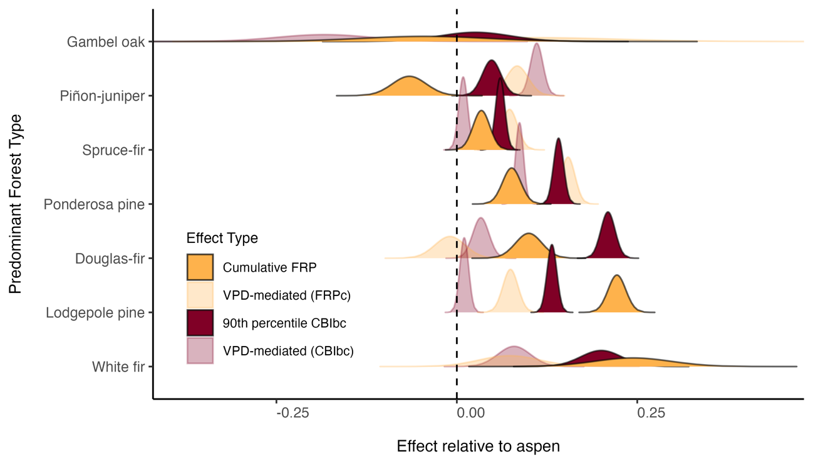

**Figure 2.** Posterior distributions of effects of majority forest type on cumulative FRP and 90th percentile CBIbc *relative to aspen* at the baseline (full color) and with VPD-mediation (transparent color). Lodgepole, Douglas-fir, white fir, ponderosa pine, and spruce-fir forest types had significant positive effects on both FRPc and CBIbc. Gambel oak and pinon-juniper forests showed a lower FRPc though credible intervals pass zero. Pinon-juniper relative to aspen but a higher CBIbc. Except for Gambel oak, all forest types showed significant positive effects on CBIbc relative to aspen. These effects were drastically diminished when interacting with VPD (i.e., effect moving towards zero for all forest types).

**Table 1.** Model comparisons using fit statistics and effective number of parameters. Spatial models with random effects for fire event and day-of-burn were far more complex (greater number of effective parameters) and performed significantly better based on WAIC and CPO.

|  |  |  |  |  |
| --- | --- | --- | --- | --- |
| Response | Model | WAIC | Mean CPO | Effective # of Parameters |
| **FRP** | **W/Fire + Temporal + Spatial Effect** | **261898.96** | **0.34** | **4700.02** |
| FRP | W/Fire + Temporal Effect | 282012.54 | 0.31 | 506.49 |
| FRP | W/Fire Random Effect | 288571.70 | 0.30 | 145.79 |
| FRP | Baseline | 295284.82 | 0.29 | 53.99 |
| **CBI** | **W/Fire + Temporal + Spatial Effect** | **264356.09** | **0.36** | **4159.85** |
| CBI | W/Fire + Temporal Effect | 273861.08 | 0.34 | 501.89 |
| CBI | W/Fire Random Effect | 278836.15 | 0.33 | 495.64 |
| CBI | Baseline | 293617.54 | 0.30 | 51.99 |

3.2. Effect of forest composition and structure

Forest composition and structure influenced FRPc and CBIbc, with aspen forests clearly demonstrating a moderating effect based on posterior distributions (**Figure 3**). We characterized composition and structure using the gridcell proportion of the dominant forest type, species total live basal area, average tree height, and average tree diameter. Aspen forest cover had a significant negative effect on both FRPc (**Figure 3A**) and CBIbc (**Figure 3B**). For every unit increase in aspen percent cover, there was a -14.6% (95% CI: -15.8%, -13.3%) reduction in FRPc and -12.6% (95% CI: -13.3%, -11.9%) reduction in CBIbc. This effect was prominent for aspen compared to other forest types, although increasing percent cover of lodgepole forests had a significant positive effect on FRPc. The influence of live basal area, tree height and tree diameter were less pronounced for aspen, although significant effects did emerge. For every unit increase in total aspen live basal area, FRPc was reduced by an average of -2.1% (95% CI: -3.5%, -0.06%). The influence of species total live basal area had a much lower or insignificant effect on CBIbc for all forest types, including aspen. Average aspen tree height and diameter had diverging effects on both FRPc and CBIbc. In aspen forests, average tree height had a significant negative influence with a -1.9% to -2.3% average decrease in FRPc and CBIbc, respectively, for each unit increase in tree height. Conversely, tree diameter had less pronounced but positive effect, where greater average diameter tended to increase both FRPc and CBIbc. For both responses, gridcell canopy cover percent had a strong positive effect, total dead trees abundance had a weak negative effect, and the gridcell diversity of species contributing to live basal area had a significant positive effect (**Figure SX, Table SX**).

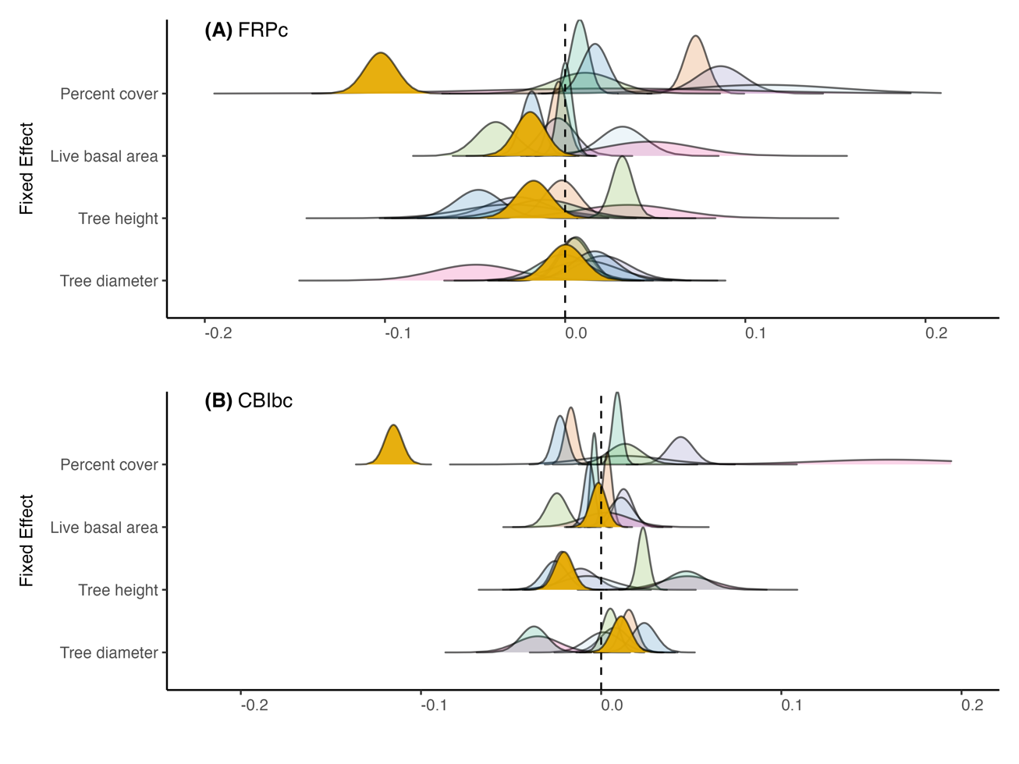

**Figure 4.** Posterior distribution of effects for forest type-specific composition and structure metrics on (**A**) cumulative FRP, and (**B**) 90th percentile CBIbc.

3.1.3. Topography and fire weather

Topography and fire weather influenced FRPc and CBIbc alongside forest composition and structure, with some key differences (**Table SX**, **Figure SX**). Elevation, for example, had a significant negative effect on FRPc, but a non-significant effect on CBIbc. Topographic features such as ridges and hilltops, characterized by higher TPI, had significant positive effect on both responses. Steeper slopes had a weak but significant positive effect on both responses. North-facing slopes tend to weakly decreased FRPc but have little effect in our models on CBIbc. Fire weather generally had a stronger positive effect on FRPc than CBIbc in our models. For every unit increase in VPD, there was a 16.2% (95% CI: -13.3%, -11.9%) increase in FRPc (**Table SX**). In the case of CBIbc, VPD showed a weak negative effect with credible intervals passing zero, indicating insignificance (**Figure SX**). ERCdv had a positive effect which was strongest for FRPc (+10.7% for every unit increase), though positive and significant for CBIbc as well (**Table SX**).

## 3.3. Aspen dominance and fire weather mediation

Quaking aspen co-occurrence and dominance relative to predominant forest types influenced FRP and CBI, although effects were often mediated by VPD (**Figure 5**). Where quaking aspen is predominant, increasing proportional live basal significantly decreased FRPc (X% for every unit increase) and CBIbc (X% for every unit increase). However, there is a strong VPD-mediating effect, where the influence of aspen dominance on reducing FRP and CBI either diminishes greatly (CBIbc, **Figure 5b**) or becomes slightly positive (FRPc, **Figure 5a**). In both cases, the credible intervals for the VPD-mediated effect slightly overlap zero, indicating a non-significant effect. Similarly, in lodgepole-predominant grids the effect of increasing aspen dominance on FRP was significant and negative, with a moderate diminishing influence of VPD-mediation. Conversely, in spruce-fir, ponderosa, and pinyon-juniper predominant grids, the VPD-mediating effect on FRP and CBI improved the effect of aspen dominance (*i.e.*, decreasing effect, reduction in the response variables). In ponderosa-dominated grids, aspen dominance tends to decrease CBI *only* when mediated by VPD, whereas it has a slight positive effect without mediation. The same is true for spruce-fir dominant grids and the effect on FRP. For pinyon-juniper and mixed-conifer predominant grids, which are relatively rare (**Figure S1**), the effects of aspen dominance exhibited extreme credible intervals overlapping zero for the FRP models. These forest types rarely co-occur with aspen in great proportions (**Figure SX**), which helps explain the wide credible intervals and uncertain estimates. Again, the credible intervals were tighter for the CBI model and the CPO was significantly higher (Table S2), suggesting better predictive power for CBI compared to FRP.

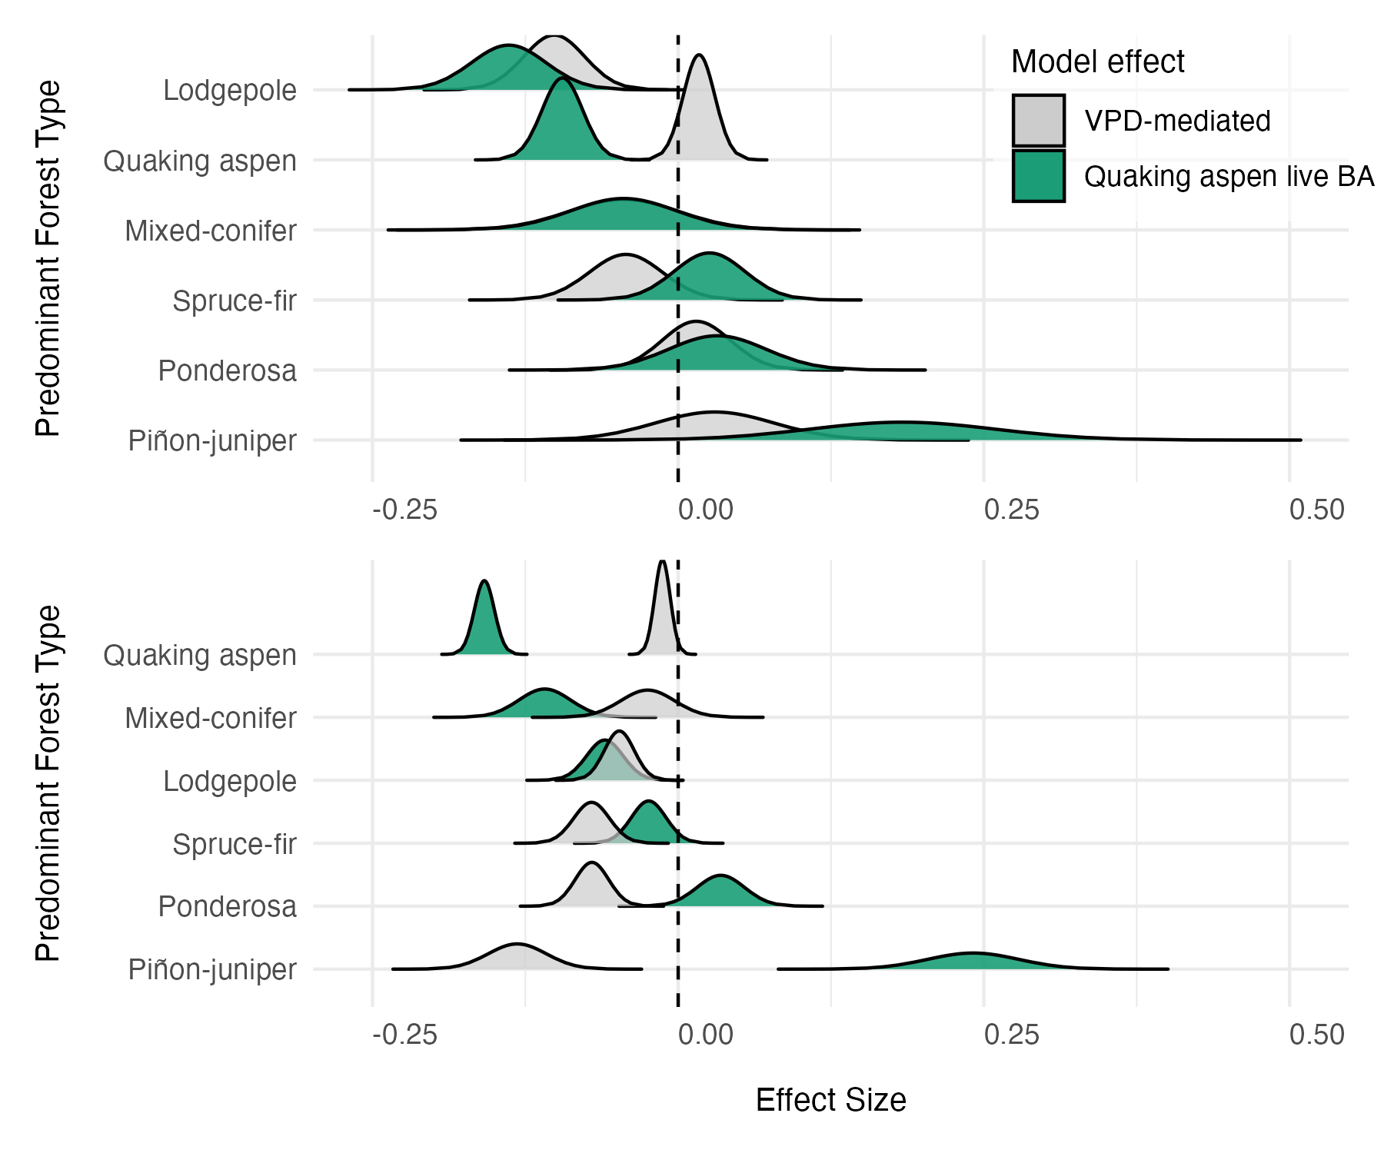

**Figure 5.** Posterior distribution of effects on (**A**) FRP, and (**B**) CBI, for the influence of quaking aspen *dominance* relative to co-occurring predominant forest types with and without VPD mediation. Grey distributions represent the VPD-mediated effect which was modeled as an interaction term (*forest type: aspen dominance * VPD*). For both models, terms were included to account for other fire weather, topography, fire-dependent random effects, day-of-burn temporal random effects, and spatial effects. Additional terms accounting for VIIRS detection aggregation were included for the FRP model (see *Section 2.7*).

### 3.1.4. Spatial patterns in FRP and CBI

Substantial spatial structure emerged for both FRPc and CBIbc, defined by the SPDE structured random effects model implemented in *R-INLA* (**Figure 3**). Semivariogram analysis provided an initial assessment of the expected spatial range (**Figure SX**), suggesting an expected mean range for FRPc of ~2.2 km and ~2.9 km for CBIbc. Results from the SPDE indicate alignment with these expectations alongside fixed and random effects, with slight differences. For FRP, the mean effective range of spatial dependence was 0.016 degrees (~1.6 km), suggesting a fine-scale clustering and influence of localized conditions unexplained by fixed or random effects (**Figure 3X**). A relatively large standard deviation (mean 0.769) indicated moderately strong spatial variation in FRP, and residual spatial effects left unexplained by the model. In the case of CBIbc, the effective range of spatial dependence increases to 0.078 (~7.8 km), suggesting more broad-scale spatial patterns in burn severity compared to FRP. With a lower standard deviation (mean 0.088), the spatial variation in CBIbc is significantly reduced compared to FRPc and may be better explained by the fixed and random effects such as forest composition and structure, fire weather and topography.

**Figure 3.** Southern Rockies spatial mesh and example for the Williams Fork Fire, CO (2020). (**A**) Spatial mesh grid covering the Southern Rockies; (**B**) Cumulative FRP (FRPc); (**C**) Spatial effect of FRPc; (**D**) Uncertainty in the spatial effect of FRPc; (**E**) 90th percentile CBIbc; (**F**) Spatial effect of CBIbc; and **(G)** Uncertainty in the spatial effect of CBIbc. Tighter spatial clustering was observed for FRPc compared to CBIbc, and spatial dependence is strongest within ~1.4 km indicating finer-scale spatial patterns. The Williams Fork Fire burned approximately 14,833 acres and emitted a cumulative FRP of 3071.13 W/km2 (ranked 14th overall) based on VIIRS active fire detections.

# Discussion

Significant differences between FRPc and CBIbc relative to aspen emerged across forest types in the Southern Rockies during recent wildfires. In the context of fire heat and post-fire severity, aspen forest composition and structure had significant moderating effects compared to other common forest types. For example, we found that compared to predominantly lodgepole pine forests, aspen radiated an average of 31.5% lower FRPc and an average of 18.7% lower CBIbc. In this forest type, and where lodgepole and aspen co-occur, every unit increase in proportional live basal area decreased FRPc by X W/km2 and the mediating effect of fire weather was weakest (-X% reduction in effect), highlighting the capacity for aspen to reduce fire heat in lodgepole forests even under more extreme conditions. The results of this study have widespread implications for forest and fire management in the context of fire hazards, suppression and response, and fuels treatments. We demonstrate a novel application of FRP as a proxy for fire intensity and successfully harmonize this with satellite-derive burn severity, imputed wall-to-wall forest inventory data, and characteristics of topography and weather to elucidate the biotic and abiotic controls on fire heat and post-fire ecosystem impacts.

## 4.1. Aspen turns down the heat during recent wildfires

Aspen forests had a strong moderating effect on both FRPc and CBIbc, especially where it was the dominant forest cover. Lodgepole pine, Douglas-fir, ponderosa pine, and spruce-fir forests types all exhibited significantly higher FRPc (+X-X%) and CBIbc (+X-X%) relative to aspen while accounting for other landscape and climatic effects such as forest composition and structure, fire weather, and topography. This result aligns with expectations of fire activity in aspen forests, which is generally considered to be lower than adjacent conifer forest types (*refs*). Previous studies have shown that fire activity is determined also by aspen stand structure and function type (e.g., seral or stable), where pure/stable stands are less likely to burn than mixed/seral stands. Our results indicate that this is likely true during recent wildfires in the Southern Rockies, with a X% reduction FRPc for every unit increase in aspen percent cover (**Figure 4A**) – indicating a more pronounced cooling effect of aspen forests when they make up a greater proportion of the landscape area. In the context of stand structure, we similarly found that as aspen total live basal area increases, there is a significant reduction in FRPc compared to other forest types. This influence is diminished in the context of burn severity, though, aspen canopy cover also significantly reduced CBIbc (**Figure 4B**).

## 4.2. Forest composition and structure effects align with expected fire regime characteristics

Forest -specific fire regime characteristics emerged when assessing the influence of structural metrics on fire heat and burn severity, highlighting the capacity of these methods to understand observed fire behavior from satellite-derived information harmonized with wall-to-wall forest inventory data. For example, the interesting relationships between tree height and diameter corroborate expected fire regime characteristics in both ponderosa pine and quaking aspen forests. Ponderosa forests have historically evolved with high frequency, low severity/intensity wildfire (*ref*). This expectation assumes open, park-like structure where large individuals are interspersed with meadows and some regeneration (*ref*). These forests have been particularly impacted by a century of fire-exclusion leading to a forest structure that is more densely packed with potentially smaller individual trees and changing fire behavior (*ref*). These findings are significant, as the methods herein provide a relatively accurate way to assess the influence of forest structure on *observed* fire behavior; an important consideration when planning fuels treatments or assessing their effectiveness.

## 4.3. Patterns of spatial dependence differ for FRP and CBI

Interesting spatial patterns emerged for both FRP and CBI across fire events. The spatial range of dependence is much smaller for FRP (~1.2 km) than for CBI (~7.8 km). This suggests more localized clustering of effects for FRP compared to more landscape-scale processes of burn severity. The much lower residual variance in the CBI models also indicates the fixed effects, particularly forest type, composition and/or structure, are better able to explain the differences in burn severity. For FRP, significant residual variance in the spatial effect suggests the opposite; forest composition and structure patterns alone cannot explain the spatial dependence of FRP as well. This is significant, as the spatial pattern on FRP is more sensitive to localized conditions unexplained in the present models such as specific live fuel moisture or fine-scale wind patterns. Future work can leverage this information to better predict radiative intensity at localized scales. Despite this, some significant effects of forest type, composition and structure did overcome the spatial dependence in FRP, albeit with wider credible intervals than for CBI. This demonstrates the importance of incorporating spatial structure into analysis of wildfire behavior, especially as it relates to satellite-based measurements. The SPDE models implemented in *R-INLA* were effective for assessing and accounting for spatial dependence and their computational feasibility makes this analysis scalable to wide geographic regions.

## 4.4. Opportunities, limitations and future directions

Broadly speaking, the methods of this study are widely applicable to other regions, forest types, and satellite-derived information. We demonstrate a novel application of satellite-derived FRP as a proxy for fire intensity and our results highlight the potential of these data to understand how landscape factors influence fire intensity, an important measure of how difficult a fire will be to control. These data could, for example, be leveraged to monitor fuel treatment effectiveness, the influence of beetle-kill on fire intensity, and understand the influence of more fine-scale measurements of live fuel moisture. The VIIRS data in particular offer an important source of *globally* available FRP information. The aggregation of active fire detections in the present study could also be used to integrate data across sensors, such as VIIRS, MODIS, and GOES, to fill the spatial and temporal gaps in detections. As new satellites come online, such as the FireSat constellation scheduled for 2026, these methods may become more applicable with higher temporal and spatial resolution imagery measuring fire activity and heat.

While we demonstrate a successful harmonization of satellite-derived FRP and CBI with imputed forest inventory data, there are some considerations for future work. These data still represent a sparse network of field sampling locations (one plot per 24.3 km2), introducing uncertainty into our estimates of forest structure. Future efforts will benefit from integrating this approach with other satellite-based or field measurements on forest composition and structure to better define these relationships. Despite this uncertainty, our results indicate agreement with expectations of fire intensity and severity in common forest types of the Southern Rockies, highlight important advancement in the integration of satellite-derived FRP as a proxy for fire intensity with wall-to-wall forest metrics from TreeMap and the information provided in the *Tree Table* provides unique estimates of understory and mixed-forest composition which have been understudied at landscape scales.

# Conclusion

Overall, this effort contributes a significant advancement in the use of satellite-derived FRP as a proxy for fire intensity and demonstrates successful harmonization of these data with burn severity, forest inventory data, fire weather, and topography. The results have widespread implications for management of aspen and other forest types in the context of fire hazards and fuels management in the Southern Rockies and the open-source methods (see *Code Availability*) provide a framework for future research using satellite-derived FRP.

This study demonstrates the influence of forest composition and structure on fire behavior and elucidates the potential moderating influences of quaking aspen forests on fire intensity and severity in the Southern Rockies. From a management perspective, the expansion of aspen forests may reduce the risk of extreme fire behavior under certain conditions, although this influence is likely mediated by the specific structure of aspen forest and the fire weather conditions. The moderating influence of aspen forests is far more pronounced in lodgepole-dominated areas and targeted management of aspen in these forests is likely to provide a larger benefit of wildfire risk reduction. Given this information, aspen management in lodgepole forests can be targeted to provide a potential buffer in regions near communities where wildfire risk and suppression difficulty are high. This study provides important insights into the effects of not only aspen forests, but other predominant forest types and their structure, on observed fire behavior in the Southern Rockies with implications for wildfire risk reduction and forest management.

# References