# **Supplement**

**Figure S1**. (**A**) Predominant forest species groups making up 97% of forested area. Hatching represents the fraction of gridcells where that species is the majority (>50% gridcell forested area). (**B**) Distribution of species structural metrics from the TreeMap *Tree Table* including the proportion of live basal area (BA) and trees/pixel (TPP).

**Figure 2.** Aggregation of VIIRS active fire detections (AFD) onto a regular grid for the Williams Fork Fire (2020). (**A**) Pixel centers of AFD from both satellites (S-NPP and JPSS-1); (**B**) Pixel ground area based on swath position (relative nadir position); (**C**) Maximum FRP based on fractional overlap aggregation.

**Figure S2.** (A)Distribution of pixel ground area in square kilometers from VIIRS active fire detections. (B) The mean pixel ground area at each swath sample location. The further off-nadir a pixel is, the greater its ground area.

**Figure S3.** Distribution of VIIRS pixel area overlaps with the regular 375 m2 grid of the Southern Rockies showing the cutoff value (>50% gridcell overlap) as a red dashed line and the 100% overlap threshold as a dashed grey line. Only gridcells with *at least* 50% overlap with VIIRS detections were retained for the analysis to limit the contributions of gridcells with very small fractional overlap. 12,639 gridcells were removed from the analysis.

**Figure SX.** Observed species co-occurrence matrix from the TreeMap Tree Table for all forest species considered to be common in the Southern Rockies.

**Figure SX.** Correlation matrix for all variables explored for the modeling procedure. Variables which were included in the models were assessed for collinearity.

**Figure SX.** Posterior distribution of effects for all non-forest type fixed effects.

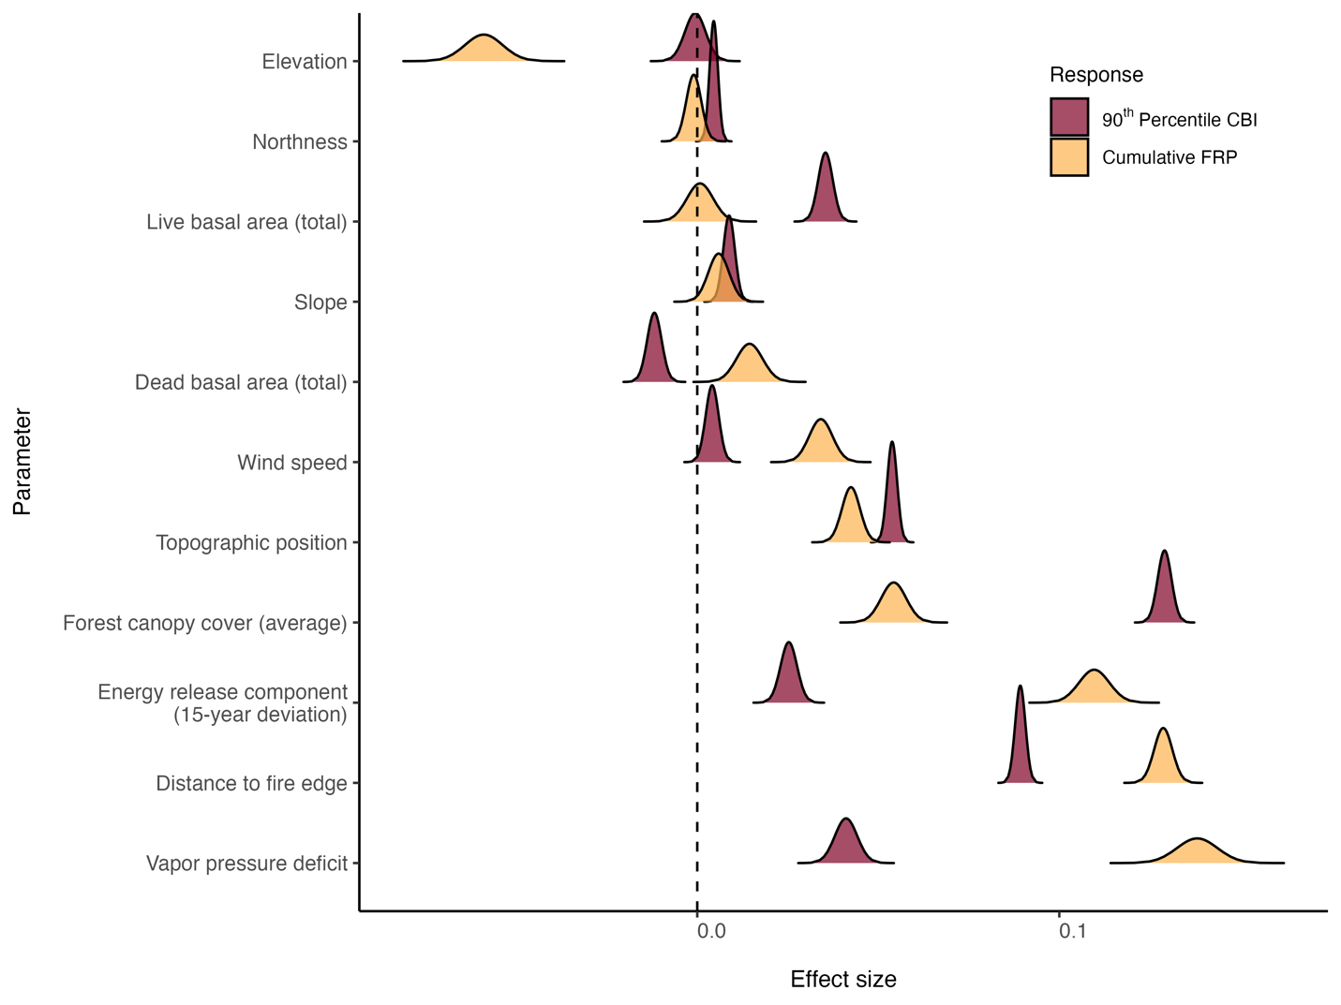

**Table SX.** Model results for FRPc models including the mean effects and credible intervals, exponentiated effects, and random effects.

|  |  |  |  |  |  |
| --- | --- | --- | --- | --- | --- |
| **Model Parameter** | **Mean Effect** | **SD** | **0.025 Q** | **0.975 Q** | **Exponentiated Mean Effect** |
| (Intercept) | 2.095 | 0.036 | 2.025 | 2.165 | 7.129 |
| fortypnm_gpdouglas_fir | 0.094 | 0.017 | 0.062 | 0.127 | 0.099 |
| fortypnm_gpgambel_oak | -0.082 | 0.06 | -0.2 | 0.035 | -0.079 |
| fortypnm_gplodgepole_pine | 0.19 | 0.011 | 0.168 | 0.212 | 0.209 |
| fortypnm_gppinon_juniper | -0.047 | 0.017 | -0.081 | -0.013 | -0.046 |
| fortypnm_gpponderosa_pine | 0.087 | 0.012 | 0.064 | 0.109 | 0.09 |
| fortypnm_gpspruce_fir | 0.039 | 0.011 | 0.016 | 0.061 | 0.039 |
| fortypnm_gpwhite_fir | 0.163 | 0.039 | 0.087 | 0.238 | 0.177 |
| fortypnm_gpquaking_aspen:fortyp_pct | -0.084 | 0.008 | -0.099 | -0.069 | -0.081 |
| fortypnm_gpdouglas_fir:fortyp_pct | 0.06 | 0.015 | 0.031 | 0.089 | 0.062 |
| fortypnm_gpgambel_oak:fortyp_pct | 0.03 | 0.04 | -0.05 | 0.109 | 0.03 |
| fortypnm_gplodgepole_pine:fortyp_pct | 0.055 | 0.006 | 0.044 | 0.067 | 0.057 |
| fortypnm_gppinon_juniper:fortyp_pct | -0.012 | 0.011 | -0.034 | 0.009 | -0.012 |
| fortypnm_gpponderosa_pine:fortyp_pct | 0.017 | 0.005 | 0.007 | 0.026 | 0.017 |
| fortypnm_gpspruce_fir:fortyp_pct | -0.013 | 0.008 | -0.028 | 0.002 | -0.013 |
| fortypnm_gpwhite_fir:fortyp_pct | 0.072 | 0.037 | -0.002 | 0.145 | 0.074 |
| species_gp_nquaking_aspen:sdi_live | -0.026 | 0.007 | -0.041 | -0.012 | -0.026 |
| species_gp_ndouglas_fir:sdi_live | -0.01 | 0.012 | -0.033 | 0.012 | -0.01 |
| species_gp_ngambel_oak:sdi_live | 0.047 | 0.017 | 0.014 | 0.081 | 0.049 |
| species_gp_nlodgepole_pine:sdi_live | -0.021 | 0.004 | -0.029 | -0.012 | -0.02 |
| species_gp_npinon_juniper:sdi_live | -0.004 | 0.01 | -0.023 | 0.016 | -0.004 |
| species_gp_nponderosa_pine:sdi_live | 0.003 | 0.004 | -0.006 | 0.012 | 0.003 |
| species_gp_nspruce_fir:sdi_live | -0.013 | 0.006 | -0.024 | -0.002 | -0.013 |
| species_gp_nwhite_fir:sdi_live | -0.001 | 0.015 | -0.03 | 0.027 | -0.001 |
| species_gp_nquaking_aspen:hdr_live | -0.008 | 0.007 | -0.021 | 0.005 | -0.008 |
| species_gp_ndouglas_fir:hdr_live | 0.005 | 0.02 | -0.035 | 0.045 | 0.005 |
| species_gp_ngambel_oak:hdr_live | -0.021 | 0.015 | -0.05 | 0.008 | -0.021 |
| species_gp_nlodgepole_pine:hdr_live | 0.004 | 0.007 | -0.01 | 0.018 | 0.004 |
| species_gp_npinon_juniper:hdr_live | 0.013 | 0.005 | 0.004 | 0.023 | 0.013 |
| species_gp_nponderosa_pine:hdr_live | 0.049 | 0.016 | 0.017 | 0.081 | 0.05 |
| species_gp_nspruce_fir:hdr_live | -0.096 | 0.012 | -0.119 | -0.072 | -0.091 |
| species_gp_nwhite_fir:hdr_live | -0.042 | 0.024 | -0.09 | 0.006 | -0.041 |
| species_gp_nquaking_aspen:ba_per | -0.003 | 0.01 | -0.022 | 0.017 | -0.003 |
| species_gp_ndouglas_fir:ba_per | 0.013 | 0.006 | 0.002 | 0.024 | 0.013 |
| species_gp_ngambel_oak:ba_per | -0.016 | 0.013 | -0.04 | 0.009 | -0.015 |
| species_gp_nlodgepole_pine:ba_per | 0.022 | 0.011 | 0.001 | 0.042 | 0.022 |
| species_gp_npinon_juniper:ba_per | 0.006 | 0.007 | -0.008 | 0.02 | 0.006 |
| species_gp_nponderosa_pine:ba_per | 0.011 | 0.005 | 0.002 | 0.02 | 0.011 |
| species_gp_nspruce_fir:ba_per | -0.077 | 0.014 | -0.104 | -0.049 | -0.074 |
| species_gp_nwhite_fir:ba_per | -0.009 | 0.008 | -0.024 | 0.006 | -0.009 |
| lf_canopy | 0.061 | 0.004 | 0.054 | 0.069 | 0.063 |
| ba_live_total | -0.002 | 0.004 | -0.01 | 0.005 | -0.002 |
| ba_dead_total | 0.019 | 0.004 | 0.012 | 0.027 | 0.019 |
| erc_dv | 0.106 | 0.004 | 0.097 | 0.115 | 0.112 |
| vpd | 0.141 | 0.006 | 0.129 | 0.152 | 0.151 |
| vs | 0.039 | 0.003 | 0.032 | 0.046 | 0.04 |
| elev | -0.054 | 0.006 | -0.065 | -0.043 | -0.053 |
| slope | 0.006 | 0.003 | 0 | 0.012 | 0.006 |
| northness | 0 | 0.002 | -0.004 | 0.005 | 0 |
| tpi | 0.046 | 0.003 | 0.041 | 0.051 | 0.047 |
| overlap | 0.688 | 0.003 | 0.683 | 0.693 | 0.989 |
| day_prop | 0.6 | 0.003 | 0.595 | 0.605 | 0.823 |
| dist_to_perim | 0.115 | 0.003 | 0.11 | 0.12 | 0.122 |

**Table SX**. Model results for CBIbc models including the mean effects and credible intervals, exponentiated effects, and random effects.

|  |  |  |  |  |  |
| --- | --- | --- | --- | --- | --- |
| **Model Parameter** | **Mean Effect** | **SD** | **0.025 Q** | **0.975 Q** | **Exponentiated Mean Effect** |
| (Intercept) | 0.117 | 0.025 | 0.068 | 0.166 | 0.124 |
| fortypnm_gpdouglas_fir | 0.209 | 0.016 | 0.179 | 0.24 | 0.233 |
| fortypnm_gpgambel_oak | -0.244 | 0.059 | -0.359 | -0.128 | -0.216 |
| fortypnm_gplodgepole_pine | 0.095 | 0.011 | 0.075 | 0.116 | 0.1 |
| fortypnm_gppinon_juniper | 0.124 | 0.016 | 0.092 | 0.156 | 0.132 |
| fortypnm_gpponderosa_pine | 0.144 | 0.011 | 0.123 | 0.166 | 0.155 |
| fortypnm_gpspruce_fir | 0.082 | 0.011 | 0.061 | 0.103 | 0.085 |
| fortypnm_gpwhite_fir | 0.201 | 0.036 | 0.13 | 0.272 | 0.223 |
| fortypnm_gpquaking_aspen:fortyp_pct | -0.14 | 0.007 | -0.155 | -0.126 | -0.131 |
| fortypnm_gpdouglas_fir:fortyp_pct | 0.022 | 0.014 | -0.005 | 0.049 | 0.022 |
| fortypnm_gpgambel_oak:fortyp_pct | -0.031 | 0.04 | -0.11 | 0.048 | -0.03 |
| fortypnm_gplodgepole_pine:fortyp_pct | -0.035 | 0.005 | -0.046 | -0.025 | -0.035 |
| fortypnm_gppinon_juniper:fortyp_pct | 0.03 | 0.011 | 0.009 | 0.051 | 0.03 |
| fortypnm_gpponderosa_pine:fortyp_pct | 0.014 | 0.005 | 0.005 | 0.023 | 0.014 |
| fortypnm_gpspruce_fir:fortyp_pct | -0.018 | 0.007 | -0.032 | -0.004 | -0.018 |
| fortypnm_gpwhite_fir:fortyp_pct | -0.02 | 0.035 | -0.089 | 0.049 | -0.02 |
| species_gp_nquaking_aspen:sdi_live | -0.016 | 0.007 | -0.03 | -0.001 | -0.016 |
| species_gp_ndouglas_fir:sdi_live | 0.001 | 0.011 | -0.022 | 0.023 | 0.001 |
| species_gp_ngambel_oak:sdi_live | 0.047 | 0.017 | 0.014 | 0.08 | 0.048 |
| species_gp_nlodgepole_pine:sdi_live | -0.005 | 0.004 | -0.013 | 0.003 | -0.005 |
| species_gp_npinon_juniper:sdi_live | 0.003 | 0.01 | -0.017 | 0.023 | 0.003 |
| species_gp_nponderosa_pine:sdi_live | 0.002 | 0.004 | -0.007 | 0.01 | 0.002 |
| species_gp_nspruce_fir:sdi_live | -0.012 | 0.005 | -0.022 | -0.001 | -0.011 |
| species_gp_nwhite_fir:sdi_live | -0.001 | 0.014 | -0.029 | 0.027 | -0.001 |
| species_gp_nquaking_aspen:hdr_live | -0.015 | 0.007 | -0.028 | -0.002 | -0.015 |
| species_gp_ndouglas_fir:hdr_live | -0.029 | 0.02 | -0.069 | 0.011 | -0.029 |
| species_gp_ngambel_oak:hdr_live | 0.02 | 0.015 | -0.008 | 0.049 | 0.02 |
| species_gp_nlodgepole_pine:hdr_live | -0.007 | 0.007 | -0.021 | 0.007 | -0.007 |
| species_gp_npinon_juniper:hdr_live | 0.014 | 0.005 | 0.004 | 0.023 | 0.014 |
| species_gp_nponderosa_pine:hdr_live | 0.097 | 0.016 | 0.064 | 0.129 | 0.102 |
| species_gp_nspruce_fir:hdr_live | -0.03 | 0.012 | -0.053 | -0.006 | -0.029 |
| species_gp_nwhite_fir:hdr_live | -0.047 | 0.024 | -0.094 | 0.001 | -0.046 |
| species_gp_nquaking_aspen:ba_per | -0.005 | 0.01 | -0.025 | 0.014 | -0.005 |
| species_gp_ndouglas_fir:ba_per | -0.001 | 0.006 | -0.012 | 0.01 | -0.001 |
| species_gp_ngambel_oak:ba_per | -0.017 | 0.013 | -0.041 | 0.008 | -0.016 |
| species_gp_nlodgepole_pine:ba_per | 0.016 | 0.011 | -0.005 | 0.037 | 0.016 |
| species_gp_npinon_juniper:ba_per | 0.014 | 0.007 | 0 | 0.028 | 0.014 |
| species_gp_nponderosa_pine:ba_per | 0.019 | 0.005 | 0.009 | 0.028 | 0.019 |
| species_gp_nspruce_fir:ba_per | 0.003 | 0.014 | -0.024 | 0.031 | 0.003 |
| species_gp_nwhite_fir:ba_per | -0.008 | 0.008 | -0.023 | 0.008 | -0.008 |
| lf_canopy | 0.136 | 0.004 | 0.129 | 0.143 | 0.145 |
| ba_live_total | 0.048 | 0.004 | 0.041 | 0.055 | 0.049 |
| ba_dead_total | -0.011 | 0.004 | -0.018 | -0.004 | -0.011 |
| erc_dv | 0.017 | 0.004 | 0.009 | 0.025 | 0.018 |
| vpd | 0.044 | 0.005 | 0.033 | 0.054 | 0.045 |
| vs | 0.004 | 0.003 | -0.002 | 0.011 | 0.004 |
| elev | 0.015 | 0.005 | 0.005 | 0.025 | 0.016 |
| slope | 0.003 | 0.003 | -0.002 | 0.009 | 0.003 |
| northness | 0.006 | 0.002 | 0.002 | 0.01 | 0.006 |
| tpi | 0.051 | 0.002 | 0.046 | 0.056 | 0.053 |
| overlap | 0.062 | 0.003 | 0.057 | 0.067 | 0.064 |
| day_prop | 0.003 | 0.002 | -0.002 | 0.007 | 0.003 |
| dist_to_perim | 0.093 | 0.002 | 0.088 | 0.098 | 0.097 |