Assignment Two

HTML5 & CSS3 – I

***Complete the tasks below. If you need help, please use the learning content provided for each topic. Have fun!***

## Part A: 300 Movie Review

### [ Learn: [1](https://www.internetingishard.com/), [2](https://www.khanacademy.org/computing/computer-programming/html-css), [3](https://web.dev/learn/css/), [4](https://developers.google.com/web/fundamentals), [5](https://developer.mozilla.org/en-US/docs/Learn) ]

1. Recreate the page pictured below.
2. There is no need for PhotoShop: everything you see in the mockup has been produced with HTML, CSS, and the assets as supplied to you. You can use any other combination of applications you wish to achieve the final goal.
3. Create your CSS in a separate linked style sheet.
4. Link the footnote reference in the body to the footnote at the bottom of the page.
5. Link to Maryann Johanson’s review of 300 in the body text.
6. Headings in the mockup are set in Trebuchet MS; body text is Georgia.
7. The result should be valid code. (Google Lighthouse).
8. Link the words “Alamo”, “Rorke’s Drift” and “Thermopylae” in the body text of the page to appropriate online resources.
9. Add appropriate microdata to the HTML.
10. Make the page responsive.
11. Add a print stylesheet.
12. The images are [**HERE**](https://1drv.ms/u/s!AnLYPxKmUDfciLFVGpZ8fpMMhWOVlQ?e=Vvfep0).
13. The page text is [**HERE**](https://1drv.ms/w/s!AnLYPxKmUDfciLFbjO6ZiWKlI2IBhA?e=9fq33D).

## Part B – Stormy Weather

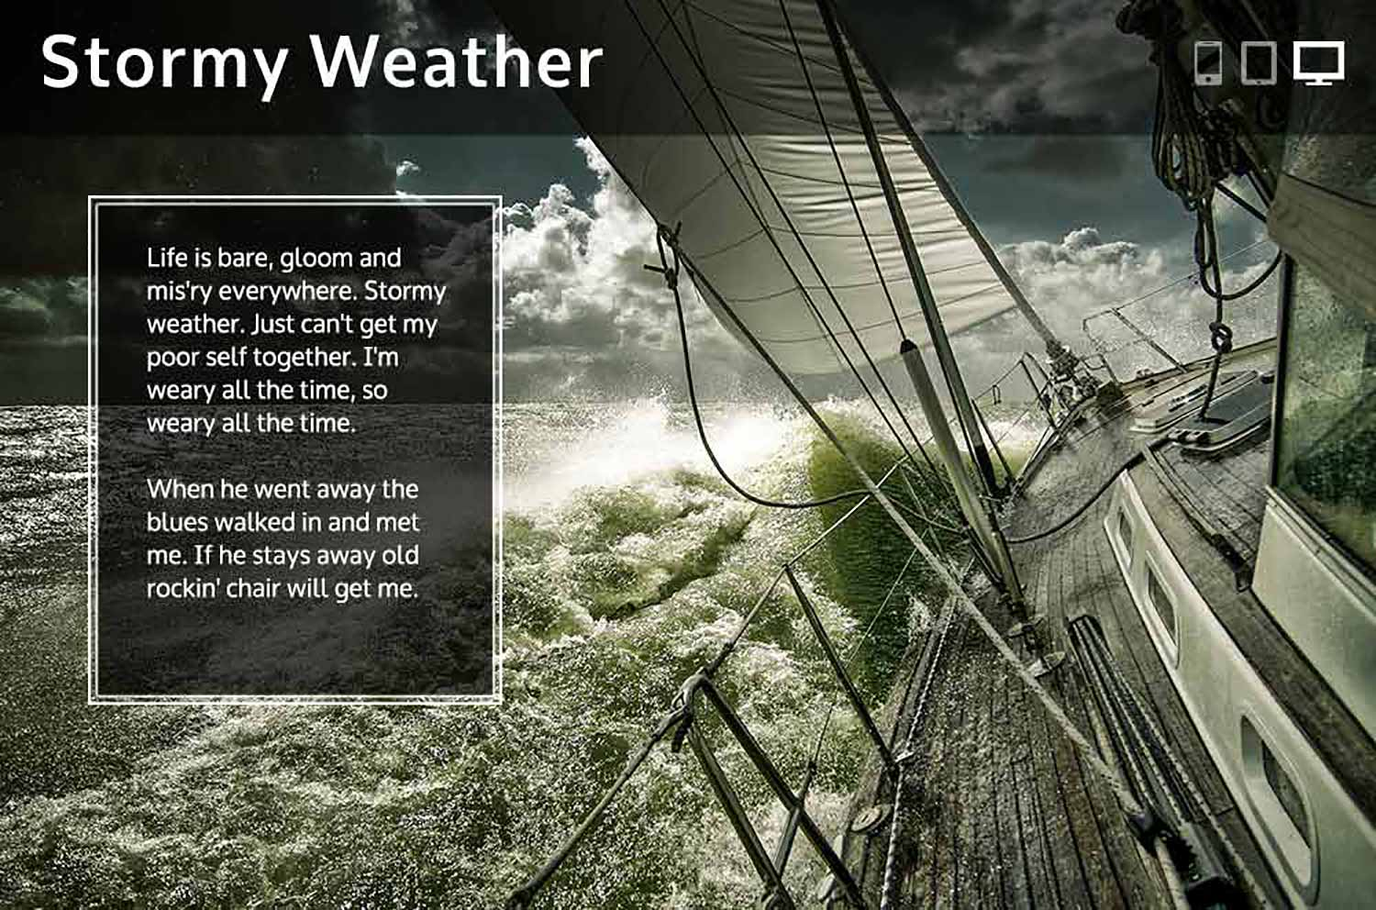

1. All instructions are the same as Part A.
2. All text on the page is in the **Oxygen** typeface, available from Google Web Fonts. The icons in the top left corner are from [**IcoMoon**](https://icomoon.io/). The body text is the second verse of the 1933 song Stormy Weather.
3. Make the icons interactive.
4. Add a print stylesheet.
5. Resources [**HERE**](https://1drv.ms/u/s!AnLYPxKmUDfciLIVCf3ETLux59ETmw?e=VGts8d)