partner2
movies <- read.csv("../data/cleaned_movies.csv")
str(movies)
## 'data.frame': 27 obs. of 7 variables:
## $ Movie : chr "Inside Out 2" "Incredibles 2" "Finding Dory" "Frozen 2" ...
## $ DomesticTotal : int 652980194 608581744 486295561 477373578 460405297 434038008 415004880 428047935 368065385 264624300 ...
## $ PrevFilmDomestic: int 356461711 261441092 339714978 400953009 248757044 415004880 245852179 341268248 251683815 368065385 ...
## $ Year : int 2024 2018 2016 2019 2024 2019 2010 2025 2013 2017 ...
## $ Budget : num 2.0e+08 2.0e+08 2.0e+08 1.5e+08 1.5e+08 2.0e+08 2.0e+08 1.5e+08 7.6e+07 8.0e+07 ...
## $ IsVideoGame : int 0 0 0 0 0 0 0 0 0 0 ...
## $ IsSpringRelease : int 0 0 0 0 0 0 0 0 0 0 ...
summary(movies)
## Movie DomesticTotal PrevFilmDomestic Year
## Length:27 Min. :143528619 Min. :143528619 Min. :2010
## Class :character 1st Qu.:173351517 1st Qu.:183212906 1st Qu.:2016
## Mode :character Median :238736787 Median :261441092 Median :2019
## Mean :301302768 Mean :259973532 Mean :2019
## 3rd Qu.:421526408 3rd Qu.:337880374 3rd Qu.:2022
## Max. :652980194 Max. :415004880 Max. :2025
## Budget IsVideoGame IsSpringRelease
## Min. : 65000000 Min. :0.00000 Min. :0.0000
## 1st Qu.: 82500000 1st Qu.:0.00000 1st Qu.:0.0000
## Median :129000000 Median :0.00000 Median :0.0000
## Mean :131555556 Mean :0.07407 Mean :0.1111
## 3rd Qu.:175000000 3rd Qu.:0.00000 3rd Qu.:0.0000
## Max. :200000000 Max. :1.00000 Max. :1.0000
colSums(is.na(movies))
## Movie DomesticTotal PrevFilmDomestic Year
## 0 0 0 0
## Budget IsVideoGame IsSpringRelease
## 0 0 0
# Convert categorical variables and create log transforms
movies$IsVideoGame <- as.factor(movies$IsVideoGame)
movies$IsSpringRelease <- as.factor(movies$IsSpringRelease)
movies$logDomestic <- log(movies$DomesticTotal)
movies$logPrevDomestic <- log(movies$PrevFilmDomestic)
movies$logBudget <- log(movies$Budget)
movies$SequelRatio <- movies$DomesticTotal / movies$PrevFilmDomestic
# Exploratory Data Analysis (EDA)
# Raw relationship
plot(movies$PrevFilmDomestic, movies$DomesticTotal,
xlab = "Previous Film Domestic",
ylab = "Sequel Domestic",
main = "Domestic vs Previous Film")
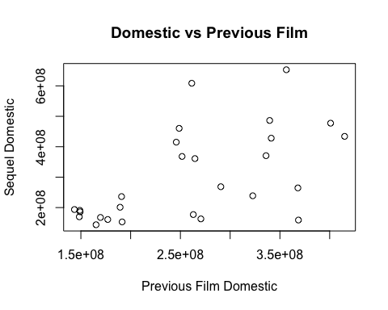
# Log-log (important)
plot(movies$logPrevDomestic, movies$logDomestic,
xlab = "log(Previous Domestic)",
ylab = "log(Domestic)",
main = "Log-Log Relationship")
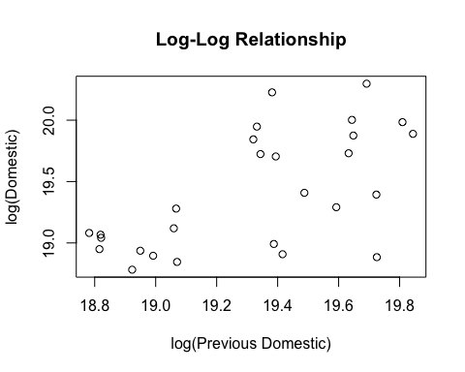
# Sequel ratios
hist(movies$SequelRatio,
main = "Sequel Ratio Distribution",
xlab = "Sequel / Previous")
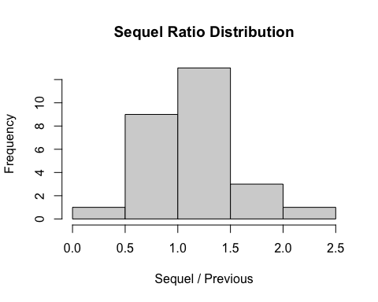
# Category comparisons
boxplot(DomesticTotal ~ IsVideoGame, data = movies)
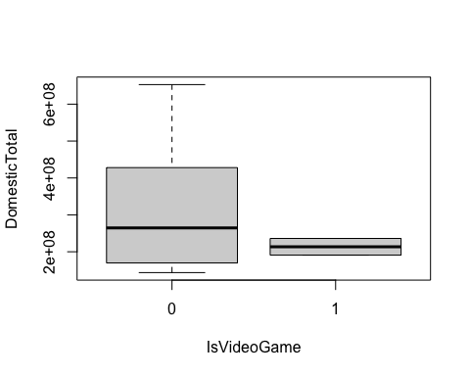
boxplot(DomesticTotal ~ IsSpringRelease, data = movies)
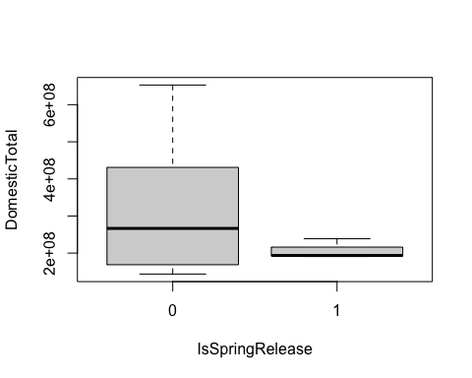
Build Models
# baseline
model1 <- lm(logDomestic ~ logPrevDomestic, data = movies)
summary(model1)
##
## Call:
## lm(formula = logDomestic ~ logPrevDomestic, data = movies)
##
## Residuals:
## Min 1Q Median 3Q Max
## -0.87995 -0.25416 0.04713 0.20389 0.76269
##
## Coefficients:
## Estimate Std. Error t value Pr(>|t|)
## (Intercept) 2.5238 4.1973 0.601 0.553062
## logPrevDomestic 0.8740 0.2172 4.024 0.000466 ***
## ---
## Signif. codes: 0 '***' 0.001 '**' 0.01 '*' 0.05 '.' 0.1 ' ' 1
##
## Residual standard error: 0.3797 on 25 degrees of freedom
## Multiple R-squared: 0.3931, Adjusted R-squared: 0.3688
## F-statistic: 16.19 on 1 and 25 DF, p-value: 0.0004659
# add Year
model2 <- lm(logDomestic ~ logPrevDomestic + Year, data = movies)
summary(model2)
##
## Call:
## lm(formula = logDomestic ~ logPrevDomestic + Year, data = movies)
##
## Residuals:
## Min 1Q Median 3Q Max
## -0.89558 -0.20291 0.00282 0.12382 0.77433
##
## Coefficients:
## Estimate Std. Error t value Pr(>|t|)
## (Intercept) -39.04674 34.91870 -1.118 0.27454
## logPrevDomestic 0.89401 0.21597 4.139 0.00037 ***
## Year 0.02040 0.01702 1.199 0.24222
## ---
## Signif. codes: 0 '***' 0.001 '**' 0.01 '*' 0.05 '.' 0.1 ' ' 1
##
## Residual standard error: 0.3764 on 24 degrees of freedom
## Multiple R-squared: 0.4274, Adjusted R-squared: 0.3797
## F-statistic: 8.957 on 2 and 24 DF, p-value: 0.001243
anova(model1, model2)
## Analysis of Variance Table
##
## Model 1: logDomestic ~ logPrevDomestic
## Model 2: logDomestic ~ logPrevDomestic + Year
## Res.Df RSS Df Sum of Sq F Pr(>F)
## 1 25 3.6041
## 2 24 3.4004 1 0.2037 1.4377 0.2422
# add video game
model3 <- lm(logDomestic ~ logPrevDomestic + Year + IsVideoGame, data = movies)
summary(model3)
##
## Call:
## lm(formula = logDomestic ~ logPrevDomestic + Year + IsVideoGame,
## data = movies)
##
## Residuals:
## Min 1Q Median 3Q Max
## -0.89577 -0.20296 0.00223 0.12464 0.77505
##
## Coefficients:
## Estimate Std. Error t value Pr(>|t|)
## (Intercept) -38.63178 36.74569 -1.051 0.304029
## logPrevDomestic 0.89738 0.23201 3.868 0.000781 ***
## Year 0.02016 0.01811 1.114 0.276942
## IsVideoGame1 0.01458 0.31043 0.047 0.962940
## ---
## Signif. codes: 0 '***' 0.001 '**' 0.01 '*' 0.05 '.' 0.1 ' ' 1
##
## Residual standard error: 0.3845 on 23 degrees of freedom
## Multiple R-squared: 0.4274, Adjusted R-squared: 0.3528
## F-statistic: 5.724 on 3 and 23 DF, p-value: 0.004452
anova(model2, model3)
## Analysis of Variance Table
##
## Model 1: logDomestic ~ logPrevDomestic + Year
## Model 2: logDomestic ~ logPrevDomestic + Year + IsVideoGame
## Res.Df RSS Df Sum of Sq F Pr(>F)
## 1 24 3.4004
## 2 23 3.4001 1 0.00032619 0.0022 0.9629
# add spring release
model4 <- lm(logDomestic ~ logPrevDomestic + Year + IsSpringRelease, data = movies)
summary(model4)
##
## Call:
## lm(formula = logDomestic ~ logPrevDomestic + Year + IsSpringRelease,
## data = movies)
##
## Residuals:
## Min 1Q Median 3Q Max
## -0.89594 -0.18697 -0.00125 0.12223 0.77011
##
## Coefficients:
## Estimate Std. Error t value Pr(>|t|)
## (Intercept) -38.71274 35.69413 -1.085 0.289351
## logPrevDomestic 0.88296 0.22899 3.856 0.000804 ***
## Year 0.02034 0.01737 1.171 0.253547
## IsSpringRelease1 -0.04362 0.24440 -0.178 0.859898
## ---
## Signif. codes: 0 '***' 0.001 '**' 0.01 '*' 0.05 '.' 0.1 ' ' 1
##
## Residual standard error: 0.3842 on 23 degrees of freedom
## Multiple R-squared: 0.4282, Adjusted R-squared: 0.3536
## F-statistic: 5.741 on 3 and 23 DF, p-value: 0.00439
anova(model2, model4)
## Analysis of Variance Table
##
## Model 1: logDomestic ~ logPrevDomestic + Year
## Model 2: logDomestic ~ logPrevDomestic + Year + IsSpringRelease
## Res.Df RSS Df Sum of Sq F Pr(>F)
## 1 24 3.4004
## 2 23 3.3957 1 0.0047038 0.0319 0.8599
# add budget
model5 <- lm(logDomestic ~ logPrevDomestic + Year + logBudget, data = movies)
summary(model5)
##
## Call:
## lm(formula = logDomestic ~ logPrevDomestic + Year + logBudget,
## data = movies)
##
## Residuals:
## Min 1Q Median 3Q Max
## -0.66832 -0.22778 0.03205 0.19680 0.62474
##
## Coefficients:
## Estimate Std. Error t value Pr(>|t|)
## (Intercept) -47.00042 31.90828 -1.473 0.154309
## logPrevDomestic 0.79579 0.20036 3.972 0.000603 ***
## Year 0.02123 0.01547 1.372 0.183180
## logBudget 0.43881 0.17853 2.458 0.021936 *
## ---
## Signif. codes: 0 '***' 0.001 '**' 0.01 '*' 0.05 '.' 0.1 ' ' 1
##
## Residual standard error: 0.3422 on 23 degrees of freedom
## Multiple R-squared: 0.5465, Adjusted R-squared: 0.4874
## F-statistic: 9.239 on 3 and 23 DF, p-value: 0.0003387
anova(model2, model5)
## Analysis of Variance Table
##
## Model 1: logDomestic ~ logPrevDomestic + Year
## Model 2: logDomestic ~ logPrevDomestic + Year + logBudget
## Res.Df RSS Df Sum of Sq F Pr(>F)
## 1 24 3.4004
## 2 23 2.6931 1 0.70734 6.0409 0.02194 *
## ---
## Signif. codes: 0 '***' 0.001 '**' 0.01 '*' 0.05 '.' 0.1 ' ' 1
# Model selection
full_model <- lm(logDomestic ~ logPrevDomestic + Year + logBudget +
IsVideoGame + IsSpringRelease, data = movies)
step_model <- step(full_model, direction = "both", trace = 0)
summary(step_model)
##
## Call:
## lm(formula = logDomestic ~ logPrevDomestic + Year + logBudget,
## data = movies)
##
## Residuals:
## Min 1Q Median 3Q Max
## -0.66832 -0.22778 0.03205 0.19680 0.62474
##
## Coefficients:
## Estimate Std. Error t value Pr(>|t|)
## (Intercept) -47.00042 31.90828 -1.473 0.154309
## logPrevDomestic 0.79579 0.20036 3.972 0.000603 ***
## Year 0.02123 0.01547 1.372 0.183180
## logBudget 0.43881 0.17853 2.458 0.021936 *
## ---
## Signif. codes: 0 '***' 0.001 '**' 0.01 '*' 0.05 '.' 0.1 ' ' 1
##
## Residual standard error: 0.3422 on 23 degrees of freedom
## Multiple R-squared: 0.5465, Adjusted R-squared: 0.4874
## F-statistic: 9.239 on 3 and 23 DF, p-value: 0.0003387
# Final model
final_model <- model5
# Diagnostics
par(mfrow = c(2,2))
plot(final_model)
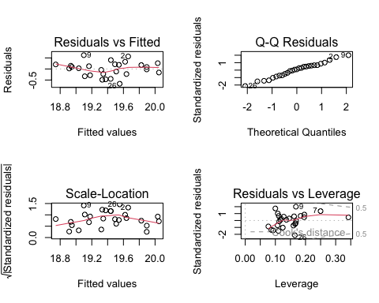
cooksD <- cooks.distance(final_model)
plot(cooksD, type = "h")
abline(h = 4/nrow(movies), lty = 2)
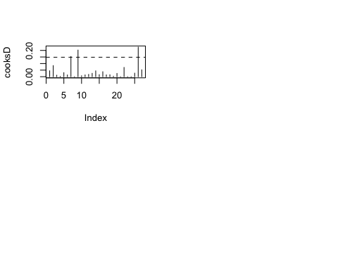
# Sensitivity Analysis
influential_index <- which.max(cooksD)
movies_no_outlier <- movies[-influential_index, ]
model_no_outlier <- lm(logDomestic ~ logPrevDomestic + Year,
data = movies_no_outlier)
coef(final_model)
## (Intercept) logPrevDomestic Year logBudget
## -47.00042278 0.79578541 0.02123365 0.43880676
coef(model_no_outlier)
## (Intercept) logPrevDomestic Year
## -44.67416690 1.02589809 0.02194566
# Predict Mario Galaxy
new_mario <- data.frame(
logPrevDomestic = log(574930000), # Mario 1
Year = 2026,
logBudget = log(180000000), # estimate
IsVideoGame = factor(1, levels = levels(movies$IsVideoGame)),
IsSpringRelease = factor(1, levels = levels(movies$IsSpringRelease))
)
predict:
pred_log <- predict(final_model, newdata = new_mario, interval = "prediction")
pred_log
## fit lwr upr
## 1 20.41079 19.56675 21.25484
convert back to dollars:
exp(pred_log)
## fit lwr upr
## 1 731636831 314581408 1701602312
# =========================
# Partner 2: Accuracy / Calibration Code
# =========================
movies <- read.csv("../data/cleaned_movies.csv")
# Prepare variables
movies$IsVideoGame <- as.factor(movies$IsVideoGame)
movies$IsSpringRelease <- as.factor(movies$IsSpringRelease)
movies$logDomestic <- log(movies$DomesticTotal)
movies$logPrevDomestic <- log(movies$PrevFilmDomestic)
movies$logBudget <- log(movies$Budget)
movies$SequelRatio <- movies$DomesticTotal / movies$PrevFilmDomestic
# -------------------------
# 1. Final regression model
# -------------------------
final_model <- lm(logDomestic ~ logPrevDomestic + Year + logBudget, data = movies)
summary(final_model)
##
## Call:
## lm(formula = logDomestic ~ logPrevDomestic + Year + logBudget,
## data = movies)
##
## Residuals:
## Min 1Q Median 3Q Max
## -0.66832 -0.22778 0.03205 0.19680 0.62474
##
## Coefficients:
## Estimate Std. Error t value Pr(>|t|)
## (Intercept) -47.00042 31.90828 -1.473 0.154309
## logPrevDomestic 0.79579 0.20036 3.972 0.000603 ***
## Year 0.02123 0.01547 1.372 0.183180
## logBudget 0.43881 0.17853 2.458 0.021936 *
## ---
## Signif. codes: 0 '***' 0.001 '**' 0.01 '*' 0.05 '.' 0.1 ' ' 1
##
## Residual standard error: 0.3422 on 23 degrees of freedom
## Multiple R-squared: 0.5465, Adjusted R-squared: 0.4874
## F-statistic: 9.239 on 3 and 23 DF, p-value: 0.0003387
# -------------------------
# 2. Predict Mario Galaxy total domestic
# -------------------------
new_mario <- data.frame(
logPrevDomestic = log(574930000), # Mario 1 domestic gross
Year = 2026,
logBudget = log(180000000) # estimated budget
)
pred_log <- predict(final_model, newdata = new_mario, interval = "prediction")
pred_total <- exp(pred_log)
cat("Regression-based TOTAL domestic prediction:\n")
## Regression-based TOTAL domestic prediction:
print(pred_total)
## fit lwr upr
## 1 731636831 314581408 1701602312
# -------------------------
# 3. Sequel ratio method
# -------------------------
ratio_mean <- mean(movies$SequelRatio)
ratio_median <- median(movies$SequelRatio)
mario1_domestic <- 574930000
ratio_total_mean <- mario1_domestic * ratio_mean
ratio_total_median <- mario1_domestic * ratio_median
cat("\nSequel-ratio TOTAL domestic prediction:\n")
##
## Sequel-ratio TOTAL domestic prediction:
cat("Using mean ratio: $", round(ratio_total_mean, 0), "\n", sep = "")
## Using mean ratio: $671178988
cat("Using median ratio: $", round(ratio_total_median, 0), "\n", sep = "")
## Using median ratio: $657334185
# -------------------------
# 4. Industry / sanity-check method
# -------------------------
# This is a manual realistic range based on comparable sequel behavior.
industry_total_low <- 500000000
industry_total_high <- 580000000
industry_total_mid <- (industry_total_low + industry_total_high) / 2
cat("\nIndustry/sanity-check TOTAL domestic range:\n")
##
## Industry/sanity-check TOTAL domestic range:
cat("Low: $", industry_total_low, "\n", sep = "")
## Low: $5e+08
cat("Mid: $", round(industry_total_mid, 0), "\n", sep = "")
## Mid: $5.4e+08
cat("High: $", industry_total_high, "\n", sep = "")
## High: $5.8e+08
# -------------------------
# 5. Convert TOTAL -> May 1 domestic
# -------------------------
# Assume about 90% of total is earned by May 1
may1_share <- 0.90
reg_may1_fit <- pred_total[, "fit"] * may1_share
reg_may1_lwr <- pred_total[, "lwr"] * may1_share
reg_may1_upr <- pred_total[, "upr"] * may1_share
ratio_may1_mean <- ratio_total_mean * may1_share
ratio_may1_median <- ratio_total_median * may1_share
industry_may1_low <- industry_total_low * may1_share
industry_may1_mid <- industry_total_mid * may1_share
industry_may1_high <- industry_total_high * may1_share
cat("\nMay 1 domestic estimates:\n")
##
## May 1 domestic estimates:
cat("Regression fit: $", round(reg_may1_fit, 0), "\n", sep = "")
## Regression fit: $658473148
cat("Regression PI low: $", round(reg_may1_lwr, 0), "\n", sep = "")
## Regression PI low: $283123268
cat("Regression PI high: $", round(reg_may1_upr, 0), "\n", sep = "")
## Regression PI high: $1531442081
cat("Ratio mean method: $", round(ratio_may1_mean, 0), "\n", sep = "")
## Ratio mean method: $604061089
cat("Ratio median method: $", round(ratio_may1_median, 0), "\n", sep = "")
## Ratio median method: $591600767
cat("Industry low: $", round(industry_may1_low, 0), "\n", sep = "")
## Industry low: $4.5e+08
cat("Industry mid: $", round(industry_may1_mid, 0), "\n", sep = "")
## Industry mid: $4.86e+08
cat("Industry high: $", round(industry_may1_high, 0), "\n", sep = "")
## Industry high: $5.22e+08
# -------------------------
# 6. Weighted final prediction
# -------------------------
# Put less weight on regression because it looks inflated / unstable
# Suggested weights:
# 30% regression, 35% sequel-ratio median, 35% industry midpoint
# Adjust ratio downward (important!)
adjusted_ratio <- 0.90 # realistic sequel behavior
ratio_total_adjusted <- mario1_domestic * adjusted_ratio
ratio_may1_adjusted <- ratio_total_adjusted * may1_share
# New weights (less regression influence)
final_submission <- 0.05 * reg_may1_fit +
0.50 * ratio_may1_adjusted +
0.45 * industry_may1_mid
cat("\nWeighted FINAL May 1 prediction:\n")
##
## Weighted FINAL May 1 prediction:
cat("$", round(final_submission, 0), "\n", sep = "")
## $484470307
# -------------------------
# 7. Scenario table
# -------------------------
low_case <- mean(c(reg_may1_lwr, ratio_may1_median * 0.95, industry_may1_low))
base_case <- final_submission
high_case <- mean(c(reg_may1_fit * 0.95, ratio_may1_mean, industry_may1_high))
scenario_table <- data.frame(
Scenario = c("Low", "Base", "High"),
Prediction = round(c(low_case, base_case, high_case), 0)
)
cat("\nScenario table:\n")
##
## Scenario table:
print(scenario_table)
## Scenario Prediction
## 1 Low 431714665
## 2 Base 484470307
## 3 High 583870193
# -------------------------
# 8. Recommended rounded submission
# -------------------------
recommended_submission <- round(final_submission / 1000000) * 1000000
cat("\nRecommended rounded submission:\n")
##
## Recommended rounded submission:
cat("$", recommended_submission, "\n", sep = "")
## $4.84e+08

