SPECIAL AWARDS AND BURSARIES COMPETITION

 BURSARY APPLICATION GUIDELINES
GENERAL INSTRUCTIONS

Your application and all supporting documents must be typed, with each page identified with your name.

All sections of the Financial Information Form must be completed. The Alberta Provincial Government has established monthly living allowances for students applying for financial assistance. To assist you, this list has been appended to the application.

Your financial shortfall must be less than or equal to the value of the bursary you are applying for. If, for example, your shortfall is - $4,000, then you are not eligible to apply for a bursary with a value greater than $4,000.

You must sign the application.

You meet all criteria set out in the Terms of Reference of the bursary.

You must complete a separate application for each bursary you are applying for and use the correct bursary application form.

You must attach transcripts and two reference letters to each bursary application. The Graduate Scholarship Office will NOT accept transcripts or reference letters sent separately to the Faculty of Graduate Studies.

Your completed application and supporting documents must be submitted as one package to the Graduate Scholarship Office, Faculty of Graduate Studies by 4:30 pm on the deadline date.

Special Awards and Bursaries Competition
Graduate Scholarship Office, Faculty of Graduate Studies
University of Calgary, Earth Sciences Building, Room 720
2500 University Drive NW
Calgary, Alberta, Canada T2N 1N4

For more information, please contact: Graduate Scholarship Office, Faculty of Graduate Studies at 220-4938 or gsaward@ucalgary.ca

BURSARY APPLICATION CHECKLIST
Applications that do not include all of the items on this checklist are incomplete and will not be processed or returned.

Family Name, Full Legal Given Name:  University of Calgary ID: | The attached application package includes:
1. Application Checklist (attached to top of application)
2. Completed and signed application form including the Financial Information Form (identified with your name)
3. One page research proposal
4. Additional statement (if required by the Terms of Reference of the bursary you are applying for)
5. List of all awards, scholarships, bursaries you hold or have applied for (if you ever held or have applied for any)
6. List of publications, theses, performances, or exhibitions if any. (additional documentation will not be accepted)
7. Two references letters (each in a sealed envelope with the referee’s signature across the seal)
8. Transcripts (in signed sealed envelope(s), including current U of C transcript; certified copies are accepted provided that each transcript is confirmed as original and signed by the Graduate Program Administrator)
Applications must be received by the Graduate Scholarship Office no later than 4:30 pm on the deadline date. Late applications will not be accepted.

SPECIAL AWARDS AND BURSARIES COMPETITION

BURSARY APPLICATION FORM
Name of Bursary: |  | (Indicate full name of bursary you are applying for)
Family Name  Previous Family Name (if the case): |  |  |  |  |  |  | Full Legal Given Name(s) |  |  |  |  |  | UCID Number |  |  |  | Male  Female
Current Address |  |  |  |  |  |  | Permanent Mailing Address (if different from current address)
Home Telephone:  Business Telephone: |  |  |  |  |  |  | FAX Number |  |  |  |  |  | E-Mail Address
Country of Citizenship |  | At the time of registration, I will be: |  |  |  |  |  |  |  | a Canadian Citizen  a Permanent Resident  attending on a Study Permit
Graduate Program |  | Degree |  | Full-time  Part-time |  |  |  |  |  | Thesis-based  Course-based |  |  |  |  | Starting Date of Program
ACADEMIC HISTORY AND TRANSCRIPTS (list ALL post-secondary institutions you have attended whether or not you received a degree from those institutions and attach transcripts from each, including current U of C transcript. Certified copies are accepted provided that each transcript is confirmed as original and signed by the Graduate Program Administrator)
Month and Year  Started |  | Academic Institution and Location |  |  |  |  |  |  |  |  | Degrees or Diplomas Completed  (or to be completed) |  |  |  |  | Month and Year  Awarded/Expected
SCHOLARSHIPS, AWARDS AND BURSARIES HELD/APPLIED FOR (Attach a separate typed sheet listing all scholarships/awards/bursaries held and/or applied for, indicating the dates within which the scholarships/awards/bursaries were or will be held and the name and location of the institution(s) at which they were/will be held)
RESEARCH PROPOSAL (Attach a one-page statement describing your research and how it meets the Terms of Reference of the bursary. The proposal must be single-spaced with three-quarter inch margins and the type size must be no smaller than 12 point)
PUBLICATIONS (Attach a list of your publications, theses, performances or exhibitions, if any)
REFERENCE LETTERS (Provide the names and addresses of the two referees you asked to support your application. If you are currently in an academic program, one of the referees must be your supervisor or someone familiar with your current academic work. Each reference letter must be in a sealed envelope with the referee’s signature across the seal.)
1. |  |  |  |  |  |  |  | 2.
Family and full legal given names: |  |  |  |  |  |  |  |  | UCID:
FINANCIAL INFORMATION FORM
- Marital status:
  - Single Married Common-law Divorced Separated Single Parent
  - Number of dependent children Ages:
Are they residing with you? Yes No
  - If you are, or intend to be, married or living common-law in the upcoming year please indicate:
    - Date of marriage or commencement of common law arrangements:
    - Name of spouse:
    - Spouse’s occupation:
    - Spouse’s net monthly income:
- Is your spouse a full-time student? Yes No
- What year did you complete high school?
- Provide the current value of your (and your spouse’s) assets (must be completed or marked “NIL”)
Asset | Value |  |  |  |  | Amount Owing |  |  |  |  |  | Date Purchased |  | Monthly Payments
House
Vehicle
Investments (identify those in an RRSP)
Other - specify
- Complete this budget for the upcoming twelve-month period (if you are married or living common-law, the budget should be for the whole family; do not include Student Loans in your budget; explain any extenuating circumstances in section 12)
EXPENSES: |  |  |  |  |  |  |  |  | RESOURCES:
Tuition and Fees |  |  |  |  | $ |  |  |  | Your savings at the start of the academic year  (excluding investments): |  |  |  |  |  |  |  |  | $
Books and supplies |  |  |  |  | $ |  |  |  | Your expected earned income during the academic year (include on and off-campus income): |  |  |  |  |  |  |  |  | $
Where do you plan to live while attending the University of Calgary?  Parents’ home Other |  |  |  |  |  |  |  |  | Scholarships/Bursaries (only those confirmed for the upcoming year): |  |  |  |  |  |  |  |  | $
Estimated living costs (including rent, food, transportation, utilities, clothing and personal expenses):  $ per month x 12 months = |  |  |  |  | $ |  |  |  | Your investments  Specify: |  |  |  |  |  |  |  |  | $
Child Care:  $ per month x 12 months = |  |  |  |  | $ |  |  |  | Contributions from your spouse: (net income during academic year) |  |  |  |  |  |  |  |  | $
Exceptional Expenses (itemized with description & amounts): |  |  |  |  | $ |  |  |  | Other Income (e.g. family contribution, RESP, income from rental property, child support, etc.):  Specify: |  |  |  |  |  |  |  |  | $
TOTAL EXPENSES |  |  |  |  | $ |  |  |  | TOTAL RESOURCES |  |  |  |  |  |  |  |  | $
Total Expenses $ minus Total Resources $ = Shortfall: $
Your financial shortfall must be less than or equal to the value of the bursary you are applying for – if, for example, your shortfall is -$4,000, you are not eligible to apply for a bursary with a value greater than $4,000

Family and full legal given names: | UCID:
- How do you expect to meet any shortfall between your expenses and resources?

- Did you apply for a student loan last year? Yes No
Amount received: $
- Did you apply for a student loan for the upcoming year? Yes No
If yes, than amount received / to be received is: $
- What is your total outstanding government student loan to date? $
- Do you have a student line of credit? Yes No
- What is your total outstanding student line of credit to date? $
- Comments / extenuating circumstances affecting your financial situation for the upcoming year:

This information is collected under the authority of the Freedom of Information and Protection of Privacy Act, the Taxation Act (Canada) and the Statistics Act (Canada) to determine your eligibility for graduate scholarships, awards and bursaries. If you are or become a student at the University of Calgary, this information will form part of the student record. Please direct any questions about the use of this information to the FOIP Advisor, Faculty of Graduate Studies, University of Calgary, Calgary, Alberta, Canada T2N 1N4. Telephone: (403) 220-4932.
By signing this application, I declare that:
- I have answered all questions applicable to me and that all information is true and complete.
- I will notify the Graduate Scholarship Office if I withdraw from full-time status, receive other external, faculty or departmental scholarships/ bursaries/ awards or otherwise change my student status.
- The Faculty of Graduate Studies may request additional information pertaining specifically to my academic performance and enrolment status for the purpose of determining my eligibility for scholarships/bursaries.
- In applying for a bursary, pertinent information may be released to the donor of the bursary, provincial funding bodies, faculty offices, appropriate University of Calgary administrative offices and the Gazette office.
- If I receive a bursary the amount may be disclosed to the Financial Services.
- If I receive a bursary, I will acknowledge the private donor(s) of the bursary with a personal letter of thanks.
- I understand the information provided on this application may be used for research and statistical analysis.

Name of Applicant (Printed): | UCID Number:
Signature | Date

Table listing the monthly living allowances for students applying for financial assistance

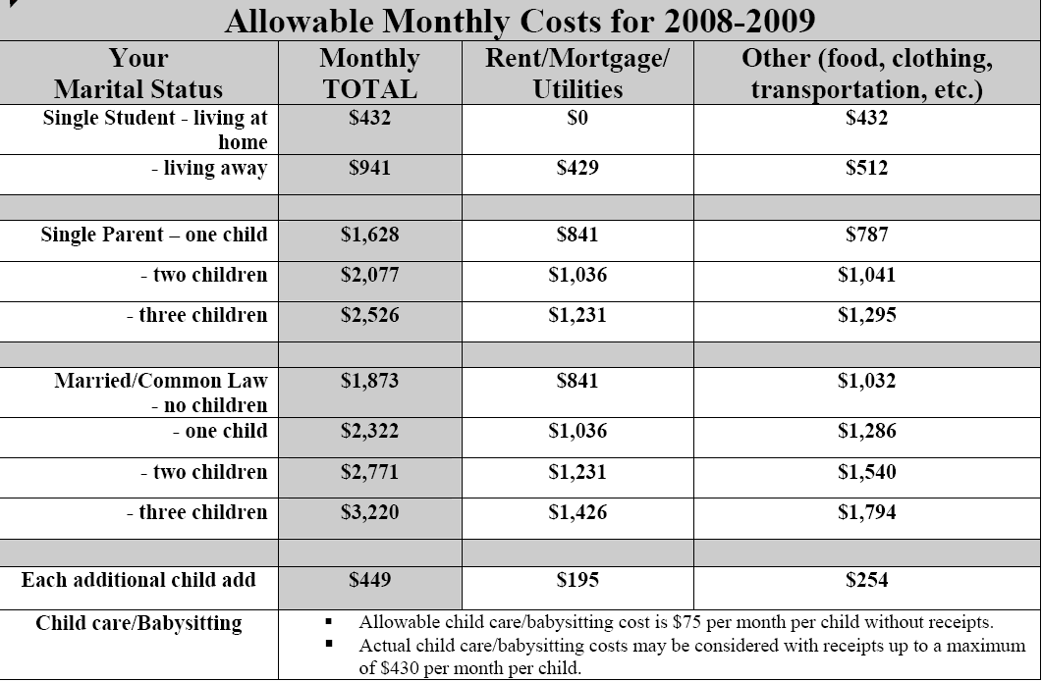

REFERENCE REQUEST FORM - BURSARY
Required ONLY for referees from Alberta
Attention referee:
- Please keep this Reference Request form as confirmation of the request for a reference.

Please return the letter to the student in a sealed envelope with your signature across the seal.
I, |  |  |  |  | request that |  |  |  | write a reference
 |  | (name of student) |  |  |  | (name of referee)
or respond to a reference check on my behalf.
I understand that in order to write the reference or provide a verbal reference,
 |  |  |  |  | will need to comment on grades and personal characteristics
(name of referee)
relating to my academic performance and/or employment history.
I agree to the disclosure of my personal information:
 |  | Only to the following institutions or potential employers:
 |  |  | 1. |  |  |  | Please note that this form does not authorize a university or any other institution to provide the referee with information about the student record beyond that which is part of the public record. The applicant must provide the referee with a program summary or transcript if comments regarding overall performance, e.g., ranking or grade point average, are to be included in the reference.
 |  |  | 2.
 |  |  | 3.
 |  |  | 4.
 |  |  | 5.
 |  |  | 6.
 | To all requests for references
This consent will be effective for one year past the signature date.
Student Signature |  |  |  |  |  |  |  | Date
If this form is not signed and attached to the Reference form, a referee from Alberta will not provide a reference.
This information is collected under the authority of and in response to the Freedom of Information and Protection of Privacy (FOIP) Act. It is required to respond to the request. If you have any questions about the collection or use of this information, contact the Faculty of Graduate Studies FOIP Advisor, telephone (403) 220-4932.

SCHOLARSHIP REFERENCE FORM
This information is collected under the Freedom of Information and Protection of Privacy Act (FOIP). It is required to evaluate the applicant for a graduate award application purposes. The applicant can have access to all or portions of this reference if a formal access request is made. Questions about the collection and use of this information may be directed to the FOIP Advisor, Faculty of Graduate Studies, University of Calgary, Calgary, Alberta T2N 1N4. Telephone (403) 220-4932.
INSTRUCTIONS FOR APPLICANT
Complete this section and the mailing address below and forward this form to an individual who is well acquainted with your education and abilities. References from your relatives, friends or colleagues are not acceptable.
Name of Award: | (Indicate name of award you are applying for)
Family Name  Previous Family Name: | First Legal Given Name | Middle Legal Given Name(s)
Graduate Program | Degree

INSTRUCTIONS FOR REFEREE

Complete the Scholarship Reference Form and provide a separate letter with your evaluation of the applicant’s merits and shortcomings in these general areas:
- Academic ability and record – applicant’s general knowledge of the field, or, where appropriate, background preparation in both course work and previous research
- Research ability and record – originality and ability to synthesize ideas, analytical thinking, skill at research design, quality of any research, familiarity with techniques or methodologies of the field, ability to discuss critically, ability to express ideas clearly
- Teaching and language ability – applicant’s teaching ability as revealed in any instructional role such as the presentation of reports or seminars, and speaking ability. If English is not the applicant’s first language, some comment on his/her proficiency in English would be appreciated.
- Professional experience and skill (if relevant) – pertinent strengths and weaknesses

Please ensure that each page of the reference is dated, signed and has the applicant’s name noted on it.

Please send the scholarship reference form and the letter back to the student in a sealed envelope with your signature across the seal to the address below.

Student Mailing Address
Send completed reference to:

Scholarship Reference Form to be completed by Referee
Student Name: |  |  |  |  |  |  |  | Program:
I have known the applicant in my capacity as teacher supervisor advisor employer
other: please explain

I have known the applicant for years and months.
The applicant ranks in the top % of approximately students at the undergraduate Master’s doctoral level I have encountered in years.
I have read the applicant’s research proposal. |  |  |  |  |  | I have not read the applicant’s research proposal.
 | Outstanding |  |  |  |  |  | Above Average |  |  |  | Average |  | Below Average | Unable to Judge
 | upper 2% | upper 5% |  | upper 10% |  |  | upper 20% |  |  | upper 30% | upper 50% |  | lower 50% | Unable to Judge
Background preparation
Originality
Potential research ability
Industry/perseverance
Judgement/critical sense
Intellectual ability
Teaching ability
Oral communication
Written communication
Overall evaluation
Please rank the applicant as a scholarship candidate:
Highly Recommended |  |  | Recommended |  |  |  |  |  | Not Recommended |  |  | Unable to judge
Name of Referee (Please Print/Type) |  |  |  |  | E-mail address
Position and Department |  |  |  |  | Institution
Address |  |  |  |  | Telephone ( )  Fax Number ( )
Signature of Referee |  |  |  |  | Date

Letter to be completed by the Referee

REFERENCE REQUEST FORM - BURSARY
Required ONLY for referees from Alberta
Attention referee:
- Please keep this Reference Request form as confirmation of the request for a reference.

Please return the letter to the student in a sealed envelope with your signature across the seal.
I, |  |  |  |  | request that |  |  |  | write a reference
 |  | (name of student) |  |  |  | (name of referee)
or respond to a reference check on my behalf.
I understand that in order to write the reference or provide a verbal reference,
 |  |  |  |  | will need to comment on grades and personal characteristics
(name of referee)
relating to my academic performance and/or employment history.
I agree to the disclosure of my personal information:
 |  | Only to the following institutions or potential employers:
 |  |  | 1. |  |  |  | Please note that this form does not authorize a university or any other institution to provide the referee with information about the student record beyond that which is part of the public record. The applicant must provide the referee with a program summary or transcript if comments regarding overall performance, e.g., ranking or grade point average, are to be included in the reference.
 |  |  | 2.
 |  |  | 3.
 |  |  | 4.
 |  |  | 5.
 |  |  | 6.
 | To all requests for references
This consent will be effective for one year past the signature date.
Student Signature |  |  |  |  |  |  |  | Date
If this form is not signed and attached to the Reference form, a referee from Alberta will not provide a reference.
This information is collected under the authority of and in response to the Freedom of Information and Protection of Privacy (FOIP) Act. It is required to respond to the request. If you have any questions about the collection or use of this information, contact the Faculty of Graduate Studies FOIP Advisor, telephone (403) 220-4932.

SCHOLARSHIP REFERENCE FORM
This information is collected under the Freedom of Information and Protection of Privacy Act (FOIP). It is required to evaluate the applicant for a graduate award application purposes. The applicant can have access to all or portions of this reference if a formal access request is made. Questions about the collection and use of this information may be directed to the FOIP Advisor, Faculty of Graduate Studies, University of Calgary, Calgary, Alberta T2N 1N4. Telephone (403) 220-4932.
INSTRUCTIONS FOR APPLICANT
Complete this section and the mailing address below and forward this form to an individual who is well acquainted with your education and abilities. References from your relatives, friends or colleagues are not acceptable.
Name of Award: | (Indicate name of award you are applying for)
Family Name  Previous Family Name: | First Legal Given Name | Middle Legal Given Name(s)
Graduate Program | Degree

INSTRUCTIONS FOR REFEREE

Complete the Scholarship Reference Form and provide a separate letter with your evaluation of the applicant’s merits and shortcomings in these general areas:
- Academic ability and record – applicant’s general knowledge of the field, or, where appropriate, background preparation in both course work and previous research
- Research ability and record – originality and ability to synthesize ideas, analytical thinking, skill at research design, quality of any research, familiarity with techniques or methodologies of the field, ability to discuss critically, ability to express ideas clearly
- Teaching and language ability – applicant’s teaching ability as revealed in any instructional role such as the presentation of reports or seminars, and speaking ability. If English is not the applicant’s first language, some comment on his/her proficiency in English would be appreciated.
- Professional experience and skill (if relevant) – pertinent strengths and weaknesses

Please ensure that each page of the reference is dated, signed and has the applicant’s name noted on it.

Please send the scholarship reference form and the letter back to the student in a sealed envelope with your signature across the seal to the address below.

Student Mailing Address
Send completed reference to:

Scholarship Reference Form to be completed by Referee
Student Name: |  |  |  |  |  |  |  | Program:
I have known the applicant in my capacity as teacher supervisor advisor employer
other: please explain

I have known the applicant for years and months.
The applicant ranks in the top % of approximately students at the undergraduate Master’s doctoral level I have encountered in years.
I have read the applicant’s research proposal. |  |  |  |  |  | I have not read the applicant’s research proposal.
 | Outstanding |  |  |  |  |  | Above Average |  |  |  | Average |  | Below Average | Unable to Judge
 | upper 2% | upper 5% |  | upper 10% |  |  | upper 20% |  |  | upper 30% | upper 50% |  | lower 50% | Unable to Judge
Background preparation
Originality
Potential research ability
Industry/perseverance
Judgement/critical sense
Intellectual ability
Teaching ability
Oral communication
Written communication
Overall evaluation
Please rank the applicant as a scholarship candidate:
Highly Recommended |  |  | Recommended |  |  |  |  |  | Not Recommended |  |  | Unable to judge
Name of Referee (Please Print/Type) |  |  |  |  | E-mail address
Position and Department |  |  |  |  | Institution
Address |  |  |  |  | Telephone ( )  Fax Number ( )
Signature of Referee |  |  |  |  | Date

Letter to be completed by the Referee

