**Names**

**1. Maxwell Wachira Mwangi E022-01-0746/2017**

**2. Daniel Chege Nduati E022-01-0695/2017**

**Unit: Electonic Product design**

**Unit Code: EMT4202**

**Task:Led Chaser using 4017 decade counter and 555 Timer**

**555 Timer**

The 555 timer is capable of being used in astable and monostable circuits. In an astable circuit, the output voltage alternates between VCC and 0 volts on a continual basis.By selecting values for R1, R2 and C we can determine the period/frequency and the duty cycle.The period is the length of time it takes for the on/off cyle to repeat itself, whilst the duty cycle is the percentage of time the output is on. ie. T1/T.In this type of circuit, the duty cycle can never be 50% or lower.

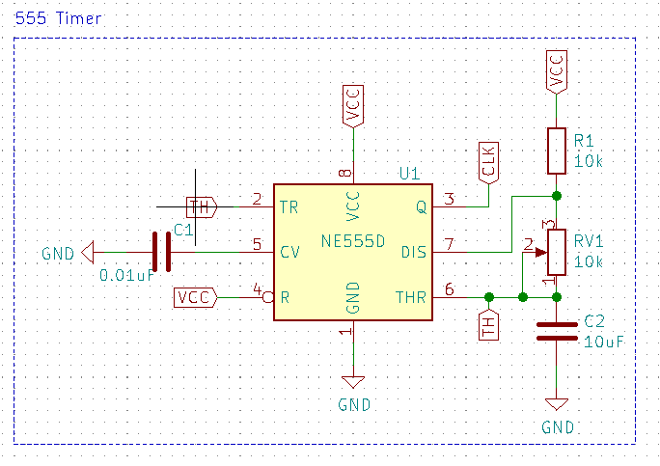

We used the above circuit to produce a square wave in which the high time (T1) and low time (T2) can be calculated. This method can be used to generate clock pulses for Microcontrollers/Digital IC’s or blink an LED or any other applications where specific time intervals are needed. The output wave obtained from pin 3 is shown with markings below

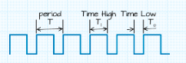

The following formulas are use to calculate the values of the components used:

|  |  |  |
| --- | --- | --- |
| Parameter | Formulae | Unit |
| Time High (T1) | 0.693x(R1+R2)xC1 | Seconds |
| Time Low (T2) | 0.693 × R2 × C1 | Seconds |
| Time Period (T) | 0.693 × (R1+2×R2) × C1 | Seconds |
| Frequency | 1.44 / (R1+2×R2) × C1 | Hertz (Hz) |
| Duty Cycle | (T1/T)×100 | Percentage (%) |

In our circuit diagram the value of Resistors R1 is 10K and R2 is a 10k variable resistor respectively, the value of capacitor C1 is 10uf. Using the above formulas we obtained the following values:

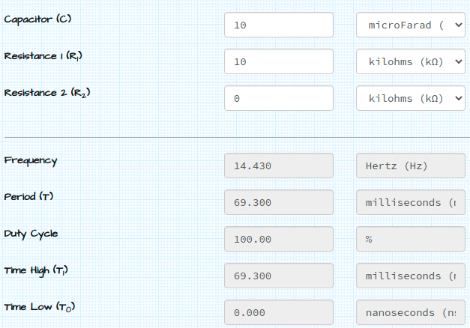

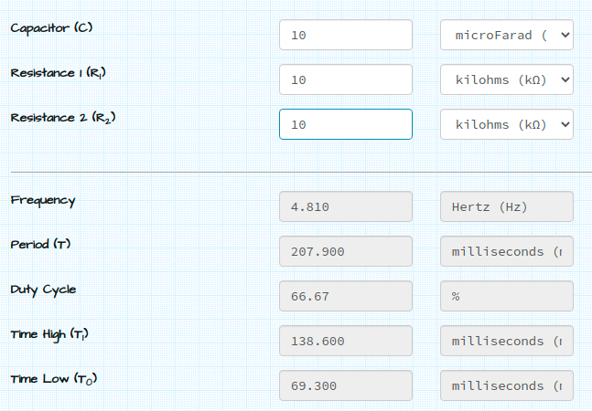

**Conclusion**

Increasing C will increase the cycle time (and hence, reduce the frequency).

Increasing R1 will increase Time High (T1), but will leave Time Low (T0) unaffected.

Increasing R2 will increase Time High (T1), increase Time Low (T0) and decrease the duty cycle

**4017 Decade Counter**

The 4017 is a CMOS decade counter cum decoder circuit that can work out of the box for most of our low range counting applications. It can count from zero to ten and its outputs are decoded. This saves a lot of board space and time required to build our circuits when our application demands using a counter followed by a decoder IC.The clk output from the 555 timer is connected to clk input of the 4017 decade counter.Whenever a clock pulse is received at the clock input of the IC 4017 counter, the counter increments the count and activates the corresponding output PIN. When the count is zero, PIN-3 is HIGH, which means LED-D2 will be ON and all the other LEDs are OFF. After the next clock pulse, PIN-2 of IC 4017 is HIGH, which means that LED-D3 will light and all the other LEDs can be turned OFF. This repeats and the LEDs turn ON and OFF successively on each clock pulse thereby producing a led chasing effect. We chose 10 leds as the dacade counter counts to 10.

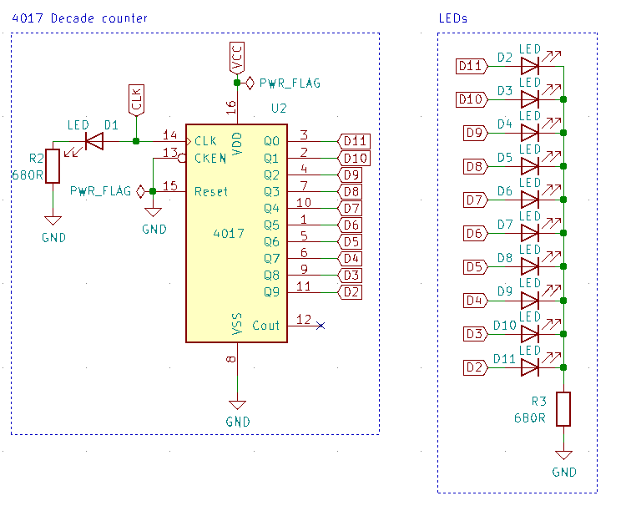

**Schematic**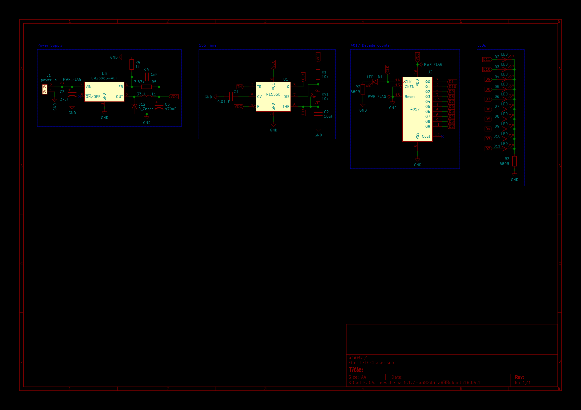

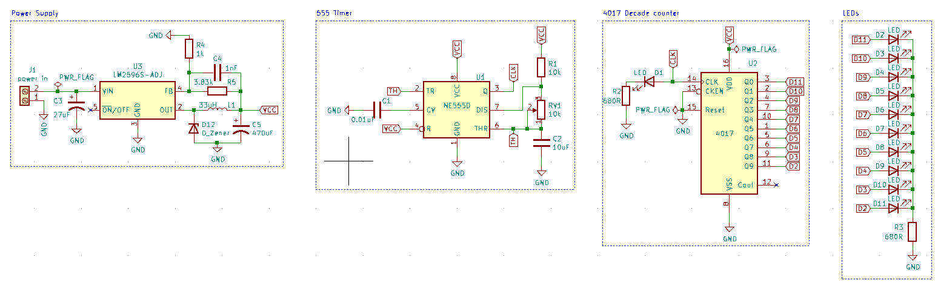

**PCB** 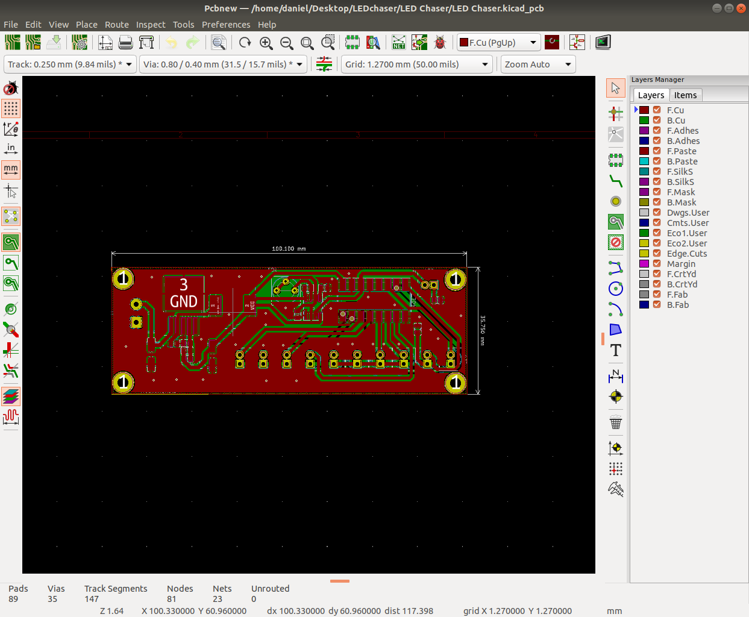

**ERC and DRC check results**

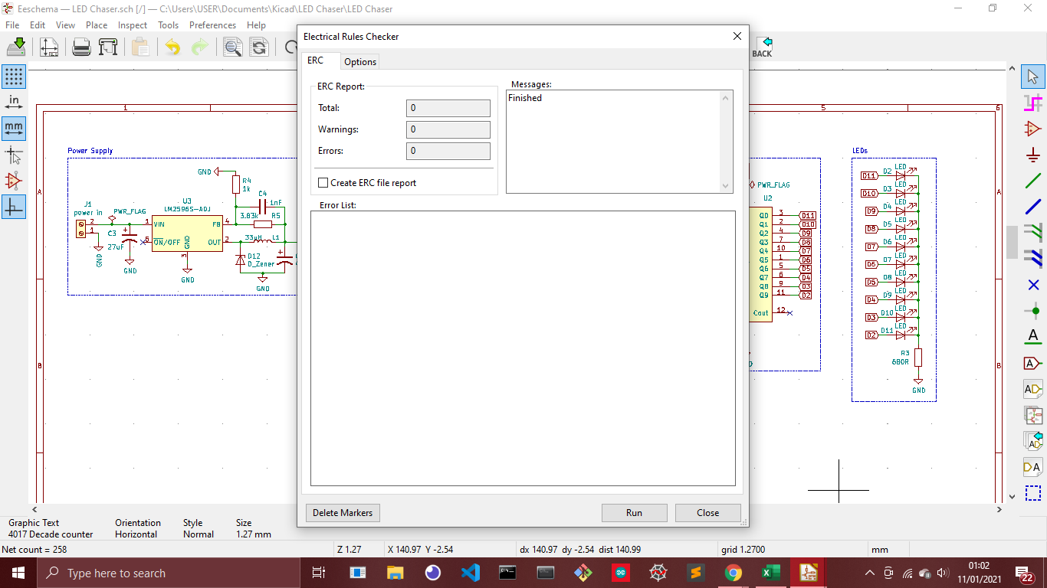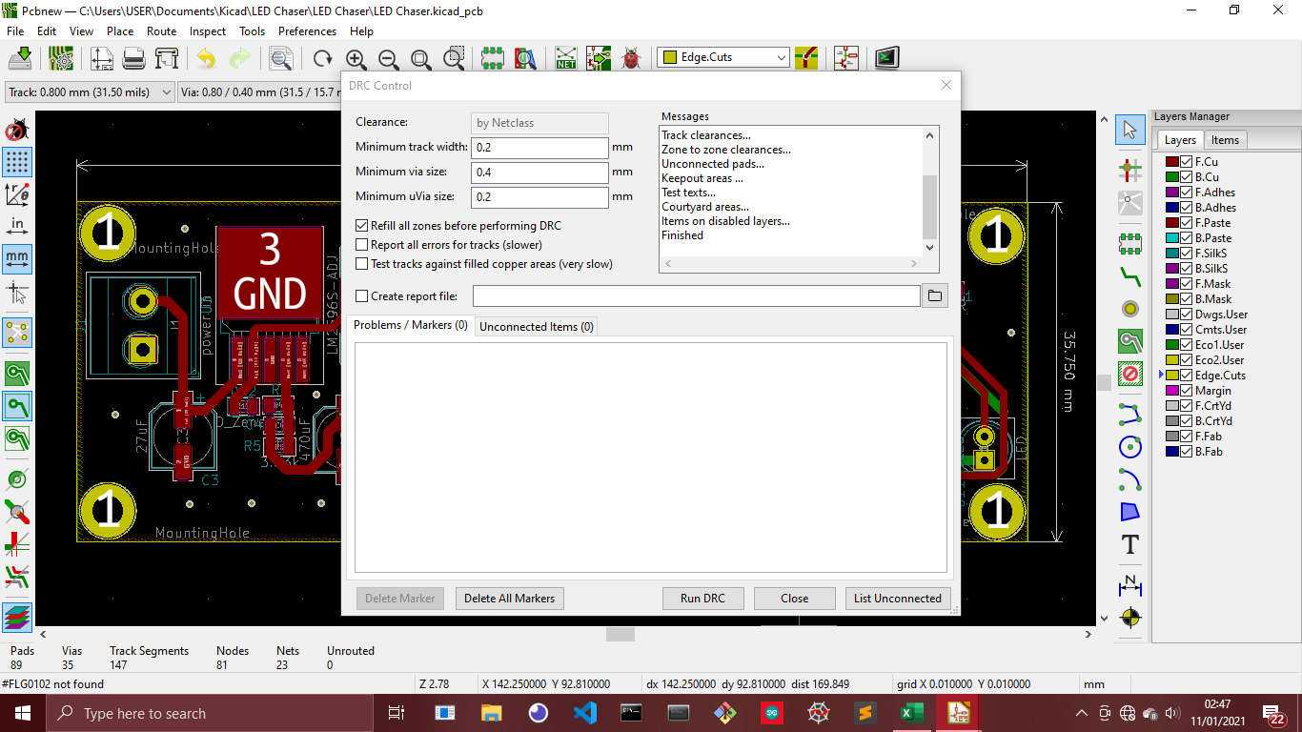

**3d view**