|  |
| --- |
| Multi-Area OSPF |
| Optimizing Large Networks with Special OSPF Areas |
|  |
|  |

Multi-Area OSPF

Optimizing Large Networks with Special OSPF Areas

# Purpose

This document outlines the use of Special OSPF Areas to optimize convergence time and Queuing delay in large networks.

# Background Information

Open Shortest Path First (OSPF) is an open standard link state routing protocol that uses cost as a metric to determine the shortest path to the destination network. OSPF can divide logical groups of routers into “Areas”. Routers must only maintain the topology information of the other routers in their common area. The use of many areas in a network topology, or Multi-Area OSPF, is a design technique that aids in the maintainability and scalability of large networks. Routing between different areas are done through an Area Border Router (ABR) that connects a given area and the backbone area. The backbone area is a special area type that must have an area number of zero and connects all areas in the topology. The backbone area is where all inter-area traffic must travel through.

## Link State Advertisements

Link State Advertisements (LSAs) is the mechanism routers use to communicate link state information. A collection of LSAs form the LSDB, which then forms the shortest path tree, which forms the routing table. There are 8 LSA Types, each describe a different part of the routing domain.

|  |  |  |  |
| --- | --- | --- | --- |
| LSA Type | LSA Name | Link-State ID | Description |
| 1 | Router | Router ID | Every router participating in OSPF will flood its area with a single Router LSA to describes the state and cost of all the router’s OSPF participating links. |
| 2 | Network | DR’s IP address | The Designated Router (DR) will describe all attached routers, including itself. |
| 3 | Network Summary | Network Number | Area Border Router (ABR) describes inter-area destinations. |
| 4 | ASBR Summary | OSBR Router ID | Area Border Router (ABR) describes inter-area destinations to a AS boundary router (ASBR). |
| 5 | AS-external | Network number | Describes destinations external to the OSPF autonomous system. |

## Special Area Types

Special area types were designed to help large organizations shrink the routing tables inside their autonomous system. They all serve the same purpose of encapsulating a logical group of routers, and abstracting inter-area destinations to the ABRs.

### Standard Areas

A standard area is any area other than area 0 unless otherwise specified. The ABR summarizes all routes and forwards those into the area.

### Stub Areas

Stub areas are like standard areas in that they summarize inter-area destinations at the ABR and forward them on. Where stub areas differ from standard areas, is stub areas filter all external routes (routes from other autonomous systems) and redistribute a default route to the ABR instead.

### Totally Stubby Areas

Totally stubby areas filter out all inter-area and external routes at the ABR, and instead redistribute a default route to the ABR.

### Not-so-Stubby Area (NSSA)

Not-so-Stubby Areas (NSSAs) are used when there needs to be an external route (another autonomous system) connected to a stubby area. The ASBR uses a type 7 LSA to forward the external route throughout the NSSA, where there ABR converts it to a type 5 LSA to flood the rest of the autonomous system.

# Topology

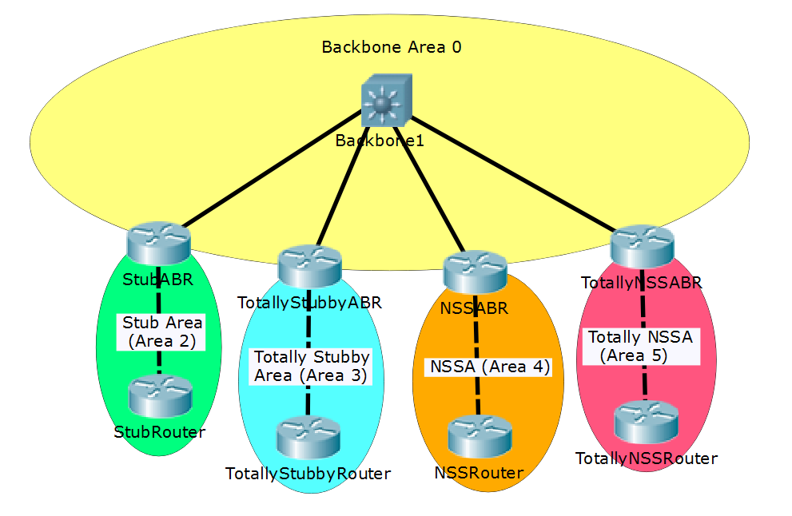

|  |  |  |  |  |  |
| --- | --- | --- | --- | --- | --- |
| Device | Interface | IPv4 Address | IPv6 Address | Connects To | Area |
| Backbone1 | Fa1/0/2 | 10.2.2.1/24 | 2001:2::1/64 | StubABR | 0 |
|  | Fa1/0/3 | 10.3.3.1/24 | 2001:3::1/64 | TotallyStubbyABR | 0 |
|  | Fa1/0/4 | 10.4.4.1/24 | 2001:4::1/64 | NSSABR | 0 |
|  | Fa1/0/5 | 10.5.5.1/24 | 2001:5::1/64 | TotallyNSSABR | 0 |
| StubABR | G0/0 | 10.2.2.2/24 | 2001:2::2/64 | Backbone1 | 0 |
|  | G0/1 | 172.16.2.1/24 | 2001:2:2::1/64 | StubRouter | 2 |
| StubRouter | G0/0 | 172.16.2.2/24 | 2001:2:2::2/64 | StubABR | 2 |
|  | Lo2 | 192.168.2.1/32 | 2001:2:2:2::1/128 | N/A | 2 |
| TotallyStubbyABR | G0/0 | 10.3.3.2/24 | 2001:3::2/64 | Backbone1 | 0 |
|  | G0/1 | 172.16.3.1/24 | 2001:3:3::1/64 | TotallyStubbyRouter | 3 |
| TotallyStubbyRouter | G0/0 | 172.16.3.2/24 | 2001:3:3::2/64 | TotallyStubbyABR | 3 |
|  | Lo3 | 192.168.3.1/32 | 2001:3:3:3::1/128 | N/A | 3 |
| NSSABR | G0/0 | 10.4.4.2/24 | 2001:4::2/64 | Backbone1 | 0 |
|  | G0/1 | 172.16.4.1/24 | 2001:4:4::1/64 | NSSRouter | 4 |
| NSSRouter | G0/0 | 172.16.4.2/24 | 2001:4:4::2/64 | NSSABR | 4 |
|  | Lo4 | 192.168.4.1/32 | 2001:4:4:4::1/128 | N/A | 4 |
| TotallyNSSABR | G0/0 | 10.5.5.2/24 | 2001:5::2/64 | Backbone1 | 0 |
|  | G0/1 | 172.16.5.1/24 | 2001:5:5::1/64 | TotallyNSSRouter | 5 |
| TotallyNSSRouter | G0/0 | 172.16.5.2/24 | 2001:5:5::2/64 | TotallyNSSABR | 5 |
|  | Lo5 | 192.168.5.1/32 | 2001:5:5:5::1/128 | N/A | 5 |

# Helpful Resources

I choose to include this section because although content from these sources were never directly used in this report, they are exemplary resources relevant to this topic that I came across during my initial research.

**Jeremy Cioara, CBP Nuggets. *MicroNugget: Key OSPF Areas and LSA Types***

Jeremy Cioara did a fantastic job explaining OSPF special areas and was able tie it right back into the LSA types relevant to each area type – the opposite direction other content has taken. Although he did not explain Totally NSSAs, this is where I would start when exploring special area types.

**Moy, J., "OSPF Version 2", RFC 1247, DOI 10.17487/RFC1247, July 1991,**

**<https://www.rfc-editor.org/info/rfc1247>.**

This is the blueprint for OSPFv2, a primary source. It is a very good place to reference if you have any questions about the OSPF protocol itself.