|  |
| --- |
| Multi-Area OSPF |
| Building scalable networks with segmented topologies |
|  |
|  |

Table of Contents

Purpose 3

Background Information 3

Lab Summary 3

Lab Commands 3

clear ip[v6] ospf process 3

Syntax Description 3

Usage Guidelines 3

ip[v6] ospf area 4

Syntax Description 4

Usage Guidelines 4

[ipv6] router ospf 4

Syntax Description 4

Usage Guideline 4

router-id 4

Syntax Description 4

Usage Guidelines 4

show ip[v6] route 5

Syntax Description 5

Usage Guidelines 5

show ip[v6] ospf neighbor 5

Syntax Description 5

Usage Guidelines 5

Lab Topology 6

Configurations 7

Problems 35

“Half” of an Adjacency 35

Problem Description 35

Steps to Reproduce 35

Expected Behavior 35

Actual Behavior 35

Troubleshooting Steps 35

Solution 35

`router ospfv3` command is not valid in Packet Tracer 35

Problem Description 35

Steps to Reproduce 35

Expected Behavior 36

Actual Behavior 36

Troubleshooting Steps 36

Solution 36

`show ip ospf interface` command crashes Packet Tracer 36

Problem Description 36

Steps so Reproduce 36

Troubleshooting Steps 36

Expected Behavior 36

Actual Behavior 36

Solution 36

Conclusion 37

Helpful Resources 37

Multi-Area OSPF

Building scalable networks with segmented topologies

# Purpose

This document demonstrates the segmentation of topologies into modular and scalable systems using the networking design pattern Multi-Area OSPF.

# Background Information

Open Shortest Path First (OSPF) is an open standard link state routing protocol that uses cost as a metric to determine the shortest path to the destination network. OSPF can divide logical groups of routers into “Areas”. Routers must only maintain the topology information of the other routers in their common area. The use of many areas in a network topology is referred to as Multi-Area OSPF. Multi-Area OSPF is a design technique that aids in the maintainability and scalability of large networks. Routing between different areas are done through an Area Border Router (ABR) that connects a given area and the backbone area. The backbone area is a special area type that must have an area number of zero and connects all areas in the topology. The backbone area is where all inter-area traffic must travel through.

# Lab Summary

Create a network topology with four standard areas with at least two interfaces participating in each area, and one backbone area. Use at least one multilayer switch, but no more than one less than the total number of OSPF participating devices in the topology. The topology must be dual stack IPv4 and IPv6, with both destinations participating in the OSPF process. All destinations must be reachable by every OSPF participating device in the topology.

# Lab Commands

## clear ip[v6] ospf process

Restarts the OSPF process.

**clear ip**[v6] **ospf process**

### Syntax Description

|  |  |
| --- | --- |
| v6 | Clears the IPv6 OSPF process |

### Usage Guidelines

This resets the OSPF process. This command is ran in EXEC mode.

## ip[v6] ospf area

To enable the OSPF process on an interface, use one of the following variants in interface configuration mode. To remove the OSPF process on the interface, prefix the same command with the **no** keyword

**ip**[v6] **ospf** process-id **area** area-id

### Syntax Description

|  |  |
| --- | --- |
| v6 | (Optional) Advertise the IPv6 address of this interface on the OSPF Process. |
| *process-id* | OSPF process the interface should advertise to |
| *area-id* | OSPF area the interface should advertise to |

### Usage Guidelines

This command was created to simplify advertising OSPF networks and can be used as a replacement or supplement to the **network** command. To successfully execute this command, the interface must be enabled and active. This command must be executed in **interface-config** mode.

## [ipv6] router ospf

Starts the IPv4 or IPv6 OSPF process on the device.

[ipv6] **router** **ospf** *process-id*

### Syntax Description

|  |  |
| --- | --- |
| ipv6 | (Optional) Start the OSPF process for IPv6 interfaces |
| *process-id* | The unique process ID the OSPF session is assigned to |

### Usage Guideline

This command starts the OSPF process on the device. Without executing this command, OSPF will not function. The process ID must be greater than 0 and less than 65536. Inside of this configuration mode you can declare OSPF settings including but not limited to router id, networks, and bandwidth.

## router-id

Sets a router id for an OSPF process.

**router-id** *router-id*

### Syntax Description

|  |  |
| --- | --- |
| *router-id* | Router ID for the OSPF process. |

### Usage Guidelines

An OSPF Router ID (RID) is a 32-bit unique identifier for the router in the autonomous system. If an RID is not set, the lowest loopback address becomes the RID. If there is no loopback, the lowest interface IP address is selected. The RID cannot be 0.0.0.0.

## show ip[v6] route

This command outputs the routing table for the router.

**show ip**[v6] **route** [ospf]

### Syntax Description

|  |  |
| --- | --- |
| v6 | Displays the IPV6 routing table |
| ospf | Displays OSPF routing information |

### Usage Guidelines

Once an OSPF network has converged, this command can be used to display all accessible destinations.

## show ip[v6] ospf neighbor

Shows the adjacent OSPF devices.

**show ip**[v6] **ospf neighbors**

### Syntax Description

|  |  |
| --- | --- |
| v6 | Displays the ipv6 OSPF adjacencies. |

### Usage Guidelines

This command displays all OSPF enabled routers that have created an adjacency with the router that executed this command.

# Lab Topology

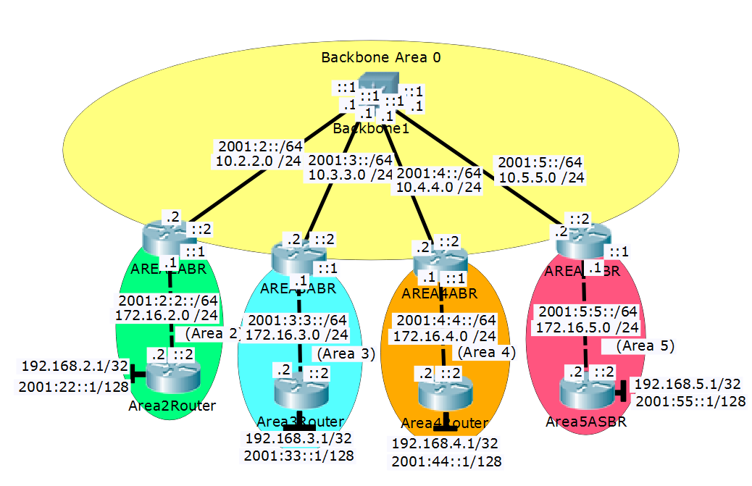

|  |  |  |  |  |  |
| --- | --- | --- | --- | --- | --- |
| Device | Interface | IPv4 Address | IPv6 Address | Connects To | Area |
| Backbone1 | Fa1/0/2 | 10.2.2.1/24 | 2001:2::1/64 | Area2ABR | 0 |
|  | Fa1/0/3 | 10.3.3.1/24 | 2001:3::1/64 | Area3ABR | 0 |
|  | Fa1/0/4 | 10.4.4.1/24 | 2001:4::1/64 | Area4ABR | 0 |
|  | Fa1/0/5 | 10.5.5.1/24 | 2001:5::1/64 | Area5ABR | 0 |
| Area2ABR | G0/0 | 10.2.2.2/24 | 2001:2::2/64 | Backbone1 | 0 |
|  | G0/1 | 172.16.2.1/24 | 2001:2:2::1/64 | Area2Router | 2 |
| Area2Router | G0/0 | 172.16.2.2/24 | 2001:2:2::2/64 | Area2ABR | 2 |
|  | Lo0 | 192.168.2.1/32 | 2001:2:2:2::1/128 | N/A | 2 |
| Area3ABR | G0/0 | 10.3.3.2/24 | 2001:3::2/64 | Backbone1 | 0 |
|  | G0/1 | 172.16.3.1/24 | 2001:3:3::1/64 | Area3Router | 3 |
| Area3Router | G0/0 | 172.16.3.2/24 | 2001:3:3::2/64 | Area3ABR | 3 |
|  | Lo0 | 192.168.3.1/32 | 2001:33::1/128 | N/A | 3 |
| Area4ABR | G0/1 | 10.4.4.2/24 | 2001:4::2/64 | Backbone1 | 0 |
|  | G0/0 | 172.16.4.1/24 | 2001:4:4::1/64 | Area4Router | 4 |
| Area4Router | G0/1 | 172.16.4.2/24 | 2001:4:4::2/64 | Area4ABR | 4 |
|  | Lo0 | 192.168.4.1/32 | 2001:44::1/128 | N/A | 4 |
| Area5ABR | G0/1 | 10.5.5.2/24 | 2001:5::2/64 | Backbone1 | 0 |
|  | Fa0/0 | 172.16.5.1/24 | 2001:5:5::1/64 | Area5Router | 5 |
| Area5Router | Fa0/1 | 172.16.5.2/24 | 2001:5:5::2/64 | Area5ABR | 5 |
|  | Lo0 | 192.168.5.1/32 | 2001:55::1/64 | N/A | 5 |

# Configurations

























































# Problems

This section describes the issues faced during the execution of this lab.

## “Half” of an Adjacency

### Problem Description

For IPv6 adjacencies, one router claimed to be adjacent, but the other router did not show the adjacency in its neighbor database. All IPv4 destinations were unaffected.

For sake of example, there is R1 and R2, both are configured properly using the ipv6 router ospf command. R1 would show an adjacency with R2, but R2 would not show an adjacency with R1.

This issue reproduced on every set of routers in the lab rack.

### Steps to Reproduce

Unfortunately, there are no clear steps to reproduce this issue on a different set of routers.

### Expected Behavior

Both routers were expected to have mutual adjacency (both having an adjacency with each other or neither).

### Actual Behavior

One router had an adjacency with the other router. The other router did not have an adjacency with the first.

### Troubleshooting Steps

After verifying the configuration was correct, the clear ip ospf process command was executed, to no avail, the issue persisted.

After switching lab racks, the issue was not able to be reproduced, even with the same configurations.

### Solution

This issue seems to be a layer one issue or a problem with the Cisco IOS. The issue could not be reproduced on a separate rack. Hopefully a new IOS will solve the issue but it has not been tested.

## `router ospfv3` command is not valid in Packet Tracer

### Problem Description

Packet Tracer 7.0.0 does not currently support the router ospfv3 command.

### Steps to Reproduce

1. Open packet tracer 7.0.0
2. Place a device that supports OSPF on the topology
3. Enable IPv4 and IPv6 routing
4. Attempt to start an OSPFv3 process with the router ospfv3 command

### Expected Behavior

The router ospfv3 command is expected to begin the OSPFv3 process.

### Actual Behavior

The % Invalid input detected at '^' marker error was thrown to the console.

### Troubleshooting Steps

After updating packet tracer and creating a new project, it did not solve the issue.

### Solution

All configurations were made by using both the router ospf and ipv6 router ospf commands.

## `show ip ospf interface` command crashes Packet Tracer

### Problem Description

On packet tracer 7.0.0, the show ip ospf interface command would crash the simulation.

### Steps so Reproduce

1. Open packet Tracer 7.0.0.0306.
2. Place 3 routers down and connect them via crossover cables.
3. Run necessary commands to set the first router in area 0, the second as the ABR between area 0 and 1, and the third in area 1.
4. Wait for a fraudulent dead timer error, use the “Fast Forward Time” feature to increase the likelihood of this.
5. On the ABR, run the command show ip ospf interface to the interface connected to area 1.

### Troubleshooting Steps

After restarting the simulation, the issue could still be reproduced. The steps taken to resolve this issue included opening a new packet tracer project, restarting the computer, and reinstalling packet tracer. All steps were unfruitful.

### Expected Behavior

This command should have outputted interface information about OSPF participating interfaces.

### Actual Behavior

Packet Tracer crashes with no informational error.

### Solution

Unfortunately, the issue could not be resolved. After searching the packet tracer bug database, a similar bug report was found. This report was said to be resolved in a previous version of packet tracer. Unable to reopen the bug due to a lack of permissions, a new one was filed (issue #21607). The physical lab was used instead.

# Conclusion

This lab demonstrated the use of dual stack Multi-Area OSPF with a layer 3 switch. It took a close look at how OSPF can be used as a scalable network technology. OSPF areas can be used to segment logical networks and encapsulate them in a modular system. LSAs provide an important role in OSPF routers communicating routing updates between adjacencies.

# Helpful Resources

If you wish to continue your research about this topic, the following topics have been found to be exemplary.

**Moy, J., "OSPF Version 2", RFC 1247, DOI 10.17487/RFC1247, July 1991,**

**<https://www.rfc-editor.org/info/rfc1247>.**

This is the blueprint for OSPFv2, a primary source. It is a very good place to reference if you have any questions about the OSPF protocol itself.