|  |
| --- |
| Special OSPF Area Types |
| Optimizing Large Networks with Special OSPF Areas |
|  |
|  |

Special OSPF Area Types

Optimizing Large Networks with Special OSPF Areas

# Purpose

This document outlines the use of Special OSPF Areas to optimize convergence time and queuing delay in large networks.

# Background Information

OSPF was designed as an enterprise routing solution. Organizations have used this protocol to route between floors, and some have used this solution to route between sites. As your organization grows, so does the routing table. It becomes a battle to maintain similar convergence time and queuing delay.

## Route Redistribution

Route redistribution a process in which two autonomous systems share routing information. This is possible even when the two autonomous systems are using different routing protocols. Only redistribution into OSPF is relevant for this lab.

## Link State Advertisements

Link State Advertisements (LSAs) is the mechanism routers use to communicate link state information. A collection of LSAs form the LSDB, which then forms the shortest path tree, which forms the routing table. There are 8 LSA Types, each describe a different part of the routing domain.

|  |  |  |  |
| --- | --- | --- | --- |
| LSA Type | LSA Name | Link-State ID | Description |
| 1 | Router | Router ID | Every router participating in OSPF will flood its area with a single Router LSA to describe the state and cost of all the router’s OSPF participating links. |
| 2 | Network | DR’s IP address | The Designated Router (DR) will describe all attached routers, including itself. |
| 3 | Network Summary | Network Number | Area Border Router (ABR) describes inter-area destinations. |
| 4 | ASBR Summary | OSBR Router ID | Area Border Router (ABR) describes inter-area destinations to an AS boundary router (ASBR). |
| 5 | AS-external | Network number | Describes destinations external to the OSPF autonomous system. |
| 6 | Multicast OSPF |  | Was designed for Multicast OSPF (MOSPF). MOSPF was never supported by Cisco and has been deprecated in RFC 5340. |
| 7 | NSSA External Link |  | ASBR in a NSSA/Totally NSSA encapsulates the external destination information in this type. The ABR replaces it with a type 5 LSA that is propagated to the rest of the OSPF autonomous system. |

## Special Area Types

Special area types were designed to help large organizations shrink the routing tables inside their autonomous system. They all serve the same purpose of encapsulating a logical group of routers, and abstracting inter-area destinations to the ABRs.

***\*The topology below will be used for the following examples***

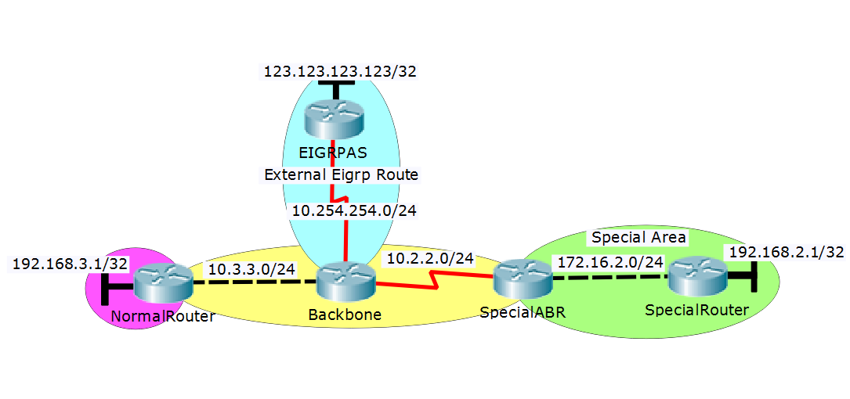

### Standard Areas

A standard area is any area other than area 0 unless otherwise specified. The ABR summarizes all routes and forwards those into the area. See Figure 2, even though GigabitEthernet0/0 is only one way out of the area, there is a route for every destination. These costs queueing time for every packet that leaves this router.



### Stub Areas

Stub areas are like standard areas in that they summarize inter-area destinations at the ABR and forward them on. Where stub areas differ from standard areas, is stub areas filter all external routes (Type 5 LSAs) and redistribute a default route to the ABR instead.



### Totally Stubby Areas

Totally stubby areas filter out all inter-area and external routes at the ABR, and instead redistribute a default route to the ABR. Totally stubby areas filter out all Type 3, 4, and 5 LSAs, leaving you with an even smaller routing table.

***\*Use the topology below for the following examples***

A close up of text on a white background

Description generated with high confidence

### Not-so-Stubby Area (NSSA)

Not-so-Stubby Areas (NSSAs) are used when there needs to be an external route (another autonomous system) connected to a stub area. The ASBR uses a type 7 LSA to forward the external route throughout the NSSA, where there ABR converts it to a type 5 LSA to flood the rest of the autonomous system. Like a stub area, an NSSA filters all Type 5 LSAs, and replaces it with a gateway of last resort.



### Totally Not-so-Stubby Area (Totally NSSA)

The last special area is a Totally Not-so-Stubby area, and this is used when you need a Totally stubby area to forward the destination for an external route. They act just as an NSSA would, but in addition to filtering out type 5 LSAs, it also filters out both Type 3 and 4 LSAs just as a Totally Stubby area would.



# Lab Summary

To thoroughly explore the concepts for this lab, a topology must be designed with all four special area types (Stub, Stubby, NSSA, and Totally NSSA), a backbone, and three separate autonomous systems redistributing routs into the backbone, NSSA, and Totally NSSA areas. There must be two routers per special area, both IPv6 and IPv4 must be implemented, and one layer 3 switch must be used.

# Lab Commands

## area nssa

This command designates an area as a Not-so-Stubby area or a Totally Not-so-Stubby area. This command is to be entered in **router-config** mode.

**area** *area-id* **nssa** [no-summary]

### Syntax Description

|  |  |
| --- | --- |
| *area-id* | Area ID of the area to be designated as an NSSA. |
| no-summary | (Optional) Designates the area as a Totally NSSA. |

### Usage Guidelines

This command is typically used when a stub or totally stubby area has unplanned growth and now requires routes to be redistributed between itself and another autonomous system.

## area stub

This command designates an area as a stub area, you must the following command in **router-config** mode on all routers in the area. To learn more about stub areas.

**area** *area-id* **stub** [no-summary]

### Syntax Description

|  |  |
| --- | --- |
| *area-id* | Area ID of the area to be designated as a stub area. |
| no-summary | (Optional) Designates the area as a Totally Stubby area. |

### Usage Guidelines

This command will successfully execute if all the following conditions are met:

* One or more ABR in the area.
* All routers participating in the OSPF area are configured with the same command.
* There is not an ASBR in the area.
* The area id is not 0.
* No virtual links go through the area.

# Lab Topology

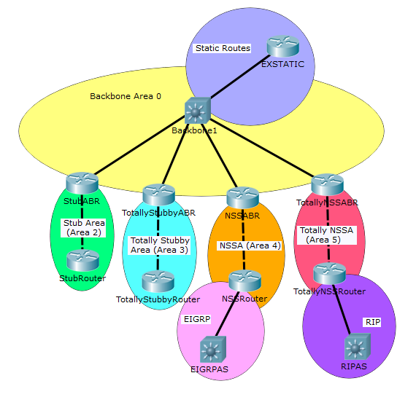

|  |  |  |  |  |  |
| --- | --- | --- | --- | --- | --- |
| Device | Interface | IPv4 Address | IPv6 Address | Connects To | Area |
| Backbone1 | Fa1/0/2 | 10.2.2.1/24 | 2001:2::1/64 | StubABR | 0 |
|  | Fa1/0/3 | 10.3.3.1/24 | 2001:3::1/64 | TotallyStubbyABR | 0 |
|  | Fa1/0/4 | 10.4.4.1/24 | 2001:4::1/64 | NSSABR | 0 |
|  | Fa1/0/5 | 10.5.5.1/24 | 2001:5::1/64 | TotallyNSSABR | 0 |
|  | Fa1/0/6 | 10.11.11.1/24 | 2001:11::1/64 | EXSTATIC | N/A |
| EXSTATIC | Fa0/0 | 10.11.11.2/24 | 2001:11::2/64 | Backbone1 | N/A |
|  | Lo0 | 192.168.11.1/32 | 2001:11:11::1/128 | N/A | N/A |
| StubABR | G0/0 | 10.2.2.2/24 | 2001:2::2/64 | Backbone1 | 0 |
|  | G0/1 | 172.16.2.1/24 | 2001:2:2::1/64 | StubRouter | 2 |
| StubRouter | G0/0 | 172.16.2.2/24 | 2001:2:2::2/64 | StubABR | 2 |
|  | Lo0 | 192.168.2.1/32 | 2001:2:2:2::1/128 | N/A | 2 |
| TotallyStubbyABR | G0/0 | 10.3.3.2/24 | 2001:3::2/64 | Backbone1 | 0 |
|  | G0/1 | 172.16.3.1/24 | 2001:3:3::1/64 | TotallyStubbyRouter | 3 |
| TotallyStubbyRouter | G0/0 | 172.16.3.2/24 | 2001:3:3::2/64 | TotallyStubbyABR | 3 |
|  | Lo3 | 192.168.3.1/32 | 2001:3:3:3::1/128 | N/A | 3 |
| NSSABR | G0/0 | 10.4.4.2/24 | 2001:4::2/64 | Backbone1 | 0 |
|  | G0/1 | 172.16.4.1/24 | 2001:4:4::1/64 | NSSRouter | 4 |
| NSSRouter | G0/0 | 172.16.4.2/24 | 2001:4:4::2/64 | NSSABR | 4 |
|  | G0/1 | 10.44.44.1/24 | 2001:44::1/64 | EIGRPAS | N/A |
|  | Lo0 | 192.168.4.1/32 | 2001:4:4:4::1/128 | N/A | 4 |
| EIGRPAS | Fa01/0/1 | 10.44.44.2/24 | 2001:44::2/24 | NSSRouter | N/A |
|  | Lo0 | 192.168.44.1/32 | 2001:44:44::1/128 | N/A | N/A |
| TotallyNSSABR | G0/0 | 10.5.5.2/24 | 2001:5::2/64 | Backbone1 | 0 |
|  | G0/1 | 172.16.5.1/24 | 2001:5:5::1/64 | TotallyNSSRouter | 5 |
| TotallyNSSRouter | Fa0/0 | 172.16.5.2/24 | 2001:5:5::2/64 | TotallyNSSABR | 5 |
|  | Fa0/1 | 10.0.0.2/8 | 2001:55::1/64 | RIPAS | N/A |
|  | Lo0 | 192.168.5.1/32 | 2001:5:5:5::1/128 | N/A | 5 |
| RIPAS | Fa1/0/1 | 10.0.0.2/8 | 2001:55::2/64 | TotallyNSSRouter | N/A |
|  | Lo0 | 192.168.55.1/24 | 2001:55:55::2/128 | N/A | N/A |

# Configurations

# Helpful Resources

If you wish to continue your research about this topic, the following topics have been found to be exemplary.

**Jeremy Cioara, CBP Nuggets. *MicroNugget: Key OSPF Areas and LSA Types***

Jeremy Cioara did a fantastic job explaining OSPF special areas and was able tie it right back into the LSA types relevant to each area type – the opposite direction other content has taken. Although he did not explain Totally NSSAs, this is where I would start when exploring special area types.

**Moy, J., "OSPF Version 2", RFC 1247, DOI 10.17487/RFC1247, July 1991,**

**<https://www.rfc-editor.org/info/rfc1247>.**

This is the blueprint for OSPFv2, a primary source. It is a very good place to reference if you have any questions about the OSPF protocol itself.