Download this document and movies.json from moodle and put it in a YourNameLab2 folder. As the page loads, it has the following elements on it:

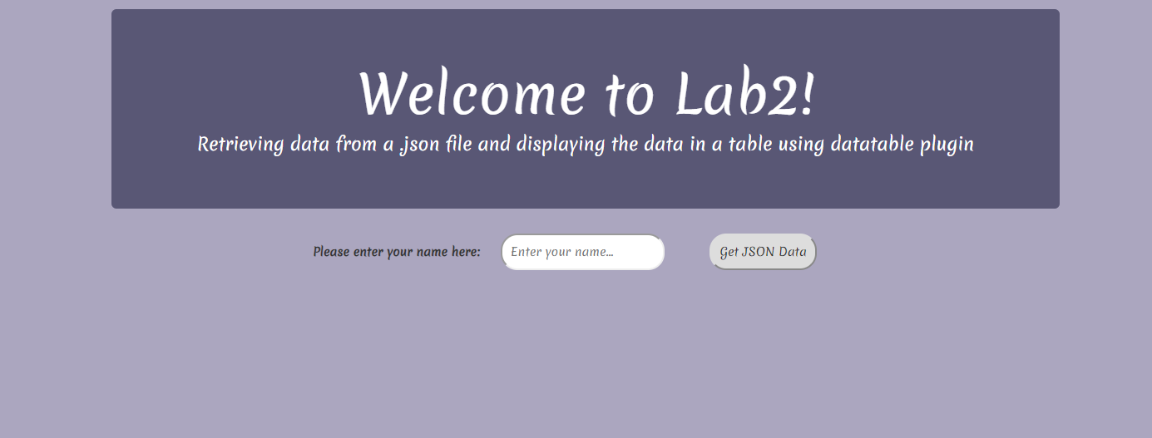

If the user does not enter his/her name, it should come up with a message saying you did not enter your name and ask to reload the page.

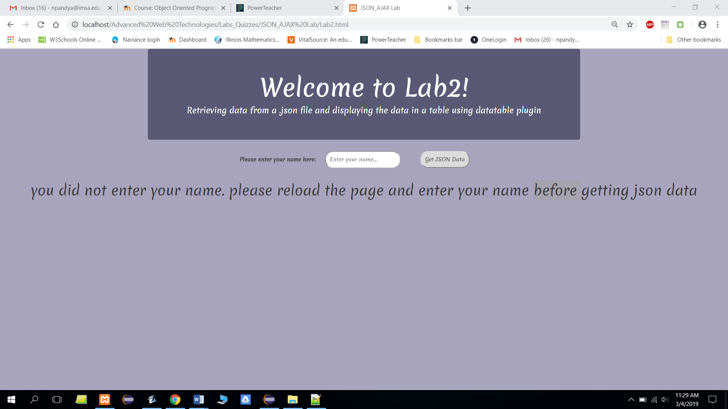

When the user enters his/her name and clicks on the getJSON button, it gets the data from the .json file and displays it as shown below using the data table plug in:

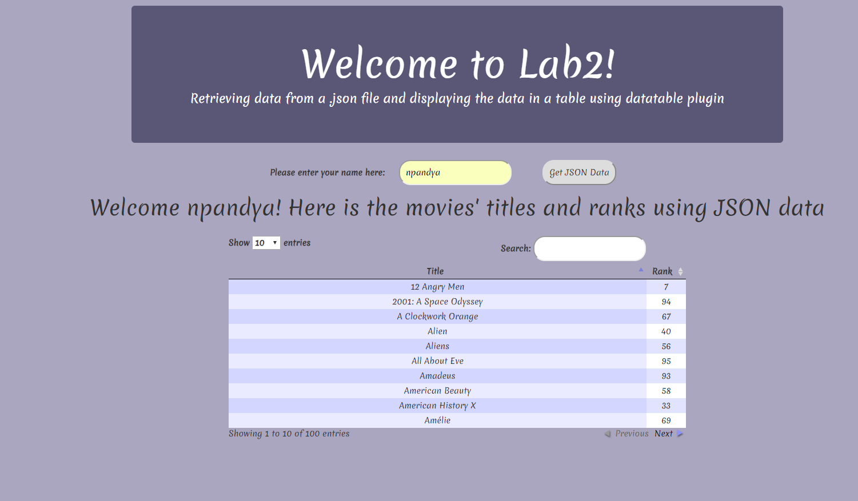

You are to use jQuery, bootstrap, and datatable plug in. You can use JavaScript or PHP to retrieve the data from the JSON file. Clearly document your code. The layout of your page has to match as shown above. Feel free to use CSS styles in addition to bootstrap to make your page looks similar to what is shown. You can use the colors and fonts of your choice. List the features that you used on your page in the comments.

Here are the colors I have used: #ABA6BF and #595775

I have used this link for the font:

<link href='https://fonts.googleapis.com/css?family=Merienda' rel='stylesheet'>

*font-family:Merienda* will be the style for using this font