|  |  |
| --- | --- |
|  |  |
| Victoria State Accident Application User Manual |  |
|  |  |
|  | 2023  2810ICT  Max Woollons s5349356  Reiss Tooze s5046939  Kail Terepai s5307474 |
|  |  |

Contents

Victoria State Accident Application User Manual 1

Getting started 2

Installation 2

Using The Application 3

## Getting started

Github Repo

### A qr code on a white background Description automatically generatedInstallation

To get started using the application you must navigate to the GitHub repository hosting the application files.  
Once on the GitHub Repository find the releases menu. Then click on the most recent release and download the Application.zip.

When the files have finished downloading extract the files into their folder as shown below.

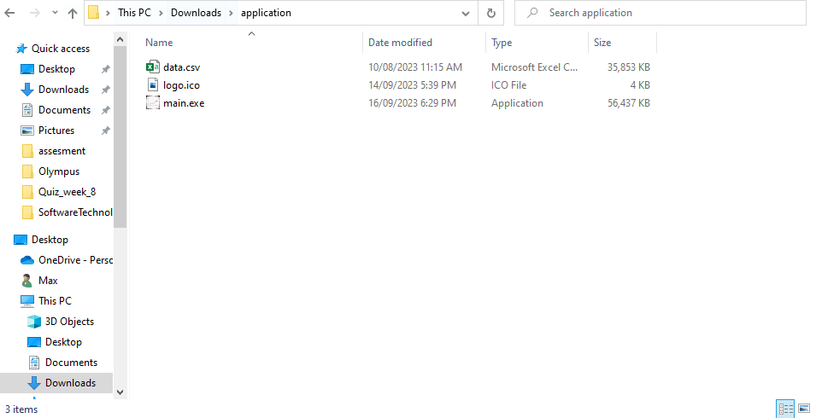

When the files are in the folder, double-click on main.exe to launch the application.

(On Windows there may be an issue with the default firewall not recognizing the application leading to an error message. To get around this click on “More info” -> “Run”)

After a few seconds, the application will start running.

### Using The Application

The application's user interface has been designed to be user-friendly where each button and section has a label relating to what it does.

Each graph asks the user for a specific input. Graphs 1 and 2 require the user to enter a Start year and End year before any graph can be created.

Graph 3 just requires the user to select a predefined keyword and a year.

Graphs 4 & 5 are predefined graphs where the user only needs to select the button they would like to see.

Minimise Program

Maximise Program

#### Basic GUI Elements

Close Program



#### Graphs 1 & 2 Inputs

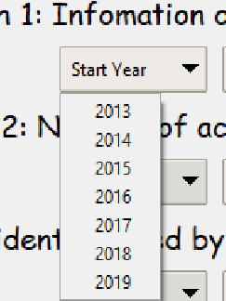



Lastly the show graph button is the final input the user can interact with. Once the two dates are selected the user can click on Show Graph to generate the graph from the data they have selected.

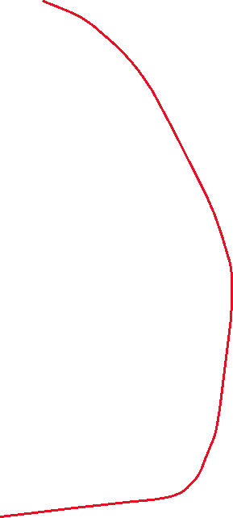

This input box allows the user to select predefined years that range from 2013 to 2019. These are the maximum and minimum years we have access to in the dataset. The user selects this input after the start year as this is when the ending year of the dataset.

This input box allows the user to select predefined years that range from 2013 to 2019. These are the maximum and minimum years we have access to in the dataset.



#### Graph 3 Inputs

Graph 3 is locked to one year. The user is allowed to select what year can be selected. Along with the year, the user can select the type of information they want to see with the Keyword Selection box. Once all the inputs are filled out the user can click on “Show Graph” and the graph will appear.



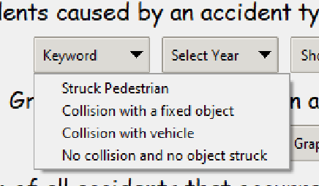

The user can select a year of data they would like to see. There is only one year input because it is locked to a 12-month period.

Key word selection- Predefined keyword types for the user to select.

#### Graphs 4 & 5

Both graphs 4 and 5 don’t allow any user input therefore the buttons can be clicked, and a graph will show up. These graphs are predefined during the development.