1.
command: ssh eltex-v14@217.71.138.1 -p 44556
The authenticity of host '[217.71.138.1]:44556 ([217.71.138.1]:44556)' can't be established.
ED25519 key fingerprint is SHA256:9EeAnPIp/wDj41XS55iG0Eff5a90ZLW9TTAI37NiBb0.
This key is not known by any other names
Are you sure you want to continue connecting (yes/no/[fingerprint])? yes
Warning: Permanently added '[217.71.138.1]:44556' (ED25519) to the list of known hosts.
eltex-v14@217.71.138.1's password:
Linux eltex-2026-summer 6.1.0-50-amd64 #1 SMP PREEMPT_DYNAMIC Debian 6.1.176-1 (2026-07-02) x86_64

The programs included with the Debian GNU/Linux system are free software;
the exact distribution terms for each program are described in the
individual files in /usr/share/doc/*/copyright.

Debian GNU/Linux comes with ABSOLUTELY NO WARRANTY, to the extent
permitted by applicable law.

2.
command: screen

command: w

ltex-v2 pts/58 :pts/5:S.1 12:32 6:47 0.01s ? screen -S -d -m
eltex-v1 pts/54 :pts/11:S.0 12:51 2.00s 0.20s 0.20s w
eltex-v1 pts/60 :pts/102:S.0 12:43 3:08 0.00s ? screen -r top
eltex-v1 pts/63 :pts/52:S.0 12:37 14:08 0.00s ? SCREEN
eltex-v4 pts/67 :pts/37:S.0 12:40 8:35 0.00s ? SCREEN
eltex-v3 pts/68 92.125.152.58 12:52 11.00s 0.00s ? -bash
eltex-v8 pts/70 88.216.75.131 12:52 1.00s 0.00s ? -bash
eltex-v1 pts/71 :pts/102:S.1 12:50 1:19 0.00s ? /usr/bin/bash
eltex-v1 pts/76 92.125.152.58 12:35 4:22 0.00s ? -bash
eltex-v2 pts/77 92.125.152.58 12:48 3:33 0.00s ? -bash
eltex-v2 pts/82 92.125.152.58 12:37 9.00s 0.01s ? screen
eltex-v4 pts/84 92.125.152.58 12:52 7.00s 0.00s ? -bash
eltex-v1 pts/86 :pts/104:S.0 12:49 8:48 0.80s 0.05s SCREEN -S top -d -m top
eltex-v1 pts/87 92.125.152.58 12:42 7.00s 0.01s ? screen -r 14095.-d
eltex-v3 pts/88 92.125.152.58 12:50 1:01 0.00s ? screen
eltex-v1 pts/89 91.78.219.164 12:41 7.00s 0.01s ? screen
eltex-v4 pts/97 :pts/99:S.0 12:49 39.00s 0.01s 0.02s SCREEN
eltex-v4 pts/99 92.125.152.58 12:42 39.00s 0.01s ? screen
eltex-v7 pts/101 :pts/8:S.2 12:42 9:11 0.13s 0.13s watch /usr/bin/vmstat
eltex-v1 pts/102 92.125.152.58 12:43 15.00s 0.00s ? screen
eltex-v1 pts/104 :pts/89:S.0 12:43 2:55 0.00s ? screen -r 17152.top
eltex-v2 pts/96 :pts/103:S.0 12:43 5:19 1.87s 1.87s top
eltex-v2 pts/105 92.125.152.58 12:50 1:54 0.00s ? -bash
eltex-v6 pts/106 :pts/44:S.0 12:44 2:23 0.00s ? SCREEN
eltex-v2 pts/109 :pts/58:S.0 12:45 6:47 0.00s ? SCREEN -S -d -m
eltex-v1 pts/111 :pts/122:S.0 12:51 13.00s 0.01s 0.01s vi report_part1.txt
eltex-v4 pts/113 :pts/49:S.0 12:50 53.00s 0.01s ? SCREEN -S report vi report_p
eltex-v4 pts/85 92.125.152.58 12:46 6:05 0.00s ? -bash
eltex-v2 pts/114 :pts/82:S.0 12:50 9.00s 0.00s 0.01s SCREEN
eltex-v4 pts/115 :pts/6:S.0 12:51 54.00s 0.07s 0.07s top
eltex-v3 pts/116 :pts/120:S.1 12:50 1:35 0.00s ? /usr/bin/bash
eltex-v2 pts/119 92.125.152.58 12:47 7.00s 0.01s 0.01s -bash
eltex-v2 pts/118 92.125.152.58 12:49 2:47 0.00s ? -bash
eltex-v1 pts/112 :pts/60:S.0 12:49 3:08 0.00s ? SCREEN -S top -d -m
eltex-v3 pts/120 79.110.48.110 12:49 1:35 0.00s ? screen
eltex-v2 pts/121 :pts/5:S.2 12:50 1:27 0.00s ? /usr/bin/bash
eltex-v1 pts/122 217.217.245.65 12:50 13.00s 0.00s ? screen -r 19397
eltex-v2 pts/123 :pts/5:S.3 12:51 1:19 0.00s ? /usr/bin/bash
eltex-v1 pts/124 :pts/102:S.2 12:51 16.00s 0.00s ? /usr/bin/bash
eltex-v3 pts/125 :pts/88:S.0 12:51 1:01 0.00s ? SCREEN

command: ctrl-a d

[detached from 26782.pts-11.eltex-2026-summer]

3.

command: screen -S top -d -m

command: screen -ls

There are screens on:
32640.top (07/06/2026 12:56:52 PM) (Detached)
26782.pts-11.eltex-2026-summer (07/06/2026 12:51:47 PM) (Detached)
2 Sockets in /run/screen/S-eltex-v14.

command: screen -r top

command: top
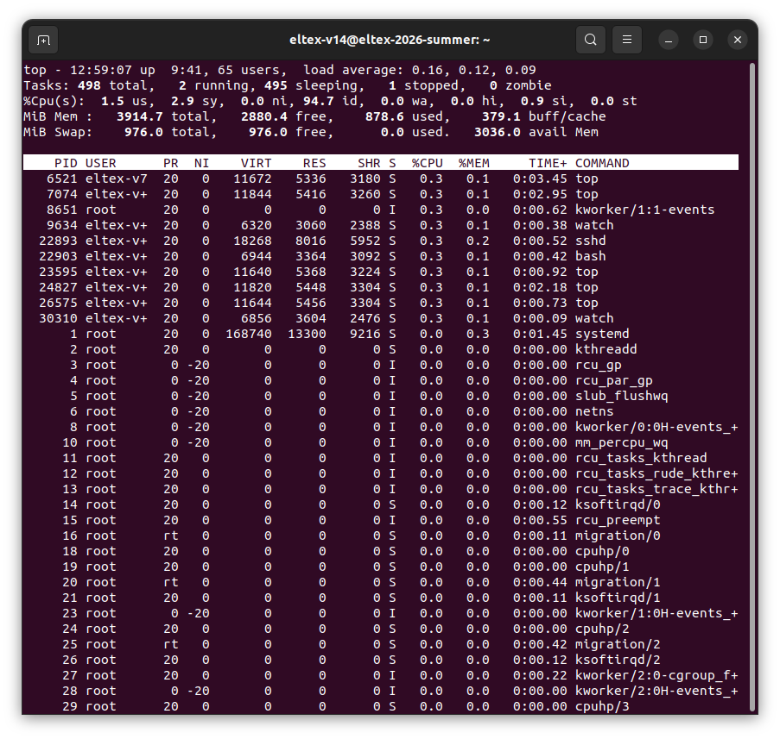
4.

command: screen -ls
There are screens on:
32640.top (07/06/2026 12:56:52 PM) (Attached)
26782.pts-11.eltex-2026-summer (07/06/2026 12:51:47 PM) (Detached)
2 Sockets in /run/screen/S-eltex-v14.

5.

command: screen -r top

6.

command: ctrl-a c

7. 8.

command: watch /usr/bin/vmstat
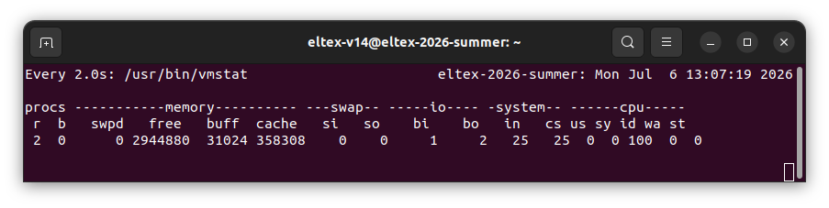

9.

command: ctrl-a «
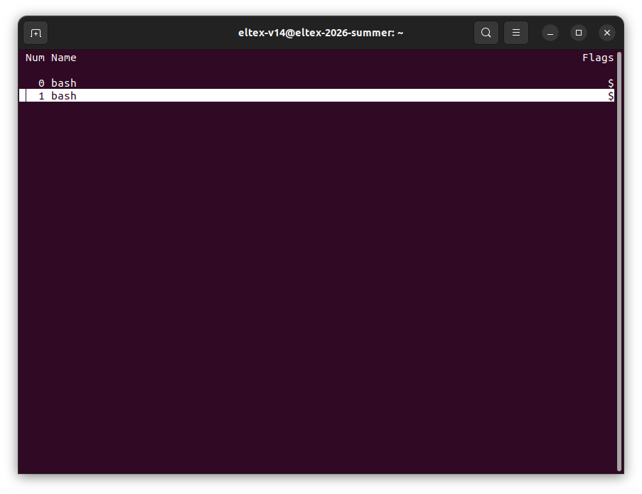
10.

command: ctrl-a A

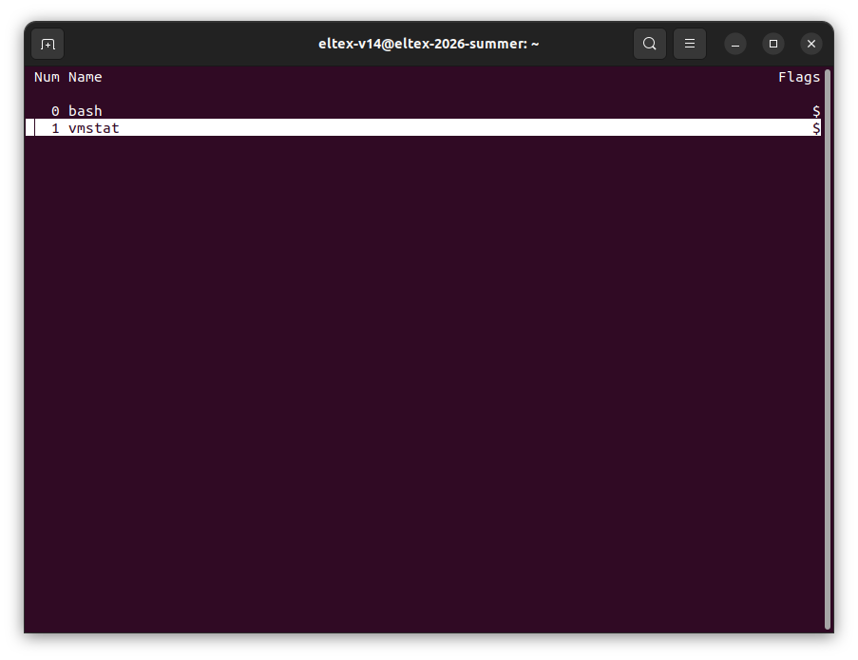

11.

command: ctrl-a n

12.

command: ctrl-a d

[detached from 32640.top]

13.

command: screen -S new13 -d -m
command: screen -r new13

command: vi report_part1.txt

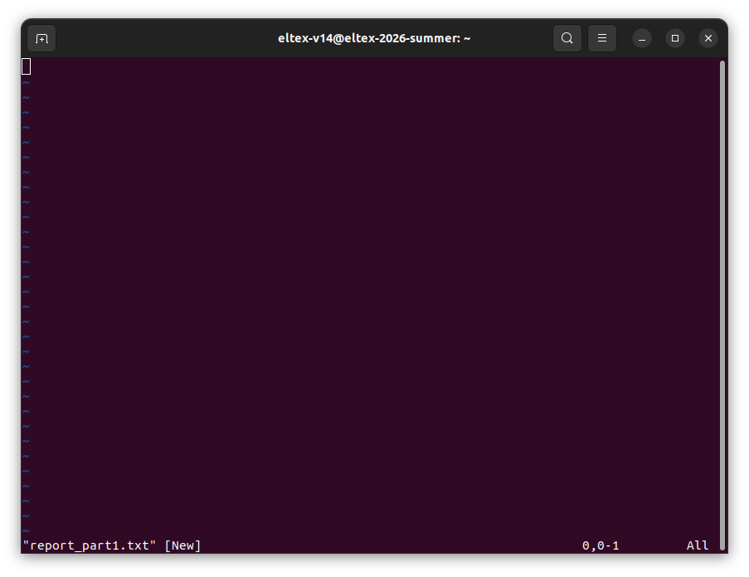

14.

command: ctrl-a d

[detached from 62623.new13]

command: screen -ls

There are screens on:
62623.new13 (07/06/2026 01:18:19 PM) (Detached)
32640.top (07/06/2026 12:56:52 PM) (Detached)
26782.pts-11.eltex-2026-summer (07/06/2026 12:51:47 PM) (Detached)
3 Sockets in /run/screen/S-eltex-v14.

15.

command: logout

Connection to 217.71.138.1 closed.

16.

command: ssh eltex-v14@217.71.138.1 -p 44556
eltex-v14@217.71.138.1's password:
Linux eltex-2026-summer 6.1.0-50-amd64 #1 SMP PREEMPT_DYNAMIC Debian 6.1.176-1 (2026-07-02) x86_64

The programs included with the Debian GNU/Linux system are free software;
the exact distribution terms for each program are described in the
individual files in /usr/share/doc/*/copyright.

Debian GNU/Linux comes with ABSOLUTELY NO WARRANTY, to the extent
permitted by applicable law.
Last login: Mon Jul 6 12:17:23 2026 from 92.125.152.58

17.

command: vi report_part1.txt

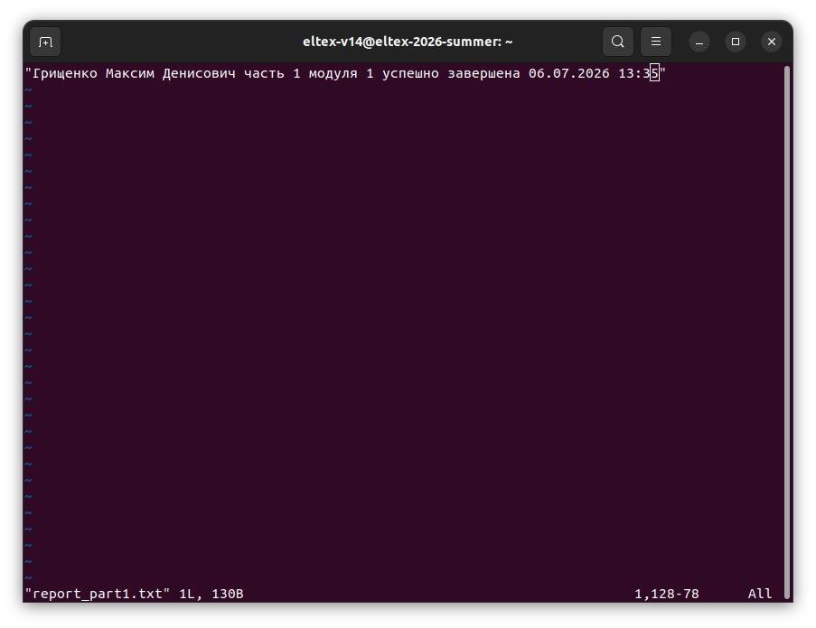

18.
command: :wq

command: ctrl-a k

