**Development of Real-Time Systems**

**Week 2 Peer Graded Assignment**

**By - Rohit Kumar** date: 28/08/2020

***Assignment***

-Create a task "matrixtask" containing the following functionality:

-Create a task "communicationtask" containing the following functionality:

-Create the tasks in FreeRTOS with the task creation call:

-"communicationtask" must send a simulated data packet every 200ms but is often blocked by matrixtask, fix this problem without changing the functionality in the tasks.

-Create a new task "prioritysettask"

* Image when code begins and according to the time taken priority is set

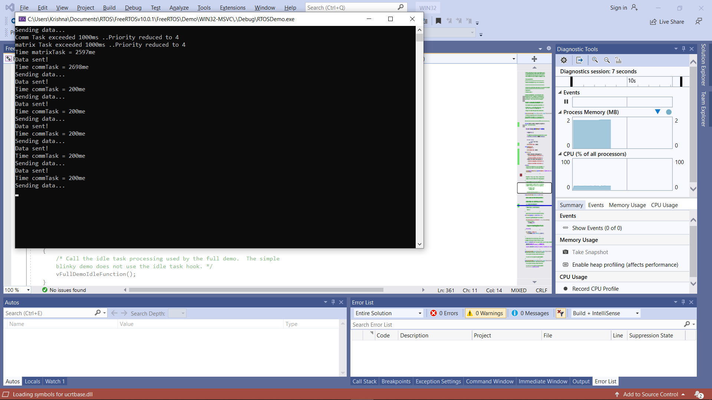

* Image when the code for communication task takes longer less than 200ms then we observe a priority change for the code

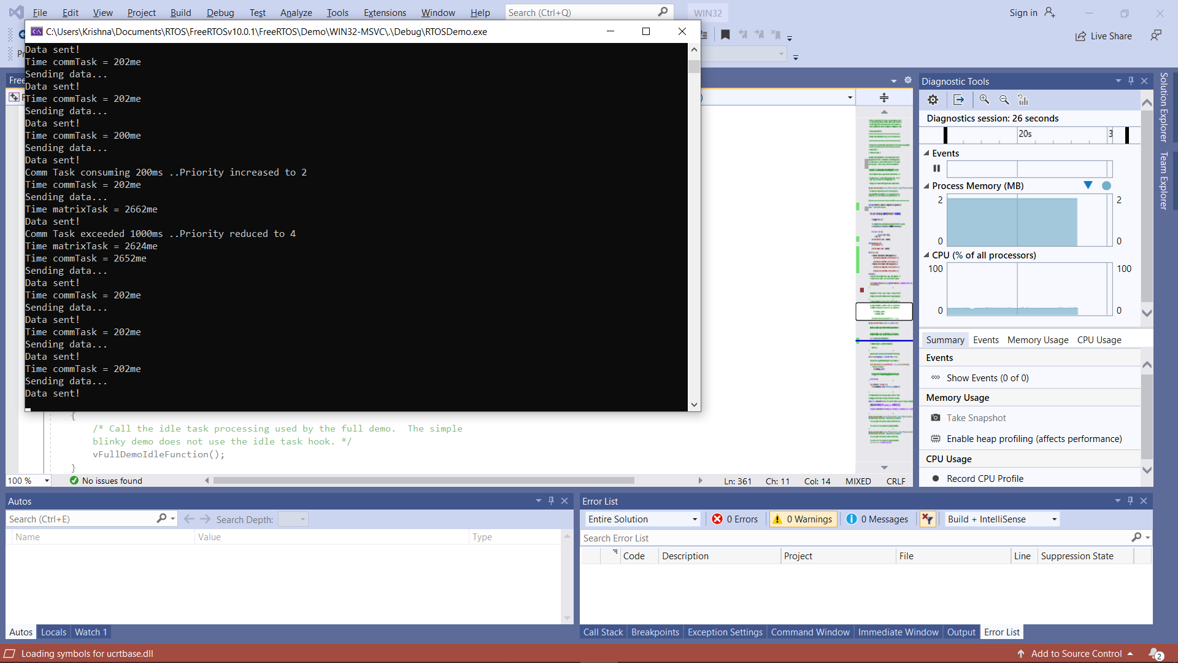

**QNA**

1. **Why is "matrixtask" using most of the CPU utilization?**

**Ans.**

Because of long for loop

for (simulationdelay = 0; simulationdelay < 1000000000; simulationdelay++)

1. **Why must the priority of "communicationtask" increase in order for it to work properly**

**Ans.**

So that to overcome of ambiguity to choose between which tasks to perform as a higher preference between the two tasks.

1. **What happens to the completion time of "matrixtask" when the priority of "communicationtask" is increased?**

**Ans.**

It is given less priority and performed when the communication task has gone into waiting mode

1. **How many seconds is the period of “matrixtask”? (Hint: look at vApplicationTickHook() to measure it)**

**Ans.**

Around 2662ms