**Cross-section of mucous membrane of the stomach: spatial statistical analysis.**

Maksym Vaskin

ETSIAAB, Technical University of Madrid, Madrid, Spain

E-mail: biomedmax@gmail.com

05-Jan-2019

Abstract

Stomach has a mucuous membrane layer which contains glands and gastric pits. It is made of many different cell types in different relative proportion. This work consists in analysing a cross section of one such membrane and asking relevant biological and statistical questions about the cells distribution and relationships between them in that particular cross-section.

1. Introduction

Gastric mucosa is one of the layers constituting our stomach. Morphologically, it consist in glands and pits (or crypt) and histologically, it consists in epithelium, lamina propria and smooth muscular layer. Its cellular composition is quite complex as it has pit cells, stem cells, enterochromaffin cells (ECL), mucuos cells, D cells, G cells as well as regenerative stem-cells. Although every kind of above-mentioned cells can be found at any location in the mucous layer, each cell type has a preferential location to be that depends on the deptht of the pit and the anatomical part of the stomach (fundus, corpus or antrum)1.

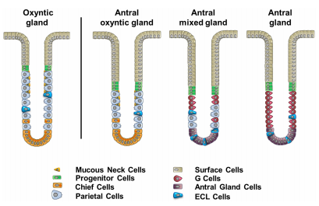

Figure . Figure taken from reference 1. Location of different cell types in the crypt of gastric mucosa.

2. Dataset

In this dataset, cells are classified into ECL (enterochromaffin cells) and “other” categories. Each cell has a coordinate in two dimensions of its center in a square space. The lower edge of the space corresponds to the part closest to the outside of the stomach. There are in total 965 cells, most of them are “other”.

3. Methods

For this dataset, questions regarding ECL cells distribution in the cross-section (independently or relative to other) were asked, as well as general characteristics of cell content in the observed area.

ECL cells are special enteroendocrine cells. They help the production of gastric acid via release of histamine, a process needed for efficient food breakdown. ECL cells are preferentially located in the bottom of the crypt and mostly in the bottom part of the stomach (antrum), as confirmed by literature, at least in humans1. Therefore, a priori, we would expect them to cluster mostly at the bottom of the window in this dataset, even though it´s a dataset from rat stomach.

For all the analysis either base R version 3.5.1 or spatstat package commands were used.

4. Results

4.1. Exploratory Analysis

4.1.1. Point intensity and CSR

First, the whole dataset was plotted and divided by quandrants. In each quadrant, the number of cells is shown. The resulting graph is shown in Figure 2. We can see that the distribution of cells by quandrants doesn´t seem homogeneous and in fact, when the quadrant test is performed (default parameters), p-value is <<0.05. The plotted quandrant test is presented in Figure 3.

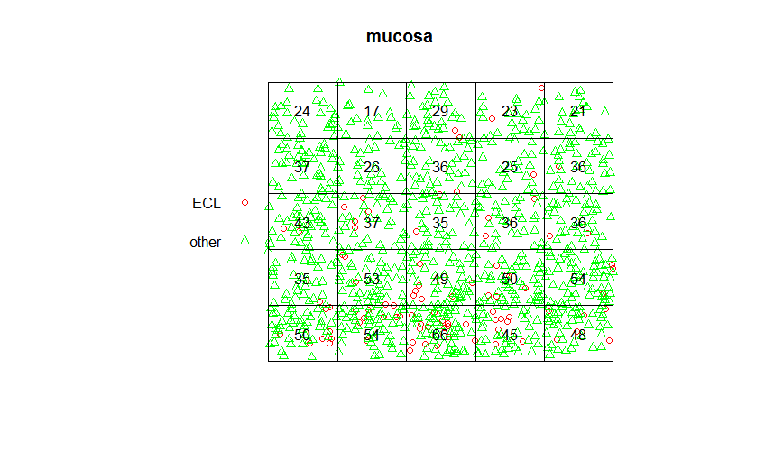

Figure 2. Whole dataset plotted and divided into quadrants.

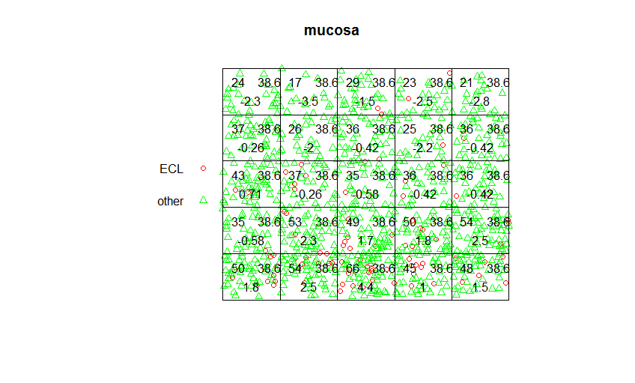

Figure 3. Quadrant test for each quadrant. First number is the actual number of cells, second is the theorethically expecte number of cells under the assumption of uniform distribution. Third number is the value of quadrant test.

Next, splitting data was tried out and quadrant count performed separately. The results presented in Figure 4, shows that we can see clustering of both cell types in the bottom of the window, although ECL clustering is much more evident.

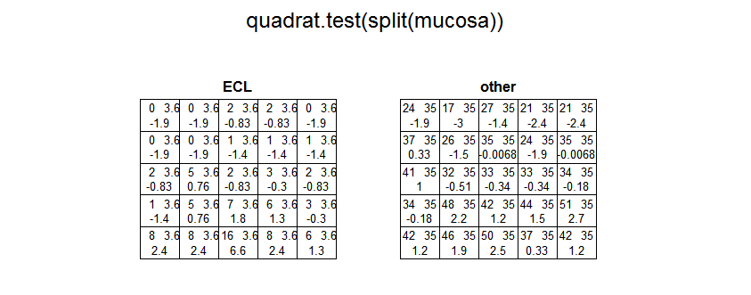

Figure 4. Quadrant test on split data.

4.1.2. Interpoint interaction.

The quadrant test for CSR gives a p-value << 0.05 for the null hypothesis. However, these results have to be interpreted carefully as the negation of null hypothesis in this test is too wide and it is greatly affected by the existence or not of interactions between points. To address the second limitation mentioned before, a Morishita plot was created for the whole dataset and individually for each class of cells (Figure 5). This test consists in division of the space in an increasingly greater number of quadrants of equal area and computation of chi-squared statistics for point distribution in quadrant (Morishita index). In the case of independent point distribution, we would expect the Morishita index to be around 1 for each division; if the points show a repulsive property, we would expect the index to increase from 0 to 1 as the number of quadrants increase; if the points present clusters, the initial scores would be high and would tend to 1 asymptotically as the number of quadrants increases.

In the graph of Figure 5 we observe that the cells of dataset probably present either independent distribution or slight repulsiveness towards each other. The Morishita plot for “other” cells isn´t much different from the first one because most of the cells are classified as “other”. For “ECL” cells, we can clearly see a clustering behaviour, but this is probably due to the fact that they are mostly present in the lower edge of the window (approximately 1/3rd lowest part). Conclusions about whether they present clustering if only the lowest 1/3rd of the window is considered can’t be made by this analysis.

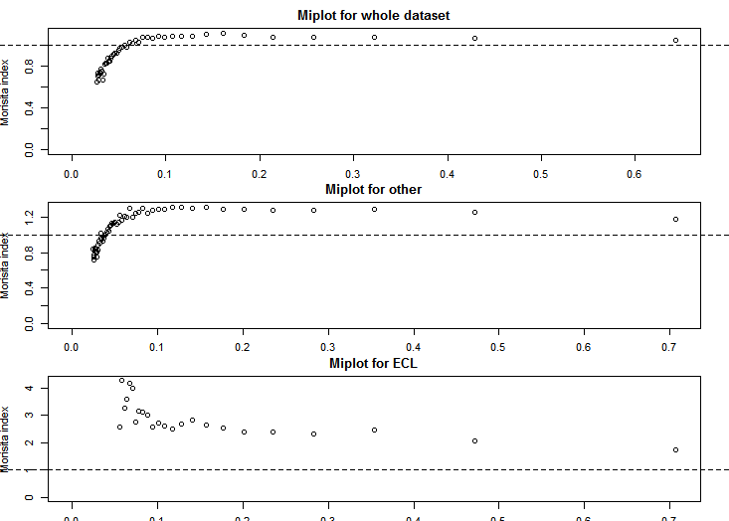

Figure 5. Morishima plot for the whole dataset, cells under the category “other” and ECL.

A better function to query the interpoint relationship is the more computationally difficult fryplot. Upon running fryplot functions, the conlusions made from fryplots are essentially the same.

4.1.3. Empty Space Distances

For this dataset, a distance map was also created (figure 6). Of note that the edge effect is probably affecting the results

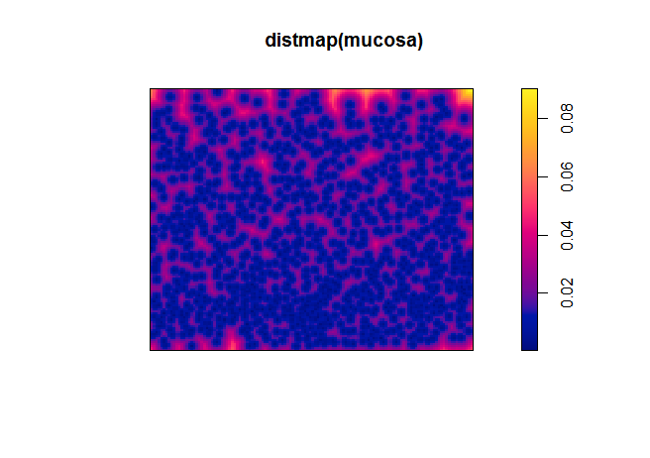

Figure 6. Distance map.

4.2. Summary Statistics

Additionally, G, F, J and K functions were plotted (marks were previously deleted).

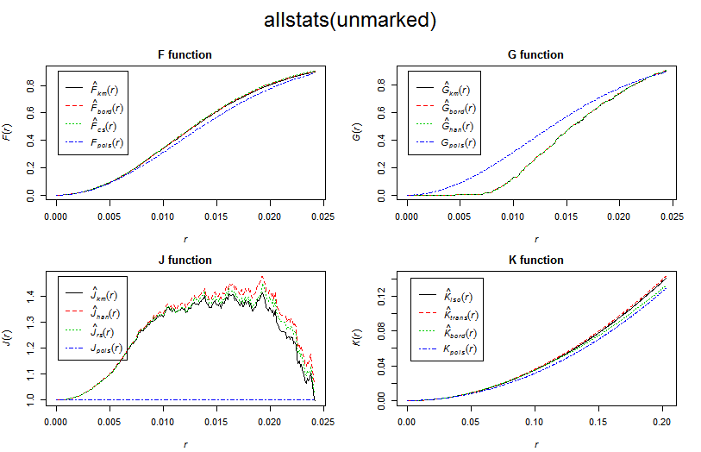

Figure 7

4.3. Envelope

Finally, an envelope function with 100 simulations of CSR distribution was used on the whole dataset (Figure 8). Lowest and highest borders of CSR distribution are presented as well as the theoretical distribution under assumption of CSR. The observed distribution is clearly slightly above the theoretical line an above the highest border, meaning that certainly data presents certain clustering properties. Plotting the same graph separately for “other” or “ECL” cells gives a similar result (data not shown).

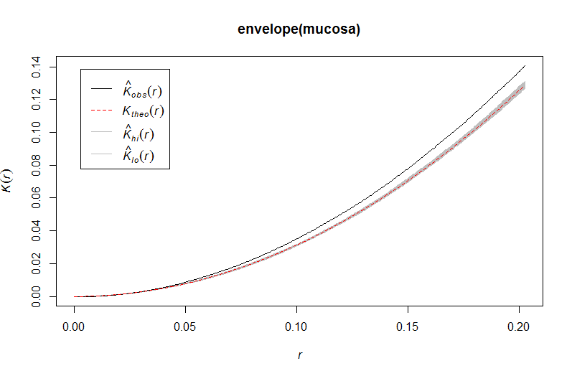

Figure

4.3. Spatial Variance

Once it became clear that the distribution of cells is spatially different, we could visualize the spational-varying probability distribution for each individual cell category by plotting a spationally-varying relative risk graph (Figure 9). We can see that the relative probability of finding an “ECL” cell is greater in the bottom of the crypt and all the other cells are located more at the top (relatively to the location of ECL).

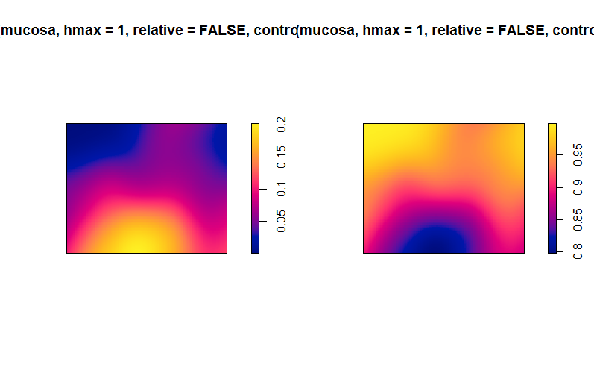

Figure . Spatially-varying relative risk for ECL cells (left) and “other cells” (right). Yellow indicates higher relative probability.

4. Conclusions

There are only two biolgically relevant conclusions that can be drawn from this dataset using tools of this work.

Firstly, the distribution of cells is not completely uniform in this section of the membrane. Considering either the whole dataset or a subset conisting of ECL or “other” cell, we observe a slight clustering behaviour of cells.

Secondly, in accordance with the literature, ECL cells are predominantely located in the lover part of the memrane, i.e in the base of the crypt.

**References**

1. Choi E, et al. Gut 2014;63:1711–1720. doi:10.1136/gutjnl-2013-305964 “Cell lineage distribution atlas of the human stomach reveals heterogeneous gland populations in the gastric antrum”