# The Dungeon Server

Meteor Miner drove us to download the so “relaxing” game of Dungeon.

Well … nor me nor Max have never played This game before, and for the kiddo the results were that he has started to use frequently this icon chatting in skype.

(Please, do not report this to his mom)

We spent the majority of our time trying to understand what the goal of the game was and how to survive it. Well … I gotta admit that the simple word of Dungeon now has a particular meaning for the two of us.

Kiddo started to play the game … and after a couple of hours stared at me saying:



**To cheat? Oh yeah, .. but you have to know the rules in order to break them !!!!**

So, we started to google-ize all the possible sites about dungeon and found out that our game was a fork of the Zork version. We downloaded the zork version from github and started to look at the code, compiling it … and ... no easy way out from there either but at least we discovered there was a debug tool called GDT inside the game (not always enabled).

**FIRST HINT:**

We were lucky, our dungeon has GDT enabled.

**SECOND HINT**:

It came out using the GDT command TK (take object).

We started to build (by hand) the full list of objects available in Zork, they were 216.

Then we compared with the version we had … and saw there were 217 objects :).

We had just one object more, the ELF .. and it was the last one.

**THIRD HINT**

The other command we used in GDT was DT. This command allows you to retrieve all the phrases you can encounter playing the game.

In zork there were 1022 phrases , (oh no, don’t worry, we didn’t read them all !!!) , we just compared with those ones in our dungeon version and saw that we had 1027. So there were 5 sentences more than in the Zork version, and they were all just in the end of that list.

**FOURTH HINT**

Last command we tried was AH, that allows you to move into different rooms in the game.

So, we supposed to find some room having an ELF and we started looking at the end of all the rooms.

We move from room 150 going on by 10 to see what was the last room. This way we discovered that the right room was the 192 in which we reached the North Pole and we were in front of an ELF :)

**HERE WE GO**

Then, kiddo started to play with the ELF and found out the magic phrase:

**> give coins to elf.**

And Booooooom we finished the challenge alive !!! :)

Really the ELF was a bit avid … and liked every object having some kind of value ..

# THE SERVER ONLINE

We launched nmap versus the server and saw that there was the port 11111 open, so

$ nc dungeon.northpolewonderland.com 11111 (*)

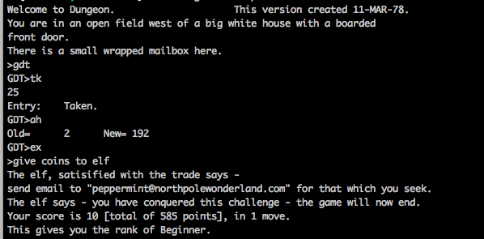

We learnt how to cheat and we won in just 1 move :)

then we wrote a mail to [peppermint@northpolewonderland.com](mailto:peppermint@northpolewonderland.com), kiddo was really enthusiast about that, above all in receiving the reply from the elf and with our 5th mp3, too !!!!

* actually we had some trouble trying to connect. 99% of the times, we were able to connect completing the syn-ack, but then server send immediately the F flag and connection dropped. We were able to connect just trying and trying …probably the server was over-croweded.